Module Assignment Submission
Cover Page

Student Name: | Rebecca Anne Williams
Student Number: | 1811604
Module No: | BMSK6001
Module Title: | Emergent Leadership Skills for the Workplace

Date submitted: | 18th July 2021
Time submitted: | 18:10
Statement of Confirmation of Authenticity
By the act of making this submission, the student declares that this is the work of the student named above. Where materials have been used from other sources it has been properly acknowledged. If this statement is untrue, the student acknowledges that an assessment offence has been committed. Proven incidents of plagiarism, collusion or cheating can result in a learner being withdrawn from a
qualification.
Attention is drawn to the Plagiarism, Collusion and Cheating Policy and Unfair Practice policies of the University and ILM.
Permission for ILM to use this script
ILM uses learners’ submissions – on an anonymous basis – for assessment standardisation. By submitting, both the centre and the learner agree that ILM may use this script on condition that identifying information is removed. However, if you are unwilling to allow ILM use this script, please refuse by ticking the box: □

Contents
Introduction 2
1.0 Evaluate own ability to use a range of leadership styles, in different situations, in different types of people to fulfil the leadership role. 3
1.1 Leadership Style – Autocratic. In Head of Operations role. 3
1.2 Leadership Style – Transactional. In Casework Investigator/Colleague role. 5
2.0 Critically assess a recognised leadership model or theory in relation to its ability to impact on individuals workplace performance. 6
3.0 Assess your own ability to set direction, motivate, delegate and empower others to bring about a workplace change. 9
References 11
Bibliography 14
Appendix 1 16
Appendix 2 17
Appendix 3 18

Introduction

This assignment will be based on emerging leadership skills and how leadership styles can affect the growth of an individual and that of an organisation. Researching two different styles in order to highlight the affects when implemented along with the similarities and differences between the two in section one. This is to gather evidence on whether there is a distinct difference, not only between a manager and a leader but how efficient a leadership style can be if implemented correctly considering the audience, emotional intelligence, and the staff/followers. The information gathered will be linked to a workplace exampleand a conclusion drawn. In section two the focus will be on a leadership model exploring its impact on staff growth along with the knowledge, skills, attitudes, and emotional intelligence which fits into and is supported by each model with questionnaires to support the outcome. Section three will be an evidence based example of how effective leadership has been used in the workplace to highlight, implement and support a change for the benefit of the individuals in the team along with the growth of the business.

Evaluate own ability to use a range of leadership styles, in different situations, in different types of people to fulfil the leadership role.

According to Drucker (1988) leadership is to bring individuals to the next level, to help others to break through limits for oneself. Drucker (1998) states that the results of attaining higher achievement and the drive to find and support individual’s potential can lead to unimaginable accomplishments. With the support of the right leader and leadership style an individual’s true professional and personal potential can be reached. In order to be a leader, you must have followers and they in turn will create a leader but to be a great leader you must lead by example in one direction to a vision or goal whilst modifying your leadership style in order to mirror that of an individual follower to obtain the highest of achievements.
According to Kotter (1990) leadership styles can largely be taught to pre-adolescents and adults in school or on the job. He also states that although leadership skills and styles can be taught an individual must also have good mental and emotional health, high energy levels as well as basic intelligence and intellectual skills in order to support and drive others with potential to the forefront. Taylor (2006) also supports Kotter (1990) but adds that leadership styles and qualities can be developed within individuals. Some individuals exhibit certain behavioural and personality characteristics that set them apart from their peers and by supporting those with the correct leadership styles it is possible to develop them into better and outstanding leaders.

1.1 Leadership Style – Autocratic. In Head of Operations role.

The difference in leadership styles will be set by an individual’s perspective on their role along with a set clear vision for their organisation or department goal whilst motivating, encouraging, and guiding their team through the process. Throughout a leader’s career they may choose to adapt their leadership style and approach depending on the specific situation, organisation’s goal or team members. Likert (1962) explains that a senior leadership role within an organisation must be knowledgeable and flexible to ensure that each member’s background, values and expectations are supported by the leader enabling them to build and maintain each individual’s personal worth and importance within the organisation. Stenmark (2000) Richards & Busch (2000) agree with Likert (1962) that an organisation’s tacit knowledge resides in its people and without the correct leadership style to draw on that knowledge and expertise can be lost resulting in failed goals and process shortcuts.
Because of its difficulty to obtain Jennex (2008) suggests that tacit knowledge needs to be nurtured from individuals as its importance is paramount to the success of a business or organisation, but this form of leadership is not supportive of an autocratic style. Identified and supported by Lewin (1944) an autocratic leader is characterised by control over his peers. Kippenberger (2002) suggests that decisions are made on an autocratic leader’s judgement and own ideas, and will rarely accept or incorporate advice, vision, or suggestions from their team. He agrees that this style of leadership is popular with smaller groups and short timeframes where a specific goal is set and individual knowledge is not required. It removes decision-making pressure from individuals and allows them to focus on the task, removing the risk of responsibility and pressure. Pena-Acuna (2017) disagrees with Lewin (1944) and suggests that all leaders must be human resource experts, knowing people and their complexity in order to adapt and design positive working groups to draw out individual’s expertise and vision.

By undertaking Northouse (2016) leadership style (Appendix 1) and skill (Appendix 2) questionnaires they have identified a democratic leader with administrative skills, this demonstrates a confident leader but with the ability to communicate effectively with all grades, gaining trust and respect of peers to forge deeper relationships enabling effective anticipation within a group but also step out and lead by example within the current workplace.

In the current workplace within the middle management level and above there has only been an autocratic style of leadership. Despite the many departments with varying levels of education, knowledge, diverse backgrounds and varying skilled individuals this is very rarely recognised or utilised. Staff are recruited en masse to do a set role, within a specific department, trained and set to work. With high reaching targets and fast turnover of applications managers have very little time to get to know their staff, assess their abilities or converse with them as individuals. In increasingly data driven workplaces, ‘Bums on seats’ daily targets and spreadsheets define a department not its staff. This approach does not support a healthy and happy workforce, with a majority of staff experiencing ‘burnout’ within the first 12 months. Whilst autocratic leaders remain managers within organisations and are unable to draw on their emotional intelligence by utilising their social skills to grow relationships and empathise with their staff there will always be a ‘them and us’ ethos amongst struggling supporting staff and early burnout.
To conclude, Drucker (1988) states that good leadership brings people together and supports results in achievement and accomplishment. This is unfortunately not commonplace in the current workplace, there are many abilities within the organisation’s workforce that are being overlooked because of the autocratic leadership style within departments.
If only one manager had the view of Pena-Acuna (2017) to engage with their staff, use their ability to empathise with their excessive workload and spend a small amount of time to motivate and encourage this would result in a happier workforce and greater productivity. It is clear that there are similarities between emotional intelligence and leadership; Thorndike (1998) described the ability to get along and work in harmony with other people as ‘social intelligence’ and interestingly Wechsler, D. Kaufman, A Et Al (2001) proposed that effective intelligence and leadership played a pivotal role producing successful staff. Even though as a leader you must have authority and vision you must also be considerate and open to your team, to get the best they can possibly give in order to reach a goal.

1.2 Leadership Style – Transactional. In Casework Investigator/Colleague role.

Bass (1990) states that a transactional style of leadership focuses on an arrangement between the leader and their peer to reach goals with the promise of reward and recognition but also penalises for under performance. Supported by Avolio, Jung et al (2003) the promise of a reward for good performance and discipline characterises that of a transactional leader but also implies that a transactional leader is more focused and reliant on its peers to accomplish their tasks and therefore rarely interacts with those who are not meeting expectations. Anderson & Son (2017) disagree stating that a transactional leader will take corrective action on the basis of results and were therefore not needed to penalise for under performance. In addition, Goodwin et al (2001) identified that the transactional reward could be separated into ‘explicit psychological contract’ and ‘implicit psychological contract’ and therefore could be closely linked to transformational leadership by the implicit psychological contract being closely associated with the behaviours of transformational leadership.

Within lower management levels in the current workplace there is clear evidence of transactional leadership behaviours along with a slight incorporation of transformational leadership. Team managers are set daily targets for their staff in line with the workload and are expected to distribute amongst their staff. With smaller teams the manager has the ability to utilise their emotional intelligence skills by establishing closer relationships, identifying individual’s strengths, and matching that with their abilities to complete certain tasks. Being target driven but also knowing your staff’s capabilities enables work to be allocated to the correct staff for them to achieve their targets but also for the manager to clear the daily workload in sufficient time. This method of allocation allows the manager the flexibility to offer each individual the opportunity for an ‘early finish’ without losing pay provided they have completed their task but also the option of helping other team members who are not on target with the offer of overtime pay until the end of their shift. This approach does support a healthy workforce with the majority of the team able to complete their workload ahead of their finishing time as their abilities, knowledge, and strengths have been considered by their manager and the work allocated fairly. Whilst transactional leaders are still restricted by utilising the basic emotional intelligence skills, it will help them, and their team achieve their goal with an ‘us’ ethos.

To conclude Kippergerger (2002) states that to understand and know your staff is to understand and know your strengths as a good leader resulting in a well-established pattern of communication, respect, and desired outcomes. Fortunately, this is commonplace amongst lower-level managers in the current workplace but continuously overlooked as a positive way of working amongst middle and senior managers who strive for a more disciplined and task focused view. If one senior manager could be influenced by the view of Ashley et al (2020), who identifies that staff with greater support and relations with their manager develop greater partnerships which results in the implementation of good working practices, goodwill measures and a high achieving team.

Critically assess a recognised leadership model or theory in relation to its ability to impact on individuals workplace performance.

According to Knight, Durham and Locke (2001) the concept of leadership is to promote a positive working environment, to monitor employees’ behaviour and motivate with an empathetic approach to achieve the individual’s goal. Hartwig, S and Mathews, S (2020) state that many organisations fail to use the appropriate leadership model and techniques to identify their employees’ strengths in order to align with the organisations goal. This therefore results in persistent gaps between the individual’s vision and their ability to reach it.
In contrast to Knight, Durham, and Locke (2001) Anthony, P (1994) argue that organisational culture is what an individual is influenced and motivated by and not the leadership ability of them or their co-workers. By outwardly portraying strong leadership values the culture within the workplace will also have a positive effect on the individual’s performance to support forward thinking, openness, inclusiveness, and change for the future. This highlights Drennan, L (2018) belief that it is simply how things are done and not how it should be done which supports an individual’s progression.

According to Konkoli, Z (2011) the Adair leadership model, also known as the overlapping three circles model, is a model that can be applied to any individual or organisational change including performance monitoring. The diagram in Appendix 3 is known as the Action Centred Leadership or the three circles model first published in 1973 by the leadership expert, John Adair and consists of Accomplish the Task, Build and maintain the team and the Individual function/need. Starting with the need to accomplish the ‘task’, this is where the individual will identify and appreciate the task objectives. By setting the tempo and timings, the individual will be able to produce a detailed plan on where they and their skills currently sit within the organisation, where they wish to be and how to get there. This allows the leader to highlight and set achievable targets that must be met whilst continuously assessing and adjusting their direction in order for the subordinate to access and utilise all available resources in order to reach the organisation’s end goal. According to Gilbert, P (2005) these factors are a driving force for an individual’s success. Feeding into the ‘team’, individuals have a sense of purpose and thrive from clear communication; praise and motivation is paramount, but this must be coupled with the discipline and effective boundaries being set in order to meet the task. Individual’s also become aware of other’s strengths within the team which encourages collaborative working. The third circle of ‘individual function/need’ highlights the importance of individual training, recognition and utilisation of the team and individual strengths whilst praising and highlighting input when appropriate.
All three circles must overlap and be constantly considered and evaluated. This is because a task cannot be met by an individual but needs a team, the team cannot function effectively if their needs and are not met. If individuals are not satisfied, this can result in an unhappy team and impaired performance to complete the task. By highlighting and implementing the three circles model above, it supports Adair’s theory that leadership can be taught and is a transferable skill. It is a model with proven success and can be easily applied by a leader with key reference points to develop metrics which can measure success. By displaying self-motivation, creating a positive working environment with recognised individual success and realistic targets, this can then create a clear distinction between a leader and a manager.

Adair’s leadership model is also supported and linked to Maslow’s hierarchy of needs (1954). His theory also highlights that you are unlikely to succeed at a higher level without addressing and sourcing lower levels of support, for example a basic need of food and warmth will help fulfil a psychological need of team spirit and accomplishment that then supports an individual to reach their full potential.
Maslow’s Hierarchy of Needs is sectioned into 3 levels of psychology with the largest and most fundamental level at the bottom. We are driven and motivated by unsatisfied needs and as each is satisfied, we encounter the needs at the next level and address them ultimately leading to self-fulfilment.
During an individual’s career and lifetime, it is inevitable that they will move up and down between each step of Maslow’s triangle steps, not every goal will be achieved if they do not have the appropriate psychological support to reach a specific goal. An example of this is low self-esteem which could have resulted from a breakdown in a marriage (moving down a step) but by attempting to build self-confidence and confidence in others will encourage respect and support from team members that are all key support steps in self-fulfilment/goal. By understanding the impact that events have on an individual, a leader can understand how this effects their motivation. This can then tie in with Adair’s third circle where an individual’s function can be impacted by a change within their hierarchy of needs, both positively or adversely.

According to Chun et al (2010) Emotional Intelligence is an essential skill for any leader and therefore for the success of any leadership model. It is a constant evolving skill that leaders must possess to ensure that their team is well supported, treated fairly, and recognised for their achievements. It is critical for any leader to know what to say, how to say it, and it can therefore be regarded as the first skill needed to ensure individual and team progression. Chun et al (2010) vision agrees with Maund, A (2018) that every leader is an individual chosen by an organisation because they display the soft skills and have the business knowledge to share. Chun et al (2010) therefore feeds directly into Adair’s second and third circles where emotional intelligence is essential in order to build the team and understand the individual’s functions.

Across all management levels in the current workplace there is clear evidence that Adair’s leadership model is being implemented. Senior managers can be seen to set a department task with a structured process plan highlighting key milestones, timings, and expectations for the staff and task. This is then filtered down to team leaders who will allocate work according to individual capabilities and timeframes. By working within the teams each leader is perfectly placed to motivate and encourage their staff throughout the day to ensure standards are met but also give their staff a sense of purpose through good communication discipline and continued praise for their efforts. Working in smaller and more specialised teams enables team leaders to identify individuals who have ‘gone above and beyond’ to complete a task, feeding the information back to senior staff through a structured chain of command. This good communication enables managers to give direct praise and recognition to high achieving staff but can also highlight individual training needs and personal (possibly non work related problems) that could be affecting performance or attendance for others. This in particular is where leaders can most effectively see the benefits of recognising the impacts of individual’s needs (as Maslow explains) whilst developing the individual and building the team as explained in Adair’s leadership model.
This leadership model works well to enable all managers to support each team member to work collaboratively and efficiently to achieve a desired outcome. Middle managers are key people who practice effective emotional intelligence in order to filter the direct requests from senior managers. This enables them to deliver messages or direction with a more friendly disposition, with enthusiasm and with an understanding of the day-to-day running of the team. Loss of these middle managers would result in the loss of staff motivation and more importantly the tacit knowledge that they have gained through their work journey and specialist training. This can then lead to a loss of sense of purpose within the team and a deviation from the senior management’s delivery plan.

To conclude, Adair’s leadership model can be used successfully with the right emotional intelligence skills and tacit knowledge for each individual leader. This is supported by the view of Ashley et al (2020) which states that staff with greater support are able to develop greater partnerships and working practices throughout their career which will result in greater leaders. It is with this view in mind that all staff irrespective of grade vision or drive for success should follow this leadership style as it will make for a more inclusive, goal orientated, motivated workforce with a sense of purpose and recognition for all their achievements. According to McGrath, J and Bates, B (2017) the purpose of a leader is mirrored by that of a good housekeeper. It is to follow a clear delivery plan whilst motivating and encouraging their staff to achieve a set goal. By recognising and praising individual’s contributions and disciplining, when necessary, it gives a team a sense of purpose and appreciation for the journey ahead. Much like that of a housekeeper where their motivation and drive to ensure rooms are laundered and customer’s expectations met by a set time will result in happy customers, recommendations for the establishment and possibly a small financial gain ‘tip’.

3.0 Assess your own ability to set direction, motivate, delegate and empower others to bring about a workplace change.

According to Northouse. P, (2016) leadership is the process whereby an individual influences a group of individuals or team to achieve a common goal. Kouzes and Posner (2012) also support Northouse, P (2016) stating that a leader is always looking forward, adapting to change, and implementing it. They have also identified that a successful leader follows the five practices of exemplary leadership in order to succeed (Model the way, inspire a shared vision, Challenge the process, Enable others to act and Encourage the heart). By modelling the way and leading by example your team are more inclined to support and follow your vision and this will identify you as a leader rather than a manager. By inspiring your staff with a shared vision and challenging processes, this will empower individuals by giving them the tools to develop and change with you along the way. Work alongside your staff, getting to know them on an individual basis will help the leader to encourage and support as this is also key to achieving success together. Always expect the best from individuals and support with encouragement and recognition for their input and success.

Within the current workplace there has been a considerable backlog of medical cases and drivers waiting for medical assessments due to the ongoing restrictions imposed by the Covid 19 regulations. The vast majority of these cases were awaiting specialised tests within a hospital facility or face-to-face assessment with consultants in order to determine the fitness to drive. Ministerial restrictions imposed on the NHS meant that non-priority (anything not Covid related) would not be addressed for a number of months leaving drivers unable to work or go about their daily business, this in effect would result in the country almost grinding to a halt with hauliers unable to stock the supermarkets, emergency services unable to drive their vehicles and in some cases medical and support staff unable to commute to work. As a result, a significantly higher number of medical assessments remained pending which caused an unsustainable volume of work for the staff allocated to the task.
There were a number of workplace factors that compounded the situation such as 74% of the workforce being furloughed, the scarce availability of secure laptops and portable systems devices to enable home working and considerations and protections being required due to the nature of the medical data being assessed in a home working environment. In order to mitigate these factors, a Vision Statement was issued alongside an action plan which explained clearly what the team were going to achieve and how it was going to be done, this was the direction and goal setting. For furloughed staff, they were already earning 80% of their wage and would need incentivising to work from home, something that had never been undertaken by these team members. They also needed new skills and working routines and some had never processed medical information before and therefore they needed specialist data protection training. The first step was to approach each furloughed member of staff with the offer that should they choose to participate in a brief on line training course and follow the process flow to identify and extend a ‘key workers’ driving licence the organisation would top up their furloughed pay by 20% and also offer incentivised time in lieu for the number of applications cleared within the week. By selecting team members to participate in this way, the organisation could allocate scarce resource such as secure laptops and portable IT systems in the most efficient and effective way. This form of leadership according to French and Raven (1959) is a legitimate power of position and fair play highlighting the ability of the team leader to offer reward and recognition to staff who wished to participate. Additional motivation for the staff was the offer of time in lieu to be taken once the backlog had dropped below 200,000 applications. This form of motivation and reward for the individuals meant that when restrictions were lifted and normal working practices in the office resumed, they would then have amassed a number of days that could be used to ‘enjoy a day off when the world was back to normal’ this degree of motivation affects how people and teams behave and productivity within an organisation can increase Raymonds, A. H (2014).

Although the route was established, and the direction set, work allocation could then begin. The strengths, weaknesses, and knowledge gaps of each member of staff were identified and then SMART Objectives Doran (1981) applied which provided a bespoke set of targets for each team member. With their SMART Objectives detailing their targets but with relative freedom about when and how they could be achieved, each individual was empowered to bring about a workplace change which contributed to reducing the back log, lower customer complaints with the wider aim of keeping the economy and country running. The team leader would have daily access to individual’s productivity and this in turn would feed into a bi weekly meeting to determine if the individual and team had achieved their targets and their rewards authorised. By assessing individual’s performance on a daily, rather than hourly basis, the leader provided the scope for the individual to manage their own time which removed unnecessary pressures on work-life balance, especially for those transitioning from being on furlough. Following a period of three months it was evident that the offer of a reward package and the delegation of work in line with staff’s capabilities and knowledge was working. The backlog is quickly decreasing and the number of staff choosing to participate in the rewards program is increasing each day. When a leader utilises their ability to identify and support individuals, to connect with them on an emotional level and develop interpersonal relationships, this will always result in a positive outcome for the team and in turn the organisation. According to Taylor, J. (2006) emotional intelligence is a critical part of a good leader and with the right balance of recognising theirs and others’ emotions, this will help them harness this effectively into the vision of the organisation’s change.

The leadership approach to solve this particular problem in the workplace, could be assessed against the Tannenbaum and Schmidt Continuum of Leadership (1958), which focusses on the level of freedom a leader gives a team. They identified 4 approaches to leadership: Tells where the autocratic leader dictates the solution; Sells where individuals are persuaded but the leader ultimately makes the decision; Consults where the leader identifies the problem and introduces it to the team, taking advice before making a decision; Joins where the leader identifies the problem and passes it on to the team to solve, a pure example of subordinate-cantered leadership. In this workplace example, there are clear elements of the Sells and Joins approach. Due to the constraints on the issues of time to implement a solution and the scarce resources available, a degree of autocracy was initially required, this was formalised in the vision and action plan. The individuals benefitted from the subsequent discussions where the plan remained fairly rigid but participants were incentivised to take part, an example of utilising the Sells approach. Once the structure was in place, SMART Objectives set and the means to measure performance were set up, individuals then had the freedom to work within set limits and solve problems independently, with support available if they wished, permitting a more subordinate-cantered form of leadership. This shows the benefits of using different approaches to the team based on the conditions set on it.

In conclusion, this particular challenge within the workplace was complex and constrained by time and resources. Given the changes within the workplace that were required, an incentive based approach was vital to ensure the individuals understood the vision and felt empowered to contribute to the end goals. Understanding the Kouzes and Posner (2012) approach where adapting to change and implementing the vision was key and the use of the varying elements of Tannenbaum and Schmidt Continuum of Leadership (1958) supports how this approach did adapt to change, whilst understanding the constraints of the current situation. The incentivisation in particular had the most significant impact and had a rapid and notable effect on productivity, showing that this is a useful tool in delivering a ‘Sells’ form of leadership and enabling workplace change.

References

Drucker, P.F. (1988) “Management.” Oxford: Oxford: Butterworth-Heinemann.

Drucker, P.F. (1999) “Knowledge-Worker Productivity” The Biggest Challenge. California management review, 41(2), pp. 79-94.

Drucker, P.F. (1999) “The practice of management.” Oxford: Butterworth-Heinemann.

Kotter, J.P. (1990) “A Force for Change” How Leadership Differs From Management. The Free Press, New York.

Likert, R. (1932) “A technique for the measurement of attitudes.” Archives of psychology. pp. 7.

Jennex, M.E. (2008) “Knowledge Management:” Concepts, Methodologies, Tools, and Applications. San Diego State University, USA

Northouse, P.G, (2016) “Leadership: theory and practice. Seventh edition” International student edition. edn. Los Angeles: Los Angeles: SAGE.

Stenmark, D. (2000) “Leveraging tacit organizational knowledge”. Journal of Management Information Systems, 17. pp. 9-24.

Richards, D. & Busch, P. (2000) “Measuring, formalising, and modelling tacit knowledge.” Proceedings of the ICSC Symposium on Intelligent Systems and Applications. Millet, Alberta, Canada: NAISO Academic Press.

Lewin, K. (1944) “A Research Approach to Leadership Problems” The Journal of educational sociology (New York, N.Y.), 17(7), pp. 392-398.

Pena-Acuna, B. (2017) “Critical Revision of Leadership Styles in Management and Company Cases”. IntechOpen.

Kippenberger, T. 92002) “Leadership styles” Oxford: Oxford: Capstone Pub.

Stam, H.J., Kalmonovitch, T. & Thorndike E.L. (1998) “E. L. Thorndike and the Origins of Animal Psychology” On the Nature of the Animal in Psychology. The American Psychologist, 53(10), pp. 1135-1144.

Kaufman, A. S & Kaufman, James C. (2001) Emotion (Washington, D.C.), 2001, Vol.1 (3), p. 258-264

Bass, B. (1990) “From Transactional to Transformational Leadership Learning to Share the Vision” Organizational Dynamics. pp 19-31.

Bass, B. Jung, D. Avolio, B. and Berson. Y. (2003) “Predicting Unit Performance by Assessing Transformational and Transactional Leadership.” Journal of Applied Psychology 88. pp. 207-218.

Anderson, M.H. & Sun, P.Y.T. (2017) “Reviewing Leadership Styles” Overlaps and the Need for a New ‘Full‐Range’ Theory. International journal of management reviews: IJMR, 19(1), pp. 76-96.

Goodwin, V.L., Wofford, J. & Whittington, J.L. (2001). “A theoretical and empirical extension to the transformational leadership construct” Journal of Organizational Behaviour, 22, pp. 759–774.

Ashley, D. Spice-Runnels & Simpson, T.E. (2020) “Developing an Intercultural Responsive Leadership Style for Faculty and Administrators”. Hershey, PA, USA: IGI Global. pp. 176

Knight, D., Durham, C.C. and Locke, E.A., (2001) “The Relationship of Team Goals, Incentives, and Efficacy to Strategic Risk, Tactical Implementation, and Performance.” Academy of Management journal, 44(2), pp. 326-338.

Hartwig, S. and Mathews, S. (2020) ‘Innovation Project Risk Analytics.’ A Preliminary Finding. Research-Technology Management, 63(3), pp. 19-23.

Anthony, P.D. (1994) “Managing culture.” Buckingham: Open University Press.

Drennan, L. (2018) “Community Narratives of Disaster Risk and Resilience: Implications for Government Policy: Narratives of Disaster Risk and Resilience.” Australian journal of public administration, 77(3), pp. 456-467.

Konkoli, Z. (2011) “Safe uses of Hill's model: an exact comparison with the Adair model.” Theoretical biology and medical modelling, 8(10).

Gilbert, P. (2005) “Leadership: being effective and remaining human.” Lyme Regis: Lyme Regis: RHP.

Chun, J.U., Litzky, B.E., Sosik, J.J., Bechtold, D.C. and Godshalk, V.M. (2010) “Emotional intelligence and trust in formal mentoring programs.” Group & Organization Management, 35(4), pp. 421-455.

Maund, A. (2018) “BA in Leadership and Management:” Skills for the Workplace Student Yearbook, Final Year. SAGE Publications Limited.

McGrath, J and Bates, B (2017) ‘The Little Book of Big Management Theories: ... and how to use them’ (2), pp. 72-91

Kouzes, J.M. and Posner, B.Z. (2017) ‘The leadership challenge: how to make extraordinary things happen in organizations’. Sixth edition. edn. Hoboken, New Jersey: John Wiley & Sons, Inc.

Taylor, J. (2006) “A survival guide for project managers.” Place of publication not identified American Management Association, pp. 103

Hinkin, T.R. and Schriesheim, C.A. (1989) “Development and application of new scales to measure the French and Raven (1959) bases of social power.” Journal of applied psychology, 74(4), pp. 561-567.

Raymondson, A. H. (2016) ‘An Introduction to Organisational Leadership and Management:’ Leading Innovation & Change, pp 35-42

Doran, G.T. (1981) “There's a SMART Way to Write Management's Goals and Objectives.” Management review (Saranac Lake, New York), 70, pp. 35-36.

TANNENBAUM, R. and SCHMIDT, W.H., 1986. How to choose a leadership pattern. Harvard business review, 64, pp. 129.

Bibliography

DU TOIT, A., 2011. Rethinking Coaching - Critical Theory and the Economic Crisis. Human resource management international digest, 19(7),.

HAWKINS, P., 2018. Leadership team coaching in practice : case studies on developing high-performing teams. Second edition. edn. New York : Kogan Page Ltd.

SUTHA, J., 2019. Workforce Coaching, Mentoring, and Counseling: Emerging Research and Opportunities. Hershey: Hershey: IGI Global.

WALL, B.(.L., 2007. Coaching for emotional intelligence the secret to developing the star potential in your employees. New York: New York : Amacom.

JACOBSON, E., LEIBEL, M., PITKIN, R. and CLIFTON, H., 2020. Strengthening All Educators Through Mentoring and Coaching. Journal of higher education theory and practice, 20(2), pp. 43-54.

JONES, R.J., WOODS, S.A. and GUILLAUME, Y.R.F., 2016. The effectiveness of workplace coaching: A meta-analysis of learning and performance outcomes from coaching. Journal of Occupational and Organizational Psychology; J Occup Organ Psychol, 89(2), pp. 249-277.

KIMSEY-HOUSE, H., 2018. Co-active coaching : the proven framework for transformative conversations at work and in life. Third edition. edn. Boston : Nicholas Brealey Publishing.

SAYERS, P., 2010. Further Techniques for Coaching and Mentoring20102David Megginson and David Clutterbuck. Further Techniques for Coaching and Mentoring. Oxford and Burlington MA: Elsevier, Butterworth Heinemann 2009. 247 pp., ISBN: 978‐1‐85617‐499‐2 UK £21.99, US $39.95 (paperback). Industrial and commercial training, 42(3), pp. 165-167.

BOZIONELOS, N., KOSTOPOULOS, K., VAN DER HEIJDEN, B. I. J. M, ROUSSEAU, D.M., BOZIONELOS, G., HOYLAND, T., MIAO, R., MARZEC, I., JĘZEJOWICZ, P., EPITROPAKI, O., MIKKELSEN, A., SCHOLARIOS, D. and VAN DER HEIJDE, C.,M., 2016. Employability and job performance as links in the relationship between mentoring receipt and career success:: A study in SMEs. Group & organization management, 41(2), pp. 135-171.

Appendix 1
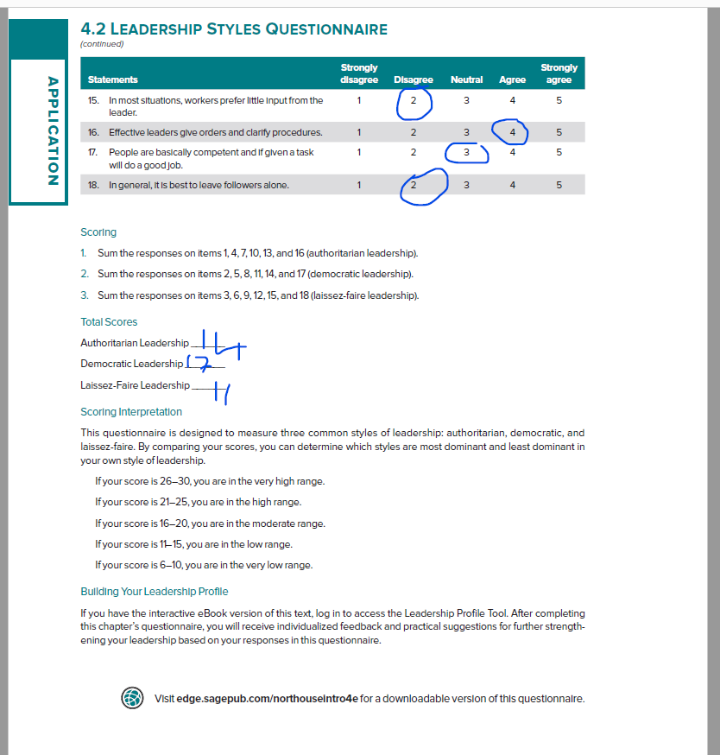

Appendix 2

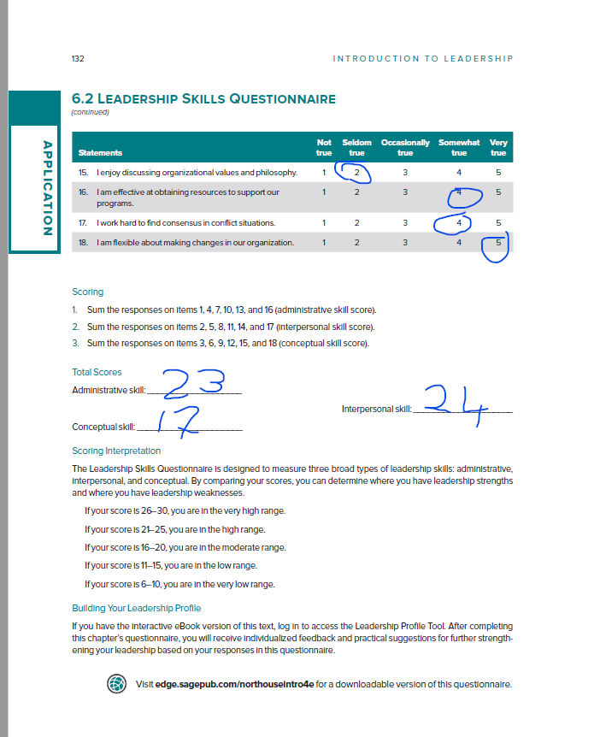

Appendix 3



