Workplace Culture and its impact on Organisation
Module Code: BMSK5005
Submitted By - Sufian Thareque Immon
Student ID - 1706493


Table of Contents
Introduction 3
1. Critical assessment of the workplace culture of KFC 4
2. Critical evaluation of KFC and the broader environment in which it operates 8
3. Critical evaluation of the cultural and ethical behaviour present in the KFC 15
Conclusion 18
References 19

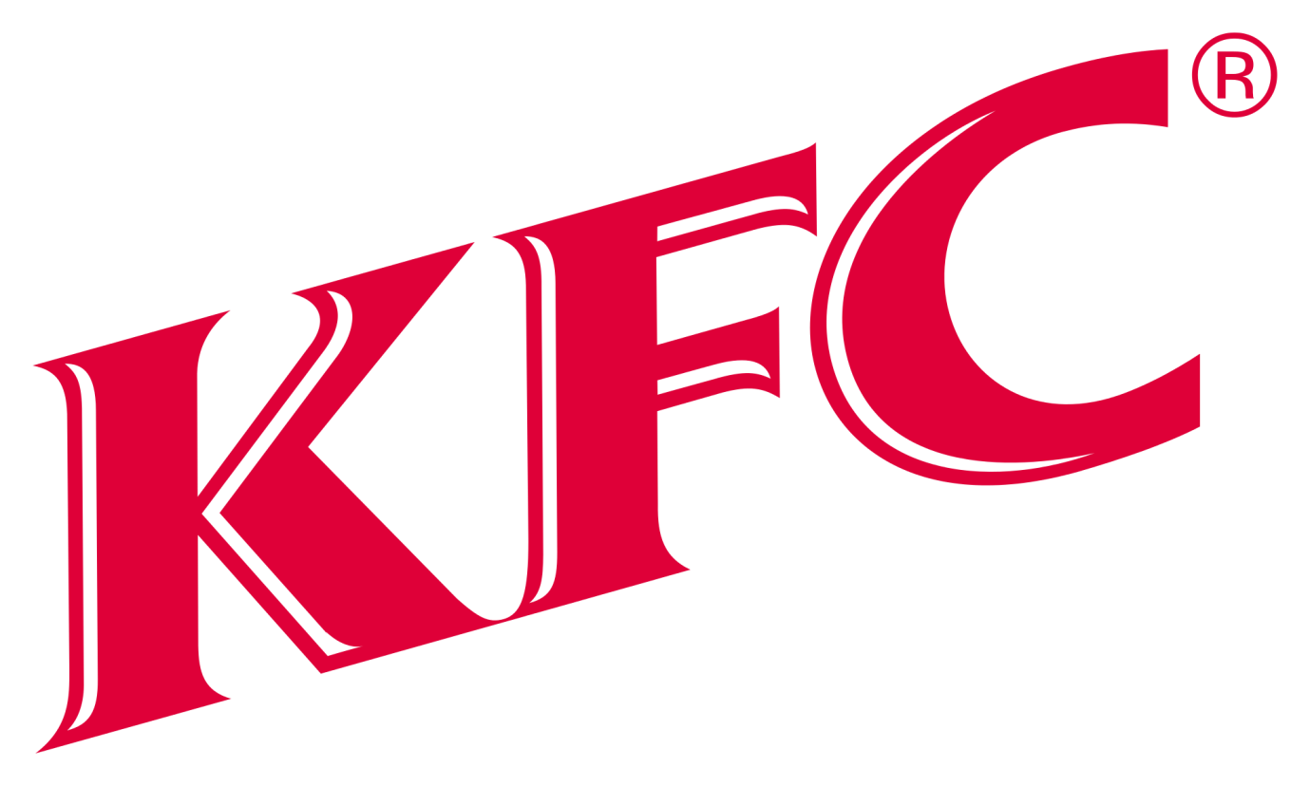

Introduction
The organisational culture is the combination of organisational norms, beliefs, values, and attitudes that influence the organisational behaviour and performance to a large extent (Schein, 2014). Organisational performance and effectiveness are largely influenced by the organisational culture and organisational structure (Pickett and Sorenson, 2016). However, this report deals with the organisational culture of KFC. KFC is a global food chain that was founded in 1952. The brand has a strong presence in more than 130 countries along with more than 21,000 stores worldwide (kfc.com). The culture of KFC is driven by the clan culture where shared norms and goals are criteria for organisational performance.

However, this report has three broad sections. The first section includes the Critical assessment of the workplace culture of KFC stating the types of culture within KFC, the communication channels, and the existing culture present in the workplace. The section includes the evaluation of the broader environment in which KFC operates using the PESTEL analysis and SWOT analysis. The final section of this report implies the Critical evaluation of the cultural and ethical behaviour present in the KFC and the recommendation for maintaining a culture of ethics.

1. Critical assessment of the workplace culture of KFC.
Organisational culture is the criterion that defines how the organisation should work in a broader environment (Schein, 2014). Culture is the combination of organisational norms, beliefs, values, and attitudes that influence the organisational behaviour and performance to a large extent (Sudsakorn and Rattanawiboonsoom, 2018). Culture also defines the assumption and ideology of KFC that bounds the working area at KFC. Culture is the strategic asset of KFC that increase the adaptability and fit between the KFC and its broader environment (Schein, 2014). However, the organisational culture of KFC mainly consists of four types of culture. These are stated as follow.

  - Types of organizational culture
- The Clan Culture: In a clan culture, KFC tends to share the values and common goals among the team members and individuals (Whiteley, Price and Palmer, 2013). The KFC creates an environment where collectivism and mutual help are emphasized. The company tries to create an atmosphere of a family where the team leaders act as the parents of the family. Stability, cohesiveness, and loyalty are the criteria to maintain the clan culture within the organisation (Pickett and Sorenson, 2016).
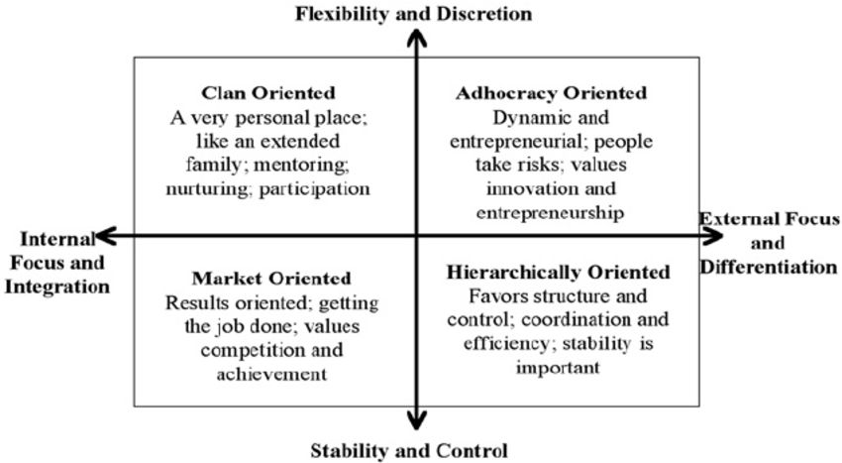
Figure: The characteristics of each type of culture (Whiteley, Price and Palmer, 2013).

- The Adhocracy Culture: The adhocracy is a temporary one where the culture the duration of this culture depends on the duration of a particular task (Sudsakorn and Rattanawiboonsoom, 2018). Wherever a task is ended, the adhocracy culture tends to end and start again with the introduction of a new task. Generally, KFC tries to focus less on this culture and this culture rarely evolves within the company (Pickett and Sorenson, 2016). However, sometimes, management of KFC introduces this type of culture to assign and finish a special type of assignment. The team leaders try to find innovation and new ideas in this organisation culture (Nedelko et al., 2017). When a new idea is formed, this type of culture in evolved and exists till the new idea is fully established.
- The Market Culture: The market culture of KFC tends to focus on the external transactions rather than an internal one (Sudsakorn and Rattanawiboonsoom, 2018). The reason of this culture is that KFC tries to focus on external factors such as external environment, market competition, consumer behaviour etc. to earn superior profitability (Pickett and Sorenson, 2016). Market competition is the common condition for this culture and to beat the competition is the main focus of this culture. This culture determines how KFC should work in a broader environment to become the industry leader and achieve competitive advantages (Nedelko et al., 2017).
- The Hierarchy Culture: In a hierarchy culture, KFC has the well-defined organisational structure, standardized rules and regulations, and well-defined control system and responsibilities (Gao, 2015). KFC establishes the stability within the organisation through the tight rules and policies where employees have less to talk about the new systems or ideas (Farina, Hahn and Vannucci, 2012). As this culture seems a rigid one and creates dissatisfaction among the employees, KFC transforms the organisation culture into the clan culture (Holman, 2015).
1.2 The culture existing within KFC
KFC promises to create a culture where employees can come to work and make their own best versions (Coffey, 2010). The employee will make a difference and can have fun among co-workers. To support this statement about the organisational culture, KFC arranges several programs to help bring the people component within the workplace and to life at the restaurant support centre (RSC) (Wallop, 2018). The culture of KFC supports the diversity and criteria of originality. In addition, KFC is passionate about creating a culture and organisational structure where everyone has a platform to grow and learn and make a culture of value and mutual respect (Nedelko et al., 2017). To make this dream culture, the management of KFC makes sure that all the people are well trained for the new processes and products that need a new environment. For instance, the team members of Gosser established all the learning materials for the recent introduction of Zinger, crispy, spicy chicken sandwich (Wylie, 2018). The culture of caring and more than market standard benefits seeks to attract new and skilled employees within the organisation. In addition, employee resource groups, wellness facilities, and mazing benefits help to increase organisational performance and employee productivity (Cameron and Quinn, 2013).
- Measuring employee engagement: To measure the effectiveness of organisational culture and performance, the management of KFC tends to conduct culture and engagement surveys both at the restaurant and RSC (Wylie, 2018). ‘’Called Your KFC’’ is a survey conducted by the management twice is a year to measure the employee’s performance and engagement with the culture and processes (kfc.com). In this survey, employees are asked plenty of questions about the organisational culture, training and development programs and how they evaluate them for further development. A number of metrics are used to measure the effectiveness of KFC’s culture (Schein, 2014). KFC focuses on the culture of employee engagement and recognition as the survey predicts the positive correlation between the training, employee engagement, recognition and performance (Wallop, 2018).
1.3 Communications channels for sharing information and building relationships
The KFC mainly focuses on the clan culture where the top management and the lower level management consisting of supervisors and management maintain the relationship among them sharing their ideas and concern for the company (Wallop, 2018).
- Email: The main communication channel used by the KFC is e-mail under which the communication is established by mail to one another (Bukhari and Sharma, 2014). This is one kind of formal and indirect form of communication channel. The customers of KFC can send their views and objections through mailing (Coffey, 2010).
- Websites: This is another form of communication channel used by the KFC (Cameron and Quinn, 2013). Under this communication channel, all the parties can communicate with each to other by visiting the official website of KFC such as www.kfc.com. This communication channel is hardly effective since the views of customers are hardly communicated with the top management and messages may be ignored (Farina, Hahn and Vannucci, 2012).
Recommendations for improving communication:
The culture of KFC focuses on employee recognition and engagement. To make this culture happen, KFC should focus strongly on the communication both at the corporate level and restaurant team members (Gao, 2015). The establishment of hierarchy culture should be evaluated beforehand so that employee dissatisfaction doesn’t arise. The communication channel between the management and the employee should be improved further where the culture of trust, quickness, and transparency exist (Holman, 2015).

2. Critical evaluation of KFC and the broader environment in which it operates
KFC is a multinational brand and the brand operates the business operations in different countries within different structure and environment (kfc.com). Each environment poses a great opportunity and threat for the company. The broader environment in which the KFC operates can be evaluated using the PESTEL analysis and SWOT analysis.
  - PESTEL analysis of KFC
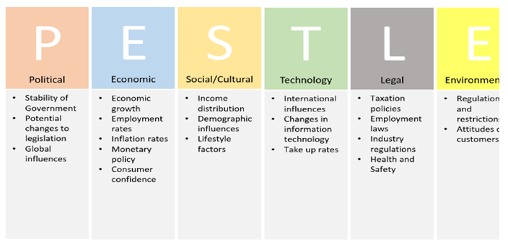
Figure: The components in a PESTEL model (Schein, 2014)
Political forces:
KFC plays with the people’s psychology to make an order in place. The consumers of KFC make the products consume through the marketing of words. But, they didn’t know the unhealthy condition of the products (Whiteley, Price and Palmer, 2013). All the nutritionist all over the world is criticising the unhealthy practice KFC. The government poses strict rules and regulations on the unhealthy practices of KFC through which the company makes a profi (Whiteley, Price and Palmer, 2013)t. Hence, the company needs to focus more on the workplace condition and workers’ health to comply with the government’s rules and regulations (Sudsakorn and Rattanawiboonsoom, 2018).

Economic forces:
The owner of KFC is struggling with the Chinese economy where some ventures of KFC are declining drastically and growth rate tend to decline to a significant rate (Pickett and Sorenson, 2016). However, the economic stability and western countries and in Europe offer a great opportunity to KFC to run the business operations. The stable economic growth rate in the UK has positive impacts on the business operations of KFC (Nedelko et al., 2017). Every year, KFC provides jobs to millions of people all around the world. Hence, the contribution of KFC to the economy is significantly important for the country. However, the currency fluctuations of dollars offer profit reduction for the company in the past few years (Wallop, 2018).
Social factors
The social issues for KFC are very big and time worthy to examine. The unhealthy consumptions of fast food create a social concern among the people (Nedelko et al., 2017). The heavy consumptions of fast foods create a serious damage to people’s health. Thus, they are becoming more concern and serious about the consumption of fast food. In this circumstance, KFC is running a big challenge of how the company will provide quality and healthy foods to the consumers at a reasonable price to attain a competitive advantage (Wallop, 2018). Moreover, the slaughtering of animals at a large also creates a social concern among the people within society (Schein, 2014).
Technological factors
Recently, KFC has introduced an app based on a mobile phone to place their orders and provide the foods to customers at home via the salespersons (Sudsakorn and Rattanawiboonsoom, 2018). In addition, the payments systems for the products are also initiated by mobile technology. Moreover, KFC uses the virtual reality programs to train the real-world cooks to the people around the world (Pickett and Sorenson, 2016). Another good initiative of KFC is the usages if mobile location tech to away the customers from the customers. This mobile tech is based on the company’s market culture of beating the market competition (Holman, 2015).

Environmental factors:
The packaging materials of KFC come from a supplier who cuts the trees contributing to deforestation to provide the raw materials to the company (Sudsakorn and Rattanawiboonsoom, 2018). This makes a sense among the environmentalists who are concern about global warming in the coming years. Besides, the slaughtering of animals also poses environmental issues for the company along with the unhealthy working conditions (Bukhari and Sharma, 2014).
Legal factors:
The unethical standards of KFC are the criteria that take the company at stake (Coffey, 2010). Chicken Abuse, and the PETA, and greasy unhealthy food are the unethical standards placed within the company (Farina, Hahn and Vannucci, 2012). Thereby, the company is facing severe criticism from the lawmakers and administration as the company is not following the standards of healthy foods and workplace condition.
  - SWOT analysis of KFC
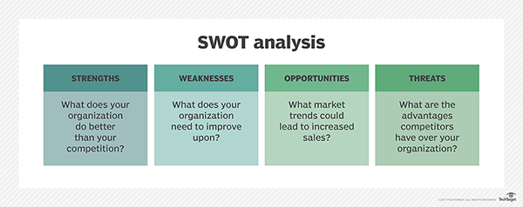

Figure: The SWOT analysis for KFC (Bukhari and Sharma, 2014)

Strengths | - KFC has high brand loyalty and popularity among the people globally that help the company to retain loyal customers and earn superior profitability (kfc.com).  - The brand has a strong presence in more than 130 countries along with more than 21,000 stores worldwide (Wallop, 2018).  - The high number of products line of KFC help to meet the customers; demand and satisfaction immediately creating a competitive resource of high customer responsiveness.  - Quick service to the customers is another indicator of high customer’s services (Wylie, 2018).  - The secret recipe of KFC is the reason why the customers all over the world prefer KFC’s products than the competitors.  - KFC has been receiving several awards in the past for its contribution to the economy (Sudsakorn and Rattanawiboonsoom, 2018).
Weaknesses | - The social health awareness and concern seek to reduce the company’s profitability as the foods offered by KFC are regarded as harmful for good health (Wylie, 2018).  - The slaughtering of animals and unethical business operations may affect brand loyalty.  - Managing the franchise and distribution channel are weaknesses where the company may have to outsource some of the value creation activities (Wallop, 2018).
Opportunities | - To tap the veg market, the company can introduce vegetarian products (kfc.com).  - The introduction of home delivery creates a new opportunity to increase the profit of the company (Sudsakorn and Rattanawiboonsoom, 2018).  - The company can expand business operations in such a country where the demand for fast food products is growing and the raw materials can be bought at a lower price (Wylie, 2018).
Threats | - The introduction of joint restaurants may pose a great threat in near future (Wallop, 2018).  - Fluctuating economy, currency fluctuation, and changing customer’s trends are the biggest challenges for the company (Wallop, 2018).

2.2 The impact of organizational cultures on the organisational effectiveness and performance
There is a strong and positive relationship between organisational culture and effectiveness and performance (Sudsakorn and Rattanawiboonsoom, 2018). According to the Ostroff and Schmitt, organisational performance and effectiveness are largely influenced by the organisational culture and organisational structure. (Pickett and Sorenson, 2016) There are mainly three effectivenesses that mainly derive from the organisational culture of KFC. These are employee attitudes, operational effectiveness, and financial effectiveness (Holman, 2015).
a) Employee Attitudes
The clan culture of KFC is driven by the values of attachment, trust, affiliation, and support. The members’ effort of KFC influences unit level of behaviour by imbuing social norms and beliefs (Farina, Hahn and Vannucci, 2012). The company establishes these beliefs and norms through articulating which behaviour is expected and desirable to be awarded. Thus, the clan culture of KFC reinforces team members to involve in an extensive teamwork, engage in open communication (Gao, 2015).

b) Operational Effectiveness
Different organisational forces drive operational effectiveness. Innovation and quality of services define the operational effectiveness that is further driven by the organisational culture (Nedelko et al., 2017).
- Innovation: The strategic culture of creating a new product and process evolves the thrust of innovation within KFC (Schein, 2014). The need for innovation is emphasized by the values of growth and stimulation, autonomy, and variety. This value of growth and stimulation seeks to take risk and creative ideas to identify the new products to respond to the customers’ need in no time (Sudsakorn and Rattanawiboonsoom, 2018). The CVF theory of KFC states that the culture of Accenture, consistency, and creativity facilitate the innovation within the company. The external business environment stated above further compels the company to find new market segments and create new products to meet the employee's demand (Farina, Hahn and Vannucci, 2012). The technological force indicates that KFC should introduce new technologies in the market to innovate new products and processes (Pickett and Sorenson, 2016).
- Quality of products and services: The external business environment and the market culture of KFC state that the company should achieve the strategic goals by incorporating customers’ feedbacks and demand through leveraging existing and limited resources such as human resources, technologies, and limited capital (Farina, Hahn and Vannucci, 2012). The need is to deliver the quality products at reasonable prices to beat the competitors and achieve the competitive advantages. The need for quality products and services emerge from the market culture of KFC where the company mainly focuses on the external environment such as market competition and market forces (Barraquier, 2011).

  - Formal and informal relationships between departments and people
In the following, the different relationship between department and people are shown-
- Formal relationship: In a formal relationship, the management of KFC also direct the leadership programs to direct the learning and development programs both at the RSC and within the Restaurant on a broader scale (Coffey, 2010). The recent innovative brand programs such as Colonel-ology and the Colonel are the examples of such a culture of development and learning through formal relationship (Bukhari and

- Sharma, 2014). The aim of these programs is to extend the culture and history of KFC to the new and existing employees to the franchisee the partnership, new hires, vendor relationship, and best self through the holistic wellness programs and employee resource group (Cameron and Quinn, 2013).
- Informal relationship: The informal relationship exists without the formal process such as celebrating between the departments and people at a big and small success (kfc.com). KFC loves to celebrate success and recognition. Recognition is an integral part of KFC that creates a smooth motivation among the employee’s mind and the management (Wylie, 2018). The company prefers to celebrate on the big and small achievement to let everyone know that their contributions are valued by the success of the company. Hence, the culture of KFC is brimmed with extensive teamwork, enjoyment, positive energy and enthusiasm (Whiteley, Price and Palmer, 2013).

3. Critical evaluation of the cultural and ethical behaviour present in the KFC
The ethical behaviour of KFC refers to the standardized and expected behaviour from all parts of the business operations (Pickett and Sorenson, 2016). The ethical behaviour states which actions and desirable and which is not that contradict the standard behaviour. However, the culture of KFC is associated with standardized and ethical behaviour (Sudsakorn and Rattanawiboonsoom, 2018). Nevertheless, the company is facing severe criticism for its unethical behaviour. The Ethical dilemmas faced by KFC are as follow.
- Providing Greasy Unhealthy Food
The current generation is very much different than the generation a few decades ago in terms of health concern and nutrition (Wallop, 2018). They are becoming better informed about the consumption of fast foods that cause a serious damage to people’s health. As KFC is the world famous food chain that offers fast food items to millions of people all over the world, the company should stick strictly to the offerings of healthy and standardized foods to the consumers (Whiteley, Price and Palmer, 2013). However, it has been found that KFC is overusing the oil in making the fast food items that contain Tran’s fatty acids and monosodium glutamate (MSG). This oil increases cholesterol and increases the risk of heart attack and obesity among the people who consume these food items (Pickett and Sorenson, 2016). This case was carried by the consumer group Centre for Science to investigate the food production of KFC.
- Chicken Abuse, and the PETA
0ver 700 millions of chickens need to be supplied to the KFC for its food production. KFC stated in a statement that the company only deals with the suppliers who are ethical and are committed to standardized behaviour to animal welfare (Wylie, 2018). But the scenario is totally different. A video is taken by the investigator of People for the Ethical Treatment of Animals (PETA) that showed the abuses of chicken by the workers purposely (Wallop, 2018). The shoot was taken in a slaughterhouse at a Pilgrim’s Pride plant in Moorefield West Virginia. In this slaughterhouse, the workers are kicking the chickens like a football alive. The workers also thumping them into the walls to make fun out of it (Wylie, 2018). This incident tends to take place on a regular basis by the KFC suppliers. There are other suppliers of KFC that do the same thing over and over again. One example is the Tyson slaughterhouse where the birds are burnt to death and were blown by the makeshift firecrackers to fit the
chickens into the slaughter-line shackles. Tyson is regarded as the number one supplier of KFC for many years (Wallop, 2018).
- Health Problems, ‘Fried’ fast food
The main course of the menu in KFC is the fried chicken that is everything for the company (Schein, 2014). A few years ago KFC had been sued by the Center for Science in the Public Interest (CPSI) for food containing “staggering sum” of trans fat. There are 15 grams of trans fat in one three-piece chicken combo meal that is an exaggeration for a person in a week (Pickett and Sorenson, 2016). The outcome of judgement was that the court prohibited the KFC to use hydrogenated oil or to use at a very minimum level. As maximum food items offered by KFC contain trans oil and fat, it is becoming difficult for the company to maintain the ethical behaviour and standards in the food production process (Wallop, 2018).
Personal ethical evaluation for KFC.
Doing business doesn’t only mean earning the profit using the unethical behaviour that harms the consumers in the long run (Barraquier, 2011). My personal ethical belief is that every action towards the people that may affect their lives should be ethical and standardized in nature otherwise that may cause the people in the long run. KFC is the world famous food chain offering fast food products to millions of people (Coffey, 2010). The health condition of these consumers largely depends on the conditions of the foods offered by the company. It is very unethical that KFC is offering unhealthy and fatty foods to the consumers who are being affected by the over consumption of these food items (Bukhari and Sharma, 2014). Furthermore, the suppliers of KFC are unable to maintain the ethical behaviours in the slaughterhouse that contradicts with my ethical beliefs. The fried foods offered by the company are causing serious damage to consumers’ health that is the opposite of ethical behaviour (Farina, Hahn and Vannucci, 2012). Thus, the company needs to focus more on creating an organisational culture where the ethical behaviour is first priority from the management (Barraquier, 2011).

Strategic Options and the Recommendations to KFC for establishing a culture of sustainability and ethics within the workplace
To my understandings of cultural and ethical behaviour, I’m providing the following recommendations for KFC to maintain the cultural and ethical behaviour within the company.
- That KFC should provide a healthy and safe workplace to the employees is the first motivation for the employees from the management to maintain ethical behaviour within the company (Farina, Hahn and Vannucci, 2012).
- It is recommended that. KFC should form a special team to monitor the workplace condition for food production and improve the monitoring by compensating them (Barraquier, 2011).
- The company should immediately take actions against the Tyson slaughterhouse for their unethical behaviour to show an example for other suppliers who tend to do the same in supplying the chickens to the company (Barraquier, 2011).
- For monitoring the ethical behaviours of suppliers, KFC needs to form a team within proper training and equipment to monitor them. This team may seek the help of law forces to keep them under the track (Coffey, 2010).
- Another strategic option to monitor the activities of the suppliers is to provide the low prices for the chickens supplied to them until the suppliers maintain the standardized behaviours in slaughtering the chickens. The bargaining power of KFC is very high over the suppliers. Hence, the company wouldn’t have to face difficulties in lowering the price and bargain over ethical behaviour (Holman, 2015).
- For maintaining cholesterol and trans fat, the company should form a monitoring team that will observe the minimum amount of cholesterol and trans fat used in the food production (Gao, 2015).
- Overall, the management, employees, and board of directors of KFC should embrace a philosophy of ethical culture existing within the company. The good things come from the management and the top management needs to be more responsible for corporate actions (Whiteley, Price and Palmer, 2013). There should be a panel in every meeting set by the management to evaluate the ethical maintenance and provide the report to every meeting. Thus, the top management would know the actual scenario and can take actions as per the recommendations stated by the pane (Cameron and Quinn, 2013).

Conclusion
The chain of KFC is diversified around the world. The company runs the business operations globally (Wylie, 2018). Thereby, the millions of people are consuming the food items offered by KFC every day. The health condition of consumers largely depends on the condition of foods (Sudsakorn and Rattanawiboonsoom, 2018). Thus, the company needs to offer healthy food items that are less harmful to the consumers and maintain the ethical behaviour in producing the foods (Pickett and Sorenson, 2016).

References
Barraquier, A. (2011). Ethical Behaviour in Practice: Decision Outcomes and Strategic Implications. British Journal of Management, 22, pp.S28-S46.
Bukhari, S. and Sharma, B. (2014). Organisation Climate, Inclusive Organisation Culture and its Influence on Organisation Effectiveness-A Study of Organisations in Jammu Region. Training & Development Journal, 5(1), p.40.
Cameron, K. and Quinn, R. (2013). Diagnosing and changing organizational culture. San Francisco, Calif.: Jossey-Bass.
Coffey, V. (2010). Understanding organisational culture in the Restaurant industry. London: Spon.
Farina, F., Hahn, F. and Vannucci, S. (2012). Ethics, rationality, and economic behaviour. Oxford: Clarendon Press.
Gao, Y. (2015). Business leaders’ personal values, organisational culture and market orientation. Journal of Strategic Marketing, 25(1), pp.49-64.
Holman, D. (2015). The essentials of the new workplace. Chichester, West Sussex, UK: John Wiley & Sons.
Nedelko, Z., Brzozowski, M., Lorber, M. and Potočan, V. (2017). Exploring the influence of personal values and cultures in the workplace. Hershey: IGI Global.
Pickett, T. and Sorenson, R. (2016). An Exploratory Investigation of the Relationships Among Organizational Cultures, Organizational Communication Systems, and Member Satisfaction and Commitment. Bingley: Emerald Group Publishing Limited.
Schein, E. (2014). Organizational culture and leadership. San Francisco: Jossey-Bass.
Sudsakorn, C. and Rattanawiboonsoom, V. (2018). Ethical Business Culture and its Impact on Unethical Behaviors in the Workplace: Conceptual Implications. SSRN Electronic Journal.
Wallop, H. (2018). ‘Chicken is where it's at’: the unstoppable rise of KFC. [online] the Guardian. Available at: https://www.theguardian.com/food/2018/aug/18/chicken-is-where-its-at-the-unstoppable-rise-of-kfc [Accessed 9 Dec. 2018].
Whiteley, A., Price, C. and Palmer, R. (2013). Corporate culture change: adaptive culture structuration and negotiated practice. Journal of Workplace Learning, 25(7), pp.476-498.
Wylie, I. (2018). A well-designed workplace can bring wellbeing to the workforce. [online] the Guardian. Available at: https://www.theguardian.com/careers/workplace-design-can-reshape-the-workforce [Accessed 9 Dec. 2018].

