

Domestic Abuse from a socio-legal perspective: A comparative analysis of domestic abuse legislative framework, policies and guidelines between the UK and USA.

Name: Tasnim Kadir
Student ID: 1900576
Degree: BA Law and Business
Wordcount: 8786

ABSTRACT

The following study is aimed at discovering underlying patterns of domestic violence and how prevalent it is in contemporary society. Accordingly, the study is aimed at displaying the current standing of domestic violence in contemporary society for example types of abuse, statistics, reasons for domestic violence and reasons for victims staying in abusive relationships. Furthermore, the study will also discuss and compare laws, policies and government responses of the United Kingdom and United States. Additionally, the study conducted questionnaires in both countries in order to assess the prevalence of domestic violence cases and whether or not sufficient laws are in place. Subsequently, it was found that the general public and victims of domestic violence expect more from the government. This concludes more effort are required on part of the government.

ACKNOWLEDGMENTS

I would like to thank my supervisor, Mike Durke for his continued support and guidance throughout the dissertation process.
I would also like to thank my family for their ongoing support over the last three years of the degree during these unpredictable times. The support from my family has enabled me to focus on my degree and give it my best. I will forever be grateful to them.

DECLARATION
This work has not previously been accepted in substance for any degree and is not
being concurrently submitted in candidature for any degree.
STATEMENT 1
This dissertation is being submitted in partial fulfilment of the requirements for the
degree of BA/BSC.
STATEMENT 2
This dissertation is the result of my own independent work/investigation, except
where otherwise stated.
Other sources are acknowledged in the Reference Section.
STATEMENT 3
I hereby give consent for my dissertation, if accepted, to be available for
photocopying and for interlibrary loan, and for the title and summary to be made
available to outside organisations.
STATEMENT 4
I hereby give consent for my dissertation, if accepted, to be available on the
university's IT system to those who have consent to use the system
Student's Name: Tasnim Kadir
Signed: T. Kadir
Date: 06/05/22

CONTENTS PAGE
1. Chapter 1 – Introduction | 8
1.1 Aims and objectives | 8
1.2 Background and rationale | 8
1.3 Types of domestic violence | 10
1.4 History of domestic violence in the UK | 10
1.5 History of domestic violence in the US | 12
2. Chapter 2 – Literature Review | 13
2.1 Introduction | 13
2.2 Why is domestic violence still a prevalent issue? | 13
2.3 Abusers’ justifications | 16
2.4 Why does domestic violence go unreported? | 16
2.5 Are abusers facing trial? | 17
2.6 The police and policing of domestic violence | 17
2.7 What changes are needed? | 18
3.8 Governments’ response | 18
2.9 Current laws | 20
3. Chapter 3 – Research Method | 23
3.1 Introduction to research methodology | 23
3.2 Research onion | 23
3.3 Peeling Saunders’ research onion | 24
3.3.1 Research philosophy | 24
3.3.2 Approach | 26
3.3.3 Research strategy | 27
3.3.4 Choices | 28
3.3.5 Time horizon | 28
3.3.6 Data collection and analysis | 28
3.4 Sample and limits to sampling | 29
3.5 Validity and reliability | 29
3.6 Limitations | 30
3.7 Ethical considerations | 30
3.8 Conclusion | 30
4. Chapter 4 – Findings | 32
4.1 Introduction | 32
4.2 Data analysis | 32
4.3 Quantitative data analysis | 33
4.3.1 Gender based violence | 33
4.3.2 How common is domestic violence | 34
4.3.3 Victims and survivors of domestic violence | 36
4.3.4 Reporting domestic violence | 38
4.3.5 Reasons behind reporting and not reporting | 39
4.3.6 Cycle of abuse | 41
4.3.7 What must change? | 42
4.3.8 Domestic violence laws and awareness | 42
4.3.9 Recommendations by participants | 44
4.4 Conclusion | 44
5. Chapter 5 – Conclusion | 45
5.1 Summary | 45
5.2 Recommendations | 45
5.3 Self-reflection | 46
5.4 Limitations of research | 46
5.5 Future research | 47
5.6 Conclusion | 47
References | 48
Appendices | 56

CHAPTER 1: INTRODUCTION

  - AIMS AND OBJECTIVES
“Home is the most dangerous place for a woman” (Dugan, 2017). In England, it is estimated that every one in three women aged 16 to 65 will face domestic violence in their lifetime (Office for National Statistics, 2019). Accordingly, the aim of this study is to highlight, arguably, the oldest forms of abuse - domestic abuse, and the reason behind it still prevailing in contemporary society. Further, the study aims to outline the possible reasons for such abuse, explain and elaborate current laws, policies and responses and finally, a comparative analysis of England with the United States in order to assess whether adequate response to domestic violence victims is provided.
This study has two main themes; firstly, the focus of this study revolves around the current position of domestic violence and secondly, conducting relevant research along with analysing the adequacy of current laws and the response given by executive bodies.
  - Background and rationale
While several academics and commentators may disagree with many issues relating to domestic abuse, the existence of the issue as a social, cultural, and legal problem is agreed upon by all (Stark, 2013). Domestic violence is a serious yet an under-reported problem which is committed mainly against women by their present or former spouse, boyfriend, cohabiting partners or even dates (Richards et al., 2008).
Despite vast academic literature on domestic violence, many questions remain unanswered, or at least contested, with the definition of domestic abuse taking a prominent place. For instance, it is difficult to give a definitive answer as to what amounts to abuse, or whether psychological or sexual abuse are considered within the ambit of domestic violence. Moreover, some of obvious signs of abuse include bruises, cuts or other physical injuries however, emotional or psychological trauma may prove to be difficult since they are not considered to be obvious signs (Campbell, 2002). Nonetheless, organisations such as WHO have attempted to define it as a behaviour by an “intimate partner or ex-partner which includes abusive actions ranging from physical aggression to psychological abuse, sexual coercion and control” (World Health Organisation, 2017). This definition highlights the gender-based roots of violence as it appropriately recognises that violence against women is one of the core social mechanisms which places women in a subordinate position to men (Groves and Thomas 2013). In addition to physical violence against the victim, the act is often followed by criminal damage, harassment and sexual abuse (Richards et al., 2008). While domestic violence involves abuse against children, siblings and the elderly, the focus of this study will revolve around domestic violence against women, also known as intimate partner violence, the frequency of it, current laws and possible reforms and protections which are needed to limit, if not eliminate, domestic violence.
According to the government of UK, in the year ending March 2020, approximately 2.3 million adults aged 16 to 74 years were a victim of domestic violence in the last year (1.6 million women and 757,000 men). Domestic violence has become an issue that is prevalent across every cultural and socio-economic status on the globe; harshly damaging women's ability to sustainable development (Klein et al., 2019). Although domestic violence has existed for centuries, it became recognized as a social problem rather than a private one since 1970s. The kind of violence included in such an act includes, but not limited to, slapping, kicking, choking, stabbing, burning, strangling, sexual assault, threatening with or without weapons (WHO 2017).
  - Types of domestic violence
Domestic abuse generally occurs either physically or psychologically. Psychological or coercive control is where the perpetrator consciously and intentionally attempting to control the victim by way of threats, mind games or emotional blackmail. As such, this leads to the victim being confused and miserable, and this type of abuse is mainly hidden due to not being widely recognised (Day and Bowen, 2015). Because of this, much of psychological abuse goes unnoticed, and often, unreported as well.
The next type of abuse is physical abuse. This is where the abuser physically harms the victim, such as slapping, choking, burning or stabbing. As physical abuse is visible to the eye, it is easier to recognise. Nonetheless, the victims will blame themselves for being clumsy or having a silly accident to lie not only to the public, but to themselves as well, and this leads to the victims misreading the true, abusive dynamics of the relationship. Subsequently, this leads to the victim being stuck in a cycle of abusive relationship (Hilton, 2021).
  - History of domestic violence in the UK
As has been discussed, domestic abuse has existed for centuries and has long historical roots which prove the inequality between men and women (Stark, 2013). Traditionally, a husband abusing his wife was considered to be a normal part of marriage, and something which women must expect and tolerate (Erez, 2002).
The 1500s, also known as “Golden Age of the Rod”, allowed limitless abuse against wives as it was considered that it was a wife’s scared duty to obey her husband (Summers & Hoffman, 2002). The extent of ignorance of English legal system towards abuse against women is seen from the tradition of ‘wife beating’ in the mid-1800s which was considered a valid excuse of the husband’s authority over his wife (Dipty, 2010). In 1857, a British judge ruled that wife beating was legal so as long as “rod is not thicker than his thumb” (Dehnel, 2016). The 1860 Law of Coverture established that because the husband was responsible for his wife’s actions, he had full authority to use any means necessary for controlling her including physical and verbal abuse (Dehnel, 2016). With the role of law and courts being one to offer rights and protection, it appears ironic for a court of law to allow for limitless abuse. In 1895, limitations in the form of curfew were applied whereby, a husband was not allowed to beat his wife from 10pm to 7am due to possible noise which may disturb the neighbours (Dehnel, 2016).
However, in the late 1800s, when Queen Elizabeth I took the throne, new reforms and proposals were introduced. This was particularly done to abolish acts of abuse and to allow protections to victims. Some of the prominent reforms included prohibition of wife beating or locking up of wives. Moreover, life threatening abuse was made a valid ground for divorce (Summers & Hoffman, 2002). Furthermore, the Matrimonial Causes Act 1878 allowed for victims to opt for separation if their husbands were found guilty of aggravated assault (Summers & Hoffman, 2002). A century later, the Domestic Violence and Matrimonial Proceedings Act 1976 was passed which offered protection to victims of domestic abuse followed by the Family Law Act 1996 which provides remedies under civil law (Burton, 2008). Finally, the Domestic Abuse Act 2021 is the current law protecting victims of domestic violence.
  - History of domestic violence in the United States
The United States shares similar history of domestic violence with the UK, whereby, wife beating was socially and legally accepted as early as 753BC (Schneider, 2008). Under the rule of Romulus, chastisement and wife beating was justified, so as long as the rod used for beating for no thicker than a thumb. This was known as the ‘rule of thumb’. The extent of the abuse is evident from the fact that the 14th century Roman Catholic Church encouraged husbands to beat their wives for the purposes of spiritual well-being (Schneider, 2008). Subsequently, in 1871, Alabama and Massachusetts made wife beating illegal. From 1962, development in law and protection for domestic violence victims is evident.

CHAPTER 2: LITERATURE REVIEW
2.1 Introduction
This literature review will be divided into three main parts. The first one being the ‘cyclical’ pattern of violence ranging from the ‘honeymoon’ tension building to severe battering phases, apologetic behaviour, and repetition of similar events (Matthews, 2004). Secondly, reasons why victims either stay in abusive relations or return after attempting to leave (Matthews, 2004; Rothman et al 2007). Lastly, the current laws and policies on domestic violence and their efficacy.

2.2 Why is domestic abuse still a prevalent issue?
The reason domestic violence has not yet been eliminated entirely is because certain individuals believe that domestic violence is necessary in certain given situations. While many people believe that the act is wrong, it is necessary, nonetheless (Browne and Williams, 1993).
The question then arises, ‘why does she not leave?’ The reason for this lies in the dynamics of the relationship between the two genders. This means that because females are considered to be the weaker gender, regardless of the fact that this may not be true, this leads to the female becoming underconfident and under the impression that leaving would lead to ruin (WHO, 2021). Predominantly, domestic violence is also reflective of, and is deeply connected to, gender socialisation and traditional gender attitudes which tend to view women as dependent, weak and fragile whereas men were viewed as independent, strong and resourceful (McPhail and Rice, 2007). Moreover, victims tend to stay for reasons including economic dependency, shelter, safety for themselves and the children (McPhail and Rice, 2997). This also contributes to the reason as to why women do not report domestic abuse to the police or local authorities.
For reasons mentioned above, a cyclical pattern is created with each new incident/event being more severe than the last (Matthews, 2004). This means that threat turns into violence, and violence turns into fatal incidents, with the victim having little to no hope for escape (Weiss, 2000). The reason for continued abuse lies in the fact that the victim usually accepts their fate of ‘walking on egg shells’ and refuses to fight for freedom (Weiss, 2000). Often, the woman believes that she is truly at fault and the abuse is ‘deserved’ since if she were a ‘better partner’, the abuse would stop. However, because of the victim constantly fearing the next attack, tension tends to build up between the abuser and the victim which eventually leads to, as Weiss (2000) calls it, ‘explosion’. This is where the abuser acts irrationally and executes his next attack (McCue, 2008). According to Weiss (2000), reports have indicated that victims were often pushed in front of moving cars, brutally raped, suffered broken noses and knees or otherwise severely injured. The next stage in this cycle of abuse is brainwashing. The abuser tends to brainwash the victim, threatening them if they let the word out or inform the police/authorities. During this stage, the abuser ‘picks’ at the victim such as calling them names, making comments or otherwise brainwashing the victim (McCue 2008). This leads to the victim having low self-esteem and low self-confidence therefore, making them believe no one else would accept them but their current, abusive partner (McCue, 2008). The next stage relates to the abuser apologizing or promising certain changes in their behaviour (Walker, 1979). Other common counter arguments in this stage include claiming that the victim is exaggerating the abuse, or even claiming that the abuse never happened (Walker, 1979). Accordingly, the victim accepts the apology, shortly after which the abuser reoffends. Therefore, this creates a cycle of abuse from which the victim often fails to escape.
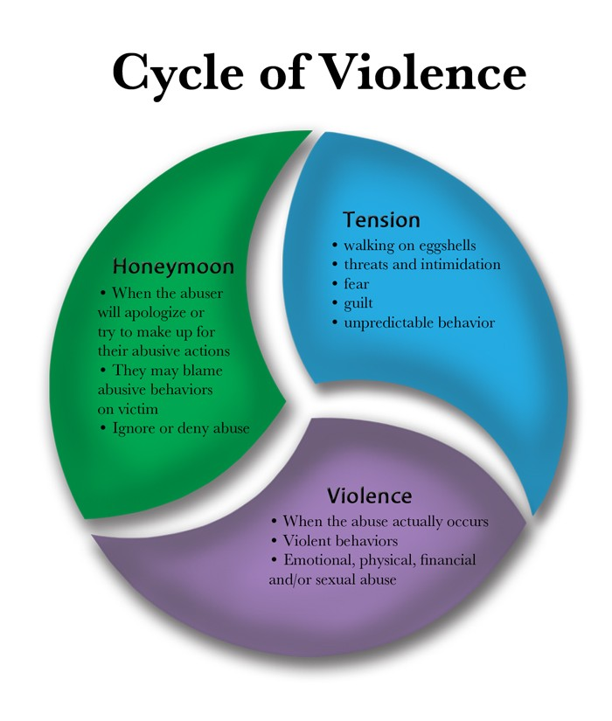
Lastly, it is not uncommon for women to still stay in abusive relationships or to return to their relationship their abusive partner. The prominent reason for this is safety (Turner, 2002). This is because the abuser may have threatened to kill the victim, her children or himself if she leaves (Matthews, 2004). Furthermore, women who have little to no support from their family, relatives or friends tend to stay in abusive relationships (Sullivan et al, 1994). Abusive relationships also lead to social isolation of the victim, which severely limits their social network and therefore, limits support as well (Levendosky, Bogat, Trotter, and Davidson, 2004). Moreover, women who are educated tend to not return as opposed to those who are not as educated (Schutte, Malouff, & Doyle, 1988). However, with growing focus on educational system, government attempts to spread awareness on their rights and relevant laws, women rights and equal pay, victims are neither staying, no returning, to their abusive partners (Hilton, 2021).
Figure 2.2 Cycle of domestic violence
  - Abusers’ justifications
How and why men are involved in abusive behaviour has been deeply analysed (Wood, 2004). 22 men were asked and their justifications for domestic violence ranged from ‘I am not the abusive type unless…’ to ‘she deserved it’ (Wood, 2004). Factors which triggered abusers included the victim attempting to escape their control and ‘provoking’ them (Cattell and Mead 2008). Dutton (1992) writes that where the abuser has reasons for justifying abuse, he may forever believe that the abuse was well deserved. Due to this reason, laws and policies in the society must be extra stringent (Dutton, 1992).
  - Why does domestic violence go unreported?
According to a charity-based organisation in the UK, Safe Lives, 600,000 incidents of domestic violence go unreported every 3 years (Scott, 2021). In the United States, and according to Police Response to Domestic Violence Report (2017), more than 50% of the cases go unreported. The reasons are both personal as well as societal. Personal reasons include fearing retaliation by partner, embarrassment, economic and emotional dependency while societal reasons include privacy of family, victim blaming behaviour of the society and unbalanced power dynamics between men and women (Shrader and Sagot, 2000). Moreover, a number of victims also believe that the abuse will end and thus, do not report. Furthermore, victims often prioritize safety and well-being of their children at the expense of being abused and assaulted. Other prominent reasons include fear of not getting sufficient support, fear of isolation and unawareness of their rights, police attitudes and lengthy court process (Hines and Douglas, 2014). Women’s Aid’s report ‘survival and beyond’ disclosed only 28% of women reported incidents of domestic abuse (Grierson, 2018). The report further highlighted that the number was even lower when it came to the perpetrator being sanctioned. Katie Ghose, the chief executive of Women’s Aid, claimed that for survivors to report domestic violence cases takes immense strength and courage. Therefore, it remains vital for all agencies from healthcare to housing, to ensure that domestic violence is appropriately tackled

Are abusers facing trial?
Even with domestic violence victims facing abuse each day, only a few of the perpetrators are prosecuted or tried in court. This is evident from the fact that the number of criminal cases being tried, or even reaching courts, have decreased from almost 125,000 five years ago to just 76,965 in the year 2019-20 (Kirk, 2021). The Director of Prosecutions confirmed that only a handful of cases go to trial (Kirk, 2021). Therefore, the issue of domestic abuse remains prevalent in contemporary society.
  - The police and policing of domestic violence
The police have always played an essential role in the investigation, charge and conviction of domestic violence cases. However, the attitude of police with regards to domestic violence cases have been criticised by many academics, commentators and even Majesty’s Inspectorate of Constabulary (Newburn & Reiner, 2007). The most pressing reason for this is that domestic violence is considered to be a private, family matter which must either be dealt by the family itself or by civil courts with the intention of keeping the family intact (Morris, 1987). While it is true that most of these irrational beliefs were prominent decades ago, it must be noted that some of these views remain unchanged (Hilton, 2021). Public confidence in the police system is considerably low such that only 27% women and 10% men claimed they would involve the police in case of domestic abuse however, 76% women and 62% men believed they would inform of such abuse to someone personally known to them (Her Majesty’s Inspectorate of Constabulary, 2014). In 2020, this number has remained less than half (Crime Survey of England and Wales, 2020).

What changes are needed?
According to Lankester and Grills (2019), the main change needed for victims to be able to report domestic violence is awareness. This can be done by way of education and awareness of rights, for instance, holding sessions which would allow for the general public to be well aware of their rights. Furthermore, it was also suggested that involvement of men is necessary, as men are evidenced as the primary, but the only, perpetrators (Lankester and Grills, 2019). Thus, it is essential that men, and boys, are provided proper training session regarding mental health, controlling emotions and anger, and consequences of domestic abuse. Furthermore, police, priests, church leaders and other prominent leaders must be dismissed from their roles with immediate effect if found involved in domestic violence (Lankester and Grills, 2019). Moreover, stories of domestic abuse survivors must be portrayed in positive light instead of blaming the victim. Lastly, attitude of the police needs change and seriousness of the issue must be established (Lankester and Grills, 2019).

Governments’ response
The Crime Survey for England and Wales (2019 – 2020) witnessed an increase of 7% in domestic violence cases from March 2019 to March 2020. A further increase was seen in just the first few months of 2020 whereby, domestic abuse cases rose to 12% by Mid-May 2020 (Crime Survey for England and Wales 2020). Furthermore, domestic abuse cases increased by a staggering 65% between April and June of 2020. Just 3 months in 2020 led to 12% increase another 3 months in led to an increase of 65% which is disturbingly high. This is evidence of the legal system, statutory bodies and executive bodies lacking in their responsibilities of reducing domestic violence cases, if not eliminating them. The extent of this deep-rooted issue is evident from the fact that the cases are increasing, even in recent years. A lack of public confidence in the system is evident as revealed by London Metropolitan Police that calls relating to domestic violence were mainly from third parties, such as neighbours, rather than the victim or survivors themselves (Harvard, 2021). Understandably, the victims and survivors are not placing their confidence in the system and which makes it clear that more efforts are needed on part of the government. Nonetheless, it would be false to say that the government has overlooked the issue entirely. In 2020, the government of UK launched an awareness programme by the name ‘#YouAreNotAlone’ which aimed at reassuring and reminding domestic violence survivors and victims that the police and specialists services are open to them 24/7 (Harvard, 2021). In November 2020, the government of England and Wales also allotted £683,000 for the purpose of setting up domestic abuse organisations. Furthermore, with the enacting of the new Domestic Violence Act 2021, the government of UK has now allocated £125 million for local authorities in order to cater to domestic violence cases, victims and survivors and for them to be able to fulfil their duties without delay (Government of UK, 2022).
In the US, domestic violence cases increased by 8.1% in the year 2020 (Impact Report, 2021). Moreover, domestic violence related phone calls cover the largest category of complains, accounting up for 15-50% of all of the calls (Friday and Hartman, 2016). As a result, the government of US reviewed and reauthorised the Violence Against Women Act of 1994 by enacting a new law Violence Against Women Act Reauthorization Act of 2021 (Congress, 2021).

2.9 Current laws
The most prominent law for domestic abuse in the UK is the recently enacted Domestic Abuse Act 2021. The act allows for strengthening the support given by relevant statutory bodies to victims of domestic violence. Victoria Atkins MP, Minister for Safeguarding claimed that the Act holds its place as a ‘landmark’ Bill in the sense that it is bound to transform the current position of domestic abuse victims, policies and laws. She further noted that the main aim of this Bill is to prevent offending and reoffending, to protect victims of abuse and to ensure that the victims have sufficient support from governmental bodies. The Act gives a statutory definition of domestic abuse under S.1 in order for the ease and understanding of the victim and in order to create awareness amongst members of the society as whole. Furthermore, the Act establishes a Domestic Abuse Commissioner who would bear the responsibility of appropriately representing victims and survivors, increasing awareness and education of the citizens regarding domestic violence. Furthermore, the Domestic Abuse Commissioner would also be responsible for monitoring the response of judiciary, local authorities and other relevant statutory bodies. Moreover, the Act further creates a domestic abuse protection notice (DAPN) and domestic abuse protection order (DAPO) where the former is responsible for immediate protection of the victim following an incident and the latter relates to long-term, flexible protection of the victim. To further provide protection to the vulnerable victims, the Act also prohibits the abuser from cross-examining their victims face to face in family courts.
Although the Act is fairly new and recent, it appears that the Parliament has covered most of the aspects that are required for domestic violence. As of now, it appears that the Act is a success. However, success of the Act is paired with the workings of the Crown Prosecution Service where it is seen that the police are immediately and positively handling cases of domestic abuse. Due to the efforts of the government and emphasis on equality between the genders in the country, the United Kingdom is considered to be one of the top 35 most liberal and progressive countries on the globe in terms of gender equality in 2020 (Szmigiera, 2020). Nonetheless, this rank must not be considered final as there are still gaps in law and a lack of public confidence in the system which makes it difficult for victims to report cases to the police or to reach higher authorities.
In the United States, the reauthorised act, Violence Against Women Act Reauthorization Act of 2021 serves the purpose of preventing cases of domestic violence, protecting, and sheltering domestic violence survivors and victims (Congress, 2021). The main purpose of this Act is to grant a choice to the victims of sexual assault and domestic violence to go to court instead of being forced into arbitration. It appears that the United States has been actively engaging in reforms and enactment of new laws in terms of domestic violence. Due to this, it is considered to be one of the top 50 most liberal and progressive countries on the globe in terms of gender equality in 2020 (Szmigiera, 2020). Comparing this to the United Kingdom, it appears that United Kingdom is seen as having a better rank than the United States however, it is no secret that domestic abuse is still prominent in both countries. This evident from the fact that both countries also take place in top 50 of the most dangerous countries for women in 2022 with United Kingdom having women danger index of 296.85 and United States 456.31 (World Population Review, 2022). Therefore, further efforts from government bodies and statutory agencies are required.

CHAPTER 3: RESEARCH METHODOLOGY
  - Introduction to research methodology
This chapter is aimed at explaining the research methods, sampling, ethical considerations, and desired outcome. While chapter 2 provided a vast range of academic resources and relevant information, it remains essential to conduct primary research in order to get a deeper understanding of the study. Accordingly, the chapter will now present the definition of research methodology, the research method used in this study and the objective of conducting the research.
Rajasekar et. al. (2006) explained that research methodology refers to a systematic and logical search which is used to gather new as well as useful information on the topic in question. It is motivated by a search for solution on the topic concerned and is used to uncover ‘hidden truths. Information may be collected using different sources such as books, journals, experience, or surveys (Rajasekar et. al. 2006). The reason why research is so essential for any area of study is because it is the only the study can appropriately progress. Finally, the information gathered must be analysed, compared and reasoned (Rajasekar et. al. 2006). The research methodology used in this study will include the research onion methodology.
  - Research Onion
Saunders (2007) developed the research onion model in order to provide a clear picture of progression of research, credit of which is given to its unique nature, which consists of various ‘layers’. Saunders (2007) suggested that the research onion must have 6 layers, each of which serves a different purpose to the effectiveness of the research.
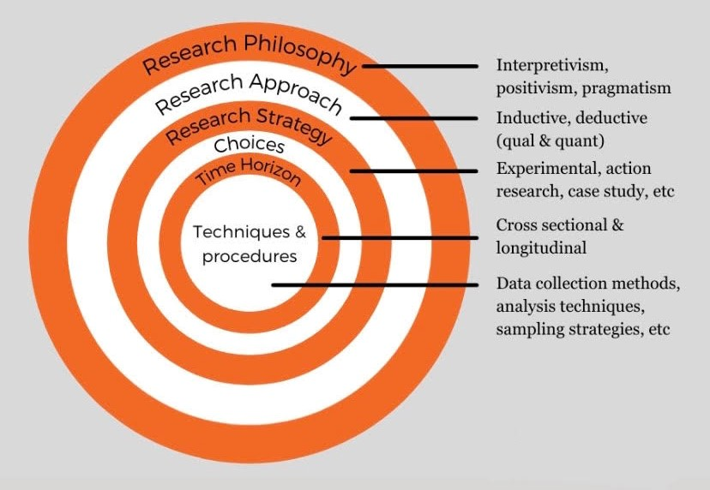

Figure 3.2
Saunders et al., (2016) Research Onion

  - Peeling Saunders’ Research Onion
    - Research philosophy
The first and outermost layer relates to research philosophy. This is the foundation of the research and refers to the researcher establishing a set of beliefs which concern nature of reality (Bryman, 2012). Therefore, the idea is based on assumptions which will be undertaken by the researcher (Flick, 2011) and accordingly, the research outcome will either support or oppose the researcher’s assumptions. From a pragmatic point of view, the assumptions or research philosophy may be distinguished into two main categories namely, positivist and interpretivist approach (Mingers, 2006 and Saunders et al., 2016). Positivism is associated with scientific evidence such as experiments and focuses on statistical data and numerical values (Comte, 1975). Phillips and Burbules (2000) suggest that research must be objective, free from any bias or prejudice, and must not consist of any values or beliefs of the researcher. On the other hand, interpretivism claims that knowledge and truth must be subjective, and must consist of information which is based on personal experiences (Bryman, 2012).

The research philosophy of this study will consist of the assumption that domestic violence is a prevalent issue in the society, and will embrace a positivist approach whereby, statistical data and numbers will be taken into account. This will be done by way of questionnaires, which is a quantitative method of research. Quantitative research method is defined as any data that can be expressed in statistical or numerical manner and is presented in either graphical or tabular form, or in the form of pie charts and bar charts (Browne, 2011). The goal of a quantitative research is to prove a generalised theory in the form of statistical or numerical data (Browne, 2011). Accordingly, this study will rely on statistical data and numbers in order to obtain a clear picture of how prevalent the issue of domestic violence is, and the number of victims who are comfortable reaching out to the police in such a circumstance.

The first layer also consists of ontological or epistemological points of view (Saunders et al, 2016). The former refers to studying the reality of nature, as Crotty (2003) puts it ‘study of being’. It further concerns investigating the nature of existence and the reality of structure. Guba and Lincolin (1989) suggest that the answer to ontological assumptions is in the question ‘what is there to be known’ and ‘what is the nature of reality’. The latter, epistemological assumptions, are based on understanding and explaining ‘how we know what we know’ (Crotty, 2003). It, therefore, is associated with forms of valid human knowledge, which can be known and transferred (Crotty, 2003). Accordingly, the study below will follow the epistemological research and positivism, and use quantitative methods to test the philosophical question.

    - Approach
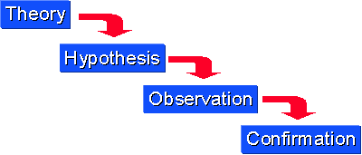
The second layer of research onion consists of using either deductive or inductive approach (Saunders, 2009). Deductive approach refers to testing an already existing theory whilst inductive theory is one which aims at developing a new theory (Trochim and Donelley, 2006). The former deals with making a general theory more specific thereby, confirming the theory (Trochim and Donelley, 2006). Deductive theory relies more on quantitative data in order to either confirm or reject the theory (Creswell, 2005). Accordingly, the study relies on deductive approach as it relies on qualitative method to confirm that domestic violence is prevalent and public confidence in laws and police is minimal.
Figure 3.3.2 Trochim and Donelley 2006, Deductive Approach

    - Research Strategy:
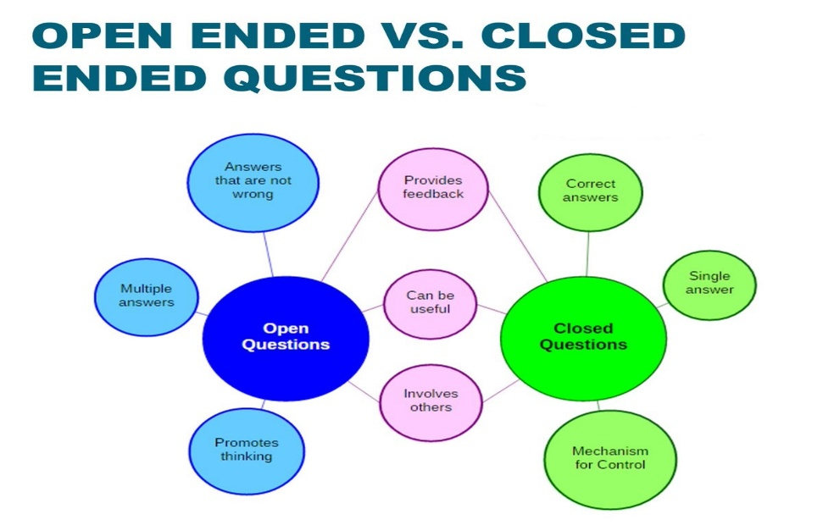
The research strategy adopted by this study includes collecting quantitative data by way of questionnaires. Because domestic violence is a sensitive and triggering area for some, it is regulated by ethical considerations and comfort of the participant. The highlight of the questionnaire is that is anonymous therefore, it protects the participant’s identity. This is essential as most participants do not prefer disclosing their identities due to the sensitivity of the topic. It is because of this reason that the questionnaire type is an online questionnaire which allows for protection and comfort of the participant. This online questionnaire was conducted by way of google forms. The reason why it remained anonymous was due to the fact that the questionnaire did not ask for any personal details such as name or phone number. Furthermore, in order to place focus on reliability, validity and accuracy, the questionnaire is formed in a way which incorporates both, open ended and close ended questions. Lastly, the data will be analysed empirically as it is a quantitative research project, involving the use of sampling which is further discussed below (Bryman & Bell, 2011).
Figure 3.3.3 Open ended and close ended questionnaire figurative explanation
    - Choices

The range of choices included in research onion include mono-method, mixed method and multimethodology, each of which serves a distinct function (Saunders et al., 2007). Briefly put, mono-method involves use of one research method, mixed method uses more than one research approach usually involving quantitative and qualitative methods and finally, multimethodology uses multiple research approaches (Bryman, 2012). Correspondingly, it appears that a mono research method involving quantitative research would prove to be adequate for the purposes of this study. This is because the study requires either confirmation or opposition of the theory and quantitative method would deliver such quickly and adequately. This is because reading, analysing and interpreting quantitative data from questionnaires is easy to use, quick and free from bias. Nevertheless, it is certain that the data will lack deep insight of the issue and may potentially overlook reality of it as well. However, the advantage of this method including anonymity, reliability and accuracy outweigh the disadvantages.

    - Time Horizons

The study will use cross sectional time horizon which means that the intended research is conducted for a single point in time, also known as to be capturing data in a ‘snap shot’ (Setia 2016).

Data collection and analysis
The final step of the research onion consists of data collection and analysis, which is the inner circle of the research onion and is known as ‘tactics’ as it revolves around finer details of the research. The research process at this stage is one which holds immense significance in the overall reliability and validity (Saunders et al., 2007). This layer includes source of data (primary or secondary research), sample and sample size, followed by sample limitations and finally, reliability and validity (Saunders et al., 2007).
Firstly, the study consists of primary research which is data collected directly from the source or first hand, usually by the researcher (Douglas, 2017). Here, the source are the participants, and the data is collected by way of a questionnaire. The questionnaire consists of 14 questions, 4 of which are close ended and 10 are open ended. The questionnaire has been labelled as ‘Research A’ for the UK and ‘Research B’ for the US and is attached in Appendix A and Appendix B.

Sample and limits to sampling
Sample refers to a small group of participants who are intended at representing the population at large (Browne, 2011). Thus, it is essential that the sample is one which would accurately display data on domestic violence, including married couples, cohabiting couples, and those in long term relationships. The research questionnaire was sent out to 50 participants in UK and the US, 20 of whom responded from the UK and 17 from the US. In quantitative research, a large sample is reliable and therefore, more accurate (Flick, 2011).
  - Validity and Reliability
Validity refers to the extent to which research accurately displays quantitative date (Blundell, 2014). The measure of accurate quantitative data is reliability which means that the data must be consistent such that it produces the same result each time (Blundell, 2014). Accordingly, the use of questionnaire is valid as well as reliable, making it an adequate research method for this study.
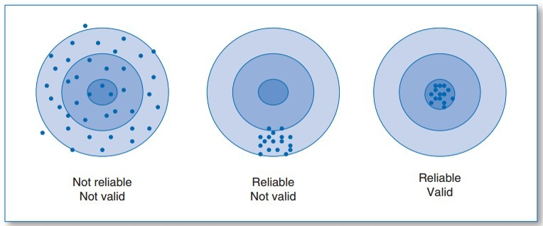
Figure 3.5 validity and reliability
  - Limitations
Often, participants provide dishonest answers and other times participants tend to leave questions unanswered (Blundell, 2014). Moreover, questionnaires lack personalization which excludes in-dept data and analysis (Browne, 2011).
  - Ethical Considerations
Ethical consideration includes a set of guidelines which aims to protect the participant, enhance validity, and maintain scientific integrity (Pretti et al., 2017). In order to protect UK General Data Protection Regulation and ethical concerns, the questionnaire was conducted using survey monkey which is a medium known for maintaining anonymity and collecting data with the aid of password encryption. Furthermore, the responses of research were stored in a password protected laptop. This was done to protect the participants identity and to refrain from any concerning ethical considerations. Furthermore, no intrusive or leading questions were asked, and the participants had a choice to skip a question if they did not wish to answer.

Conclusion
The objective of the research, which was to collect data regarding the extent of domestic violence in contemporary society has been fulfilled. Quantitative method provided the baseline for this study’s research which allows numerical and statistical data and accuracy. The questionnaire included open ended and close ended questions in order to widen the ambit of research validity and reliability. Further, anonymity promised participation comfort and protection. Lastly, data that has been gathered will be discussed in the next chapter.

CHAPTER 4: FINDINGS: Data Analysis, Presentation and Interpretation.

4.1 Introduction
Chapter 4 will present and analyse the data collected from the questionnaires. Research A consists of 14 questions and was conducted amongst participants residing in the United Kingdom. The questionnaire was sent to 30 participants, of which 17 responded. The same questionnaire was sent to 30 participants from the United States of America, of which 19 responded.

4.2 Data Analysis:
Schwandt, 2007 claimed that the core aim of data analysis is to interpret and process data in order to understand the structure, frequency and outcome of the data. Therefore, to fully understand underlying trends and patterns of domestic violence and the relationship of the research to the purpose of this study, the data collected from the questionnaire will be analysed in the form of descriptive analysis and pie charts. For further clarity of the method of analysis, descriptive analysis will be used for open ended questions used in the questionnaire whereas, pie charts will be used for closed ended questions. This will allow for the data to be analysed thoroughly, not only through description but also by way facts, figures and statistics.

4.3 Quantitative data analysis

4.3.1 Gender based violence
Figure 4.3.1(a): Research A, Q1 result
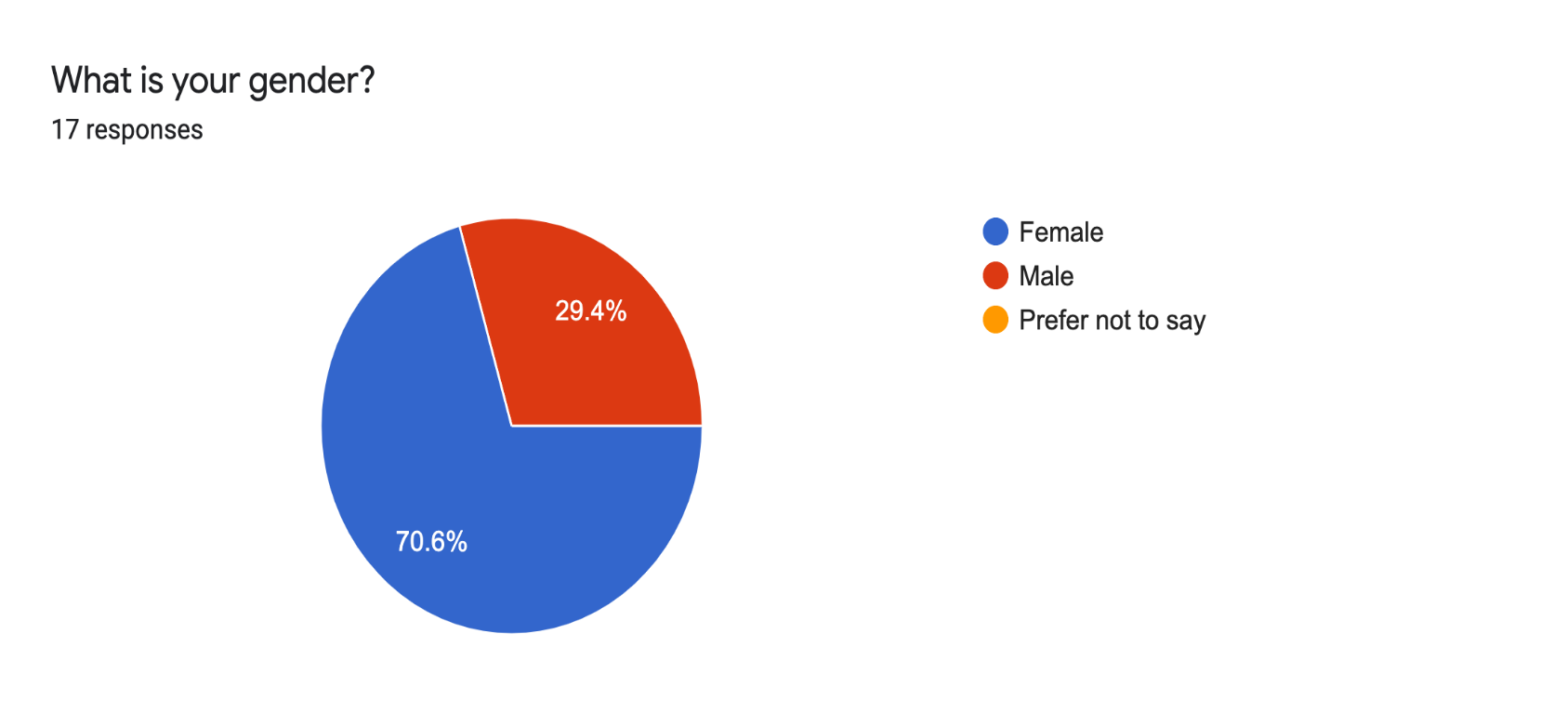
As has been put forward by Richards et al., 2008 that victims of domestic abuse are mainly women, the above questionnaire result confirms that more women than men have either been abused or know someone who has been abused. The above pie chart presents that 70.6% participants involved in domestic violence are women compared to only 29.4% males in the United Kingdom. In the United States, the numbers vary slightly, with 68.4% women being victims/survivors of domestic violence compared to 31.6% men.
Furthermore, the Office of National Statistics in 2019 produced that more females than males experience domestic violence. Accordingly, figure 4.3.1(a) and figure 4.3.1(b) confirm that it is mainly females who are victims or survivors of domestic violence. Conclusively, this confirms the historical pattern of abuse against women.
A disadvantage which is evident from the above result is that the outcome has been limited to two traditional genders, that is, male and female. Other genders and sexualities did not take part in the research thereby, limiting the scope of research. Whereas, provided that if more genders took part in the research, the outcome would be more diverse and therefore, portray a clearer picture of the position of domestic violence in contemporary society. Another possible disadvantage is that around 10 participants for each questionnaire refused to take part in the research entirely. This may affect the accuracy of the desired outcome.

4.3.2 How common is domestic violence?
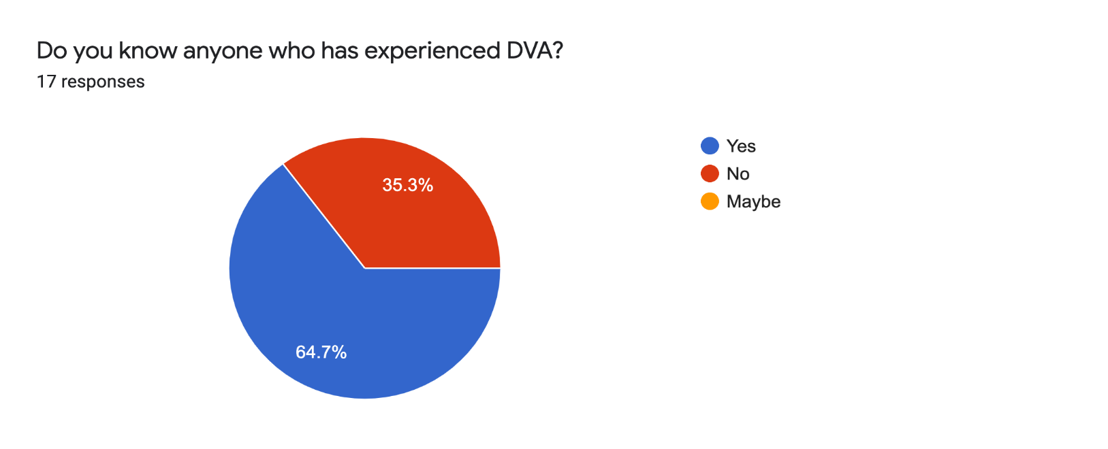
Figure 4.3.2(a): Research A, Q2 result
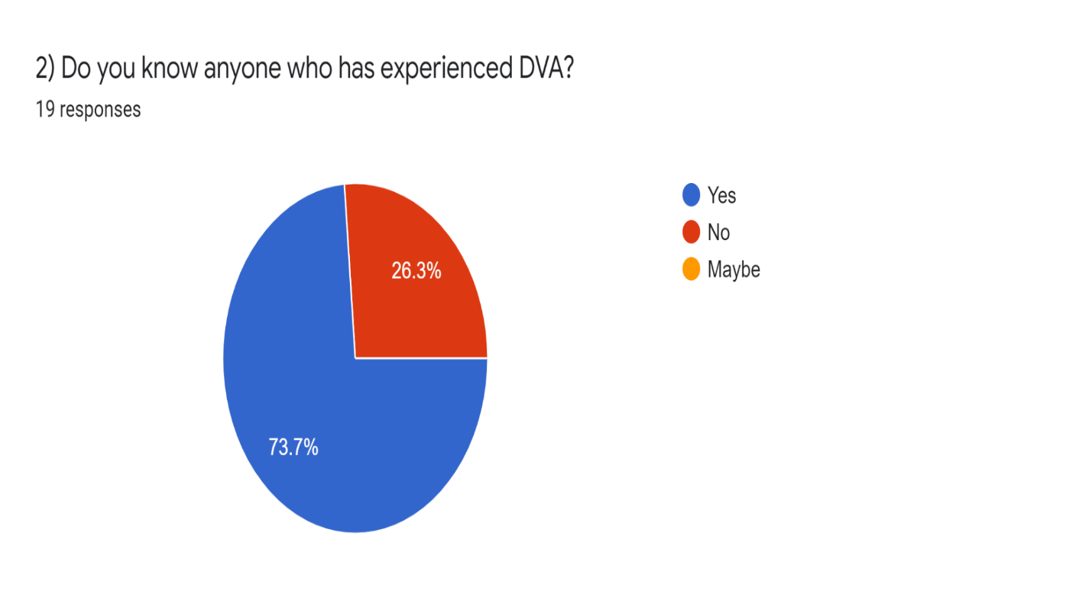
Figure 4.3.2(b): Research B, Q2 result

From figure 4.3.2(a), it appears that 64.7% of the participants knew a victim of domestic violence. This number is even higher in the United States where 73.7% of the participants knew someone who is a survivor or victim of domestic violence. By comparison, it appears that the US is home to more victims than the UK. Comparing this outcome to the assumption taken above, of domestic violence being prevalent in the society, stands corrected. This is because more participants know someone who has experienced domestic abuse than those who do not. Therefore, this highlights the fact that domestic violence is still common in contemporary society and that more needs to be done by the government to ensure that this number decreases. Furthermore, as has been provided in the literature review above that 76% women and 62% men believed they would inform of such abuse to someone personally known to them (Her Majesty’s Inspectorate of Constabulary, 2014) shows that victims/survivors tend to inform people around them than to the police. Thus, this, again, confirms the assumption that victims would rather inform about the abuse to someone whom they know personally instead of going to the police.
Furthermore, stance taken by Klein et al (2019) that domestic violence is an issue that is prevalent across every cultural and socio-economic status on the globe stands corrected when comparing the results of the research. This is because, two of the relatively ‘progressive’ and ‘liberal’ countries in terms of gender equality, in fact consist of deep-rooted domestic violence. As has been mentioned in Chapter 2.9 of this study, the United Kingdom and United States remain in the top 50 most dangerous countries for women in 2022 and this has been confirmed by the result obtained from this research.

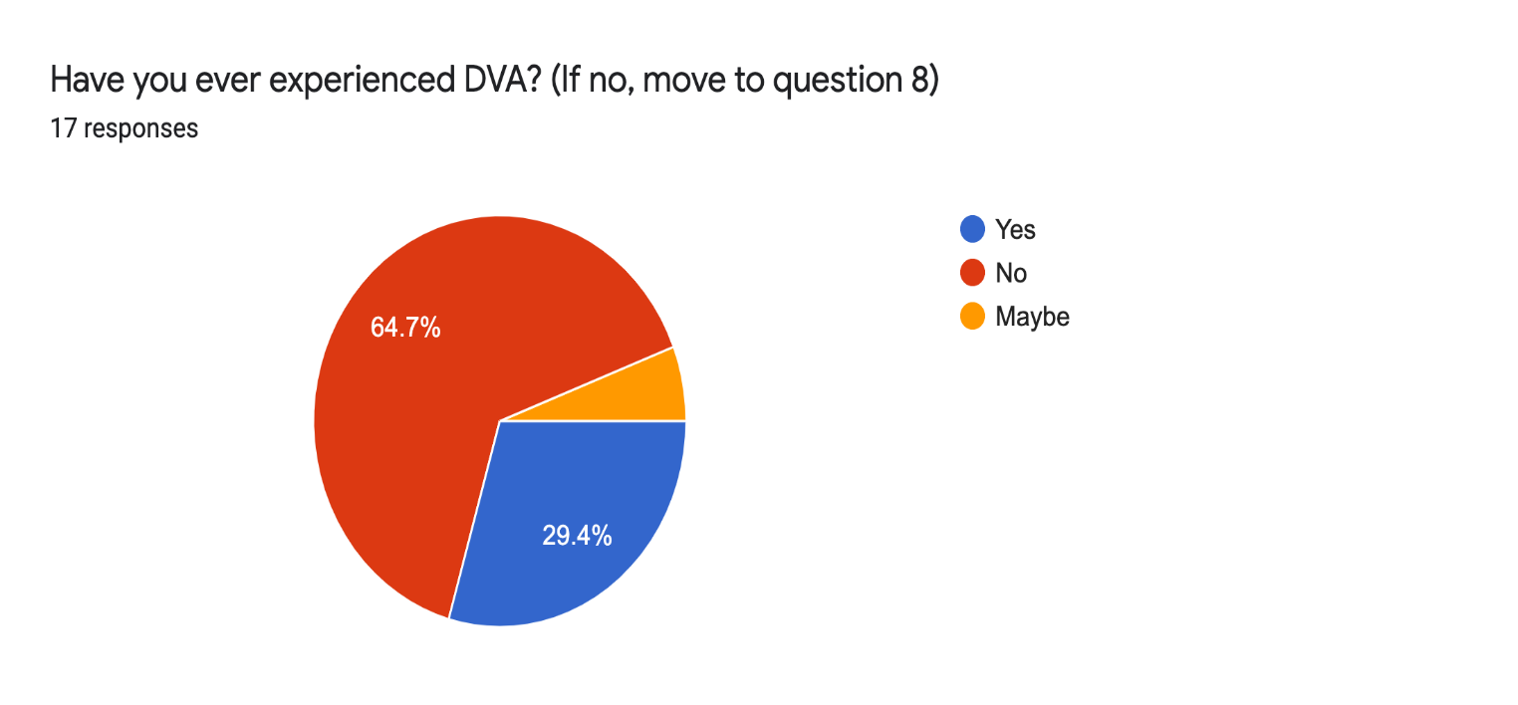
4.3.3 Victims and survivors of domestic violence
Figure 4.3.3(a): Research A, Q3 result
5.9%

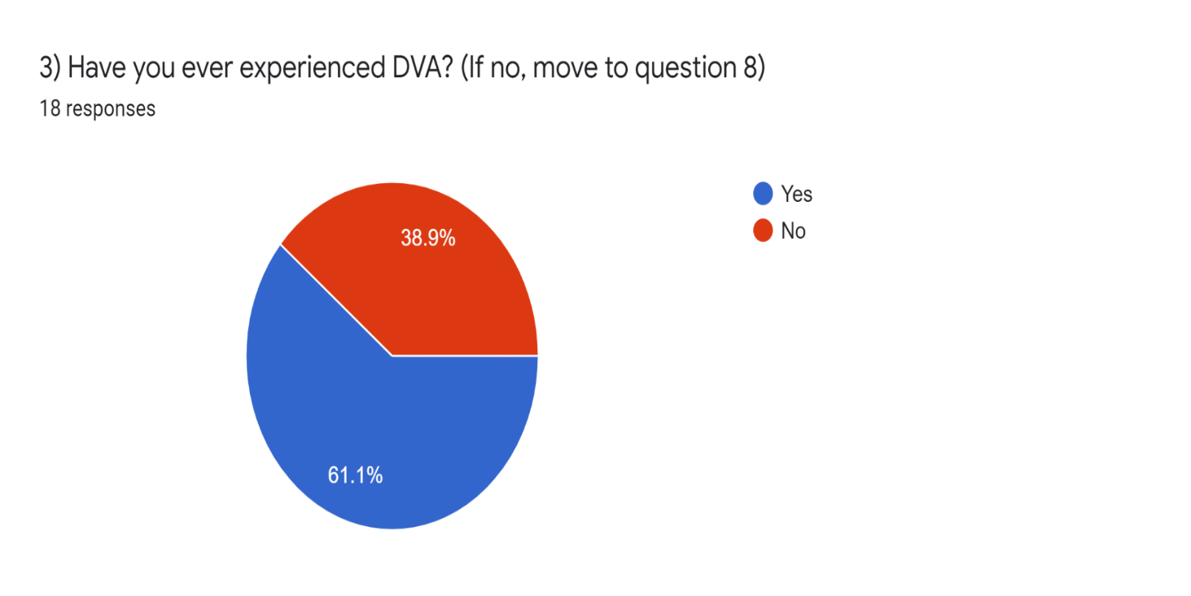
Figure 4.3.3(b): Research B, Q3 result
The above presented results follow and depart from the assumption taken in this study. Taking ‘Research A’ into consideration, it appears that most participants answered that they have not experienced domestic violence. With 64.7% participants claiming that they did not experience domestic and 5.9% unsure of their position, it appears that the United Kingdom has been relatively successful in reducing domestic violence. The assumption taken in this study included prominent prevalence of the issue of domestic abuse in current society. While the UK has not entirely eliminated domestic abuse, the number is lower than that of the United States. Subsequently, the prevalence of domestic violence in the United States is apparent, with 61.1% of participants claiming they have experienced domestic violence. In terms of the stance taken by many academics including Klein et al (2019) regarding the universality of domestic violence in society appears to have been confirmed by the research result. Furthermore, and as highlighted in Chapter 2, in the United States, domestic violence related phone calls cover the largest category of complains, accounting up for 15-50% of all of the calls (Friday and Hartman, 2016) stands corrected since the number of domestic violence victims in the States in considerably high as per the research result. Therefore, it appears that both countries have been unsuccessful in entirely eliminating domestic abuse.

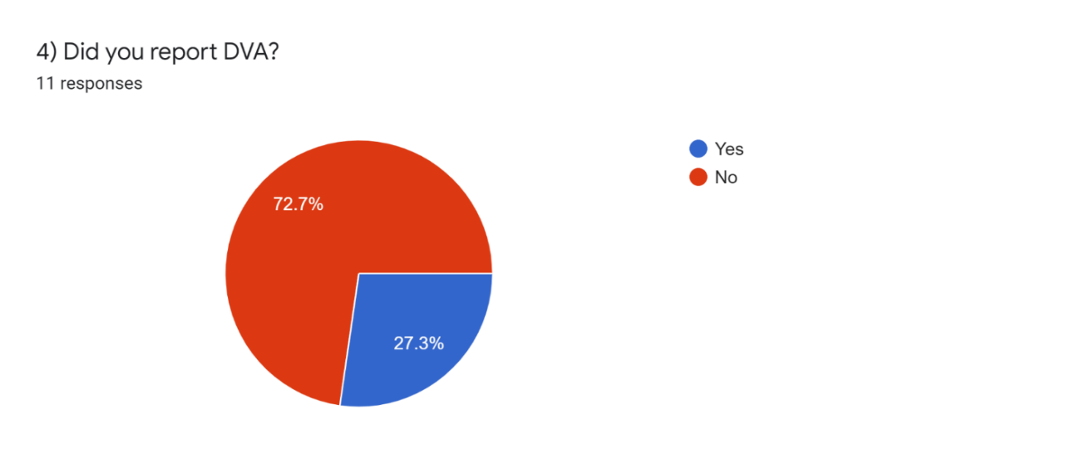
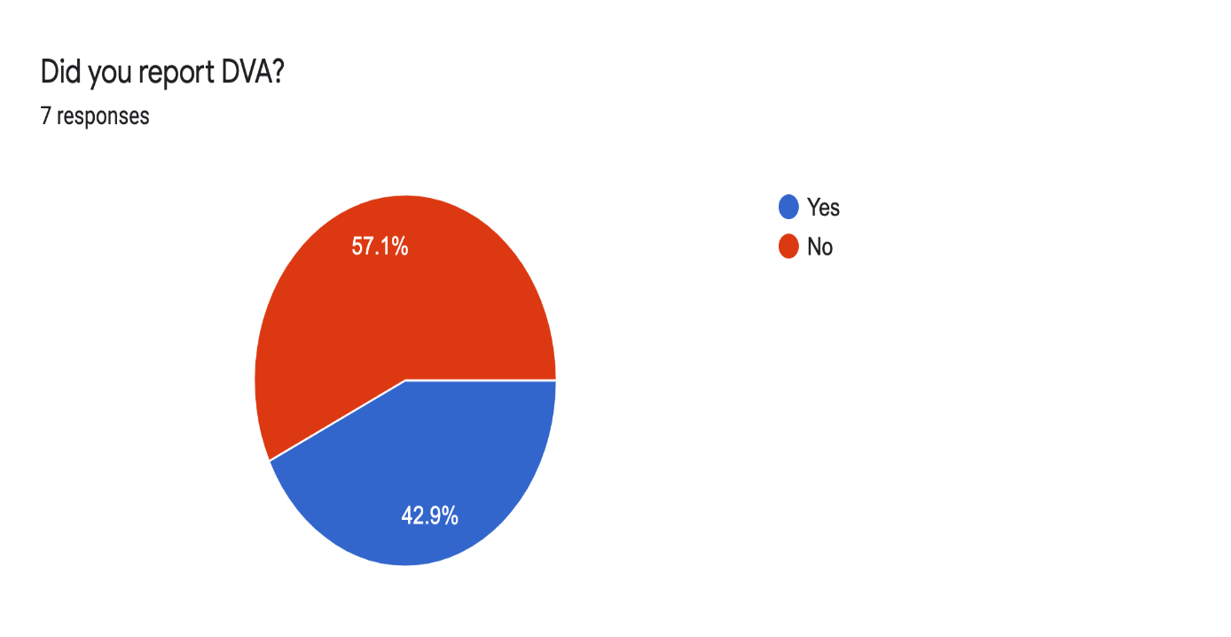
4.3.4 Reporting domestic abuse
Figure 4.3.4(a) Research A, Q4 result
Figure 4.3.4(b): Research B, Q4 result
Participant engagement in Research A for question 4 was only 41% however, a fair reason for this is likely to be question 3 where they were asked to directly skip to question 8 if they were not victims of domestic abuse. An advantage of this low participant number is that the 7 participants are undeniably victims of domestic violence. Therefore, the responses and results are likely to be almost accurate. Similarly, Research B presents 57.9% participant engagement for question which indicates that the participants are, without fail, victims or survivors of domestic abuse.
Analysing the above presented data, it appears that in both countries, most participants did not report the crime of domestic abuse. 57.1% of participants from the United Kingdom responded that they did not report to the police while 72.7% of the participants from the United States claimed that they refused to go to the police. This outcome sits comfortably with the findings of both countries in terms of underreporting of domestic abuse cases. Considering the reports mentioned in Chapter 2, 600,000 incidents in the UK go unreported every 3 years (Scott, 2021) while, in the United States, more than 50% of the cases go unreported (Police Response to Domestic Violence Report, 2017). The research result confirms both claims. 57.1% of the participants in the UK claimed they did not go to police which is a considerably high number and an even higher number has been extracted from the United States, amounting to 72.7% participants, which is more than 50% as mentioned by the report of 2017.

4.3.5 Reasons behind reporting and not reporting
The responses of question 5, 8 and 13 of the questionnaires (please refer to Appendix C) will be discussed in this section. The questions given are open ended questions in the questionnaire. With particular regards to Research A, responses for question 5, which is relates to the United Kingdom, it appears that victims lack awareness as they believed that only ‘extreme’ cases are to be reported. This means that the government has lacked in informing the general public of their rights and has lacked in publicising the role of the police, which is to help victims. This response corresponds correctly to the statement of Hines and Douglas (2014) who believe that victims do not report incidents because they are unaware of their rights. Other victims believed that the process is long and tedious, with no positive outcome. This is in line with the stance taken by Hines and Douglas (2014) who focused on personal reasons for not reporting including fear of retaliation, fear of isolation, attitude of the police along with the lengthy process. Moreover, as per the response of the victim ‘needing to stay alive’ confirms the statement made by Hines and Douglas (2014) that victims fear retaliation by their abuser if they go to the police. The victim here is likely to have been fearing retaliation in the sense that she believed the abuser may kill her. Considerably, this confirms the assumption that domestic violence still exists in the society and exists for personal and societal reasons. Taking the second response of question 5 of Research A into consideration, whereby the victim stated that he abused physically and the abuser had also damaged property, confirms the statement of Richards et al., (2008) that domestic violence is often followed by criminal damage. Furthermore, as has been claimed by Hilton (2021) that one of the most prominent types of domestic abuse exists as physical abuse is also verified by the second victim’s response. Moreover, one of the victims is seen as bearing abuse solely for the reason of having shelter and safety which confirms the theory laid down by McPhail and Rice (2007) and Turner (2002). Nonetheless, positive responses are also seen whereby, the abuser stopped the abuse after the victim reported. This opposes the assumption of the study which includes low public confidence in the police and CPS. Research B also consists of some positive replies which indicates that victims do, in fact, report to the police. Nevertheless, reasons including child safety, insufficient support from police and government, self-blaming and fear of losing children favour the stance taken by Hines and Douglas (2014), Hilton (2021) and McPhail and Rice (2007).

4.3.6 Cycle of abuse
The data presented in questions 6 and 7 of Appendix C and Appendix D relates to the number of years victims who stayed in their relationships and the reasons for staying. It appears that the number of years for which the victims stayed in their relationships range from six months to 18 years. Outwardly, it may appear that all victims are still in abusive relationships, however, a small portion of responses indicate that the relationship stopped being abusive once reported to the police. Hence, the survivor is still in the relationship which is free from domestic violence. Opposing to the assumption, it seems that the government and police has delivered sufficiently in solving the problem of domestic violence. Nonetheless, most victims appear to be in abusive relationships for years, even if they reported to the police. As has been discussed in Chapter 2, the police appear to be strongly opinionated about cases of domestic violence, believing it to be a family matter (Hilton, 2021). Furthermore, the numbers of years along with the reasons for staying, or returning, to abusive relationships reflect the wheel of domestic violence. This has been conveyed in Chapter 2 as ‘cyclical’ pattern of domestic violence (Matthews, 2004). Accordingly, the responses indicate the correctness of the cyclical pattern, with victims staying in the relationship for reasons including the need to save the relationship, children, financial dependency and societal judgement. This falls in line with the stance taken by Weiss (2000) where he claimed that often the victim is manipulated and made to be believe they are at fault, and that it is the victim’s responsibility to save the relationship. Thus, the assumption of domestic abuse being prevalent, stands corrected.

4.3.7 What must change?
Most responses given under question 9 of Research A and Research B (see Appendix C and D) relate to changing attitudes of government, police and even people. The participants are seen as requiring more support and reassurance from government bodies, police and statutory agencies in order for domestic abuse victims to feel safe and comfortable. Such reassurance and support are seen by the government of UK (chapter 2.8). According to the participants, this can also be done by way of having more female officer, strong court system and laws, education and awareness, and harsher sentences.

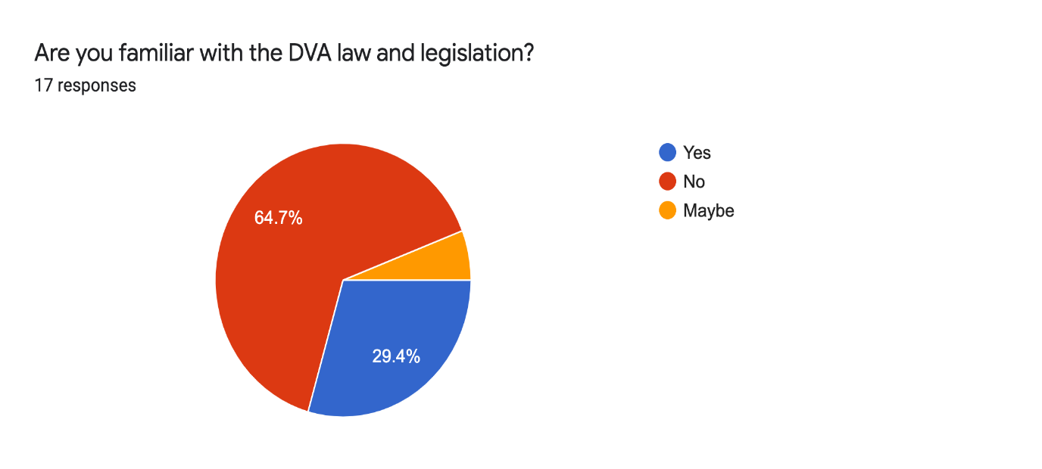
4.3.8 Domestic violence laws and awareness
5.9%
Figure 4.3.8(a): Research A, Q10 result

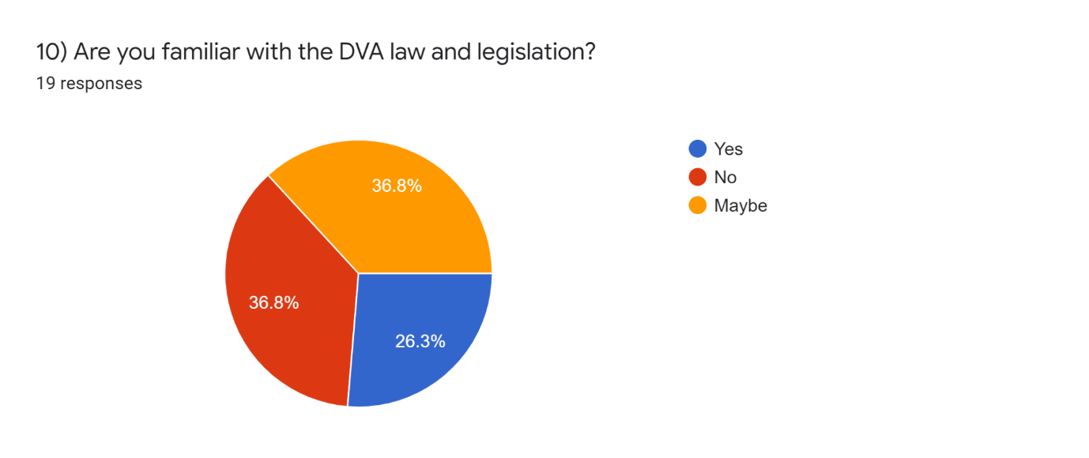
Figure 4.3.8(b): Research B, Q10 result
Responses of question 10 and 11 of Research A and B (see Appendix C and D) will be discussed in this section. Hilton (2021) and Lankester and Grills (2019) claim that with sufficient education, awareness of rights and laws, domestic violence case will reduce to a minimal level. Correspondingly, it appears that most participants side with the academics mentioned above, believing that government must take initiatives to convey rights for example in the form of sessions, schools and/or arranging therapy for perpetrators. Furthermore, the fact that only 29.4% of the participants from the UK and 26.3% of the participants in the US are aware of their rights indicate a deep problem on part of the government relating to spreading awareness. Responses show that victims who survived and were served justice must be highlighted. This aligns with Lankester and Grill (2019)’s view that survivors’ stories must be portrayed in positive light. Furthermore, other responses also fall in line with Lankester and Grill (2019) whereby, creating public awareness and changing attitudes of police remain an essential requirement.

4.3.9 Recommendations by participants
Some of the prominent suggestions and recommendations given under question 14 of Research A and Research B (Appendix C and Appendix D respectively) include support by government, additional funding by government, prioritizing domestic violence cases, female officers, new laws, adequate training of police and awareness/education of rights. Collectively, the participants have asked more from the government organisations in order to minimise the number of domestic abuse cases. With regards to funding, and as stated in Chapter 2, the government of UK has set aside a large sum of £683,000 for the purposes of establishing, maintaining and running organisations which would support domestic violence victims and cases. The result of this step is yet to come. Nonetheless, as of now, the assumption stands corrected which means that more efforts are required by the government.

4.4 Conclusion
The theory undertaken by this study which relates to prevalence of domestic violence due to inadequate support from the government seems to be correct. However, it would be unfair to disregard all efforts of the government, since both countries have made changes in law fairly recently and have also organised other methods of support such as UK’s #YouAreNotAlone movement.

CHAPTER 5: CONCLUSION

5.1 Summary
The study revolves around the issue of domestic violence in the United Kingdom and the United States. Accordingly, the study compared and analysed laws and government actions of each country in order to fully understand the efforts made by the government to cater to the issue of domestic abuse. Moreover, it was aimed at highlighting the struggles faced by domestic abuse victims and survivors such as insufficient support from police and government, difficulty in leaving toxic situations, unawareness of rights and legislations, and societal judgement. Furthermore, the study also highlighted the wheel of domestic violence in which the victims are trapped, making it difficult to escape and attain independency. Additionally, the study conducted a questionnaire for each country in order to obtain responses relation to number of domestic violence victims, involvement of police and government, and reasons for staying in abusive relationships. The results of the questionnaire portrayed that victims are still in dire need of government support and strong laws, leading to the suggestions of better laws, court system and police attitude.

5.2 Recommendations
With regards to the recommendations given by participants regarding better and stronger laws, the Parliament of UK has confirmed that domestic abuse victims will be given more time to report their cases. This is because victims and survivors often take a long time before reporting the offence (Gov.uk, 2022). Nonetheless, because of the crime being reported much later than the date of the incident, it is often overlooked and deprioritized. Currently, the prosecution must commence within six from the date of the incident however, it has been recommended that this much change to two years from the date of reporting. Thus, there are two changes being made (Gov.uk, 2022). Firstly, the increase of time from six months to two years and second, replacing ‘date of incident’ to ‘date of reporting of the incident’. This will allow the victims sufficient time to build up courage and strength, along with being emotionally ready. Moreover, other suggestions which would help strengthen the support from government include hiring more female officers for domestic violence cases, sensitivity and understanding by the police, training of the police and government bodies, awareness, and education of rights.

5.3 Self reflection
The study allowed the researcher to understand the depth of the issue and understand the underlying reasons for it still existing. While the issue of domestic violence is not new, people still seem to talk about it in whispered tones when it must be talked about freely and loudly. Thus, the study allowed the researcher to understand the victims, why they stay in abusive relationships and what they require in order to get help. With the hope that the recommendations will be enforced someday soon, the researcher till then shall educate themselves more in order to be able to sensitively deal with victims if they ever come across one.

5.4 Limitations of research
Due the nature of the topic being sensitive, much of research questions had to be restrained and regulated. For this particular reason, much of the detail was seen as being limited. For instance, type of abuse and whether it included physical harm such as slapping, kicking or punching. Other questions such as abuse towards children and elderly, and whether children witnessed the abuse were also limited for ethical reasons.

5.5 Future research
For the purposes of future research, emphasis would be on qualitative research such as interviews in order to get a micro-view of the issue. While the current questionnaire was created in a way which included open ended questions, an even deeper analysis and data can be achieved. Furthermore, an increase in the number of participants would also prove to be helpful.

5.6 Conclusion
The study has achieved its objectives of highlighting the prevalence of domestic violence in the 21st century along with the need for further reforms, laws, and policies. Finally, the study has also provided recommendations that can be put into practicality.

References:
Becker, S., Bryman, A. and Ferguson, H. eds., 2012. Understanding research for social policy and social work 2E: themes, methods and approaches. policy press.
Blundell, J., 2014. Cambridge IGCSE Sociology Coursebook. Cambridge University Press.
Browne, A. and Williams, K.R., 1993. Gender, intimacy, and lethal violence: Trends from 1976 through 1987. Gender & Society, 7(1), pp.78-98.
Browne, K., 2005. An introduction to sociology. Polity.
Bryman, A., 2011. Research methods in the study of leadership. The SAGE handbook of leadership, pp.15-28.
Burton, M., 2008. Legal responses to Domestic Violence. Oxon: Routledge-Cavendish.
Campbell, J. (2002) ‘Health consequences of intimate partner violence’, The Lancet, Vol. 359, no.9314.
Cattell, H.E. and Mead, A.D. (2008) 'The sixteen-personality factor questionnaire (16PF)', The SAGE handbook of personality theory and assessment, 2, pp. 135-178.
Clark, V.L.P., Creswell, J.W., Green, D.O.N. and Shope, R.J., 2008. Mixing quantitative and qualitative approaches. Handbook of emergent methods, 363.
Comte, A., 1975. Auguste Comte and positivism: The essential writings. Transaction Publishers.
Council on Criminal Justice. Impact Report: COVID-19 and Domestic Violence Trends (2021). Available at https://counciloncj.org/impact-report-covid-19-and-domestic-violence-trends/
Crime Survey of England and Wales (2020): Year ending June 2020. Available at https://www.ons.gov.uk/peoplepopulationandcommunity/crimeandjustice/bulletins/crimeinenglandandwales/yearendingjune2020
Crotty, M. (2003): The Foundations of Social Research: Meaning and Perspectives in the Research Process, London: Sage Publications, 3rd edition, 10.
Day, A. and Bowen, E. (2015) 'Offending competency and coercive control in intimate partner violence', Aggression and violent behavior, 20, pp. 62-71.
Dehnel, J., (2016). A report on domestic abuse. Rutland.
Dipty, M.D., (2010). The Three Dimensions of Domestic Violence. Tate Publishing.
Domestic Abuse Act 2021. Available at https://www.legislation.gov.uk/ukpga/2021/17/contents
Domestic Violence and Matrimonial Proceedings Act 1976. Available at https://www.legislation.gov.uk/ukpga/1976/50/enacted
Dugan E. Phumzile Mlambo-Ngcuka: Home can be the unsafest place for women. The Independent. 26 April 2015. Available from: http://www.independent.co.uk/news/people/phumzile-mlambongcuka-home-can-be the-unsafest-place-for-women-10204379.html
Dutton, M.A. (1992) 'Understanding women's responses to domestic violence: A redefinition of battered woman syndrome', Hofstra L.Rev., 21, pp. 1191.
Erez, E., 2002. Domestic violence and the criminal justice system: An overview. Online Journal of Issues in Nursing, 7(1), pp.1-24.
Family Law Act 1996. Available at https://www.legislation.gov.uk/ukpga/1996/27/contents
Flick, U., 2011. Mixing methods, triangulation, and integrated research. Qualitative inquiry and global crises, 132(1), pp.1-79.
Friday, P., V. Lord, M. Exum, and J. Hartman. “Evaluating the Impact of a Specialized Domestic Violence Police Unit.” Final report for National Institute of Justice, grant number 2004-WG-BX-0004. Washington, DC: U.S. Department of Justice, National Institute of Justice, May 2006, NCJ 215916. Available at http://www.ncjrs.gov/App/Publications/abstract.aspx?ID=237505
Grierson, J. Domestic abuse still under-reported in England, says Women's Aid. The Guardian (2017). Available at https://www.theguardian.com/society/2018/mar/07/domestic-abuse-still-under-reported-in-england-says-womens-aid
Hartley, J., Alford, J., Knies, E. and Douglas, S., (2017). Towards an empirical research agenda for public value theory. Public Management Review, 19(5), pp.670-685.
Harvard, T. Domestic abuse and Covid-19: A year into the pandemic. House of Commons Library (2021). Available at https://commonslibrary.parliament.uk/domestic-abuse-and-covid-19-a-year-into-the-pandemic/
Her Majesty’s Inspectorate of Constabulary (2014:) Everyone’s business: Improving the police response to domestic abuse. Available online: https://www.justiceinspectorates.gov.uk/hmicfrs/wpcontent/uploads/2014/04/improving-the-police-response-to-domestic-abuse.pdf
Her Majesty’s Inspectorate of Constabulary and Fire and Rescue Services, ‘The Police Response to Domestic Abuse – an updated report’ (2019).
Hilton, N.Z., 2021. Domestic violence risk assessment: Tools for effective prediction and management. American Psychological Association.
Hines, D., & Douglas, E. (2014). Health problems of partner violence victims: Comparing help-seeking men to a population-based sample. American Journal of Preventive Medicine, 48, 136–144.
Kirk, T (2021). London prosecution rate for domestic violence worst in UK. Published by Evening Standard. Available at https://www.standard.co.uk/news/crime/london-prosecution-rate-domestic-violence-worst-uk-cps-b924635.html
Lankester, T and Grills, N (2019) ‘Setting up Community Health Programmes in Low and Middle Income Settings” OUP, 4th edn.
Lincoln, Y.S. and Guba, E.G., 1989. Ethics: The failure of positivist science. The Review of Higher Education, 12(3), pp.221-240.
Matrimonial Causes Act 1878.
Matthews, D.D. (2004). Domestic violence sourcebook, 2nd ed. Detroit, MI: Omnigraphics.
McCue, M.L. (2008). Domestic Violence: A Reference Handbook, 2nd ed. Santa Barbara, CA: ABC-CLIO, Inc.
McPhail, B.A., Busch, N.B., Kulkarni, S. and Rice, G., 2007. An integrative feminist model: The evolving feminist perspective on intimate partner violence. Violence against women, 13(8), pp.817-841.
Mingers, J., 2006. A critique of statistical modelling in management science from a critical realist perspective: its role within multimethodology. Journal of the Operational Research Society, 57(2), pp.202-219.
Newburn, T (2017) Criminology, 3rd edition. London: Routledge.
Office for National Statistics (2019) Domestic abuse in England and Wales overview: November 2019. Available at https://www.refuge.org.uk/our-work/forms-of-violence-and-abuse/domestic-%20violence/domestic-violence-the-facts/
Office for National Statistics, Domestic abuse prevalence and trends, England and Wales: year ending March 2019.
Phillips, D.C., Phillips, D.C. and Burbules, N.C., 2000. Postpositivism and educational research. Rowman & Littlefield.
Rajasekar S., Philominathan P. & Chinnathambi V. (2006). Research methodology, Ar XIV Physics. Available at http://arxiv.org/abs/physics/0601009.
Richards, L., Letchford, S. and Stratton, S. (2008) “Policing domestic violence”, Oxford University Press.
Rothman, E., Hathaway, J., Stidsen, A., de Vries, H. (2007). How employment helps female victims of intimate partner violence: A qualitative study.
Saunders M, Lewis P, Thornhill A (2007) Research methods for business students. Essex. Pearson Education limited
Saunders M, Lewis P, Thornhill M (2012) Research methods for business students. 6th Ed. Essex. Pearson education limited.
Schneider, E.M., 2008. Domestic violence law reform in the twenty-first century: Looking back and looking forward. Family Law Quarterly, 42(3).
Scott, M (2021), “One million domestic abuse cases unreported every year, experts warn” published by Sunday Post. Available at https://www.sundaypost.com/fp/one-million-domestic-abuse-cases-unreported-every-year/
Setia, Maninder Singh. "Methodology series module 3: Cross-sectional studies." Indian journal of dermatology 61, no. 3 (2016): 261.
Shrader E, Sagot M. (2000). Domestic violence: women’s way out. Washington, DC: Pan American Health Organization, http://www.paho.org/english/hdp/hdw/womenswayout.pdf
Stark E (2013) The Dangers of Dangerousness Assessment. Family and Intimate Partner Violence Quarterly, 6(2): 13-22.
Sullivan, C.M., Campbell, R., Angelique, H., Eby, KK, Davidson, W.S. II. (1994). An advocacy intervention program for women with abusive partners: Six-month follow-up. American Journal of Community Psychology, 22 (1) 101-122.
Summers, R.W. and Hoffman, A.M. eds., 2002. Domestic violence: A global view. Greenwood Publishing Group.
Szmigiera, M (2020). Most gender equal countries in the world 2020. Published by Statistics.com. Available at https://www.statista.com/statistics/1221060/most-gender-equal-countries-in-the-world/
The World Health Organization Violence Against Women. 2017. Available at https://www.who.int/news-room/fact-sheets/detail/violence-against-women
Trochim, W.M. and Donnelly, J.P. (2006) The Research Methods Knowledge Base. 3rd Edition, Atomic Dog, Cincinnati, OH.
Turner,J.S. (2002). Families in America. Santa Barbara, .CA: ABC-CLIO, Inc.
U.S. Department of Justice Office of Justice Programs Bureau of Justice Statistics (2017): Police Response to Domestic Violence, 2006-2015. Available at https://bjs.ojp.gov/content/pub/pdf/prdv0615.pdf
Vazquez, S.P., Stohr, M.K. and Purkiss, M. (2005) 'Intimate partner violence incidence and characteristics: Idaho NIBRS 1995 to 2001 data', Criminal Justice Policy Review, 16(1), pp. 99-114.
Walker, L. (1989). The Battered Woman Syndrome. New York, NY: Harper and Row.
Weiss, E. (2000). Surviving Domestic Violence: Voices of Women Who Broke Free. Volcano, CA: Volcano Press.
Wood, J.T. (2004) 'Monsters and victims: Male felons' accounts of intimate partner violence', Journal of Social and Personal Relationships, 21(5), pp. 555-576.
World Population Review (2022). Most Dangerous Countries for Women 2022. Available at https://worldpopulationreview.com/country-rankings/most-dangerous-countries-for-women
Zegwaard, K.E., Campbell, M. and Pretti, T.J., 2017. Professional identities and ethics: The role of work-integrated learning in developing agentic professionals. In Work-integrated learning in the 21st Century. Emerald Publishing Limited.

Appendices
Appendix A
Research A – UK questionnaire
- What is your gender
- Male
- Female
- Prefer not to say
- Other:
- Do you know anyone who has experienced DVA?
- Yes
- No
- Maybe
- Have you ever experienced DVA? (If not, please move to question 8)
- Yes
- No
- Maybe
- Did you report DVA?
- Yes
- No
- Why/why not

- How long did you remain within the relationship?

- What impacted the decision of how long you stayed?

- Why do you think that people may not report DVA experiences?

- What do you think needs to change in order for people to report DVA?

- Are you familiar with DVA laws and legislations?

- What do you think needs to be done in order for people to know law and rights?

- In your own words, why do you believe DVA may be committed by the offender?

- Do you think victims are supported adequately with supporting agencies? (Please explain your answer)
- What could change to better the support?

Appendix B
Research B – USA Questionnaire
- What is your gender
- Male
- Female
- Prefer not to say
- Other:
- Do you know anyone who has experienced DVA?
- Yes
- No
- Maybe
- Have you ever experienced DVA? (If not, please move to question 8)
- Yes
- No
- Maybe
- Did you report DVA?
- Yes
- No
- Why/why not

- How long did you remain within the relationship?

- What impacted the decision of how long you stayed?

- Why do you think that people may not report DVA experiences?

- What do you think needs to change in order for people to report DVA?

- Are you familiar with DVA laws and legislations?

- What do you think needs to be done in order for people to know law and rights?

- In your own words, why do you believe DVA may be committed by the offender?

- Do you think victims are supported adequately with supporting agencies? (Please explain your answer)
- What could change to better the support?

Appendix C
Research A responses
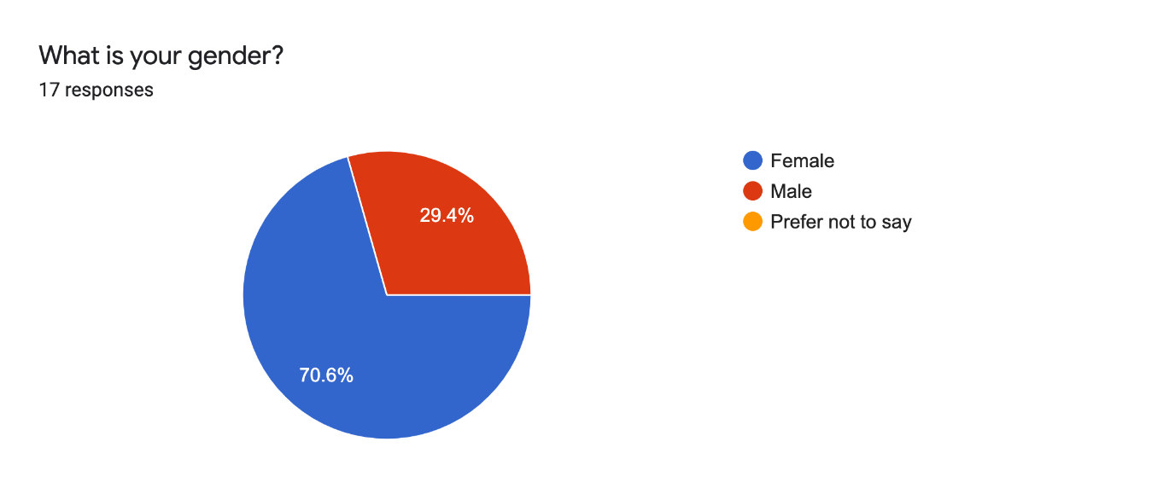
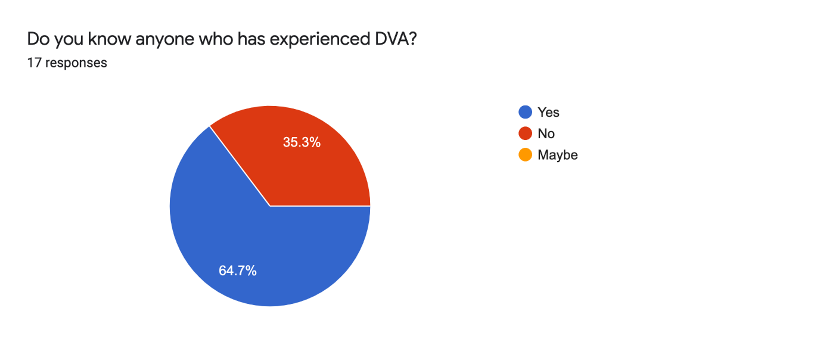
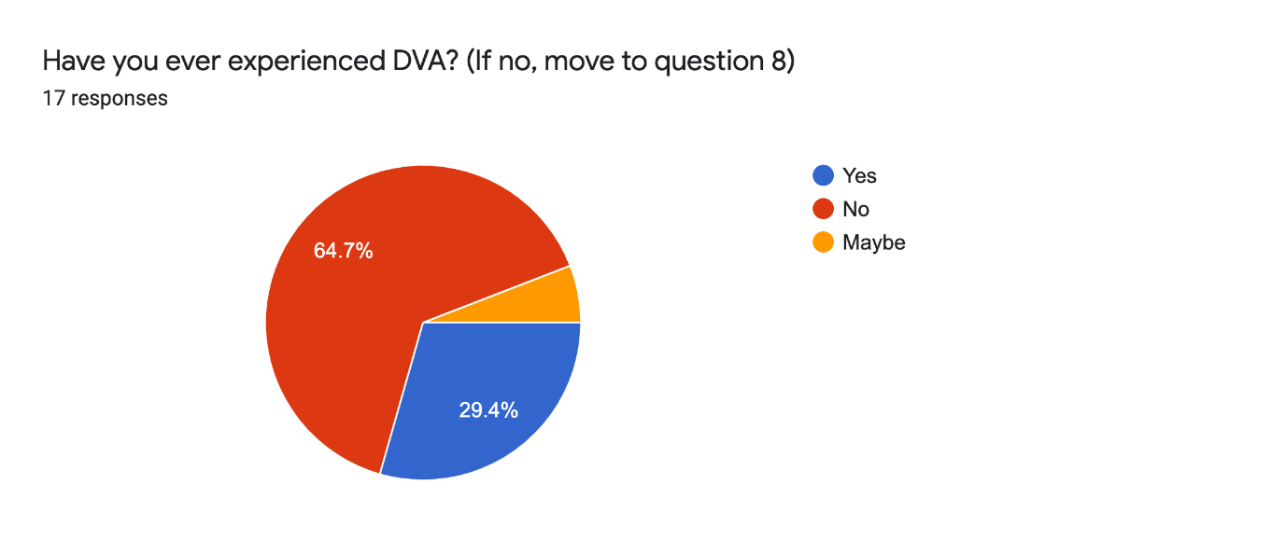
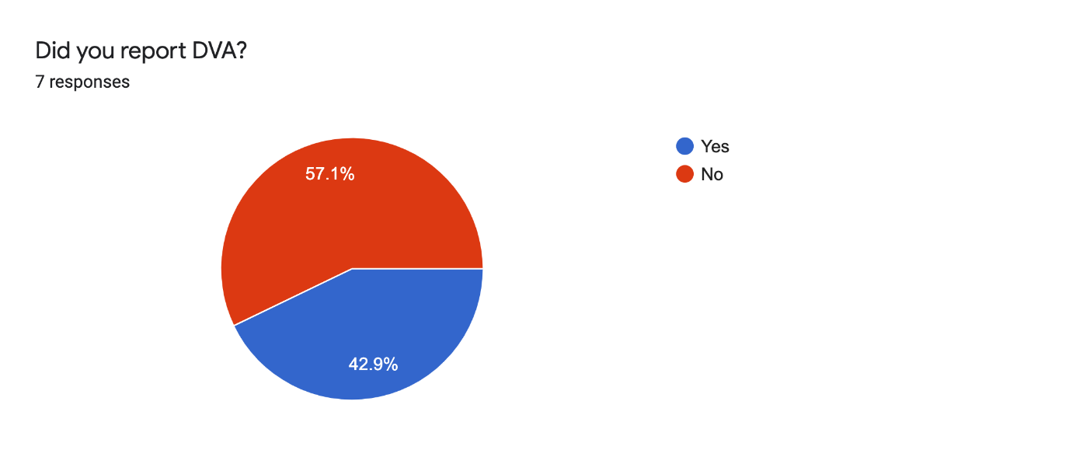
Why/Why not?8 responses
I don't know if it constituted ad DVA to be honest. In fact looking back now, it probably did. But I couldn't report it. Also, I always thought that you could only report in EXTREME cases.

Because she started to harass me after we finished dating. Also she was phsyically attack me and she damaged my property

Victim not comfortable

I had to in order to stay alive

What was the point in doing so? It wouldn't have got anywhere. It's a lengthy process and there's no point

Because I had to live with the person and still do.

I reported it to the police because i thought it was wrong for my husband to hit me, it wasnt nice. If he hit me once and because i reported it he did not hit me again and stayed within his barriers. I have also experienced physical abuse from my brother- and this was also reported to the police.

I wasn’t supposed to know about it

How long did you remain within the relationship?
4 years
After the DVA, only 6 months
Almost a year
3 years
Still within it.
Still in the relationship- domestic violence only happened in 2004.

What impacted the decision of how long you stayed?6 responses
The relationship eventually fizzled out really. It didn't have anything to do with the DVA.
I couldn't take it no more and my family supported me in leaving her. I had nowhere else to go and stayed with her. It was only when my family gave me a place to stay that I was able to finally leave, otherwise I would have been with her still. I also wouldn't have reported it.
I was trauma bonded and heavily manipulated
To be honest, I remained in the relationship until he left me...
I can't leave due to having no financial independence. I reply heavily on my partner. Also, I'm from a culture that says we have to deal with it. I cannot separate or get a divorce unless my husband instigates it.
The reason i stayed was because of my two sons. I did not want them to suffer in terms of education and give them the best chance at life in terms of stable careers etc.

Why do you think that people may not report DVA experiences?14 responses
Because it's not clear what is/isn't DVA. How bad does it need to be before you can actually report it? Like it is not known.

Fear of not being believed. I wasn't believed when I told police about my experiences. Maybe due to the connotation that women cannot be the perps?

Because of the fear of repercussions. I think I wouldn't report low level stuff that happens, and would wait for something really bad to occur before thinking about it. Maybe that's the mentality that comes with it.

They may fear no one will believe them or they may feel shame as there’s a stigma attached to it

Because of how long it takes, the lack of evidence, some officers still see it as being a domestic issue and they don't want to get involved.

Because you don't do that to someone you care about. Whether things are bad or not.

Cultural issues. I feel like we cannot bring upon shame, and so we just go through it.

They are scared of consequences

Due to fear of further consequences. Due to inability to live independently.

Fear of never really getting away from it. Fear for their life.

People may not report DVA purely because the experiences can be quite traumatic and therefore impact mental health in the short, mid and long term. In Asian culture- it is normal for domestic violence to be brushed under the carpet because of financial dependancy or living arrangements which benefit the perpetrator rather than the victim. Asian Society will also tend to side with the perpetrator which is often the male in the marriage or relationship.
Personally i think that people might be scared, being separated from partners how going to run the house financially, how to bring up the children. Some individuals may think it doesnt matter that the partner has hit them- but they do not know that it is not legal. People need to learn about the rules and regulations.

Scared of the person conducting DVA

Because they may feel intimidated by their offender. They may feel disclosing it will harm them or their loved ones and may have negative consequences overall

What do you think needs to change in order for people to report DVA?

More awareness of DVA is, what can and can't be reported, what actually happens when you do report it. It's not understood.

Stop thinking men are always the perpetrators...

Potentially knowing what it right or wrong. Understanding what you can and can't do when you find yourself in the situation.

The stigma attached to DVA and the victims and survivors, society need to be educated and trauma informed so they can understand better without judgment
understanding and responses with the police, being taught these things within schools potentially

Nothing. I just think that couples are able to sort things out between themselves.

Cultural changes.

More public knowledge about it

More social awareness campaigns to let people know that this is not normal. And to educate people on different types of violence such as physical/ financial/ emotional

Guaranteed protection plan and regular follow ips after escaping DVA.

Better help processes, better understanding of different types of DVA and the need to ensure the victim gets the relevant support. It is not always necessary to have one type of support will fit all cases- some individual cases will need specific help in a unique manner. Social services need to take this into account and also keep an open mind to each new case- rather than being numbed to the whole experience (because they have heard similar stories in the past).

There needs to be morally and mentally stronger. Will power needs to be stronger- it shouldnt be doesn't matter they hit us because the partner gives food, shelter and being hit once in a while doesnt matter. This thought process needs to change. Worrying about what society will think needs to change and victims need to be put first. ''If my husband hits me the word should not go out of the house- its between me and my husband'' but that mentality will not help in the time of mental health issues rising.

More immediate action/response. Taking those in the situation and dependants out of it

Peoples mentality and general awareness

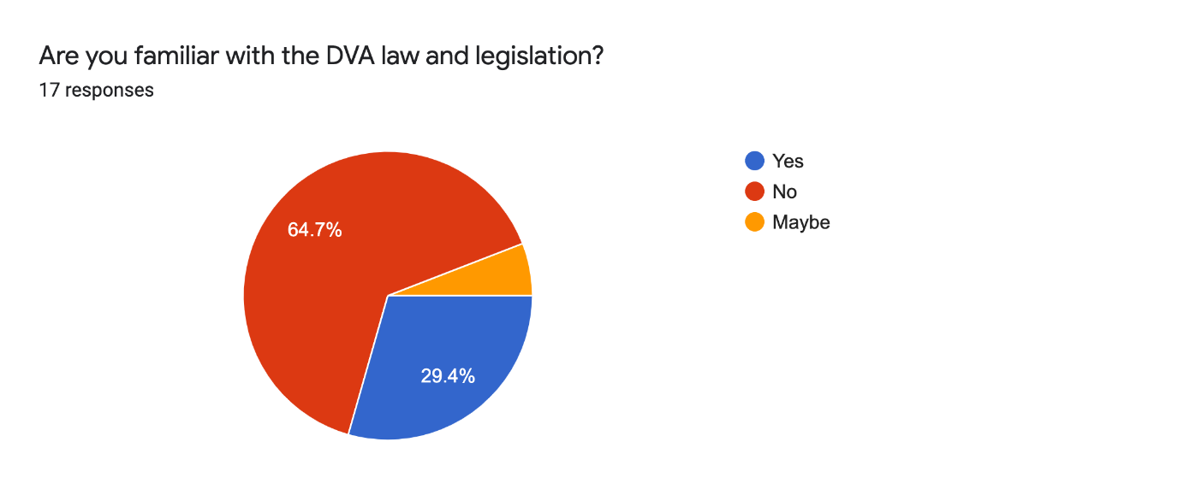
What do you think needs to be done in order for more people to know the law and rights?16 responses
There need to be more campaigns from charities to drive awareness and local governments need to communicate what services are available for victims.

Educatate us, show us what it is, tell us through media platforms. Theres so many ways, yet it doesn't happen.

No-one knows the rights really- in a relationship you don't research it- so maybe it needs to be a part of education.

More legislation on financial abuse

Education definitely, and more agencies that can signpost when you are going through it. who do you turn to? You don't know that right. Maybe GPs could check in and see how things are etc?

Influencers on social media and the media on a larger scale need to push out more
information regarding this so it can reach everyone

Teach it at school

I don't believe I need to know the law and rights, neither do others really.

Advertise these more, and signpost them. It'll be nice to know what we can do, can't do.

Maybe even where to turn for support.

More workshops and influencers talking

Widely advertised in medical practices/ dentists. TV and even in supermarkets

Be more readily available. Speak more about it.

I think better advertising and education is needed especially in ethnic minority households.
This will allow more people suffering from DVA in the UK to be able to get the right support with regards to national law and rights that are in place to protect them.

I think there could be more moral support for women with young children, but there isnt nowhere near as much as needed. When i reported my husband they put him outside of the house for 24 hours but then they said he needs to live here. The option was to put me into a refugee house- when it should have been him to move out because he was the perpetrator rather than the victim. This may have changed somewhat now but a few years ago this was the case. I was told to move out about 30 miles from my current premises- but the government does not think about the childrens education. How is it possible to move out and then ensure children go to school 30 miles away. I have seen a such accomodations before but this was not enough. The government and council pretend to be there for you but there was not enough support. This could be down to a lack in financial aid given by the central government, but this needs to be changed for effective help.

National campaigns

Training at workplaces, schools and universities

In your own words, why do you believe DVA may be committed by the offender?16 responses
They most likely believe they need to control their partner, and exhibit this through asserting physical dominance over them.

Cultural impacts, masculinity, insecurities, childhood trauma, relationship trauma, there's so many different reasons.

Insecurities, they are brought up to think it's right, they maybe don't realise or care about the impact on others.

They have past trauma, dominance, thinking it's right behaviour to engage in.

The perpetrator may have a mental illness or personality disorder and if not then they are just toxic and abusive by nature but it may have stemmed from their own trauma in the past which has made them this way

Because they have unresolved trauma

They just need some love and attention maybe.

It's been allowed for generations and so behaviour is seen as right. You can't change it on your own.

Sense of authority?

Due to insecurity / unhappiness / anger issues

Loss of power or control. Also through experiencing it within their close circle which may make it feel like the norm.

I believe there are many reasons for offenders to commit DVA. Although none are excusable in my opinion, some are more serious than others. DVA may be committed under pressure, in financial or trust issues. It could be the partner is not financially or mentally stable and does not trust their partner with other people, their money etc. In other issues of drug and alcohol abuse, it is common for DVA to occur when the perpetrator may suggest that they were not in control of their actions. Better mental health and better provisions to allow for safe discussion and conversations rather than heated arguments and physical alterations may be the right way for couples to deal with issues that may crop up within the relationship/in marriage.

I think, to be honest, in the Asian community it might be because of financial constraints. With my case it was because finances needed to be to support his family rather than spending it on his own children. He was more interested in welfare of others rather than his own children.

Mental health, childhood trauma, substance abuse

Doesn’t know what DVA is and it grows from verbal arguments to verbal and physical DVA

To make them feel superior, powerful and in control

Do you think victims are supported adequately with supporting agencies? (Please explain your answer)

Probably not as much as they should, because often society doesn’t believe victims, which means they are probably not coming forward when they should be. This means they don’t get the right support when they really need it

Yeah, they probably are. I think it depends on the abuse and how far they have taken the complaint. E,g I don't know if you can gain support if you haven't reported the crime.

No, they are not. I wasn't supported, in fact I got no support. I was told I could get support from WOMEN's aid...I'm a man and evidently that sees women as victims

No. Very limited protection

Yeah I think so

No I do not especially in the UK the services we have are terrible the police are the worst in these situations however Womens aid are very pro active and helpful it’s the only support agency I would say which is truly validating and helping dva victims.

No, I think they can be let down majorly. People don't give the time we need. They think group work is effective

I wouldn't know. I would assume they are, there are so many different agencies out there, so im sure there's something for everyone.

I'm not sure. From what I know, no. They can't help the cultural changes.

Yes lots of charities and help out there

Not sure. This is not openly available to public to know about if not in that position

I would like to think so as more people may be escaping DVA.

I personally believe that with funding cuts in place from the Conservative government in the UK over the last decade the level of support available through local councils has deteriorated. To improve the plight of dv victims it is necessary for supporting agencies to be properly funded, and trained to best support the needs of victims. Throughout the last 3 years with the pandemic- those suffering from DV may have been ignored or put in less priority purely because of the lack of options available to protect victims. This also needs to be tackled.

NO- as mentioned in the question above. I do not think social support facilities were adequate when i required them. I cannot comment on the support available in 2022. People being moved out of their own houses, to be put into new schools and social housing- whereas the perpetrator is allowed to stay in their house. This is just not good enough.

Yes, if they are able to report it. No, I don’t think male victims get the required support.

Do not have enough knowledge on this but i would say no

Not sure because I have not had contact with anyone who has seeked help from supporting agencies

What could change to better the support?

More awareness of the support available, maybe an anonymous phone line that people can call when they need help

Understanding of what it is and how to go about getting support. Understanding cultural impact on people and support them daily, not just weekly or on an adhoc basis.

Make sure that there is actual support. It isn't right that males have to just grin and bare it.

Knowing where to get support and what support they provide would be a start

The police need adequate training and they need to be trauma informed when communicating with victims and handling their cases because the process of going to the police causes further trauma to a victim if not handled correctly. There should be an easier way for DVA victims to change address without going into refuge and without going through the long winded process of applying which takes years hence the reason why many victims end up dead. There should be a housing association or BCC should have more options to help out DVA victims.

Treat us like individuals

Education maybe?

Education, a lot more of it.

N/A

More places to report to in person such as at GP

Not sure

Better training and funding in the right areas of social support. Ensuring the victims interests are put ahead of the perpetrators.

Additional funding. The perpetrator should be asked to leave the property rather than the victim. This is especially when both own the house. In my situation my tooth was taken out and I had severe bruising on my face. The mental trauma of being beaten up is too great and the support systems in place need to be more apologetic.

Government legislation, continued encouragement to those in DVA situations to speak out

Enable third parties to report on a victims behalf

More immediate action/response. Taking those in the situation and dependants out of it.

More help points in common areas like supermarkets, gym etc where the offender could be reported without the victim being suspected of reporting him/her.

Appendix D
Research B results

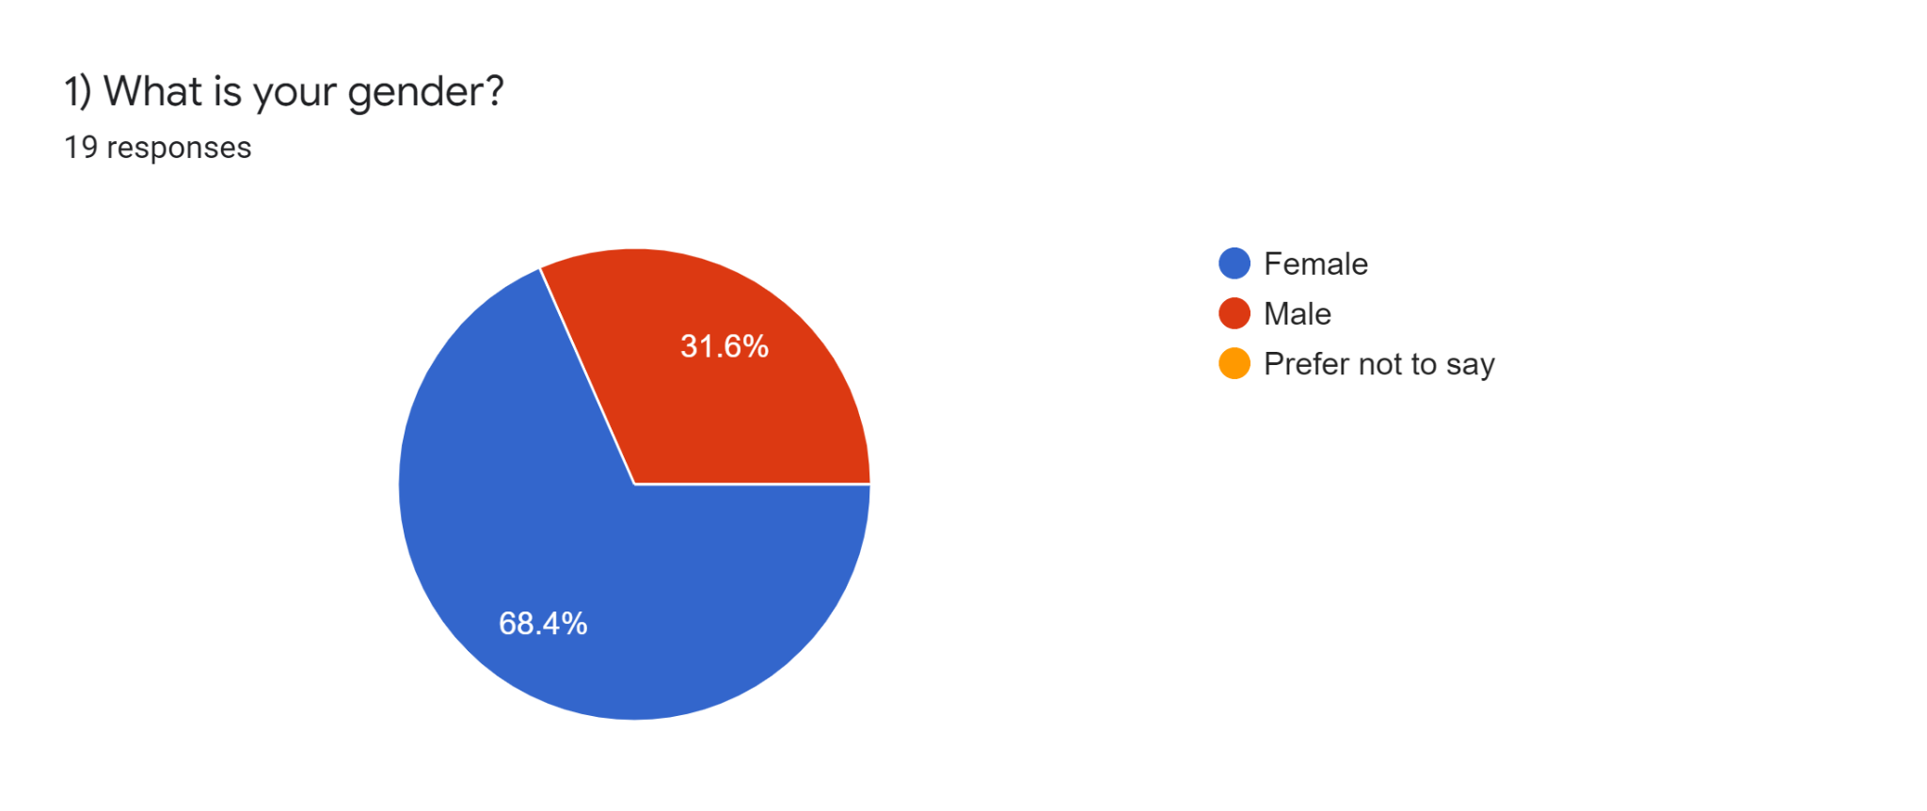

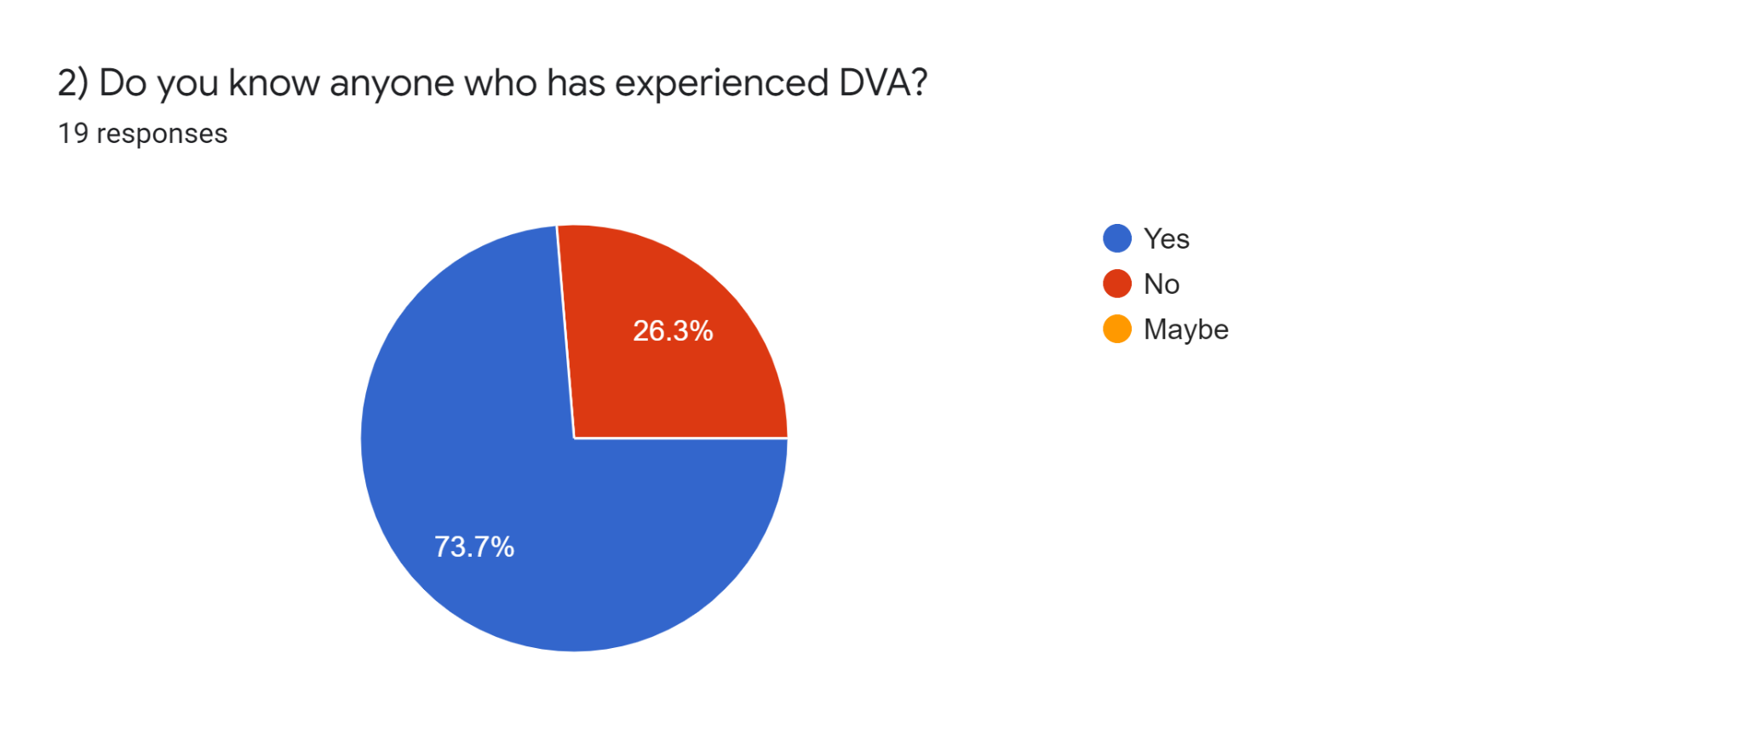
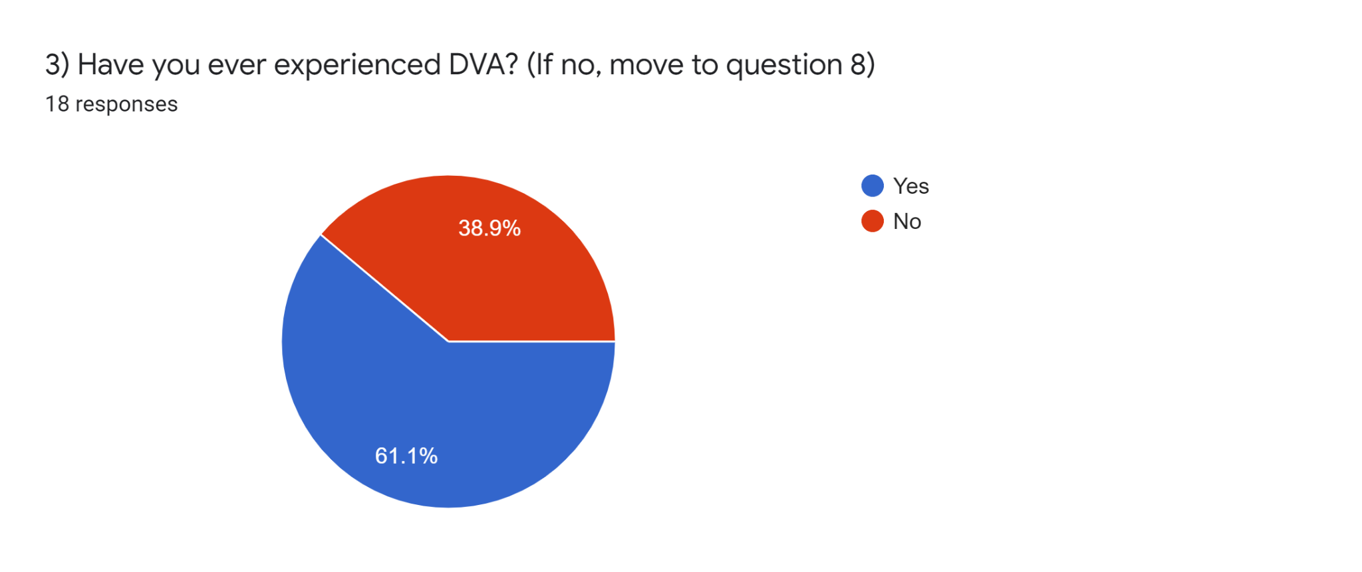
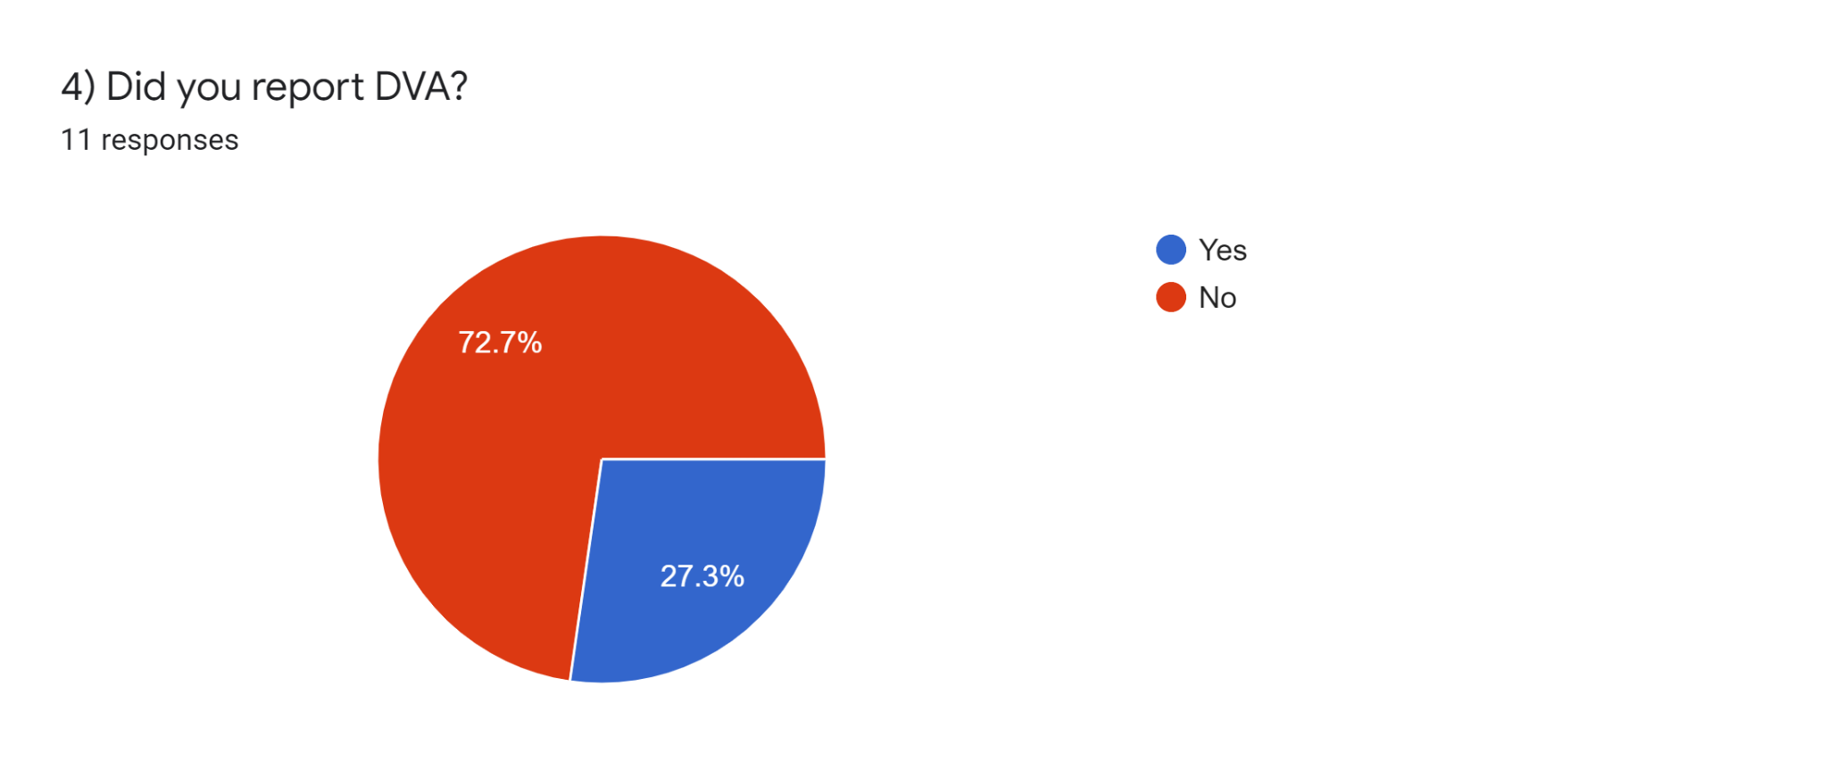5) Why / Why not?10 responses
Police does not take it seriously
To get justice for myself.
It happened to me before when I was a little and I didn’t get any justice.
To save the relationship
In fear of losing custody of my child
Because there is no hope from the government that they can get me justice.
Had to report abuse
Police does not prioritise
I did not want to create family issues
Domestic violence is a crime so I had to report
6) How long did you remain within the relationship?10 responses
3 years
3 years
I left
6 years
4 years
5
Left immediately
2 years
10 years
0 years
Did not stay
7) What impacted the decision of how long you stayed?10 responses
Safety for kids and myself
Hoping that one day he will change.
I didn’t stay
To save the marriage
To save marriage and not lose the child’s custody
He threatened to kill me if I left.
supportive family and friends
societal judgment
I did not want my children to get negatively affected
Family support
Im independent
8) Why do you think that people may not report DVA experiences?19 responses
The police do not take it very seriously. They often treat as least priority cases and think women are exaggerating
Because they’re afraid that if their husband or wife finds out they will do something that is life threatening.
Because we don’t get justice from this corrupt system.
In fear of not getting a positive response from the police
It may not turn out in their favour
The court procedure is hectic and long and can turn out against the victim if there aren’t enough proofs
The lawyers are expensive and court takes a very long time to come to a conclusion
Too expensive and time consuming
Not enough support from government
They still have a lingering emotional attachment to the abuser. Many abusers will utilize this sense of emotional attachment and manipulate their victims.
I have had good experience with police on the case
police does not take it seriously
They do report
They know they won’t get support from the government
Not getting a positive response from family or the police. People do not take it as a big problem
Out of embarrassment
The abuser never gets the punishment they deserve so it feels useless to even go to the police or go to the court
I think abusers do report, police does a decent job

9) What do you think needs to change in order for people to report DVA?18 responses
There should be different committees or commissions set up for dv cases
Our government needs to be more strict in the matter.
People should start getting justice that they deserve
It should be easier for them and must be treated like other emergencies to the police
The system should work actively against abusers
The system should be supportive towards the victims
The police must actively available for the victims so that they have the courage to leave and report them
More positive cases need to be introduced that will help others to come forward.
more support from government
Harsher punishment and greater confidentiality
To realize their abuser's behavior is not okay and the victim themselves needs to be treated better and find help.
police must take cases seriously
more female officers on domestic violence cases
Can’t say
reassurance and support from government and police.
Government does not take it seriously
Strong court system who would sentence abusers
Supportive system for victims
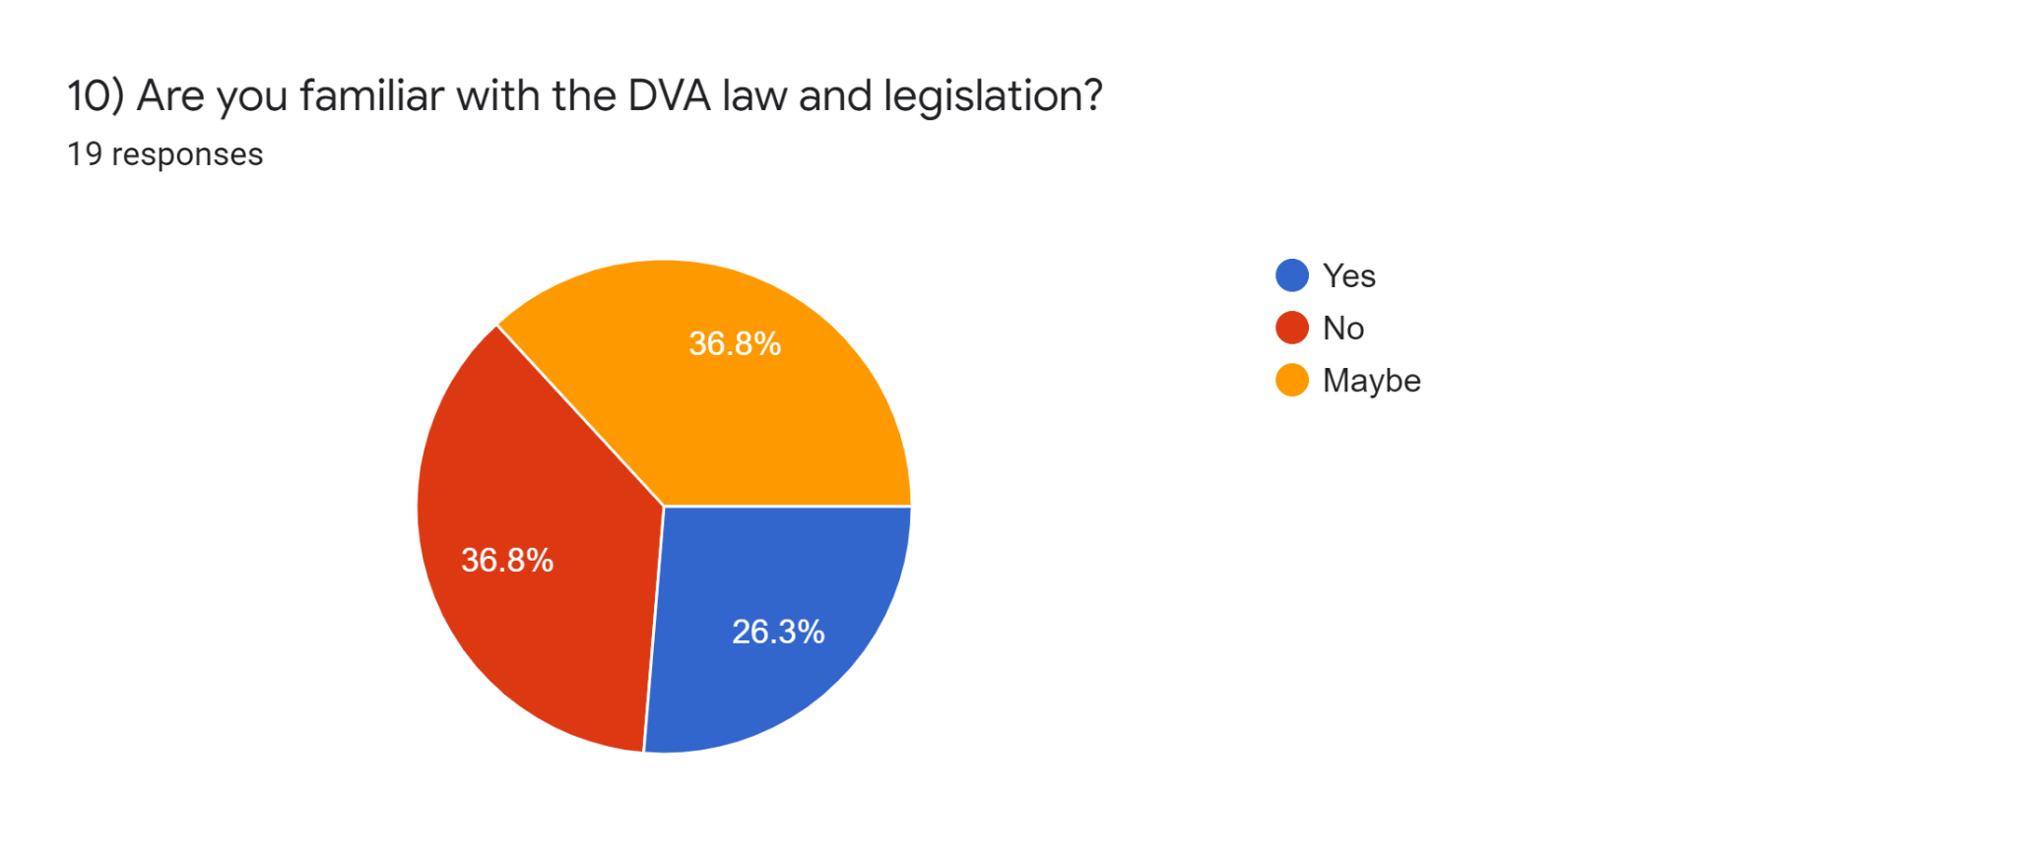

11) What do you think needs to be done in order for more people to know the law and rights?16 responses
public awareness
spreading awareness and adding public service messages on social media or tv
Talk about cases and people that got justice for their abuse.
Government needs to do something that will motivate people to want to know more about laws and rights.
Creating awareness
I think these laws should be told at the time of marriage when signing the contract
The government should make sure everyone is aware of their rights
Create awareness
More awareness needs to be provided in areas where people don’t know about the laws and rights.
Awareness public activities
There needs to be a domestic abuse awareness class starting in middle school so individuals can identify what is DVA and should not be tolerated.
Awareness sessions
There should be special Centers for victims
Publish laws online category wise
It’s the government’s responsibility to give awareness about the rights of people

12) In your own words, why do you believe DVA may be committed by the offender?17 responses
Frustration, to impose power or assume power
Because he or she is weak and to prove them self they harm those that they assume to be weak.
To satisfy their ego and their fake manhood.
Egoistic behaviour
To show themselves as superior
They want to scare their partner
So that the partner may listen to them
Because he can’t hurt anyone else so he takes his frustration off on his wife. But that’s just an excuse to sugarcoat his crime.
prefer not to say
Inability to control one’s own emotions
I think it is done by extreme emotions, but in a sadistic manner. A person who does not have a proper understanding of what love is, can often treat the people they care or love most as property.
mental illness
Frustration
To impose power on females and to make them scared
To get things done their way
To show they are strong
They are fearless as they know they won’t be facing much consequences
13) Do you think victims are supported adequately with supporting agencies? (Please explain you answer)17 responses
No. if it was then we would not have thousands of dv cases everyday
No, some agencies either don’t have enough support to give or they can’t provide support to everyone.
No, because places like these are ran by the government. Same government that either took forever to get justice for the victims or couldn’t properly provide enough for those victims.
No they aren’t. DVA is not taken as seriously as other crimes
No , they aren’t. DVA is taken lightly by the police.
No, the courts are very formal and overlooks emotions and wants evidence for everything. A person can never provide evidence of the mental stress they go through
No not as much as they should. The judges are harsh and insensitive
No, because the support isn’t enough to help through this dark experience.
Maybe
Yes I think there are agencies that can help
No, because many victims are too afraid to reach out.
i think they are supported more now than last decade
Yes but could be better
No they are not
No they are not supported as much as they should as it isn’t considered that big of a crime
No, government is busy making unnecessary laws
No, the police are not active

14) What could change to better the support?17 responses
better implementation of law. new laws
Many things like follow ups, group meetings and talking about a better and more safer life.
Our government needs to be more vigilant and realize the problem and take action.
Police cooperation
The victims must be carefully listened to and the abuser must be punished .
Awareness campaign so that victims can fearlessly report without having to think of the long court procedures
The court system
More funds so that the support could be better and new activities that will direct their minds to something else.
more government agencies working for dv victims
More advertisement and funding for support agencies
We need to find a way to create preventative awareness measures for young teens and also have a program that can reach out to victims but remain discrete to their abusers.
dv cases should be a priority
more female officers
Government should prioritise domestic abuse survivors
Police and other governmental organisations being more helpful towards the victims
More organisations that would support domestic abuse victims
Better court system

