FUTURE DEVELOPMENTS IN THE FIELD OF MARKETING

TUI’S MARKETING DEPARTMENT
Unethical practices

University of Wales Trinity Saint David

Module code: BMMB7012
Lecturer: Chris Wilkin
Student: Ariadna Nagy
Student number: 1812193

Executive summary

This report is going to focus on TUI Group and perform an analysis on their marketing department. The main purpose of the report is to evaluate their marketing tools and practices, as well as highlight the unethical marketing practices met in their organisation regarding animal use and their approach towards it. Based on the conclusion drawn from all the findings, the last part of the report will compile a recommendation section for future improvement and development.

Table of Contents
Executive summary 2
1.0 Introduction 4
2.0 Analysis 5
2.1 The concept and importance of marketing 5
2.2 The micro and macro environment of TUI Group 8
2.3. Target market – target segmentation, channels used, capturing demand 12
2.4. Measuring success at TUI 15
3.0 Conclusion 16
4.0 Recommendation 17
5.0 Appendices 18
6.0 Reference List 24

1.0 Introduction

This report is going to evaluate the marketing department of TUI Group by looking into their unethical marketing regarding animals and wild life attractions and how they are using neuromarketing in order to enhance the emotional response from the customers and create relationships with them. The report will evaluate the resources invested in their marketing strategies, the macro and micro environment of the organisation, their targeted market and their selected channels for engaging with customers, and the success of all their strategies. These will be analysed and evaluated through different marketing frameworks that will suggest their validity, efficiency and based on a conclusion drawn from the findings, the shortcomings will also be addressed through a recommendation section at the final of the report.
TUI Group is a leisure, travel and tourism company founded in 1923 with the headquarter in Hannover, Germany. The organisation is encompassing the entire tourism umbrella and is facilitating tour, hotel and resort and cruise services, as well as flights to destinations too (Kelleher, 2022).
Under a general definition, Kotler described marketing as a practice under the form of formal or informal activities that people or companies are engaging with. Kotler also stated that the success of an organisation is depending on the marketing ability is has got. The role of marketing during the 21st century is to help an organisation to survive while prospering although facing threats never faced before by the industry.
In “Marketing Management”, Kotler exemplifies the presidential campaign of Barak Obama which had as two main goals: the expansion of the electorate while aiming to target a very specific audience. The researches resulted that the more the voters learnt about Obama, the more they identified with him and therefore supported and voted him (Kotler and Keller, 2012).

2.0 Analysis

2.1 The concept and importance of marketing

In other words, the concept of marketing refers to the use of marketing data to focus on the needs and wants of customers in order to develop marketing strategies that will satisfy and accomplish both the customers’ needs as well as the organisation’s goal. All the marketing strategies applied by an organisation have to be aligned with the “right” principle and be oriented towards satisfying customers by offering value (Keane, 2018).
Creating and maintaining good marketing practices is one of the keys to success. The importance of marketing consists in the fact that this is the primary tool that enables effective consumer engagement, building and maintain a good reputation, creating competitive advantage, boosting sales, and helping an organisation to stay relevant (Jaiswal, 2022).
Analysing tourism group’s strategy back in 2016, the organisation’s aim was to become a “flexible, individual holiday designer”, as Barbara Haase, Chief Creative Officer at TUI Group mentioned; they applied this strategy by inducing their customers that their holidays are not just a vacation, but a lifestyle. Haase also claimed that their ‘oneBrand’ strategy which consisted in unifying more than 1600 travel agencies across the globe and rebrand them to the global TUI Master brand had as main reason gaining more loyalty and credibility (Huttenberend, 2016).
In 2018, Jane Ashton, TUI Group Director of Sustainable Development was stressing the importance of promoting responsible tourism and sustainability and stated that TUI does that through their campaign “Better World, Better Holidays”. Ashton explained that a recent customer research revealed that 67% of customers make buying decisions based on emotional stimulus and care about the organisation’s attitude towards the world, and therefore, their efforts are part of their CSR and marketing strategy (Tui UK wins in Best Communication category at responsible tourism awards, 2018).
However, TUI’s focus does not involve care for wellbeing of the wild animals and continue to practice unethical marketing involving animals in captivity.
Analysing TUI website, the organisation has displayed The Global Welfare Guidance for Animals in Tourism in order to ensure its customers that all their practices are following and respecting all the legal aspects. Nevertheless, TUI Group is marketing animals as attractions which are kept in captivity in order to generate revenue for the organisation (White, page 30, 2013).
As per (Munro, 2021), PETA and other several animal protection associations have addressed the animal abuse issue in the tourism industry to the Chief Executive of ABTA, requesting that the animal abuse will end.
Although the practices and the marketing at TUI is legal and effective for the organisation, many people of the general public are unsupportive and consider their practices very unethical. “Why Tui must drop the dolphins” article (2020) has investigated the way TUI was marketing dolphin attractions (See Figure 1 and Figure 2) help captive in dolphinariums and marine parks and concluded that these practices are very unethical and unhealthy for the animals.
As a response to Animal Rights group Peta, TUI explained again that they only partner with excursion venues that respect Abta’s Global Welfare Guidance for Animals in Tourism Standard, refusing therefore to acknowledge the harm they are doing (Ireland, 2020).
Rob Lott, associate of UK Whales had a meeting with Christian Rapp, TUI’s Head of Communication, in April 2022, in order to present the animals’ concerns on behalf of 20,200 people, asking to stop the whale and dolphin cruelty. Lott has also emphasised the fact that a Beluga whale died at SeaWorld, Orlando - attraction that TUI supports (Lott, 2022).
In 2020, it was determined that the travel operator needed to revamp its brand identity and used the time off as an opportunity rather than a threat in order to gain credibility and strengthen the relationship with buyers. TUI’s brand and content Director, Toby Horry, declared that the pandemic offered them the time acknowledge the need of digitalisation and the lack of emotional resonance in their past approaches as well as the reliance the organisation had on its consumers. Hence, a new identity for the brand was created which involved a set of creative principles developed around positive energy, confident leadership and a modern and stylish touch along with a new media strategy which was designed in four financial steps:
- maintain brand reputation and build emotional connections with customers in relation to the brand;
- continue to change perceptions and drive reappraisal;
- focus on sales;
- capturing demand (Rogers, 2021).

The changes in their marketing strategy were meant to futureproof the organisation for at least five years. Its primary marketing focus moved from strictly making profit to strictly creating and delivering the best tailored experiences that would enrich the lives of their customers; as part of their new campaign - “Live Happy”, the new visual smile logo was design to articulate the new identity of the organisation (marketingweek.com, 2022).

2.2 The micro and macro environment of TUI Group

This section will analyse the micro (see Figure 3) and macro (see Figure 4) marketing environment met it TUI and evaluate their influences in their marketing strategy; the environment refers to all factors that affect the way an organisation performs overall, as well as the influences these factors have on how the company carries out its daily activity.
The micro environment refers to the environment which comes in direct contact with the organisation and is directly impacted by, such as:
- Customers – who are the most important factor in the micro marketing environment of an organisation as the whole value of the company depends on how it is perceived by its consumers (Philip, 2019).
- Kotler and Keller (2012), argue the importance of a holistic approach when it comes to building relationships with customers; they claim that “moving from a product-and-sales philosophy to a holistic marketing philosophy gives a better chance to outperform the competition” (Kotler and Keller, 2012, page 123)
- TUI understood the need of change from money-orientation to customer-focus and reconsidered their marketing strategy, leading to their latest campaign “Live Happy” which claims that TUI’s actions are driven now by the desire to create and offer their customers the best tailored experiences (marketingweek, 2022).
- Blake Morgan, Senior Contributor at Forbes argued that “as a result of changing times, millennials want to seize the moment, and they are skipping the mall for carpe diem” (2019); therefore, he explained that the new trend of experiences instead possessions is a result of the millennials witnessing their parents’ lives crumble due to financial meltdown. Thus, access over ownership is the lifestyle that continues to grow (Morgan, 2019).
- Compensating in different aspects, the organisation moved the attention from the bad practices involving animals.
- Suppliers – have an important role in facilitating an organisation the means to deliver value to its customers. They provide ways and enable an organisation to capture demand – the ultimate goal. Therefore, the reliability of an organisation’s partners is essential in delivering quality.
- Checking TUI’s development page, it reveals that their suppliers are described under different clubs/categories: TUI Blue – which targets families and promotes TUI’s new lifestyle and is offering personalised experiences, TUI Magic Life – which targets millennials as well as families, and claims to deliver the ultimate all-inclusive holiday at 4-star clubs, Robinson – TUI’s premium club which targets mostly Generation X and offers countless opportunities for relaxation, with high demand in developing destinations and TUI Hotels & Resorts which is their Joint-Venture Brands club and has a wider target segmentation, created to fit various personas (TUI, 2022).
- One of the main suppliers of TUI’s animals’ attraction is SeaWorld which offers services such as swimming with dolphins (see Figure 5 and Figure 6) and other experiences involving wild animals for human entertainment purposes (SeaWorld Parks & Entertainment, 2022)
- Marketing intermediaries – these refer to the third-party companies or sales agents that promote and facilitate the sell of a product/service to customers.
- TUI’s UK and Ireland Managing Director, Andrew Flintham, claims during a press event in London, in 2020 that the tourism group’s biggest strength desires to be an enhanced and strong relationship between the organisation and its customers; however, Flintham also mentioned that the partnerships with the third-parties will remain a commitment (Griffiths, 2021)
- However, TUI’s uses online tools as marketing intermediaries too which allow their users to personalise their holidays and book experiences themselves (Global Data Travel and Tourism, 2021)
- Competitors – according to the marketing concept, the competitors are the biggest threat of an organisation. Although this has always had a negative connotation, this may as well be turned into an opportunity and one company can gain competitive advantage based on its rivals’ approaches (Philip, 2019)
    - Organisations such as Virgin Holiday, Thomas Cook, British Airways Holidays, Expedia, Airbnb and Booking.com have stopped marketing any attraction that include wild animals in captivity, leaving TUI be the exception – this attracting a bad reputation and a disconnection from their customers, offering therefore a competitive advantage to their competition (Lott, 2022).
- General public – refers to the people who present a potential interest in the organisation’s product/service and could become a customer
    - In an article written by Dana Stefan - Kathrin Wise, campaigns manager at World Animal Protection, declared during an interview in October, 2022 that the petition started against TUI’s practices regarding dolphins that “live in cruel and unnatural conditions for the sake of huge profits” has almost reach its aim of 70,000 signatures; the public does not appreciate TUI’s involvement in attractions and entertainment involving animals.
    - According to the same article, TUI is profiting from over 400 captive dolphins and the World Animal Protection (WAP) is determined to convince the organisation to follow the example of their competitors (Stefan, 2022).

The macro environment of an organisation refers to the outside factors that can affect the organisation’s performance or the way it performs its activity (Philip, 2019). In order to analyse the macro environment of TUI, a CAGE framework will be performed:

Cultural differences: - TUI operates in more than 140 countries worldwide, demonstrating therefore a deep understanding and embrace of cultural differences;
Administrative differences: - during the 2020 pandemic, based on Corporate Watch (2021), TUI has compelled the Greek government into dropping their quarantine requirements in order for them to proceed with their holidaymakers;
Geographical differences: - TUI Group operates in over 140 countries, across the world, having therefore the need to develop means and different online channels such as phone apps, websites, social media, etc, to communicate with its customers
Economic differences: - TUI has been accused of stressing the hotels in the Canary Islands in order to make them stop hosting migrants arriving on wooden boats, as they ruin the islands’ image in their customers’ eyes (Corporate Watch, 2021)

2.3. Target market – target segmentation, channels used, capturing demand

According to Harvard neuroscientist Gerald Zaltman, 95% of buys are driven by an emotional impulse. He claims that this is due to neuroscience – a science which can manipulate people’s reactions, resulting in them acting upon an impulse; neuroscience affects the same area in the brain where the fight or flight reaction takes place and in the area of the limbic system which controls the emotions, explaining therefore the practice’s efficiency (Lockett, 2021).
TUI Marketing department understood the importance of creating an emotional reaction and maintaining a relationship with their customers, thus, they have worked with Dr Tali Sharot from the University College of London’s Affective Brain Lab to evaluate the life cycle of “the holiday feeling” from booking the holiday to arriving at the resort; the results of the study showed that tourists reach the peak holiday feeling 43 hours from arrival and lose it 3.7 days after arriving back home. The study aimed to emphasise the factors that trigger that feeling and try to prolong it through different tricks once the holiday is over (Brits lose holiday feeling faster than their tans, 2019).
TUI’s Chief Marketing Officer, Katie McAllister, claimed that the pandemic time offered the organisation time to rethink their marketing strategies and therefore they completely changed the way they used to target their market as well as widen the market share through their new strategy based on digital retailing and marketing, expressing a new vision where they provide “a million things for a million people to do”; as part of their marketing changes, TUI Destination Experiences has been renamed TUI Musement – which aims to reach and cover as many potential customers as possible, as well as allowing customers to create personalised experiences (Hayhurst, 2020).

This section is going to highlight the position of TUI’s Group services within the tourism industry by performing a BCG matrix analysis (See Figure 7).
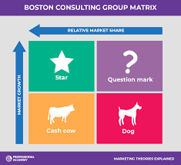

Figure 7 – Boston Consulting Group Matrix

Using Alan’s Zakon matrix, it allows an organisation to evaluate the feasibility of a service/product, therefore it highlights the potency and the life cycle of a product/service.
Based on Fritz Joussen (2017), CEO of TUI at a FVW Congress, he claimed that the “new customers” – young generation - has a different view over life and prefer experiences over ownership, therefore they developed new strategies and presented new megatrends in concordance to their needs, such as: Brand Centric, Mobile First, Customer in the Cloud and Inventory on Blockchain – all of which refer to digitalisation and automatization.
Their Question mark which refers to their new marketing strategy of digitalisation and personalisation has straight away developed into a Star, therefore the leadership focused on enhancing and maximising all their tools and efficiency, leading to a Cash cow, which is represented by low growth and high share.

TUI is using all traditional marketing approaches such as: social media, TV, emails, radio, etc, but is also using a more professional tool which enables them to differentiate themselves within the industry through personalisation and reach their desired persona – Google Marketing Tools include analysing tools that allow the organisation to collect data and evaluate it in order to target more focused customer profiles through their marketing campaigns.
By extending their strategy to using Google Marketing Platform products, these insights can be used and evaluated along with the Boston Consulting Group’s index for a maximised potential (Google Marketing platform, 2022).

2.4. Measuring success at TUI

Since adopting the new automated approach via Google Marketing Platform, TUI saved more than 25% on advertising costs, as well as reduced their staff work by 45-60 hours monthly (Tui UK drives 13% higher return on ad spend by investing in digital maturity, 2022).
As a result, following the “Live Happy” campaign launch in 2020, the company’s website traffic was 12% up on a two-year basis, and by early 2022, TUI site visits were 70% up on its nearest rival (Marketing Week, 2022).
TUI also evaluates their success through the Triple Bottom Line concept created by Elkington 28 years ago. The 3 P’s – People, Profits and Planet approach is considered a tool which enables one to measure the social, environmental and economic impact and success of an organisation. However, Elkington believes that success and failure in terms of sustainability goals are assessed by the health of the Earth and the people, not by financial gain or loss (Elkington, 2018).
Therefore, TUI Group has incorporated the Triple Bottom Line Concept in their Corporate Social Responsibility, in order to connect the company with the social community and wider stakeholders, and also facilitates sustainable processes at strategy and operational levels to be shaped (Emba Pro, 2022)
As a proof of their support for different cultures and biodiversity, TUI offered employment opportunities to young people in Morocco and The Dominican Republic to protect endangered species of turtles (TUI, 2018).

3.0 Conclusion
Drawing a conclusion based on the findings throughout this report, it proves that TUI marketing concept has changed in the recent years and is based now on offering tailored experiences to their customers, instead of just traditional holidays; the organisation had to learn new adaptability skills in order to mould on the frequent changing trends of their integrated market – which mostly prefer access over ownership, and whose demands are digitalisation and personalisation.
However, creating strong relationships between the brand-customers does not only rely on the individual experience one buys, concerns nowadays also fall on the ethics the organisation where they purchase from practices – section where TUI Group still falls short to its customers’ expectations by being involved with and offering animal attractions kept in captivity for human entertainment purposes. Although TUI is using neuroscience now in order to create and maintain brand loyalty, the animals have also been used in the past in order to develop their emotional connection between their brand and their customers.
The buyers’ expectations have now changed and are no more interested in taking part in activities that can be harmful for the animals or environment, thus, TUI is in need of a real rebrand, where their customers are able to perceive them as a new company with altogether different ethics and practices.

4.0 Recommendation

Rebranding – needed in order for TUI to be perceived ethical by the public/customers.
This report is going to suggest the use of RACE Framework in resolving TUI’s rebranding issue by approaching a digital marketing strategy.
Ellis-Chadwick and Chaffey (2019) argued that a digital marketing strategy enables an organisation to have and maintain direct communication with consumers at different customer touchpoints; therefore, this method allows TUI to create a new image for them and maintain it.
- REACH:
- SEO, social media, third parties
- Email marketing to spread their brand-new image - in order to keep the existing customers engaged (customer retention and acquisition); survey results revealed 65% of the marketers were planning to allocate more budget on email marketing (Zahay and Roberts, 2013).
2. ACT:
- Cut strings with unethical partners and start creating and engaging in online communities with customers via website, blogs, influencers in order to spread awareness and inform about how organisation is being developed
3. CONVERT:
- new marketing automation strategy results in regain trust of lost customers, capture their demand and turn it into a sale
4. ENGAGE:
- focus on brand-to-customer relationship – develop online platform that offer tailored substitute experiences for the withdrawn attractions with animals in order to not only compensate for less services, but also demonstrating an ethical approach towards the animals - enhanced customer loyalty – competitive advantage.

5.0 Appendices

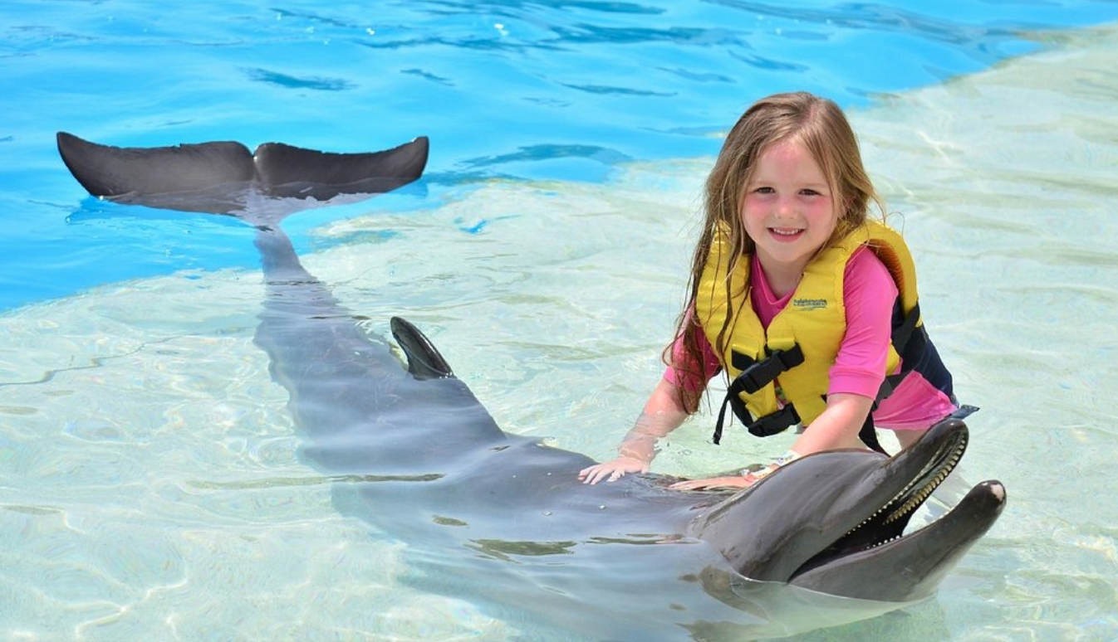
Figure 1 (Tui, 2020)

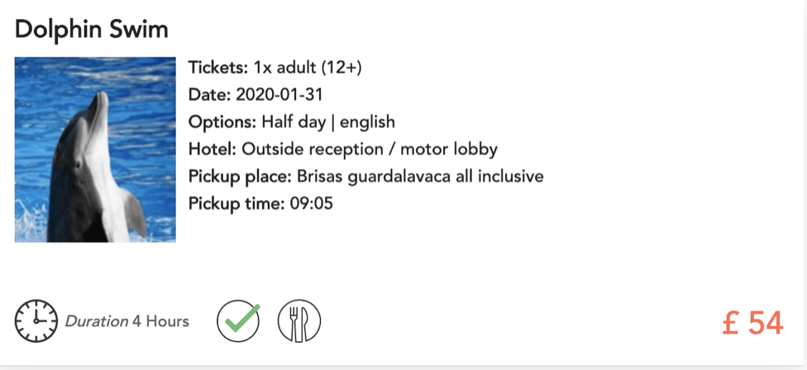
Figure 2 (SeaWorld, 2022)
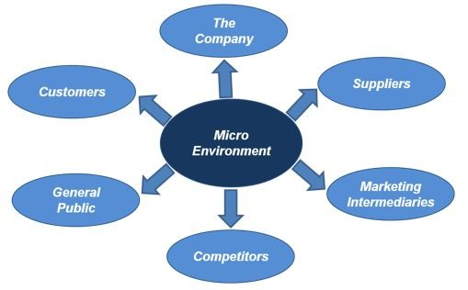
Figure 3

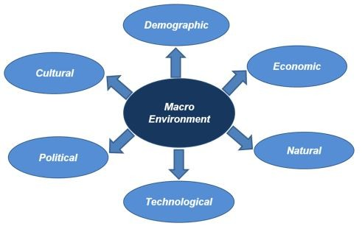

Figure 4


Figure 5 (SeaWorld Parks & Entertainment, 2022)

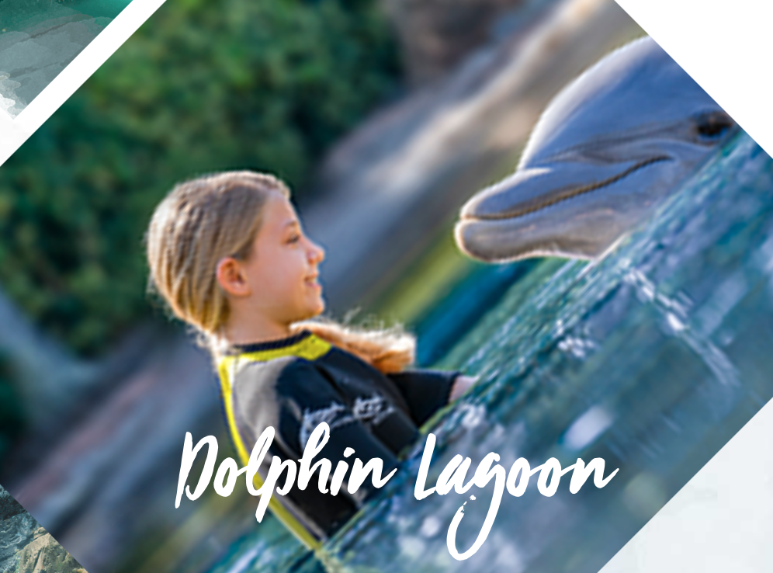

Figure 6 (SeaWorld Parks & Entertainment, 2022)

Porter’s 5 Forces
    - In order to perform a focused analysis of the competitors, Michael E. Porter has created the Porter’s 5 Forces scheme which help determine a company’s competitive environment and is structured as 5 steps:
- Competition in the industry:
    - Indicates the number of competitors which are able to undercut an organisation; the smaller the number of competitors, the bigger the power an organisation has over the price capitalisation (Scott and Williams, 2022)
    - As per Neilpatel.com website, it was resulted that TUI’s competitors altogether generate 7,672,617 online visits a month and those are worth $4,511,744 - reflecting a good SEO given the figures (neilpatel.com, 2022)
    - According to similarweb.com, TUI Group is ranked as no.2 in the Travel and Tourism industry in United Kingdom, demonstrating a great SEO which resulted in 12.8M visits online. TUI’s biggest and closest competitor is Thomas Cook which sits on the 27th under the same category, followed by lastminute.com, jet2holidays.com, loveholidays.com, travelsupermarket.com and onthebeach.co.uk (similarweb.com, 2022)
- Potential of new entrants into the industry:
- The possibility of new entrants into an industry can result into an increased cost and time for an existing organisation into maintaining its position on the market (Scott and Williams, 2022)
- TUI Group scores number 2 at most accessed Travel and Tourism company’s websites in the United Kingdom, showing therefore a high-competitive advantage already achieved (similarweb.com, 2022)
- Power of suppliers:
- Evaluates how easily suppliers can change the cost of a good or service; the fewer the suppliers, the more an organisation is dependent on one contractor (Scott and Williams, 2022)
- TUI Group represents one of the biggest international tourism and hospitality organisations offering a range of services such as: tours, hotels, cruises, and flights; therefore, managing to offer such a full package and be self-sufficient, the suppliers (other hotel/cruises/airlines partners
- Power of customers:
- Argues the ability of customers to change an organisation’s prices based on their demand; the more customers a company has, the bigger its power to sell its goods/services at higher prices (Scott and Williams, 2022)
- According to TUI’s reports, the number of guests between beginning of summer 2022 and 2019 were by 84% higher, while in the Q3 of 2022, the results are showing an improvement of 4.43B Euros compared to the same period in the previous year (650M Euros) (TUI Group, 2022). Just by analysing the organisation’s revenue figures, this suggests a high number of customers, implying therefore that TUI has a comfortable position at the top of the industry.
- Threat of substitute products:
- Discusses the unicity of one product/service and the power to increase prices having this strength in an organisation;
- This focuses on ensuring that the company cannot be weakened by having competitors offering a substitute at a better price (Scott and Williams, 2022)
- Considering the large variety of services TUI has to offer, it places it on top of the tourism and hospitality industry, therefore the lights fall on improving their own services. Thus, TUI invested in their latest campaign “Live Happy” which promotes tailored experiences that enhance the lives of their customers (marketingweek.com, 2022)

6.0 Reference List
Ashton, J. (2018) Tui UK wins in Best Communications category at responsible tourism ..., TUI. Available at: https://www.tui.co.uk/press/tui-uk-wins-in-best-communications-category/ (Accessed: December 8, 2022).
Brits lose holiday feeling faster than their Tans (2019). Available at: https://www.tui.co.uk/press/brits-lose-holiday-feeling-faster-than-their-tans/ (Accessed: December 10, 2022).
Chaffey, D. and Ellis-Chadwick, F. (2019) Digital Marketing: Strategy, implementation and practice. 7th edn. Harlow, United Kingdom: Pearson. pp. 139.
Collaborate (no date) TUI Hotels Resorts. Available at: https://www.tui-development.com/ (Accessed: December 3, 2022).
Corporate Watch (2021) The two sides of Tui: Crisis-hit holiday giant turned deportation specialist, Corporate Watch. Available at: https://corporatewatch.org/the-two-sides-of-tui-crisis-hit-holiday-giant-turned-deportation-specialist/ (Accessed: December 10, 2022).
Elkington, J. (2018) 25 years ago I coined the phrase "triple bottom line." here's why it's time to rethink it., Harvard Business Review. Available at: https://hbr.org/2018/06/25-years-ago-i-coined-the-phrase-triple-bottom-line-heres-why-im-giving-up-on-it (Accessed: December 1, 2022).
Free seo checker: Website seo analysis tool & audit report (2022) Neil Patel. Available at: https://neilpatel.com/seo-analyzer/ (Accessed: December 5, 2022).
Griffiths, S. (2021) Tui still committed to third parties, says Flintham, TTG. Available at: https://www.ttgmedia.com/news/tui-still-committed-to-third-parties-says-flintham-31398 (Accessed: December 3, 2022).
Hayhurst, L. (2020) Travo Summit 2020: Tui targets experiences,..., Travolution. Available at: https://www.travolution.com/news/travel-sectors/tour-operators/travo-summit-2020-tui-targets-experiences-digital-platforms-and-personalised-marketing/ (Accessed: December 10, 2022).
Huttenberend, M. (no date) For you: TUI's first Europe-wide advertising campaign on the repositioning of the Tui Brand, TUI Group – Einer der weltweit führenden Touristikkonzerne. Available at: https://www.tuigroup.com/en-en/media/press-releases/2016/2016-10-20-tui-for-you (Accessed: November 29, 2022).
Ireland, B. (2020) Animal Rights Group targets staff at TUI's UK headquarters, Travel Weekly. Available at: https://travelweekly.co.uk/articles/353925/peta-targets-staff-at-tuis-uk-headquarters (Accessed: December 8, 2022).
Jaiswal, S. (2022) What is the importance of marketing for business?: Emeritus India, Emeritus. Available at: https://emeritus.org/in/learn/what-is-the-importance-of-marketing-for-business/ (Accessed: November 28, 2022).
Joussen, F. (2017) Millennials: a generation that lives, not collects. Available at: https://www.tuigroup.com/en-en/media/stories (Accessed: December 10, 2022).
Keane, R. (2018) Marketing concept definition, LinkedIn. Available at: https://www.linkedin.com/pulse/marketing-concept-definition-rebecca-keane-bsc-avea (Accessed: November 28, 2022).
Kelleher, S.R. (2022) 'stop the bloodshed' says Russian oligarch, largest shareholder of World's largest tour company, Forbes. Forbes Magazine. Available at: https://www.forbes.com/sites/suzannerowankelleher/2022/03/01/stop-the-bloodshed-says-russian-oligarch-largest-shareholder-of-worlds-largest-tour-company/?sh=399553d5728b (Accessed: November 26, 2022).
Kotler, P. and Keller, K.L. (2012) Marketing management. 14th Edition. Harlow, New Jersey: Pearson Education.
Lockett, S. (2021) Neuromarketing: The booming business of pushing people's buttons, Aspen Brain Institute. Aspen Brain Institute. Available at: https://aspenbrain.institute/blog-posts/neuromarketing-the-booming-business-of-pushing-peoples-buttons (Accessed: December 11, 2022).
Lott, R. (2022) Talking to Tui – will they stop supporting whale and dolphin captivity?, Whale & Dolphin Conservation UK. Available at: https://uk.whales.org/2022/05/03/talking-to-tui-will-they-stop-supporting-whale-and-dolphin-captivity/ (Accessed: December 8, 2022).
Morgan, B. (2019) Nownership, no problem: An updated look at why millennials value experiences over owning things, Forbes. Forbes Magazine. Available at: https://www.forbes.com/sites/blakemorgan/2019/01/02/nownership-no-problem-an-updated-look-at-why-millennials-value-experiences-over-owning-things/?sh=610d02c9522f (Accessed: December 3, 2022).
Munro, C. (2021) Will the UK's Largest Travel Association discourage orca abuse?, PETA UK. Available at: https://www.peta.org.uk/blog/abta-letter-orca-abuse/ (Accessed: December 8, 2022).
Philip, B. (2022) Micro and macro environment factors to be analyzed for companies, LinkedIn. Available at: https://www.linkedin.com/pulse/micro-macro-environment-factors-analyzed-companies-bobin-philip (Accessed: December 3, 2022).
Pro, E.M.B.A. (no date) Tui (United Kingdom) triple bottom line analysis, embapro.com. Available at: https://embapro.com/frontpage/tblcoanalysis/17909-tui (Accessed: December 1, 2022).
Reporters, M.W. (2022) How Tui's marketing team 'futureproofed' the Brand, Marketing Week. Available at: https://www.marketingweek.com/tui-marketing-team-brand-strategy/ (Accessed: November 29, 2022).
Rogers, C. (2021) Tui on revamping its media strategy to 'evolve' past covid crisis, Marketing Week. Available at: https://www.marketingweek.com/tui-revamping-media-strategy/ (Accessed: November 29, 2022).
Seaworld parks bookings (no date) | SeaWorld Parks Bookings. Available at: https://www.seaworldparks-bookings.co.uk/ (Accessed: December 4, 2022).
Stefan, D. (2022) Petition launched against Tui's 'swimming with dolphins' trips, Travel Tomorrow. Available at: https://traveltomorrow.com/petition-launched-against-tuis-swimming-with-dolphins-trips/ (Accessed: December 10, 2022).
Strong travel Summer for TUI Group (2022) TUI Group Q3 2022. Available at: https://www.tuigroup.com/en-en/media/press-releases/2022/2022-08-10-strong-travel-summer-for-tui (Accessed: December 5, 2022).
Tourism, G.T.and (2021) Verdict media limited, Aerospace Technology. Available at: https://www.aerospace-technology.com/comment/tui-excursion-booking-platform/ (Accessed: December 10, 2022).
Tui Group - Crunchbase Company Profile & Funding (2022) Crunchbase. Available at: https://www.crunchbase.com/organization/tui-group (Accessed: December 5, 2022).
Tui Partner sites | thomson now tui (no date). Available at: https://www.tui.co.uk/destinations/info/partner-sites (Accessed: December 3, 2022).
Tui UK drives 13% higher return on ad spend by investing in digital maturity (no date) Google. Google. Available at: https://marketingplatform.google.com/about/resources/tui-uk-drives-13-percent-higher-return-on-ad-spend-by-investing-in-digital-maturity/ (Accessed: December 10, 2022).
Tui UK wins in Best Communications category at responsible tourism awards (2022). Available at: https://www.tui.co.uk/press/tui-uk-wins-in-best-communications-category/ (Accessed: December 4, 2022).
Tui.com Traffic Analytics & Market Share | similarweb (2022). Available at: https://www.similarweb.com/website/tui.com/ (Accessed: December 5, 2022).
White, N. (2013) Specific guidance manual - tui group. Available at: https://www.tuigroup.com/damfiles/default/tuigroup-15/de/nachhaltigkeit/Animal-Welfare/ElephantsinCaptiveEnvironments_IA.indd.pdf-69b677198d5057f79160bbcbd315db21.pdf (Accessed: December 7, 2022).
Why Tui must drop the dolphins (2020) Dolphin Freedom UK. Available at: https://dolphinfreedom.net/why-tui-must-drop-the-dolphins/ (Accessed: December 8, 2022).
Zahay, D.L. and Roberts, M.L. (2018) “Email marketing to build consumer and business relationships,” in Internet marketing: Integrating Online & OFFLINE STRATEGIES IN A digital environment. 3rd edn. Boston, MA: Cengage Learning, pp. 172–175.

