What helps me learn language and mathematics? : An analysis of a child’s learning in
Mathematics and language with recommendations for ensuring progress.
The purpose of this assignment is to discuss and analyse the ways in which a chosen child learns mathematics and language by means of collecting data through a mosaic approach while on Professional Teaching Experience (PTE). The pupil at the centre of this analysis attends a large school with two form entry, located in a deprived area in South Wales with 39% children eligible for free school meals. At the time of my PTE Child A was aged 9 and is of middle to low attainment and was placed in the ‘nurture’ year 5 class. Prior to the collection of work and engagement with conversations regarding their learning, I ensured I clearly communicated, in an age appropriate way, that taking part in this research was optional and explained the purpose of the research adhering to the Bera (2018) ethical educational research guidelines.
Data for this study was collected using the ‘Mosiac approach’ (Clark and Moss, 2011) encompassing a “multi-method approach” (Clark and Moss, 2011, p.7); this technique allows for data collection from a range of mediums including, but moving beyond the spoken word and observation such as learning walks and drawings. This approach can therefore be applied to children of varied ages and abilities, connecting to Howard Gardner’s ‘Multiple Intelligences’ (2003) outlining the specific learning styles such as picture or word smart which would therefore impact the way learners express themselves. This collection of data can be seen as an assessment for learning (AFL) tool as it will provide me with a clear outline of where the child is and what is needed to progress the child on further (Black and William, 1998).
In order to examine Child A’s work I have chosen to use the ‘ASK’ learning model (Nottingham, 2013) and evaluate the child against their attitude, skills and knowledge to better provide avenues to further their learning.
Mathematics
Throughout my observations while on placement, Child A had a very positive attitude towards mathematics and during discussions, he said that he enjoyed Mathematics because he felt that he was ‘good at it’ (Appendix 12) therefore he was always engaged and focussed with maths lessons. During the sessions I taught I noticed that he would always be one of the first to complete the warm up activities on the whiteboards and would be keen to show me his workings out to ensure they were correct, a method supported by Clutterbuck and Evans (2010) who suggest that positive re-enforcement is key to ensuring learners success. On the contrary, Barton’s (2009) argues that too much positive reinforcement can lead to too much teacher reliance and can prevent independent learning, a key element the new curriculum (Donaldson, 2015) and suggests that errors are ‘reassuringly’ corrected. Due to this eagerness, he was very quick to attempt new concepts such as fractions and during the exploration of this new topic he did face a common misconception when addressing ordering of fractions (Appendix 1) and as Ryan and Williams (2007) state are particularly common when dealing with two-step processes in mathematics. However, once the error was addressed and explored by utilising white boards, practical resources and ICT equipment the child could identify the mistake and independently correct it. Commenting on the incorporation of physical resources, symbols and practical explanations encompasses Haylock and Manning (2014) connections model to deepen the learning and secure the knowledge. During the sessions I taught, I felt it was fundamental to incorporate ICT because it would allow the children to view mathematics through another medium and as noted by Haigh (2009) ICT “removes barriers, provides instant feedback and is non-judgmental”. Upon observation Child A was always extremely enthusiastic about using ICT resources such as ‘Maths Whizz’ and when asked about this he said that he enjoyed using ICT as it was ‘different from writing’ (appendix 12). In contrast to what Child A achieved and demonstrated during lessons his feedback on the work would not always reflect this, see Appendix 2, where Child A would commonly say that the work was tricky but not verbally express this during sessions. Child A was introverted, very shy and muted in lessons and while socialising during break times; however, during maths sessions Child A became very confident and showed authority and ownership of their learning vital components needed to become a ‘good learner’ (Claxton, 2005). In contrast to this, the child did not display this level of self-confidence during other sessions; this could be due to the mathematics class being grouped by ability and therefore socialising with different children, which allows for varied experiences and results (Tomlinson, 2005). Therefore, due to Child A’s growing understanding within this topic I appointed him has the ‘Table Teacher’, a method supported by Hattie (2012) and Donaldson (2015) the aim of this was to further develop his social and self-confidence through a topic he was very competent in. As part of the schools assessment for learning strategies, the ‘purple pen’ method was introduced to give on the spot feedback that is meaningful and purposeful (Black and William, 1998) and to provide extensions on work. While using this method I felt that it was important for the children to explain how they came to their answers opposed to challenging them to more of the same type of questions (Appendix 3). This would strengthen their reasoning skills and deepen their understanding on the topic. The subject school were also implementing a Cath Delve approach, which brings foundation phase ‘provisions’ into KS2, and therefore there were a range of ‘Rio challenges’ available in the corridors for pupils to independently complete during topic sessions. While observing Child A I noted that the mathematics activities were selected first and he was very keen to see if he was able to complete the tasks. This demonstrated the child’s ability to apply his mathematical skills beyond the mathematics classroom, ESTYN (n.d) recommends that skills be applied in a range of conducts through a variety of activities and environments. As mentioned, the topic I taught within mathematics session were fractions, decimals and percentages upon assessing Child A’s work it was clear to see they had a good concept of number and relationships between numbers (division and multiplication tables). This knowledge was strengthened by their excellent consciousness of timetables, which was practiced at the start of every mathematics lesson; repetition being a key factor of the behaviourist theory outlined by Skinner (Weibell, 2011). This secure knowledge of number was crucial to the understanding of fractions; I noted that Child A easily achieved the learning objective to “Match two fractions that are equivalent” (Appendix 1) with the use of the ‘Mathswhizz’ online resources. The child was also able to achieve the learning objective and curriculum requirement “calculate fractional quantities” (Welsh Government, 2016) with ease, I then went onto extend this by asking the child to explain the process verbally and write it down (Appendix 3). In relation to national levels, the child displays elements of level 3 in regards to the work that I taught while on placement. At the time the data for this assignment was collected, many areas of the curriculum had not been covered due to the progression of coverage in the year.
Language
As child A was very introvert, he was reluctant to volunteer himself to give answers unless specifically requested, however he would be very comfortable to do so if he had already validated his answers with a member of staff in class, thus aligning with the behaviourist theory where praise and approval is given for correct answers (Nye, 1979). This method worked well for this child as he was motivated by positive reinforcement. Thinking time was a vital to Child A’s participation within group and class activities, Black, et.al, (2003) maintain the practice of allowing thinking time to give children time to process information and provide higher quality talk; with the use of thinking time and ‘think, pair, share’ assessment for learning techniques this allows development of higher order thinking skills (Darwazeh, 2017). Child A had a very soft voice and therefore was difficult to hear in a large class therefore it was vital that a class ethos of respect was withheld to ensure everyone could have their opportunity to share their ideas (Barrell et al., 2017). It was clear that this child had exposure to reading materials outside of school and appeared to enjoy reading a range of texts alone and with peers as part of lessons and during break times. OFSTED (2014) advise that lifelong engagement with literature require the engagement and enjoyment at a young age. The exposure to literature impacted on the range of vocabulary used by the child. Upon observation, Child A appeared comfortable when asked to read in small groups and would offer help to other group members if he could sense that they were finding words difficult, it was evident that this confidence came from secure knowledge of phonics which would have been developed at a younger age, a key recommendation of the Rose Report (2006). With regards to writing, Child A would complete written work and it was visible that he did work hard to do so, however he clearly produced higher quality of work when using a laptop or tablet (Appendix 7 and 8). Spelling and overall quality of work was much greater, this could be attributed to a theory stating that boys in education respond better to ‘doing’ activities and produce higher quality work as a result (Dodson 1974 and Askew and Ross 1988). Listening was a strong skill that Child A possessed, this was observed during a conversation between myself, the child and another pupil, where I observed a disagreement between the two pupils as to what the instruction was at the start of the lesson, Child A was able to recall almost word for word the instruction that I had given. Following this, I noted that other children would rely on Child A to communicate objectives while in the ‘Challenge area’. During guided reading sessions, Child A would read a variety of materials with ease and would use decoding methods to break down unknown words, Reading Rockets (2019) state that decoding is a life-long skill that is valuable to all aspects of life. Upon observing Child A’s writing it is clear to see that his handwriting was poor and sometimes unreadable (Appendix 11) Wyse and Jones (2008) note that poor handwriting could be linked to underlying physical problems, which in this scenario is the case as Child A has problems with his weight which affect his physical abilities. After completing an activity on persuasive language (Appendix 6 ), Child A would recall his newly discovered knowledge of persuasive language, apply this to other aspects of his work, and in turn expand his knowledge of vocabulary. It appears that Child A was able to transfer this knowledge, as there was a clear explanation of the relevant context for this use of vocabulary, a fundamental rule supported by Wray (2004). Upon assessing the child against the curriculum documents, Child A clearly demonstrated that they achieved the LNF skill to “listen to others, asking questions and responding to both the content and the speakers’ viewpoints” (Welsh Government, 2016), this was achieved by eliciting information in a structured way. Currently, Child A achieving a level 2 in Oracy and beginning to achieve elements of level 3. In relation to writing programme of study Child A was able to “Recognise and understand the characteristics of an increasing range of texts (continuous and non-continuous) in terms of language, structure and presentation, e.g. the language of an autobiography, the language of a speech for the identify text types” (Welsh Government, 2016). Various aspects of this skill were achieved previously through instruction of the class teacher and during my teaching time the child achieved this in a language session by outlining the components of a newspaper report (Appendix) and during a topic session looking into the ‘I have a dream’ speech by Martin Luther King. Concerning the areas I have taught, Child A is achieving a secure level 3 in in reading and with further progression would comfortably move to a level 4. With regards to the writing element of the curriculum Child A was able to “Use a variety of methods to present ideas, including ICT” (Appendix 7 and 8) and used “techniques in planning writing, e.g. mindmapping” (Appendix 9) (Welsh Government, 2016) to achieve this skill the child used word banks to support his learning, worked as a pair and observed model work. The work I evaluated in relation to the writing strand displays Level 2 descriptors and some elements of level three.
Future Progression
Mathematics
In order to move Child A on in relation to mathematics it would be beneficial to continue to use the Cath Delve approach and incorporate foundation phase techniques within KS2 with use of hands on activities (Welsh Government, 2015) the would allow the child to visually develop concepts that are growing in complexity. It would also be beneficial to incorporate mathematical skills throughout the curriculum in a cross curricular approach, this would avoid the common idea of standalone subjects and easier transition skills and knowledge to everyday life (Barnes, 2015). In order to develop teamwork and Oracy through mathematics a possible method would be to utilise one mathematics session a week as a task session where children would be grouped by mixed attainment and are given a multistep problem to solve in an allotted time. This could incorporate worded problems and areas of the curriculum covered in previous weeks but would allow children to call upon their previous knowledge; this type of task would be of benefit to reasoning skills and exam preparation. EYSTN (2009) supports this method of information consolidation and deems it good practice as it avoids giving children more of the same work and requires them to use more than just their mathematics skills. From observing Child A’s attitudes in mathematics sessions it was evident that a change of peers was beneficial to his development, this is not always the case for all pupils (OFSTED, 2010) however could be a beneficial change in order to develop Child A’s social skills and overall confidence. From a teaching perspective, I would also aim to ensure I was able to explain concepts through a range of methods in order to ensure that every child could understand this would require secure subject knowledge and personal upskilling to achieve this (Bourne and Pollard 2001). I would also aim to be conscious when marking work to ensure that I could clearly see the difference between a misconception and an incorrect answer; if misconceptions had been made, I would aim to be able to identify them and discuss them with the pupil at the earliest convenience, rather than simply just making it as incorrect. This would boost morale and prevent the learner from thinking that they are ‘bad at maths’ (Holt, 1964). The AFL technique of ‘table teacher’ proved to be very successful with all children who were appointed during that session and especially the child in question; Child A displayed great pride with the responsibility and it was visible that the activity benefited him as well as other learners. This would be tool I would continue to use as it is beneficial for other learners to hear concepts explained by their peers in a way they can relate to and also deepens the understanding for the ‘table teacher’ as they explore orally the concept in discussion. Vygotsky who outlines the importance of talk within the classroom (Miller, 2011) supports this type of method.

Language
In relation to levels regarding Language there are a number of recommendations that could be put in place to develop their knowledge further. Concerning Oracy, the main element that Child A is failing to achieve are those requirements relating to confidence, this lack of confidence influences the learner through every aspect of their education. Therefore, to improve this Childline (2019) suggest talking about insecurities and creating a plan of action with achievable steps to take to improve, this could be done through intervention groups relating to social development. In order to achieve level 3 in writing the main area of focus would need to be spelling, punctuation and handwriting. Spelling specific lessons are currently timetabled for 1 hour a week sessions; in order to apply these new spelling words to the rest of the curriculum a word wall could be created to encourage the use of the new words during other lessons that week, the visual aid helps embed the information within a child’s mind and makes the information more easily accessible (Pascal 2006). Creating a ‘dictionary corner’ within the class would also be beneficial for the learner as they could find out for themselves the correct spelling and adjust their work accordingly. It also would be favorable to have whiteboard in the area where learners could write out the words they have found correct the spelling for to display independent learning to the class, linking to the core purposes of the new curriculum (Donaldson, 2015). To improve Child A’s handwriting I would aim to further understand the child’s physical issues in order to establish methods to support this and their writing, specific handwriting sessions could be timetabled as part of interventions to improve legibility of writing. I would also advise that the child should practice this at home and when giving homework tasks ensure that the child was given one that involved writing rather than ICT, strong links with parents and home life would needed to be created in order for this to be successful (Wyse and Jones, 2008). It would also be beneficial to explore a range of stimuli, incorporating Oracy through role-play, this would develop speaking and listening skills and develop social understanding. For this learner in particular I feel this method would allow the child to experience taking on a range of different characters and boost his confidence. Finally in order to support Child A’s development of language throughout the curriculum I would aim to create a gradual release of responsibility with the learner in order for them to become more independent with their learning, in order to achieve this I would need strong communication and support from support staff.
To conclude, through collection of evidence, conversation and observation, it is clear to note that Child A was able to learn language through a range of mediums such as:
- Modelling
- Word banks
- Books
- Range of stimuli
- Adult confirmation
- Discussion with peers
And learn mathematics through:
- ICT resources
- Whiteboards
- Physical resources
- Explaining to other class members
- Calculators
Following the use of the mosaic approach and the ASK model both have been vital to understanding the way in which a selected child learns mathematics and language, from the findings in is clear to see that learning is done through a multisensory methodology and a ‘one size fits all’ approach does not work. It is with this understanding that I was able to level the child and create recommendations to move their learning forward.

Askew, S. and Ross, C. (1988). Boys dont cry. Milton Keynes: Open Univ. Press.
Barnes, J. (2015) Cross-Curricular Learning 3-14. 3rd Ed,. London. SAGE.
Barton, A. (2009). Getting the buggers into languages. London: Continuum.
Black, P. and Wiliam, D. (1998). Inside the black box. GL Assessment.
Black, P. and Wiliam, D. (1998). Inside the black box. GL Assessment.
Black, P., Harrison, C., Lee, C., Marshall, B. and Wiliam, D. (2003). Assessment for Learning; Putting it into practice. Berkshire: Open University Press.
Bourne, J. and Pollard, A. (2001). Teaching and learning in the primary school. 2nd ed. London: Routledge in assoc. with the Open University.
British Educational Research Association [BERA] (2018)Ethical Guidelines for Educational Research, fourth edition, London.https://www.bera.ac.uk/researchers-resources/publications/ethical-guidelines-for-educational-research-2018
Childline (2019). Building confidence and self-esteem | Childline. [online] Childline.org.uk. Available at: https://www.childline.org.uk/info-advice/your-feelings/feelings-emotions/building-confidence-self-esteem/ [Accessed 4 Apr. 2019].
Clark, A. and Moss, P. (2011) Listening to Young Children: The Mosaic Approach (2nd ed.) National Children’s Bureau
Claxton, G. (2005). Building learning power. Bristol: TLO.
Clutterbuck, P. and Evans, L. (2010). Positive reinforcement. Carmarthen: Crown House Publishing
Darwazeh, A. (2017). A New Revision of the [Revised] Bloom's Taxonomy. Distance Learning, 14(3), 13-28.
Dodson, C. (1974). Language teaching and the bilingual method. New York: Pitman.
Donaldson, G. (2015) Successful Futures. Crown Copyright. Available at: http://gov.wales/docs/dcells/publications/150225-successful-futures-en.pdf [Accessed 13 Oct. 2018].
ESTYN (2009). Best practice in mathematics for pupils aged 3 to 7. [online] Estyn.gov.wales. Available at: https://www.estyn.gov.wales/sites/default/files/documents/Best%20practice%20in%20mathematics%20for%20pupils%20aged%203%20to%207%20years%20-%20June%202009.pdf [Accessed 4 Apr. 2019].
ESTYN (n.d.). Developing pupils’ skills across the curriculum | Estyn. [online] Estyn.gov.wales. Available at: https://www.estyn.gov.wales/effective-practice/developing-pupils%E2%80%99-skills-across-curriculum [Accessed 4 Apr. 2019].
Gardner, H. (2003). Multiple intelligences. New York: BasicBooks.
Haigh, G. (2009). Maths teaching livened up by ICT resources. The Guardian. [online] Available at: https://www.theguardian.com/resource/maths-ict-resources [Accessed 3 Apr. 2019].
Hattie, J. (2012). Visible learning for teachers. London: Routledge.
Haylock, D. and Manning, R. (2014). Mathematics Explained for Primary Teachers. 5th ed. London: SAGE Publications
Holt, J. (1990). How children fail (2nd ed.). London: Penguin.
Howard, C., Burton, M., Levermore, D. and Barrell, R. (2017). Children's mental health & emotional well-being in primary schools. London: SAGE.
Miller, R. (2011). Vygotsky in perspective. Cambridge ; New York: Cambridge University Press.
Nottingham, J. (2013) Encouraging Learning Oxon: Routledge
Nye, R. (1979). What is B.F. Skinner really saying?. Englewood Cliffs, N.J.: Prentice-Hall.
OFSTED (2010). The special educational needs and disability review. [online] Assets.publishing.service.gov.uk. Available at: https://assets.publishing.service.gov.uk/government/uploads/system/uploads/attachment_data/file/413814/Special_education_needs_and_disability_review.pdf [Accessed 4 Apr. 2019].
OFSTED (2014). Getting them reading early. [online] Assets.publishing.service.gov.uk. Available at: https://assets.publishing.service.gov.uk/government/uploads/system/uploads/attachment_data/file/379490/Getting_20them_20reading_20early.pdf [Accessed 4 Apr. 2019].
Pascal, L. (2006). Dyslexia Support | Teachers TV. [online] Archive.teachfind.com. Available at: http://archive.teachfind.com/ttv/www.teachers.tv/videos/dyslexia-support.html [Accessed 4 Apr. 2019].
Reading Rockets (2019). Word Decoding and Phonics. [online] Reading Rockets. Available at: http://www.readingrockets.org/helping/target/phonics [Accessed 4 Apr. 2019].
Rose, J. (2006). Independent review of the teaching of early reading. London: Department for Education and Skills.
Ryan, J. and Williams, J. (2007). Children's mathematics 4-15. Maidenhead: McGraw-Hill/Open University Press.
Tomlinson, C. (2005). How to differentiate instruction in mixed-ability classrooms. Upper Saddle River, N.J.: Pearson/Merrill Prentice Hall.
Weibell, C. J. (2011). Principles of learning: 7 principles to guide personalized, student-centered learning in the technology-enhanced, blended learning environment. [online] Available at: https://principlesoflearning.wordpress.com/dissertation/chapter-4-results/themes-identified/repetition/ [Accessed 14 Dec. 2018].
Welsh Government (2015). Foundation Phase Framework. Cardiff: Welsh Government.
Welsh Government (2016). Curriculum for Wales: Programme of Study for English, Key Stages 2–4. [online] Learning.gov.wales. Available at: https://learning.gov.wales/docs/learningwales/publications/150717-nc-english-en-v3.pdf [Accessed 4 Apr. 2019].
Welsh Government (2016). Programme of Study for Mathematics. [online] Learning.gov.wales. Available at: https://learning.gov.wales/docs/learningwales/publications/150717-nc-maths-en-v2.pdf [Accessed 4 Apr. 2019].
Wray, D. (2004). Teaching literacy. London: David Fulton.
Wyse, D. and Jones, R. (2008). Teaching English, language and literacy. 2nd ed. London: Routledge.
Wyse, D. and Jones, R. (2008). Teaching English, language and literacy. London: Routledge.

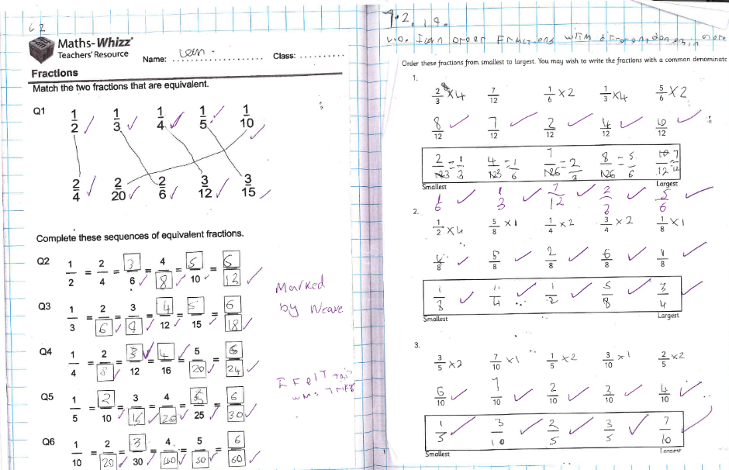
APPENDIX 1
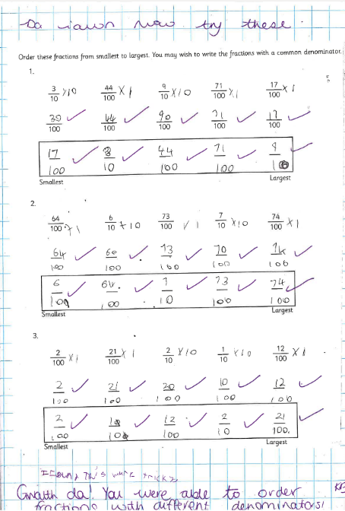
APPENDIX 2

APPENDIX 3

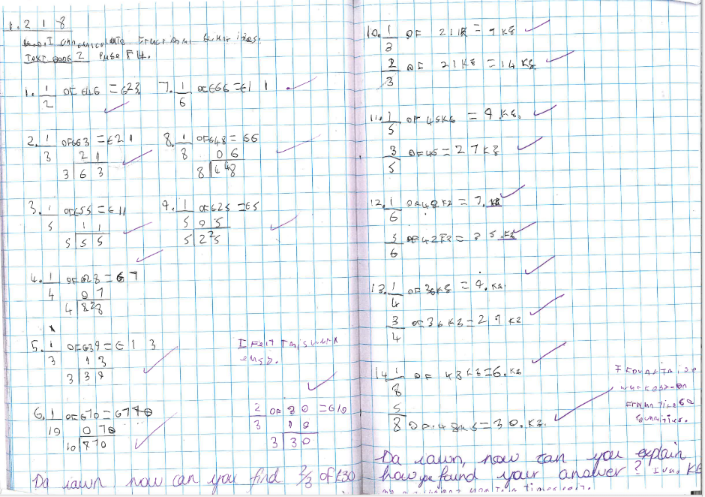

APPENDIX 4

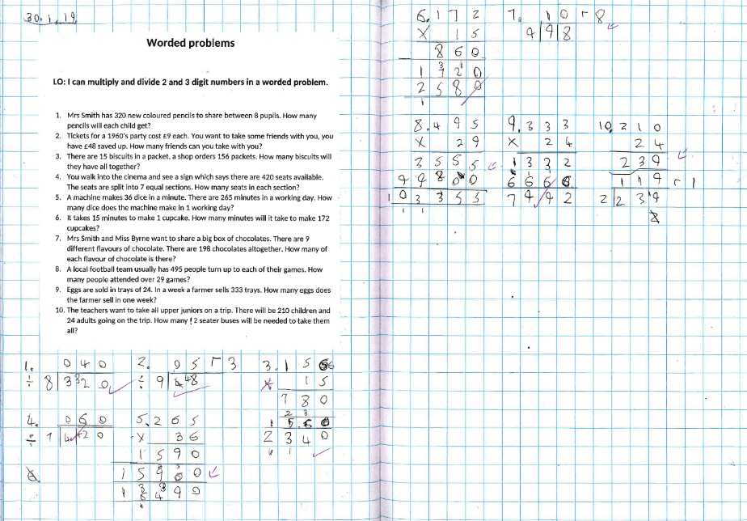

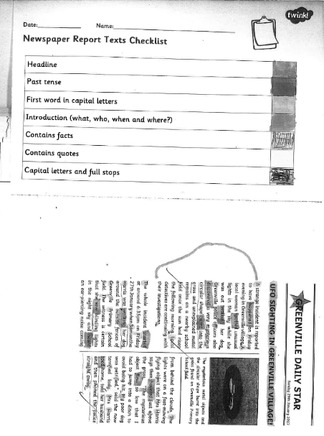
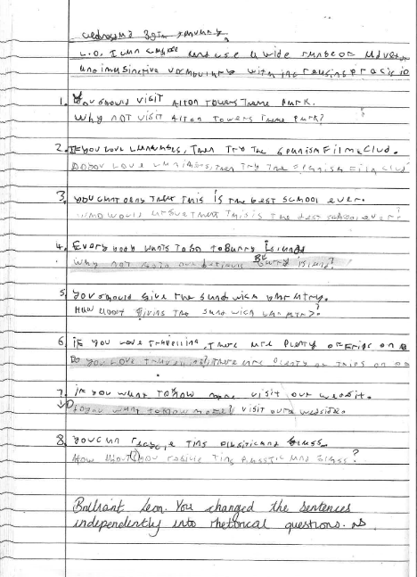
APPENDIX 6
APPENDIX 5
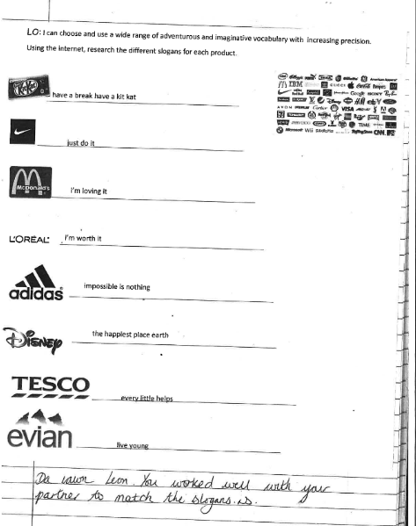
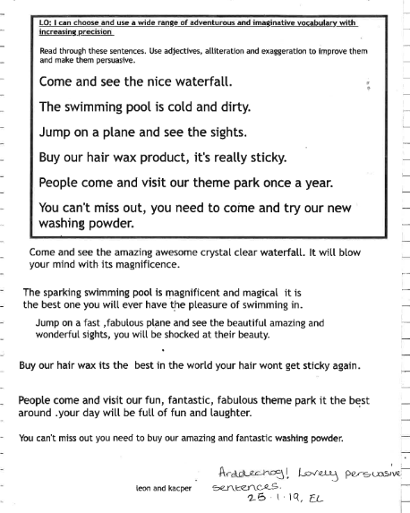
APPENDIX 8
APPENDIX 7

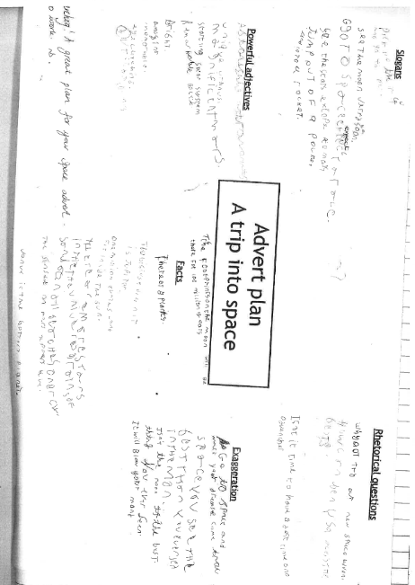
APPENDIX 9

APPENDIX 10

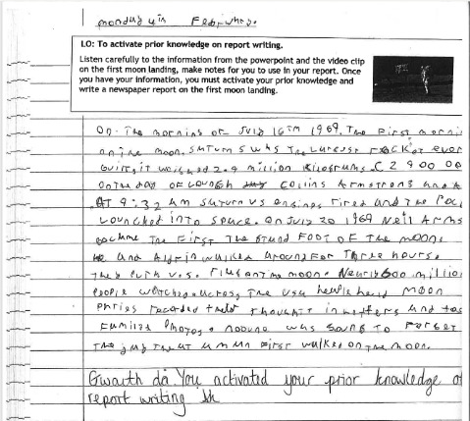

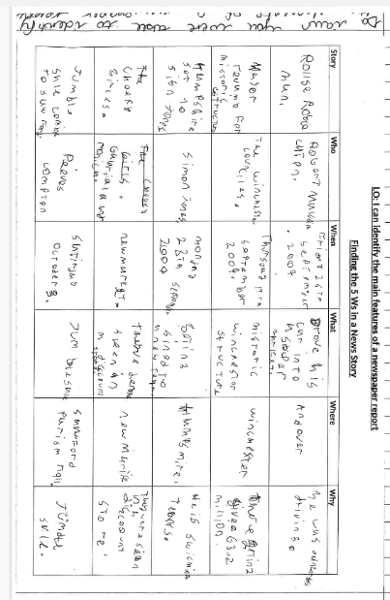
APPENDIX 11

APPENDIX 12

How do you learn maths?
we learn maths using computers,calculates.
What methods do you use to work out maths problems?
bus stops,columes and adishions sumes.
What resources do you use in class?
wightbourdes,calculates and computers
Do you enjoy learning maths?
yes because I like maths.
What other things would help you to learn maths?
teacher,your family and maths bookes
Are there things we teach on the board that help you to learn maths? what are they?
yes because we do kahoot to help us learn.
why do you like maths?
because it helps me learn.
How do you lean in language lessons?
by talking to my freinds to help
What resources do you use that help you?
workshets, bookes, dictinary
Do you enjoy writing?
its ok but i like to use the laptop more
Do you think your work is better if you do it on the laptop?
yes becauyse it looks nicer and its fun

