Contents
Abstract 2
Introduction 2
Chapter 1 – programming techniques 2
HTML, CSS & JS 2
PHP 2
MYSQL 2
Frameworks 2
Bootstrap 2
MDB 2
PHPmygraph5 2
Chapter 2 – libraries 3
Chapter 3 – implementation, Screenshots & Annotations 4
Conclusion 4
Appendix 5

Abstract
Giving an understanding, and also showing the breakdown of using different languages, frameworks and software packages that was used to aid the creation of this website. There will also be a screenshot showing the final version of the website with annotations of the code, for explanations to give more depth around the material that has been submitted.

Introduction
Exploring PHP & MYSQL to create a website that interacts with user data is growing more and more every year with IOT becoming a common name within the tech industry. This project uses an array of different tools and packages to create a fully interactive user website, the show data that has been uploaded to the database though the php files, then interpreted into graphs that allows to show the user data that can be filtered.

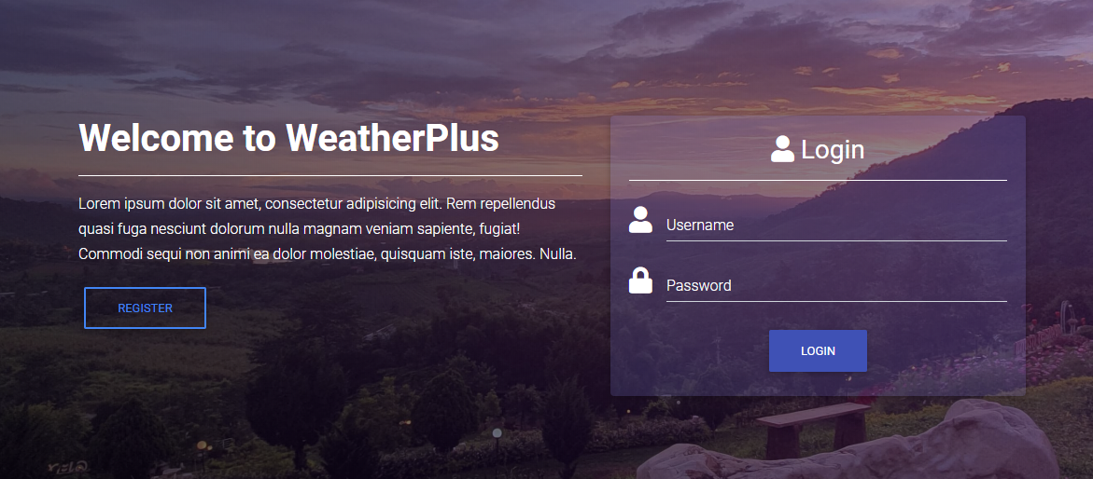

Chapter 1 – programming techniques

HTML, CSS & JS
HTML, CSS and JavaScript can be found in all websites, as it’s the fundamental structure. Each one of the languages complement each other to create better looking and more functional websites.
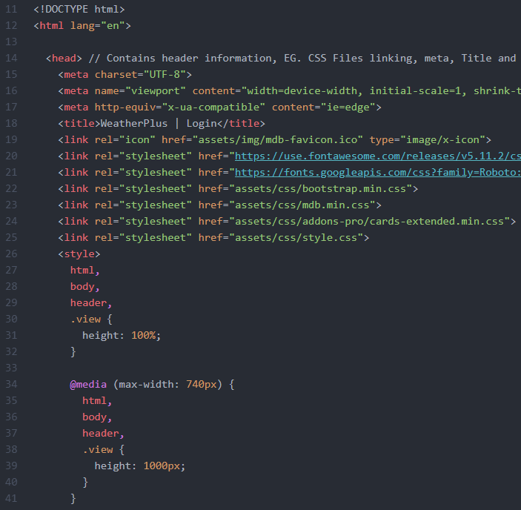
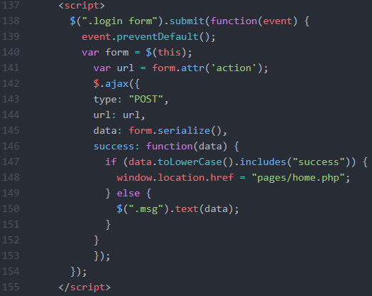
(Figure 1 - 1) - (Credit Author) - (Screenshot from index.php, to show use of HTML, CSS & JS)

PHP
PHP is a server side language, this is allowing the server to read the php code and output it as HTML for the user. This will mean that the user will be unable to read the php code from the browser. This allows php to be surece enough to access databases and secure information.
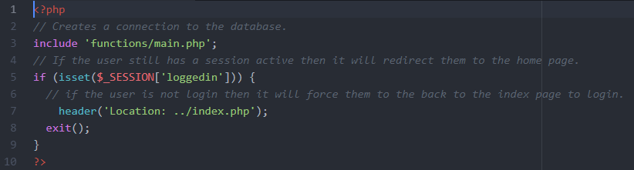
(Figure 1 - 2) - (Credit Author) - (Screenshot from index.php, to show use of PHP)

MYSQL
MYSQL is free database software that was created by Oracle. MYSQL is used as the database collecting and storing information, in combination with the php it is able to allow for a login system and also to display data on the website using graphs and tables.
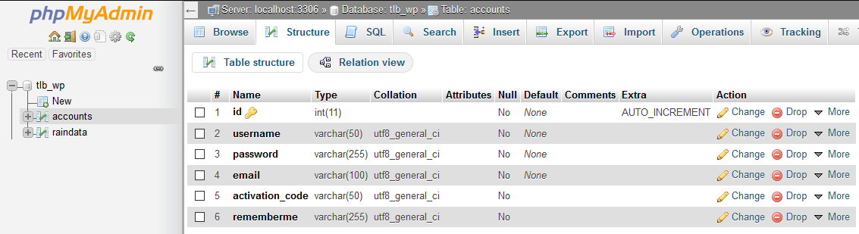
(Figure 1 - 3) - (Credit Author) - (Screenshot from phpmyadmin, show use of the database backend)

Frameworks & Library
This project had the assistants of using premade framework that are open source for developers to use. The two frameworks are Bootstrap and MDB and also the library that was being used for the php graphs phpmygraph5. These were used to create and help assists with development time.

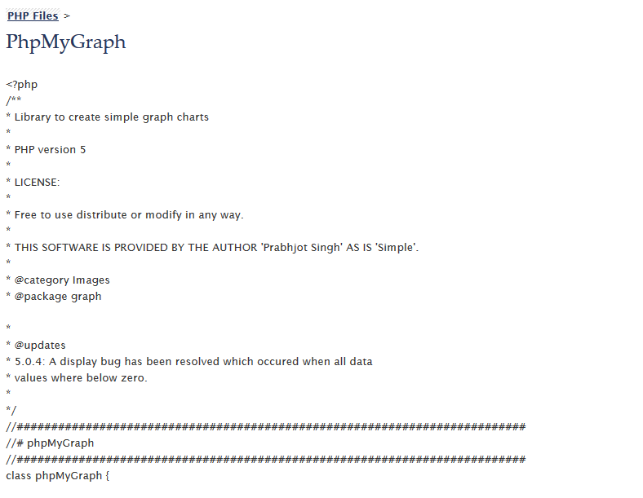
- Bootstrap
- PHPmygraph5



(Figure 1 - 4) - (Credit Prabhjot Singh) - (Code from phpmygraph)

(Figure 1 - 5) - (Credit Bootstrap) - (Logo from Bootstrap website)

Chapter 2 – implementation, Screenshots & Annotations

Searches
The datatables are displaying all the information from the database, these are placed into 4 columns presenting data in rows that can be read by the user. The user is able to create filters by using the drop down menus. The reason why this is used is because it allows the users to sort though the data interactively.
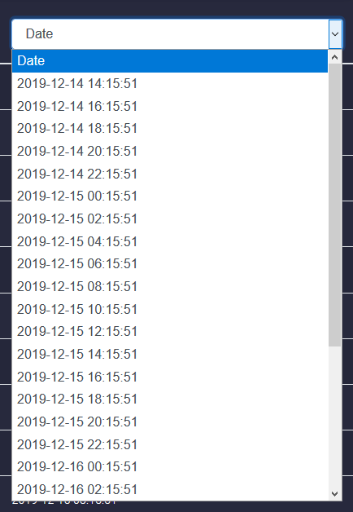
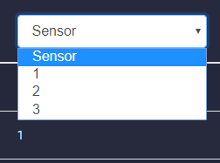
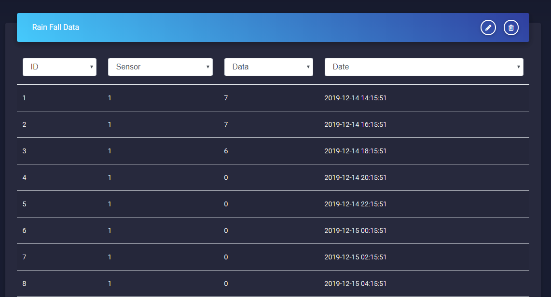
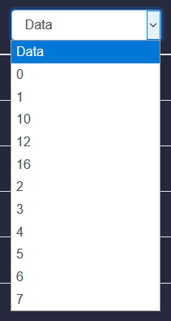
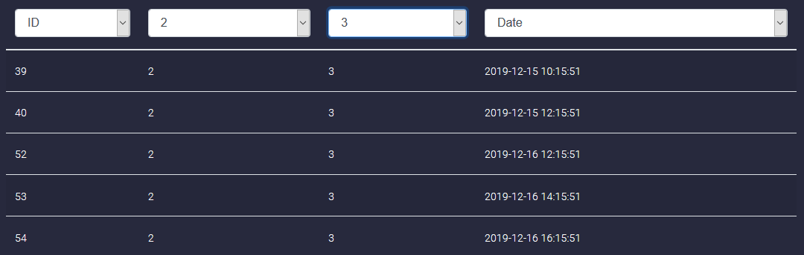
(Figure 2 - 1) - (Credit Author) - (Screenshot of the final table)

Code snippet from table.php
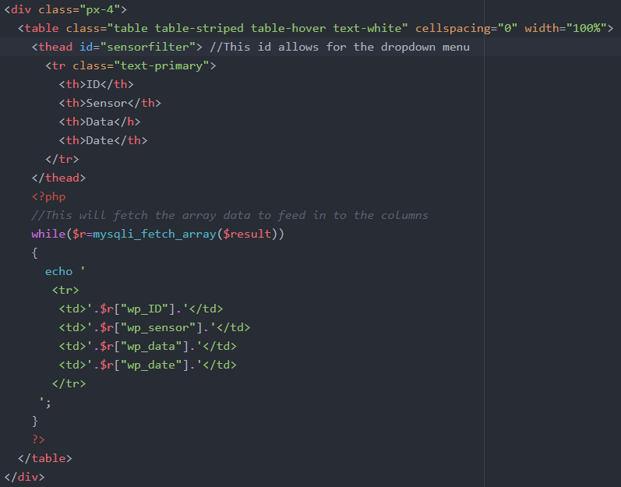
(Figure 2 - 2) - (Credit Author) - (Screenshot of the code from the table php)

Graphs + Library
The graphs that can be seen on the website are a mixture of different types to make it not all look the same, it helps represent the data in different view. Showing the data in a variety of different graphs allows the user to visualize and understand better. The types of graphs that have been used in the website are:
- Bar Charts
- Line Charts
- Horizontal Bar Chart
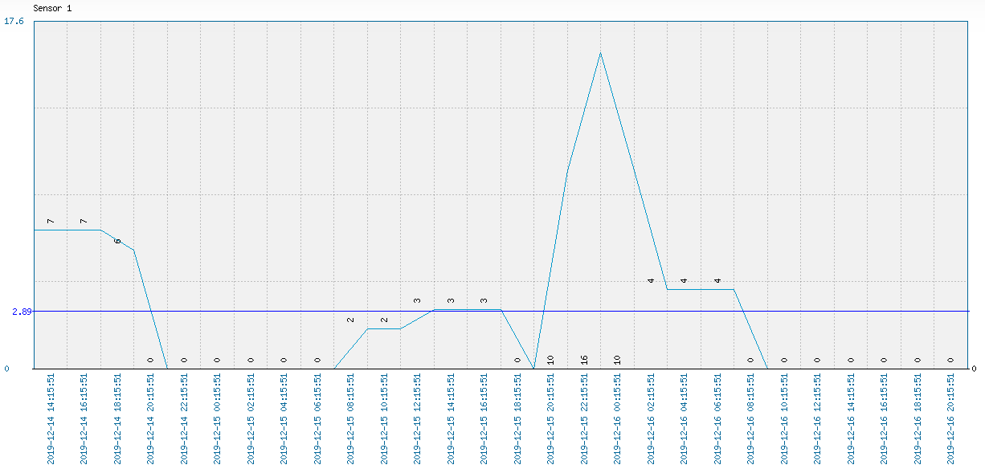
Line charts are very good at showing huge spikes in data, so this would be good to show when the weather can go from a “0” to “16” in over 4 hours by looking at the graph. Bar charts are very useful to see data over a long period of time.

(Figure 2 - 2) - (Credit Author) - (Screenshot of the line chart - Showing Sensor 1)
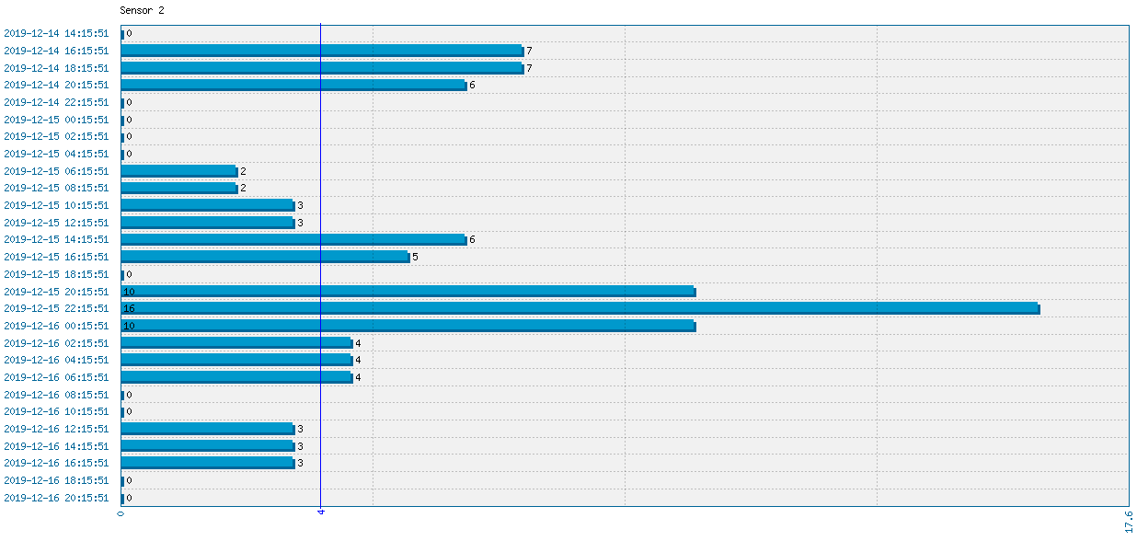
(Figure 2 - 3) - (Credit Author) - (Screenshot of the horizontal line chart - Showing Sensor 2)

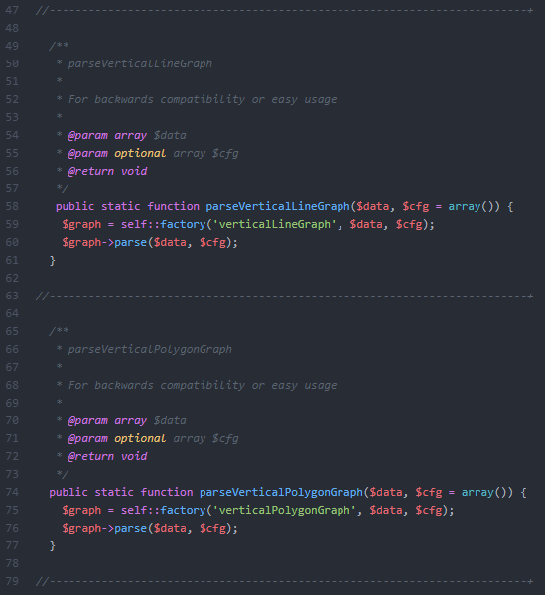
The graph library that was used was the phpmygraph, this was used to create the graphs that are being seen on the website. The library is very limited and doesn't offer much in customization, but it is good and showing and representing the data that is needed to be shown to the users. Phpmygraph was used to create 4 graphs, 3 of them were users to show the data from the sensor separately, where the last graph was showing all the data so that the user would be able to view the wettest day.

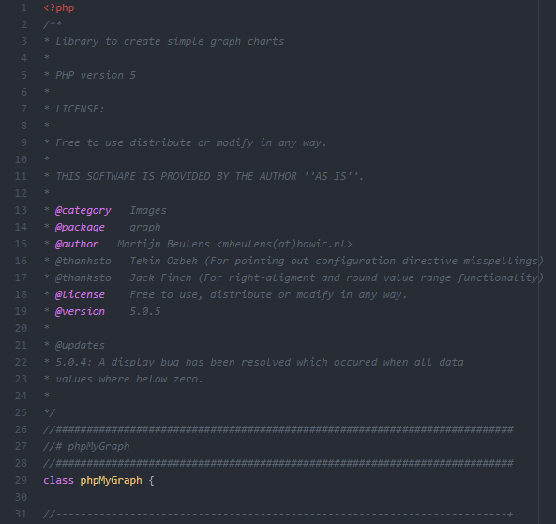
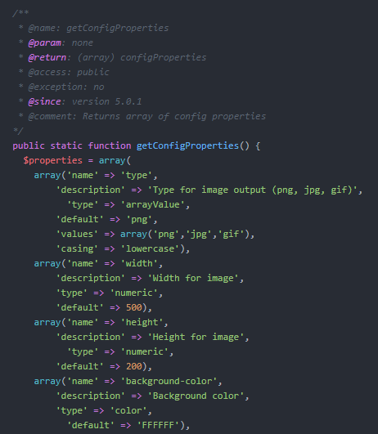
(Figure 2 - 4) - (Credit Author) - (Screenshot of the phpmygraph - Showing source code)

Code with Annotations
This section will be screenshots, with annotations. short and brief comments.
Index.php
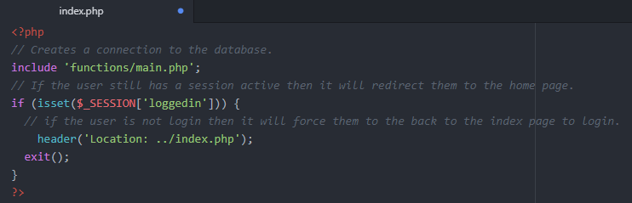
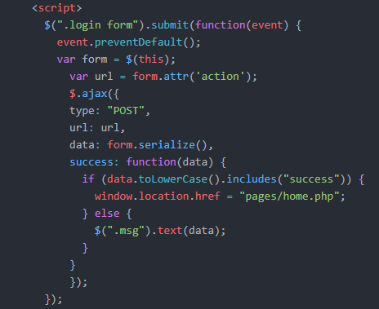
(Figure 2 - 5) - (Credit Author) - (Screenshot from index.php - Showing login and session code)
Authenticate.php - This is the Authenticator file, it job is to make sure that the same username / email is used at the same time and also when the user logs in that the correct fields are filled in with the right information.
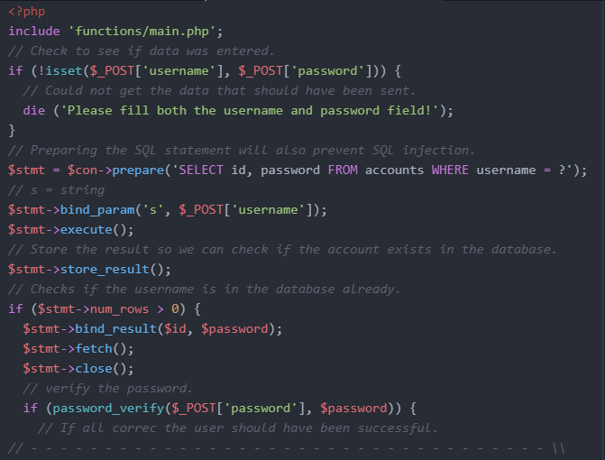
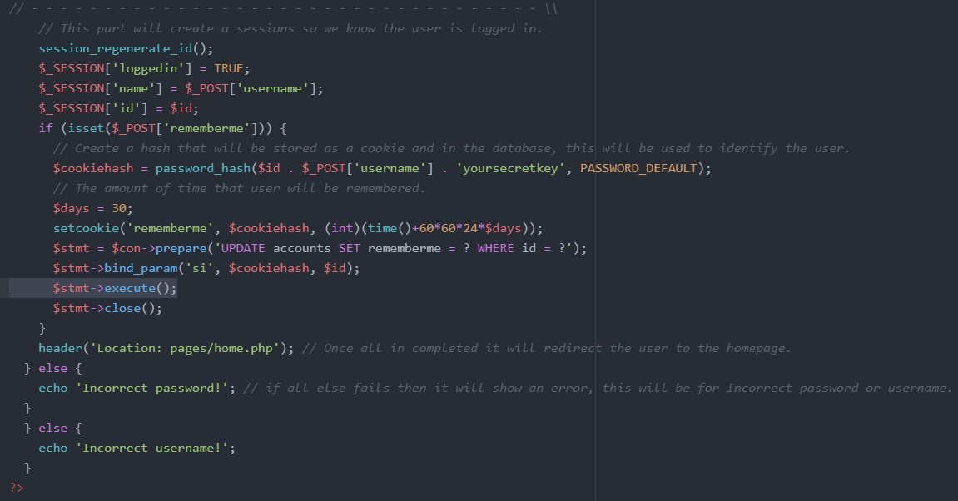
(Figure 2 - 5) - (Credit Author) - (Screenshot from uthenicate.php - Showing login and session creation code)

main.php - This file is used to check all the sessions of the user that are logged in to the website, it connects to the database and compares the data that is stored in the session (cookie) for a match.
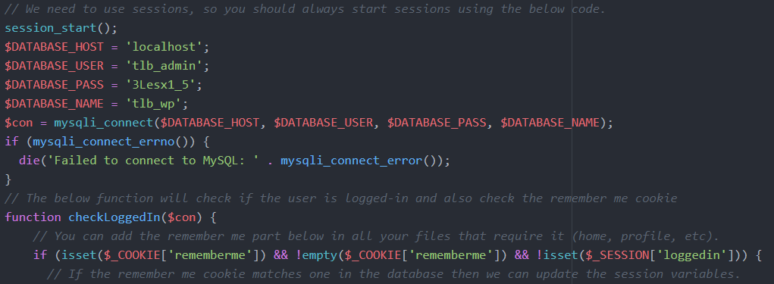
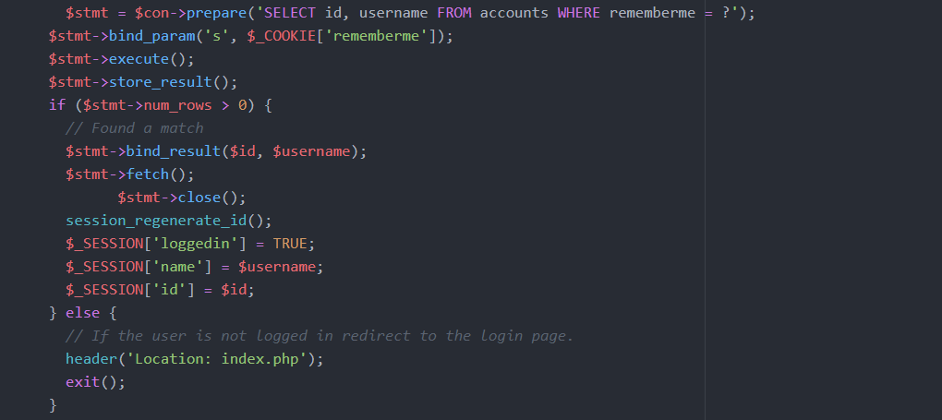
(Figure 2 - 6) - (Credit Author) - (Screenshot from main.php - Showing active sessions code)

auth.php - Connection to the database.
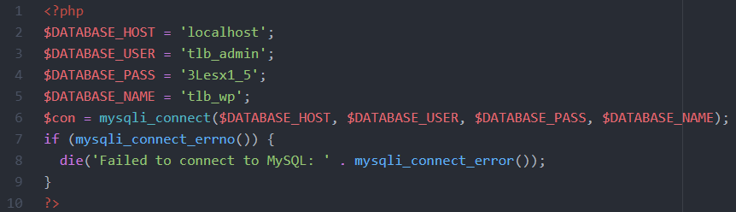
(Figure 2 - 7) - (Credit Author) - (Screenshot from auth.php - Showing connection details to database )

tables.php - This is very simply take the array and outputting the data in the columns
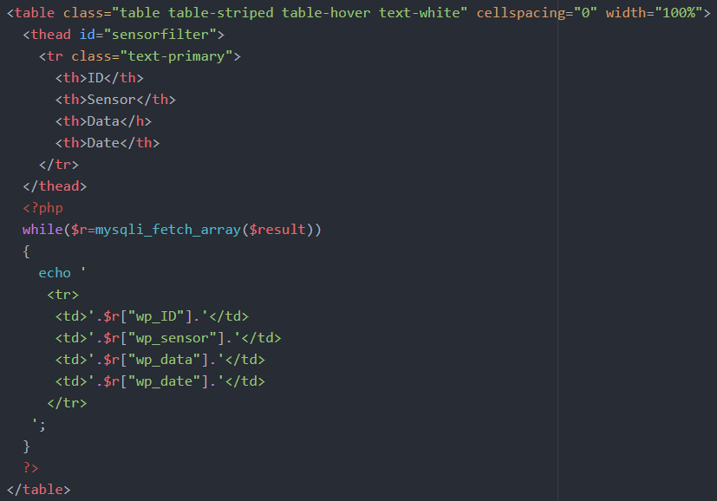

(Figure 2 - 8) - (Credit Author) - (Screenshot from tables.php - Showing code that was written for the tables)

Graphs chart - All the charts are in their own php file, and then using an img tag it will then call them to the page. These files are the four core files that are used to generate the graphs into images.
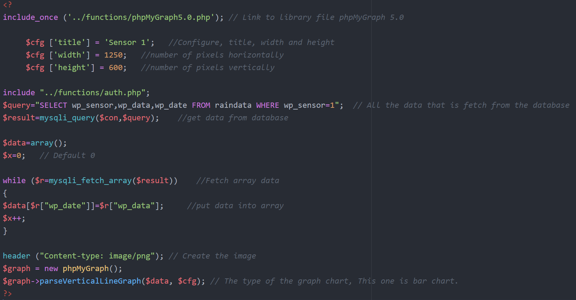
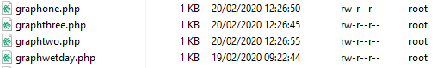
(Figure 2 - 9) - (Credit Author) - (Screenshot from graphone.php - This show the sql code for making graphs)

Conclusion
Creating websites that use server side languages and databases is what the internet works around, everything requires a database, from small projects to large projects they are required. Learning SQL, PHP HTML & JS is needed when you are learning how to make an IOT website. This project has created new paths and choices to take with skills, plenty to learn.

References
[1]M. Otto, “Bootstrap,” Getbootstrap.com, 2020. [Online]. Available: https://getbootstrap.com/. [Accessed: 02-Feb-2020].
[2]“Material Design for Bootstrap,” Material Design for Bootstrap, 2013. [Online]. Available: https://mdbootstrap.com/. [Accessed: 06-Feb-2020].
[3]“PHP: PHP Manual - Manual,” Php.net, 2020. [Online]. Available: https://www.php.net/manual/en/. [Accessed: 12-Feb-2020].
[4]“PHP Tutorial,” W3schools.com, 2020. [Online]. Available: https://www.w3schools.com/php/. [Accessed: 15-Feb-2020].
‌

Appendix
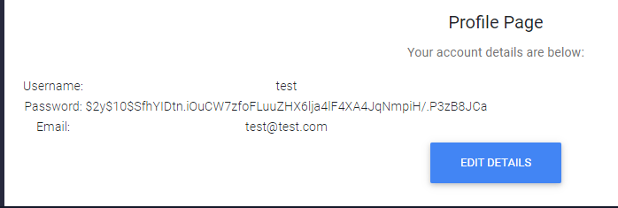

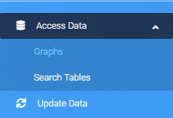
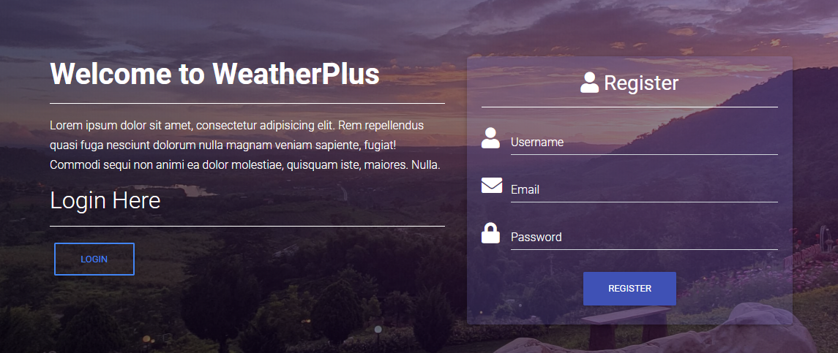

Files - All the files for the website are in here
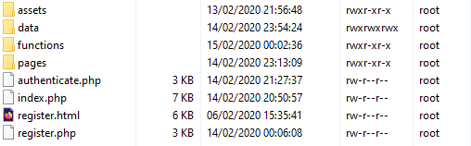
Inside the functions
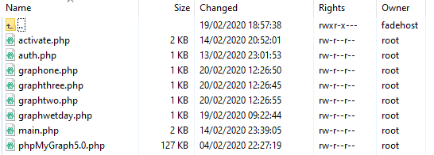
These are all the pages that have been made
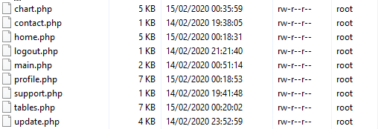
Data file had all the data from the the text file


