Name and Student number: Dan Andreea-Monica 2127612
Assignment Title: Planning and delivering an International Meeting/ Event
Module Title: International Meeting Management BMIH6007
Lecturer Name: Jemma Smith
Executive Summary
The purpose of the summit is to inform hospitality industry workers about present day technological trends affecting different spheres of the industry, and help the hospitality industry to understand how it can manage the guest experience in all domains. The goals established as SMART goals include the improvement of attendee knowledge of new hospitality technologies to 70%, formation of 20% more partnership via business and networking meetings and an AI match-making tool, and the increase of exposure to new solutions by 30% aimed at clients’ satisfaction and better operational results. The occasion will bring together hospitality management, IT experts, and other involved /interested parties to share their experience on the potential of new technologies including Artificial Intelligence, Virtual Reality, and touchless solutions as well as; discuss the arising issues like change management and data security. Specifically, the summit will be addressed to hospitality managers, executives, technology startups, and investors; it will be held at Fira Barcelona Convention Centre, Barcelona, Spain. It will comprise of the cramming, focuses on the formats such as the workshops, stands, debates and discussions, and mingling over the two days and the cost of $600,000 shall be covered by tickets, sponsors, exhibitors’ fees, and crowdfunding. Focusing on the current challenges, conditions, and prospects of industry development, the summit covers the analysis of SWOT and PESTLE, so, the participants will be able to get the necessary amount of information, establish contacts with the members of the industry, and consider new possibilities for further development. Since different people have different cultural practices and feelings about themselves, cultural and situational factors will be taken into consideration to guarantee a good and culturally appropriate event experience. At the end, it also provides the best platform to the hospitality industry professionals to get updated with the technological advancement and use the technologies to create better guest experience and to grow the hospitality business fronts.

Table of Contents
1. Introduction 2
1.1 Name of the Meeting/Event 2
1.2 Description of the event 2
1.2.1 Brief description of the meeting or event and its purpose 2
1.3 Background of the meeting, problems and future opportunities 2
1.3.1 Background of the meeting 2
1.3.2 Problems and future opportunities 2
1.4 Location of the event with its city, venue or selected online platform 3
2. The Event Cycle 3
2.1 Brief definition of the event management cycle - 5 Steps of event management cycle 3
2.2 Justification of the selected event management cycle for the proposed event 4
3. Event Concept 6
3.1 Theme of the event 6
3.2 Itinerary 6
3.2.1 Schedule of the event with key activities, presentations and breaks 6
4. Aim and Objectives of the Meeting / Event 8
4.1 Aim of the event 8
4.2 Smart Objectives 8
5. Event Operations 9
5.1 Skills and resources required for the meeting/event 9
5.1.1 Resources 9
5.1.2 Skills 10
6. Event Budget 10
6.1 Income and expenditure 10
6.2 Explanation of costs 11
6.3 Funding sources and income generation related to the meeting/event 11
7. Industry Trends / Issues / Impacts 12
7.1 Latest trends, issues and impacts linked to the meetings/events industry 80 12
7.2 SWOT Analysis 12
7.3 PESTLE Analysis 13
8. Cultural and Situational Considerations 15
8.1 Wider cultural / situational considerations linked to the meeting/event 15
8.1.1 Cultural considerations 15
8.1.2 Situational considerations 15
List of References 16

1. Introduction

1.1 Name of the Meeting/Event
The event which has been chosen is “Analyses and Effects of Technological and Innovative Trends in the Hospitality Summit 2024”

1.2 Description of the event

1.2.1 Brief description of the meeting or event and its purpose
On this summit, hospitality leaders and professionals will congregate with IT professionals to deliberate on the new shifts and breakthroughs taking place in the hospitality market. It will identify the advantages and disadvantages of such inventions and demonstrate the concept that transforms client experience and improves productivity.
- To evaluate and review the innovation and advancement in the application of technology in the hospitality industries.
- To enhance the sharing of the knowledge, partnership, and collaboration by the industry players.
- To promote innovative ideas that help the improvement of the clients’ stay and overall organisational performance in the hospitality industry.

1.3 Background of the meeting, problems and future opportunities

1.3.1 Background of the meeting
Currently, the hospitality industry has been characterised by tremendous technological disruptions such as Artificial Intelligence and Virtual Reality (Calisto and Sarkar, 2024). In fact, the proposed event seeks to do this by assembling stakeholders in the industry to deliberate on these trends.

1.3.2 Problems and future opportunities
Problems
- Current hospitality practices might not align with evolving customer needs owing to change in general demographics and increasing rate of technological development.
- Owing to financial and operational complexities, businesses are not able to align functions and activities with the evolving pace of technology.
Future Opportunities:
- It is more probable that knowledge shared and collaboration can result in better guest satisfaction and innovative ways of doing business.
- The perspective of the event can be useful for future conferences and for the development of hospitality services in the industry.

1.4 Location of the event with its city, venue or selected online platform
Regarding the setting of the event “Technological and Innovative Trends in the Hospitality Summit 2024: Analyses and Effects,” the event will be held in Barcelona, Spain.
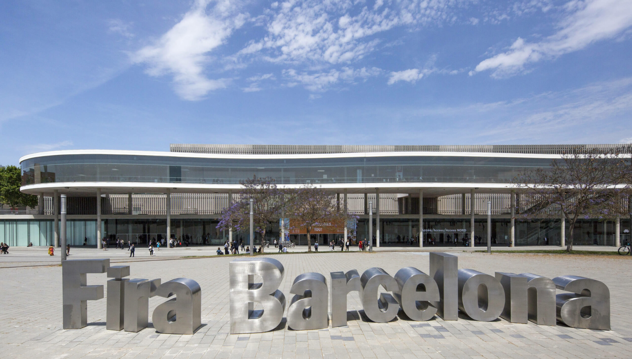
Figure 1: The location of the event
(Source: Fira Barcelona, 2024)
The specific venue is Fira Barcelona Convention Centre which is a modern venue and quite easily accessible (Fira Barcelona, 2024).

2. The Event Cycle

2.1 Brief definition of the event management cycle - 5 Steps of event management cycle
The event management process entails designing, coordination, staging, and controlling, which is always enhanced with every staging of an event (Bridges, 2019).
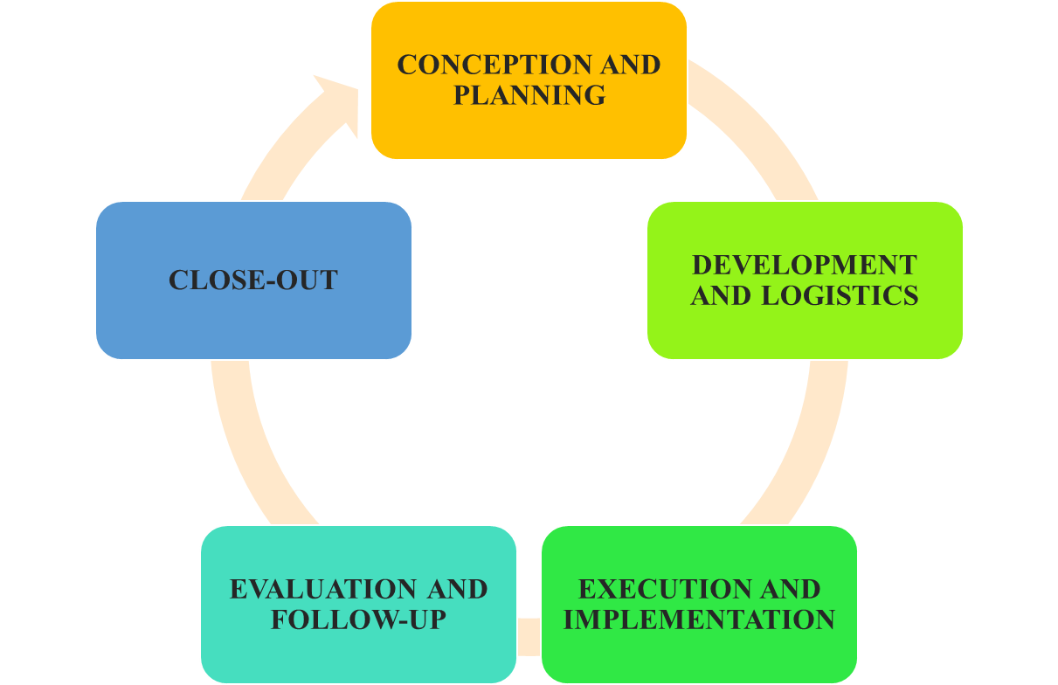
Figure 2: 5 Stages of event management cycle
(Source: Self created)
The five stages are:
- Conception and Planning: identification of goals, target clients, amount of money to spend, and time frame.
- Development and Logistics: Booking the vendors, hiring venues and designing advertised materials (Bridges, 2019).
- Execution and Implementation: To coordinate the event and also ensure there is no issue during the event.
- Evaluation and Follow-up: The stage should help the company to collect feedback, measure the identified goals and objectives success level, and highlight areas that require improvement (Bridges, 2019).
- Close-out: This stage helps complete office related functions such as adding up the accounts, paying the suppliers, and balancing the accounts.

2.2 Justification of the selected event management cycle for the proposed event
Based on the above discussions, the event plan has been divided into specific stages in the following table.
Stage | Details
Conception and Planning (Now) | - Goal: Exhibiting how trends in hospitality technology look like.  - Target Audience: Hotel managers/owners, IT specialists, and other interested parties.
Development and Logistics (Next 6-12 Months) | - Venue: Approaching Convention Fira Barcelona Center in Barcelona.  - Speakers: Inviting industry leaders and technology experts.  - Marketing: Initiating digital campaigns, social media promotion, and partnerships.  - Budget: Creating a detailed plan including estimated costs for venue, speakers, advertising, etc.
Evaluation and Follow-up (Post-Event) | - Logistics: Coordinating meetings, talks, seminars, and PR activities.  - Technology: Managing audio-visual equipment and online facilities.
Evaluation and Follow-up (Post-Event) | - Feedback: Collect feedback from attendees and speakers.  - Analysis: Analysing data for future improvements
Close-out (Post-Event) | - Finalise Finances: Using the collected money to pay vendors and finalise the budget, considering negotiations, available budget, and fees for equipment and hall rentals.
Table 1: Event management cycle
(Source: Self created)
Using technology as the backbone of this plan, one gets to promote knowledge sharing, partnership, and industry development in hospitality.

3. Event Concept

3.1 Theme of the event
The theme of the event relates directly to the event’s theme of how hospitality is incorporating the trending advanced technologies such as AI, VR and smart solutions among others. It focuses on the positive aspects and the issues of this shift.

3.2 Itinerary

3.2.1 Schedule of the event with key activities, presentations and breaks
The conference is held to analyse how technology plays a role in it which has been described in the table below:
Day | Time | Activity | Description
Day 1 | Morning | Invited Address | Welcome speech by a renowned leader in the hospitality industry.
Day 1 | Mid-Morning | Breakout Sessions | Focused discussions on specific topics  - Artificial Intelligence in Hospitality  - Virtual Reality (VR) & Augmented Reality (AR) Applications  - Internet of Things (IoT) for Hospitality  - Sustainability and Green Practices
Day 1 | Afternoon | Hands-on Workshops | Practical sessions for attendees to learn and experiment with cutting-edge technologies relevant to the industry.
Day 1 | Evening | Networking Cocktail Party | Social gathering with AI-powered matchmaking to facilitate connections and roundtable discussions on specific themes.
Day 2 | Morning | Exhibition | Showcase of the latest hospitality products and related services from industry vendors.
Day 2 | Afternoon | Panel Discussions | Interactive sessions with industry experts exploring the future of technology in hospitality.
Day 2 | Late Afternoon | Innovation Competition Awards Ceremony | Presentations by finalists and announcement of winning and runner-up innovation initiatives, judged by hospitality business leaders.
Breaks | Morning & Afternoon | Coffee Breaks | Informal networking opportunities for attendees to connect with colleagues.
 | Lunch Break | Lunch | Extended break for attendees to socialise, explore the exhibition area, and network.
Table 2: Schedule, activities and breaks of the event
(Source: Self created)
There will be an opening speech, AI, VR, IoT, and Sustainability sessions on Day 1, workshops, and AI-driven networking event. Day 2 offers new products and an opportunity to listen to the experts and discuss with them, and in the end – Innovation competition award ceremony.

4. Aim and Objectives of the Meeting / Event

4.1 Aim of the event
The main aim will be to educate hospitality professionals on relevant and advanced technological advancements in different aspects, and business functions in the hospitality field. In addition, the event will also focus on developing the guest experience by effectively managing each phase.

4.2 Smart Objectives
The SMART objectives are presented based on the proposed event with the help of proper stages of the objectives which are description, specific, measurable, achievable, relevant and time-bound
Objective | Description | Specific | Measurable | Achievable | Relevant | Time-bound
Knowledge Sharing | Increase attendee awareness of new hospitality technologies. | 70% increase in attendees by focusing on improving communication factors for spreading proper news regarding the event. | Pre- and post-event Likert scale surveys. | Interactive workshops, panels, pre-event materials. | Critical for industry adaptation. | End of summit (post-event survey).
Industry Collaboration | Foster new partnerships between hospitality and IT sectors. | 20% increase in new contacts between attendees. | Post-event surveys & dedicated connections platform. | AI-powered matchmaking networking event. | Critical for developing innovative solutions (Miranda et al.). | During the summit (networking event) & post-event survey.
Solution Exposure | Increase attendee exposure to innovative hospitality technologies. | 30% increase in attendee traffic and engagement to manage guest experience and operational efficiency of the event. | Badge scans & polls/questionnaires at booths. | Dedicated exhibition area showcasing industry vendors. | Essential for identifying guest experience & operational improvements. | Throughout the summit (traffic & engagement).
Table 3: SMART Objectives
(Source: Self created)
The objectives which are being focused are Knowledge Sharing Industry Collaboration and Solution Exposure through which SMART objectives have been prepared.

5. Event Operations

5.1 Skills and resources required for the meeting/event

5.1.1 Resources
Personnel
- Staff: Event coordinator, brand promoter, operational organiser, information technology, audio visual engineers.
- Volunteers: Friendly receptionist, receptionists, and hall ushers.
- Speakers: Executives, technocrats, hoteliers, and managers.
Equipment
- Audio/Visual: projectors, large screens, microphones, speakers.
- IT: Computer, internet connection, registration software, artificial intelligence-based matchmaking web application.
Materials
- Signage: Advertising at the event, direction, and guidance signs and billboards.
- Handouts: Overhead transparencies, schedules of the attendees, activities related to exhibitors.
- Marketing Materials: Flyers, communicating through the website, using social media accounts, press releases.

5.1.2 Skills
To ensure a successful Hospitality Summit on cutting-edge technologies, the team must excel in event planning, project management, logistics, marketing, speaker recruitment, and budgeting. Technical skills in audio/visual production and IT management are essential for smooth presentations and AI matchmaking (Bakhshi et al., 2017). Strong communication, public speaking, negotiation, customer service, and teamwork are crucial for interacting with attendees, staff, speakers, and vendors (Miller et al., 2023).

6. Event Budget

6.1 Income and expenditure
The focus of the proposed event is based on the planned budget of $600,000 with revenues from ticket sales, sponsorships, and exhibitors. Some specific cost areas are
Category | Percentage of Total Budget | Justification
Venue Costs | 20% | Rental, setup, and breakdown for accommodating attendees and speakers.
Speaker Fees & Travel | 15% | Attracting high-profile speakers and covering their travel expenses.
Marketing & Promotion | 20% | Ensures the target audience is aware of the event and maximises attendance.
AI Matchmaking Platform | 10% | Facilitates valuable connections between attendees by leveraging AI technology.
Audiovisual & Technical Services | 15% | High-quality audio, visual equipment, and technical support for a seamless event experience.
Miscellaneous Expenses | 10% | Essential costs like catering, staff salaries, logistics, and materials.
Contingency Fund | 20% | Accounts for unforeseen circumstances that may arise during event planning or execution.
Table 4: Income and Expenditure
(Source: Self developed)
It also determines a successful and informative event by balancing the available income in order to finance all factors.

6.2 Explanation of costs
The Hospitality Summit has an amount of $600,000 for the implementation of its agenda. Thus, an optimization is created with 20% ($120,000) dedicated to the Fira Barcelona venue rental for a professional environment. It is necessary to invite outstanding speakers and 15% ($90,000) is considered for them since they will take some of the budget as a fee for their performance. Marketing (20% or $120,000) is responsible for attendee registration as well as selling of sponsorships. Another key budget is allocated to the AI matchmaking platform, and it gets $60,000 (10%). Finally, the remaining $210.000 is for event production, food and beverage, personnel and reserve.

6.3 Funding sources and income generation related to the meeting/event
The Hospitality Summit can adopt crowdfunding beside the normal ways of obtaining income to be unique. To achieve this, the campaign shall be launched on an established crowdfunding website and the most likely patrons will be hospitality professionals, technophiles, and pioneers (Baber et al., 2022). Rewards pertaining to contribution levels will be early bird tickets at a lower cost, additional and special workshops/ networking events, free access to recordings of events and limited-edition merchandise. Additionally, offering various ticket tiers will cater to diverse budgets: The three levels of participation are Event, Workshop, and Star. This double-edged strategy makes income sources more versatile, potential viewers broader, supports communities and interest groups,

7. Industry Trends / Issues / Impacts

7.1 Latest trends, issues and impacts linked to the meetings/events industry
Latest trends include artificial intelligence, virtual reality, touchless solutions and green hotel initiatives. Coupled to these advances, matters that will be discussed include; change management, the effect on employment, and data security. Together, they will cover such aspects as a demonstration of services and products, knowledge sharing, and networking with the main target audience comprising hospitality managers, executives, innovators and investors. Taking place in the colourful city of Barcelona, Spain, this summit is technologically advanced and supportive towards foreign culture (Roig, Sun-Wang and Manfredi-Sánchez, 2020).

7.2 SWOT Analysis
The SWOT analysis which has been prepared has targeted the event to identify its strengths, weaknesses, opportunities and threats:
Factor | Description
Strengths | Timely, covers diverse tech, interactive sessions, strong location (Barcelona)
Weaknesses | New event, potential competition
Opportunities | Fills tech gap, attracts investment & talent, improves guest experience & efficiency
Threats | Keeping up with tech advances, job displacement due to automation, data privacy concerns
Table 5: SWOT Analysis
(Source: Self developed)
The event shows the Hospitality Tech & Innovation Summit as the one that addresses the shift in the hospitality business towards technology. AI, VR and sustainability in talks with workshops followed by networking is also provided. Staged in Barcelona that is widely known to be a technology and hospitality hub, this new event was intended to provide the technology knowledge which is lacking and spur the service industry.

7.3 PESTLE Analysis
The table which has been pasted below addresses the feasibility of the event by judging the current condition of Spain with the help of PESTLE analysis:
Factor | Description | Example | Impact on Event Management
Political | Spain stands in 36th place among 180 countries which indicates the country has a stable political climate (Transparency International, 2023). | Spain is now VAT free for non-Spanish companies which provides a consistency in regulations for event permits (Lotus-DMC, 2023). | Positive impact  Easier planning and budgeting
Economic | With 3.11% growth in 2023 and a projected revenue of $26.22 billion, Spain possesses a strong tourism industry (Statista, 2024a). | Increased demand for event services | Negative impact  Potentially higher event costs
Social | Spain is ranked 14th 2019 Europe Sustainable Development Report which indicates that the country has a  growing interest in sustainability (ICEX, 2024). | Spain has an EPI score of 24.5 which indicates the country is looking for eco-friendly event options (Yale Center for Environmental Law & Policy, 2024). | Positive Impact  Adapting to preferences for reduced waste and carbon footprint
Technological | Spain ranks 29th among the 132 economies featured in the GII 2022 which indicates that the country has high-tech infrastructure (Global Innovation Index, 2023). | AR & VR market users in Spain is expected to amount to 36. 3M users by 2029 which indicates that the company can support VR, live streaming capabilities for the proposed event (Statista, 2024b) | Positive impact  Creating more engaging and interactive events
Legal | Spain has implemented –Basic Law 7/2021 of 26 May – Directive 2016/680 which indicates strict data privacy regulations (Avendano and López-Lapuente, 2023). | Spain has implemented LOPDGDD which allows stricter data collection and usage compliance (One Trust, 2023). | Positive impact  Increased focus on data security measures
Environmental | 40% of the Spanish customer has increased buying sustainable products which indicates the consumer’s commitment to sustainability (Tighe, 2024). | Spain’s Long-Term Climate Strategy (ELP 2050) seeks to reduce emissions by 90% (relative to 1990 emissions) by 2050 which indicates that Spain has been focused on waste reduction and carbon offsetting (Carbon Gap, 2023). | Positive Impact  Sustainable solutions for catering, venue selection, etc.
Table 6: PESTLE Analysis
(Source: Self developed)
The table has provided a detailed analysis regarding the market capability of Spain in handling the proposed event. In fact, it can be concluded that the country is suitable for the event to be conducted.

8. Cultural and Situational Considerations

8.1 Wider cultural / situational considerations linked to the meeting/event

8.1.1 Cultural considerations
To address cultural consideration, the event needs to think about how to organise a culturally sensitive summit in Barcelona keeping in mind Spain’s focus on the building of relationships. Furthermore, other cultural considerations are:
- Preparing for the tales and proactively addressing dynamic and even conflict-oriented communication which means that it may be indirect and one must factor nonverbal context. Explaining applications of the siesta and flexible deadlines.
- Comply with the business casual wear’s dress code and provide the documents in both Spanish and Catalan (Helmich, 2020).

8.1.2 Situational considerations
When organising a hospitality tech summit in Spain, there should be long intervals of time for meals and other social activities as people have chances to build various necessary relationships. This means being ready for that certain flow of passionate arguments and maybe even rather implied communication.

List of References

Avendano, U.M.-I.E. and López-Lapuente, L. (2023). Spotlight: how are data protection laws enforced in Spain? [online] Lexology. Available at: https://www.lexology.com/library/detail.aspx?g=a5e0441b-01d0-4336-824c-ad94e3700768#:~:text=Spain%20has%20implemented%20%E2%80%93%20through%20Basic [Accessed 29 May 2024].
Baber, H., Ramkissoon, H., Salem, I.E., Ghasemi, V. and Munim, Z.H. (2022). Hospitality enterprises’ revival through crowdfunding: a cross-country study. Consumer Behavior in Tourism and Hospitality, [online] 17(4), pp.396–412. doi:https://doi.org/10.1108/cbth-09-2021-0213.
Bakhshi, H., Downing, J., Osborne, M. and Schneider, P. (2017). THE FUTURE OF SKILLS EMPLOYMENT IN 2030. [online] Available at: https://futureskills.pearson.com/research/assets/pdfs/technical-report.pdf [Accessed 29 May 2024].
Bridges, J. (2019). How to Plan an Event (Checklist Included). [online] ProjectManager.com. Available at: https://www.projectmanager.com/training/how-to-plan-an-event [Accessed 29 May 2024].
Calisto, M. de L. and Sarkar, S. (2024). A systematic review of virtual reality in tourism and hospitality: The known and the paths to follow. International Journal of Hospitality Management, [online] 116, p.103623. doi:https://doi.org/10.1016/j.ijhm.2023.103623.
Carbon Gap (2023). Carbon Removal Policy in Spain. [online] Carbon Gap - Policy Tracker. Available at: https://tracker.carbongap.org/region/spain/ [Accessed 29 May 2024].
Fira Barcelona (2024). Gran Via. [online] Fira de Barcelona. Available at: https://www.firabarcelona.com/en/gran-via/ [Accessed 29 May 2024].
Global Innovation Index (2023). SPAIN 29th Spain ranks 29th among the 132 economies featured in the GII 2022. [online] Available at: https://www.wipo.int/edocs/pubdocs/en/wipo_pub_2000_2022/es.pdf [Accessed 29 May 2024].
Helmich, M. (2020). Spain, Catalonia, and the Supposed Authority of the Judiciary. Jus Cogens, [online] 2(3), pp.259–279. doi:https://doi.org/10.1007/s42439-020-00026-x.
ICEX (2024). Sustainability in Spain. [online] www.investinspain.org. Available at: https://www.investinspain.org/en/sustainability#:~:text=Spain%20is%20ranked%2014th%20in [Accessed 29 May 2024].
Lotus-DMC (2023). New Tax Regulations in Spain Allow VAT Exemption for Spanish DMCs. [online] www.linkedin.com. Available at: https://www.linkedin.com/pulse/new-tax-regulations-spain-allow-vat-exemption-spanish-3o0cf/ [Accessed 29 May 2024].
Miller, B.T., Camarda, A., Mercier, M., Burkhardt, J.-M., Morisseau, T., Bourgeois-Bougrine, S., Vinchon, F., El Hayek, S., Augereau-Landais, M., Mourey, F., Feybesse, C., Sundquist, D. and Lubart, T. (2023). Creativity, Critical Thinking, Communication, and Collaboration: Assessment, Certification, and Promotion of 21st Century Skills for the Future of Work and Education. Journal of Intelligence, [online] 11(3), p.54. doi:https://doi.org/10.3390/jintelligence11030054.
One Trust (2023). Spain - Data Protection Overview. [online] DataGuidance. Available at: https://www.dataguidance.com/notes/spain-data-protection-overview [Accessed 29 May 2024].
Roig, A., Sun-Wang, J.L. and Manfredi-Sánchez, J.-L. (2020). Barcelona’s science diplomacy: towards an ecosystem-driven internationalization strategy. Humanities and Social Sciences Communications, [online] 7(1). doi:https://doi.org/10.1057/s41599-020-00602-y.
Statista (2024a). AR & VR - Spain | Statista Market Forecast. [online] Statista. Available at: https://www.statista.com/outlook/amo/ar-vr/spain#:~:text=In%20terms%20of%20users%2C%20the [Accessed 29 May 2024].
Statista (2024b). Travel & Tourism - Spain | Statista Market Forecast. [online] Statista. Available at: https://www.statista.com/outlook/mmo/travel-tourism/spain [Accessed 29 May 2024].
Tighe, D. (2024). Evolution of sustainable shopping in Spain 2022. [online] Statista. Available at: https://www.statista.com/statistics/1378151/shift-to-buying-sustainable-products-spain/#:~:text=In%202022%2C%20around%2040%20percent [Accessed 29 May 2024].
Transparency International (2023). Spain. [online] Transparency.org. Available at: https://www.transparency.org/en/countries/spain [Accessed 29 May 2024].
Yale Center for Environmental Law & Policy (2024). Spain | Environmental Performance Index. [online] epi.yale.edu. Available at: https://epi.yale.edu/epi-results/2020/country/esp [Accessed 29 May 2024].

