INVESTIGATING THE RELATIONSHIP BETWEEN EMPLOYEE RETENTION AND BRAND AWARENESS: AN EXPLORATION STUDY OF MARRIOTT INTERNATIONAL CUSTOMER REVIEWS ON TRUST PILOT AND EMPLOYEES’ FEEDBACK ON GLASSDOOR

Student name: Judith Hope Kidenya
Student id: 2242265
Institute: University of wales Trinity saint David
Programme: MBA General management
Supervisor: Prof. Dennis Pepple

Declarations

I, Judith Hope Kidenya declare that this dissertation has been composed by myself, that the work contained herein is entirely my own except where explicitly stated otherwise in the text, and that this work has not been submitted for any other degree or qualification, in whole or in part, except as specified.

Signature:.... ..
Date: …05.05.2024…………………………….........................

Acknowledgement
I would like to tender my heartfelt appreciation to these institutions and people for their plausible guidance, support, and encouragement I have received throughout my journey towards getting my doctoral degree. In the first place, I highly appreciate my mentor for his unwavering commitment, economic, and inspiration towards myself in the course of research project. My gratitude goes to the staff and all the mentors who by giving me their expertise, patience, and highly valuable feedback made it possible to give this dissertation its best form. I take this opportunity to make my heartfelt gratitude for committee member and advisors whose well-calculated comments, criticisms and suggestions have really helped me a lot. Besides that, they motivate me to discover the other point of views which had already impacted the research and enabled me to modify my ideas. I am grateful to who is responsible for my having a good assortment of resources, facilities and learning environment which are core items necessary for the completion of my dissertation. That is not to say that I've never struggled, but I found strength in family love, support, and understanding. They never gave up and always supported me, which greatly inspired me to overcome every impediment in the process. Extra special thanks are due to my friends and peers whose constant encouragement, ear for a listening, or occasional distractions when required were always readily available and welcome.

Abstract
Marriott Hotel is a prominent actor alone in the business, but it deserves the highest praise as almost nothing else can be compared. It has built up the reputation of unmatched excellence in services and happiness of guests. Indeed, the Marriott brand’s employee retention level is highly affected by the interaction between its employees and clients, but it is not easy to spot this connection. Investigating the outcome of Marriott hotel staff's loyalty and unity enhancement stemming from complimentary reviews on the Glassdoor platform involves quite a hefty and valuable consequence in the long run. Beside this, the non-existence of sufficient evidence toward the likely link between the positive online and the far term desire to continue with the organization in Trustpilot, there is the need of comprehensive study. By Trustpilot as well as Glassdoor reviews, a systematic analysis can be seen. It helps as collecting reviews from both sources, researchers can analyse with sentiment values and data of Glassdoor compared customer satisfaction score and brand perception score of Trustpilot reviews and bring out more detailed perceptions. Interestingly, there is evidence that proper employee retention could be helpful for the growth of the internal brand awareness if efficient application of the Herzberg’s Two-Factor Theory of motivation (known as the Motivation-Hygiene Theory) is utilized. Thereby, this paper focused on collecting and analysis of anecdotal reviews from Trust pilot (that represent the collective feedback of the Marriott international hotel. The findings suggested that jobs consist of the segments, how happy employees are and why they are miserable, such as factors are utterly dependent on hygiene.

Table of Contents
Chapter 1: Introduction 7
1.1 Chapter introduction 7
1.2 Research background 7
1.3 Research aim 9
1.4 Research objective 9
1.5 Research question 9
1.6 Research rationale 9
1.7 Research problem 11
1.8 Significance of the study 11
1.9 Chapter summary 12
Chapter 2: Literature Review 13
2.1 Chapter introduction 13
2.2 Analysing effectiveness of trustpilot reviews for employee retention in Marriott hotels 13
2.3 Depicting the impact of trustpilot reviews for generating brand awareness for Marriott hotels 15
2.4 Critical analysis of the impact of consumer satisfaction in developing employee motivation within the hospitality industry 17
2.5 Analysing impact of efficient strategies for employee retention and brand awareness 18
2.6 Analysing the links between employee retention and brand awareness for Marriott International hotels 21
2.7 Theoretical underpinning 23
2.8 Conceptual framework 26
2.9 Literature gap 27
2.10 Implication of the literature review 27
2.11 Chapter summary 28
Chapter 3: Methodology 29
3.1 Chapter introduction 29
3.2 Research onion 29
3.3 Research philosophy 30
3.4 Research design 31
3.5 Research strategy 32
3.6 Research approach 32
3.7 Data collection and analysis 34
3.8 Data reliability and validity 36
3.9 Ethical consideration 37
3.10 Chapter summary 37
Chapter 4: Findings, analysis and discussion 38
4.1 Chapter introduction 38
4.2 Trustpilot reviews and analysis for hotel Marriott International 38
4.2.1 Challenges occurred in brand awareness based on the consumer feedbacks in hotel Marriott 38
4.2.2 Fall backs of employee retention strategies that employee suffer within the hotel Marriott International 42
4.3.3 Recommendation towards employee retention along with developing brand awareness for the Marriott hotel International 45
4.2.4 Impact of the review system for the analysis 46
4.3 Discussion 48
4.4 Chapter summary 53
Chapter 5: Conclusion and recommendation 55
5.1 Chapter introduction 55
5.2 Summary of main findings 55
5.3 Conclusion based on the research questions 56
5.4 Research gap analysis 57
5.5 Recommendation 57
5.6 Limitation of Research 58
5.7 Recommendation for Future Work 58
References 60
Appendices 67
Appendix 1: Ethics form 67
Appendix 2: Research proposal 68

List of Figures
Figure 2.1: Relationship between consumer and employee 18
Figure 2.2: Employee retention strategies in hospitality sector 19
Figure 2.3: Herzberg’s two-factor motivation-hygiene theory 24
Figure 2.4: Customer based “brand equity theory” 25
Figure 3.1: Research Onion 30
Figure 3.2: Inductive research approach 34
Figure 4.1: Example of a trustpilot review and employee feedback 48
Figure 4.2: “Number of Marriott International employees worldwide from 2007 to 2023” 52
Figure 4.3: Employee retention trending at Marriott, 2024 53

Chapter 1: Introduction

1.1 Chapter introduction
Hospitality industry is already highly competitive, the essential elements of premium brand image reviews are maintaining strong customer loyalty and successful sustainable business. When on the list of many factors that build a brand's awareness and reputation, employee turnover seems to be one of the areas that grabs enough attention. Here, Hotel Marriott is not only one of the hotels, but it stands out as a leader in the industry, being nearly unparalleled in its service excellence and guest satisfaction. However, the detailed interaction between employee retention and brand awareness in the Marriott brand is not easily recognizable. As such, comprehensive exploration of these dynamics would be required. This chapter starts with a study of the relationship between employee retention and brand recognition in connection to Hotel Marriott considering Satisfactions customers reviews on Trustpilot along with employee reviews on glassdoor as the main source of data. The conducted examination has been focused on the experiences and perceptions of customers along with employees with the objective of finding out key insights; which is helpful to describe the bridge between employee retention and brand perception among consumers.

1.2 Research background
Employee retention, a tried-and-true success factor of organizational operations, is by now well-known. Tourism industry that directly relates to rendering service to the customers making the real motivation and capacity of the employees’ vital issue. According to Sürücü et al. (2019), studies have revealed that high levels of staff turnover not only affects operational performance but also lowers the service quality. This in aggregate results in decline of the brand image and failure among customers to remain loyal.
The global hotel Marriott, known for its superb service, has always assigned its employees a central role in making guests leave the hotel happier than when they came. By means of adequate training programs, competitive compensation schemes and a powerful corporate culture, Marriott has been bearing in mind the creation of an environment promoting both job fulfilment and loyalty of the staff (Neupane and Khanal, 2022). On the one hand, the efforts aimed at employee retention do help, but on the other hand, an important topic to touch upon is the fact that the degree to which employee retention contributes to brand awareness is debatable and warrants a deeper investigation.
Employee retention is the length of time that company's workers stick together or collectively stay in the organization. In apparently remunerative hospitality, with high turnover rates and tremendous competition for the staff, the problem of staff retention for hotel management comes to the fore (Dwesini, 2019). Due to the results of the studies accumulated, the cost of high turnover in the hotel sector, it is not only that it takes lots of money to attract and train the staff but also that it has a negative impact on customer service quality and customer satisfaction. A high turnover among employees can hinder the delivery services or may cause a drop in employee morale, and that could be detrimental to a brand's reputation. Consumer`s opinion about a brand is formed due to a lot of factors through their direct experiences, word of mouth statements, and online reviews (Maria et al. 2019). The Internet era has brought up the appearance of the various online platforms of reviews, such as Trustpilot, that have proven to be very efficient in building consumer attitude and brand perception, especially for the industry of tourism and hospitality (Nuseir and Elrefae, 2022). It has been seen that the online reviews basically are significant drivers of purchasing decisions by buyers. This means that buyers equally take into account the individual experiences written down by other users to inform their choices.
Body language such as smile can act as a significant influencing determinant that leads to the high response rate amongst the population. As per the opinion of Fagyas and Datta (2023), for instance, smiling has a 90% chance to have a positive response in smiling back among others. A significant emphasis was also put on the atmosphere and impression to establish a suitable environment that the management believed would affect the overall performance of the hotel. Furthermore, the staff are the key transmitters of culture or behaviour in colossal establishments, their attributes and a kind of service. The data was coming out as in the category, the waiting time, was identified as the main negative influence.

1.3 Research aim
The research aims is to investigate the relationship between employee retention and brand awareness based on the hotel Marriott International depending upon the customer reviews on trust pilot and employees’ feedback on glassdoor.

1.4 Research objective
The objectives of the research are as follows:
● To examine the factors of employee retention in relation to customer review on Trustpilot and employee reviews from Marriott hotels
● To identify the challenges of brand awareness for the consumer perspectives in regards of employee retention for hotel Marriott
● To recommended strategies to eliminate the challenges of ineffective brand awareness by reducing the employee retention rate in hotel Marriott

1.5 Research question
The questions of the research are as follows:
● What are the factors of employee retention in relation to customer review on Trustpilot and employee reviews from Marriott hotels?
● What would be the challenges of brand awareness for the consumer perspectives in regards to employee retention for hotel Marriott?
● What would be the recommended strategies to eliminate the challenges of ineffective brand awareness by reducing the employee retention rate in hotel Marriott?

1.6 Research rationale
Employee retention, as a real challenge for all organizations allowing itself to be categorized into the hospitality industry group, is not an exception for Hotel Marriott either. Besides high spending on recruiting and training, it leads to the disruption of services that are dependent on continual employee presence. Employee retention, not surprisingly, is considered to be an important matter for hotels, such as Hotel Marriot. As per the views of Yang et al.(2019), turnover states not only waste tonnes of money but even destroy productivity which eventually lowers service quality. For the host operating in a service-oriented environment where employees are a crucial element for providing customer delight and building long-term loyalty, the role of employee retention becomes equally vital in marketing (Iglesias et al. 2019). To that end, this study has potential to reflect how the customer reviews on Trustpilot, which brand awareness factor, is influenced by the retention of employees who in turn affect employee satisfaction. Consequently, this effectively leads to the discovery of the indirect effects of employee satisfaction on brand perception. Deciphering these dynamics is an imperative step in order for the Hotel Marriott to optimize its human resource management service and provide guests with exceptional experiences that contribute to the positive steps in brand loyalty.
Research on the relationship between staff retention and brand awareness of Hotel Marriott serves as a chance for the finding of significant revelations, which enhance the organization's competitive edge in the market (Bharadwaj et al. 2022). Through the determination and understanding of the dimensions of the loyal customers' positive brand image opinions and the pronounced role of employee retention in shaping these perceptions, Hotel Marriott can prioritize its human resource management strategies and customer service delivery programs, thereby improving its brand loyalty, and hence, differentiating itself from rivals (Hultman et al. 2021). For that matter, the importance of learning the intricacies of the customer reviews on Trustpilot can possibly allow Hotel Marriott to take emotions and comply with any issues coming up on time and then take control of the brand reputation within the wider competitive environment.
The research that unravels the connection between the retained workforce and brand presence in Hotel Marriott has promising strategic findings that may implicate a competitive edge in the marketplace. Through recognising the key factors that shape the brand perceptions of customers accompanied with the significance of the employees staying with the Hotel Marriott may gain applicable insights to design their human resource management systems and delivery services which can build up the brand loyalty and make it distinct from the competitors. Hence, comprehending the details of the feedback from Trustpilot as well as Hotel Marriott's response to it in a timely manner can encourage the hotel to handle with care any negative mentions effectively thus upholding their brand amidst a highly competitive environment. In the era of digital dexterity, the website committed to the Tripadvisor group of reviewers offers consumers, mainly the hospitality sector, an effective point of information. Research has proved that the online reviews weigh technically a lot in consumer decision-making processes, with prospective travellers relying on the stories told by previous customers in order to evaluate the various hotels available.

1.7 Research problem
The hospitality industry, as seen in Hotel Marriott, runs in a competitive environment that is shaped by brand awareness and customer expectation of how they will perceive the hotel as well as similar hotels. The lack of the division of labor in the pre-industrial society not only led to extremely low productivity, but it also provided little room for specializing expertise and job creation in certain areas. This study aspires to interpret the narrative and ratings given by the reviews from the consumers in order to identify the patterns, trends, and correlations which will, then, map out the connection between employee retention and the Marriott's brand personality.
On the contrary, the Marriott international hotel maintains market share as well as profitability. This is partly because employee retention is seen as one of the pillars of successful hotel operations, a fact that underlines its role in service quality and guest satisfaction. Contrary to this, a large investment made towards employee retention drive, the fact that brand awareness is affected by employee retention rate is clearly indicated. However, a reason for this tendency has not yet been found, particularly on customer and employee feedback shared online on platforms like Trustpilot, Glassdoor.

1.8 Significance of the study
The research is important for the various sectors of studies like hotel operators, tourism, and universities. The results of this study could be applied in the strategic planning which in other cases is crucial for other organizations functioning in the hospitality area. Thus, through identification of the factors driving brand awareness and the attitudes of the customers, the research can serve the hotel ownership as the base for evidence-based employee retention strategies, and significant enhancements in service quality and brand loyalty. Realising that customer reviews about trustpilot speak for employee retention and brand awareness help Hotel Marriott to be a step ahead by proactively managing its online reputation can be highly effective. Through the monitoring and the resolution of customer feedback, this organization shows the attention to any issues, points out the strengths and highlights the dedication to providing the best services possible. This in turn results in the chances of higher brand credibility and customers’ trust.

1.9 Chapter summary
The research is conducted on customers' reviews on Trustpilot who stayed at the Hotel Marriott during a period of sometime and this is presented in the introduction chapter while the influence of employee retention on the brand awareness of the hotel is technically analysed. Using the instance of the hospitality industry as an example, it serves as a starting point to stress the importance of distinguishing employee retention from brand awareness in the market. Employee retention of employees is found to be hard currency since service quality; customer satisfaction and brand impression ultimately rely on this. Highlighting the importance of explaining the purpose of choosing a research topic: considering the theoretical and practical impacts carrying this out can be most effective. Through this fact, it emphasizes the importance not only in recognizing customer experiences but also in incorporating this data into strategic process decision making within the organization. The introduction chapter which is actually the first chapter gives the whole outline of the research topic, and lays the grounds for a varied and greater exploration of employee retention on brand awareness in Hotel Marriot.

Chapter 2: Literature Review

2.1 Chapter introduction
The introduction represents where the researchers can describe the purpose, aim, and value of the research. Stress the importance of “employee retention” factor’s effect on brand awareness in the context of International hotels and encourage students to use trustpilot reviews as a means to explore it. Explaining research contributes to existing knowledge by filling a gap and how it is distinctive from the other studies. Review of literature will help in development of the theoretical framework for research. This enables one to be able to conduct an appropriate search and find useful theories, models or conceptual frameworks that will form the basis for interpreting and analysing research findings. Illustrating a broad understanding of the key literature in the field will boost reputation as a researcher. It illustrates the current state of the knowledge in the field and respects the efforts of those that paved the way in the study. This shows that adding new insights, rather than merely copying and pasting information. Thus, one becomes a knowledgeable expert in the designated field.

2.2 Analysing effectiveness of trustpilot reviews for employee retention in Marriott hotels
In every business there exists an indispensability of customers, but for services, and science based businesses, customers are the backbone of all functionality. The idea of customer perception on behalf of service encounters delves deeper into the deep-rooted issues of customer service satisfaction, which leads to employee retention depending upon the reviews. While addressing these issues takes customer lifestyle, attractiveness or values into account, hence, the discussion enables us to review and assess all of these properties (Bryson et al. 2020). The value of the experience has also to be investigated in all service transactions, but this value is subjective. It is the consumer that decides whether the service provided was worth the price and the individual case is complex to estimate and measure. The customers of the service are rather likely to perceive the value developed in the engagement process. As customers are need-based and their expectations are dictated by their experiences they may rate the level of service based on their previous encounters. Service firms have two types of customers: namely internet services, cloud computing, online shopping, and online banking. There are different kinds of travel services, each with its own nature. These differences are reflected in two ways: in the service meeting and in the marketing services. Hence it can be started that it is high time for hotels to focus on preserving their place in this new market. It is indeed Airbnb that to some extent stands for the issue of vice versa. Besides, how the customer value is perceived and how it affects the industry in the future is the other aspect of focus that will be considered as the new platform affects the hospitality industry. In past studies in this facility, the “hotel Marriott” theme worked as a tool to determine how it affected customer behaviour (Lu and Tabari, 2019). With such an approach, consideration of how the newly developed accommodation and service platform will affect customer behaviour within the international hotel industry is made the main thing. The study specifically aims to answer the following question: what countermeasures can hotels and the hospitality sector implement during disasters. Management acts as a mediator of impactful and meaningful steps and industrial standards of user satisfaction in this aspect of the review of employee retention.
Researching on the effects of beneficial TrustPilot reviews in relation to loyalty and connectivity within employees of the Marriott hotels in the long term has the utmost impact. Although little data is available about the possible ties between the positive online and the long term intention to stay with the organization, the actual investigation is essential. As per the opinion of Phan (2020), the hospitality market especially Marriott hotel that is characterized by the dynamic beat and interactivity of the market, the customer satisfaction is directly important for companies for business development. Consumers' feedback on the property convinces other potential tourists to book a hotel in both the physical property and online resource centers such as OTAs and online review sites. Management views about guest satisfaction are most effective for the situational analysis of hotels in terms of employee productivity and incentives (Hanlon, 2019). It has been found out that the links between the high levels of trust and the position of customer satisfaction within the hotels is significant to that of employee satisfaction. In-depth research on what sort of positive outward perception affects how employees perform their job and their happiness levels within the organization paved the notion of employee retention. On the contrary, by pinpointing the problems endured by both customers and the workforce and offering tips stemming from the analysis of the product manufacturers' reviews that are available online is basically dependent on the hospitality sector (Senthilnathan and Rajendran, 2024). Quality improvements within this business can mutually help the hotel to retain more consumers as well as employees. Retrieval of reviews online by the customers themselves and employees utilizing web scraping tools, cleaning text data, looking up answers and therefore analysing and identifying issues are important.

2.3 Depicting the impact of trustpilot reviews for generating brand awareness for Marriott hotels
The problem is getting more pressing as customers are becoming increasingly patient with the internet reviews that they utilize for making consumption choices. Misinformation and fake happenings are the facts that people encounter in modern society. It is of importance to notice that various online review platforms brand themselves as watchdogs guiding faithful information transition. In recent years, more people usually use online opinions to make a responsible buying decision rather than making their own choice. Regrettably, one common trick is the fake review, which unluckily deceives customers, recently. As per the views of Gryka and Janicki (2023), in that way, visualization of the harmful substances is still a challenge for experts. An experiment of fake recognition with a private entity can also be included because it helps with review analysis which is authored by private accounts. These can formulate by not being able to do the signs-in to the account page but can only see the basic information about it.
Conversely, few findings have been demonstrated on the strategies that businesses can implement to make platforms that are not only trusted but also properly secured by consumers. Developing governance and identity disclosure streams to propose five practices that mitigate fakery and build trust in the platform: “supervision, accountability, publicity, popularity generation, as well as the visualization of profile” (Beck et al. 2023). The five distinct ways for brand awareness have been put forwarded, (1) illustrates the place and joint power of these practices on platform trust, (2) pinpoints the processes these working mechanisms of trust and also reveals the ecological value of the construct, (3) supports the notion of the practices' saliency and also (5) illustrates the independent contribution of these practices above and beyond review at the content characteristic's level. For instance, expository, community building, and status endowment alter users' need to reveal themselves or their deep desires when building trust in the platform, which can potentially lessen the associated privacy concerns. All together, these findings can change the way the platforms are formed, and review sites can therefore behave on the basis of their main goal, which is to eliminate deception and increase trust.
Positive reviews increase organic traffic through search-engine optimization (SEO). A positive review effectively helps the hotel rise in ranking in search engines which is a plus for the customer that is searching for accommodation giving them an opportunity to come across Marriott Hotels. Trustpilot reviews are user-generated content that are mostly instrumental in achieving the objectives of promoting a brand. According to Bailey (2020), user-generated content comes from customers rather than advertisements, and usually gets positive responses from potential customers that can be regarded as real experiences. Marriott is indicating that it cares about customer satisfaction by addressing feedback on the comments section of Trustpilot, regardless of it being customer’s praise or criticism. This effectively enables customers to stay informed about new offers or services that the brand may provide. So, the interaction between the brand and its customers can strengthen the relationship and create a good image.
Employee retention plays a key role in making the company a reputable brand by enabling a climate that is conducive and positive. In my opinion, vision, mission and values of an organization not only determine the strength of a brand but also the brand awareness in the market battlefield (Winit and Kantabutra, 2022). The creation of new opportunities is one of the factors that can be cited as a contributor to the increased awareness regarding an organisation and its brand. Employees who become acquainted with the organisational values and share these goals with the company will spread brand awareness over time. As specified by Sija (2021), it can be seen that employee retention becomes effective in reducing annual cost and an elevator of annual revenue, relationship with customers and staffing turnover of an organization. In this sense, developing a robust corporate culture gives rise to creativity and increases efficiency, finally leading to the values of, so to speak, unity.

2.4 Critical analysis of the impact of consumer satisfaction in developing employee motivation within the hospitality industry
Exploring how stimuli related to employment and people-related stimuli are connected with employee motivation, job satisfaction, and employee commitments in the context of the hospitality industry are very much necessary in the realm of analysis. Among individual and job-related stressors there is a linear causal dependence between the work ability of the staff, their job satisfaction, commitment and loyalty to the enterprise. According to Khuong and Linh (2020), motivators aid employees having direct effect on their motivation (more keen on their activities) performance of the functions they perform but indirectly can affect their job satisfaction (lower involvement and energy) and employee loyalty. One explanation for this can be the flexibility and unpredictability associated with this type of work, which means long working hours, seasonal, part-time, and temporary work that may make the employees enjoy the job so much. Employees not feeling the pressure because they are assuming they know the job requirements and that is why they will do their best. Firstly, a high-stress job is also considered to be routine and natural in this field of work to employees. Work stress could bring out positive or negative attitudes which consequently can induce or make no change towards job satisfaction and disloyalty, as shown clearly by the effect size.
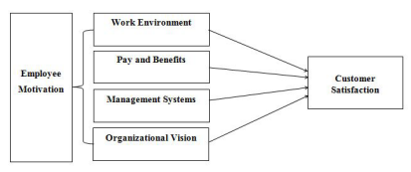

Figure 2.1: Relationship between consumer and employee
(Source: Influenced from Prayag et al. 2019)
After customer experience such as fairness, emotional attachment, corporate social responsibility, and employee satisfaction. The satisfaction effect extension between loyalty, behavioural intentions, and less switching costs is shown by the research. Contented clients will buy again, praise the brand to others, or even recommend the product and service. These results in a circular process where the employees see the converted customers who are happy with the results and the same way are dedicated customers (Prayag et al. 2019). Long-run customer connections can be a moving point for the worker to be engaged in. Satisfied customers are most likely to buy additional services and upgrades. That means more options for employees to try to sell more and offer more. That could be fostering more upselling and cross-selling for the employees. With the chance for more commission through sales and commissions increasing the number of motivated employees looking to do better in their posts is not surprising. The absolute delight of meeting happy customers that give praises and gratitude can as well keep the employees working joyfully. This is not only a feeling of triumph and approval during the interaction, but it will increase job satisfaction as well.

2.5 Analysing impact of efficient strategies for employee retention and brand awareness
Employee satisfaction is among the top concerns for firms in the service industry when we can talk about success. The prime concern in this regard is to boost employee satisfaction because it is the most important factor determining the level of operation of the business in the long-run by making the employees to be more productive and retaining the customers who are the source of income. The objective of this experiment will mainly be to practice the people's involvement in customer services. With the knowledge management, skills, and productivity, employees are the most valuable and priceless assets of the firms (Singh, 2019). Hence, keeping them with the organization is one of the hardest things to do for the managers. Replacement Cost of The Crucial Staff That is involved in Personnel Turnover Is Huge.
Therefore a Summary Retention Policy Is One of the Solution Strategies To Solve Such an Issue. In this regard, the critical analysis started various contributions made in the area of employee retention and present factors which triggered employees to leave and those retention efforts followed to keep them. paradigm of supervision, freedom of decision-making and problem-solving, career advancement and skills development, work schedule flexibility and moving onward career ambitions and expectation on retaining key employees.
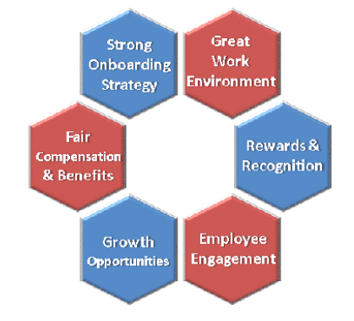

Figure 2.2: Employee retention strategies in hospitality sector
(Source: influenced from Singh, 2019)
Branding that is frequent and strategically wise pays off in terms of building brand equity. To embellish the image of their brand, lodging marketers now tend to build the brand equity via the name of the hotel as the quality of well-known brands often means the quality of the hotel. Sürücü et al (2019), brand equity is a marketer's term that describes the value generated by a brand name, which is recognized as a unit of a company's products as opposed to a generic substitute. Brand equity is created in simple words, which means the product would be distinctive, easy to remember, associated with reliability and outstanding in quality. It is the fact that anything or everything has a name, design, or sign with qualities that makes these things of the same nature be valued more than the ones unknown to the consumer.
A brand story with a plot having a clear framework, extensive cultural connections and a first-person narrator has better perceived brand image. A brand story that is in a logical structure helps customers' imagination with the story of the luxury hotel. Narrative transportation and recognition of the brand image of the luxury hotel can be much more positive. Brand narrative transportation interacts with the relationship between the story shapes of brands (Ryu et al. 2019). The brand story structure should be carefully thought through with the use of the narrative transportation tool in order to achieve brand image sublimation. Hotels convey brand individualism through storytelling. Studies brought to light the fact that if a luxury hotel consumer is to form a higher perception of the brand, this is best achieved when brand elements are delivered in a story involving narratives rather than logic-based advocacies on the functional attributes. This narrative is a great tool which could play a good and advantageous role for luxury hotels in their attempt to convey the abstract advantages to potential guests. Social media can bring newer rewards and benefits in perceiving brand commitment by users. Social media interactivity and rewarding ideas have very great effects in enhancing the brand image (Barreda et al. 2020). Affecting brand commitment and brand image also lead to positive emotional bonding of consumers. Other forms of unstudied concepts can be added to the explanation of why brands have been built using social media. how social media activities, particularly interactivity, psychological effects and prizes influence brand image and brand commitment, as well as the effects of brand image and brand commitment on emotional attachment in the travel context.

2.6 Analysing the links between employee retention and brand awareness for Marriott International hotels
Work performance is interlinked with the elements of how well employees perform their duties and how they behave in the office. Mostly, a business places conversion objectives to the individual employees whereby the employees deliver premium service to customers, operate efficiently and minimize waste. Employee performance is closely related to work quality, production, velocity, precision, and skills effectiveness, and efficiency. One of the very important aspects of effective “Human Resource Management” is job performance assessment that works as a tool in performance assessment and management (Neupane and Khanal, 2022). The evaluation of how staff is an extremely valuable property of the company to run the business. The role of an employee performance management is simply to ensure that the employees’ performances are done to meet the organizations’ expectations. It is basically a science which is known for the management of knowledge. The applications of people who are under its influence are done in a way as to result in positive ideas, skills, competence, and confidence (Hultman et al. 2021). How parent brand attributes influence the success of brand extensions, and what are moderating role brand extension orientation plays in this relationship for the hotel sector.
Positive attributes associated with the mother brand and the attributes that are perceived to have linkages to it, awareness, attitude, and loyalty to the parent brand are the major drivers in perceived enhanced value of the extension. This perceived enhanced value increase, and the magnitude of this increase are higher for step-down extension when compared to step-up extension products. According to Koo and Curtis (2020), the international hotel consumers’ point of view shows just some parts of the extension’s parent brand seems to get positive assessment on the shaping of the extension’s value and the prediction of their return because of it. In addition, the co-integration test finds that the positive relations of this variable become stronger in the case of an extension, especially in the form of a step-down, whereas insignificant relations are in the case of a step-up. While managers should not mistakenly rely on step-up extensions for further gaining marketing advantage in every case, step-down extensions should be seriously considered since the concept proves to be much more useful and a more behaviour-influencing tool.
All these brands have been proven to be effective in building up a storyline that also creates an engaging atmosphere in which the consumer will anticipate to fully satisfy his needs making them co-producer of value. And with respect to hotel business, such brands as Marriott or Hilton hotels might be internationally interpretable as iconic brand types that bind product attributes and establish expectations (Buhalis and Park, 2021). Branding of the travel industry and in particular destination branding is a very difficult job because it is an industry in which to win the loyalty of guests so much is not under the control of the brand makers. In the context of the tourism and hospitality industry, it becomes quite a dynamic process of co-creating brands and experiences within a very complex service eco-system that is very much affected by random and unpredictable factors of the external environment. It is provided with the cultural and familiarity ethos of consumers that defines how brands are perceived, experienced, judged and encouraged.
With international and domestic tourism and hospitality becoming more competes and unifying as business ecosystems, introduces a new dimension of complexities to the branding process. First, originally it was product brand development that manifested in the marketing information departments’ passive acceptance of customers’ signals. Nowadays, the original focus of brand development is becoming associated more with the concept of co-creation that is largely controlled and managed through the proactive customer involvement and contribution to the brand from the large network of people surrounding the brand. Hence, “consumer plays an active part along with the marketer in brand meaning formation while brand exists and does the marketing management and consumer commitment occurring at the same time”. The psychological construction of identity is poorly understood in the waiting sector; however, the creation of a framework that relates to occupational burnout and employee turnover in restaurants would be a decisive step in improving staff retention (Jerez-Jerez et al. 2021). developing focused on defining variables that contribute to occupational identity construction and its implications, as they relate to resignation intention.

2.7 Theoretical underpinning
Herzberg’s two-factor motivation-hygiene theory
Frederick Hertzberg proposed the Two-Factor theory as a Motivational and Job Satisfaction theory. Considering the hygiene and motivator factors it could be said that the motivating factors were considered as quite precious for employee retention and brand development (Tezel, 2023). Job satisfaction has been one of the most significant outcomes of the employees who are very much satisfied with the company along with client acknowledgement. Based on the customer reviews, the tourism industry set their maximum contribution to the organization's goal achievement. Workers are the same people who build or destroy the organization, and they can be seen as resources to the company. After that, getting a job in an organization gives, other than the experience and needs but also wants. Job satisfaction is a kind of combination of positive, and negative that the employees have towards the work. Also, the employees can influence the organization in many aspects. Employee loyalty is among the fundamentals that underpin it (Nyein and Kohsuwan, 2019). Further, it is generally believed that satisfied employees will be loyal to the organization and will be more productive in the long-term perspective. Depending upon the consumer reviews happy employees can be effectively productive and committed to the job, the opposite can be seen with unhappy employees who can turn out to be less useful and are very likely to quit their job.
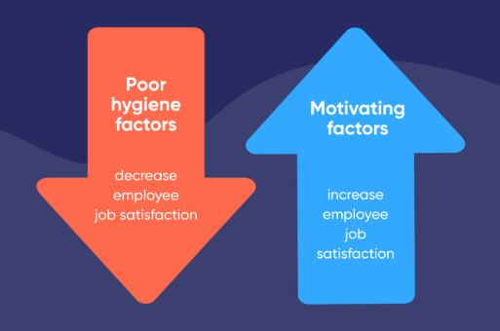

Figure 2.3: Herzberg’s two-factor motivation-hygiene theory
(Source: influenced from Tezel, 2023)

Brand equity theory
Customer loyalty has great importance among advantages that a hotel company earns. The most challenging are balancing the concepts of the brand and the means by which it helps enhance customer commitment. Branding is important in the hotel industry as a number one reason for customer needs for a particular product and service experience (Sürücü et al. 2019). “Brands in the evoked set build certain expectations.” In order to achieve a competitive edge, the hotel industry deploys branding strategies, while consumers label hotels as brands that help them reduce risks when making their purchase decisions. Determining the value of a brand based on a customer's perspective has become an essential duty for hotel marketers. The customer brand engagement is treated as multidimensional constructs comprising three main aspects: (CP), (AF), and (AC) (Algharabat et al. 2019). Using the brand equity approach as a theoretical model, the dissertation seeks to underpin the complex structures of employee retention strategies within Hotel Marriott, brand awareness and perceptions of customers as reflected in the TrustPilot reviews. Therefore, the study will build on the existing literature by providing a differential view of the operation of brand equity principles at the hospitality context specifically within the upscale segment represented by Hotel Marriott.
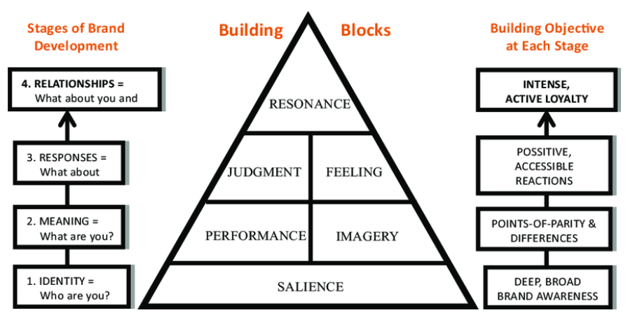

Figure 2.4: Customer based “brand equity theory”
(Source: influenced from Algharabat et al. 2019)

2.8 Conceptual framework
Customer reviews on trustpilots and employee reviews from Glassdoor effective for employee retention and motivation
INVESTIGATING THE RELATIONSHIP BETWEEN EMPLOYEE RETENTION AND BRAND AWARENESS: AN EXPLORATION STUDY OF MARRIOTT INTERNATIONAL CUSTOMER REVIEWS ON TRUST PILOT AND EMPLOYEES’ FEEDBACK ON GLASSDOOR

Analysing impact of efficient strategies for employee retention and brand awareness
Depicting the impact of trustpilot reviews for generating brand awareness for Marriott hotels
Brand equity theory
Herzberg’s two-factor motivation-hygiene theory
Critical analysis of the impact of consumer satisfaction in developing employee motivation within the hospitality industry
Theoretical underpinning
Analysing effectiveness of trustpilot reviews for employee retention in Marriott hotels

2.9 Literature gap
While a vast amount of studies considering the importance of employee retention for brand awareness and customer perceptions have been already conducted, upscale hotels like Marriott still remain the topic for further in-depth study. Even though limited scholarly attention has been paid to the investigation of the specific interplay between retention strategies and brand awareness of Marriott as a case in point (Kim, 2024). The former’s niche sector has been neglected, especially when the latter is prominently represented by the customer reviews on social platforms such as Trustpilot along with employee reviews from Glassdoor (Wilson, 2022). Since there is too much literature focused on either general information on employee retention and brand management or has hardly eliminated the gap of their perfect understanding in relation to employee satisfaction and loyalty towards the formation of brand image more especially in the case of Hotel Marriott.
More so, the current research mainly hangs on the conventional metrics of consumer satisfaction while neglecting the growing role of online forums of which consumers use in the creation of their current attitudes. Trustpilot as the major player in this context creates a peculiar corner for encouraging employee retention, customer experiences, and brand awareness (Algharabat et al. 2019). Hence, there is a high requirement for a study with the exploration purpose that investigates the connection between employee retention strategies implemented by Hotel Marriott, customer reviews on Trustpilot and the consequential effect on brand awareness.

2.10 Implication of the literature review
The review of literature possibly comes with prior research as well as theories about what relationship between employee retention and brand awareness does really exist. It assists in conditions to know why employees' engagement and optimization should produce positive grey wash. The two subjects are destination branding and residents branding as well because those will really touch the hearts of visitors. Those addresses or contacts have an internal part that is external and is forming a picture of the destination towards the audience. Beside the attitude of locals, their role during the trip is essential, and being integrated has been proven to be very effective, as they share their facilities and resources. As such, it is vital that they are addressed and be involved in the branding of tourism. Employees live the brand, stepping into the role of the brand ambassadors and reinforcing the image of the company on the support side. Companies ought to have staff members who strive for and engage those people who have burning desire and inspire the organization.
Through researching literature on customer reviews, especially from social media platforms such as TrustPilot, enables one to form up a deep understanding of how customers' perception of and evaluate hotels depends on their prior stay as expressed online. The ability to recognize the implications of customer reviews is very crucial in the structure and performance of a brand. Explore the academic work on TrustPilot and similar web platforms to better understand the way customers assign trust and relevance to reviews. Various businesses rely on client reviews to shape brand perception, especially because these reviews are considered influential on the part of the customers. Consequently, literature review is not only a source of the questions addressing the issue and research methodology chosen, but it also provides temporal and geographical perspective locating the study within the academic landscape. It offers a theoretical groundwork and gives practical explanations that allow the significance of the investigation on employee retention and brand awareness relationship in hotel Marriot to be justified.

2.11 Chapter summary
By summarizing the sea of literature on employee retention, brand awareness, and customer reviews in the hospitality industry, this review responds to the overview of what is currently known in the field. There were some main ideas and insights, which provide the fundamentals for the searching of the context of the Hotel Marriott International in the rest of my dissertation. Numerous studies have focused on the significance of employee retention as the key factor contributing to organizational success, notably in contemporary service organized hotels. Over the years, researchers have investigated in-depth the link between employee satisfaction and customer experiences where a positive relationship between the contented employees and favourable brand perceptions has been established.

Chapter 3: Methodology

3.1 Chapter introduction
Online platforms like Trustpilot became places where customers exchange their stories about products or services, whether positive or negative. As this study concentrates on the possibility expressed through the medium of TrustPilot, which is doubtlessly abundant in customer reviews, and the core issue that the employees' retention rate at Hotel Marriott has and will have on the brand awareness. Walking through the candid narratives and comments from customers, this seeks to elicit what part of the Hotel operation, particularly the employee retention, does affect the public opinion publicly. The research, while it is in question and also necessary, is important in fortifying strategies that would sustain the quality brand image of the Hotel Marriott International. The hospitality sector naturally consists of big rivals and fervent competition environments as well as the relatively unending strive for perfection in service provision. In this background employee retention comes to the surface and is a paradoxical influence on the brand perception from employees. The company attempts to establish and reinforce its brand identity sense; consequently, it becomes obvious that the complex relationship between the retention of employees and brand awareness is important to them. This research concentrates on the interplay between the aforementioned two elements for Hotel Marriott, the leading player of the hospitality sector on a global scale.

3.2 Research onion
The research onion offers a systematic route for study design and implementation that narrows down choices and decision-making to the logical level. The research paper in the dissertation has its major significance in constructing philosophical assumptions, selecting research design alternatives, and structuring the research with the entire required rigor (Saunders et al. 2019). It promotes the critical analysis of researchers, who should focus on the rationality of their strategy. Thus, it contributes to the transparency and the logic of the research process. Theoretical framework that, assists researchers in doing in-depth analysis on what factors emanate from the "doing research study" phenomenon. Through the onion imagery, the symbolism of multiple levels of details and complexity is given to understand how the protocol of research should be carried out. The research onion is effective in portraying a particular research methodology so that the trust pilot reviews would have the best implication on the employee retention along with the brand awareness within the hotel Marriott International.
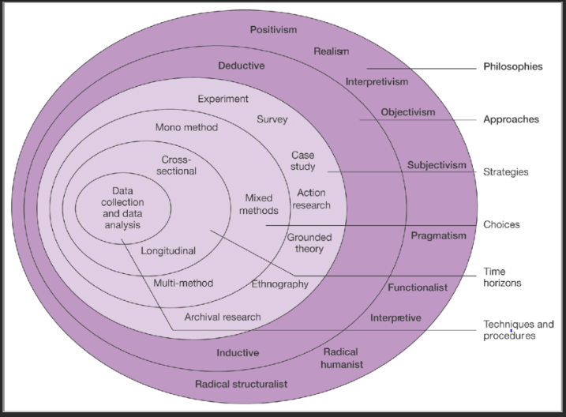

Figure 3.1: Research Onion
(Source: Saunders et al. 2019)

3.3 Research philosophy
The worldview is taken on the grounds of the assumption that truth is not universal and hence more accurate is to investigate it through the perceptions and experience of the people. Interpretivism enabling to really delve into the reasons customers are giving on TrustPilot by exploring the meanings and interpretations they have attached to their self-searching experience. This approach looks at the quality and calls for originality to follow up and discover the depth, breadth, and unique attributes of all participants who loosely revolve around employee retention and its impact on brand awareness for the hotel Marriott. This view from the interperivist side of the study fits well with the unknown and unlimited condition of the study. It assists to extract new discoveries that haven't been well-defined before, which could turn out to be quite a revelation to explore all spectrums of a subject. Interpretivism is integral to tailoring and giving highly specific recommendations (Alharahsheh and Pius, 2020). By reflecting on the human-side of the issue the interpretivists approach promotes diverse solutions for Hotel Marriott to ensure continual improvement of employee retention strategies and the hotel’s public image and recognition that are customer-centered and favourable.

3.4 Research design
Descriptive research in Hotel Marriott further anchor results within the unique social setting of the hotel. Through venturing into the customer reviews on how the hotel's unique characteristics and operations form the opinion that the quality of employees and customers brings about a high brand awareness. By cutting through the comments in the TrustPilot reviews of customers, this is highly effective for setting out the key themes and patterns. Descriptive research gives an opportunity to showcase a descriptive account of people’s sentiments and perceptions (Gopalan et al. 2020). This allows us to figure out the challenges retaining employees pose to a brand’s popularity. Descriptive research contributes to the development of wide-ranged and crisp recommendations explicit of the setting in question. Given the analysis of the specific circumstances in the feedback, it might recommend tailor-made practices for employee retention, which confirms the customer expectations and promotes brand awareness. With an eye on the customer centered retention practices and their importance, the hotel can make better decisions that will improve the brand image and overall consumer satisfaction.

3.5 Research strategy
The usefulness of a qualitative research strategy in dissertation on "Investigation on Employee Retention Influence to Brand Awareness in Hotel Marriott: 'A Study of TrustPilot Customer Review" presents a unique possibility to conduct deep research, explore the details, and touch upon human complexity thoroughly. Qualitative research lets the researcher have a comprehensive perception by collecting information that is complex and rich, utilizing, among others, focus groups and the analysis of customer reviews. This way, detailed perspectives about the influence of the rate of employee retention on the awareness of the brand of the Marriott Hotel can be discovered. Since qualitative research specifically explores how employees and customers relate to brand awareness and employee retention experiences, qualitative research is well-suited for the meaning and perception exploration of employee retention and brand awareness. It gives the participants a chance to tell the story in their own way which results in the unique details about the phenomena from the personal perspective (Gray et al. 2020). Humanistic research is suitable and effective to disclose the layer of hidden nature and help understand the problems in a more holistic way. Exploring the specific case of Hotel Marriott as well as the organizational culture, where employees specifically view retention practices can make a difference and whether it affects organizational brands or identity is part of the investigation.

3.6 Research approach
An inductive form of reasoning, which usually brings to light new aspects, such as patterns, relationships, or insights, is ideal for the studies that are meant to be exploratory. Since, the study enquires the role of employee retention in the brand awareness via customer reviews that are novel, therefore, the inductive approach grants the opportunity to deep dived into this new territory. Inductive research is where the researcher assembles data and analysis without having any pre-established hypotheses. This process lets ideas emerged from the data in its own way and without the need for existing assumptions. After considering the reviews customers make at Trustpilot to ensure that the study implementation and idea validation are not get biased. The Inductive approach along with the study helps to know how employees’ retention impacts brand awareness from the customer’s eye-point. Human features, especially the ones related to products and customers audience of attitudes, tend to be complicated and have many facets (Casula et al. 2021). Inductive research allows having a look at these behaviours from different angles that accommodate a general investigation of how employee retention shapes brand perception.
This probably outcome is perfectly aligned with the aim to probe the issue from different perspectives within the study. Since the research entails the analysis of customer reviews, then can use an inductive mode of attack to derive information-rich, qualitative insights from the data. Thus, it can allow dynamic transformation of themes and aspects via customers, which gives the broader scope to capture clearly. The multiple indications of their experience in employees’ retention programs and brand management are useful based on the inductive approach; no other can be justified (Vears and Gillam, 2022). To conclude the project inductive research results provides a basis to improve effective decision-making of Hotel Marriott and other organizations in the hospitality sector. Through acquaintance, with relation of employee retentions to brand perception among customers, Marriott can develop right employee strategies, this helps in amplification of brand awareness and customers satisfaction, and hence better business performance can be attained.

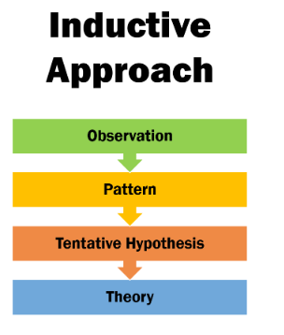

Figure 3.2: Inductive research approach
(Source: influenced from Casula et al. 2021)

3.7 Data collection and analysis
The data for the present study has been collected from the trusted online sources. The trust pilot reviews from authentic sources such as, BBC, FT, Tweeter, Company websites, LinkedIn, Ambitionbox, Glassdoor etc are considered. About 90 online reviews of the Marriott hotel have been considered for aiming to represent the answers of the research question. Along with this, considering employee reviews from the available websites such as Glassdoor to understand if employee retention is truly dependent on the basis of customer review for the Marriott hotel. This can be accompanied by the company portfolio of employee retention at that particular geographic location. Multiple repetition of the context of data is strictly avoided; however, representation of the online reviews which are specifically of the diverse themes while representing the similar contexts based on brand awareness and employee retention are utterly considerable..
The analysis has been settled to be included with the thematic representation. The reviews that are collected from the trusted sources based on the Marriott hotel. Decoding the reviews while making sub-themes as per the proposed research questions have the top notched authenticity in order to meet the research criteria. Transcription of the reviews is helpful in demonstrating exploratory research fundamentals. This is also helpful in developing the trustworthiness of the research finding based on the published online reviews.

Prisma framework for customer review collection from trustpilot

Records identified from*:
Trustpilot reviews for year 2020 (n=1600)
Trustpilot reviews for year 2021 (n=5650)
Trustpilot reviews for year 2022 (n=2350)
Trustpilot reviews for year 2023 (n=1535)
Trustpilot reviews for year 2024 (n=2155)

Records removed before screening:
Removed records based on language (n= 11,000)

Identification

Records excluded**
(n = 590)
Records screened
(n = 2290)

Records sought for retrieval
(n = 1700)
Records not retrieved
(n = 1000)

Screening

Reports assessed for eligibility
(n = 700)
Records excluded:
Reason 1 : matching study context (n = 500)
Reason 2 : unavailable for analysis (n = 150)

Records included in the analysis
(n=50)
Included

Prisma framework for employee review collection from Glassdoor

Records removed before screening:
Removed records based on language (n= 10000)
Records identified from*:
The Glassdoor review from 2020-24 (n=14000)

Identification

Records excluded**
(n = 3000)
Records screened
(n = 4000)

Records sought for retrieval
(n = 1000)
Records not retrieved
(n = 700)

Screening

Reports assessed for eligibility
(n = 300)
Records excluded:
Reason 1 : (n = 110)
Reason 2 : (n = 150)

Records included in the analysis
(n=40)
Included

3.8 Data reliability and validity
The characteristics of reliability and validity of data is effectively helpful in accumulating accurate data for the current research. This measure is also helpful for making smooth consistency for developing credible findings based on the research questions. Analysing data which are mostly authentic for the present study is the most effective implication of data reliability and validity. Developing appropriate research strategy thereby mist authentic and crucial data based on the trustpilot reviews of Marriott hotels is the most replicable impact of adherence to the measure of data reliability and validity.
Increasing consistency based on the varied aspects of data along with its management on the particular research is the key aspect of using reliability and validity as per the conduct of the study. As the study deals with the original reviews that have been posted on several trust pilots such as Twitter, company websites, Glassdoor, linkedIn etc so prioritising the authenticity of the data collection based on the topic provides utmost value for the research.

3.9 Ethical consideration
The standards adhered to conduct research prevents plagiarism and make the research solid which facilitate the verification of its findings. This is a principle of research that is very crucial as it signifies that all the data will be retrieved and analysed based on the research objective, with no harm of lending to anyone in the research process and or intention. The paper credibility of the research is done well when the authors are acknowledged appropriately with the necessary citation to do so. Conforming to the policy of anonymity remains the best interest in this research work. The statement relating to the manipulation of the data with the aim and objective of the research is not allowed. In particular, data keeping will be the only aspect neglected to ensure the research is conducted in an appropriate manner.

3.10 Chapter summary
It starts by characterizing the philosophical aspect, then it adopts the interpretive brand of discussion which focuses on employee retention and its subjective experience and the meanings attached to the impact it makes to the brand. The selected research strategy is qualitative and the data collection instruments used is the customer reviews at TrustPilot. The thematic approach as the main method to catch all repeating topics and ideas from the Marriott reviews are highly attractive phenomena. This is effective to get a complete view of the role of the employee retention practices and ways they impact brand image. To summarize, this chapter sets forth the research methodology, which involves a purposeful and specific context to examine the employee retention effect on brand awareness at Hotel Marriott. Research design that falls under the interpretivism paradigm, guides to an appreciation of the levels of customer subjectivity provided by the nature of these reviews.

Chapter 4: Findings, analysis and discussion

4.1 Chapter introduction
This study explores the staff retention tactics of Marriott International, Inc. Furthermore, includes insights from an evaluation of a pilot study. Marriott employs around 148,000 individuals around the world, thus its capacity to hold ability has a major effect on the type of its services and picture as a brand. It mean to assess the effectiveness of Marriott's efforts in establishing a blissful workplace and keeping skilled employees even with obstacles like high turnover rates and the difficulties of a diverse labour force by closely looking at representative criticism and retention indicators.

4.2 Trustpilot reviews and analysis for hotel Marriott International

4.2.1 Challenges occurred in brand awareness based on the consumer feedbacks in hotel Marriott
- Customer responsibility management
The reformation in service industries discussed continuously is the reason why current business practices are changed around the world. However, the consumers’ pattern of behaviour keeps changing endlessly in online and offline businesses. Consequently, service providers are forced to think out of the box, to understand the dynamics that affect consumers’ purchase behaviours and the major reasons for the observed deviation (Singh et al., 2022).

“Big shout out to colleagues at Marriot Twickenham stadium hotel. I’ve stayed a few times , usually rugby related . I emailed a colleague there today and asked if he could sort my rooms out for an upcoming game. No bother and constant communication. Saved me a lot of hassle and I know that everything is in place. Thank you Borja . Great customer service. (Date of experience: 03 May 2023)”

Customer relationship management (CRM), customer loyalty and consumer commitment, consumer services, consumer behavior and customer satisfaction, brand’s influence & ensuring consumer service & having fulfilling experiences. Creating and nurturing innovative culture and using it to develop brand awareness grounded on client comments in the hospitality industry, bears a range of obstacles (Keiningham et al. 2019). This might have an effect on e-customer’s behavior, cross-channel environment, service satisfaction, consumer behaviour and decision-making process, shopping convenience and fulfillment, service quality, customer satisfaction, and service delivery experience from a customer.

“More information should be provided to guests about what the delta hotel Milton Keynes is being used for. ……Shame we won’t be back as the hotel was in the perfect location for business travel. (Date of experience: 19 July 2023)”

“Recommend Victoria for all corporate event tours and enquiries.
Our visit to the Marriott in Waltham Abbety has been excellent. ….We appreciate herself going above and beyond to assist us during our visit. On behalf of our company, we Highly recommend! (Date of experience: 30 September 2021)”

Customers have seen the businesses of today lead via an effective integration of digital avenues in relationships management. Social, cultural and personal factors, such as age, occupation, status play important roles in shaping consumers behaviours. On the other hand, consumer behaviors impact consumer purchase intentions. Consumers frequently rely on service quality to be constant over all link-up points. Building an innovative atmosphere and working hand-in-hand with standard service delivery consistently is a difficult endeavour, because many times new ideas and processes do not match well with the established standards (Buhalis and Park, 2021). Consumer surveys create an opportunity for a market-player to capture views of the evolving trends and customers' needs and expectations. But, on the flipside, to ensure that a brand takes these insights into account while mapping out its innovation strategy, there is a need to adopt a flexible approach and a willingness to adjust the strategy quickly in response to evolving consumer demands.

“Stayed at the hotel Marriott in Birmingham 24/07/21 for two nights. Had an excellent experience. Large comfortable room with excellent facilities. Good air conditioning too. Staff were warm and welcoming. Excellent access to city centre. ………………… Would definitely recommend this hotel and will be coming back! (Date of experience: 26 July 2021).”

“Swindon Delta marriot
Went to a wedding and just wanted to say the staff were brilliant, …… I honestly couldn't fault the staff.
Thank you 😊 (Date of experience: 02 September 2023)”

Measuring the exact influence of creative programs on buyers’ consciousness could also not be easy. However, a consumer’s review cannot be exactly at the specific innovation that has occurred. Therefore, it’s hard to give an accurate link between the brand perception and innovation, making future initiatives seem not crucial enough (Boella and Goss-Turner, 2019). Innovation will be Marriott’s primary lift as it strives to find an edge over rivals. Marriott must not lose the focus of changing industry trends and consumer expectations while it tries to maintain the lead.

“Myself and 2 friends have just had a night away at Marriott Peterborough, I am local to the area but haven’t stayed/used the hotel for many years and my friends came from Leicester and London. …………………….. We would absolutely come back again in the future and recommend it to others. Thank you. Lucy/Nat/Zena (Date of experience: 10 September 2022)”
- Poor service quality
Parent brand attitudes are important for extensions brand perceived values in the hospitality sector and these relationships are modulated depending on the type of product for extension in question. Referring to the brand equity logic, the study argues that if the consumers attribute the brand positively, become aware of the brand, display positive attitudes and show their loyalty towards the parent brand then there will be a strong positive relation between that and the higher value attributed to the brand extension. On the other hand, the step-down extension will have a more positive impact than the step-up extension.

“Fantastic service - never experienced anything else. Alvaro Menendez has been fantastic. Thank you Marriott (Date of experience: 27 February 2023)”.

“Their Moxy branches have incompetent and low level people who do not understand any customer service. …….. …….. Speaking to Marriott on this and they argued instead of fixed their staff issue. They tried to bribe me instead but they can actually be sued for their disgusting behaviour (Date of experience: 04 January 2022)”

It seems that as long as a brand behaves with its own character and acts as it owns success, only then transfer of specific brand association to product extension as well as revisit intentions of it are positively influenced. In addition, within the framework of the results of moderations, it has been revealed that the existing effect of relationships become stronger when those relationships are longitudinal and step-down extensions and become insignificant when the relationships are cross-sectional and step-up extension (Hultman et al. 2021). Hence managers are requested to follow this principle with moderate degrees, as these degree of steps-up extensions doesn‘t create such value for consumers and no perception of customer value could be neither derived nor possible behavioral intentions. However effectiveness varies in the cases of step-down extensions.

“My stay at Marriott was outstanding. I had booked a standard room, but upon arrival, the front desk manager, Emily, surprised me with a complimentary upgrade to a suite! The suite was luxurious and offered breathtaking views of the city. Throughout my stay, the staff were attentive, and their attention to detail was impressive. Marriott Hotels truly exceeded my expectations! (Date of experience: 01 June 2023)”

Constant substandard service levels tarnish the brand by lowering customers' trust in the brand. Customers might have a conflict of mind and would wonder whether Marriott is dedicated to customer satisfaction and reliability, which can eventually erode the brand credibility and erode its brand awareness which would make the situation worse. Low quality experiences discourage customers from being the brand loyal of Marriott hotels in subsequent visits (Alnawas and Hemsley-Brown, 2019).

“I was very upset with my stay at Hanbury as I came to stay for the amenities…
I wanted to not only use the pool, but the gym also I was very disappointed as the gym had a trainer named Lilia who has her bag and clip board, and sits on the equipment while guests are trying to use it…
She runs her business out of there … a gentleman in the gym went to use a part of the equipment and she said you cannot use that I am using that… ……. ….I have stayed at many high End hotels including marriott and never experienced such a thing. (Date of experience: 22 January 2022)”.

“Writing this review at 4am in the morning after being again woken up by Moxy Slough having deliveries of laundry. I'm a neighbor and my life has been hell because of this inconsiderate hotel. Please don't support a business so inconsiderate to the local community. (Date of experience: 08 September 2023)”

Repeat sales will pay dividends in maintaining the brand ever-present in the minds of customers and having them loyal. Customers of Marriott, when they decide to go with the competition due to the inefficiency of the service, the brand’s visibility get lessened as well as its market share Quality of service, which is a key element of the brand, is an intrinsic feature of an ideal branding. Customer's negative feedback can extremely spoil Marriot's image, which answer "unprofessional, indifferent and unreliable" to mention some. These unfavourable views could persist, making Marriott’s brand awareness lower, and damaging the ability of the customers to want to book accommodation there.

“I recently stayed at Courtyard Edinburgh with the family. Loved every minute. Superb interior room clean and location, fantastic welcome etc. Will definitely return! (Date of experience: 18 April 2020)”

“We parked with Marriott Courtyard Gatwick during a family holiday 23/24. On returning to the car, it was underwater. ………….. Their response was that they accept no liability for the duty of care of the car. (Date of experience: 07 January 2024)”

4.2.2 Fall backs of employee retention strategies that employee suffer within the hotel Marriott International
- Management problems at the workplace
Conservativeness in the leadership or the vagueness in the decision-making structures leads to misunderstandings and annoyance among employees. Whenever managers are not explicitly clear what to do as a team or do not do as they say then the job may lose its attractiveness and disaffections may come with their sudden departure. Lack of good communication from the management can result in the loss of employees' commitment and their unwanted disengagement. Managers are inept with regards to making clear their expectations from employees, changes within the organization or avenues for advancing their careers, employees may feel devalued, hence, it will be difficult for them to connect with the organization (Garavan et al. 2021). Micro-management minimizes employee’s freedom and creativity; soon negative impacts on job satisfaction and morale are inevitable. It is needed that the managers modify their way of working a bit and do not do it on their own but act in advance like being too much involved is not a good option for employees as they may become unmotivated and roles will be specified more. Managers who ignore by not refusing to sufficiently notice and compensate the relevant workers may turn them into less enthusiastic members of the company who just want to get their paychecks and then leave for home. Ahmad et al. (2021) have stated that when the evaluation is not treated fairly or when there are no chances to evolve and to be rewarded, employees feel estranged and may look for recognition in another place. The duty of managers lays on the distribution of the workload among workers in such a way that fairness is ensured to avoid the burnout and to satisfy the employees. Managers must learn to get staff to work evenly if workload imbalances are not sorted out or the employee is not provided the needed support by the manager, it can lead to more stress and staff turnover.

“Hanging on by a thread..
Server
Current employee, less than 1 year
Nashville, TN
Recommend
CEO Approval
Business Outlook

Pros
Fast paced, money can be good

Cons
No management. Hostile work environment. Harassment prevalent and if you complain people ignore you like you're a problem for bring it up. The Gaylord brand is not living up to what it could be and once was...sad

Advice to Management
manage, set standards, and give 5 star service not like walking into the hotel wad a burden… (26 Jul 2022)”

- Employee competency issues at the workplace
Training programs are not at a par or have missing topics; employees will remain unaware of how they can be in the know and how to do their roles correctly. If training programs do not consider all aspects of the job or lack practical sections, employees may easily face a situation when they cannot achieve performance expectations, which may, in turn, cause lack of motivation and, possibly, increased turnover. According to Neupane and Khanal (2022), the items that are contemplated are skills, knowledge, abilities, attitudes, self-assurance, and accuracy & time perspective. Thereafter, the research study showed all dimensions of employee performance highly correlated based on employees themselves score on the scale of expression which is not greater than five. The effect of born-on-the-job training on employee productivity, the effect of out-of-the-room training on employee productivity, and the impact of internet training on employee performance in Marriott worldwide hotels. Employees applaud companies that provide for continuous development of their competencies. The career development of employees is tremendously affected by training programs that do not give them the scope to develop more skills or acquire new ones. The employees may get to the point that they feel stagnant at their jobs and our only option may be to quit and seek employment elsewhere where there is a chance of professional growth. As per the opinion of Zheng et al. (2022), instructional programs will inevitably reflect their efficiency. The productivity of staff may be low if the training techniques adopted are old-fashioned or they do not attract the workers well or they fail to captivate the employees effectively, and thus learning retention drops, and employees become disengaged. Instructional and kinesthetic training methods can possibly be better in inspiring the sustenance of an employee's interest and in acquiring a skill.

“NO breaks, NO sitting.
Front Desk Agent
Current employee, less than 1 year
Springfield, PA
Recommend
CEO Approval
Business Outlook

Pros
Guests are nice, and the discount is great.

Cons
You can't SIT! EVER! One of Marriott's goofy standards is that front desk people must stand at all times. Normally you work alone so forget taking a decent break. Forget breaks completely. They don't exist, because with Marriott you are a ROBOT who must only do one thing, SMILE, and STAND. The standing standard sends people running because who the heck wants to stand for eight hours straight with your only sitting breaks being bathroom breaks. Since most Marriott properties are short staffed you won't get a break, EVER.

Advice to Management
Let people SIT! Letting your front desk agents sit isn't going to kill the company, if anything it will make you look like a compassionate, and caring company. (23 Jan 2023).”

4.3.3 Recommendation towards employee retention along with developing brand awareness for the Marriott hotel International
With more and more strategic managers involved, the hotel would be beneficially integrating and coordinating the supply chain processes and systems with their key partners. Hence, the company may enhance and restructure the ways of delivering information, by introducing the newest data produced every day that can be applied to bring changes and smoother operation of the purchasing function. As per the opinion of Daghfous and Belkhodja (2019), they do that by using primary sources and expertise to find their suppliers and narrowing down key suppliers’ viability through the performance and base optimization procedure methods. Centristically, those procurers with more transactional attitude focus on the outputs of the crucial supply chain aspects, and spend fewer resources on the optimization of the supply chain.
Encouraging staff to take responsibility of their work adopt their opinions and contribute to decision making thus increasing the feel of independence and sense of accountability. This task requires imparting aspects when needed and allowing staff the authority to invent and solve problems by themselves. Instilling value to team members not only by recognizing and praising their separate efforts but the values and outcomes the team has achieved together. The creation of an incentive system oriented on the results, job bonuses, and the public appraisal of the employees who follow the rules. Providing educational support for career advancement and life-long learning as well as on-the-job training programs (Hassanein and Özgit, 2022). Provide mentorship initiatives, job swaps, and introduce internal career growth opportunities so employees can advance, stay connected to Marriott, and remain engaged. To ensure brand congruity, the employees need to be educated about Marriott's brand values, mission, and unique selling points. The training needs to be conducted on a regular basis to instill the brand messaging in their employees minds. The brand ethos shall emanate from each of the team members during their communication with the guest and other colleagues. In addition, all these people shall work together to continually create a brand experience that is consistent.

“Great in Perks
Senior Global Sales Executive
Former employee, more than 1 year
Gurgaon, Haryana
Recommend
CEO Approval
Business Outlook

Pros
It is employee friendly company

Cons
Management could be better and rest assured you will enjoy

Advice to Management
Chill (29 May 2021)”

4.2.4 Impact of the review system for the analysis
Employee recognises the review system when it is done fairly. Performance matrices along with developing smooth communication and transparency are the two most important aspect appreciated by the employees based on the review system. Employees like when administrative support considers the employee's desires on career advancement and provides the plan to achieve the objectives. Two-way Communication on Reviews can be a very useful conversational tool if they are not a single way broadcast. Staff members appreciate the chance to speak their minds and showcase their knowledge and priorities with their co-workers. Hearing and understanding seem to be the building blocks of the spirit of trust and respect in the working environment.
TrustPilot, being essentially a customer review platform, puts emphasize on and shines the spotlight on the reviews of customers about the different businesses and their products or services. Though Trustpilot can be a powerful marketing tool for companies to win over the customers and the credibility for the workers as well, impact for the employees of the staff retention is limited. The fundamental aim of Trustpilot is to base the program on feedback from clients and is not meant to seek feedback from employees. Even though positive reviews that customers leave encompass the employees with the best reputation in the industry who deliver impeccable services or products, the platform itself does not have any feedback to protect or collect the same from the staff. Unlike those employee engagement platforms including the employee satisfaction surveys or performance lever systems that exclusively support direct interacting with employees, Trustpilot does not facilitate this. If staff don’t have a way to share their experiences, give feedback or make suggestions privately, its influence on high turnover will remain elusive to say the least.
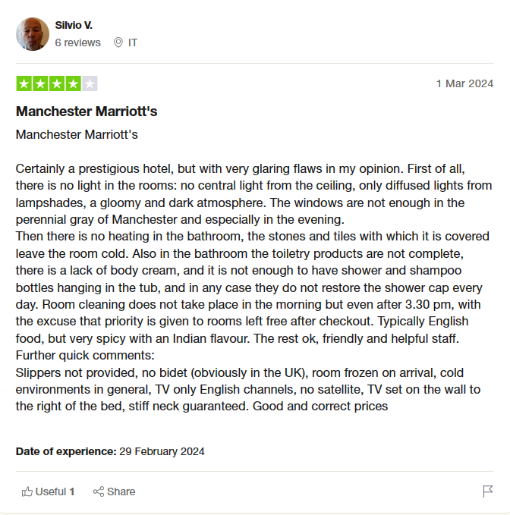

Figure 4.1: Example of a trustpilot review and employee feedback
(Source: uk.trustpilot.com, 2024)
Moreover, utilizing the benchmarking approach, through the lens of Glassdoor reviews for gaining more comprehensive understanding of the situation. Glassdoor is a channel which people who are employees of this companies or those who were the companies’ earlier employees share their experiences anonymously, for instance company’s culture, leadership, salary payments, and job advancement. Through contrasting of the sentiment values and data of the Glassdoor reviews with customer satisfaction scores and brand perception ratings of the Trustpilot reviews, researchers can bring out for more detailed perceptions.
Nevertheless this is not the only aspect of employee retention but more personal interviews on the Internet not conducted during picking these analyze lines.
Marriott's brand awareness could grow as a result of effective retention of employees, in line with Herzberg’s Two-Factor Theory of motivation(also known as the Motivation-Hygiene Theory), in which this concept will be explored in a research where Trustpilot’s anecdotal reviews are collected for the Marriott hotels. Herzberg's view point is that he found out those components in the jobs (Satisfiers) that make individuals happy and those elements that make them unhappy (Hygiene factors) (Peramatzis and Galanakis, 2022). Through the interpretation of Herzberg's Two-Factor Theory in the context of consumer ratings for Marriott hotels on Trustpilot, it is important to be able to note mood and demonstration priorities and how they hence corroborate and eventually project brand awareness. Positive reviews which exposition the fields of employee experiences create conditions of job satisfaction, motivation and loyalty that make staff to stay with longer periods which in turn resulting to the improvement of companies' brands among its customers (Chiat and Panatik, 2019).

4.3 Discussion
A critical component of organizational success is representative retention, especially in the hospitality sector where customer satisfaction is of the utmost significance. The overall hotel organization Marriott International, Inc. must contend with the two opportunities and difficulties in keeping its staff. This discussion compares and contrasts the viability of Marriott's staff retention tactics with their effects on the organization's general execution and brand awareness.
Advantages of Marriott's Staff Retention:
- Obligation to Representative Satisfaction: Despite fluctuating ratings among reviewers, Marriott's retention score consistently demonstrates a guarantee to worker satisfaction (Kurdi and Alshurideh, 2020). Employees who work for an organization that maintains a positive workplace and offers possibilities for development report with best HRM practices are more noteworthy levels of occupation satisfaction.
- Cutthroat Retention Score: Marriott continuously places in the top half of businesses of a practically identical size with regard to retention, even with rating swings. This implies that when contrasted with competitors in the business, Marriott's retention efforts are nearly successful along with its HRM protocols.
- Marriott's retention efforts seem to include recognition and awards programs, based on the good comments made by workers about the corporation and their HRM policies. Representative dependability and confidence can be increased through recognition programs, which lower turnover rates leads to brand awareness.
The drawbacks of Marriott's representative retention strategy:
- Marriott has a by and large positive retention score, but there appears to be some fluctuation in representative satisfaction levels based on the scores given in various evaluations. This implies that staff retention might be troublesome in some areas or places.
- Raised Attrition in Specific Divisions: The meticulous examination indicates that divisions like Customer Success and Communications can experience raised attrition rates in contrast to other divisions like Design and HR (Boutmaghzoute and Moustaghfir, 2021). The disparity in retention rates might be a sign of problems with organizational culture or occupation satisfaction specifically departments.
- Influence on Brand Reputation: Variations in representative retention might affect how customers view Marriott's image. High turnover rates can severely influence brand dependability and awareness by causing service interruptions, lower efficiency, and at last, lower guest pleasure.
Impact of employee retention on brand awareness with Herzebeg theory of motivation:
Motivation of the employees at the Marriott hotel is a critical variable which is dependent on the influences of recognition, accomplishment, and professional growth.
Astonished staffs who appreciate and enjoy motivating factors keep giving their best service to customers that keep customers happy with positive reviews on the Trustpilot for instance (Sobaih and Hasanein, 2020). Consistent positive reviews with the help of best practices along with policies with behaviour will be indicating exceptional customer service and guest experiences are the weapon of this hotel in resonating brand awareness among prospective guests who also read the praises and reviews of the hotel.
The hygiene factors including the environment where the employees work, company policies and interpersonal connection can not only determine how long an employee work for Marriott but possibly impact their level of satisfaction with their employment (Shaikh et al. 2019). Solving these issues by modulating policies timely will ensure the company's continued growth as fewer employees will be disappointed and quitting.
Along with this employee dissatisfaction results in a demotivation of the workforce, their consequent deliver less quality service, and negative reviews on trustpilot or glassdoor meaning that the quality of the hotel brand is being questioned.
Involved staff, whose minds are set on the job and who are at the same time motivated and happy, are the ones who are most likely to provide the best services to the customers. Customers' overall experience of high quality service with employees is a critical factor for getting favorable reviews on the multipurpose website, the Trustpilot (Bhatt et al. 2022). These evaluations prove, Marriott puts the customer first in the process which, consequently, make the brand more known and draw new clients to Marriott hotels. Hence, providing recognition to the employees along with receives and training are efficient in order to achieve employee retention at the hotel.

Comparison with Rivals:
Wyndham Hotels and Resorts, Hilton, Hyatt, and other adversary companies' staff retention tactics can be contrasted with Marriott's. Marriott may be a forerunner in some areas, similar to development prospects or recognition programs, yet it could miss the mark in other others, such as taking care of division specific turnover problems. In contrast, industry trends show that for businesses hoping to attract and keep top ability, worker retention is turning out to be increasingly vital (Hassan and Govindhasamy, 2020). In a work market that is exceptionally serious, companies such as Marriott need to adjust their retention tactics on a constant basis to address the issues of their labor force and follow industry standards.
Marriott's staff retention tactics demonstrate the two advantages and disadvantages, in summary. Concerns about departmental turnover rates and possible effects on brand reputation persist despite the organization's cutthroat retention scores and dedication to worker satisfaction. Marriott should concentrate on resolving specific departmental challenges, further developing recognition and incentives programs, and planning retention efforts with industry trends and worker expectations to further develop representative retention and eventually positively boost brand awareness (Zayed et al., 2021). Marriott can sustain its upper hand in the industry and solidify its position as a top hospitality supplier by putting worker satisfaction first and executing focused retention strategies.
Any organization must focus on representative retention, yet it's especially basic in the hospitality sector where client pleasure is foremost. As one of the biggest hotel chains all around the world, Marriott International, Inc. must keep a labour force that can consistently convey excellent service and a positive guest experience through its extensive arrangement of locations. Examining representative retention scores from websites like comparably provides important information about Marriott's initiatives around here. The organization's retention methods are considered somewhat positive, as shown by the "B-" retention score that 2,472 employees gave it. Either way, the grade varies between "B-" and "C+," and 39% of workers are considering taking on new position, which begs the issue of how successful Marriott's retention tactics are.
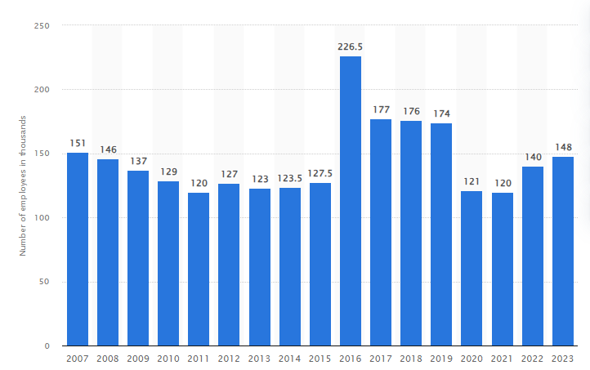

Figure 4.2: “Number of Marriott International employees worldwide from 2007 to 2023”
(Source: Statista.com, 2024)
Marriott performs obviously better than its peers generally speaking, as proven by its retention score, which places it in the top portion of businesses of an equivalent size. Nevertheless, it's basic to keep up with competitiveness in retention, especially considering the difficulties welcomed on by the high turnover rates in the hospitality industry (Aman-Ullah et al., 2021). Despite the fact that the retention score has been stable at 70-71/100 throughout the course of recent months, there might be some areas of stress that Marriott needs to address assuming it hopes to keep its labour force. Marriott's retention initiatives have yielded extraordinary results, as seen by the huge level of workers (71%) who express enthusiasm about coming to work consistently. This suggests a supportive working environment and representative commitment programs that upgrade work satisfaction. Furthermore, Marriott appears to be serious in its efforts to hold ability, as seen by its positioning as the fourth rival in retention (Kim et al., 2020).
Nevertheless, how 39% of workers might be pondering taking on new tasks indicates expected areas for development. High turnover rates can adversely affect the resolve, effectiveness, and eventually the happiness of guests of representatives. Concerns like work unhappiness, an absence of professional improvement chances, or insufficient compensation and benefits might urge workers to search for work elsewhere.
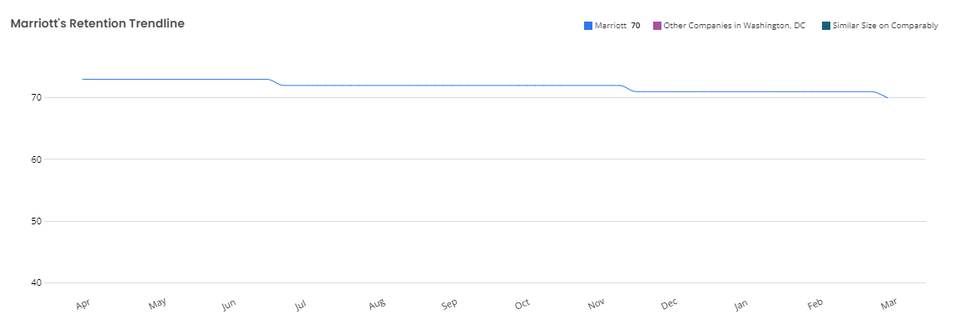

Figure 4.3: Employee retention trending at Marriott, 2024
(Source: comparably.com, 2024)
Marriott's worldwide labour force, with around 148,000 workers, poses a striking test in keeping up with uniform retention strategies all throughout its heterogeneous labour force (Asif and Nisar, 2022). Various departments' retention rates, as shown by which departments are bound to stay set up longer or have higher turnover, call for designated interventions to address specific issues inside every division.

4.4 Chapter summary
In summary, regardless of whether Marriott's retention initiatives demonstrate good features including strong representative dedication and a serious position compared with its competitors, there are still issues that should be addressed. Variations in retention rates and a high level of workers considering new assignments demonstrate that Marriott needs to assess and upgrade its retention initiatives continually. Marriott can bolster its predominant position in the hospitality sector by handling issues that lead to representative turnover and developing an inviting and empowering workplace.

Chapter 5: Conclusion and recommendation

5.1 Chapter introduction
This chapter aims to conduct the summary of the study that gains insight which helps to identify the intriguing connection between employee retention and brand awareness within Hotel Marriott context. Using an exploration research of customer review on trustpilot- an online platform, that is famous for its candid and unvarnished feedbacks to provide insights into the retention of employees and their impact on Marriot perception. Acknowledging the importance of the results is not only for the Hotel Marriott`s, but also has the whole of the hospitality industry as an entity. Effectiveness of the organization's executive in employee retention will be unveiled through this how-to guide that provides professional insight founded on the stakes of the industry, so that different managers can have an applicable action to take in order to strengthen their organizational strategies, boost employee engagement, and sharpen their brand resonance.

5.2 Summary of main findings
The emergence of service industries as the dominant type of economic activity requires businesses to review and realign their positioning to support new consumer behavior models. Things, such as CRM, customer loyalty, and consumer engagement, are enormous powerful tools used not only for explanation, but also for influencing customer actions (Aluri et al. 2019). The need of innovation in the hospitality industry and the brand awareness that comes along with that brings some challenges in forming the new ideas go side by side with the existing traditions.
As customers may encounter various touch points throughout their journey, it is absolutely necessary for the customer to be satisfied and stay loyal to your service provider through the maintenance of service quality through the all touch points. Consumer views are significantly influenced by the availability of service quality and consistency (Shokouhyar et al. 2020). Leadership capabilities and reliable communication play an important role in staffs' engagement and staying at the organization. Balance of employees' involvement and autonomy is fundamental for managers to determine in order to promote engaged employees (Emre and De Spiegeleare, 2021). The training programs must be comprehensive enough to address everything and to make sure that not only the job performance will improve but the motivation of the employees too. In-time creation of any new working skills is a core element in building the employee's resilience and loyalty to the company. Coordinating supply chain flows and partnering with MIS agencies would be very important to ensure information flow and better decision-makers will be developed in the process (Chen, 2019). With staff, the management may be able to develop a good relationship and this leads to their empowerment, recognition of efforts and provision of growth opportunities which are key elements in the fostering the accountability and teamwork culture. Brand values training is done on a periodic basis. This is a way of achieving uniform customer experience.

5.3 Conclusion based on the research questions
Linking to first research question: actors of retention affects reviews officially created on company platform Trustpilot in the hotels of Marriott. This involves employee satisfaction, training possibilities, managerial support, salary, and recognition. Good interaction of the employees with the clients makes a better service in turn increases customers rating of which most of them use Trustpilot as a platform to share.
Linking to second research question: Problem of brand recall from customer point of view in case of Marriott Hotels, in relation to employee retention is complicated because of unpredictable service quality arising from multiple job changes, bad reviews affecting the brand's reputation, employees with different values, diminishing trust, and difficulty in maintaining the same brand experience (Schneider and Harknett, 2019).
Linking to third research question: Marriott hotels’ efficient brand recognition can be achieved by reducing frequent employee turnover with the following measures, providing solid employee training on company culture/ values, creating reward programs, establishing an inviting work environment, offering career promotion prospects, controlling employees’ satisfaction, and ensuring effective internal communication. According to Verčič (2021), the activities are meant to increase employee engagement, commitment to the brand, and fit with the organization, all which ultimately lead to more significant brand recognition and better customer perceptions.

5.4 Research gap analysis
The employee retention is considered a significant contributor to brand awareness in the hotel business and therefore, the research in this field is also largely concerned with analysing the relationships between employee retention and brand awareness. However, there still exists a marked deficit of literature focusing on the reflection of this relationship in respect to customer reviews on platforms such as Trustpilot. As per the views of Chang and Busser (2020), unlike other sectors, the underlying factors affecting employee retention and brand awareness, are not very distinct in hospitality context. This goes to a level that their linkages, especially in hotels like Marriot is rather seldom mentioned. This study gap underscores the need for a thorough investigation which would encompass the main role played by the retention strategies employed by the organization and then assessed the same by customers in the form of online reviews. On the contrary, according to Sürücü et al. (2019), hospitality sector businesses need to control the retention of employees as well as maximum satisfaction of customers and the brand name. Research on this gap will contribute to the insight into the practices of employee center, the feedback of customers, and the overall picture of brand reputation and customer satisfaction of Hotel Marriott, which in turn will present the operational implications that people use to promote the brand name and satisfy customers.

5.5 Recommendation
- Implement targeted employee retention initiatives: Creating and putting in place employee retention systems which can be used to support brand awareness campaigns. This includes employee training, recognition schemes, career paths development and the delivered work culture should align with the brand values.
- Foster a positive work environment: Bring about a congenial workplace which seeks to address the workers’ welfare and attitudes. Encourage them to open up by carrying on and recognize your employees' progress, and for their positive attitude boost the brand.
- Align employee training with brand values: See that employee training program should be link to the brands core values and role standards. Through the procedure of linking business operations with the brand identity, this will make the customers’ ideas of the brand much stronger, and in the end, will have the chance to make the brand more popular.

5.6 Limitation of Research
Undertaking due and diligent examination involving both period of time and financial investment is a mandatory stage before undertaking any endeavour. Missed deadlines might undermine efficiency of investigation process and it might not be possible to get credible information on the merits of hiring and retention strategies in the aspects of producer brand awareness. As per the opinion of Coelho et al. (2020), external factors such as the state of the market, industry tendencies, or the situation of the whole world could be responsible for the job retention and brand popularity in Hotel Marriott being volatile, so the reliability of the results could be compromised. Lack of resources such as time, money, data and access might curb the size and the depth of the research; beside this these limits may weaken the claim of the collected data and the extension of the conclusions drawn. Research to a great extent describes client reviews, leaving unaddressed the points of view of Marriott International workshop. The employee views and experiences of brand awareness retention approaches and how they affect the brand awareness gap in this study can be explored but may not be fully recorded.

5.7 Recommendation for Future Work

Longitudinal study: Do a longitudinal study to get the data on the ways the HR strategies have developed, brand awareness has grown, and clients’ reviews have worsened or improved over a long period of time. Coming up with this will likely be informative to the care of reputation due to prolonged employee retention (Chiat and Panatik, 2019).
Comparative analysis: Compare Hotel Marriott's findings with other competitors in the hotel sector to find the ways in which the hotel employees' retention programs impact the brand awareness, which differs across the hotels' brands.
Employee training evaluation: Evaluate how the employee training programs impact the brand values and customer service experience by comparing different hotels. Monitor the influence of training on employee retention and the outcome of the same through customer awareness, brand appreciation, and loyalty (Abbas, 2019).
Cross-functional collaboration: Become the focal point of collaboration between HR, marketing, and operations departments in the Hotel Marriott so they can have a common approach with retention strategies that plug philosophical gaps.

References
Abbas, S.A., 2019. Brand loyalty of higher education institutions. Abbas, SA (2019). Brand loyalty of Higher Education Institutions. Marketing and Management of Innovations, 1, pp.46-56.
Ahmad, A., Barakbah, S.M.B.S.F. and Majdi, A.A., 2021. Hotel Employees’ Burnout and Turnover Intentions. Management.
Algharabat, R., Rana, N.P., Alalwan, A.A., Baabdullah, A. and Gupta, A., 2020. Investigating the antecedents of customer brand engagement and consumer-based brand equity in social media. Journal of Retailing and Consumer Services, 53, p.101767.
Alharahsheh, H.H. and Pius, A., (2020). A review of key paradigms: Positivism VS interpretivism. Global Academic Journal of Humanities and Social Sciences, 2(3), pp.39-43.
Alnawas, I. and Hemsley-Brown, J., 2019. Examining the key dimensions of customer experience quality in the hotel industry. Journal of Hospitality Marketing & Management, 28(7), pp.833-861.
Aluri, A., Price, B.S. and McIntyre, N.H., 2019. Using machine learning to cocreate value through dynamic customer engagement in a brand loyalty program. Journal of Hospitality & Tourism Research, 43(1), pp.78-100.
Aman-Ullah, A., Aziz, A., Ibrahim, H., Mehmood, W. and Abbas, Y.A., 2021. The impact of job security, job satisfaction and job embeddedness on employee retention: an empirical investigation of Pakistan’s health-care industry. Journal of Asia Business Studies, 16(6), pp.904-922.
Asif, R. and Nisar, S., 2022. Policies, rewards and opportunities: Antecedents of employee retention. Indian Journal of Commerce and Management Studies, 13(1), pp.18-26.
Bailey, C., 2020. Customer Insight Strategies: How to Understand Your Audience and Create Remarkable Marketing. Kogan Page Publishers.
Barreda, A.A., Nusair, K., Wang, Y., Okumus, F. and Bilgihan, A., 2020. The impact of social media activities on brand image and emotional attachment: A case in the travel context. Journal of hospitality and tourism technology, 11(1), pp.109-135.
Beck, B.B., Wuyts, S. and Jap, S., 2023. Guardians of Trust: How Review Platforms Can Fight Fakery and Build Consumer Trust. Journal of Marketing Research, p.00222437231195576.
Bharadwaj, S., Khan, N.A. and Yameen, M., 2022. Unbundling employer branding, job satisfaction, organizational identification and employee retention: a sequential mediation analysis. Asia-Pacific Journal of Business Administration, 14(3), pp.309-334.
Bhatt, N., Chitranshi, J. and Mehta, M., 2022. Testing Herzberg's two factor theory on millennials. Cardiometry, (22), pp.231-236.
Boella, M.J. and Goss-Turner, S., 2019. Customer care and service quality. In Human Resource Management in the Hospitality Industry (pp. 437-446). Routledge.
Boutmaghzoute, H. and Moustaghfir, K., 2021. Exploring the relationship between corporate social responsibility actions and employee retention: a human resource management perspective. Human Systems Management, 40(6), pp.789-801.
Bryson, J.R., Sundbo, J., Fuglsang, L., Daniels, P., Bryson, J.R., Sundbo, J., Fuglsang, L. and Daniels, P., 2020. Customer First: Understanding Customers. Service Management: Theory and Practice, pp.147-163.
Buhalis, D. and Park, S., 2021. Brand management and cocreation lessons from tourism and hospitality: introduction to the special issue. Journal of Product & Brand Management, 30(1), pp.1-11.
Casula, M., Rangarajan, N. and Shields, P., 2021. The potential of working hypotheses for deductive exploratory research. Quality & Quantity, 55(5), pp.1703-1725.
Chang, W. and Busser, J.A., 2020. Hospitality career retention: the role of contextual factors and thriving at work. International Journal of Contemporary Hospitality Management, 32(1), pp.193-211.
Chen, C.J., 2019. Developing a model for supply chain agility and innovativeness to enhance firms’ competitive advantage. Management Decision, 57(7), pp.1511-1534.
Chiat, L.C. and Panatik, S.A., 2019. Perceptions of employee turnover intention by Herzberg’s motivation-hygiene theory: A systematic literature review. Journal of Research in Psychology, 1(2), pp.10-15.
Coelho, P.M., Corona, B., ten Klooster, R. and Worrell, E., 2020. Sustainability of reusable packaging–Current situation and trends. Resources, Conservation & Recycling: X, 6, p.100037.
Daghfous, A. and Belkhodja, O., 2019. Managing talent loss in the procurement function: insights from the hospitality industry. Sustainability, 11(23), p.6800.
Dwesini, N.F., 2019. Causes and prevention of high employee turnover within the hospitality industry: A literature review. African Journal of Hospitality, Tourism and Leisure, 8(3), pp.1-15.
Emre, O. and De Spiegeleare, S., 2021. The role of work–life balance and autonomy in the relationship between commuting, employee commitment and well-being. The International Journal of Human Resource Management, 32(11), pp.2443-2467.
Fagyas, C. and Datta, P., 2023. An investigation of the factors associated with consumer behaviour at arrival, check-in and the check-out process: A case study Marriott International Inc. in the UK. Journal of Business and Retail Management Research, 17(2).
Garavan, T., Matthews-Smith, G., Gill, A.M. and O’Brien, F., 2021. Strategic talent management in the hospitality industry. In Talent management innovations in the international hospitality industry (pp. 9-30). Emerald Publishing Limited.
glassdoor.co.in, (2024), Marriott & Co., Available at: Marriott & Co. - Great team. | Glassdoor, [Accessed on: 30/03/2024]
Gopalan, M., Rosinger, K. and Ahn, J.B., (2020). Use of quasi-experimental research designs in education research: Growth, promise, and challenges. Review of Research in Education, 44(1), pp.218-243.
Gray, L.M., Wong-Wylie, G., Rempel, G.R. and Cook, K., (2020). Expanding qualitative research interviewing strategies: Zoom video communications. The qualitative report, 25(5), pp.1292-1301.
Gryka, P. and Janicki, A., 2023. Detecting Fake Reviews in Google Maps—A Case Study. Applied Sciences, 13(10), p.6331.
Hanlon, A., 2019. The digital dilemma: An investigation into social media marketing within organisations. University of Derby (United Kingdom).
Hassan, Z. and Govindhasamy, C., 2020. An investigation on extrinsic and intrinsic rewards on employee retention among Gen Y: A study in Malaysian manufacturing companies. Journal of Business and Economic Analysis, 3(01), pp.55-69.
Hassanein, F. and Özgit, H., 2022. Sustaining human resources through talent management strategies and employee engagement in the Middle East hotel industry. Sustainability, 14(22), p.15365.
Hultman, M., Papadopoulou, C., Oghazi, P. and Opoku, R., 2021. Branding the hotel industry: The effect of step-up versus step-down brand extensions. Journal of business research, 124, pp.560-570.
Iglesias, O., Markovic, S., Singh, J.J. and Sierra, V., 2019. Do customer perceptions of corporate services brand ethicality improve brand equity? Considering the roles of brand heritage, brand image, and recognition benefits. Journal of business ethics, 154, pp.441-459.
Jerez-Jerez, M.J., Melewar, T.C. and Foroudi, P., 2021. Exploring waiters’ occupational identity and turnover intention: A qualitative study focusing on Michelin-starred restaurants in London. Journal of Hospitality and Tourism Management, 47, pp.22-34.
Keiningham, T.L., He, Z., Hillebrand, B., Jang, J., Suess, C. and Wu, L., 2019. Creating innovation that drives authenticity. Journal of Service Management, 30(3), pp.369-391.
Khuong, M. and Linh, U., 2020. Influence of work-related stress on employee motivation, job satisfaction and employee loyalty in hospitality industry. Management Science Letters, 10(14), pp.3279-3290.
Kim, J., Milliman, J. and Lucas, A., 2020. Effects of CSR on employee retention via identification and quality-of-work-life. International Journal of Contemporary Hospitality Management, 32(3), pp.1163-1179.
Kim, J.J., 2024. Brand portfolio extension of international hotel chains: a perspective on consumer confusion and consumer decision-making process. International Journal of Contemporary Hospitality Management.
Koo, B. and Curtis, C., 2020. An examination of the role of internal brand management: impact of contractual models. Journal of Hospitality Marketing & Management, 29(4), pp.503-525.
Kurdi, B. and Alshurideh, M., 2020. Employee retention and organizational performance: Evidence from banking industry. Management Science Letters, 10(16), pp.3981-3990.
Lu, L. and Tabari, S., 2019. Impact of Airbnb on customers' behavior in the UK hotel industry. Tourism Analysis, 24(1), pp.13-26.
Maria, S., Pusriadi, T., Hakim, Y.P. and Darma, D.C., 2019. The effect of social media marketing, word of mouth, and effectiveness of advertising on brand awareness and intention to buy. Jurnal Manajemen Indonesia, 19(2), pp.107-122.
Neupane, R. and Khanal, T.R., 2022. Evaluation of The Impacts of Training on Employee Performance in The UK Hotel Industry: An Analysis of Employees’ Perspectives at Marriott International. International Journal of Research-GRANTHAALAYAH, 10(3), pp.57-85.
Nuseir, M. and Elrefae, G., 2022. The effects of facilitating conditions, customer experience and brand loyalty on customer-based brand equity through social media marketing. International Journal of Data and Network Science, 6(3), pp.875-884.
Nyein, A.S. and Kohsuwan, P., 2019. The Influence of Employer Brand Asset and Herzberg’s Two-Factor on Job Satisfaction, Employee Engagement and Employee-based Brand Equity:: The Case of Myanmar Millennial Employees Investment in the Online Financial Markets. The Journal of Risk Management and Insurance, 23(2), pp.25-40.
Peramatzis, G. and Galanakis, M., 2022. Herzberg’s motivation theory in workplace. Psychology, 12(12), pp.971-978.
Phan, L., 2020. A research on guest satisfaction at Hotel St. George Helsinki.
Prayag, G., Hassibi, S. and Nunkoo, R., 2019. A systematic review of consumer satisfaction studies in hospitality journals: Conceptual development, research approaches and future prospects. Journal of Hospitality Marketing & Management, 28(1), pp.51-80.
Ryu, K., Lehto, X.Y., Gordon, S.E. and Fu, X., 2019. Effect of a brand story structure on narrative transportation and perceived brand image of luxury hotels. Tourism Management, 71, pp.348-363.
Saunders, M.N., Lewis, P., Thornhill, A. and Bristow, A., 2019. Understanding research philosophy and approaches to theory development.
Schneider, D. and Harknett, K., 2019. Consequences of routine work-schedule instability for worker health and well-being. American sociological review, 84(1), pp.82-114.
Senthilnathan, V.P. and Rajendran, S., 2024. Understanding the voice of customers and employees in ride-sharing companies using text analytics. Transportation Research Interdisciplinary Perspectives, 23, p.101002.
Shaikh, S.H., Shaikh, H. and Shaikh, S., 2019. The impact of job satisfaction and job dissatisfaction on Herzberg theory: A case study of Meezan Bank Limited and National Bank Limited. International Journal of Business and Social Science, 10(6), pp.143-147.
Shokouhyar, S., Shokoohyar, S. and Safari, S., 2020. Research on the influence of after-sales service quality factors on customer satisfaction. Journal of Retailing and Consumer Services, 56, p.102139.
Singh, D., 2019. A literature review on employee retention with focus on recent trends. International Journal of Scientific Research in Science and Technology, 6(1), pp.425-431.
Singh, P., Arora, L. and Choudhry, A., 2022. Consumer Behavior in the Service Industry: An Integrative Literature Review and Research Agenda. Sustainability, 15(1), p.250.
Sobaih, A.E.E. and Hasanein, A.M., 2020. Herzberg’s theory of motivation and job satisfaction: Does it work for hotel industry in developing countries?. Journal of Human Resources in Hospitality & Tourism, 19(3), pp.319-343.
Sürücü, Ö., Öztürk, Y., Okumus, F. and Bilgihan, A., 2019. Brand awareness, image, physical quality and employee behavior as building blocks of customer-based brand equity: Consequences in the hotel context. Journal of Hospitality and Tourism Management, 40, pp.114-124.
Tezel, M.S., 2023. Herzberg’s Two-Factor Theory, and knowledge workers’ motivation and job satisfaction: a study on academicians at foundation universities
trustpilot.com, (2024), Marriott International, Available at: https://www.trustpilot.com/review/www.marriott.com?page=10, [Accessed on: 19/02/2024]
uk.trustpilot.com, (2024), Marriott, Available at: Marriott Reviews | Read Customer Service Reviews of www.marriott.co.uk (trustpilot.com), [Accessed on: 30/03/2024]
Vears, D.F. and Gillam, L., 2022. Inductive content analysis: A guide for beginning qualitative researchers. Focus on Health Professional Education: A Multi-Professional Journal, 23(1), pp.111-127.
Verčič, A.T., 2021. The impact of employee engagement, organisational support and employer branding on internal communication satisfaction. Public Relations Review, 47(1), p.102009.
Wilson, M., 2022. The adoption, use, and climate implications of online food hubs
Yang, C., Guo, N., Wang, Y. and Li, C., 2019. The effects of mentoring on hotel staff turnover: Organizational and occupational embeddedness as mediators. International Journal of Contemporary Hospitality Management, 31(10), pp.4086-4104.
Zayed, N.M., Edeh, F.O., Islam, K.M.A., Nitsenko, V., Dubovyk, T. and Doroshuk, H., 2022. An investigation into the effect of knowledge management on employee retention in the telecom sector. Administrative Sciences, 12(4), p.138.
Zheng, C.J., Wu, J.S. and Zhao, X.R., 2022. How could hospitality employees survive? The individual costs, career decisions and autonomy support of furlough strategies in a crisis. International Journal of Hospitality Management, 106, p.103279.

Appendices

Appendix 1: Ethics form
APPLICATION FOR ETHICAL APPROVAL

In order for research to result in benefit and minimise risk of harm, it must be conducted ethically. A researcher may not be covered by the University’s insurance if ethical approval has not been obtained prior to commencement.

The University follows the OECD Frascati manual definition of research activity: “creative work undertaken on a systematic basis in order to increase the stock of knowledge, including knowledge of man, culture and society, and the use of this stock of knowledge to devise new applications”. As such this covers activities undertaken by members of staff, postgraduate research students, and both taught postgraduate and undergraduate students working on dissertations/projects.

The individual undertaking the research activity is known as the “principal researcher”.

Ethical approval is not required for routine audits, performance reviews, quality assurance studies, testing within normal educational requirements, and literary or artistic criticism.

Please read the notes for guidance before completing ALL sections of the form.

This formmust be completed and approved prior to undertaking any research activity.Please see Checklist for details of process for different categories of application.

SECTION A: About You (Principal Researcher)
1 | Full Name: |  | Judith Hope Kidenya
2 | Tick all boxes that apply: |  | Member of staff: | ☐ | Honorary research fellow: | ☐
 | Undergraduate Student | ☐ | Taught Postgraduate Student | ☐ | Postgraduate Research Student | ☐

3 | Institute/Academic Discipline/Centre: | University of wales Trinity saint David
4 | Campus: | Birmingham
5 | E-mail address:
6 | Contact Telephone Number:
 | For students:
7 | Student Number: | 2242265
8 | Programme of Study: | MBA General management
9 | Director of Studies/Supervisor: | Prof.Dennis Pepple

SECTION B: Approval for Research Activity
1 | Has the research activity received approval in principle?  (please check the Guidance Notes as to the appropriate approval process for different levels of research by different categories of individual) |  | YES | ☐ | NO | ☐
 |  |  |  |  | Date
2 | If Yes, please indicate source of approval (and date where known):Approval in principle must be obtained from the relevant source prior to seeking ethical approval | Research Degrees Committee |  | ☐
2 |  | Institute Research Committee |  | ☐
2 |  | Other (write in) |  | ☐

SECTION C: Internal and External Ethical Guidance Materials
 | Please list the core ethical guidance documents that have been referred to during the completion of this form (including any discipline-specific codes of research ethics, location-specific codes of research ethics, and also any specific ethical guidance relating to the proposed methodology). Please tick to confirm that your research proposal adheres to these codes and guidelines. You may add rows to this table if needed.
1 | UWTSD Research Ethics & Integrity Code of Practice | ☐
2 | UWTSD Research Data Management Policy | ☐
3 | [List any other relevant documents here] | ☐

SECTION D: External Collaborative Research Activity
If there are external collaborators then you should gain consent from the contact persons to share their personal data with the university. If there are no external collaborators then leave this section blank and continue to section E.
1 | Institution
2 | Contact person name
3 | Contact person e-mail address
4 | Is your research externally funded? |  | YES | ☐ | NO |  | ☐
5 | Are you in receipt of a KESS scholarship? |  | YES | ☐ | NO |  | ☐
6 | Are you specifically employed to undertake this research in either a paid or voluntary capacity? | Voluntary | YES | ☐ | NO | ☐
7 |  | Employed | YES | ☐ | NO | ☐
8 | Is the research being undertaken within an existing UWTSD Athrofa Professional Learning Partnership (APLP)? | If YES then the permission question below does not need to be answered. | YES | ☐ | NO |  | ☐
9 | Has permission to undertake the research has been provided by the partner organisation? | (If YES attach copy)  If NO the application cannot continue | YES | ☐ | NO |  | ☐

Where research activity is carried out in collaboration with an external organisation
10 | Does this organisation have its own ethics approval system? | YES | ☐ | NO | ☐
 | If Yes, please attach a copy of any final approval (or interim approval) from the organisation (this may be a copy of an email if appropriate).

SECTION E: Details of Research Activity
1 | Indicative title: | INVESTIGATING THE RELATIONSHIP BETWEEN EMPLOYEE RETENTION AND BRAND AWARENESS: AN EXPLORATION STUDY OF MARRIOTT INTERNATIONAL CUSTOMER REVIEWS ON TRUST PILOT AND EMPLOYEES’ FEEDBACK ON GLASSDOOR
2 | Proposed start date: | 25.01.2024 | Proposed end date: | 03.05.2024
Introduction to the Research (maximum 300 words per section)
Ensure that you write for a Non-Specialist Audiencewhen outlining your response to the points below:
- Purpose of Research Activity
- Proposed Research Question
- Aims of Research Activity
- Objectives of Research Activity
Demonstrate, briefly, how Existing Research has informed the proposed activity and explain
- What the research activity will add to the body of knowledge
- How it addresses an area of importance.
3 | Purpose of Research Activity  Brand awareness has an important impact when it comes to measuring the relevancy of the hospitality industry, the sale of the Marriott is of particular significance. Retention of employees and its effect on brand awareness is the chosen parameter by which to measure the contribution of the hospitality sector which generated £59.3 billion and accounted for 3% output in the economy (parliament.uk, 2022).The study is conducted based on the problem statement of research which explains how the decreasing employee retention rate affecting the consumer’s brand awareness concerning Marriott hotels. On the one hand, this can be efficient to determine the effect of customer reviews from the trust pilot on employees in the hotel, thus is effective in employee retention But there is a question of whether customer review impacts employee retention which may even affect the brand awareness prospect of Marriott international hotels. This is, nevertheless, an issue: 90% of consumers rely on online ratings and reviews on Trustpilot to determine whether Marriott is suitable for them (Narciso, 2022). Therefore, the degrees of retention and the influence on brand awareness of employee retention can be determined based on the reviews of the customers. The Trustpilot survey indicates that 58% market customers are informed about the consumer values (Trustpilot.com, 2020). This study will be dealing with the effect of consumer reviews on the rate of employee turnover and extent to which it is reflected in the hotel’s brand awareness for Marriott hotel.
4 | Research Question  - What are the factors of employee retention in relation to customer review on Trustpilot in Marriott hotels?  - What would be the challenges of brand awareness for the consumer perspectives in regards of employee retention for hotel Marriott?  - What would be the recommended strategies to eliminate the challenges of ineffective brand awareness by reducing the employee retention rate in hotel Marriott?
5 | Aims of Research Activity  The research aims to examine impacts of Trustpilot customer reviews' on employee retention and brand awareness in the Marriott hotels.
6 | Objectives of Research Activity  - To examine the factors of employee retention in relation to customer review on Trustpilot in Marriott hotels  - To identify the challenges of brand awareness for the consumer perspectives in regards of employee retention for hotel Marriott  - To recommended strategies to eliminate the challenges of ineffective brand awareness by reducing the employee retention rate in hotel Marriott
Proposed methods (maximum 600 words)
Provide a brief summary of all the methods that may be used in the research activity, making it clear what specific techniques may be used. If methods other than those listed in this section are deemed appropriate later, additional ethical approval for those methods will be needed. You do not need to justify the methods here, but should instead describe how you intend to collect the data necessary for you to complete your project.
7 | Inclusion of “research onion” will aid to communicate this research through selection of what lawyers of research and as well as how it is conducted. Saunders et al. (2018) claims that research reviews highlight the best practice for the suitable research procedures by answering the research questions clearly. Thus, one will have a hint of the inhibition of apoptosis through highlighting the vital issues in this research. “Research philosophy” is a supporting view of the phenomena of research and it comes from analysing the critical component. There could be four types of “research philosophy”, namely “positivism”, “interpretivism”, “pragmatism” and “realism”. In this instance, “interpretivism research philosophy” will be picked as a method of analysis of subjective reality of the trustpilot reviews of Marriott hotels of the trust which will consequently translate into brand awareness and employee retention. The authors posited that “interpretivism research philosophy” permits a sociological event analysis by the participant’s beliefs, norms and customs. On the other hand, “pragmatism” and “research philosophy” will not be used mostly because of the fact that they possess complicated procedures which do not allow us to define differences between different types of data. The “positivism philosophy” will be disregarded for being inflexible to measure data gathered from the research. The assumption is that, “research approach” is the “extensive process” of gathering, analysing and interpreting data. Research approach can be broken down into the two groups: inductive and deductive research approach. Application of “deductive research approach” will be valuable in this research study by illuminating the patterns of customer reviews impacting upon employee retention in Marriott hotels. In accordance with Corley et al., (2021) “deductive research approach” involves systematic critical thinking on the data accumulated and helps in developing theories and concepts effectively. "Inductive research approach" will not be used as the outcome of results is not observatively/empirically possible by the subject of investigations.  “Research strategy” is a plan that provides the necessary guideline to carry out the research process as a whole and reach its goals in an effective manner. There are two types of research strategy i.e. “Qualitative research strategy” and “Quantitive research strategy”. Implementation of “qualitative research strategy” will be helpful in getting depth understanding on how Trustpilot reviews is motivating employee retention that in turn is strengthening brand awareness within the hospitality sector. Basing on Gray et al. (2020), the positive thing with “qualitative research strategy” is that it is flexible and allows for exploration of multiple phenomena to derive results. Quantitative “research strategy” will not be useful because it is the inability to present a detailed account of how employee retention and brand awareness are affected by consumer reviews. “Research strategy” is a plan that facilitates the handling of the overall research activities and makes them effective to conclude. Research can be divided into two categories including qualitative research strategy and quantitative research strategy. Including “qualitative research strategy” will allow to achieve a better “depth understanding” of how customers’ reviews on Trustpilot is impacting employee attendance which is affecting brand’s awareness in the Hospitality sector in the . According to Gray et al. (2020), an advantage of “qualitative research strategy” is that it is flexible and is capable of exploring various phenomena to deduce results. The “quantitative research strategy” will not be considered where there is no clear results on the relationship between employee retention and brand awareness from consumers’ points of view.
Location of research activity
Identify all locations where research activity will take place.
8 | NA  (this box should expand as you type)
Research activity outside of the
If research activity will take place overseas, you are responsible for ensuring that local ethical considerations are complied with and that the relevant permissions are sought. Specify any local guidelines (e.g. from local professional associations/learned societies/universities) that exist and whether these involve any ethical stipulations beyond those usual in the (provide details of any licenses or permissions required). Also specify whether there are any specific ethical issues raised by the local context in which the research activity is taking place, for example, particular culturaland/or legal sensitivities or vulnerabilities of participants. If you live in the country where you will do the research then please state this.
9 | NA  (this box should expand as you type)

10 | Use of documentation not in the public domain: Are any documents NOT publicly available? | NO | ☐
10 |  | YES | ☐
11 | If Yes, please provide details here of how you will gain access to specific documentation that is not in the public domain and that this is in accordance with the current data protection law of the country in question and that of England and Wales.  (this box should expand as you type)

 | Does your research relate to one or more of the seven aims of the Well-being of Future Generations (Wales) Act 2015? | YES | NO
12 | A prosperous Wales | ☐ | ☐
13 | A resilient Wales | ☐ | ☐
14 | A healthier Wales | ☐ | ☐
15 | A more equal Wales | ☐ | ☐
16 | A Wales of cohesive communities | ☐ | ☐
17 | A Wales of vibrant culture and thriving Welsh language | ☐ | ☐
18 | A globally responsible Wales | ☐ | ☐
19 | If YES to any of the above, please give details:
 | (this box should expand as you type)

SECTION F: Scope of Research Activity
 | Will the research activity include: | YES | NO
1 | Use of a questionnaire or similar research instrument? | ☐ | ☐
2 | Use of interviews? | ☐ | ☐
3 | Use of focus groups? | ☐ | ☐
4 | Use of participant diaries? | ☐ | ☐
5 | Use of video or audio recording? | ☐ | ☐
6 | Use of computer-generated log files? | ☐ | ☐
7 | Participant observation with their knowledge? | ☐ | ☐
8 | Participant observation without their knowledge? | ☐ | ☐
9 | Access to personal or confidential information without the participants’ specific consent? | ☐ | ☐
10 | Administration of any questions, test stimuli, presentation that may be experienced as physically, mentally or emotionally harmful / offensive? | ☐ | ☐
11 | Performance of any acts which may cause embarrassment or affect self-esteem? | ☐ | ☐
12 | Investigation of participants involved in illegal activities? | ☐ | ☐
13 | Use of procedures that involve deception? | ☐ | ☐
14 | Administration of any substance, agent or placebo? | ☐ | ☐
15 | Working with live vertebrate animals? | ☐ | ☐
16 | Procedures that may have a negative impact on the environment? | ☐ | ☐
17 | Other primary data collection methods. Please indicate the type of data collection method(s) below. | ☐ | ☐
 | Details of any other primary data collection method:  (this box should expand as you type) | ☐ | ☐
If NO to every question, then the research activity is (ethically) low risk and may be exempt from some of the following sections (please refer to Guidance Notes).

If YES to any question, then no research activity should be undertaken until full ethical approval has been obtained.

SECTION G: Intended Participants
If there are no participants then do not complete this section, but go directly to section H.

 | Who are the intended participants: | YES | NO
1 | Students or staff at the University? | ☐ | ☐
2 | Adults (over the age of 18 and competent to give consent)? | ☐ | ☐
3 | Vulnerable adults? | ☐ | ☐
4 | Children and Young People under the age of 18?(Consent from Parent, Carer or Guardian will be required) | ☐ | ☐
5 | Prisoners? | ☐ | ☐
6 | Young offenders? | ☐ | ☐
7 | Those who could be considered to have a particularly dependent relationship with the investigator or a gatekeeper? | ☐ | ☐
8 | People engaged in illegal activities? | ☐ | ☐
9 | Others. Please indicate the participants below, and specifically any group who may be unable to give consent. | ☐ | ☐
 | Details of any other participant groups:  (this box should expand as you type) | ☐ | ☐

Participant numbers and source
Provide an estimate of the expected number of participants. How will you identify participants and how will they be recruited?
10 | How many participants are expected? | (this box should expand as you type)
11 | Who will the participants be? | (this box should expand as you type)
12 | How will you identify the participants? | (this box should expand as you type)

 | Information for participants: | YES | NO | N/A
13 | Will you describe the main research procedures to participants in advance, so that they are informed about what to expect? | ☐ | ☐ | ☐
14 | Will you tell participants that their participation is voluntary? | ☐ | ☐ | ☐
15 | Will you obtain written consent for participation? | ☐ | ☐ | ☐
16 | Will you explain to participants that refusal to participate in the research will not affect their treatment or education (if relevant)? | ☐ | ☐ | ☐
17 | If the research is observational, will you ask participants for their consent to being observed? | ☐ | ☐ | ☐
18 | Will you tell participants that they may withdraw from the research at any time and for any reason? | ☐ | ☐ | ☐
19 | With questionnaires, will you give participants the option of omitting questions they do not want to answer? | ☐ | ☐ | ☐
20 | Will you tell participants that their data will be treated with full confidentiality and that, if published, it will not be identifiable as theirs? | ☐ | ☐ | ☐
21 | Will you debrief participants at the end of their participation, in a way appropriate to the type of research undertaken? | ☐ | ☐ | ☐
22 | If NOto any of above questions, please give an explanation
 | (this box should expand as you type)

 | Information for participants: | YES | NO | N/A
24 | Will participants be paid? | ☐ | ☐ | ☐
25 | Is specialist electrical or other equipment to be used with participants? | ☐ | ☐ | ☐
26 | Are there any financial or other interests to the investigator or University arising from this study? | ☐ | ☐ | ☐
27 | Will the research activity involve deliberately misleading participants in any way, or the partial or full concealment of the specific study aims? | ☐ | ☐ | ☐
28 | If YESto any question, please provide full details
 | (this box should expand as you type)

SECTION H: Anticipated Risks

Outline any anticipated risksthat may adversely affect any of the participants, the researchers and/or the University, and the steps that will be taken to address them.

If you have completed a full risk assessment (for example as required by a laboratory, or external research collaborator) you may append that to this form.
1 | Full risk assessment completed and appended? |  | Yes | ☐
1 |  |  | No | ☐
2 | Risks to participants  For example: sector-specific health & safety, emotional distress, financial disclosure, physical harm, transfer of personal data, sensitive organisational information
 | Risk to participants:  (this box should expand as you type) | How you will mitigate the risk to participants:  (this box should expand as you type)
3 | If research activity may include sensitive, embarrassing or upsetting topics (e.g. sexual activity, drug use) or issues likely to disclose information requiring further action (e.g. criminal activity), give details of the procedures to deal with these issues, including any support/advice (e.g. helpline numbers) to be offered to participants. Note that where applicable, consent procedures should make it clear that if something potentially or actually illegal is discovered in the course of a project, it may need to be disclosed to the proper authorities
 | NA
4 | Risks to the investigator  For example: personal health &safety, physical harm, emotional distress, risk of accusation of harm/impropriety, conflict of interest
 | Risk to the investigator:  (this box should expand as you type) | How you will mitigate the risk to the investigator:  (this box should expand as you type)
5 | University/institutional risks  For example: adverse publicity, financial loss, data protection
 | Risk to the University:  (this box should expand as you type) | How you will mitigate the risk to the University:  (this box should expand as you type)
6 | Environmental risks  For example: accidental spillage of pollutants, damage to local ecosystems
 | Risk to the environment:  (this box should expand as you type) | How you will mitigate the risk to environment:  (this box should expand as you type)

 | Disclosure and Barring Service
 | If the research activity involves children or vulnerable adults, a Disclosure and Barring Service (DBS) certificate must be obtained before any contact with such participants. | YES | NO | N/A
7 | Does your research require you to hold a current DBS Certificate? | ☐ | ☐ | ☐
8 | If YES, please give the certificate number. If the certificate number is not available please write “Pending”; in this case any ethical approval will be subject to providing the appropriate certificate number.

SECTION I: Feedback, Consent and Confidentiality

1 | Feedback  What de-briefing and feedback will be provided to participants, how will this be done and when?
 | (this box should expand as you type)
2 | Informed consent  Describe the arrangements to inform potential participants, before providing consent, of what is involved in participating. Describe the arrangements for participants to provide full consent before data collection begins. If gaining consent in this way is inappropriate, explain how consent will be obtained and recorded in accordance with prevailing data protection legislation.
 | NA
3 | Confidentiality / Anonymity  Set out how anonymity of participants and confidentiality will be ensured in any outputs. If anonymity is not being offered, explain why this is the case.
- Data that are collected and analysed is strictly based on the research purpose, there will be no intentions of harming anyone’s sentiments during this research process.
- Plagiarism will be avoided to maintain the authenticity of the research and support its findings efficiently.
- Authors will be acknowledged with appropriate citations to support the credibility of the research.
- Anonymity of the data is the top notched priority doing this research.
- Manipulation of the data in order to meet the research aim and objective is strictly prohibited.
- During data analysing the chances of data fragmentation will be ignored to conduct the research appropriately.

SECTION J: Data Protection and Storage

 | Does the research activity involve personal data (as defined by the General Data Protection Regulation 2016 “GDPR” and the Data Protection Act 2018 “DPA”)? | YES | NO
1 | “Personal data”means any information relating to an identified or identifiable natural person (‘data subject’). An identifiable natural person is one who can be identified, directly or indirectly, in particular by reference to an identifier such as a name, an identification number, location data, an online identifier or to one or more factors specific to the physical, physiological, genetic, mental, economic, cultural or social identity of that natural person. Any video or audio recordings of participants is considered to be personal data. | ☐ | ☐
 | If YES, provide adescription of the data and explain why this data needs to be collected:
2 | (this box should expand as you type)
 | Does it involve special category data (as defined by the GDPR)? | YES | NO
3 | “Special category data” means sensitive personal data consisting of information as to the data subjects’ –  (a) racial or ethnic origin,  (b) political opinions,  (c ) religious beliefs or other beliefs of a similar nature,  (d) membership of a trade union (within the meaning of the Trade Union and Labour Relations (Consolidation) Act 1992),  (e) physical or mental health or condition,  (f) sexual life,  (g) genetics,  (h) biometric data (as used for ID purposes), | ☐ | ☐
 | If YES, provide adescription of the special category data and explain why this data needs to be collected:
4 | (this box should expand as you type)

 | Will data from the research activity (collected data, drafts of the thesis, or materials for publication) be stored in any of the following ways? | YES | NO
5 | Manual files (i.e. in paper form)? | ☐ | ☐
6 | University computers? | ☐ | ☐
7 | Private company computers? | ☐ | ☐
8 | Home or other personal computers? | ☐ | ☐
9 | Laptop computers/ CDs/ Portable disk-drives/ memory sticks? | ☐ | ☐
10 | “Cloud” storage or websites? | ☐ | ☐
11 | Other – specify: | ☐ | ☐
12 | For all stored data, explain the measures in place to ensure the security of the data collected, data confidentiality, including details of backup procedures, password protection, encryption, anonymisation and pseudonymisation:
 | (this box should expand as you type)

 | Data Protection
 | Will the research activity involve any of the following activities: | YES | NO
13 | Electronic transfer of data in any form? | ☒ | ☐
14 | Sharing of data with others at the University outside of the immediate research team? | ☐ | ☐
15 | Sharing of data with other organisations? | ☐ | ☐
16 | Export of data outside the or importing of data from outside the ? | ☐ | ☐
17 | Use of personal addresses, postcodes, faxes, emails or telephone numbers? | ☐ | ☐
18 | Publication of data that might allow identification of individuals? | ☐ | ☐
19 | Use of data management system? | ☐ | ☐
20 | Data archiving? | ☐ | ☐
21 | If YESto any question, please provide full details, explaining how this will be conducted in accordance with the GDPR and Data Protection Act (2018) (and any international equivalents, where appropriate):
 | NA
22 | List all who will have access to the data generated by the research activity:
 | Researcher and professor
23 | List who will have control of, and act as custodian(s) for, data generated by the research activity:
 | Researcher and professor
24 | Give details of data storage arrangements, including security measures in place to protect the data, where data will be stored, how long for, and in what form. Will data be archived – if so how and if not why not.
 | Data based on the reviews on trust pilots would be collected from Twitter, linked, indeed etc.. Influencing factors of employee retention exhibiting clients’ reviews from several trust pilots will be collected and analysed.
25 | Please indicate if your data will be stored in the UWTSD Research Data Repository (see https://researchdata.uwtsd.ac. /). If so please explain. (Most relevant to academic staff)
26 | Confirm that you have read the UWTSD guidance on data management (see https://www.uwtsd.ac. /library/research-data-management/) | YES | ☐
27 | Confirm that you are aware that you need to keep all data until after your research has completed or the end of your funding | YES | ☐

SECTION K: Declaration
The information which I have provided is correct and complete to the best of my knowledge. I have attempted to identify any risks and issues related to the research activity and acknowledge my obligations and the rights of the participants.

In submitting this application I hereby confirm that I undertake to ensure that the above named research activity will meet the University’s Research Ethics and Integrity Code of Practice which is published on the website: https://www.uwtsd.ac. /research/research-ethics/
1 | Signature of applicant: |  | Date:

For STUDENT Submissions:
2 | Director of Studies/Supervisor: |  | Date:
3 | Signature: |  | Date:

For STAFF Submissions:
4 | Academic Director/ Assistant Dean: |  | Date:
5 | Signature: |  | Date:

Checklist: Please complete the checklist below to ensure that you have completed the form according to the guidelines and attached any required documentation:
☐ | I have read the guidance notes supplied before completing the form.
☐ | I have completed ALL RELEVANT sections of the form in full.
☐ | I confirm that the research activity has received approval in principle
☐ | I have attached a copy of final/interim approval from external organisation (where appropriate)
☐ | I have attached a full risk assessment (where appropriate)ONLY TICK IF YOU HAVEATTACHED A FULL RISK ASSESSMENT
☐ | I understand that it is my responsibility to ensure that the above named research activity will meet the University’s Research Ethics and Integrity Code of Practice.
☐ | I understand that before commencing data collection all documents aimed at respondents (including information sheets, consent forms, questionnaires, interview schedules etc.) must be confirmed by the DoS/Supervisor, module tutor or Academic Director.

RESEARCH STUDENTS AND STAFF ONLY
All communications relating to this application during its processing must be in writing and emailed to pgresearch@uwtsd.ac. , with the title ‘Ethical Approval’ followed by your name.
You will be informed of the outcome of your claim by email; thereforeit is important that you check your University and personal email accounts regularly.
STUDENTS ON UNDERGRADUATE OR TAUGHT MASTERS PROGRAMMES should submit this form (and receive the outcome) via systems explained to you by the supervisor/module leader.

This form is available electronically from the Academic Office web pages:https://www.uwtsd.ac. /academic-office/appendices-and-forms/

Appendix 2: Research proposal

INVESTIGATING THE RELATIONSHIP BETWEEN EMPLOYEE RETENTION AND BRAND AWARENESS: AN EXPLORATION STUDY OF MARRIOTT INTERNATIONAL CUSTOMER REVIEWS ON TRUST PILOT AND EMPLOYEES’ FEEDBACK ON GLASSDOOR

STUDENT NAME: Judith Hope Kidenya
STUDENT ID: 2242265
Table of Contents

Introduction 3
Background of the study 3
Research aim and objectives 3
Research questions 4
Problem statement 4
Rationale 4
Significance of the study 6
Literature Review 6
Introduction 6
Influence of employee retention to brand awareness 6
Factors influencing employee retention within the hospitality sector 7
Challenges of brand awareness due to high rate of employee retention 7
Strategies to eliminate the challenges of ineffective brand awareness by reducing the employee retention rate 8
Theoretical Perspective 9
Herzberg’s two-factor motivation-hygiene theory 9
Brand equity theory 10
Literature Gap 10
Summary 10
Methodology 11
Introduction 11
Research Onion 11
Research Philosophy 11
Research Approach 12
Research Design 12
Research Strategy 12
Data Collection and analysis 13
Inclusion and Exclusion Criteria 13
Ethical Consideration 14
Time Horizon 14
Summary 15
Findings 15
Potential Risk 15
Findings of secondary qualitative data 15
Conclusion 16
References 18

Introduction

Background of the study
Employee retention has impacted the progression value of the hospitality sector in the marketplace. It has been reported that annual staff retention in the hospitality sector has reached 37.6% suggesting the challenging working environment (Borrow, 2023). The worldwide chain Marriott is one of the largest in the world with hotels in more than one hundred countries. The company that is almost 100 years old is also included in the list of best employers in the world. However, while 85% of employees state that Marriott International is a great place to work, the average satisfaction rate is about 59% for U.S. companies. Marriott ranks at the 40% percentile of like-size companies in terms of the quality of employees that it retains (comparably.com, 2024). The outcome is not certain as 40% of employees would not take other job offers because of the higher pay, but 71% of them are eager to come to work. Overall, 61% of Marriott's employees experience the organization as doing its best to keep them and 39% might leave the circle. It is hard to get good people which mean even more that keeping them should be prioritized.
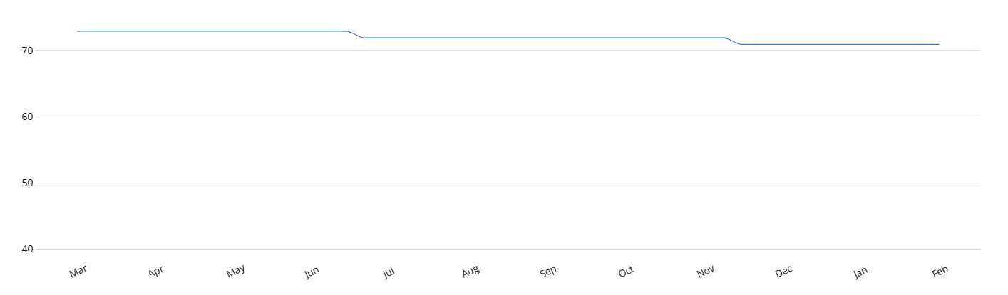
Figure 1: Employee retention trending at Marriott, 2024
(Source: comparably.com, 2024)

Research aim and objectives
The research aims to examine impacts of Trustpilot customer reviews' on employee retention and brand awareness in the Marriott hotels.
The objectives of the research are as follows:
- To examine the factors of employee retention in relation to customer review on Trustpilot in Marriott hotels
- To identify the challenges of brand awareness for the consumer perspectives in regards of employee retention for hotel Marriott
- To recommended strategies to eliminate the challenges of ineffective brand awareness by reducing the employee retention rate in hotel Marriott

Research questions
The questions of the research are as follows:
- What are the factors of employee retention in relation to customer review on Trustpilot in Marriott hotels?
- What would be the challenges of brand awareness for the consumer perspectives in regards of employee retention for hotel Marriott?
- What would be the recommended strategies to eliminate the challenges of ineffective brand awareness by reducing the employee retention rate in hotel Marriott?

Problem statement
The problem statement of the study is to show how declining employee retention rate influencing the brand awareness for the consumers of Marriott hotel. In other way it can be effective to find out how customer reviews from trust pilots are influencing employee within the hotel that is effective for employee retention.

Rationale
Brand awareness plays a crucial role in deciding the relevancy of the ’s hospitality sector especially on the Marriott. Employee retention and its influence on brand awareness is chosen as the hospitality sector is responsible for generating £59.3 billion and putting 3% output in the economy (parliament. , 2022). Impact of customer review on employee retention is an issue as it is affecting the brand awareness prospect of Marriott hotels in the . This is an issue as 90% of customers look up to online customer reviews on Trustpilot to decide the suitability of the Marriott hotels (Narciso, 2022). Therefore, the trajectory value of employee retention and its influence on brand awareness can be determined based on customer reviews. The survey of Trustpilot shows 58% of customers are aware about the consumer values of the market (Trustpilot.com, 2020). This research will address the impact of consumer reviews affecting the rate of employee retention and its influence on brand awareness in the hotel Marriott.

Significance of the study
The significance of the study is that it will help in understanding the importance of customer reviews on Trustpilot in case of employee retention and developing brand awareness for the hotel Marriott. It will also help in identifying how negative customer reviews causes employee retention and impact ineffective brand awareness.
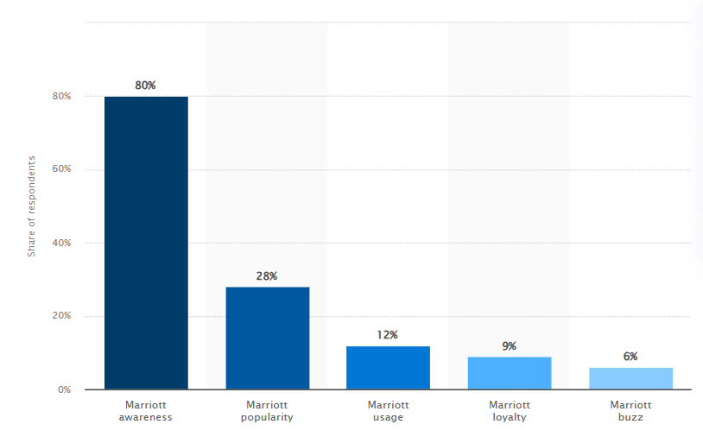
Figure 2: Brand awareness reviews for Marriott hotel
(Source: Statista.com, 2024)
Marriot’s brand awareness among hotel customers is 80%. The survey was conducted employing the principle of brand identification with visuals, as both the brand logo and its name were shown to respondents. Handle employees in exactly the way one could expect them to treat the customers, and most of the time one will get the response that they are looking for. For the most part, sizable organizations such as Marriott International place their brand reputations in the hands of people like desk clerks, housekeeping personnel, and other frontline employees (forbes.com, 2020). If this staffs doesn’t have a nice experience at work, they will not have a real reason to give any good feelings to guests.

Literature Review

Introduction
The factors regarding employee retention, brand awareness, challenges and its strategies will be discussed in literature review. Theoretical perspectives will be provided to support the recommended strategies appropriately.

Influence of employee retention to brand awareness
Employee retention helps an organisation in enhancing employer brand by fostering a positive work environment. As mentioned by Winit and Kantabutra (2022), vision, mission and values of an organisation impact the overall brand awareness prospect of a company in the competitive marketplace. Encouraging employees to become aware regarding the values of a company and aligning their personal goals with organisational values can improve the brand awareness prospect. As stated by Sija (2021), employee retention influences annual cost, revenue, customer relationship and turnover of an organisation. Therefore, it can be stated that building strong corporate culture can encourage becoming productive and maintaining the cooperative value of brand awareness effectively.
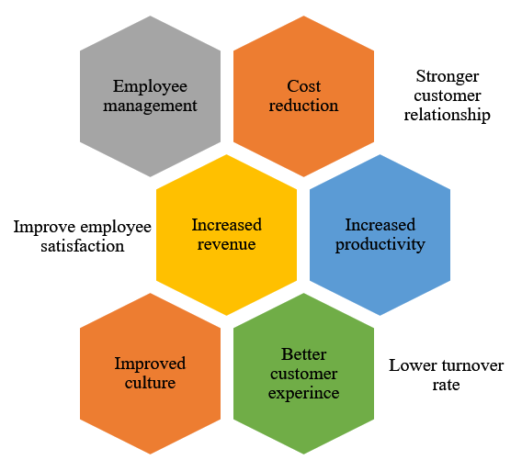
Figure 3: Influence of effective employee retention on brand awareness
(Source: Self-created)

Factors influencing employee retention in hotel Marriott
Marriott is believed to be the largest asset because of their workforce. The hotels these days are tough to make and tough to sustain; but the hotels take care of the employees and customers. Employee satisfaction in the hotel industry is critical since employees must work in shifts, and hotels run 72 hours a day, and it is the duty of the employees to serve the customer with wide smiles (Joshi and Sathe, 2021). One side might be the same normal thing for the employees because they do it on a daily basis and another side for the customers this might be the first time to avail the service but again this is a daily routine for the employees, and the challenge here is to minimize the gap between customer expectation and actual service.
Corporate social responsibility has been influential on the development process of enterprise planning. Those enterprises who want to prosper will never lack the social practice of corporate responsibility, especially the tourist hotel industry like Marriott (Ge, 2020). The interest in CSR practice is so limited it is hard to estimate the success of luxury hotels like Marriott. According to the data published during 10 years it can be concluded that there is a positive relationship between the social responsibilities of corporate and the background of executives; the number of female top managers correlate positively to the practice corporate social responsibility of Marriott Hotel. The Marriott executives with a more complete understanding of Corporate Social Responsibility (CSR) and with the ability to make more effective decisions.

Theoretical Perspective

Herzberg’s two-factor motivation-hygiene theory
Incorporation of “Herzberg’s two-factor motivation-hygiene theory” can help in determining the reasons for satisfaction and dissatisfaction of employees. As suggested by Bundtzen (2023), the hygiene factors of “Herzberg’s two-factor motivation-hygiene theory” include job necessities, condition and salary and motivators include recognition and achievement. These combinations of hygiene and motivators can encourage employees to engage effectively within an organisation. Therefore, this theory can improve the working condition of an organisation and reduce the employee retention rate in an effective manner.
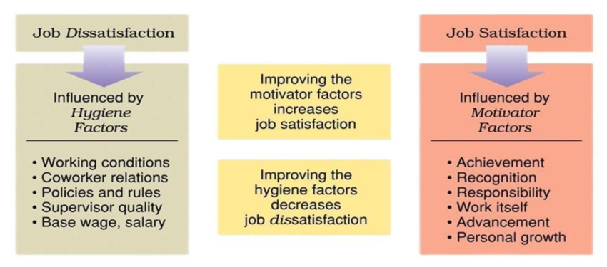
Figure 4: Herzberg’s two-factor motivation-hygiene theory
(Source: Sun and Zuo, 2023)

Brand equity theory
Brand equity theory can improve the brand awareness prospect of an organisation supporting the “equity” and “assets”. According to WU et al. (2020), “brand equity theory” helps in identifying resonance, judgements and performance prospects in a detailed manner. It can help an organisation in determining the areas that require feather improvement to enable brand awareness. Effective brand equity can help in reducing employee retention and enhance customer relationships appropriately. Therefore, it will provide a detailed perspective of brand awareness and support managing the effectiveness of brand equity.
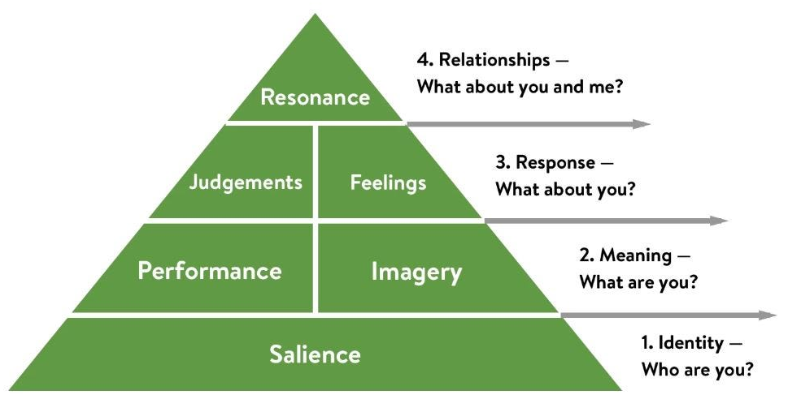
Figure 5: Brand Equity Theory
(Source: Hawker, 2019)

Literature Gap
The literature gap includes lack of focus on the organisational culture and its values in relation to employee retention. Inadequate benefits within the hospitality sector have also impacted the progression value of literature review.

Summary
It can be summarised that gathering in-depth knowledge regarding the research topic has helped in understanding the relevance of the topic. It has supported the overall prospect of the research by providing theoretical background.

Methodology

Introduction
The detailed process of research methodology will help in understanding the steps of the research effectively. It will help in gathering sound information and reach the conclusion of the research.

Research Onion
Incorporation of “research onion” will help in articulating this research by choosing the lawyers of research in an appropriate manner. According to Saunders et al. (2018), research onion supports the suitable research practices by answering the research questions effectively. Therefore, it will guide in terms of inhibition of apoptosis by highlighting the critical factors of the research.
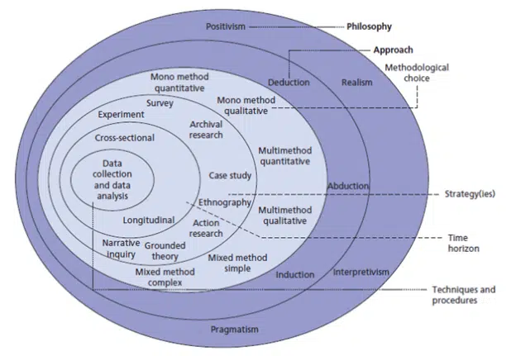
Figure 6: Research Onion
(Source: Saunders et al. 2018)

Research Philosophy
“Research philosophy” is a belief that supports the phenomena of a research by analysing the critical component appropriately. There are four types of “research philosophy” include “positivism”, “interpretivism”, “pragmatism” and “realism”. In this case, “interpretivism research philosophy” will be chosen to analyse the subjective reality of trustpilot reviews in developing brand awareness and employee retention in the hotels of Marriott of the . As stated by Alharahsheh and Pius (2020), “interpretivism research philosophy” helps in analysing a sociological event based on the beliefs, norms and values. On the other hand, “pragmatism” and “realism research philosophy” will be avoided due to its complex procedures and inability to establish sound discrepancies between different types of data. “Positivism research philosophy” will be ignored due to its inflexibility in measuring gathered data from the research.

Research Approach
The extensive process of collecting, analysing and interpreting data is considered as the “research approach”. Research approach can be divided into two groups such as “inductive” and “deductive research approach”. Incorporation of “deductive research approach” will support the research by understanding the patterns of consumer reviews impacting upon employee retention in Marriott hotels of . As mentioned by Corley et al. (2021), “deductive research approach” encourages critical thinking based on the gathered data and helps in developing theories, and concepts effectively. “Inductive research approach” will be avoided as its lack of possibility in producing replicable results according to the subject of research.

Research Design
The critical process of answering research questions based on the empirical data is referred to as the “research design”. There are four types of “research design” such as “descriptive”, “explanatory”, “experimental” and “correlation”. In this case, “descriptive research design” will be selected to describe the primary prospect of analysing reviews influencing employee retention and brand awareness by developing effective theories. As suggested by Gopalan et al. (2020), “descriptive research design” uses the data to derive results and provide extensive insight according to a topic. On the contrary, “experimental research design” has been avoided for its time-consuming and complex nature to analyse data. “Explanatory” and “correlation research design” have been ignored due to the possibility of a confounding factor and its inability to derive a concrete result from the gathered data.

Research Strategy
“Research strategy” is a plan that guides the overall research activities and helps in reaching its conclusion in an effective manner. There are two types of research strategy such as “qualitative” and “quantitative research strategy”. Incorporation of “qualitative research strategy” will help in gaining in-depth understanding as how customer reviews on Trustpilot is driving the employee retention which is impacting brand awareness within the hospitality sector of the . As commented by Gray et al. (2020), the advantage of “qualitative research strategy” is that it is flexible and explores different phenomena to derive results. The possibility of “quantitative research strategy” will be ignored due to its inability to provide a detailed result regarding the influence of employee retention and brand awareness on the basis of consumer reviews.

Data Collection and analysis
The process of “gathering", “measuring”, and “analysing” accurate data to derive the result for research is called “data collection”. There are two types of “data collection method” which include “primary” and “secondary data collection”. In this case, “secondary data collection method” will be followed considering the published reviews from consumers on the several trustpilots for Marriott hotels. In this regard information from research journals will also be considered for analysing and justifying the instances might have happened. According to Bustani (2022), the advantage of the “secondary data collection method” is that it is cost effective and saves time appropriately. Data based on the reviews on trust pilots would be collected Twitter, linked, indeed etc. Influencing factors of employee retention exhibiting clients’ reviews from several trust pilots will be collected and analysed.
The systematic process accompanying with review transcription would be condensing and evaluating the gathered data as the process of “data analysis”. Based on the “secondary qualitative data” this research will conduct a mode of review transcription. Collected data which will be reviews collected from twitter and other trust pilots will be analysed using the transcription.

Ethical Consideration
The ethical considerations for this research are as follows:
- Data that are collected and analysed is strictly based on the research purpose, there will be no intentions of harming anyone’s sentiments during this research process.
- Plagiarism will be avoided to maintain the authenticity of the research and support its findings efficiently.
- Authors will be acknowledged with appropriate citations to support the credibility of the research.
- Anonymity of the data is the top notched priority doing this research.
- Manipulation of the data in order to meet the research aim and objective is strictly prohibited.
- During data analysing the chances of data fragmentation will be ignored to conduct the research appropriately.

Time Horizon
Factors | Week 1 | Week 2 | Week 3 | Week 4 | Week 5 | Week 6 | Week 7 | Week 8 | Week 9 | Week 10
Selection of the topic
Research aim and definition
Background of the project
Outline research objectives
Literature review
Methodology
Data collection
Data analysis
Conclusion
Final submission

Table 1: Time plan of the research
(Source: Self-created)

Summary
The summarisation that can be derived is that the overall implication of these methodological processes will support the research. It will provide credibility to the research by answering the research questions.

Potential Risk
The potential risk can occur while deriving information according to the research objectives to support the progression value of the research. The potential risk to individual subject can alter the subjective value of the research while answering research questions. It can be stated that it can be unsuitable for the overall value of the research.

Findings
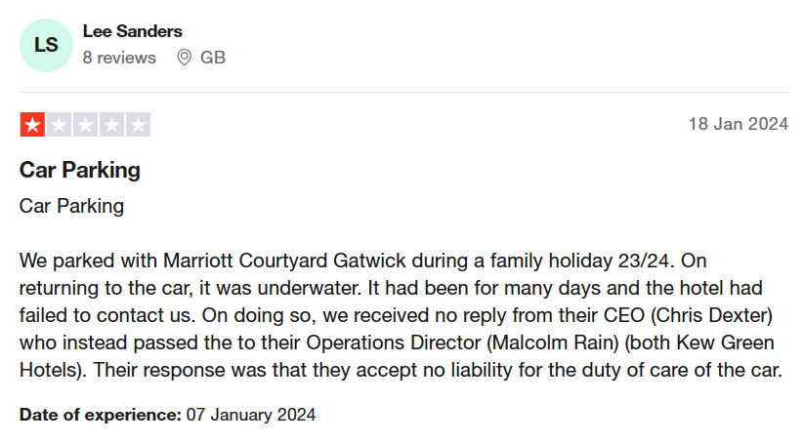
Figure 7: Trustpilot reviews for hotel Marriott
(Source: .trustpilot.com, 2024)
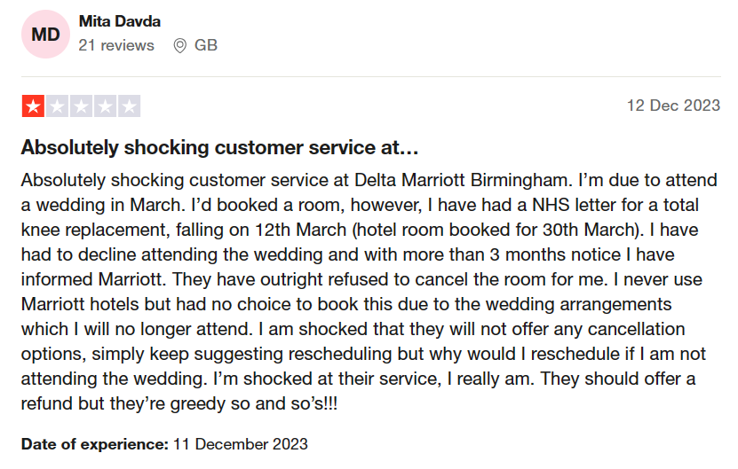
Figure 8: Trustpilot reviews for hotel Marriott
(Source: .trustpilot.com, 2024)
Trustpilot reviews on Marriott hotel shows that the manager of the hotel showed a discrepant attitude while maintaining consumers liabilities while they were availing hotel services. a client may be dissatisfied with the situation being handled that way, because of that they can leave negative reviews, which can affect the choice of the potential visitors. Negative reviews are one of the factors that influence a hotel's reputation. Bad reviews on customer service lead to the hotel's reputation decrease. This can cause a decline in the trust among potential guests who use reviews for guidance in making well-informed bookings (Neves, 2019). The negative experience can be amplified by social media platforms. When the client decides to publish their story on social media platforms the message will be able to spread rapidly and create negative publicity. Customers who are not satisfied with the services provided by a hotel are less likely to stay with the same hotel in future. For a hotel to address such a complaint and not lose that customer, and not lose the potential of repeat business can be the hardest thing to do.
To deal with these probable challenges, hotels, including Marriott, will time to time revisit and update their policies based on the feedback from the customers and in accordance with the industry trends. To navigate these potential challenges, hotels, including Marriott, may periodically review and adjust their policies based on customer feedback and industry trends. Notably, good communication and customer service are essentials for managing guest expectations and also handling issues that stem from policies like the no-cancellation. In general, guests are inclined to value transparency and explicitness of the hotel regulations. Associated with a no-cancellation policy is the situation where customers may find that this policy was not well explained or was unclear (Altin et al. 2023). These negative reviews may highlight this aspect, which can affect the reputation of the hotel. The negative reviews that the customers received because of the strict no-cancellation policy could influence how satisfied the customer is with the company in general. The guests may have a negative attitude towards the hotel if they feel that the flexibility or understanding they expect from the hotel isn’t given in case of any unpredicted situation or change in plans. The issues of the no cancellations policy can lead to a negative image of the hotel, and customers might become disinclined to book their stays at this hotel thus disturbing its reputation management.
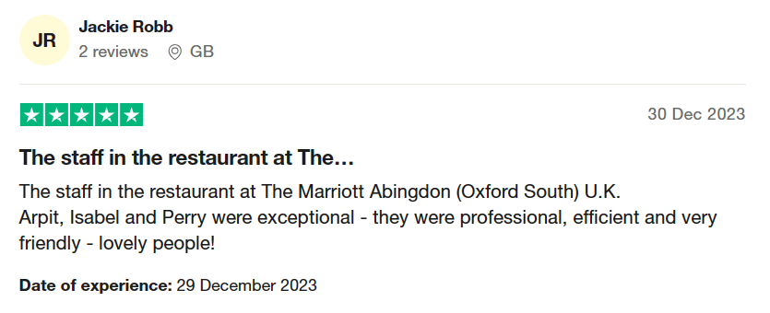
Figure 9: Trustpilot reviews for hotel Marriott
(Source: .trustpilot.com, 2024)

The recognition of Marriott’s positive contributions by its employees helps them to feel like they belong to the team. The environment in the workplace; which includes the relationship between the workers and the organization, helps to shape the overall job satisfaction and minimizes the chances of looking for opportunities elsewhere. Employees who receive recognition will be given more opportunities to focus on their development and growth virtually any time there is an opening for training, promotions, or other professional growth opportunities in the company that they can benefit from, and this will also make them more likely to stay with the company. Positive feedback cultures enhance the worker's bond to the organization. When the employees’ efforts are recognised and support is provided, they are more prone to hold the organization in a positive light hence loyalty and lower turnover result.

Conclusion
It can be concluded that negative customer reviews can drive employee retention and cause ineffective brand awareness in Marriott international hotels. Cultural values, leadership and lack of training and development is causing the employee retention rate in the competitive marketplace. The absence of effective employee and consumer relationship along with lack of transparency is causing the high employee retention rate over the course of time.

References
Alharahsheh, H.H. and Pius, A., (2020). A review of key paradigms: Positivism VS interpretivism. Global Academic Journal of Humanities and Social Sciences, 2(3), pp.39-43.
Altin, M., Chen, C.C., Riasi, A. and Schwartz, Z., 2023. Go moderate! How hotels' cancellation policies affect their financial performance. Tourism Economics, 29(8), pp.2165-2182.
Borrow, I (2023), Could poor onboarding be the reason for your high staff turnover? Available at: https://www.hospitalitynet.org/opinion/4117334.html [Accessed on: 2nd February, 2024]
Braun, V. and Clarke, V., (2023). Toward good practice in thematic analysis: Avoiding common problems and be (com) ing a knowing researcher. International Journal of Transgender Health, 24(1), pp.1-6.
Bundtzen, H., (2023). Adapting Herzberg’s Motivation-Hygiene Theory to a VUCA world–a repertory grid study.
Bustani, B., Khaddafi, M. and Ilham, R.N., (2022). Regional Financial Management System of Regency/City Regional Original Income In Aceh Province Period Year 2016-2020. International Journal of Educational Review, Law And Social Sciences (IJERLAS), 2(3), pp.459-468.
comparably.com, (2024), Marriott Retention Score, Available at: Marriott Retention Score | Comparably, [Accessed on: 10.02.2024]
Corley, K., Bansal, P. and Yu, H., (2021). An editorial perspective on judging the quality of inductive research when the methodological straightjacket is loosened. Strategic Organization, 19(1), pp.161-175.
forbes.com, (2020), 3 Things You Can Learn From Marriott About Taking Care Of Employees, Available at: 3 Things You Can Learn From Marriott About Taking Care Of Employees (forbes.com), [Accessed on: 10.02.2024]
Ge, X., 2020. Exploring factors of corporate social responsibility in luxury hotels: The case of Marriott Hotel
Gopalan, M., Rosinger, K. and Ahn, J.B., (2020). Use of quasi-experimental research designs in education research: Growth, promise, and challenges. Review of Research in Education, 44(1), pp.218-243.
Gov. , (2023), Economic insights Available at: https://assets.publishing.service.gov. /media/5d67a363ed915d53b4904899/Hospitality_and_Tourism_Workforce_Landscape.pdf [Accessed on: 2nd February, 2024]
Gray, L.M., Wong-Wylie, G., Rempel, G.R. and Cook, K., (2020). Expanding qualitative research interviewing strategies: Zoom video communications. The qualitative report, 25(5), pp.1292-1301.
Hawker, (2019), Keller’s Brand Equity Model — What It Is & How to Use It Available at: https://medium.com/@keatonhawker/kellers-brand-equity-model-what-it-is-how-to-use-it-84e42d562299 [Accessed on: 2nd February, 2024]
Joshi, A. and Sathe, S., 2021. A study on factors affecting staff turnover in five star Hotels.
Nariso, M (2022), The Unreliability of Online Review Mechanisms Available at: https://www.ncbi.nlm.nih.gov/pmc/articles/PMC9001162/ [Accessed on: 2nd February, 2024]
Neves, M.S., 2019. Exploring customer interaction and management response in luxury hospitality through online reviews in social media
Parliament. , (2022), Hospitality industry and Covid-19 Available at: https://commonslibrary.parliament. /research-briefings/cbp-9111/#:~:text=Hospitality%20industry%20in%20the%20 %3A%20pre%2Dpandemic,in%20each%20country%20and%20region. [Accessed on: 2nd February, 2024]
Parmelee, M (2023), Making waves: How Gen Zs and millennials are prioritizing—and driving—change in the workplace Available at: https://www2.deloitte.com/ /en/insights/topics/talent/recruiting-gen-z-and-millennials.html [Accessed on: 2nd February, 2024]
Saunders, M.N., Lewis, P., Thornhill, A. and Bristow, A., (2018). Understanding research
Sija, A., (2021). The influence of job satisfaction and its effect on employee turnover intention in financial service industry of Malaysia. European Journal of Economic and Financial Research, 5(1).
statista.com, (2024), Marriott brand awareness, usage, popularity, loyalty, and buzz among hotel customers in the in 2022, Available at: Marriott brand profile 2022 | Statista, [Accessed on: 10.02.2024]
Sun, P. and Zuo, X., (2023). The Missing Piece: Incorporating Organizational Factors in Employee Motivation Research. Sun, P., & Zuo, X.(2023). The Missing Piece: Incorporating Organizational Factors in Employee Motivation Research. International Journal of Science and Business, 25(1), pp.24-33.
.trustpilot.com, (2024), Marriott International, Available at: Marriott International Reviews | Read Customer Service Reviews of www.marriott.com (trustpilot.com), [Accessed on: 10.02.2024]
.trustpilot.com, (2024), Marriott International, Available at: Marriott Reviews | Read Customer Service Reviews of www.marriott.co. (trustpilot.com), [Accessed on: 10.02.2024]
Winit, W. and Kantabutra, S., (2022). Enhancing the prospect of corporate sustainability via brand equity: A stakeholder model. Sustainability, 14(9), p.4998.
WU, W.Y., DO, T.Y., NGUYEN, P.T., Anridho, N. and VU, M.Q., (2020). An integrated framework of customer-based brand equity and theory of planned behavior: A meta-analysis approach. The Journal of Asian Finance, Economics and Business, 7(8), pp.371-381

