Literature review of current motorcycle dynamic studies
Iriney Georgiev
Wales Institute of Science and Art, University of Wales Trinity Saint David, Swansea, United Kingdom
1900719@student.uwtsd.ac.uk

Literature review of current motorcycle dynamic studies

Abstract
Compared to other simulations and studies of vehicle dynamics, motorcycle dynamics is relatively new. Significant progress has been made in the last few years. This paper reviews current studies in the field of motorcycle dynamic simulations. To identify areas where further research is needed, other authors' results were evaluated. There is no outstanding motorcycle simulator at present, research indicates its potential and future implementation.

Keywords: motorcycle dynamics; modelling; simulation; manoeuvre; lap time

Introduction
A vehicle undergoes numerous tests before it is released on the market, which are designed to evaluate its safety, performance and durability. In the event that test results are unsatisfactory, the vehicle design is modified and the testing procedure is repeated. A greater number of iterations means higher costs for the manufacturer since expensive instrumented prototypes must be developed and tests must be conducted on tracks by a skilled driver. As part of its efforts to reduce costs, save time, and reduce the number of physical prototypes required for verification, the automotive industry uses virtual prototyping tools (VPT) such as dynamic vehicle simulators [1].
The motorcycle industry falls far behind the automotive industry when it comes to the use of simulation technology. The motorcycle development process is evolving and virtual prototyping tools have become more prevalent in the past decade, particularly in the racing world, "...computer modeling systems enable Ducati to develop comprehensive simulations that can predict a bike’s behavior before it leaves the garage. Smarter tech means smarter simulations, greater speed and more races won." [2].
There are not many official multibody tools available for public motorcycle simulations. Most two-wheeled vehicle software packages are chassis programs, which can only simulate changes in geometry in static conditions [3,4]. A few mathematical models have been developed in recent years to simulate dynamic motorcycle behavior, such as "VI-BikeRealTime" and "BikeSim" [5,6]. Despite their powerful nature, these simulation programs are not yet accepted as industry standards and it remains unclear what complexity issues are held responsible for their non-reliability.
The purpose of this paper is to identify the potential problems associated with commercially developing a motorcycle dynamic simulator. Research papers published within the past five years are reviewed in terms of comparing different methodological approaches, contrasting evidence and assessing therapeutic potential.
The work is organized as follows. In section 2, the author examines different research approaches and results to identify potential limitations of simulations. In Section 3, important aspects of developing a reliable simulation platform as well as other alternatives that have not yet been explored are discussed.

Literature Search
One of the first authors to investigate the different approaches to virtual motorcycle control were Alessandri Beghi and Ruggero Frezza [7]. In this research, a nonlinear control method was used to control a riderless motorcycle. An optimization algorithm followed by a closed-loop system provided the right steering and throttle/brake inputs to prevent the virtual model from crashing.
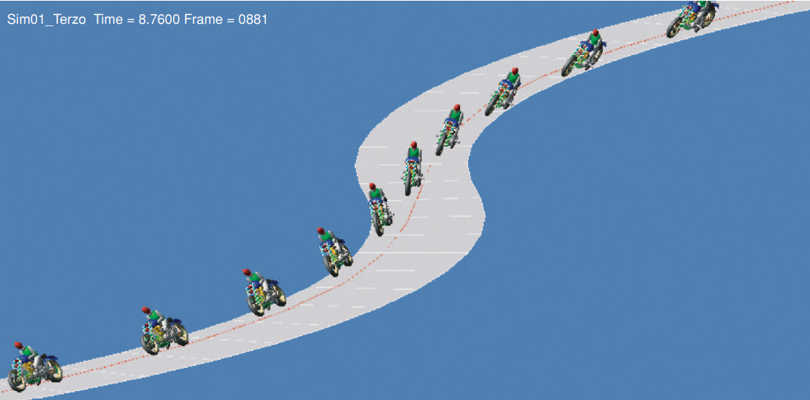
Figure 1: Model of a custom motorcycle covering a chicane at a constant speed while staying close to a reference trajectory [7].

Figure 1 illustrates corners 4 and 5 of the Mugello circuit. A substantial amount of data was available on this track, so simulations were conducted on it. A total of 70 motorcycle models were tested for minimum lap times. According to research [7], the virtual racing motorcycle was capable of extremely aggressive maneuvers where maneuverability was emphasized over handling, which was not always the case in reality. Moreover, since the rider was expected to perform at the limit, the tyres were assumed to have a zero width and to be capable of producing infinite lateral forces without slipping.
According to a recent study, R. Barbegallo et al. [8] developed a multibody control model by implementing Adams/View/Matlab/Simulink co-simulation techniques. The non-linear rider model was programmed to view certain aspects of the trajectory in advance and based on the acquired information, decide how to steer, accelerate, brake or position its body.
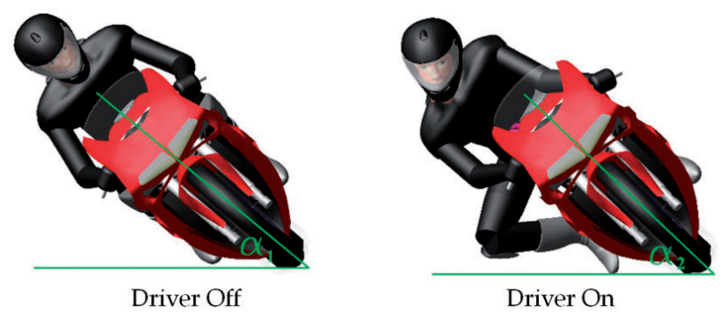
Figure 2: A comparison between a bike model with and without a virtual rider [8].
The researchers used Adams' PAC-MC, derived from the MAGIC-FORMULA [9], to model the tyre-road interaction forces and to account for both carcass stiffness and combined longitudinal/lateral slip. There were 28 degrees of freedom in the virtual rider, although only six of them could be controlled during maneuvers by the model as shown in figure 2.
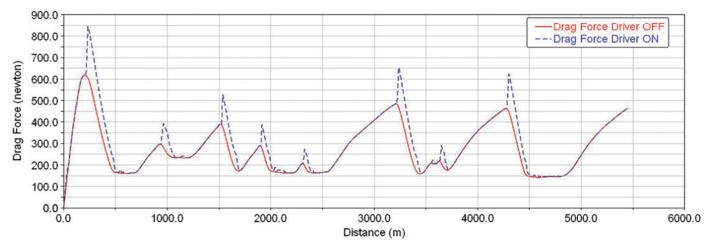
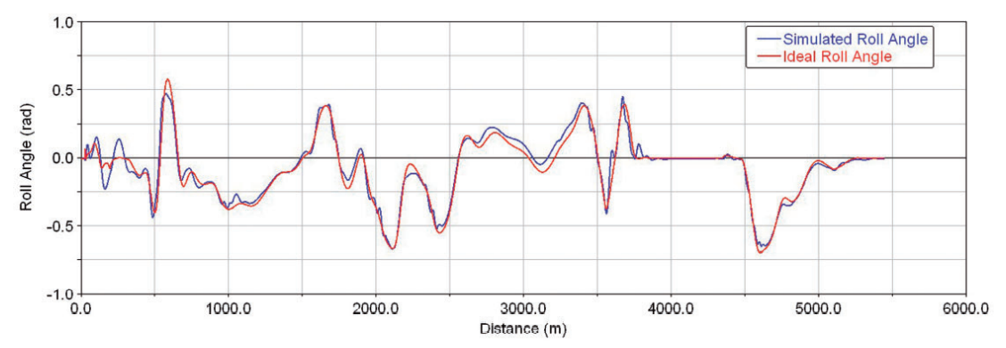
Figure 3: A comparison of the ideal roll angle calculated by V. Cossalter [10] and the simulated roll angle [8].
Figure 4: Difference between drag forces with and without a rider [8].

The research was able to simulate an entire lap of the Monza circuit at a particular velocity profile while maintaining low position, roll angle errors and showing the difference between driver-on and driver-off simulations. As illustrated in figure 3, the virtual motorcycle cannot lean as far as the ideal equation estimates due to external factors. Additionally, drag force was also affected as shown in figure 4 by the straight-up position of the rider when approaching a corner or when leaning away from the bike during a turn. There was a primary limitation to this research in that the simulated model required pre-set data to determine the trajectory of the virtual model. Although the results obtained in this study were theoretically true, some form of validation was required to verify them. The simulation model required pre-set data for determining the line trajectory, which limited the utility of the virtual model since every rider and maneuver would require a different approach.
M. Bruschetta et al. [11] developed a nonlinear model control system where lateral and longitudinal forces of the tyres were influenced by throttle and brake inputs and drag was affected by the rider's body position. Contributions to motorcycle modeling include the effects of caster and roll on the steering angle, as well as gyroscopic effects. The maximum transmission torque was changed on-line to introduce gearbox effects. In this study, the researchers examined how motorcycles steer and how rider’s torque input/position can influence it.
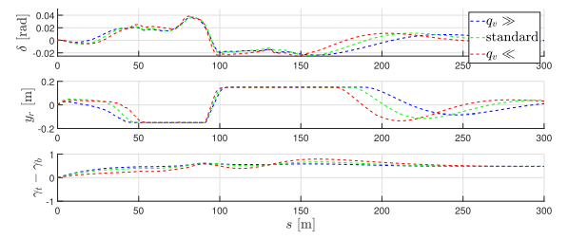
Figure 5: Analysis of different weight configurations ($q\text{v}$) in relation to steering angle ($δ$), rider position ($γ\text{r}$) and throttle ($γ\text{t}$) /braking ($γ\text{b}$) inputs [11].

The first virtual test was conducted using three identical bikes with different weights controlled by the same rider in a chicane maneuver with a radius of 40 meters. Figure 5 illustrates that the rider model could possibly cut a corner to maintain high velocity by adjusting its movement and inputs when the bike weight is higher and vice versa. In addition, a comparison was conducted between a stationary rider and a moving rider with the exact same weight configuration.

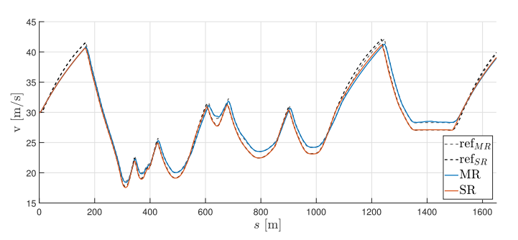
Figure 6: The actual and reference speeds of a moving rider (MR) and a stationary rider (SR) along the selected track [11].

In figure 6, the researchers stated that the motorcycle with MR control was able to travel all curves at a faster speed than the motorcycle with SR control, while maintaining similar or slightly smaller values of roll angle. To support this theory, they replicated the same experiment using the commercial software "VI-Grade" [5].
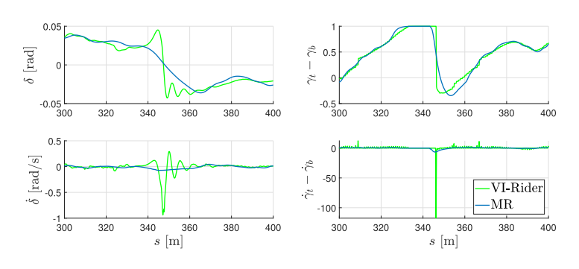
Figure 7: Steering angle and longitudinal commands comparison between MR and VI-Grade [11].

Ultimately, the authors of this report [11] concluded that their study represented a more realistic rider movement due to smoother input characteristics, as shown in figure 7. Since VI-Grade was initially developed for automotive simulation, it may not necessarily be the most reliable validation technique, since the vehicle's trajectory also remains fixed.
In a study undertaken by A. Przibylla [12], a dynamic motorcycle response to torque input was investigated by integrating an inertial measurement platform and a multi-antenna global positioning system into a 2012 Ducati Panigale 1199S. The sensors were directly connected to a 2D data logger mounted on the bike, from which all necessary calculations were made. Tests were conducted on track and on the road and torque signals along with steer and lean angles were recorded to verify the operation of the system. The use of this type of system might be more appropriate for comparing rider behavior in a virtual environment to that in a real environment.
Usually, free-trajectory solutions are based on an optimal control problem (OCP) approach to lap time simulations in which the virtual model generates the quickest path to follow within circuit limits [13]. In dynamic simulations, OCP is an unrealistic time-solving technique due to the computational burden associated with solving the best trajectory of a vehicle. S. Garlicka and A. Bradley [14] have conducted a study on optimal vehicle trajectory planning using machine learning techniques. It was found that by using feed-forward artificial neural networks (ANN), with Sigmoid and Hard Sigmoid activation functions, the simulation time was reduced by 9000 times. Having a greater number of tracks available would enable the ANN to learn to drive at a faster pace and thereby establish the fastest trajectory quicker.
It was established by E. Marcon and M. Massaro [15] that a similar principle could be applied in order to identify the optimal recovery maneuver following a driving error to complete a lap within a minimum period of time.
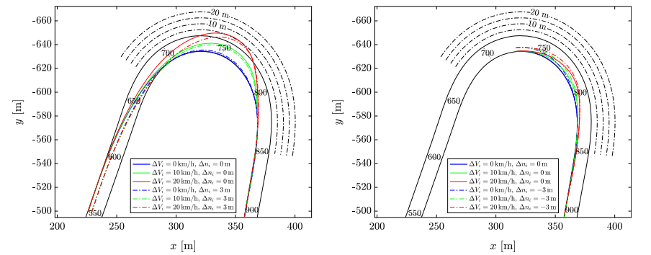
Figure 8: Trajectories of recovery based on combined speed and lateral position errors, where ($s\text{i}$) is braking point [15].

Research was conducted using a nonlinear OCP, where the authors implemented a three-dimensional minimum-time method based on quasi-steady-state models in order to eliminate the computational difficulties presented in the literature [15]. In this study, only Turn 1 from the Mugello circuit was modelled through curvilinear coordinates, and two types of errors were investigated, speed and lateral position. Figure 8 illustrates the results.

Evaluation and Interpretation
A review of scientific papers was conducted in order to identify the steps that can be taken in the development of a fully functioning dynamic model for a motorcycle. In addition to that, the main two potential problems associated with simulation models were identified as follows:
- Availability of computational power
- Simulation validation
Depending on the application, the level of detail of the simulation will vary since computational power plays a significant role in the accuracy of the results. For a simulation to be validated, real-world data is necessary. Due to their dynamic sensitivity, motorcycles, however, are notoriously difficult machines to measure on the road or track. It has been attempted to simulate motorcycles in closed environments based on car simulators, as their technology is at a much higher level [16]. However, the gyroscopic effect has always been difficult to reproduce. A recent experimental study conducted by P. Michel et al. [17] was able to get around this phenomenon to some extent by using instrumentation choices such as systematically falling motorcycle, if weight compensation is not present. The motorcycle simulator could solve a number of issues that were raised by the complexity of the motorcycle dynamics and the interference of the human factor.
This case study shows how if a motorcycle-rider software package is developed and validated against real motorcycle data as described in the literature, the industry could be deeply affected. This raises the question of whether such a package is even necessary after the industry has survived so long without one.

References
- Danquah, B., Riedmaier, S. and Lienkamp, M. (2020) “Potential of statistical model verification, validation and uncertainty quantification in Automotive Vehicle Dynamics Simulations: A Review,” Vehicle System Dynamics, 60(4), pp. 1292–1321. Available at: https://doi.org/10.1080/00423114.2020.1854317.
- Lenovo (2022) Big Data and Ai are pushing motogp to achieve unthinkable speeds. Available at: https://news.lenovo.com/big-data-and-ai-are-pushing-motogp-to-achieve-unthinkable-speeds/ (Accessed: December 4, 2022).
- MotoSPEC (2022) MotoSPEC CHASSIS PROGRAM. Available at: https://www.motospec.ca/ (Accessed: December 4, 2022).
- Zerochassis (2022) Zero One Racing:Motorcycle chassis and suspension software. Available at: https://www.zerooneracing.com/zerochassis/ (Accessed: December 4, 2022).
- VI-Grade (2022) Motorcycle dynamics: ViGrade. Available at: https://www.vi-grade.com/en/applications/motorcycle_dynamics/ (Accessed: December 4, 2022).
- AMET (2022) BikeSim: Bike Dynamics Simulation - 2 wheels vehicle. Available at: https://www.amet.it/en/software/bikesim-en/ (Accessed: December 4, 2022).
- Frezza, R. and Beghi, A. (2006) “A Virtual Motorcycle Driver for Closed-Loop Simulation,” Multibody tools for evaluating system performance, pp. 70–76.
- Barbagallo, R. et al. (2016) “Multi-Body Dynamics,” Dynamics of a high-performance motorcycle by an advanced multibody/ control co-simulation, pp. 211–217.
- Fouka, M. et al. (2018) “IEEE Conference on Decision and Control (CDC,” Adaptive Observer for Motorcycle State Estimation and Tire Cornering Stiffness Identification.
- Cossalter, V. (2006) Motorcycle Dynamics. 2nd edn. Pandova, Italy
- Bruschetta, M. et al. (2021) “IEEE TRANSACTIONS ON CONTROL SYSTEMS TECHNOLOGY,” Real-Time Nonlinear Model Predictive Control of a Virtual Motorcycle.
- Przibylla, A. (2018) Ducati Panigale 1199 S Dynamic Vehicle Response Measurement Platform. thesis. University of Wales Trinity Saint David.
- Evans, L. (2022) An Introduction to Mathematical Optimal Control Theory. rep. Berkeley: University of California.
- Garlick, S. and Bradley, A. (2021) “Real-time optimal trajectory planning for autonomous vehicles and lap time simulation using machine learning,” Vehicle System Dynamics, 60(12), pp. 4269–4289.
- Marconi, E. and Massaro, M. (2022) Optimal recovery manoeuvres of racing motorcycles, pp. 457–469.
- Bartolozzi, M. et al. (2022) Similarities in steering control between cars and motorcycles: application to a low-complexity riding simulator, pp. 2862–2873.
- Michel, P. et al. (2022) Rider in the Loop Dynamic Motorcycle Simulator: An Instrumentation Strategy Focused on Human Acceptability, pp. 1–18.

