Student Name: Evan Bartley
P Number: 150558
Programme of Study: Illustration
Module: M4X01559

Imagined Exhibition - Mission Gallery

For my imagined exhibition I have chosen to use the space in the Mission Gallery. My theme for the exhibition is 'participation', this will involve the audience taking part in each artists area. The idea is that the exhibit will be physically engaging and therefore more rewarding for the audience. I will be looking at ideas to do with participation and how to tackle the problems. I will also discuss the artists and artworks included in my imagined exhibition.
We participate in all exhibitions we go and see because we are there, in the space. We might not be contributing to the exhibition but we are participating. Just like Graciela Carnevale's project for the experimental art series 1968, where she prepared an empty room with one glass wall and had an audience locked inside without them knowing. However they reacted "their positive or negative reaction is always a form of participation." This can link to how technology has taken over, we are so engrossed in our phones nowadays it is almost like we aren't even there.
In order for my exhibition to work I need someone to conduct it. In this case each individual artist which I have chosen will be the conductors. For example, an orchestra needs a conductor otherwise they wouldn't be in sync and wouldn't have a point of reference. However, the band needs each individual member to participate or the music wouldn't sound good either. So what I need is a collaboration between the artist and audience. Such theories from Walter Benjamin state that we need to turn "more readers or spectator into collaborators." Hence "the work of art should actively intervene in and provide a model for allowing viewers to be involved in the processes of production."
My aim with this exhibition is to bridge the gap between the audience and the artist and the Mission Gallery is a fantastic way of doing this. By hosting the exhibit there, it will metaphorically and literally "reduce the distance between actors and spectators." Sometimes I feel like society disassociates itself from the art world and therefore they lose a connection or belief that they themselves can also produce great work. This exhibition is all about participating, I want it to have a personal impact on each person who visits and with the artists I have chosen I believe this is certainly possible.
The exhibition layout will run in a coherent and comfortable manner for the audience, working anti clockwise. As the audience enter they will be greeted and their first stop will be with Roman Ondak (more information about the artists and artworks later on). Then they'll continue onto Marina Abramovic, Peter Draws, Georges Rousse and finally Mary March. How the exhibition is displayed has a big impact on the way it is received by the audience. Each artists work needs sufficient space in order to give the viewer the time they need to immerse themselves and fully engage with what is happening in front of them. "The interaction of works with the site, with each other or with the public seemed to give the exhibition its own life force."

The first artist I have chosen is Roman Ondak. He is a conceptual artist born in Slovakia and the artwork of his which I have chosen is 'Measuring the Universe.'
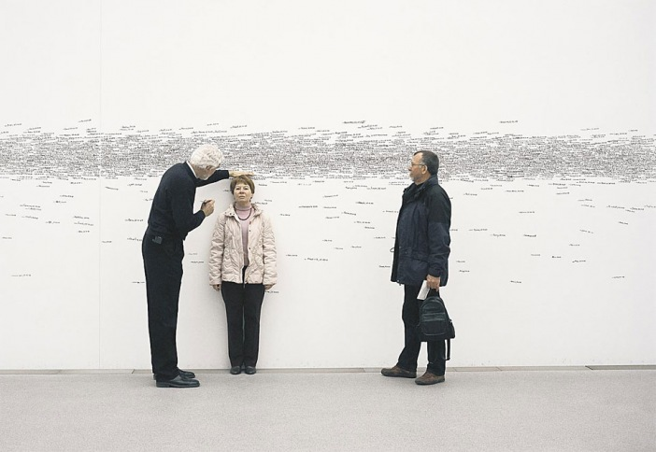
Roman Ondak, Measuring the Universe 2007
This artwork begins with an empty, white wall room, where the audience is encouraged to mark their height onto the wall with a marker and also their name and the date. Gradually, over the duration of the exhibition more and more names will appear and they will start to overlap and cover up the previous markings, producing a constellation of measurements. Each person measured contributes to the 'Universe' which Ondak is attempting to create. Anyone is able to alter the existing 'Universe' depending on their height and where they choose to place their recording. Once the exhibition finishes the walls will be re-painted in order for the audience to focus on the brief moments of participation.

Continuing around the room, Marina Abramovic is the second artist I have selected. She is a performance artist born in Serbia and she will be performing her piece 'Rhythm 0'.
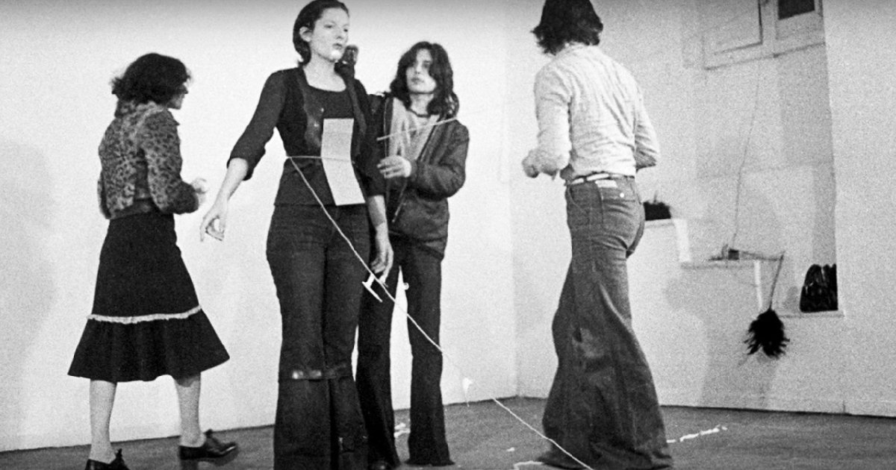
Marina Abramovic, Rhythm 0 1974
In this performance, Marina Abramovic stood still for six hours. The instructions stated that the audience could use any of the 72 objects from the table and use them on her as desired. She also stated that she is "the object" and that she takes "full responsibility" for the outcome of the performance. To begin, the audience were rather tame, just turning her around and tying objects to her. But as the act continued things became more horrifying for Abramovic, as some audience members cut her, ripped her clothes and made her point a loaded gun at herself. At the end of the performance none of the crowd could bare to confront her. "It seemed as if they wanted to forget how much they relished hurting her." This shows the notion of humanity under "favourable circumstances."

Working counter-clockwise, the next artist will be Peter Draws (Deligdisch). He is an American illustrator/ doodler and posts all his content on YouTube.
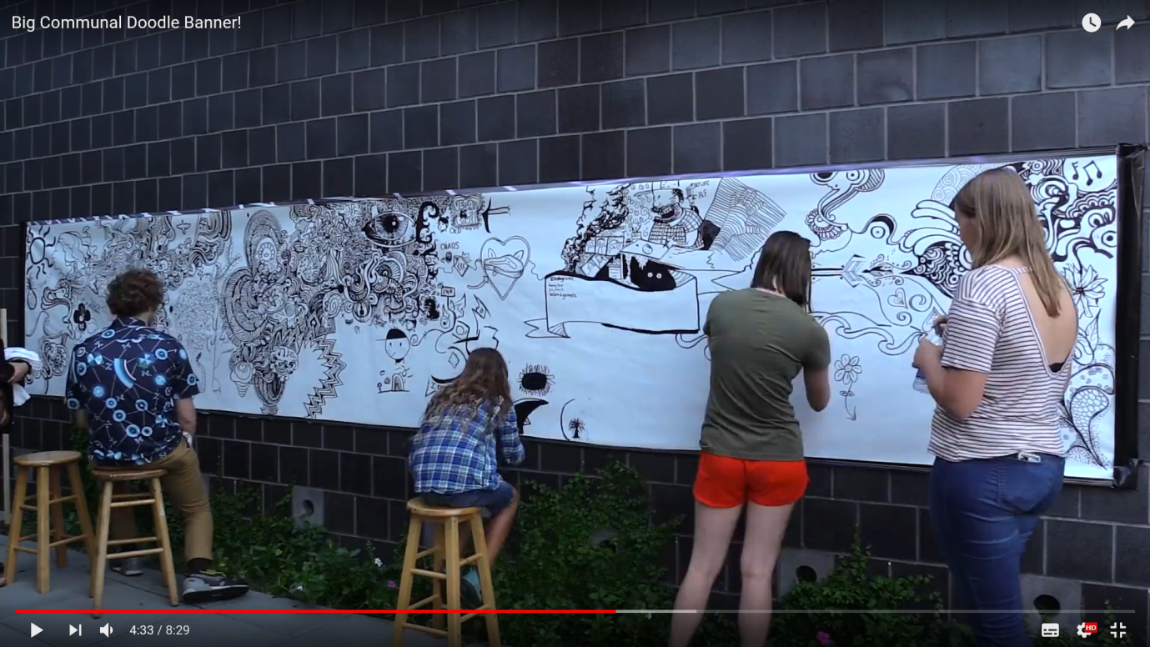
Peter Draws (Deligdisch), Big Communal Doodle Banner 2017
I have chosen to include this piece by Peter Draws because I love his work and regularly watch his videos. He is a wacky guy and having his personality in my exhibition would be great. His 'Big Communal Doodle Banner' took place at the Cameron Art Museum in Wilmington. He was in charge of this 24 hour drawing event where the public can participate and draw whatever they like on the banner. This allows each individual to have their own creative freedom to express themselves with drawing. Once completed the banner will provide, everyone who took part, a sense of accomplishment and teamwork.
The forth artist I have chosen is Georges Rousse. He is a French artist and photographer who works with perspective.
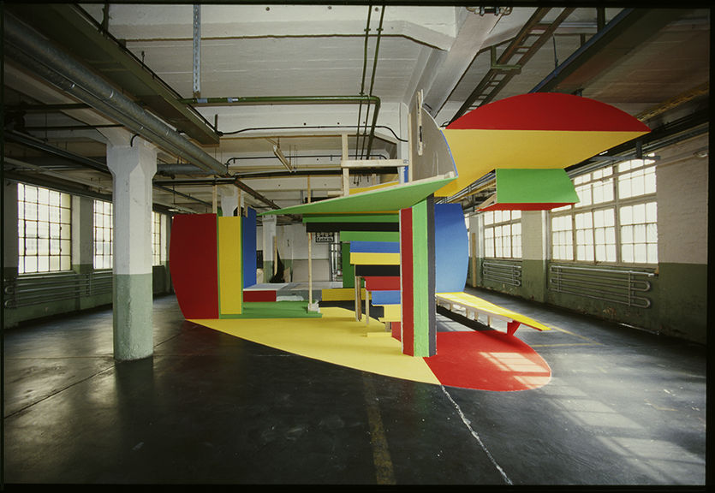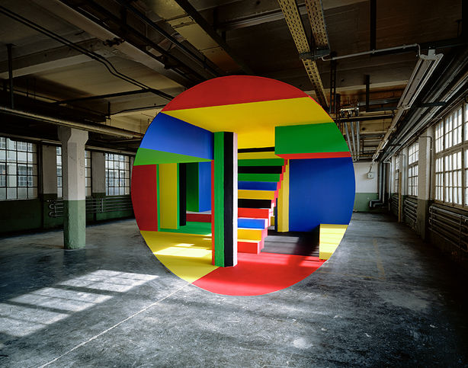
Georges Rousse, Russelsheim 2003
Here, Rousse plays with the audiences perspective by creating this almost Photoshop look in real life. In order to view the artwork, the viewer needs to participate by standing in certain spot. Otherwise they won't see the finished article. This piece is a recreation by Rousse in Russelsheim, the first was 10 years before and the exhibition wanted to bring it back to life.
Finally the last artist exhibiting will be Mary Corey March and her Identity Tapestry. She is a contemporary visual artist.
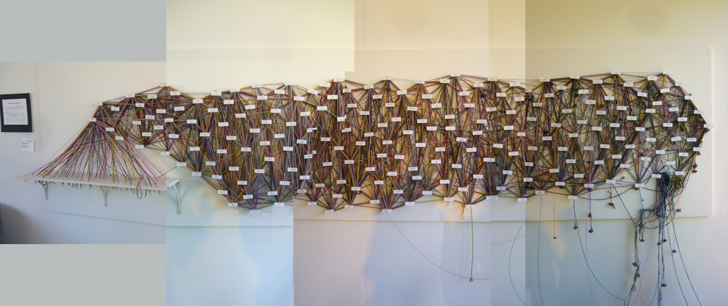
Mary Corey March, Identity Tapestry 2008
For this piece, there are multiple statements of the wall which the audience can relate to. On the left is a bag of coloured wool. Each individual participating chooses a colour and wraps their wool around each statement which applies to them. A complex spider web will begin to develop as more people share their story. Once an individual finishes, they leave their wool hanging with a stone attached to the end. During the process, members are able to discover details about one another which can make for a fun exercise. "The tapestry as a whole also reflects the group of people who participate in it and it becomes a group portrait."

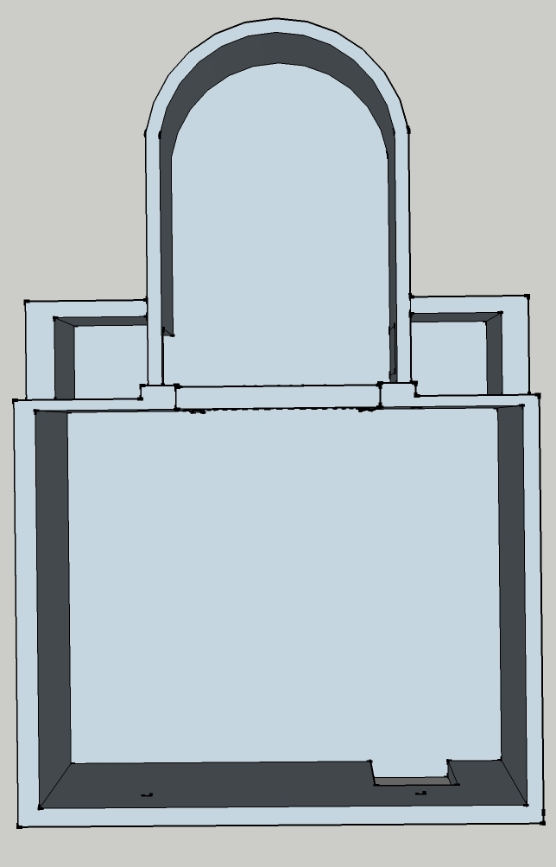
Floor Plans to my exhibition:

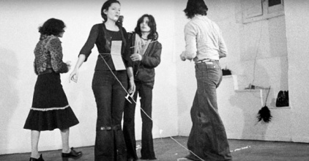

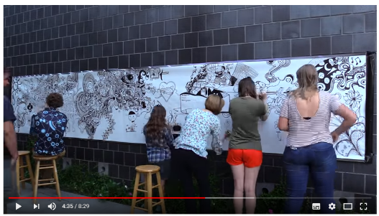
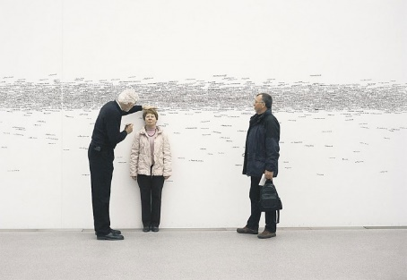

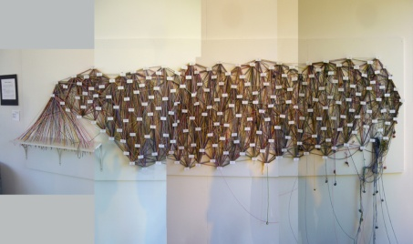
Entrance/Exit
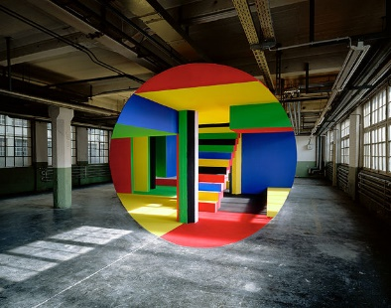

Bibliography
Books:
Bishop, C. (ed) (2006) Participation, Documents in Contemporary Art. UK: Whitechapel Gallery and The MIT Press
Greenberg, R, Ferguson, B and Nairne, S. (1996) Thinking about Exhibitions. London: Routledge.
Benjamin, W. (2003) Author as Producer. Cambridge, Massachusetts: Harvard University Press.
Web links:
Carnevale, G. (1968) El encierro – Project for the Experimental Art Series. Available at: http://www.reactfeminism.org/entry.php?l=lb&id=27&e=a&v=&a=Graciela%20Carnevale&t= (Accessed 3 May 2018)
Cline, Anna C. (2012) The Evolving Role of the Exhibition and its Impact on Art and Culture. Available at: https://digitalrepository.trincoll.edu/cgi/viewcontent.cgi?article=1275&context=theses (Accessed 3 May 2018) p22
Roman Ondak. Available at: http://www.tate.org.uk/research/publications/performance-at-tate/case-studies/roman-ondak-measuring-universe http://www.tate.org.uk/research/publications/performance-at-tate/resources/films-and-videos/roman-ondak (Accessed: 5 May 2018)
Marina Abramovic. Available at: https://www.elitereaders.com/performance-artist-marina-abramovic-social-experiment/ (Accessed: 5 May 2018)
Pater Draws: Big Communal Doodle Banner. Available at: https://www.youtube.com/watch?v=XknexKZxRqM&t=6s (Accessed: 5 May 2018)
Georges Rousse. Available at: http://www.georgesrousse.com/en/archives/article/georges-rousse-in-ruesselsheim/ (Accessed: 5 May 2018)
Mary Corey March. Available at: http://www.marymarch.com/Identity_Tapestry.html (Accessed: 5 May 2018)

