ASSESSMENT COMPONENT 1:

Coursework- E-portfolio

STUDENT NAME | Pedro Gaetjens Molongua
STUDENT NUMBER | 2327143
MODULE NAME | Learning in the Digital Era (ACCA4025_LON)
LECTURERS NAME | Balendran Kandasamy
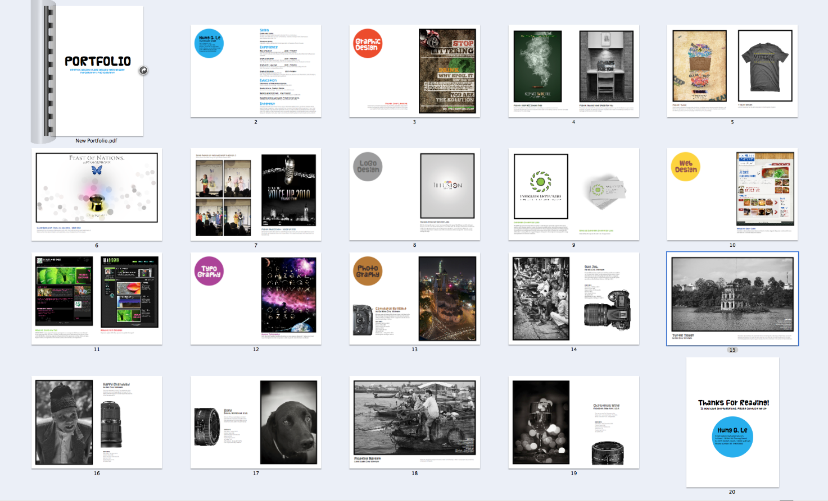
Image from Wikipedia
INDEX
INTRODUCTION 3
IEEE REFERENCING & WRITTEN SUMMARY ON ESSENTIAL ACADEMIC AND EMPLOYMENT SKILLS 3
a) ESSENTIAL SKILLS FOR STUDY AND EMPLOYMENT 3
b) SIMILARITY SCORE & THE REFLECTION USING THE “GENERIC ASSESSMENT CRITERIA” 4
• Similarity Score 4
• Auto rate of my work 4
COLLABORATIVE TEAMWORK AND PROFESSIONAL ACADEMIC POSTER (A3 POSTER) 4
MAIN POINT AND DESCRIPTION 4
A3 ACADEMIC POSTER 6
MIND-MAP 7
POSTER WITH THE MIND-MAP INSIDE 8
AUTOMATIC REFERENCING TOOL 9
SUMMARY 9
Section 1: Tuckman’s stages of team development, Storming 9
Section 2: Roles and responsibilities 10
HOW DID I REFERENCE IT? 10
1st step 10
2nd step 10
3rd step 12
REFERENCES 13

INTRODUCTION
In this assessment, I must create an e-portfolio for my course in Learning in the Digital Era following the specifications and units the teacher uploads for us in Moodle and the instructions I receive in the classes.

IEEE REFERENCING & WRITTEN SUMMARY ON ESSENTIAL ACADEMIC AND EMPLOYMENT SKILLS
Learning what it is referencing and how to apply it to my projects.

ESSENTIAL SKILLS FOR STUDY AND EMPLOYMENT
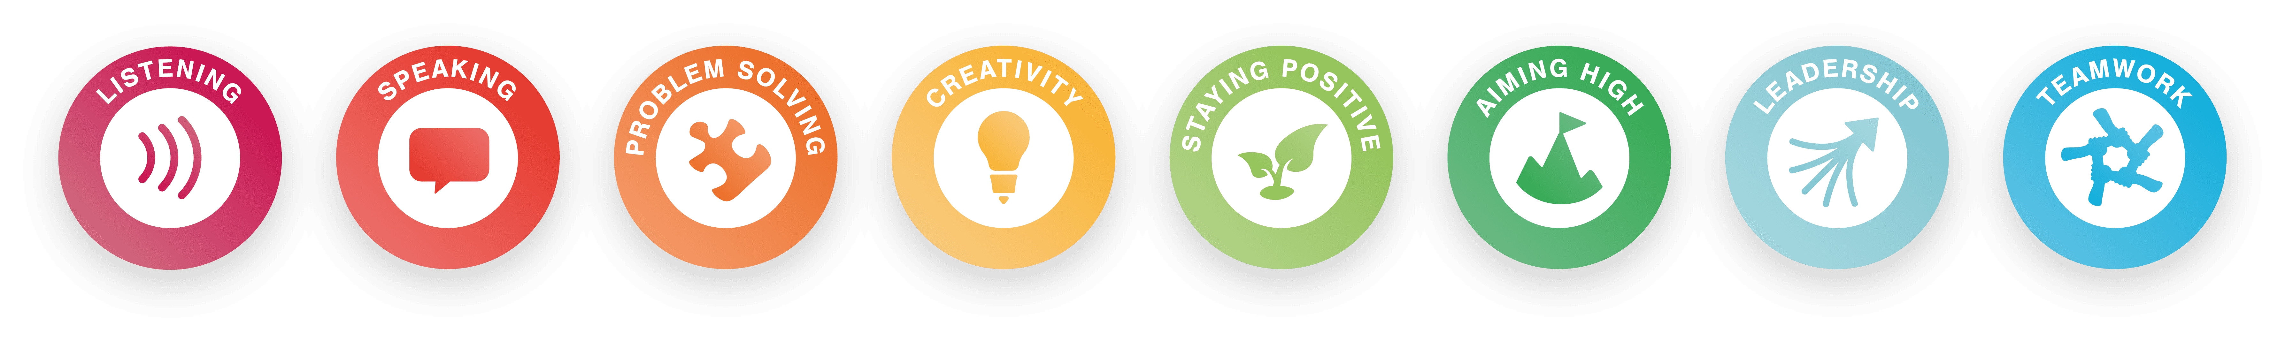
There are eight essential skills that we must know and use on a daily basis, using them with studies, work or simply to socialise. According to Business in the Community (BITC), the eight essential skills are listening, speaking, problem-solving, creativity, staying positive, aiming high, leadership, and teamwork. Those skills help cover the communication, creative problem-solving, self-management, and interpersonal skills aspects we all need to have and use in our lives [1]. The essential skills help with the progress of learning in the classroom, improving academic outcomes, perseverance and self-belief. They also reduce the chances of not being able to get a job and increase wealth across a lifetime. They even help with well-being and life satisfaction [2].
A weakness in basic skills can affect performance in everyday tasks. It’s therefore important to continue to maintain the numeracy and literacy skills we gained at school [3]. Skills such as creativity, critical thinking, teamwork, problem-solving and resilience are likely to become very important for jobs across the economy [4].
I honestly think that every single one of the skills mentioned before will help me with the performance of my academic year, with a better perception of the lessons I will receive and the assessments the teachers will send me. Developing all these skills I also will have a better understanding of what they are teaching me.

SIMILARITY SCORE & THE REFLECTION USING THE “GENERIC ASSESSMENT CRITERIA”

Similarity Score
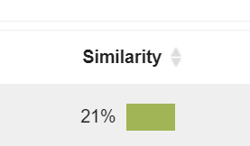
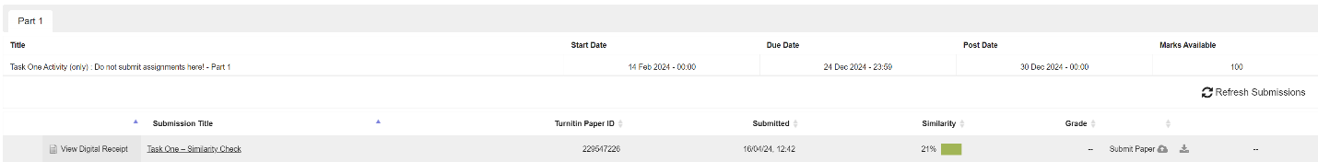
The similarity score I got was 21%, I think I could improve the score by adding more essential information from the sources I get it from and making it more brief. I will leave an image of the score I have got.

Auto rate of my work
I will give me a “2.1/Merit”. I gave myself that score because I think my work is coherent, well-structured, organised and with a good employability of the information of it. Additionally, I mostly try to add relevant and credible information in all I do, understanding what I am implementing to the assessment and referring with sense to the places I get them.

COLLABORATIVE TEAMWORK AND PROFESSIONAL ACADEMIC POSTER (A3 POSTER)

MAIN POINT AND DESCRIPTION
In this task I must create a A3 poster and a mind-map talking about the concepts covered in the Moodle Unit 2 topic 4 ‘Life is a Team Sport’ and explain why are important for academic and career success in my chosen discipline. The topic 4 had two main points that explain how can help you better understand how to relate to your colleagues at work, those learning paths are called and talk about:
- Managing emotions; in this learning path they are explaining us about how the emotions can affect us in the workplace ambit and it trying to explain us how we can react, and he explains that even if we cannot control how our emotions affect us, we can control our response to them. Depending on our response, it can affect us, our colleagues or the project we are working on as a whole in one way or another, for better or worse. Additionally, it shows us the worst emotions that could happen to us and teaches us how we can improve our way of thinking to improve our response to the different emotions that affect us in the work environment.
- Empathy; in this particular learning path, they teach us about empathy and sympathy, so that we know how to react to many moments in our working career. Empathy teaches us to think before we act and to connect more with the people around us, a person may be going through a difficult time in their life and, even if we could notice something different, the people around them would only put more and more pressure on them and generate a lot of stress, but by being a bit more empathetic we could talk to them more tactfully without touching on any issues that could make it worse for them. Also with sympathy, we can improve their mood even the slightest bit by just showing support and making them feel heard and noticed.
I made my A3 academic poster using Canva following the steps of “Creating Academic Poster Using PowerPoint” inside of “A3 Poster Creation” on Moodle. Also, I only used the information that appeared on the Moodle Unit 2 topic 4 ‘Life is a Team Sport’ for complete the poster and all the images that appeared on the academic poster where generated by the keywords I give to the Magic Media AI, the Canva’s image generator, for the better look of my final poster.
My mind-map was made in "Mindmeister.com" and all the information I have used were from:
- University of California, Berkeley [5]
- DeakinCo [6]
- MichaelPage [7]

A3 ACADEMIC POSTER
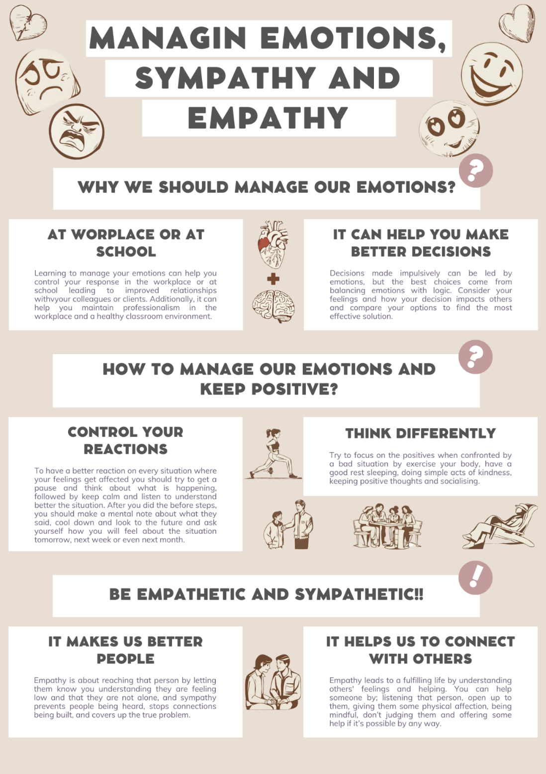

MIND-MAP
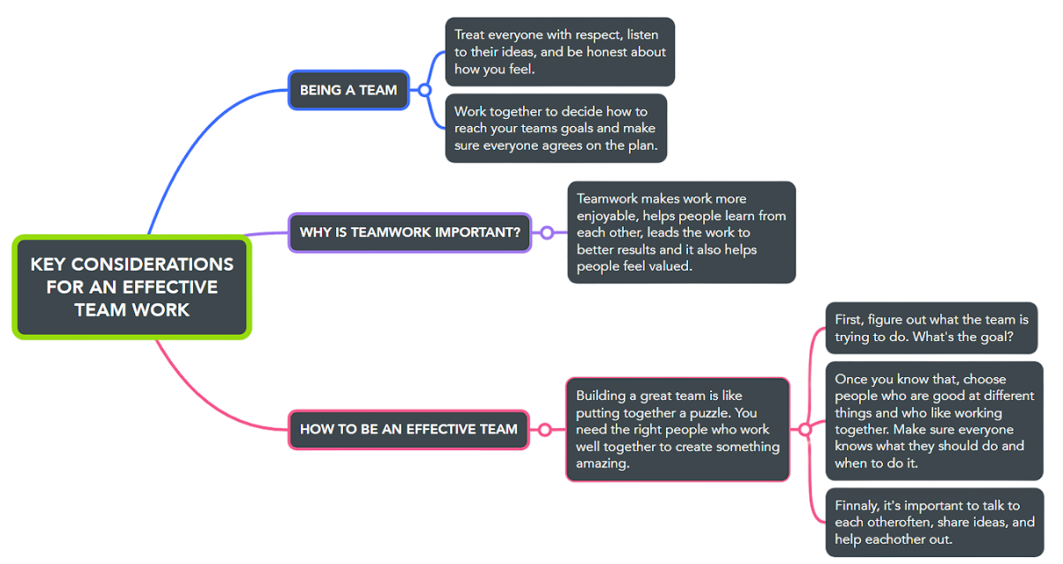
University of California, Berkeley
DeakinCo
MichaelPage

POSTER WITH THE MIND-MAP INSIDE
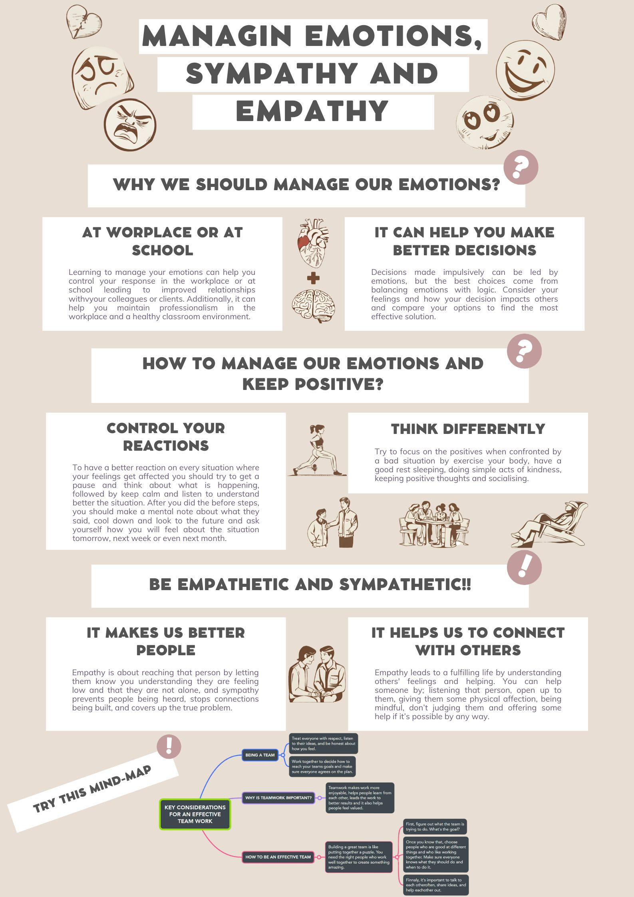

AUTOMATIC REFERENCING TOOL
In this task I must summarise some of the main points with several supporting IEE citations and accompanying screenshots/images using an automatic referencing to one of the topics I will choose from the “Unit 3 - Virtual collaboration”. The topic I decide to use is “Topic 2: Riding the storm”.

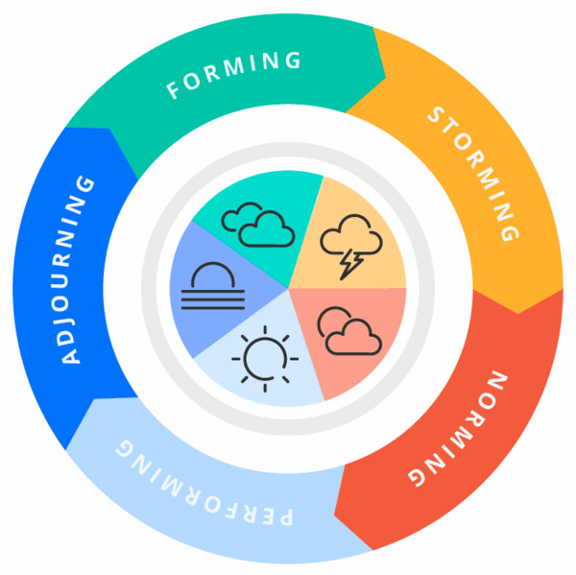
SUMMARY
The whole unit explain how the Tuckman’s stages of team development model works (Forming, Storming, Norming, Performing and Adjourning), the topic I choose explain the second stage, “Storming”. This stage explains how conflicts and frictions can occur between virtual team members and the dangers associated with conflict avoidance. It also explains how the roles an responsibilities of a group must be clear for a great success.
Image from Wikimedia Commons

Section 1: Tuckman’s stages of team development, Storming
The storming stage is a tumultuous period in a team's lifecycle marked by conflict, competition, and resistance to control. Team members often clash over goals, roles, and responsibilities, leading to power struggles and the formation of subgroups. Communication can be strained, with members avoiding confrontation or expressing discontent indirectly. A hierarchical structure may emerge, with one person assuming a dominant role while others adopt coping mechanisms such as peace-making, humour, or scapegoating. As tensions rise, team dynamics become complex and challenging to navigate. Essentially, the storming stage is a period of adjustment and growth, where the team grapples with its identity and purpose [8]. During this stage, team members assert their individuality looking for leadership and influence. Although, disagreements about goals, roles, and processes are common. In any case, contrary to what one might believe, power struggles and the formation of subgroups can hinder progress because that leads to more honest opinions. But, in order for this to be beneficial to the team, effective communication is crucial during this stage to navigate tensions and avoid group dissolution. While necessary for growth, the storming stage can be shortened through assertive communication and focused leadership [9].

Section 2: Roles and responsibilities
The roles, responsibilities, and strategies are key elements in understanding teamwork because each team member has a specific role with corresponding duties. Following this, a role defines the part that a member of the team chooses. Although, the responsibility it is crucial to complete as a part of that role. Finally, the strategy is chosen to fill the responsibility. Often, teams employ strategies that involve multiple members working together to reach the goal they set as a group [10]. To conclude, all these keys are important to manage the team work together with a good guideline and to have a well ended project.

HOW DID I REFERENCE IT?
I have used the reference tool that MS Word Document has. The steps I have follow are:

1st step
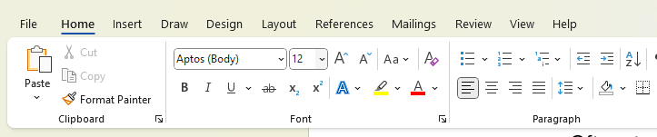
Click on the “References” tab on the top of the app:

Then it will show this:

2nd step
Go to the “Citations & Bibliography” section and select the style you are going to use, Microsoft Word will use the APA style as predetermined but I have use the “IEEE” style. After select the style, press on “Insert Citation”:

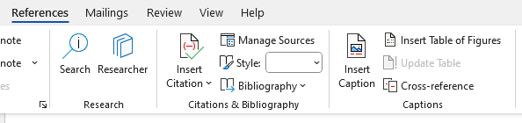
It will show some options bellow so you will have to press on the “Add new source…” option:
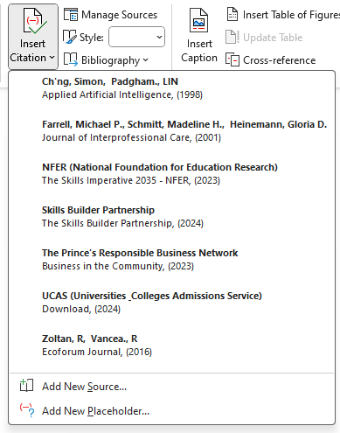
This option will pop up a small window where you can add the new reference to your list, to can be able for me to do it I have to change the language of my MS Word Document to Spanish. It is the only way I can show it properly but the distribution it is the same for every language.

3rd step
When the small window pops up you will have to select the type of source it is (book, website, website document…) fill up the blank spaces. I will choose the website document so my distribution will be like this:
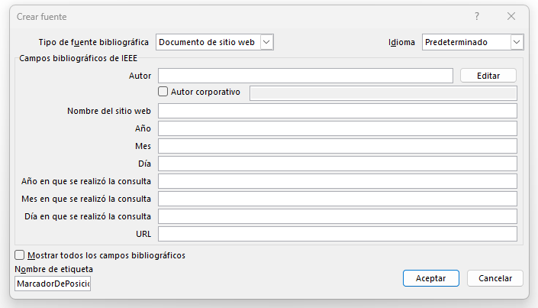
To insert the properly author of the website document you will have to press on the “Edit” button on the right side and fill up the name, surname and middle name, if it has, and then press to add and then save it. Additionally, if the reference has more than one author you can just add them one by one until finish with the author section, but if the website document it is from a corporative author you will just press on the little box on the left of the section and write the name of the company. Finally, you will fill up the rest of the blank spaces, save it and it will appear on the “Insert Citation” of your tab.

REFERENCES

[1] | The Prince's Responsible Business Network, «Business in the Community,» The Prince's Responsible Business Network, 06 09 2023. [En línea]. Available: https://www.bitc.org.uk/essential-skills/. [Último acceso: 2024].
[2] | Skills Builder Partnership, «The Skills Builder Partnership,» Skills Builder Partnership, 17 07 2024. [En línea]. Available: https://www.skillsbuilder.org/. [Último acceso: 2024].
[3] | UCAS (Universities & Colleges Admissions Service), “Download,” 2024. [Online]. Available: https://www.ucas.com/file/130381/download?token=zX_vZu_9. [Accessed 2024].
[4] | NFER (National Foundation for Education Research), “The Skills Imperative 2035 - NFER,” NFER (National Foundation for Education Research), 10 07 2023. [Online]. Available: https://www.nfer.ac.uk/key-topics-expertise/education-to-employment/the-skills-imperative-2035/. [Accessed 2024].
[5] | University of California, Berkeley, «Steps to Building an Effective Team | People & Culture,» [En línea]. Available: https://hr.berkeley.edu/hr-network/central-guide-managing-hr/managing-hr/interaction/team-building/steps. [Último acceso: 2024].
[6] | DeakinCo., «Key Elements of Effective Teamwork | DeakinCo.,» [En línea]. Available: https://deakinco.com/resource/key-elements-of-effective-teamwork/. [Último acceso: 2024].
[7] | MichaelPage, «Building an effective team | Michael Page,» [En línea]. Available: https://www.michaelpage.ae/advice/management-advice/development-and-retention/building-effective-team. [Último acceso: 2024].
[8] | M. P. Farrell, M. H. Schmitt and G. D. Heinemann, “Journal of Interprofessional Care,” 2001. [Online]. Available: https://research-ebsco-com.ezproxy.uwtsd.ac.uk/c/onvpsy/viewer/pdf/taxp6tiwpj. [Accessed 2024].
[9] | R. Zoltan and R. Vancea., “Ecoforum Journal,” 2016. [Online]. Available: http://www.ecoforumjournal.ro/index.php/eco/article/viewFile/362/226. [Accessed 2024].
[10] | S. Ch'ng and L. Padgham., “Applied Artificial Intelligence,” 1998. [Online]. Available: https://www.tandfonline.com/doi/pdf/10.1080/088395198117839. [Accessed 2024].

