Assignment
In my role as a trainer in the crime training department the majority of the learners on my courses are detectives or those aspiring to be detectives. There will be those with several years of police service or others who have come through a direct entry route which is education based and will still have policing experience before they come on any of the courses I teach.
In our organisation any individual who may have any additional support needs can be supported screened through the wellbeing team, occupational health and the universities (if applicable). Individuals then who attend courses do not have to disclose anything to the trainers on courses and the trainers are not made aware.
By the time learners are on my course any additional needs or support would have been identified and the support should be in place for them. As we don’t have to be told I will only become aware if the learner tells me themselves or another trainer who has had previous experience may relay the information to me.
One of the individuals I will now discuss has been on several courses where I have either been the trainer or assisted in the delivery on the course. During the practical element of this course, which is when the class is divided into groups. The group will then be given a range of scenarios in which they will then plan and conduct interviews in a role play. I was required to assist in this part and the individual was in my group. I was not made aware of any additional learning needs and support that may have been required.
A part of the scenario requires the interviewee (who is one of the other learners in role play) to be assessed for vulnerabilities as per the Achieving Best Evidence guidelines⁴. Upon speaking with them it was disclosed to me that they were dyslexic and had been diagnosed with autism, this had an impact on how they obtained and processed information. There were also occasions when they would say what they were thinking before processing how this information would be perceived by others.
According to Reid⁵, dyslexia refers to differences in individual processing, in which they are characterized by difficulties in the beginning of literacy, affecting the acquisition of reading, writing, and spelling. In addition, there are failures in cognitive, phonological and/or visual and memory processes, information retrieval, speed processing, time management, coordination, and automation.
Glazzard, J. and Stones, S. (2021). Dyslexia. London: Intechopen.
Fortunately for myself I have been trained in and I now provide training in dealing with individuals with vulnerabilities or additional learning needs. One of the tools we are advised and advise others to use is the Advocate’s Gateway², this is an online tool which gives excellent advice and guidance. The guidance is free to use and is useful to refer back to when dealing with an individual who may need additional help.
One of the first things we discussed was how they were obtaining the notes from the lessons and the individual showed me that they were using a form of AI to help speed up the process and get the information required taken in note form. Upon reviewing the information generated by the AI, I was at first impressed, there was additional information generated and it appeared in a coherent and easy to understand format. I looked further at some of the information presented and noticed that it was not however wholly accurate, for example in interviewing, the Police, were provided with the seven principles of interviewing by the Home Office in 2009. These principles are still used today.
They are: -

Principle 1

The aim of investigative interviewing is to obtain accurate and reliable accounts from victims, witnesses, or suspects about matters under police investigation.

Principle 2
Investigators must act fairly when questioning victims, witnesses, or suspects. They must ensure that they comply with all the provisions and duties under the Equality Act 2010 and the Human Rights Act 1998.

Principle 3
Investigative interviewing should be approached with an investigative mindset.

Principle 4
Investigators are free to ask a wide range of questions in an interview in order to obtain material which may assist an investigation and provide sufficient evidence or information.

Principle 5
Investigators should recognise the positive impact of an early admission in the context of the criminal justice system.

Principle 6
Investigators are not bound to accept the first answer given. Questioning is not unfair merely because it is persistent.

Principle 7
Even when a suspect exercises the right to silence, investigators have a responsibility to put questions to them.

These principles are a key part of the interview process, when I reviewed the notes taken by the individual, I immediately noticed that the AI generated notes regarding the seven principles were incorrect, there were seven principles, but they were not the Home office principles.
I waited initially to speak to the individual during the break and then discussed how would it be best for them to obtain the necessary information from the course. As part of the professional standards of Adult teaching by demonstrating commitments to my learners, their wellbeing, safety and learning¹. I also want everyone on my course to feel valued and included. One of the initial things we decided was that I would share all the presentation material and research material as a reference point, this would assist them in regard to having to take notes. It was agreed that everyone on the course would have the material. By doing this I did not want to make the individual feel like the only one having this.
One of the things I did notice too was how the individual processed information and how they put this into practice. When we interview in the Police, we like to use what we call the questioning funnel. This gives us the ability to ask open questions to obtain an account, probing questions to obtain the fine grain detail and then any closed confirmatory questions to check the information.
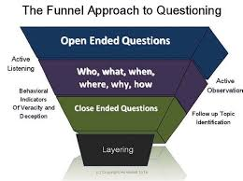
D Matsumoto 2015
In order to get sufficient information when describing an individual, we use what we call the 10-point description.
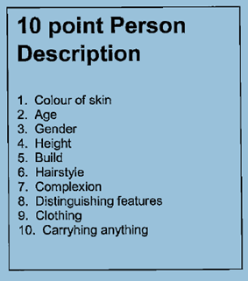
For the exercise we ask the role-player to describe someone famous or in the public eye. In this exercise the individual was asking the questions relating to colour of skin/ethnicity. I could see from the questions they were asking it was a struggle and almost become inappropriate, as per the Professional standards of valuing and promoting diversity and inclusion and demonstrate dignity and respect towards others¹.
Even though the language was bordering on inappropriate there was no malice in what was being said and it was a genuine attempt at trying to obtain the information. I had to intervene to assist them but did it in a way as not to draw attention to the individual rather help in using a different way to ask the question. I was conscious as not to make the individual feel embarrassed or singled out, but I did need to do something before it caused an issue in the group. (Wong 2009)
Another behaviour I got used to was that they would say comments after what I presented as part of the lesson. At first, I thought they were being sarcastic and disruptive but I noticed very early on its how they would relax themselves and feel comfortable in the class. This did take a little getting used too but as the lessons progressed, I felt like I had developed a good rapport with the individual and they were obtaining sufficient information from the lesson.
It was noted by another learner, and they asked me “DOES THE BEHAVIOUR WIND YOU UP?”. This was away from the individual and it did make me question if the individual’s behaviour was then disrupting the rest of the class. I asked them if they found it distracting and they said they didn’t, but they thought it came across as disrespectful. I explained I was used to the behaviour, and it helped with the individuals learning. They thought I handled it quite well. I have to be aware though that if others see this type of behaviour, then they may think its acceptable too. I usually discuss ground rules at the start of the lesson and one of which is showing respect. Due to the individual’s way of learning and integrating this can seem that they are not showing respect. As we work in the policing environment and the majority of my learners are accredited or working towards detective accreditation, they are very adaptable and understanding of others needs and requirements. (Mezirow 1991)
I have seen the individual on several courses now and I feel we get on quite well and I am used to their behaviours. There are certain things I can do to help them, such as speak to them during group work to check how they are getting on, show an interest in their hobbies, this gets them talking straight away. As they have additional needs in work, they will stay a little later on occasions to catch up on other work. This gives me an opportunity then to discuss with them any needs, concerns and to check if they have understood what was taught in the lesson.
I am about to begin training of a new cohort of direct entry detectives, this is the first time I have ran the course. This course is for individuals who are joining the Police who will then be fast tracked to becoming detectives. I will be with them from their first day until the completion of their initial training, which is six months long. As previously stated, we will not be made aware of any additional needs from anyone joining and any requirements will either be volunteered by the individuals or if they speak with the university who may provide additional support around examinations.
I have noticed that from being at the front of a class you are far more aware of what is happening in the class. I can see when individuals are not paying attention, are distracted, or chatting. This can have an impact on others in the class and if someone does have additional learning needs this may cause them further issues. During the first week it is mainly a chance for everyone to meet the others, make themselves familiar with the building, the classroom and feel comfortable (Maslow 1943,1956). One of the things I have considered is to have a one to one with all the new starters in the 1st week. This could potentially give myself and them the opportunity to explain any needs, concerns or additional support that may be required³
As its going to be a class of around 20 there will likely be a variety of ways individuals learn and progress. When I have the one to one with them this will be something I will discuss and see what is best for them. The training itself is varied between, PowerPoint presentations, individual and group work, practical assessments, and exams. They will also have various external speakers come in and give inputs around specialist areas.
I will check with everyone too around how they take notes, all police officers are given a laptop to use whilst on duty. This can also be used on any courses and for them to complete the necessary university work. I will be mindful as some like to use the laptops to take notes in class, some may prefer to write their notes in their own words, whilst others may prefer a handout as a reference. This will have an impact on the way in which I deliver the lesson as I want my learners to maximise their learning opportunities and I want them to feel comfortable in the way in which they obtain and retain the information provided to them.
I will be aware of the different learning styles and still refer back to Kolb’s learning cycle: -
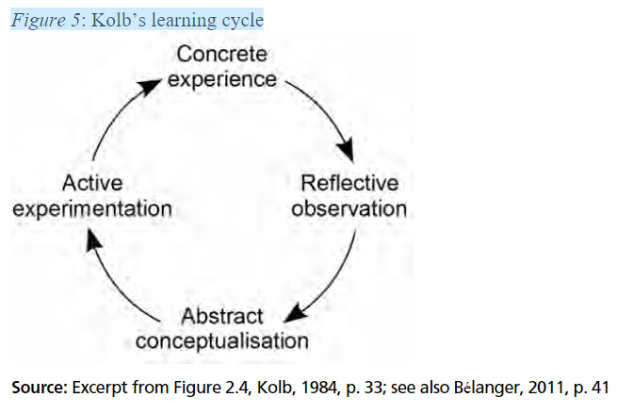 Henning Pt̃zold (2011)
I believe this model to be one of the most effective for reflection and will introduce it to my learners at the start of the training.
I will look to set ground rules too and explain clearly that no question is a stupid question as if they need to ask it, then clearly, they need something further explained to them. I will also make myself available for any one-to-one appointments if any of the learners need to discuss anything with me.
If anyone does approach me or I am informed of them requiring any further assistance, then I will make sure I research ways in which to adapt any of my training to assist. As part of my role and the role I was in before joining the training department, I would deal with various people and some of these would have had vulnerabilities that needed to be assessed and then a plan would be devised to enable me to obtain the best information from them. I am fortunate in the role I am into be able to utilise previous research, access to other trainers, the team from the university, a wellbeing, occupational health and human resources. All of these would have experience in dealing with individuals who had additional learning needs and as the main trainer on the course, if required, I will engage with them to seek advice.
I will be responsible for the delivery of the course from day one, I have never taught this part of the curriculum before, and it is going to be a new challenge for me. I am having a meeting with one of the other trainers from the initial training team to go through the material and how the course runs. This will then require me to upskill myself on the material to plan and prepare for the lessons¹. The training itself is going back to the initial training officers receive when joining the Police. Most of this material will be all the information and knowledge carried over from experience, but I must not get complacent and be confident in the what I will be delivering.
I have already met with the university; the recruitment team and I did attend the awareness session with the new starters. I have also discussed with my colleagues within crime training for them to assist with lessons, practical’s and to also be on hand if we have to deal with any issues that arise during the training.

References
1 - Professional standards for further education teachers and work-based learning practitioners in Wales. (2017). Available at: https://hwb.gov.wales/storage/460a740a-7bf1-4c7b-b4ae-348ae380879b/professional-standards-further-education-teachers-work-based-learning-practitioners-wales.pdf
2 - Theadvocatesgateway.org. (2012). Home - The Advocate’s Gateway. [online] Available at: https://www.theadvocatesgateway.org/.
3 - College of Policing (2024). Competency and values framework (CVF) | College of Policing. [online] www.college.police.uk. Available at: https://www.college.police.uk/career-learning/competency-and-values-framework.
4 - Ministry of Justice (2022). Achieving Best Evidence in Criminal Proceedings: Guidance on Interviewing Victims and Witnesses, and Guidance on Using Special Measures Achieving Best Evidence in Criminal Proceedings: Guidance on Interviewing Victims and Witnesses, and Guidance on Using Special Measures. [online] Available at: https://assets.publishing.service.gov.uk/media/6492e26c103ca6001303a331/achieving-best-evidence-criminal-proceedings-2023.pdf.
Henning Pt̃zold (2011). Learning and teaching in adult education : contemporary theories. Verlag Barbara Budrich
Reid G. Dyslexia: A Practitioner’s Handbook. Hoboken, Nova Jersey, EUA: John Wiley & Sons; 2016

Maslow, A. H. (1943). A theory of human motivation. Psychological Review, 50(4),
370–396
Maslow, A. H. (1954). Motivation and personality. New York: Harper & Row
Wong, H.K. and Wong, R.T. (2009). The First Days of School : How to Be an Effective Teacher. Mountainview, California: Harry K. Wong Publications.
Glazzard, J. and Stones, S. (2021). Dyslexia. London: Intechopen.

