
Competing Business Models in Hospitality: A Comparative Study of Airbnb and Marriott

Student Name: Tirth G Patel
Student ID: 2522415

Module Name: Marketing Management
Module Code: LCMB7024
Lecturer’s Name: Laila Maazouz Dian Mayasari
Work Count:2653

Term 1
Table of Contents
1. Introduction 3
2. Company Overview 5
2.1 Airbnb business model 5
2.2 Marriott business model 6
3. Task 1: Macro Marketing Environment Analysis 7
3.1 Legal / Regulatory Factors 7
3.2 Social/ Consumer Behaviour Factors 9
4. Task 2: Strategic Response Evaluation 11
4.1 Porter’s Generic Strategies 11
4.2 Ansoff’s Growth Matrix 13
5. Conclusion 15
Reference list 16

1. Introduction
The worldwide hospitality sector stands as one of the most economically important sectors globally, and its effect is estimated to be about 4.7 billion dollars in the year 2024 and 8.79 billion dollars in the year 2032, with a compound annual growth rate (CAGR) of 6.1% (Donnellan, 2024). The industry includes the accommodation, food and beverage, travel, and leisure service, and the trend of technological disruption, changing consumer behaviour, and the sharing economy is increasingly influencing its growth (Guttentag & Smith, 2017).
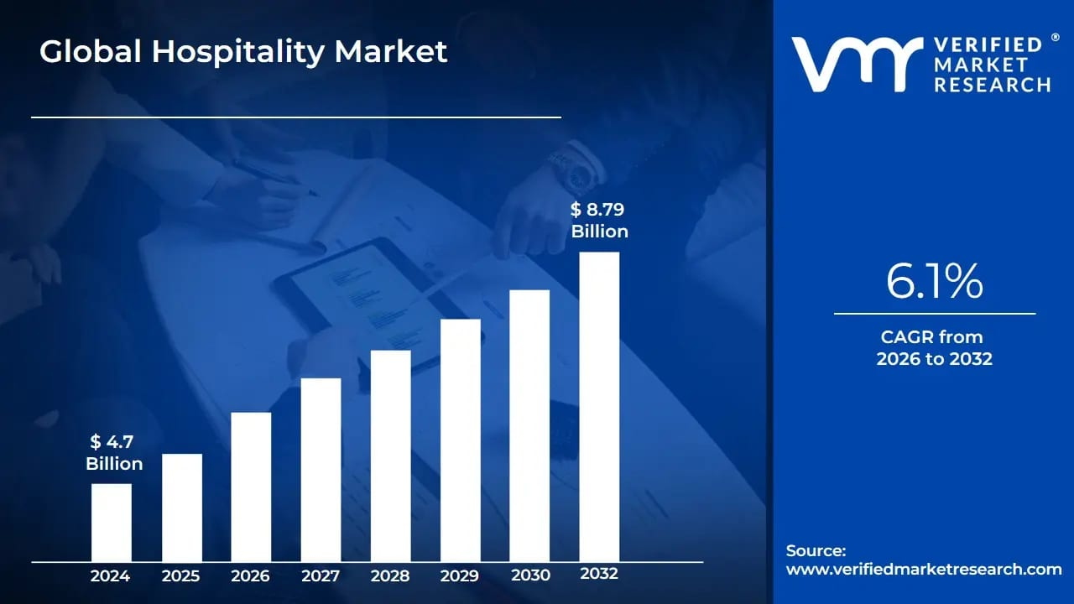
Figure 1 Global Hospitality Market Growth Forecast (2024–2032)
Image source:(Donnellan, 2024)

Among this dynamism, there are two organisations that can be described as polar strategic players. Airbnb is a San Francisco-based company, which was established in 2008 by Brian Chesky and Joe Gebbia and which is extensively discussed in the scholarly literature as a disruptive innovator (Yoon, Jung and Erdem, 2020). Through the use of a peer-to-peer (P2P) digital platform, Airbnb essentially reinvented accommodation services, allowing the use of private hosts to offer space to travellers in countries all over the world, and it currently exists in more than 220 countries (Hati et al., 2021). Contrarily, the incumbent follower is Marriott International, one of the largest traditional hotel chains in the world with more than 8,500 hotels under over 30 brands (Bianco, Zach and Singal, 2022). With the disruptive nature of the entrance into the industry with Airbnb, Marriott has had to adapt strategically by undertaking massive digitalisation and positioning around experiences (Marriott International, 2024).
This report critically evaluates two macro-environmental forces that have an impact on both organisations and critically evaluates the strategic response of both organisations based on Porter's Generic Strategies and Ansoff Growth Matrix.

2. Company Overview

2.1 Airbnb business model
Started in 2008 in San Francisco, Airbnb was a fast-growing textbook example of disruptive innovation in the hospitality sector (Guttentag & Smith, 2017). Instead of having any tangible assets, Airbnb is a digital platform that is peer-to-peer (P2P) and is known to connect individual hosts who provide their private houses, rooms, or unique spaces with guests who want to be accommodated (Hati et al., 2021). It is a typical C2C (consumer-to-consumer) system, supported by a trust system like user ratings, host checking, and security over a digital payment method instead of having centralised ownership or business processes (Yoon, Jung and Erdem, 2020). It is an asset-light platform; all the capital expenditure is borne by hosts, with Airbnb receiving revenue in a commission model (commonly 3 per cent of hosts and 14.2 per cent of guests per reservation) (Hati et al., 2021). Airbnb was based in more than 220 countries as of 2024 and has more than 6 million listings, which also fundamentally changes the way travellers receive accommodation (Dolnicar & Reinhold, 2021).


Figure 2 Airbnb Company logo
Image source: company website

2.2 Marriott business model
Marriott International was established in 1927, and today it is the largest hotel chain in the world, with more than 9000 properties under 30 brands in 140 countries, such as the Ritz-Carlton, Sheraton, and Courtyard (Bianco, Zach, and Singal, 2022). Although it had been dependent on owned and controlled hotel property, Marriott has evolved into an asset-light business model, collecting revenue via franchise fees (5-7% of room revenue) and management contracts (2-3.5% of total hotel revenue). With Airbnb threatening to enter their market, Marriott created a new brand, Homes and Villas by Marriott, in 2019 (Guttentag & Smith, 2017) and has since invested massively in digital transformation, artificial intelligence, and its Bonvoy loyalty programme with more than 210 million members (Marriott International, 2024).


Figure 3 Marriott company logo
Image source: company website

3. Task 1: Macro Marketing Environment Analysis
3.1 Legal / Regulatory Factors
Impact on Airbnb
The regulation is one of the most serious macro-level threats to the Airbnb business model. The supply of the platform has been directly limited by short-term rental (STR) laws introduced in cities worldwide (Guttentag & Smith, 2017). The clearest instance is in New York City, where the Local Law 18 (LL18) made all STR hosts officially registered, which means that Airbnb listings dropped from an estimated 22,000 to 6,841 in an instant (Anastasi et al., 2025). Other such restrictions were enacted in Amsterdam (a 30-night annual limit created in 2019), which in turn caused Airbnb listings to reduce by 54 percent between 2019 and 2024 (Airbnb, 2025), and Barcelona, where a moratorium on new STR licences has existed since 2014, leading to a 24 percent reduction in Airbnb listings by 2024 (Airbnb, 2025). On the academic side, Steiner discovered that the stricter the regulation of STR, the higher the occupancy rates of a hotel and the lower the Airbnb supply and its price - another clear indication of a substitution effect between Airbnb and hotel (Yeon, Song and Lee, 2020). In the case of Chicago, when it introduced STR regulation, it was discovered that active Airbnb listings had fallen by 16.4% (Ginger Zhe Jin, Wagman and Zhong, 2024).
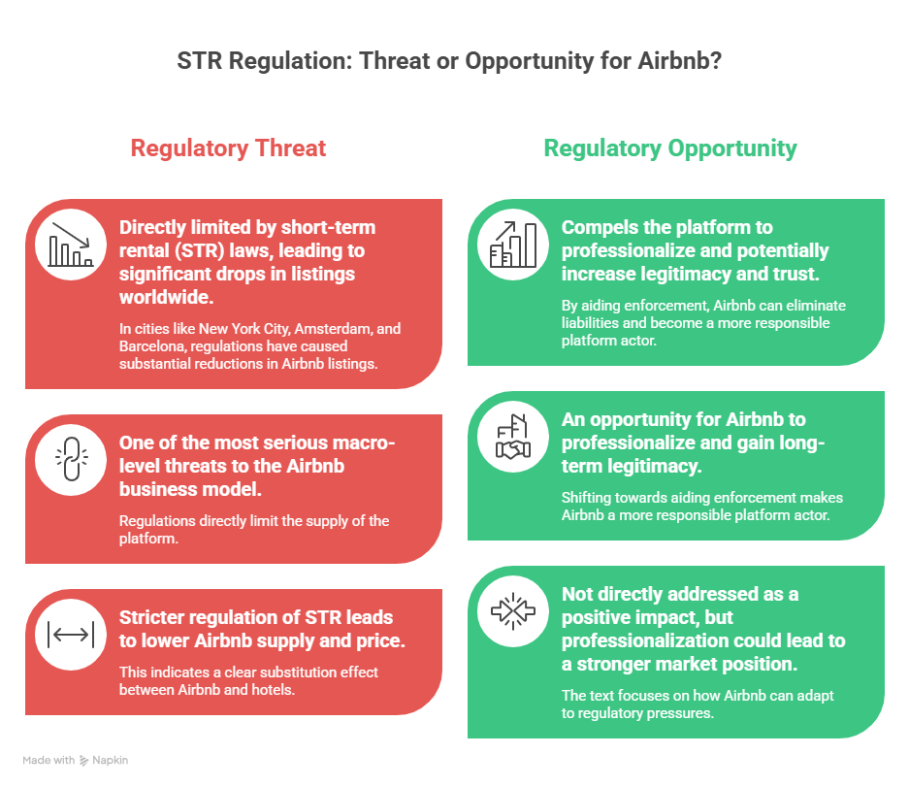
Figure 4 STR Regulation: Threat or Opportunity for Airbnb
Image Source: created by the author

Nevertheless, regulatory pressure is also an opportunity for Airbnb: it will compel the platform to professionalise, add superior host verification, and communicate with policymakers to promote proportional regulation, which will possibly result in long-term legitimacy and trust (Warren, 2024). By shifting towards aiding enforcement itself, Airbnb eliminates the liabilities of its listing being flagged by municipalities, making it a more responsible platform actor (Airbnb, 2025).
Impact on Marriott
In the case of Marriott, regulation is not an existential threat, but it is more of a compliance load. Marriott, being a legal and actively regulated hotel operator, has to meet food safety standards, fire and safety standards, data privacy laws (including GDPR in Europe and CCPA in the US), as well as anti-bribery laws and regulations, such as the UK Bribery Act (Tarlavski, Edmon Oude Elferink and Dekker, 2018). The 2020 Marriott data breach class action lawsuit, in which the company was sued due to a lack of protection of its customer data, highlights the growing legal and reputational costs of non-compliance in a more regulated digital environment (Tarlavski, Edmon Oude Elferink and Dekker, 2018).
On the other hand, the regulation of the STR is an obvious opportunity for Marriott: all the regulatory limitations of Airbnb decrease the supply of short-term rentals and shift the demand to the traditional hotels. Yeon et al. (2020) clearly showed that incumbents such as Marriott are directly benefited by a tighter regulation of STR, which increases the rates of hotel occupancy (Yeon, Song and Lee, 2020).

3.2 Social/ Consumer Behaviour Factors
Changing Consumer Behaviour:
The underlying macro-social change that has supported the emergence of Airbnb is the shift in ownership to access-based consumption, which is based on the values of collaborative consumption (Barbu et al., 2018). Consumers (some of the younger age groups, especially) are now after authentic, local, experience-based travel than a standardised hotel experience (Paulauskaite et al., 2017). Mody and Gomez (2018) note that they are driven by these key trends in society: the transition to new luxury, that is, unique experiences, the need to belong to a community and be connected to it locally, and value-consciousness (Agapitou et al., 2020). These preferences are institutionalised in the sharing economy, and Airbnb is in an ideal location to exploit them (Agapitou et al., 2020; Barbu et al., 2018).
Impact on Airbnb
These social trends are a strong market opportunity for Airbnb. According to a 2023 poll of Gen Z customers by Expedia, 67% prefer that longer stays be in home-style accommodations, and data provided by Airbnb suggests that Gen Z visitors are overrepresented in their preferences towards offbeat neighbourhoods and unusual accommodation (treehouses, cabins, vans) (Atlys, 2025). The emergence of bleisure travel (business and leisure), which has been accelerated by remote working after the pandemic, has also offered significant growth of Airbnb's addressable market since workers are extending their travels and demanding longer-stay, home-like amenities (Shin, Lee and Kim, 2023). The demand trend is shown by the results of Airbnb, which made more than USD 11 billion in 2024, having more than 490 million nights and experiences booked (Airbnb, 2025).

Nevertheless, social aspects are also dangerous: constantly increasing public disquiet regarding the effects of Airbnb on housing affordability is shifting the mood. More than three-quarters of surveyed travellers (especially Gen Z and millennials) feel that short-term rentals drive up housing prices in major destinations and pose a social licence threat that directly contributes to calls for more regulation (Lutz et al., 2024).
Impact on Marriott
The social issue that Marriott is confronted with is that the growing number of consumers, particularly younger travellers, are more interested in experience and authenticity than brand loyalty (Lutz et al., 2024).
However, there are also social preferences towards safety, consistency, and amenity, which Marriott may ride for the long term: a 2025 Upgraded Points study revealed that 62% of US travellers still book hotels, not because of their superior amenities, absence of any hidden costs or obscure cancellation policies (Atlys, 2025). The Bonvoy programme (210M+ members) offered by Marriott is based on loyalty-related social behaviour and community, which Airbnb does not offer in the form of a formal programme.
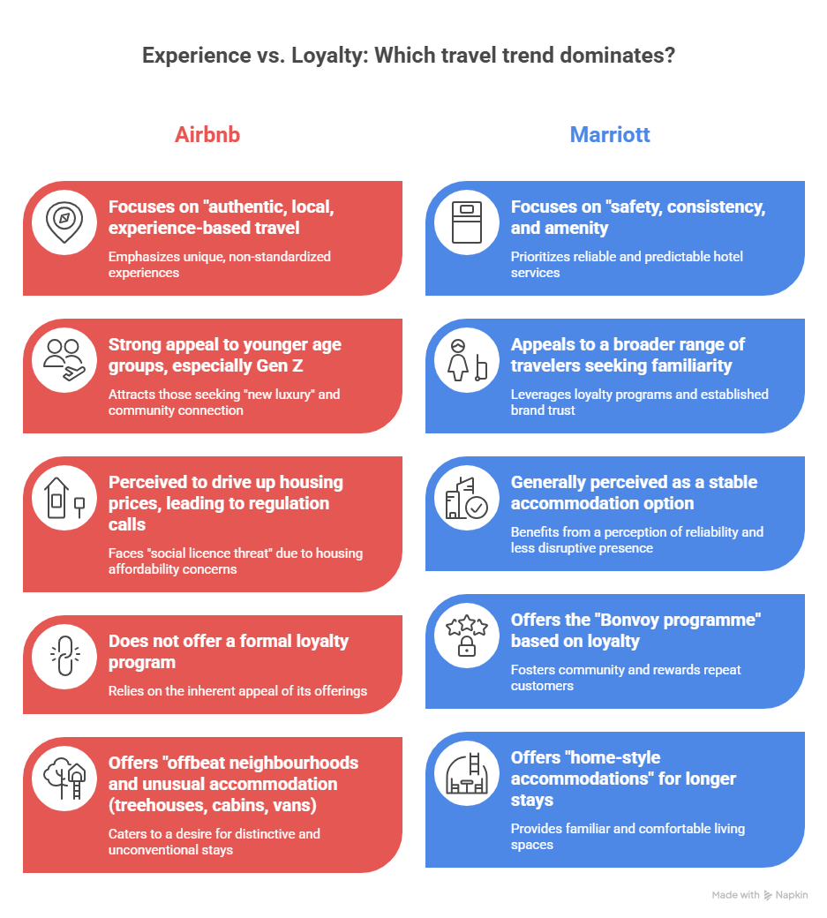
Figure 5 Experience vs. Loyalty: Airbnb and Marriott Travel Trends Compared
Image source: Created by the author
4. Task 2: Strategic Response Evaluation
4.1 Porter’s Generic Strategies

Porter (1980) believes that firms experience competitive advantage because of three generic strategies: cost leadership, differentiation, and focus (Northwood, 2025). Airbnb mainly focuses on the differentiation strategy, competing based on the uniqueness, authenticity and variety of the accommodation experiences in place of the standardised quality of its service. Instead of focusing on being cheaper than hotels, the founders of Airbnb purposely made the brand experience based on the narrative of being a local, which is a value proposition that cannot be structured by traditional hotel chains (Northwood, 2025). The sheer and wide range of products in the platform (treehouses, boats, castle stays, urban apartments) allows a near-infinite product differentiation that is naturally hard to replicate by the incumbents.
At the same time, the asset-light nature of the Airbnb business model makes it possible for Airbnb to have some sort of cost advantage: having no properties, Airbnb's capital spending is not large, and it can therefore provide competitively priced offers as compared to hotels (Northwood, 2025). Bhat (2023) cautions that differentiation and cost leadership are mutually exclusive and end up in the middle; rather, the platform model used by Airbnb allows both to be uncoupled, as it is hosts (not Airbnb) who bear the costs (Curnes et al., 2023). This ambivalent stance is what makes the competitive advantage of Airbnb structurally unusual and hard to imitate.

Marriott Strategy: Widely Differentiated and Focused Sub-brands
Marriott follows a wide differentiation strategy, that is, competing in a number of market segments with its more than 36 different brands, i.e., the ultra-luxury segment (The Ritz-Carlton, St. Regis) and the low-end one (Fairfield Inn) (Deng, 2022). The different brands serve a particular market segment with varied pricing, services and quality of services, so that Marriott can exploit a broad spectrum of traveller types without necessarily having head-to-head price wars. This multi-brand differentiation is further amplified by the presence of Marriott Bonvoy, a loyalty programme with more than 210 million members, which generates high switching costs and direct booking incentives, which is a structural competitive advantage that Airbnb does not have at all (Deng, 2022).
As a response to the threat of Airbnb, Marriott has launched focus-differentiation by creating sub-brands: Moxy Hotels are aimed at millennials, Autograph Collection is aimed at the independent-lifestyle segment, and Edition Hotels are aimed at luxury experience-seekers (Deng, 2022).

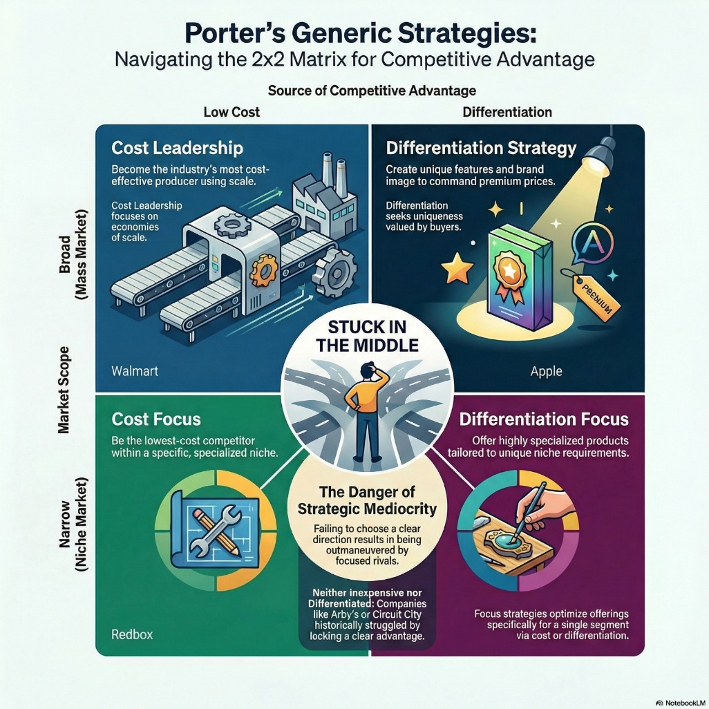
Figure 6 Porter’s Generic Strategies: Navigating the 2x2 Matrix for Competitive Advantage
Image source: Created by the author

4.2 Ansoff’s Growth Matrix
The Matrix by Ansoff (1957) has defined four strategic growth or developmental pathways: market penetration, market development, product development, and diversification. All four strategies are implemented by both Airbnb and Marriott, but with varying degrees of focus, as these two companies represent the categories of pioneer and follower.
Airbnb's Growth Strategies
Market penetration: Airbnb is a firm with strong marketing strategies, incentives, and enhancements of the platform, which ensure further penetration of the existing markets. The number of active listings increased 19% year-over-year in Q2 2023, showing the level of penetration efforts. The Airbnb controls 43 per cent of the short-term rental sector in the US and 40% in Europe (Walters, 2025).
Market Development: Airbnb has become a global company, expanding its origins in San Francisco to more than 220 countries, with the main focus on Latin America and Asia-Pacific. The growth of room nights in new markets is higher than in the core ones in Q3 2024 (Walters, 2025).
Development of products: In 2016, Airbnb introduced Airbnb Experiences - guided tours and events hosted by locals - as a direct expansion of its product in existing traveller markets (Walters, 2025). Airbnb is expected to invest 200-250 million dollars in new services it is entering in 2025, such as personal chefs, spa, and concierge-like capabilities (Walters, 2025).
Diversification: Airbnb has diversified into luxury mansions and villas, and Airbnb Services - where local (as well as guest) people can book host experiences - aims at a different group of consumers.

The Growth Strategies in Marriott
Market Penetration: Marriott is employing Bonvoy (more than 210M members), competitive pricing, and promotional discounts as a way of pushing repeat bookings within its current portfolio. In 2024, it increased the revPAR by 3-5 per cent and net room growth by 6.8 per cent (123,000 rooms added) (Walters, 2025).
Market Development: Marriott has added 558 properties and 81,000+ new rooms in 2023 alone, aiming at new markets such as Southeast Asia, the Middle East, and Greater China, where it has already signed 17 new destination marketing agreements in 2022 alone (Walters, 2025).
Product Development: In 2019, Marriott introduced Homes and Villas by Marriott Bonvoy, which has since expanded to 160, 000 destinations with a growth rate of 39% per year and an increase of 38% in international demand - a direct competitor to Airbnb in the home-rental segment. Further product development is in the form of new wellness brands (Edition Wellness Hotels, Eco-Luxe Resorts) (Walters, 2025).
Diversification: Marriott has been entering branded homes, vacation ownership (Marriott Vacations Worldwide), co-living, and digital nomad-friendly extended-stay accommodations.
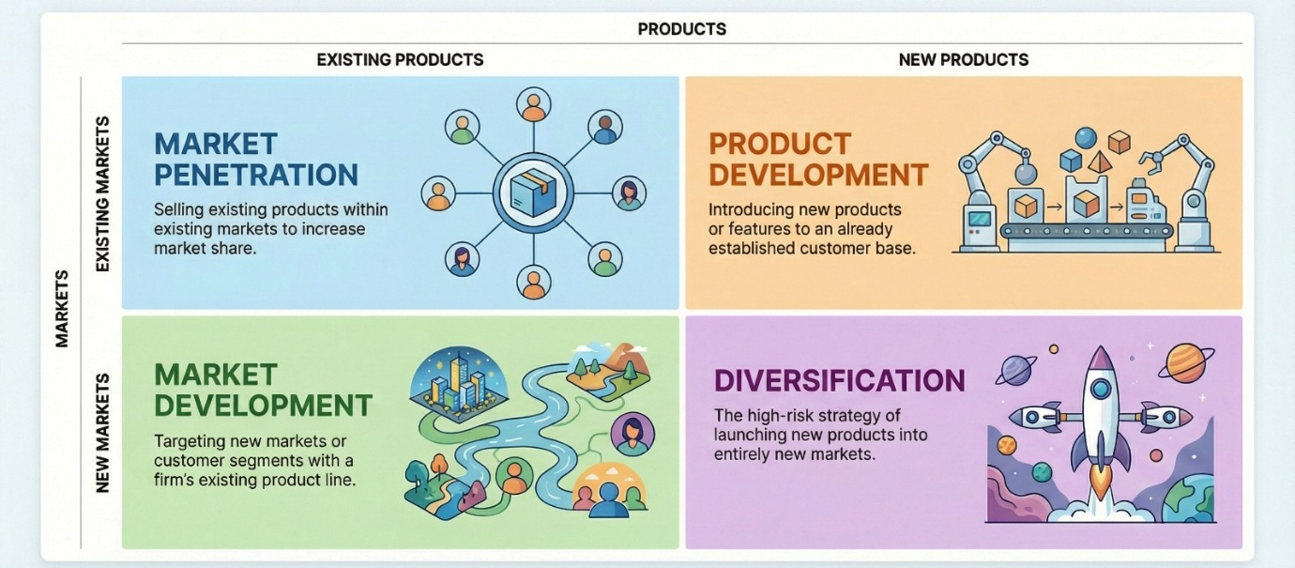
Figure 7 Ansoff Matrix: Growth Strategies for Markets and Products
Image source: created by the author

5. Conclusion

This report has critically evaluated how regulatory/legal forces and changing consumer behaviour have influenced the competitive positioning of Airbnb and Marriott International in the global hospitality sector. The results show that the asset-light model provided by Airbnb allows much better margins, scalability, and flexibility, as compared to the differentiation strategy offered by Marriott with the help of an extensive brand portfolio and an effective loyalty programme that guarantees a stable increase in revenues and market sustainability.
When it comes to performance, it can be said that neither of the two companies can be said to be universally superior since each of them is functioning successfully within various strategic approaches. Airbnb has a competitive edge in profitability, innovation, and flexibility to change consumer tastes (Tajeddini et al., 2021). Conversely, Marriott is superior in terms of the provision of stable shareholder returns, operational stability, and long-term brand loyalty.
As far as looking into the future, the lines of competition between the two companies are becoming thinner. Airbnb is now entering the lifestyle and service-oriented demands, and Marriott is increasing its presence in the short-term hotel market with such efforts as the premium home rentals and digital innovations. Even as both companies have to deal with comparable external forces such as tighter regulations and an increase in price sensitivity, both companies will probably coexist, catering to different but more overlapping customer groups in the changing hospitality market.

Reference list
Agapitou, C., Liana, A., Folinas, D. and Konstantoglou, A. (2020). Airbnb is customers’ choice: Empirical findings from a survey. Sustainability, 12, p.6136. doi:https://doi.org/10.3390/su12156136.
Airbnb (2025). New analysis shows stringent STR regulations have failed to improve the housing situation in Amsterdam and Barcelona. [online] Airbnb Newsroom. Available at: https://news.airbnb.com/new-analysis-shows-stringent-str-regulations-have-failed-to-improve-the-housing-situation-in-amsterdam-and-barcelona/.
Anastasi, S.C., Marsella, A., Melo, V., Frank, S.E. and Wagner, G.A. (2025). Short-term rental bans and the hotel industry: Evidence from New York city. European Journal of Political Economy, [online] 89, p.102725. doi:https://doi.org/10.1016/j.ejpoleco.2025.102725.
Atlys (2025). Gen z travel trends: Statistics, insights and what it all means for the industry [2025]. [online] Atlys.com. Available at: https://www.atlys.com/blog/gen-z-travel-trends.
Barbu, C.M., Florea, D.L., Florin, O.R. and Barbu, (2018). From ownership to access: How the sharing economy is changing the consumer behavior. www.amfiteatrueconomic.ro, 20, p.373. doi:https://doi.org/10.24818/ea/2018/48/373.
Bianco, S., Zach, F.J. and Singal, M. (2022). Disruptor recognition and market value of incumbent firms: Airbnb and the lodging industry. Journal of Hospitality & Tourism Research, 48, p.109634802210852. doi:https://doi.org/10.1177/10963480221085215.
Curnes, A., Kreun, A., Royal, T., Zadalis, J. and Hohn, C. (2023). Airbnb strategic audit overview airbnb strategic audit overview. [online] Available at: https://digitalcommons.unl.edu/cgi/viewcontent.cgi?article=1642&context=honorstheses.
Deng, J. (2022). Hotel Brands and the Impact of Brand Differentiation on the Success of the Global Hotel Brands. Highlights in Business, Economics and Management, [online] 1(3), pp.265–276. doi:https://doi.org/10.54097/hbem.v1i.2582.
Dolnicar, S. and Reinhold, S. (2021). The evolution of Airbnb’s business model. [online] uq.pressbooks.pub. Available at: https://uq.pressbooks.pub/airbnb-978-1-74272-321-1/chapter/the-evolution-of-airbnbs-business-model/.
Guttentag, D.A. and Smith, S.L.J. (2017). Assessing airbnb as a disruptive innovation relative to hotels: Substitution and comparative performance expectations. International Journal of Hospitality Management, 64, pp.1–10.
Hati, Sri Rahayu Hijrah, Balqiah, Tengku Ezni, Hananto, A. and Yuliati, E. (2021). A decade of systematic literature review on Airbnb: The sharing economy from a multiple stakeholder perspective. Heliyon, 7. doi:https://doi.org/10.1016/j.heliyon.2021.e08222.
Jin, G.Z., Wagman, L. and Zhong, M. (2024). The effects of short-term rental regulation: Insights from chicago. International Journal of Industrial Organization, 1, pp.103087–103087. doi:https://doi.org/10.1016/j.ijindorg.2024.103087.
Lutz, C., Filip Majetić, Miguel, C., Perez-Vega, R. and Jones, B. (2024). The perceived impacts of short-term rental platforms: Comparing the united states and united kingdom. Technology in society, 1, pp.102586–102586. doi:https://doi.org/10.1016/j.techsoc.2024.102586.
Marriott International (2024). Environmental, social & governance global progress. [online] Available at: https://serve360.marriott.com/wp-content/uploads/2024/07/2024ESGProgress.pdf.
Northwood, R. (2025). Airbnb’s Asset-Light Model and New Revenue Streams: a Pathway to Sustained Growth in a Post-Pandemic World. [online] Ainvest. Available at: https://www.ainvest.com/news/airbnb-asset-light-model-revenue-streams-pathway-sustained-growth-post-pandemic-world-2509-39/.
Paulauskaite, D., Powell, R., Andres, C.-S.J. and Morrison, A.M. (2017). Living like a local: Authentic tourism experiences and the sharing economy. International Journal of Tourism Research, 19, pp.619–628. doi:https://doi.org/10.1002/jtr.2134.
Shin, H., Lee, J. and Kim, N. (2023). Workcation (workation) travel experiences, satisfaction and revisit intentions: Focusing on conceptualization, scale development, and nomological network. Journal of Travel Research, 63. doi:https://doi.org/10.1177/00472875231188717.
Tajeddini, K., Mostafa Rasoolimanesh, S., Chathurika Gamage, T. and Martin, E. (2021). Exploring the visitors’ decision-making Process for Airbnb and Hotel Accommodations Using value-attitude-behavior and Theory of Planned Behavior. International Journal of Hospitality Management, [online] 96(5), p.102950. doi:https://doi.org/10.1016/j.ijhm.2021.102950.
Tarlavski, R., Edmon Oude Elferink and Dekker, S. (2018). GDPR: Major impact on hotel industry. [online] Cms.law. Available at: https://cms.law/en/nld/publication/gdpr-major-impact-on-hotel-industry [Accessed Mar. 2026].
Walters, J. (2025). Marriott Posts RevPAR, Rooms Growth amid Strong Travel Demand. [online] Hotel Dive. Available at: https://www.hoteldive.com/news/marriott-earnings-revpar-rooms-growth-travel-demand/739802/.
Warren, S. (2024). The failure to regulate airbnb. Contexts, 23, pp.32–37. doi:https://doi.org/10.1177/15365042241293432.
Yeon, J., Song, H.J. and Lee, S. (2020). Impact of short-term rental regulation on hotel industry: a difference-in-differences approach. Annals of Tourism Research, 83, p.102939. doi:https://doi.org/10.1016/j.annals.2020.102939.
Yoon, S., Jung, S. and Erdem, M. (2020). case study airbnb: A disruptive innovation-based business. Airbnb: A Disruptive Innovation-based Business, [online] 8. Available at: https://www.chrie.org/assets/docs/JHTC-case-notes/JHTC-vol-8/JHTC_Vol%208_Issue%203_Yoon_Case.pdf.

