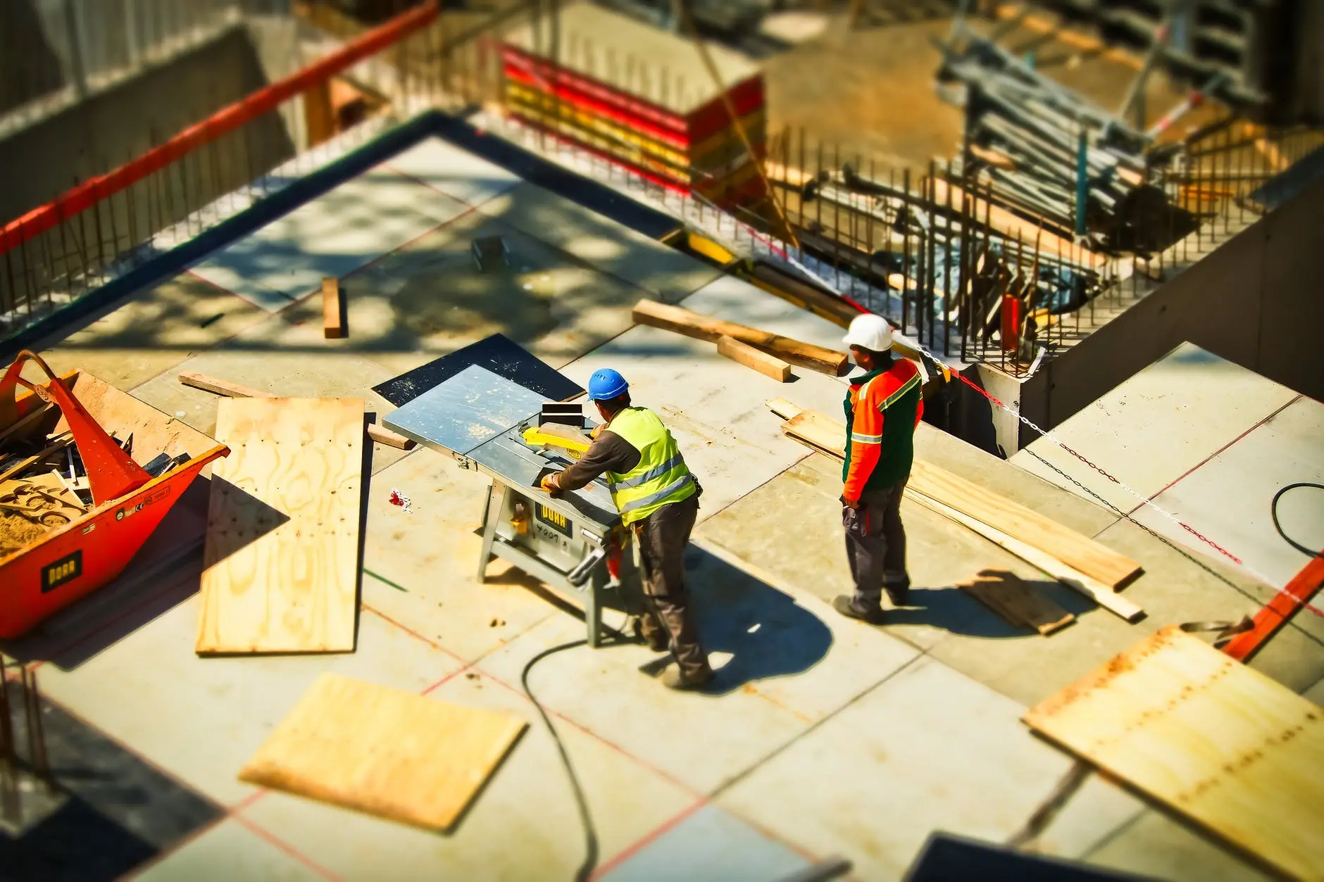
Health & safety within construction
Health, Safety and Welfare ACBA4023
Francis Barcelo (2401983) | 5/15/25 | University of Wales Trinity Saint David’s

Table of Contents
2 Introduction 2
3 Building Safety Act 2
3.1 Scenario 2
3.2 Potential Impacts 3
4 Health and Safety Legislation 4
4.1 Working with Heights (2005) 4
4.2 Reporting of Injuries, Diseases and Dangerous Occurrences Regulations 2013 (RIDDOR) 6
4.2.1 Reportable Injuries 7
4.3 Barriers to Health and Safety 7
5 CDM Regulations 8
6 Conclusion 10
7 Appendix 11
7.1 Risk Assessment 11
7.2 Glossary of Terms 13
8 Reference 14

Introduction
This assignment is a report about Health, Safety, and Welfare within the construction industry. The report highlight’s challenges and risks that can occur in a construction workplace and how regulations and legislations help minimise the impact it can have on a project. These challenges would determine what actions needs to be performed to ensure the safety of everyone working in a site.
This report will use an existing site to help determined all the risks that can occur, and would feature various ways on how to prevent, and what to do when an accident happens. It also talks about the major regulations that apply to the construction industry.

Building Safety Act

Scenario
(Everstock Development Ltd, (ND) Figure 1)
A block of flats has been proposed to be built in SA1 next to Swansea’s River Tawe where it will provide both commercial and residential spaces. Figure 1 shows the design and what the building would look like after construction has finished. It is planned to be a four to six-story building, making adherence to various legislation and regulations throughout the project crucial in ensuring the safety of everyone involved around the structure (Youle. R, 2023). The Building Safety Act is one key legislation that needs to be taken into consideration throughout the project. This Act is a major factor in determining how various procedures would need to take place to ensure the safety of everyone involved in this project.

Potential Impacts
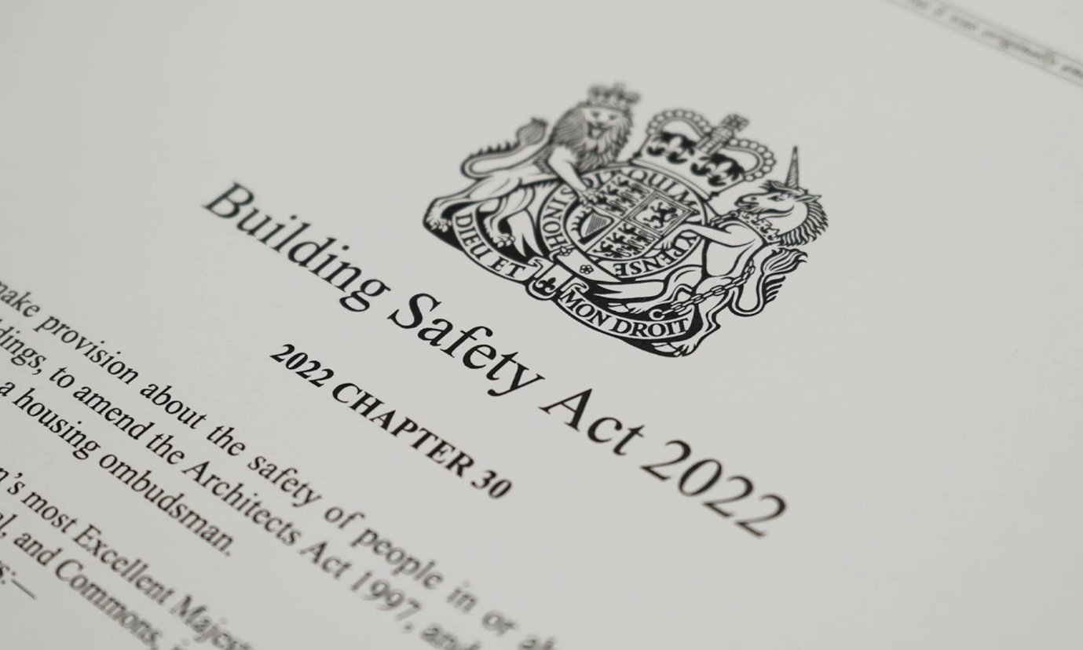(GIA, ND Figure 2)
The main aim of the legislation is to help improve various aspects of high-risk buildings. Aspects such as the designing, construction, and management of a project all play a pivotal role in ensuring both the success of the building and the safety on site. This Act came into force in the UK in April 2023 when it was introduced due to the fire that occurred in Grenfell Tower. The purpose of the Act is to give residents and homeowners of a building more rights and power to help make their homes safer and more protected. It makes sure that leaseholders find a solution to a reported problem no matter the cost, which ensures that the building is properly maintained. The BSR oversees all the safety and performance of all buildings especially taller buildings. Three new bodies are provided to be overseer to ensure that the buildings are maintained and managed to a certain standard that helps create high-quality homes (Ministry of Housing, Communities and Local Government et al (2022).
New requirements about how a building should be constructed and how all the products needed meet the standards stated in the Act. This makes sure that the UK market provided to all buildings is safe for their intended use. The accountable person of a building will need to show that they have put certain measures in place to help further manage the building’s safety and prevent any risks from occurring. People who do not adhere to these requirements may face criminal charges and are responsible for whatever happens in the building (Ministry of Housing, Communities and Local Government et al (2022).
Although the BSA applies to everyone in the UK, Wales has implemented a different “regime” from England. The Welsh Government is planning to develop its own strategy to help tackle the safety problems that occur in high-rise buildings. The new regime in Wales would include all occupied residential buildings in Wales no matter how high they are. This would apply to the proposed plan on SA1 where the building includes residential units at four to six stories (James. J 2024).

Health and Safety Legislation

Working with Heights (2005)
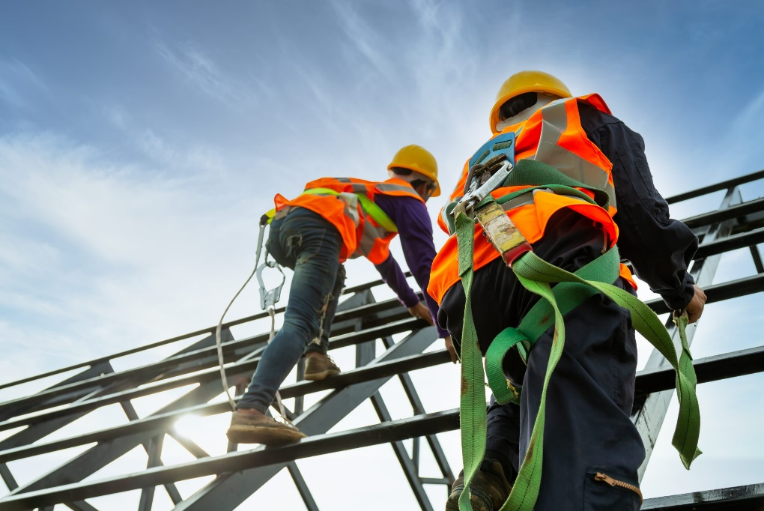
(Warwick. L, 2023 Figure 3)
The proposed construction plan is to build a new four to six-story block of flats in SA1 Swansea. With this comes various health and safety concerns that need to be addressed to ensure the safety of everyone involved on site. Due to the height of the proposed building plan, it comes under The Work at Height Regulations 2005. The purpose of this regulation is to prevent any death or injuries that are caused by a fall from height. The regulation is a guide for employers and how to ensure the safety of their workers while they are at work. They are the ones responsible if any accidents occur in the workplace which is why the appropriate procedures must be followed (HSE, ND A).
The regulation states that all employers must include the right type of equipment when it comes to working at height. Before any work is to be done the employer must assess the potential risks that can occur on-site, this can be done by doing a risk assessment. Assessing the situation would help determine whether working at height is avoidable, if not they should make a plan. A good plan would make tasks easier, safer, and require less effort to achieve. Avoiding working at heights includes doing most work from the ground such as installing cables or eliminating the risk of falls by using equipment to reduce the height of fall if one does occur (HSE, ND B).
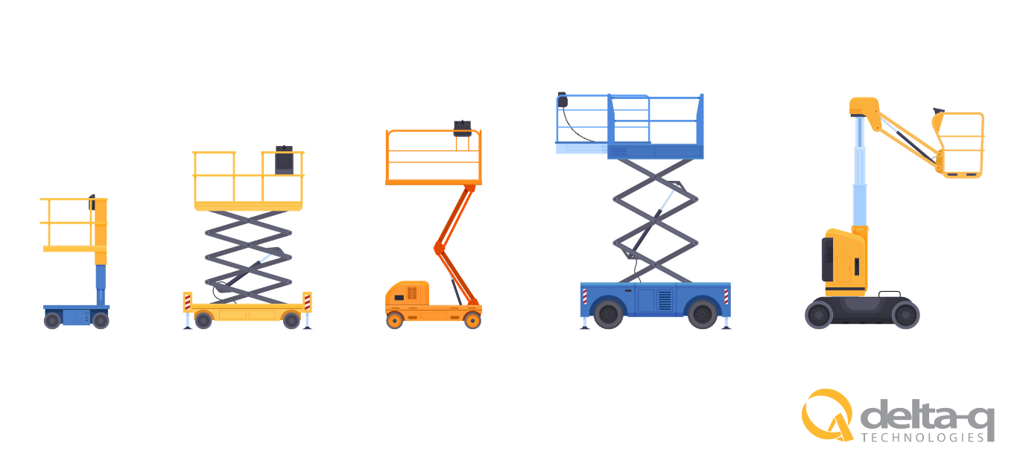(Delta-Q Technologies, 2024 Figure 4)
Falls from heights in the construction industry are the biggest cause of fatalities, making it more crucial to tackle the problem and help prevent them from occurring (HSE, ND C). Proper planning when it comes to working at heights involves providing the appropriate PPE such as harnesses or equipment such as safety nets to minimise the distance or the use of MEWPs and scaffolds to help eliminate the risk. The use of MEWPs requires workers who are qualified and trained to safely operate the machine. The usage of this type of equipment would come under another piece of regulation LOLER. This allows employees to be able to reach the task much more quickly and do work faster and more efficiently, with MEWPs having guard rails it further prevents a person from falling (HSE, ND B). The use of other equipment such as ladders should be used with great care, employers must make sure that workers are qualified and have been trained on how to safely handle equipment like ladders (Rhodri. T 2025 A)

Reporting of Injuries, Diseases and Dangerous Occurrences Regulations 2013 (RIDDOR)
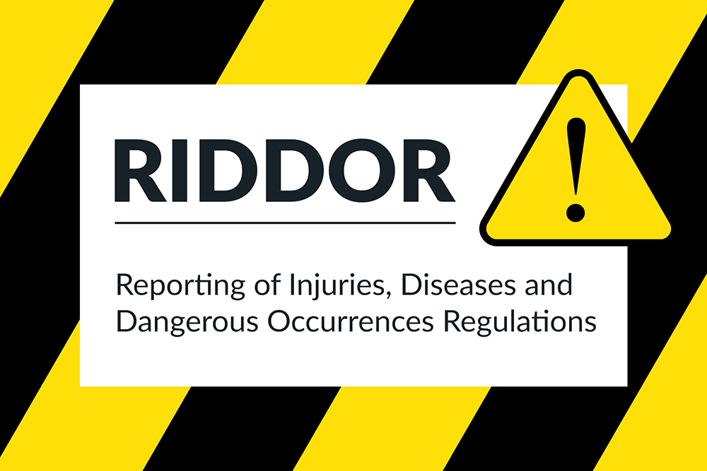
(Ardent Safety, 2023 Figure 5)
RIDDOR is another piece of legislation that is key in every workplace in the UK. Its main purpose is to make sure that the people responsible in a workplace such as an employer or a supervisor make and keep records of any work-related accidents. These can include any deaths, injuries, reportable occupational diseases, and incidents that have the potential to cause harm to others. RIDDOR helps make sure that the right people are informed when such accidents occur in a workplace, people like the HSE or the local authority are usually the ones who report when the health and safety of everyone is involved. A report should only be made by the ‘responsible person’ on the site this may be the supervisor/manager. Reporting would help raise any concerns on the site with the HSE this may be a work-related accident or an ongoing risk that hasn’t yet been solved (HSE, ND D)
In the construction industry, the use of heavy machinery and equipment makes work-related injuries more common. This makes reporting and letting the correct authorities know of any injuries that occur so the right procedures can be taken. Creating a report and keeping a record would help prevent the same accident from occurring again further helping keep the workplace a safer environment (HSE, ND D).

Reportable Injuries
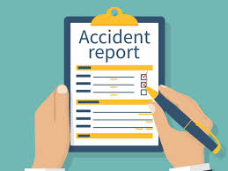
(Sleighthom. K, 2018 Figure 6)
It is important that reporting an accident is reportable under the RIDDOR regulation. It states that an accident is reportable if is identifiable, unintended, separate, and causes physical harm to someone. Injuries such as death, injuries that cause the worker to not be able to work for more than 7 days, minor injuries caused to the public, and certain injuries to employees/workers. Specified injuries include fractures, amputation, loss of sight, crush and burn injury, etc (HSE, ND D)
Accurate and detailed copies of the report should be kept for any accidents. Employers can do this by keeping copies in form of a filing system or keeping a record online (Rhodri. T, 2025 B).

Barriers to Health and Safety
Health and Safety in the construction industry puts a lot of responsibility on everyone involved in a project. This makes good management in the workplace essential. Having a good management structure helps ensure that everyone involved knows their responsibilities, they are qualified and trained, always being monitored, supervised, and supported during work. This comes with many benefits, creating a more efficient and safer work environment (Rhodri. T 2025 C)

CDM Regulations
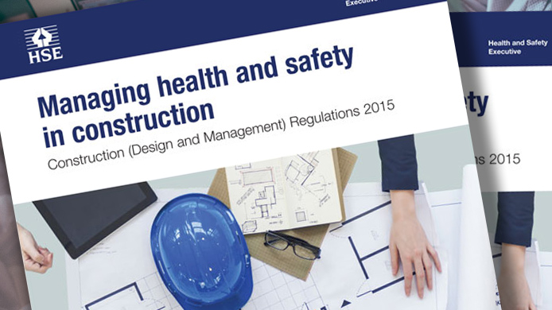(RDS, ND Figure 7)
The Construction (Design and Management) Regulations is a set of steps to help people in the construction industry identify what their role is when it comes to health and safety. The CDM’s main aim is to help improve health and safety by providing steps on various aspects such as how to plan the work to where all risks are planned for and help minimise from happening, make sure the right people are suitable for the various jobs, and so on. The CDM helps spread information on how crucial health and safety is in the workplace and it is essential that this information is passed on to the people who need it the most (HSE, ND F). The CDM regulations were first introduced in 1994 but have been revised and changed over time. The most recent revision came into effect in 2015 with multiple changes in the regulations making it important that people in the construction industry adhere to the correct version (Rhodri. T 2025 D).

The CDM regulations have different effects on different people depending on their role in the project. It ensures that everyone has their own responsibilities to create a safer work environment. The CDM regulations appoint various “dutyholders” to perform certain tasks at different aspects of the project. There are 7 main duty holders that the CDM regulations recognise Commercial Clients, Domestic Clients, Designers, Principal Designers, Principal Contractors, Contractors, and Workers all have a role in ensuring the health and safety of everyone involved in the project (HSE, ND F).

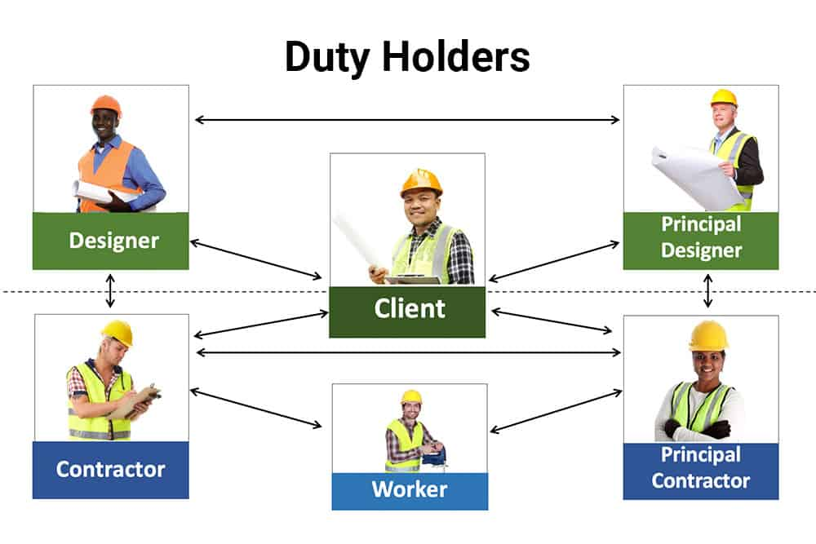
(HumanFocus, 2022 Figure 8)
The main duty holders are the clients in a project. Commercial Clients are companies or individual’s where the project is carried out due to a deal made, their main duties are to ensure that the entire project is properly managed where and they have appointed appropriate duty holders to the right people. It is their responsibility to provide all the necessary information about the construction to ensure an efficient and safe workplace. They are the people who need to ensure that the correct welfare facilities are provided such as toilets and clean drinking water. Domestic clients are the similar with commercial clients, but they are the people where construction is carried out as not part of a business deal. The clients are the main foundation in a project, and they are the ones who would appoint and share the responsibilities that adhere to the CDM regulations. The designers are the people who create an image of the projected building, the contractors are responsible for the construction phase of the project. Contractors are the people with the expertise and knowledge needed in ensuring the construction of the project is done to a standard. Workers are the one who works under the control of the contractors (HSE, ND F).

Conclusion
To conclude, Health and Safety in any workplace has a significant impact on a project. With the various legislation and regulations created to keep everyone safe, making it is essential that everyone adheres to each relevant one. Each legislation has been created due to an accident that has occurred in the past, by adhering it helps prevent that certain accident from occurring again, prevents delays, helps prevent any legal troubles, and creates a more a safer workplace in construction.

Appendix

Risk Assessment

Activity to be Assessed |  |  |  |  |  |  |  |  |  |  |  |  |  |  |  |  | Assessment Number
Construction of apartments at SA1. Working at height. |  |  |  |  |  |  |  |  |  |  |  |  |  |  |  |  | 0001
 |  |  |  |  |  |  |  |  |  |  |  |  |  |  |  |  | DKW020616
Persons undertaking or affected by the activity
 |  |  | Employees |  |  | Contractor |  |  |  | Public |  |  |  |  | Pupil |  |  |  |  |  |  | Service User
 |  |  | Other …………………………………………………………………………………………….
Identified Hazards and Associated Risks |  |  |  |  |  |  |  |  |  |  | Likelihood |  |  |  |  |  | Severity |  |  |  |  |  | Risk Level
1 | Working at heights- The use of ladders or doing construction at a higher altitude at various parts of the building. Can cause injuries can be minor or fatal depending on how high. |  |  |  |  |  |  |  |  |  | 5 |  |  |  |  |  | 3-5 |  |  |  |  |  | High
2 | Exposure of electrical wires- Can cause burns, shock which can be minor or even fatal in serious cases. |  |  |  |  |  |  |  |  |  | 4 |  |  |  |  |  | 4-5 |  |  |  |  |  | High
3 | Vibration and Noise- Continuous exposure to noise and vibration can cause various health problems in the long run. |  |  |  |  |  |  |  |  |  | 5 |  |  |  |  |  | 2-3 |  |  |  |  |  | Medium
4 | Poor weather conditions- Conditions such as powerful winds can lead to more falls, Rain can cause problems if any faulty wires or electrical components are exposed, slips and falls are more common. |  |  |  |  |  |  |  |  |  | 3 |  |  |  |  |  | 4-5 |  |  |  |  |  | High
5 | Exposure of dangerous goods- such as chemicals and flammable materials can cause serious injuries such as burns or irritation of the skin. |  |  |  |  |  |  |  |  |  | 3 |  |  |  |  |  | 4-5 |  |  |  |  |  | High
6 | Manual Handling- Lifting heavy equipment's and carrying them around the site can cause strain to the muscles and can injuries. |  |  |  |  |  |  |  |  |  | 3 |  |  |  |  |  | 3 |  |  |  |  |  | Medium
Control Measures Required
1 | Make sure that the correct PPE are worn before working at higher places. Depending on the situation harnesses and other equipment's should be provided to the workers. Make sure to inform someone to keep an eye on you in case any problems occur. Make sure that working at a specific height is needed if not avoid if can.
2 | Make sure to cover any exposed wires, any broken needs to replace or fixed using the correct PPE. Anyone using electrical equipment's should be qualified with enough training. The use of PPE such as specialised gloves can reduce the chance of shocks or burns from occurring when handling any electrical components.
3 | The use of the appropriate PPE when handling any equipment's that cause constant vibration can help reduce the effect in the long run. The use of specialised headphones to minimise noise exposure can reduce any damage in a worker hearing.
4 | Avoid doing work in harsh conditions. If working with powerful winds, make sure equipment's such as a harness is provided and a person to supervise you. Make sure or equipment's and wires are protected with a cover, and all are fixed or replaced. Wearing the appropriate PPE in these conditions are crucial such as specialised boots to prevent any slips and falls.
5 | All chemicals and any flammable goods should be stored properly in accordance with COSHH regulation. Handling any chemicals should be done with great care and with the use of the appropriate PPE. The person handling should be trained on how to properly and safely use them. Flammable goods should be kept separated from anything that may cause a fire such as electrical equipment's.
6 | When transporting and carrying heavy materials or components the use of heavy equipment's can make it easier and safer to do. Make sure that the person using the machine has been trained and is qualified to use it. The use of the correct PPE would also help reduce the severity of the injury if any heavy materials is dropped.
Reassessment of Activity Hazards |  |  |  |  |  |  |  |  |  |  | Likelihood |  |  |  |  |  | Severity |  |  |  |  |  | Risk Level
1 | Working at Heights |  |  |  |  |  |  |  |  |  | 3 |  |  |  |  |  | 3-4 |  |  |  |  |  | Medium
2 | Exposure of Electrical Components/Wires |  |  |  |  |  |  |  |  |  | 2 |  |  |  |  |  | 2-3 |  |  |  |  |  | Medium
3 | Vibration and Noise |  |  |  |  |  |  |  |  |  | 2 |  |  |  |  |  | 1-2 |  |  |  |  |  | Low
4 | Bad Weather Condition |  |  |  |  |  |  |  |  |  | 3 |  |  |  |  |  | 1-2 |  |  |  |  |  | Medium
5 | Exposure of chemicals and flammable goods |  |  |  |  |  |  |  |  |  | 2 |  |  |  |  |  | 2-3 |  |  |  |  |  | Medium
6 | Manual Handling |  |  |  |  |  |  |  |  |  | 1 |  |  |  |  |  | 2 |  |  |  |  |  | Low
Name: Francis Barcelo  Position: Supervisor |  |  |  |  |  |  | Signed: Rhodri.T |  |  |  |  |  |  |  |  |  | Date of Completion: 15/05/2025
Reviews |  |  |  | Key
Review Date: 15/05/2026 |  |  |  | Likelihood |  |  |  | Severity |  |  | Severity of Injury |  | 5 | 5 |  |  |  | 10 |  |  | 15 |  |  | 20 |  | 25
Reviewed by: 15/05/2027 |  |  |  | 1 very unlikely  2 unlikely  3 likely  4 very likely  5 certainty |  |  |  | 1 nuisance  2 minor  3 medical treatment  4 major  5 fatal |  |  |  |  | 4 | 4 |  |  |  | 8 |  |  | 12 |  |  | 16 |  | 20
Review Date: 15/05/2028 |  |  |  |  |  |  |  |  |  |  |  |  | 3 | 3 |  |  |  | 6 |  |  | 9 |  |  | 12 |  | 15
Reviewed by: 15/05/2029 |  |  |  |  |  |  |  |  |  |  |  |  | 2 | 2 |  |  |  | 4 |  |  | 6 |  |  | 8 |  | 10
Review Date: 15/05/2030 |  |  |  |  |  |  |  |  |  |  |  |  | 1 | 1 |  |  |  | 2 |  |  | 3 |  |  | 4 |  | 5
Reviewed by: |  |  |  |  |  |  |  |  |  |  |  |  | 0 | 1 |  |  |  | 2 |  |  | 3 |  |  | 4 |  | 5
Review Date: |  |  |  |  |  |  |  |  |  |  |  |  |  | Likelihood of Injury
Reviewed by: |  |  |  |  |  |  |  |  |  |  |  | Low Risk |  |  |  |  |  |  | Medium Risk |  |  |  |  |  | High Risk

Glossary of Terms
Terms | Definition
Building Safety Act (BSA 2022) | A piece of legislation in the UK to improve building safety
Building Safety Regulator (BSR) | In England a part of the HSE and is set up under the Building Safety Act
Health and Safety Executive (HSE) | The national regulator for workplace health and safety in the UK
Construction (Design and Management) Regulations (CDM) | Sets of rules in the UK for managing health, safety, and welfare on construction projects.
Personal Protective Equipment (PPE) | Equipment's worn in a construction site or in any workplace.
Control of Substances Hazardous to Health (COSHH) | A set of regulation to ensure employers control the exposure of any hazardous substances in the workplace.
Lifting Operations and Lifting Equipment Regulations (LOLER) | A regulation that ensures that lifting equipment is maintained and regularly inspected.
Mobile Elevated Work Platforms (MEWPs) | Powered machines used to temporary get access to elevated areas.
Reporting of Injuries, Diseases and Dangerous Occurrences Regulation (RIDDOR) | A law in the Uk that requires employers and others to report specific accidents to the HSE or to the local authority.

Reference
Safesitefacilities (nd) Building and Construction Safety Regulations and Standards [online] Available at: https://www.safesitefacilities.co.uk/knowledge-base/building-and-construction-safety-regulations-and-standards [Accessed on 4 February 2025]
Youle. R (2023) Block of 104 ‘affordable 'flats se to be built in Swansea’s SA [online]. Available on https://www.walesonline.co.uk/news/wales-news/swansea-property-affordable-housing-sa1-28120201 (Accessed on 1 March 2025).
Everstock Development Ltd, (ND) Kings Road, SA1 Swansea [online] Available at: https://www.coastalha.co.uk/our-developments/ (Accessed on 1 March 2025)
GIA (ND) Understanding the upcoming changes to the Building Safety Act [online] Available at: https://gia.uk.com/understanding-the-upcoming-changes-to-the-building-safety-act/ (Accessed on 1 March 2025)
Ministry of Housing, Communities and Local Government and Department for Levelling Up, Housing and Communities (2022) The Building Safety Act [online] Available at: https://www.gov.uk/guidance/the-building-safety-act (Accessed on 1 March 2025)
James. J (2024) Written Statement: Building Safety in Wales [online] Available on: https://www.gov.wales/written-statement-building-safety-wales-1#:~:text=It%20is%20our%20intention%20to,residential%20units%20regardless%20of%20height (Accessed on 1 March 2025).
Warwick. L (2023) What Safety standards apply to operating at heights? [online] Available at: https://www.manutan.co.uk/blog/health-safety/what-safety-standards-apply-to-operating-at-heights/ (Accessed on 5 April 2025)
Delta-Q Technologies (2024) How a Smaller Charger Can Do More: Optimizing Battery Charging in MEWPs [online] Available at: https://delta-q.com/industry-news/how-a-smaller-charger-can-do-more-optimizing-battery-charging-in-mewps/ (Accessed on 5 April 2025)
HSE (ND A) The work at Height Regulations (The Law) [online] Available at: https://www.hse.gov.uk/work-at-height/the-law.htm (Accessed on 5 April 2025)
HSE (ND B) Work at height (Step-by-step guide) [online] Available at: https://www.hse.gov.uk/work-at-height/step-by-step-guide.htm (Accessed on 5 April 2025)
HSE (ND C) Work-related fatal injuries in Great Britain [online] Available at: https://www.hse.gov.uk/statistics/fatals-overview.htm (Accessed on 5 April 2025)
Thomas. R (2025 A) Health, Safety, and Welfare, ACBA 4023, University of Wales Trinity Saint David’s. Lecture slides (Working at Heights) accessed via by the University learning platform. (Accessed on 1 March 2025)
Ardent Safety (2023) Why is RIDDOR important? [online] Available at: https://ardentsafety.co.uk/why-is-riddor-important/ (Accessed on 12 April 2025)
HSE (ND D) RIDDOR explained [online] Available at: https://www.hse.gov.uk/riddor/key-definitions.htm (Accessed on 12 April 2025)
Sleightholm. K (2018) RIDDOR [online] Available at: https://www.protrainings.uk/wiki/riddor/ (Accessed on 12 April 2025)
Thomas. R (2025 B) Health, Safety, and Welfare, ACBA 4023, University of Wales Trinity Saint David’s. Lecture slides (RIDDOR) accessed via by the University learning platform. (Accessed on 12 April 2025)
Thomas. R (2025 C) Health, Safety, and Welfare, ACBA 4023, University of Wales Trinity Saint David’s. Lecture slides (Barriers to H&S Management and how they can be overcome) accessed via by the University learning platform. (Accessed on 12 April 2025)
RDS (ND) CDM Regulations [online] Available at: https://rds-sm.co.uk/services/cdm-regulations (Accessed on 19 April 2025)
HSE (ND F) Summary of duties under construction (Design and Management) Regulations 2015 (CDM 2015) [online] Available at: https://www.hse.gov.uk/construction/cdm/2015/summary.htm (Accessed on 19 April 2025)
Human Focus (2022) The Role of Duty Holders Under the CDM Regulations 2015 [online] Available at: https://humanfocus.co.uk/blog/role-of-duty-holders-under-the-cdm-regulations-2015/ (Accessed on 19 April 2025)
Thomas. R (2025 D) Health, Safety, and Welfare, ACBA 4023, University of Wales Trinity Saint David’s. Document Handout (Risk Assessment) accessed via by the University learning platform. (Accessed on 8 March 2025)

