

A Comparative Analysis of Adidas' International Marketing Strategy in India and the United States

Student Name: Ranjit Masaribhai Modhwadiya
Student ID Number: 2529489
Programme: Master of Business Administration
Module: International Marketing: Principles and Practices
Module code: LCMB7026
Contribution to Overall Module Assessment (%): 100%

Lecturer:
Tushara Balendran (London)
Dian Mayasari (Birmingham)

Internal Verifier:
Vasilios Tavlaridis
Hoang Nguyen

Assignment Title: Assessment Component 1: Individual Report
Word count (or equivalent): 5000 words (±10%)
Submission deadline: Friday 24th July 2026
Return date of provisional marks & written feedback: 21st August 2026


Table of Contents
List of Figures 4
List of Tables 4
1. Introduction 5
1.1 Background of Adidas 5
1.2 Purpose of the Report 5
1.3 Report Objectives 6
Section 1: International Marketing Report 6
2.1 Comparative Market Analysis of India and the United States 6
2.2 Critical Discussion of the PESTEL Factors 8
2.3 Hofstede's Cultural Dimensions 10
3. Comparative Analysis of Adidas' STP Strategy 11
3.1 Segmentation 12
3.2 Targeting 12
3.3 Positioning 13
4. Comparative Analysis of Adidas' International Marketing Mix (7Ps) 14
4.1 Product 15
4.2 Price 15
4.3 Place 15
4.4 Promotion 16
4.5 People 16
4.6 Process 16
4.7 Physical Evidence 17
5. Market Entry Strategy 17
5.1 Adidas' Market Entry into India 17
6. Ethical Issues in Adidas' International Marketing 19
6.1 Selected Ethical Issue: Supply Chain Labour Practices 19
7. Recommendations 21
Section 2: Reflection Using Gibbs' Reflective Cycle 22
9.1 Description 23
9.2 Feelings 23
9.3 Evaluation 23
9.4 Analysis 23
9.5 Conclusion 24
9.6 Action Plan 24
References 25

List of Figures
Figure 1. Hofstede's Cultural Dimensions: India vs United States
Figure 2. Adidas' STP Strategy in India and the United States
Figure 3. Adidas' International Marketing Mix (7Ps): India vs United States
Figure 4. Adidas' Market Entry Strategy in India
Figure 5. Adidas' Global Supply Chain and Worker Engagement Model
Figure 6. Gibbs' Reflective Cycle

List of Tables
Table 1. Comparative PESTEL Analysis of India and the United States

1. Introduction
Multinational companies can gain a sustainable competitive advantage in international markets by adapting their marketing strategies to varying economic, cultural and competitive environments rather than relying on a standardised global approach (Ayub, 2025). This report compares Adidas' international marketing strategy in India and the United States by critically analysing macro-environmental conditions, cultural factors, marketing strategy decisions, market entry and ethical issues through the lens of various marketing frameworks and current evidence.

1.1 Background of Adidas
Adidas AG is a leading multinational sportswear company with a global presence in over 160 countries, providing performance and lifestyle consumers with products and services from footwear, apparel and sporting equipment (Adidas, 2026). Established in Germany in 1949, the company has built an excellent global brand through product innovation and international marketing which focuses on both global brand consistency and local market adaptation. The Adidas Annual Report 2025 shows that the company net sales grew to a record €24.81 billion, and operating profit rose 54% to €2.06 billion, as a result of the effectiveness of the international growth strategy (Adidas, 2026). Multinationals are gaining a competitive edge by adjusting marketing strategies to market conditions rather than by standardisation, as Kotler et al. (2024) state. This is especially true of Adidas, which relies on its ability to adapt to a wide range of economic, cultural and consumer landscapes.

1.2 Purpose of the Report
This report aims to critically analyse the overall international marketing strategy of ADIDAS and its performance in India and the United States. The report discusses the impact of contrasting business environment & culture on marketing decisions and analyses Adidas' international marketing practices based on the theories and evidence from the present day.

1.3 Report Objectives
This report aims to:
- Compare the macro-environmental conditions of India and the United States using PESTEL analysis.
- Analyse cultural differences using Hofstede's Cultural Dimensions.
- Evaluate Adidas' Segmentation, Targeting and Positioning (STP) strategy in both markets.
- Critically compare Adidas' international marketing mix (7Ps).
- Assess Adidas' market entry strategy in India.
- Evaluate a key ethical issue affecting Adidas' international marketing.
- Develop evidence-based recommendations to improve Adidas' international marketing performance.

Section 1: International Marketing Report

2.1 Comparative Market Analysis of India and the United States
India and the United States are two key markets strategically important for Adidas, but the markets are vastly different in terms of the economic maturity, consumer base, and business environment. The U.S. is a mature sportswear market, with high purchasing power, developed retail and digital infrastructure, while the Indian market is an emerging economy with a growing interest in sports and fitness, coupled with increasing disposable incomes and urbanisation (IMF, 2025). Thus, a comparative PESTEL analysis is a systematic approach to understanding the opportunities and challenges that affect Adidas' international marketing strategy in both markets.
Table 1: Comparative PESTEL Analysis of India and the United States
PESTEL Factor | India | United States | Implications for Adidas
Political | Stable government promoting foreign investment through initiatives such as Make in India (Government of India, 2025). | Stable political system but affected by trade tensions and tariff uncertainties. | India supports long-term expansion, while US trade policies may increase supply chain costs.
Economic | GDP growth forecast 6.4% (2025) with expanding middle-class consumption (IMF, 2025). | GDP growth forecast 1.8% (2025) but remains the world's largest consumer market (IMF, 2025). | India offers stronger growth potential, whereas the US generates higher premium sales.
Social | Young population, increasing sports participation, and growing demand for athleisure products. | High health awareness and established sports culture with strong brand loyalty. | Adidas must tailor products and marketing to different consumer lifestyles.
Technological | Rapid digitalisation and growth of e-commerce platforms such as Flipkart and Myntra. | Advanced digital infrastructure with highly developed omnichannel retailing. | Digital marketing and e-commerce are essential in both markets but require different execution strategies.
Environmental | Increasing sustainability regulations and consumer awareness regarding eco-friendly products. | Strong environmental expectations from consumers and ESG reporting requirements. | Sustainability has become a key source of competitive advantage in both markets.
Legal | Foreign investment regulations, taxation reforms, and intellectual property protection continue to improve. | Strict consumer protection, labour, and competition laws. | Adidas must adapt compliance strategies to different regulatory environments while protecting its global brand.
Source: Adapted from IMF (2025), Government of India (2025), and Kotler et al. (2024).

2.2 Critical Discussion of the PESTEL Factors
Table 1 details the macro-environmental differences between India and the United States but the impact of these factors is not limited to what they are. Political, economic, social, technological, environmental and legal factors will influence Adidas decisions on entering the international market and its success in each market where it enters, to gain a competitive edge in that market.
Political Factors
India and the United States are both politically stable countries, but political policies differ between the two, impacting Adidas' international marketing strategy. The investment-friendly measures adopted by the Government of India pave the way for long-term growth and allow Adidas to invest in retail stores, partnerships, and supply chain development locally. Conversely, uncertainty regarding trade and tariffs in the United States raises sourcing expenses and makes it essential for Adidas to have a versatile global supply chain (Guan et al., 2023). However, localisation will provide support in improving market penetration in India while a higher reliance on local policies can lead to an increased regulatory risk. Thus, in this instance, there is a need to balance local responsiveness and supply chain flexibility to enable Adidas to gain a competitive advantage.
Economic Factors
The economy influences Adidas's pricing, product positioning and investments. India's projected GDP growth of 6.4% affords good growth opportunities, however, there is income inequality which makes the company balance at positioning products at a premium while also keeping the products in an affordable range to penetrate the market (IMF, 2025). Higher purchasing power in the United States could justify premium pricing and product innovation, which leads to higher profitability (Kotler et al., 2024). But if it happens to so much the price is being lowered, then the premium image of Adidas may get a bit weaker in India, which is why the balance of accessibility and the value of the brand is crucial.
Social Factors
Adidas' marketing strategy is greatly affected by the social and demographic factors. India's rising youth population and the interest in sports has made it an ideal market for the Adidas, which rely on affordable products and culturally appropriate campaigns to create brand recognition and consumers' loyalty (Sengupta and Sengupta, 2019). But consumers in the U.S. prefer performance, innovation and lifestyle, with premium branding and athlete endorsements being more effective (Schmidt-Devlin et al., 2022). Being too local can decrease the consistency of the brand regardless of the country, but being too much local can decrease the engagement with the brand.
Technological Factors
In international marketing, technology has become a crucial factor in the business for competitive advantage. Adidas has been able to extend its customer base in India with online retailing thanks to the speed at which digitalisation and e-commerce is growing in the country. However, users in the United States demand personalisation and an omnichannel experience, and continuous investments in digital innovation are crucial (Barbosa, 2022). While the investments in technology enhance customer satisfaction and improve operational efficiency, they also drive up technology costs and demand constant innovation to stay competitive.
Environmental Factors
Consumer trust and buying choices are growing more and more dependent on environmental sustainability. Adidas's focus on recycled materials and circular economy efforts, along with their commitment to sustainable product innovations, has helped to further enhance its brand reputation and position itself ahead of the competition (Adidas, 2026). These measures do give a competitive edge and customer loyalty, but they do come with a price tag, especially in markets like India, where price is a critical factor. Thus, Adidas needs to take a pragmatic approach to sustainability and consider both cost and feasibility to ensure that their products remain competitive in the long-term.
Legal Factors
This raises legal issues because Adidas must ensure it governs the world while complying with local laws. Consumer protection, labour laws and intellectual property regulations impact on marketing activities and supply chain management in both markets (Kotler et al., 2024). Compliance is essential to protecting Adidas' reputation and to sustainable growth in the international market, but it makes business more complex and expensive due to compliance requirements with different legal jurisdictions. Adapting to local regulations, without compromising global standards helps Adidas minimise risk and maintain its competitive edge.

2.3 Hofstede's Cultural Dimensions
In international marketing, it is necessary to understand cultural differences as there is a difference in value and buying behaviour of consumers across countries. The Hofstede's Cultural Dimensions offer a helpful framework to understand consumer preferences and marketing decisions based on national culture (Hofstede, 2011). Figure 1 shows the comparison of India and the USA on all the six dimensions of culture and its implications for the international marketing strategy of Adidas.
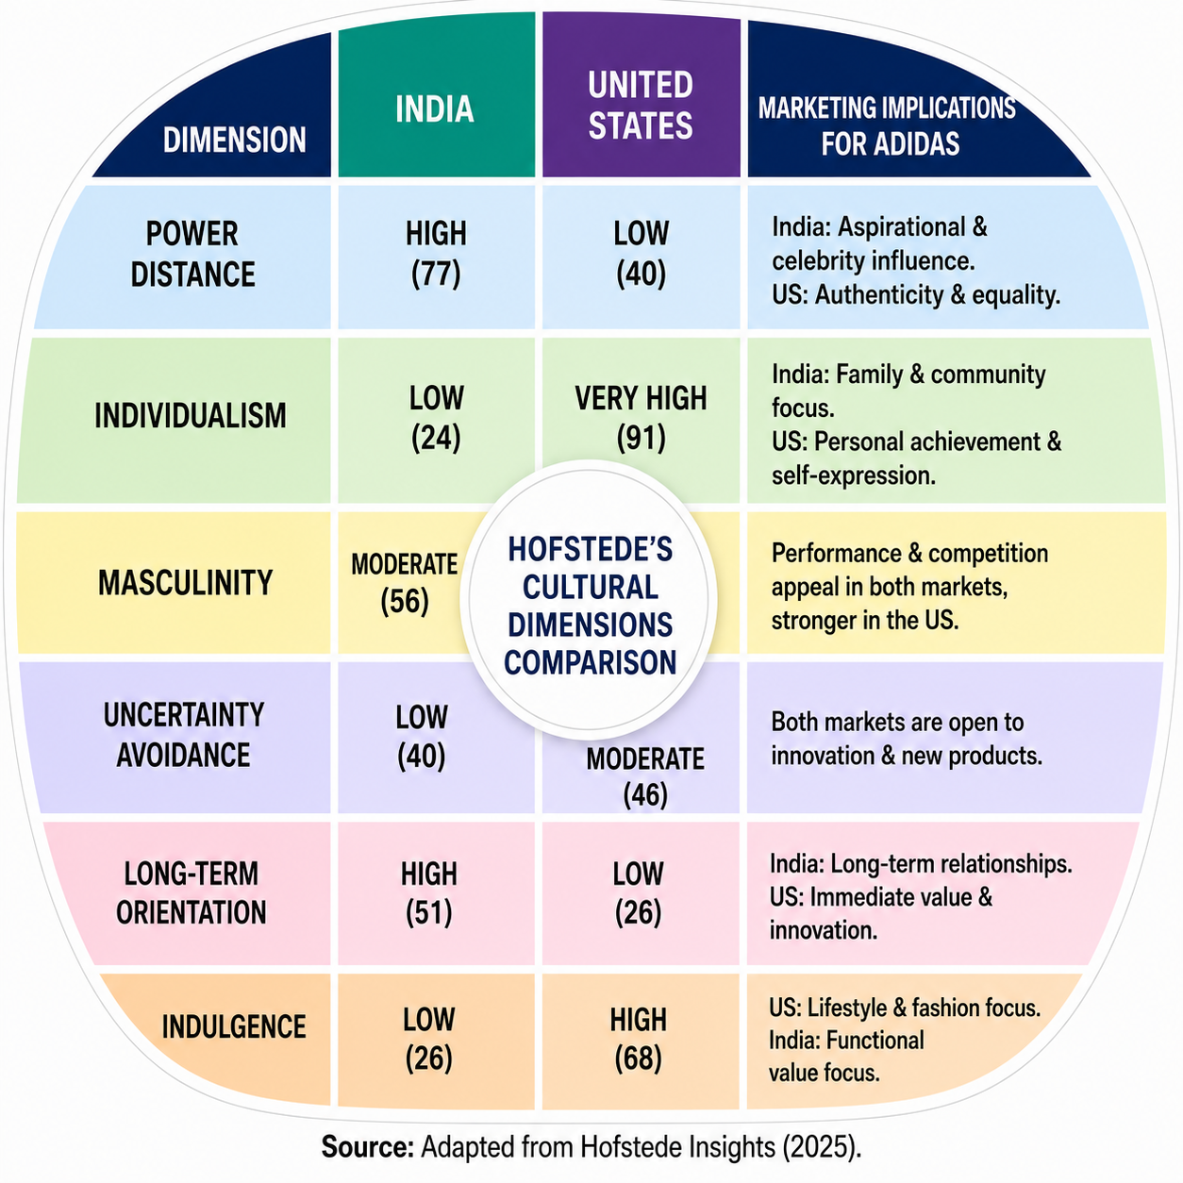
Figure 1. Hofstede's Cultural Dimensions: India vs United States.
Source: Adapted from Hofstede Insights (2025).
The cultural comparison revealed that Adidas is not able to market its products in a standardised way in both markets. In India, the strong power distance and collectivist values foster the importance of celebrity endorsements, cricket sponsorships, and community initiatives, enabling Adidas to build deeper customer connections and enhance its market presence (Gashi, 2025). However, if local campaigns significantly differ from Adidas' global image, there could be less global brand consistency.
By contrast, the United States' individualistic culture drives Adidas' focus on athlete endorsements, product innovation and exclusive partnerships, which help to further position Adidas as a premium brand and increase its brand differentiation (Kotler et al., 2024). This approach can generate competitive advantage by making customers more loyal, and ensure Adidas can charge a high price, but is a long-term process that relies on ongoing investment in marketing and innovation.
Long-term orientation and consumer spending are also different, which affects consumers' purchasing behaviour. However, American consumers are more likely to buy high-quality sportswear as a lifestyle item while many Indian consumers are more price sensitive and prefer the products to last long (Hollensen, 2022; Panagopoulos et al., 2023). To improve market penetration, while serving to global brand image, Adidas positions its products at an affordable price in India and at a premium price in other markets. This capability of maintaining a global coherence while remaining culturally sensitive locally continues to be an important strength for Adidas in terms of their international competitive advantage.

3. Comparative Analysis of Adidas' STP Strategy
Segmentation, Targeting and Positioning (STP) is a fundamental strategic marketing framework that helps the multinational companies identify attractive groups of customers, allocate resources effectively and set a competitive position in the markets it serves (Kotler et al., 2024). To Adidas, the success of their international marketing strategy relies on balancing the consistency of the brand as well as the responsiveness towards the markets (Holtbrügge and Schuster, 2024).
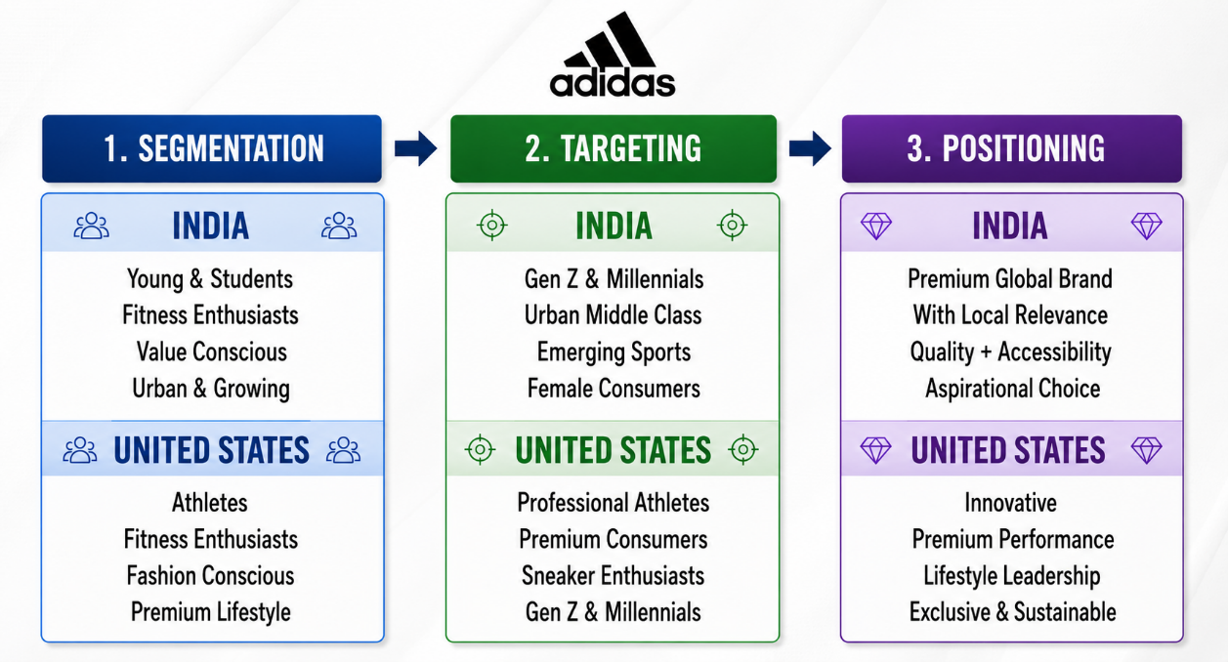
Figure 2. Adidas' STP Strategy in India and the United States.
Source: Author's illustration adapted from Kotler et al. (2024), Hollensen (2022), and Adidas (2026).

3.1 Segmentation
Adidas segments their consumers in four different segments; demographic, psychographic, behavioural and geographic to cater for the needs of consumers across international markets (Whelan, 2021). But the significance of each of the segmentation variables vary across India and United States. The growing middle-class consumer and development of sportswear industry in India gives impetus to Adidas to launch its premium and affordable product line to tap a larger market and increase its market share. In contrast, segmentations in the USA are based more on lifestyles, performance and fashion preferences due to higher purchasing power and demand for high quality sportswear (Fabbian, 2021). This flexibility allows Adidas to adapt to market conditions, keeping its brand identity intact worldwide. But India could see Adidas' premium image get compromised if the price of the products is the only consideration.

3.2 Targeting
The strategy of targeting is differentiated to the Adidas because of the difference in their need in both markets and the competitive conditions in both markets. The company’s strategy is mainly focused on affordable price ranges and digital marketing to attract Millennials, Generation Z, women and recreational sports enthusiasts in India to foster long-term consumer loyalty for the brand and ensure customer acquisition (IMF, 2025). It is a strategy designed to promote sales growth through the acquisition of new market segments. Adidas, on the other hand, caters to the professional athletes and sneaker enthusiasts and luxury consumers in the USA with innovative products, exclusive partnerships and celebrity brands, strengthening its premium brand positioning (Kotler et al., 2024). Indeed, this approach boosts profitability and sets it apart from the competition, but it also demands ongoing investment in innovation and marketing to stay competitive with global giants like Nike.

3.3 Positioning
Adidas' global brand is driven by innovation, quality and sporting excellence, while the brand's value proposition is tailored to consumer expectations in various regions and countries. In India, the brand advertises and markets itself as a high-end sportswear brand that is now becoming more accessible, and also promotes cricket, fitness among the young, and campaigns related to culture, which will create a stronger emotional bond between the brand and the consumers. On the other hand, Adidas establishes itself as a high-quality performance and lifestyle brand in the United States by innovation, sustainability, and special partnerships with athletes and fashion designers (Hollensen, 2022). This local adaptation boosts the engagement and competitive edge of both customers. But too much localisation can make it hard to find consistency in brands across the world, and maintaining a premium brand in the United States would be difficult without constant innovation to stay competitive with the established brands and new direct-to-consumer players.
In the comparison it is clear that Adidas is able to maintain a brand complete and consistent around the globe while adapting to local markets. This will help in expanding the market in India and assist in premium value creation in the United States. However, as consumer needs evolve and competition grows, Adidas must continually adapt its segmentation, targeting and positioning strategies to ensure they stay competitive in the long-term (Kotler et al., 2024; Guan et al., 2023).

4. Comparative Analysis of Adidas' International Marketing Mix (7Ps)
Multinational companies can use the marketing mix to adjust their product and services to the various markets, but at the same time keeping their brand identity. Kotler et al. (2024) argue that the development of marketing decisions towards consumer needs and market conditions will give a competitive advantage through the extended 7Ps framework. While Adidas is a well-known brand worldwide, there are a number of differences when it comes to marketing mix for Indian market and the American market, due to the differences in purchasing power, consumer behaviour and retail development.
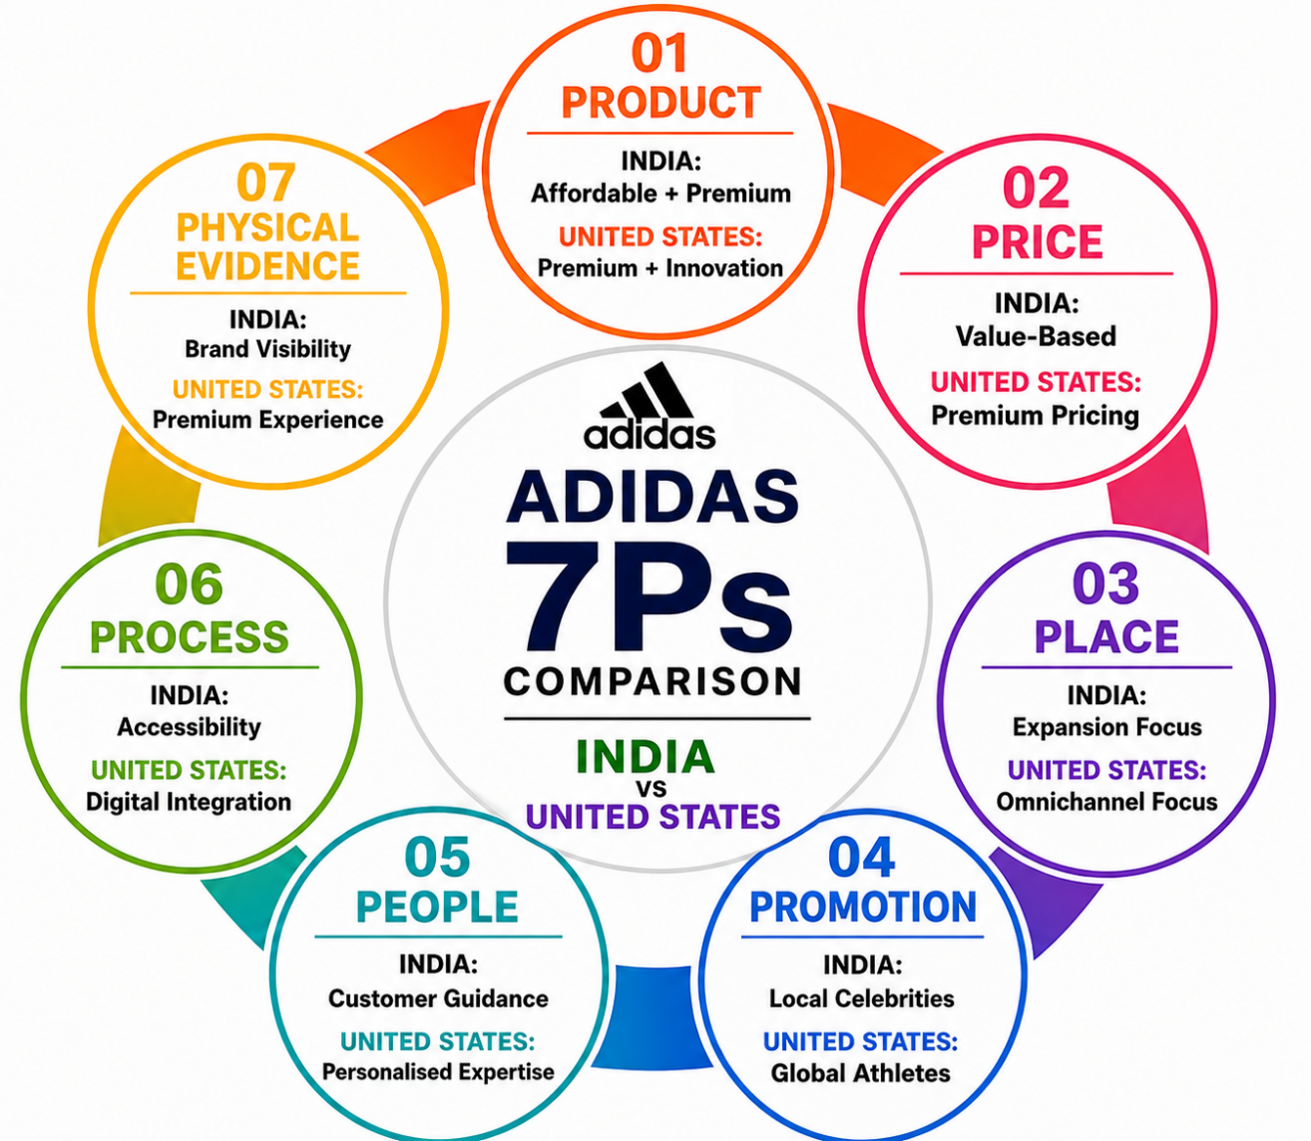
Figure 3. Adidas' International Marketing Mix (7Ps): India vs United States.
Source: Adapted from Kotler et al. (2024), Hollensen (2022), and Adidas (2026).

4.1 Product
Adidas ensures a global uniformity of its product portfolio, focusing on innovation and quality, while localising selected products to best meet local needs. The company sells high-quality and low-cost sportswear in India owing to the wide income gap between the people, it does not need to restrict the participation of the price-sensitive consumers in the rapidly growing middle-class population. Expanding brands to lower price points, however, could dilute the appeal of the Adidas brand if being affordable becomes the primary reason to buy the product. In contrast, Americans are more interested in performance, innovation and exclusivity, which pushes Adidas to produce technologically advanced products and limited-edition collections, which are also designed with athlete and designer collaborations in mind (Adidas, 2026). This mirrors the more developed U.S. market, in which constant product innovations are critical to stay one step ahead of the competition.

4.2 Price
The prices of Adidas products vary in keeping with the distinction in purchasing power and value perception of consumers. In India, the premium pricing is linked with promotional offers and competitively priced product lines as many consumers are still price conscious even with an increase in their disposable income, thus enabling Adidas to boost market penetration without compromising on its premium positioning. However, consumers could be tempted to think that the brand is synonymous with low prices because of the frequent promotions. Adidas can afford to charge a higher price in the U.S. owing to the high disposable income as well as the strong brand loyalty, while the constant pressure of differentiating its products and creating a better brand experience means that it must continually justify higher prices.

4.3 Place
In both countries the distribution concept of Adidas is an omnichannel distribution, but the way it is applied varies according to the state of the market. Not only in India, but in other countries where the company operates, the company expands with exclusive stores, multi-brand retailers and e-commerce outlets where broad access is necessary to cater to a geographically diversified consumer base. This approach can be a good way to gain market share quickly, but it can also bring with it a lot of complexity in retail operations. On the other hand, distribution in the United States prioritizes flagship stores, direct-to-consumer and integrated digital experiences, as consumers demand convenience as well as high-quality retail experiences (Strmel, 2024). Therefore, distribution is not just a means to make products available, but also a means to strengthen the brand value.

4.4 Promotion
Adidas promotes its brand message consistently world-wide, but adjusts its promotions to the local culture to better engage consumers. In India, campaigns with cricket personalities, Bollywood celebrities and digital influencers resonate better, as local personalities are the ones who influence consumers the most. But too many local endorsements could diminish the uniformity of Adidas' international brand. By contrast, U.S. promotional campaigns focus on bringing up high-profile athletes, innovation and exclusive product launches as people think of top performance wear as an individual expression. This makes for a more effective promotional response than a level of standardisation, and more so because of cultural relevance and the ability to reinforce brand differentiation.

4.5 People
Adidas understands that the customer experience is one of the key factors that gives them a competitive edge, and adjusts employee engagement to the expectations of the local consumer. In India, it is found that when a consumer makes a purchase, he or she depends on the in-store assistance a lot and employees are expected to gain their trust and offer guidance on products, which ultimately lead to a higher level of customer satisfaction. On the other hand, consumers in the United States want knowledgeable employees, personal service, and ease of integration across the physical and digital space, which means that employees' expertise is a key component of the premium shopping experience (Hollensen, 2022). In both customer bases, consistent service levels boost customer loyalty, and ongoing investment in employee development is necessary to ensure consistently high levels of service.

4.6 Process
Adidas combines physical and digital processes to optimize the customer journey and to digitize processes based on the varying degrees of digitization. Making e-commerce more accessible and user-friendly and offering flexible payment methods can help promote digital adoption and drive market growth in India, but the level of digital infrastructure in each region can vary, impacting the uniformity of the customer experience. However, consumers in the United States are looking for personalisation, efficient fulfilment, and seamless omnichannel experiences powered by AI, prompting Adidas to focus extensive resources on digital technologies (Rainy et al., 2024). Process innovation, therefore, has the potential to improve the satisfaction levels of customers and the effectiveness of the operations but it also demands ongoing technology investment to stay competitive.

4.7 Physical Evidence
Adidas is aligning its brand image worldwide through high-end store design, eco-friendly packaging and enhanced digital integration and by customising retail settings to meet local consumer needs. While retail stores in India primarily aim to boost the brand's visibility and customer trust in a growing market, flagship stores in the U.S. offer a more immersive shopping experience, further solidifying the brand's high-end image. While it allows Adidas to adapt to various market demands, it also demands significant investment in financial resources to ensure that retail stores maintain high standards in different countries around the world, and ongoing innovation is essential to sustain the brand's value and customer engagement.

5. Market Entry Strategy
The methods of entering the market will influence the degree of control, investment risk and competitiveness in international markets. Hollensen (2022) says that at the time of choosing the mode of entry, companies need to evaluate the entry mode based on the market conditions and organisational goals. This is a sign that with strategic planning, a company can enter a new market and implement all the necessary steps to ensure sustainable growth yet still retain the brand's global consistency. This is a testament to the fact that with careful planning, a company can enter a new market and take the necessary steps to ensure sustainable growth while keeping the brand uniform throughout the world.

5.1 Adidas' Market Entry into India
Adidas came to India via a 100% subsidiary, enabling the company to exercise complete control over its business, brand and strategic direction and gain market share through a focused retail network of stores, online platforms and specific partnerships with local retailers (Adidas, 2026). This is in line with Dunning's OLI Framework, whereby direct investment is undertaken by firms with strong ownership advantages, valuable location advantages and benefits from operation internalisation (Dunning, 1988). The advantages that Adidas has with their globally recognised brand, their technology expertise and marketing expertise give them immense ownership advantages while India's consumer market and rising disposable income provide them with location advantages. The consolidation of its operations allows Adidas to safeguard its intellectual property, to ensure consistency of product quality and to have more control over the customer experience.

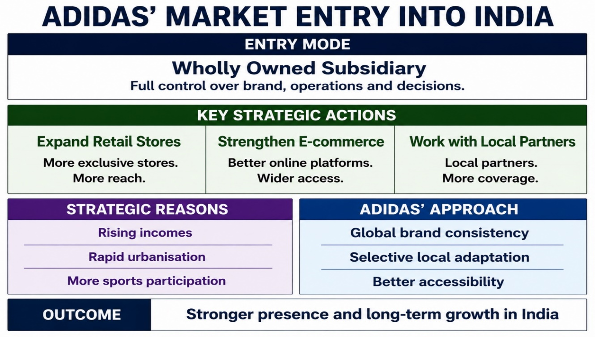
Figure 4. Adidas' Market Entry Strategy in India.
Source: Adapted from Adidas (2026), Kotler et al. (2024), and Hollensen (2022).
Exports would have had a positive effect on the investment costs and operation risk, but would have restricted Adidas' ability to react quickly to local consumers' preferences and have controlled its retail network in a fast-growing market. Likewise, licensing/franchising could have helped to grow the market faster at a lower cost but would have diminished the ability to control the positioning, brand quality, and the customer experience, raising concerns about inconsistencies in brand standards. Thus, having a wholly owned subsidiary gives more strategic control, albeit at a higher cost of investment.
The approach is also inspired by the “Uppsala Model” which suggests that companies incrementally expand their international engagement as they gain knowledge and experience of the market (Johanson and Vahlne, 1977). Adidas started its direct presence in India and slowly started to grow its retail footprint with their local partnerships and digital channels as consumer demand rose. This incremental growth helped to ease market uncertainty and enhance the competitive position in the longer term. But, keeping a 100% subsidiary entails a lot of operating costs and increased risk of market and regulatory changes. However, the level of control enables Adidas to maintain its consistent brand globally while at the same time adapting it to the local market, which makes it more appropriate to enter India as an alternative to exporting, licensing or franchising for sustainable growth in the market.

6. Ethical Issues in Adidas' International Marketing
Ethical issues in international marketing have emerged as a strategic concern given that they impact on the corporate image, consumer confidence and businesses' performance in the long run. Ethical behaviour is becoming a source of competitive advantage for multinational companies rather than a mere compliance requirement, as the expectations of customers are increasing. Kotler et al. (2024) state that consumers, especially around the world, are increasingly demanding responsible labour practices, environmental sustainability and supply chain transparency from multinational companies. As Adidas has relied heavily on independent suppliers from developing countries, it is crucial to ensure that there are ethical standards throughout the chain of suppliers to preserve its brand image and give consumers confidence in the product it is manufacturing.

6.1 Selected Ethical Issue: Supply Chain Labour Practices
Adidas has been criticised for its working practices in its global supply chain, such as low wages, working hours, and working conditions (Hollensen, 2022). The issues go beyond operational concerns with negative publicity in the form of a loss in consumer trust, a negative impact on corporate reputation, and a shift in consumer purchasing decisions, especially for those who have become more ethical and sustainable with their consumer choices. As a result, low consumer confidence can impact sales, reduce customer loyalty and result in a decline of Adidas competitive edge in the global sportswear industry.

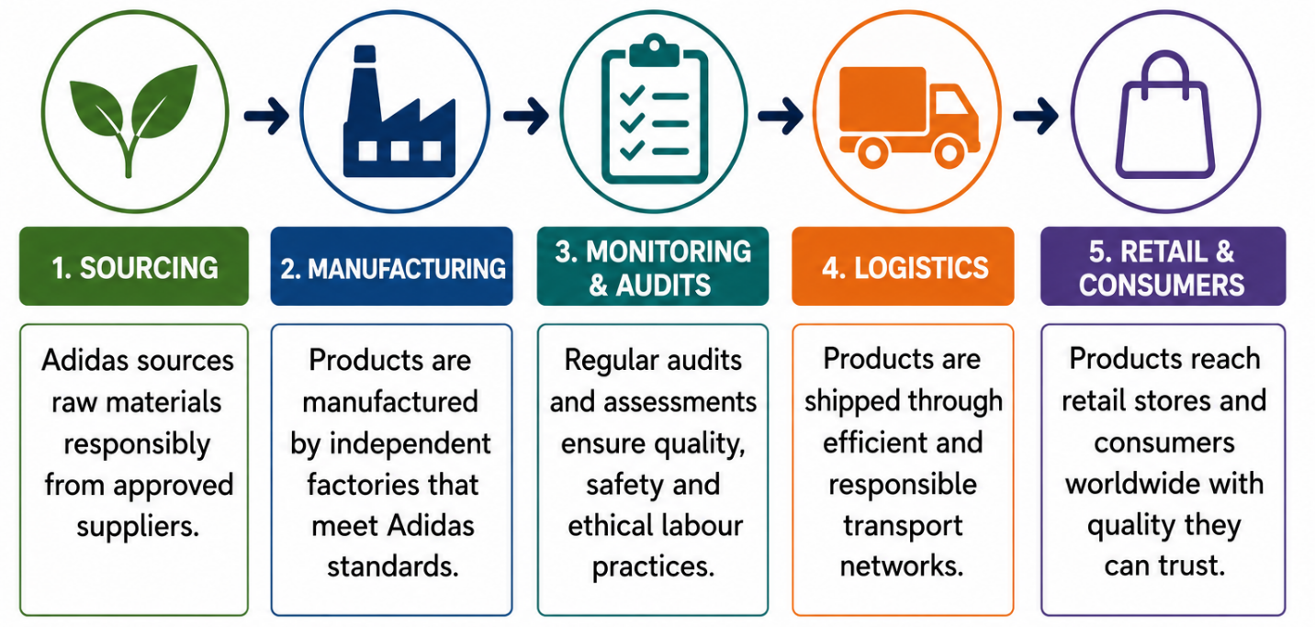
Figure 5. Adidas' Ethical Global Supply Chain Model
Source: Author’s own Illustration
To address these concerns, Adidas has enhanced its supply chain transparency by reporting on sustainability regularly (Adidas, 2026), the audits of suppliers have been reinforced and Workplace Standards have been introduced. These efforts build trust and credibility with stakeholders and reinforce brand responsibility. Achievement of labour standards, however, is difficult in a complex international supplier network due to the differences in the conditions under which suppliers work, in particular, their legal, economic and cultural environment. Therefore, it is essential to consider ethical supply chain management as an ongoing strategic investment, not merely a compliance checklist, as upholding high labour standards will benefit Adidas' reputation and long-term viability, foster customer satisfaction, and ensure sustainable competitive advantage within global markets (Kotler et al., 2024).

7. Recommendations
Adidas needs to do more to make their products and marketing campaigns localised in India and it's better that they have more sports personalities and digital influencers from India to do the promotion. This would enhance the cultural relevance, market penetration and brand loyalty without compromising its global brand. The company should also leverage AI in their digital marketing and omnichannel platforms to offer personalised suggestions and targeted promotions based on customer data. This will drive engagement, improve shopping experience, and boost long-term profitability in India and the United States (Kim and Cha, 2025). Furthermore, Adidas needs to improve ethical sourcing by conducting regular audits of suppliers, increasing transparency and continuous monitoring. These would consolidate the consumer's confidence in the company, safeguard its reputation and improve its competitive strength in the face of an increasing demand for ethically produced products (Adidas, 2026).
Last, Adidas needs to improve its customer loyalty initiatives, by leveraging customer data for customised rewards and marketing messaging. This would help to promote repeat purchases, boost customer lifetime value and sustain profitability for Adidas as a global brand, while ensuring an adaptation to local markets (Kotler et al., 2024).

Section 2: Reflection Using Gibbs' Reflective Cycle
This reflective account will be based on Gibbs' Reflective Cycle (1988) and will critically examine the learning which has been acquired from the international marketing report. The model offers a vehicle for thinking about the research process; focused learning outcomes; and ways to apply learning to future academic and professional practice.
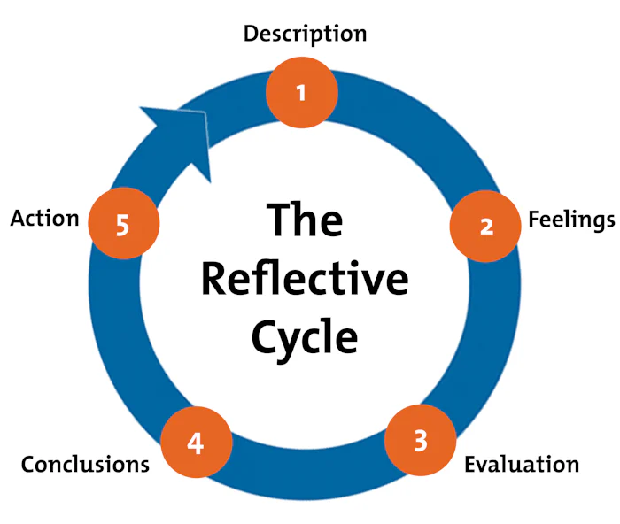
Figure 6. Gibbs' Reflective Cycle.
Source: Adapted from Graham Gibbs (1988).

9.1 Description
The report was an analysis of the Adidas marketing strategy in India and United States, as it is a comparison of Adidas' strategy in foreign country with the domestic country, so it can be termed as critical. The analysis focused on key marketing frameworks, such as PESTEL, Hofstede's Cultural Dimensions, STP, the 7Ps marketing mix, market entry strategy and ethical marketing and how Adidas' strategies are adjusted in contrasting business environments. In order to make the analysis, I combined academic sources with recent industry reports and publications of Adidas' company, making sure that the conclusions were based on evidence.

9.2 Feelings
It was difficult at the beginning to bring together various theories and mix them in a single analysis and still be critical. Careful judgement and thorough research were needed to distinguish between critical evaluation and description, and also to pick out reliable evidence that was current. However, as the report developed, I realised that I felt more confident at the synthesis of theory and practical evidence in business. The comparative analysis helped me better understand that consistent global marketing is balanced with market adaptation is a key to successful international marketing (Rubeiz, 2025). All in all, I was reinforced in the process of research to have a critical thinking, analytical writing and evaluating of international marketing decisions based on academic theory and real-world evidence.

9.3 Evaluation
The quality of the report was the incorporation of the academic theories and the existing findings from the industry, thereby making the analysis more credible. It was also possible to make comparisons between two contrasting markets; thereby a more thorough assessment of the influence of economic and cultural differences on international marketing decisions could be made. But it was difficult to be critical enough in all parts as a consequence of the limited word count for analysing more than one framework. Furthermore, getting timely and accurate market data was a big challenge, as they had to assess and select the appropriate sources.

9.4 Analysis
It showed that international marketing strategies cannot be standardized on all countries since organisations have to react to the various political, economic, social, technological and cultural conditions. When using PESTEL and Hofstede's Cultural Dimensions, it was found that these factors have an impact on marketing decision-making (Hollensen, 2022; Kotler et al., 2024). The study of Adidas showed that it is imperative to strike a balance between maintaining a global brand image and catering to local market requirements and preferences for competitive advantage. My first thought was that it was only through standardisation that one would succeed and this proved to be wrong and strategic flexibility was highlighted. The assignment also helped develop my critical appraisal of academic and industry evidence, which enhanced my research, analytical and decision-making skills. I have developed a better understanding of international marketing through these experiences and will benefit my future studies and career.

9.5 Conclusion
The reflection revealed that creating a good international marketing report is not an issue of simply copying theories into practice. This demands critical analysis, the assessment of academic and industry evidence and the capacity to substantiate marketing decisions in various markets. The assignment helped me to understand the balance between global consistency and local adaptations within the context of a multinational organisation. It also helped to build my knowledge on international marketing and improve my research, analytical and academic writing skills, all of which will benefit my academic studies and future career.

9.6 Action Plan
In order to enhance my future academic work, I will start researching earlier, to have time to analyse and integrate academic and industry sources. I will build up my critical analysis by taking into account other points of view, backing arguments with more than description, and fully developing them. I will also seek to enhance my knowledge of international marketing through a wider range of international multi-national organisations from different industries. Last but not least, I'll keep working to enhance my academic writing skills by developing my ability to effectively synthesize literature and to appropriately use the Harvard referencing system and apply theory to practice. These will improve my academic performance and equip me with skills required for a career in international business and marketing.

References
Adidas AG (2026) Annual Report 2025. Herzogenaurach: Adidas AG. Available at: https://report.adidas-group.com/2025/en/ (Accessed: 20 July 2026).
Ayub, F. (2025) 'Key trends in the market entry strategies of the USA footwear MNEs, encompassing brand localization, digital engagement and dynamic capabilities', Research Journal for Social Affairs, 3(5), pp. 423–456.
Barbosa, D.L.T. (2022) Adapting to the New Sporting Goods Market Era: Adidas Differentiation in Digital Retail. Master's dissertation. Universidade NOVA de Lisboa, Portugal.
Chiu, W.H., Shih, Y.S., Chu, L.S. and Chen, S.L. (2022) 'Merger and acquisitions integration, implementation as innovative approach toward sustainable competitive advantage: A case analysis from Chinese sports brands', Frontiers in Psychology, 13, p. 869836.
Dunning, J.H. (1988) 'The eclectic paradigm of international production: A restatement and some possible extensions', Journal of International Business Studies, 19(1), pp. 1–31.
Fabbian, S. (2021) Global Brands Connect with the Local Culture: Advertising Strategies of Coca-Cola in China. Master's dissertation. Ca' Foscari University of Venice. Available at: https://unitesi.unive.it/handle/20.500.14247/8066 (Accessed: 20 July 2026).
Gashi, A. (2025) 'Sports marketing strategies: Navigating the intersection of globalization and internationalization', Interdisciplinary Journal of Research and Development, 12(1), pp. 190–190.
Gibbs, G. (1988) Learning by Doing: A Guide to Teaching and Learning Methods. Oxford: Further Education Unit, Oxford Polytechnic. Available at: https://thoughtsmostlyaboutlearning.files.wordpress.com/2015/12/learning-by-doing-graham-gibbs.pdf (Accessed: 20 July 2026).
Government of India (2025) National Portal of India. Available at: https://www.india.gov.in/ (Accessed: 20 July 2026).
Guan, L., Chakrabortty, R.K., Abbasi, A. and Merigó, J.M. (2023) 'An Intelligent Decision Support System for Defence Supply Chain Risk Management', in Proceedings of the 20th ANZAM Operations, Supply Chain and Services Management Symposium. September 2023.
Hofstede Insights (2025) Country Comparison Tool. Available at: https://www.hofstede-insights.com/country-comparison/ (Accessed: 20 July 2026).
Hofstede, G. (2011) 'Dimensionalizing cultures: The Hofstede model in context', Online Readings in Psychology and Culture, 2(1), Article 8. Available at: https://scholarworks.gvsu.edu/orpc/vol2/iss1/8/ (Accessed: 20 July 2026).
Hollensen, S. (2022) Global Marketing. 8th edn. Harlow: Pearson. Available at: https://www.pearson.com/en-gb/subject-catalog/p/global-marketing/P200000003529/9781292443250 (Accessed: 20 July 2026).
Holtbrügge, D. and Schuster, T. (2024) 'The internationalization strategy of Adidas', in The Internationalization of Firms. Baden-Baden: Nomos Verlagsgesellschaft mbH & Co. KG, pp. 21–44.
IMF (2025) World Economic Outlook: A Critical Juncture amid Policy Shifts. Washington, DC: International Monetary Fund. Available at: https://www.imf.org/en/Publications/WEO/Issues/2025/04/22/world-economic-outlook-april-2025 (Accessed: 20 July 2026).
Johanson, J. and Vahlne, J.E. (1977) 'The internationalization process of the firm: A model of knowledge development and increasing foreign market commitments', Journal of International Business Studies, 8(1), pp. 23–32.
Kim, D.J. and Cha, S.S. (2025) 'Digital transformation in retail: A systematic review on omnichannel, AI, and big data', Journal of Distribution Science, 23(6), pp. 111–124.
Kotler, P., Armstrong, G. and Balasubramanian, S. (2024) Principles of Marketing. 19th Global edn. Harlow: Pearson. Available at: https://www.pearson.com/en-gb/subject-catalog/p/principles-of-marketing/P200000010788 (Accessed: 20 July 2026).
Panagopoulos, N.G., Menguc, B. and Mullins, R. (2023) 'Will you speak up for me? Inducing retail store managers' engagement with MNCs' brands across cultures', Journal of International Business Studies, 54(7), pp. 1222–1255.
Rainy, T.A., Rahman, M.A. and Mou, A.J. (2024) 'Customer relationship management and data-driven decision-making in modern enterprises: A systematic literature review', American Journal of Advanced Technology and Engineering Solutions, 4(4), pp. 57–82.
Rubeiz, R. (2025) Global Sports Brands in Lebanon: A Comparative Analysis of Consumer Behavior and Perceptions among Sports and Non-Sports University Students. Doctoral dissertation. Université de Bordeaux.
Schmidt-Devlin, E., Özsomer, A. and Newmeyer, C.E. (2022) 'How to go glocal: Omni-brand orientation framework', Journal of International Marketing, 30(4), pp. 1–20.
Sengupta, M. and Sengupta, N. (2019) 'Journey towards sustainability in fitness fashion: The Adidas way', Shri Dharmasthala Manjunatheshwara Research Centre for Management Studies, 8, pp. 117–152.
Strmel, M.S. (2024) Innovative Retail: A Framework for the Future of Brick-and-Mortar Retail in an Omnichannel Market.
Whelan, B. (2021) The Influences of Brand Personality, Culture, and Social Media on Iconic Brand Preferences. Doctoral dissertation. The University of North Carolina at Charlotte.

