

BSc (Hons) Health and Social Care (BMHP5015_BIRM)

Changemakers: Building Your Personal Brand for
Sustainable Employment

Component 1: Portfolio

Parese Ahmed

Thara Bi (2243859)

18th November 2025
Contents
Task 1: 3
Introduction 3
Body 3
Conclusion 3
Task 2: Network map 4
Rational 4
Task 3: Blog 5
Introduction 5
Main body 5
Conclusion 6
Task 4: Equality and Diversity Quiz 7
Task 5 9
A Letter to My Younger Self 9
Task 6: Gantt Chart 10
Task 7 13
Making Changes - report 13
Introduction 13
Planning the Change 13
Skills Required 13
Barriers and Solutions 13
Conclusion 14
Task 8: Self-Reflection 14
Description 14
Feelings: 14
Evaluation: 14
Analysis 14
Conclusion 15
Action Plan: 15
References: 16

Task 1:

Introduction
People use personal branding to promote themselves by emphasising special traits, values, and abilities. As an inspirational occupational therapist (OT), I can establish credibility, win over clients, and stand out in a crowded profession (Yakup and Sevil, 2011). However, an authentic personal brand must also reflect professional ethics and evidence-based practice, not only self-promotion (Shepherd, 2005).

Body
My present personal brand embodies traits that will be helpful in my future work as an OT, such as empathy, perseverance, and effective communication. These qualities enable me to relate to people, maintain my composure, and demonstrate compassion. However, I am aware of my shortcomings, which include developing my human capital (Halder, 2018) through expanding my professional network, acquiring real-world experience, and enhancing my confidence in my clinical knowledge. Additionally, to enhance my personal brand, I intend to volunteer, seek work placements, and pursue ongoing education. According to the DHSC (2022), employers in the health and social care sectors place a high value on flexibility, collaboration, and a commitment to learning. Aligning values and abilities with professional standards enhances personal branding (Yakup and Sevil, 2011). Furthermore, through these actions, I will exhibit professionalism, improve my employability, and move one step closer to achieving my OT career goal (Babiker, 2014).

Conclusion
Developing my personal brand through experience, skill development, and professional identity building will help me become more employable, leave an impression on prospective employers, and move steadily closer to my OT career goal (Shepherd, 2005). Additionally, continuous reflection and evidence-based self-promotion will ensure that my brand remains credible and aligned with person-centred practice.

Task 2: Network map
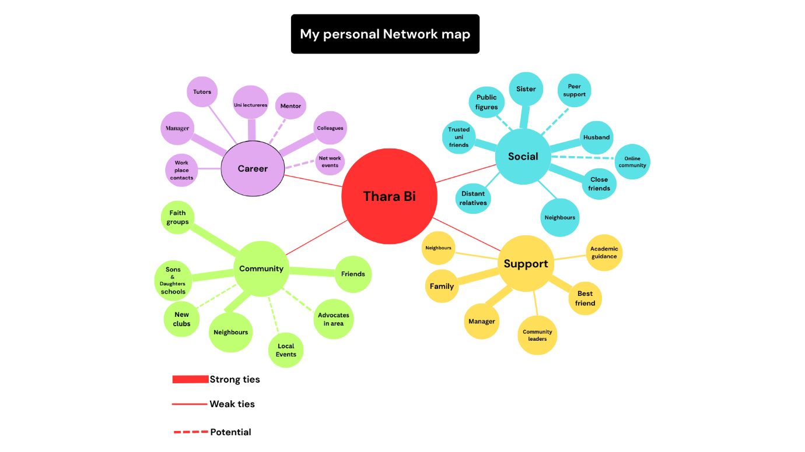

Rational
Networking involves individuals, services, or organisations collaborating to promote health and well-being (Health Foundation, 2013). A hybrid network type, which includes strong bonding social capital (family, close friends, manager, dependable university classmates), underdeveloped connecting capital, and selective bridging relationships, reflects my current network. According to Shin (2021), bonding social capital promotes emotional stability and daily support. However, bridging and linking ties that traverse social circles or connect to people in power are underrepresented in my social, professional, and community spheres.
Specifically, I have weak and promising relationships with public personalities, community leaders, networking event contacts, and mentors. According to Comfort (2024), these are essential for bridging social capital, which facilitates new possibilities and knowledge. In my network, it is much harder to link social capital or connect with organisations or people in authority. Lack of strong linking may limit access to resources that advance one's career (Kirkbride et al., 2024).
To strengthen this, I plan to adopt a more strategic approach, joining professional bodies such as the Royal College of Occupational Therapists (RCOT) and engaging in sector webinars to enhance visibility and credibility (RCOT, 2021). Building relationships across disciplines encourages innovation and reflective learning (Borrill et al., 2020)
Additionally, I need to build more connecting and bridging relationships to improve social capital. This entails attending networking events, seeking mentors, engaging with leaders in public and organisational spheres, and becoming more involved in larger communities (Wittwer, 2023).
Furthermore, by improving emotional support (bonding), strengthening these connections should balance my network by providing access to fresh information, resources, and influence (bridging & linking).


Task 3: Blog
Caring for the Carers:
Supporting Mental Health Among Healthcare Workers

(stock image)

Target Group: The wider public and policymakers - to build understanding and foster commitment to supporting frontline workers.

Introduction
The NHS and social care system depend on their workforce, yet these professionals face mounting exhaustion and stress. Their mental well-being has suffered due to extended hours, staff shortages, and roles that require emotional investment (NHS Employers, 2024). Additionally, prioritising caregivers' psychological well-being is vital to maintaining a resilient and empathetic healthcare system.


Main body
This ongoing strain results in tangible human and organisational damage. These alarming burnout levels are a major factor in the current wave of skilled staff leaving the health service, creating a harmful spiral. Departing employees increase pressure on those remaining, worsening the burnout epidemic. Moreover, an overburdened and inadequately supported workforce cannot maintain safe, effective care, threatening both worker health and patient welfare.
(National Health Executive, 2025)
However, data from the 2024 NHS Annual Survey indicated that 41.6% of staff members reported becoming ill due to work-induced stress (NHS Employers, 2024). Furthermore, 30% report experiencing workplace burnout (NHS Employers, 2024). Nash (2025) argues that tackling burnout requires systemic change, embedding compassionate leadership and adequate staffing, not isolated wellbeing initiatives.
To confront these issues, workplaces can introduce confidential therapeutic support, wellness champions, and colleague assistance programs. Moreover, establishing emotionally safe spaces permits workers to address mental health concerns transparently without facing judgment. Evidence confirms that these strategies improve staff wellbeing, increase retention, and enhance overall service delivery (NICE, 2022). Furthermore, actively engaged staff are associated with lower patient death rates, fewer staff illnesses, and fewer complaints (NHS England, no date).

Conclusion
Those in healthcare give their lives to patient care. Now the system must invest in caring for them. Mental health support for staff benefits employees, raises care quality, and sustains the NHS workforce. All carers should feel valued, supported, and given a voice.

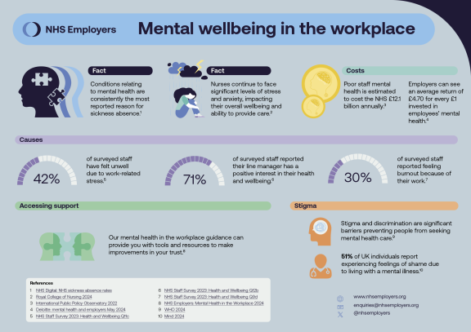

Vital statistics showing employee mental health in the NHS
(NHS Employers, 2024)

Task 4: Equality and Diversity Quiz

- What is the primary goal of the NHS Equality, Diversity, and Inclusion Improvement Plan?
To enhance staff members' sense of belonging and promote equality, diversity, and inclusion throughout the NHS workforce, improving patient care (NHS England, 2023). This goal reflects a broader commitment to inclusive leadership and fair opportunity across all levels of the organisation.

- How does the NHS EDI Improvement Plan propose to tackle the gender pay gap?
By mandating that organisations create and execute a pay-gap reduction strategy addressing gender (as well as race and disability), incorporating measures such as robust flexible-working policies and promoting flexible arrangements in job advertisements, with annual decreases in pay gaps serving as the performance indicator (NHS England, 2023).

- What is meant by the term ‘intersectionality’ as used in the NHS EDI Improvement Plan?
It acknowledges that individuals possess multiple, interconnected identities and that forms of disadvantage can accumulate; therefore, interventions must extend beyond addressing a single protected characteristic and tackle these overlapping impacts (Anwar, 2022). This ensures that equality strategies recognise complex lived experiences rather than relying on one-dimensional policy responses.

- Why is it important for the NHS to create a psychologically safe work environment?
Harassment and bullying behaviours weaken psychological safety, which inhibits people from speaking out and acknowledging errors, negatively impacting teamwork. Thus, building safe environments is essential for employee well-being and better performance (NHS England, 2023).

- How does the NHS EDI Improvement Plan suggest improving the experience of internationally recruited staff?
By implementing a comprehensive onboarding and induction process for newly recruited overseas employees, while tracking progress through training-quality indicators and staff surveys (NHS England, 2023). Cultural-awareness sessions and mentoring are also promoted to strengthen integration and retention.

- What role does leadership play in advancing EDI objectives according to the NHS Improvement Plan?

Leadership, including chairs, chief executives and boards, must define concrete, measurable EDI targets, model expected behaviours, and accept personal and shared accountability for implementation (NHS England, 2023).

- Identify one way the NHS EDI Improvement Plan aims to reduce health inequalities within the workforce.

Through the reduction of bullying, enhancement of civility, and implementation of strong measures against abuse and harassment, tackling shared factors that lead to poor health, absenteeism, and turnover rates that are not evenly distributed across demographics (NHS England, 2023).

- Why does the NHS EDI Improvement Plan emphasise the importance of collecting and analysing data on protected characteristics?

Consistent, reliable, and timely data provides the basis for targeted measures and monitoring; creating a national dashboard and enhancing protected-characteristic datasets are fundamental to tracking developments (NHS England, 2023).

- Explain how flexible working policies can contribute to equality and inclusion in the NHS workforce.

Successful flexible-working arrangements, clearly promoted during recruitment, facilitate participation and career advancement (e.g., for carers and parents), and serve as a specific mechanism for narrowing gender, race, and disability pay gaps (NHS England, 2023).

- What is one strategy mentioned in the NHS EDI Improvement Plan to combat bullying and harassment in the workplace?

In addition to removing the circumstances that allow bullying and harassment, reviewing the disciplinary and employee relations procedures to guarantee fair, compassionate treatment and taking prompt action when data indicates inconsistencies (NHS England, 2023). This also reinforces a culture of trust, civility, and accountability at every level of practice.

Task 5

A Letter to My Younger Self

To My Former Self,
I recall how stressed and overburdened you were that first year at university. You were constantly juggling academic work, a part-time job, and family responsibilities. You aimed to impress everyone, but this pressure led to exhaustion and disconnection. You rarely paused to assess your emotions, and your well-being suffered.
This module taught me the value of emotional intelligence in recognising my own and others' emotions (Luna et al., 2021). Had you stepped back and acknowledged your stress rather than hiding it, you might have sought help earlier. Being self-aware and empathetic would have shown you that struggling is human, not weakness. According to Brackett and Elbertson (2019), emotional intelligence involves recognising and regulating emotions. Expressing your concerns to family or tutors could have brought the support you needed.
I have also learned that resilience is key to well-being. A UK study by Abulfaraj et al (2024) shows that interventions like mindfulness and reflection can ease stress and anxiety in students. Resilience can be built gradually. Moreover, developing resilience also requires adopting a growth mindset, viewing setbacks as opportunities for learning rather than failure (North, 2023).

The most important thing I wish you would understand is that asking for help is not fragility, it is wisdom. Every challenge you faced helped shape your strength and self-compassion.
Sincerely,
Your Future Self

Task 6: Gantt Chart

Invented by Henry Gantt around 1910. A Gantt chart is a project management tool used in agile environments to structure and track how various tasks and activities advance during a project. It shows the start and end dates of each task, important milestones, task dependencies, and team members assigned to it on a graphic timeline (APM, 2025). In the context of my career planning, it allows me to visualise goals, manage competing priorities and remain accountable for progress.
Timeline table:
Task | Start Date | End Date | Timeframe | Requirements (if any)
Finish all Level 5 assessments | Jan 2025 | Dec 2025 | 12 months | None
Engage in relevant educational workshops | Jan 2026 | Dec 2026 | 12 months | None
Finish all Level 6 assessments | Jan 2026 | Dec 2026 | 12 months | Level 5 assignments achieved
Obtain hands-on work experience (during Level 6) | Jan 2026 | Sep 2026 | 9 months | Level 6 academic work in process
Build a formal CV and accompanying cover letter | Nov 2026 | Nov 2026 | 1 month | Work experience concluded
Prepare & Submit MSc MHOT Applications | Oct 2026 | Nov 2026 | 2 months | Level 6 Coursework + Work Experience
Attend Interviews for MSc MHOT | Dec 2026 | Dec 2026 | 1 month | MSc Applications Submitted
Complete a master’s in Mental Health Occupational Therapy | Jan 2027 | Dec 2027 | 12 months | Successful Offer & Enrolment
Apply for Occupational Therapist Roles | Jan 2028 | Feb 2028 | 2 months | Master's Completed
Secure and Start Role (Band 5 MHOT) | Mar 2028 | Mar 2028 | 6 Months | Successful Interviews/Pre-employment Checks

Gantt Chart - Mental Health Occupational Therapy Pathway
Timeline: Jan 2025 → Mar 2028

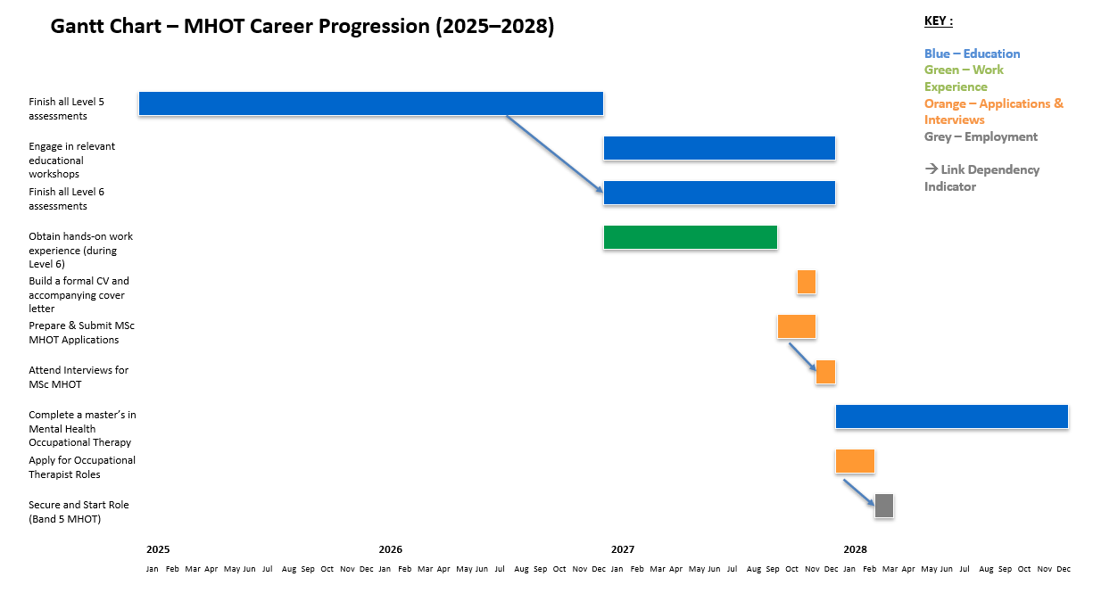

Task 7

Making Changes - report

Introduction
This proposal details implementing an electronic care platform in a residential facility housing forty elderly residents. This change aims to replace manual record-keeping with electronic systems, boosting the reliability, accessibility, and operational efficiency of care documentation for residents. Digital transformation is increasingly recognised as central to person-centred, safe, and sustainable care (DHSC,2022).

Planning the Change
Kotter's 8-Step Model (2012) will serve as the implementation framework, providing a structured pathway for change management through urgency establishment, coalition development, and integration of new approaches. A sense of urgency will be established by emphasising mistakes in record-keeping and inefficient use of staff time. A coalition of senior staff members and IT support will guide the change. Meetings and training programmes will be used to communicate the vision of improved resident care quality. Moreover, the system will be championed by early adopters, who will celebrate quick wins. Embedding the change will occur over three months via sustained support and incorporation into standard operating procedures. Additionally, the change will also require continuous evaluation and reflection to consolidate learning

Skills Required
Crucial managerial skills include the ability to communicate benefits, leadership qualities to generate engagement, and technological literacy to support and guide employees. Managing resistance will involve conflict resolution skills, whilst strategic time planning will ensure training activities do not disrupt routine work (SfC, 2024).

Barriers and Solutions
- Employee resistance: Senior staff may fear technology.
Solution: Assist peers and offer specialised training (HEE, 2024).
- Time constraints: Training reduces staffing.
Solution: Provide cover and stagger sessions.
- Insufficient funding: Device and software expenses.
Solution: Seek NHS Digital funding and phase rollout (CQC, 2020).
- Technical difficulties: system malfunctions.
Solution: Maintain paper backups and guarantee IT assistance.

Conclusion
Electronic systems will improve documentation accuracy and time efficiency. Furthermore, this change can significantly enhance care home operations and improve resident outcomes when supported by structured planning. Long-term success will depend on embedding digital competence into everyday culture and evaluating its impact on both staff satisfaction and quality of care.

Task 8: Self-Reflection

This module has provided a strong foundation for career planning and professional development, with a focus on my professional brand, supporting my goal of becoming a Mental Health Occupational Therapist. Reflecting through Gibbs’ Reflective Cycle (Gibbs,1988) has helped me consolidate my learning, deepen my self-awareness, and identify future actions. According to Gibbs (1988), reflection transforms experience into learning.
Description: A key moment was creating a Gantt chart (Task 6) to map my career pathway from completing coursework to securing a Band 5 MHOT role. This required realistic goal setting, identifying dependencies, and planning for challenges.
Feelings: Initially, I felt overwhelmed by the long-term nature of my goals. Breaking the process into manageable steps helped me feel more confident, focused, and excited about future opportunities.
Evaluation: I developed a clear and achievable career plan. However, I recognised the need to remain flexible and continually develop my skills to stay competitive and responsive to change.
Analysis: This task was valuable because it gave me a structured roadmap and highlighted the importance of strategic planning. Moreover, it reinforced the need to be proactive, adaptable, and reflective in managing my career path. Analysing my progress against Gibbs’ (1988) stages also showed that feedback and peer discussion enhance deeper learning.
Conclusion: I could have improved my plan by seeking feedback from professionals to ensure alignment with industry expectations. I also realised the importance of networking to gain insights, mentorship, and opportunities.
Action Plan: I will regularly review my career plan, engage in networking, and pursue continuing education to enhance my skills. By actively managing my development and staying open to learning, I am confident in achieving my goal of becoming a Mental Health Occupational Therapist. Ongoing reflection will ensure my professional identity evolves with sector standards and patient-care priorities.

References:

Abulfaraj, G.G., Upsher, R., Helena and Dommett, E.J. (2024) ‘The Impact of Resilience Interventions on University Students’ Mental Health and Well-Being: A Systematic Review’, Education sciences, 14(5), pp.510–510. doi:https://doi.org/10.3390/educsci14050510.
Anwar, S. (2022) Understanding intersectionality for diverse engagement | NHS Employers. Available at: https://www.nhsemployers.org/articles/understanding-intersectionality-diverse-engagement (Accessed: 11 October 2025).
Association for Project Management (2024) What is a Gantt chart? Available at: https://www.apm.org.uk/resources/find-a-resource/gantt-chart/ (Accessed: 17 October 2025).
Babiker, A. (2014) ‘Health Care Professional development: Working as a Team to Improve Patient Care’, Sudanese Journal of Paediatrics, 14(2), pp.9–16. Available at: https://pmc.ncbi.nlm.nih.gov/articles/PMC4949805/.
Borrill, C., West, M. and Dawson, J. (2020) Team working and effectiveness in health care. Journal of Health Organization and Management, 34(7), pp. 807–820.
Brackett, M. and Elbertson, N. (2019) ‘Emotional Intelligence’, Character Lab Playbook. doi:https://doi.org/10.53776/playbooks-emotional-intelligence.
Care Quality Commission (2024) Regulations for service providers and managers. Available at: https://www.cqc.org.uk/guidance-regulation/providers/regulations-service-providers-and-managers (Accessed: 13 October 2025).
Comfort, C. (2024) ‘Mentoring, social capital and young people’, International Journal of Evidence Based Coaching and Mentoring, 22(2), pp. 38-52
Department of Health and Social Care (2022) Leadership for a collaborative and inclusive future. Available at: https://www.gov.uk/government/publications/health-and-social-care-review-leadership-for-a-collaborative-and-inclusive-future/leadership-for-a-collaborative-and-inclusive-future (Accessed: 14 October 2025).
Department of Health and Social Care (2022) A Plan for Digital Health and Social Care. Available at: https://www.gov.uk/government/publications/a-plan-for-digital-health-and-social-care/a-plan-for-digital-health-and-social-care (Accessed: 13 October 2025).
Gibbs, G. (1988) Learning by Doing: A Guide to Teaching and Learning Methods. Oxford: Oxford Polytechnic.
Halder, N. (2018) ‘Investing in human capital: exploring causes, consequences and solutions to nurses’ dissatisfaction’, Journal of Research in Nursing, 23(8), pp.659–675. doi:https://doi.org/10.1177/1744987118807251.
Health Education England (2024) Future digital workforce. Available at: https://www.hee.nhs.uk/our-work/future-digital-workforce (Accessed: 13 October 2024).
Health Foundation (2013) Leading networks in healthcare. Available at: https://www.health.org.uk/sites/default/files/LeadingNetworksInHealthcare.pdf (Accessed: 26 September 2025).
Kirkbride, J.B., Anglin, D.M., Colman, I., Dykxhoorn, J., Jones, P.B., Patalay, P., Pitman, A., Soneson, E., Steare, T., Wright, T. and Griffiths, S.L. (2024) ‘The social determinants of mental health and disorder: Evidence, prevention and recommendations’, World Psychiatry: Official Journal of the World Psychiatric Association (WPA), 23(1), pp.58–90. doi:https://doi.org/10.1002/wps.21160.
Kotter, J.P. (2012) Leading change. Boston: Harvard Business Review Press.
Luna, L.M.B., Vilar, M.M., Soto, C.M. and Santiago, J.L.C. (2021) ‘Emotional Intelligence Measures: a Systematic Review’, Healthcare, 9(12). doi:https://doi.org/10.3390/healthcare9121696.
Nash, S. (2025) From Burnout to Belief: Reflections on Reforming the NHS from Within. Available at: https://www.kingsfund.org.uk/insight-and-analysis/long-reads/burnout-belief-reforming-the-nhs (Accessed: 9 October 2025).
National Health Executive (2025) NHS Staff Fatigue: A Critical Risk to Patient Safety. Available at: https://www.nationalhealthexecutive.com/articles/nhs-staff-fatigue-critical-risk-patient-safety.
National Institute for Health and Care Excellence (2022) Mental wellbeing at work. Available at: https://www.nice.org.uk/guidance/ng212/chapter/Recommendations (Accessed: 9 October 2025).
NHS Employers (2024) Mental wellbeing in the workplace infographic. Available at: https://www.nhsemployers.org/articles/mental-wellbeing-workplace-infographic (Accessed: 9 October 2025).
NHS Employers (2024) Supporting our NHS people experiencing stress. Available at: https://www.nhsemployers.org/articles/supporting-our-nhs-people-experiencing-stress (Accessed: 9 October 2025).
NHS England (2023) NHS equality, diversity, and inclusion improvement plan. Available at: https://www.england.nhs.uk/long-read/nhs-equality-diversity-and-inclusion-improvement-plan/ (Accessed: 11 October 2025).
NHS England (no date) Friends and Family Test (FFT) and National Quality PROMs Programme (NQPS). Available at: https://www.england.nhs.uk/fft/nqps/ (Accessed: 9 October 2025).
North, J. (2023). Growth Mindset: Develop the Confidence to Succeed. Available at: https://bigbangpartnership.co.uk/growth-mindset/ (Accessed: 11 October 2025).
Royal College of Occupational Therapists (RCOT) (2021) Professional Standards for Practice, Conduct and Ethics. Available at: https://www.rcot.co.uk/explore-resources/standards-guidelines/professional-standards-conduct-ethics (Accessed: 13 October 2025).
Shepherd, I.D.H. (2005) ‘From Cattle and Coke to Charlie: Meeting the Challenge of Self-Marketing and Personal Branding’, Journal of Marketing Management, 21(5–6), pp.589–606.
Shin, B. (2021) ‘Exploring Network Measures of Social Capital: Toward More Relational Measurement’, Journal of Planning Literature, 36(3), p.088541222199941. doi:https://doi.org/10.1177/0885412221999415.
Skills for Care (2024) Skills for Care launches two-month campaign focused on developing 'everyday leaders'. Available at: https://www.skillsforcare.org.uk/news-and-events/news/skills-for-care-launches-two-month-campaign-focused-on-developing-everyday-leaders (Accessed: 13 October 2025).
Wittwer, J. (2023) 3 Different Types of Social Capital: Bridging, Bonding, & Linking. Available at: https://successacrosscultures.com/2023/02/24/3-different-types-of-social-capital-bridging-bonding-linking/ (Accessed: 25 September 2025).
Yakup, D. and Sevil, Z. (2011) ‘Teoratical Aproach to the Concept of Brand’, Contemporary Marketing Review, 1(3), pp. 1–5.

