Awe and Wonder:
An exploration into nutrition in the wild
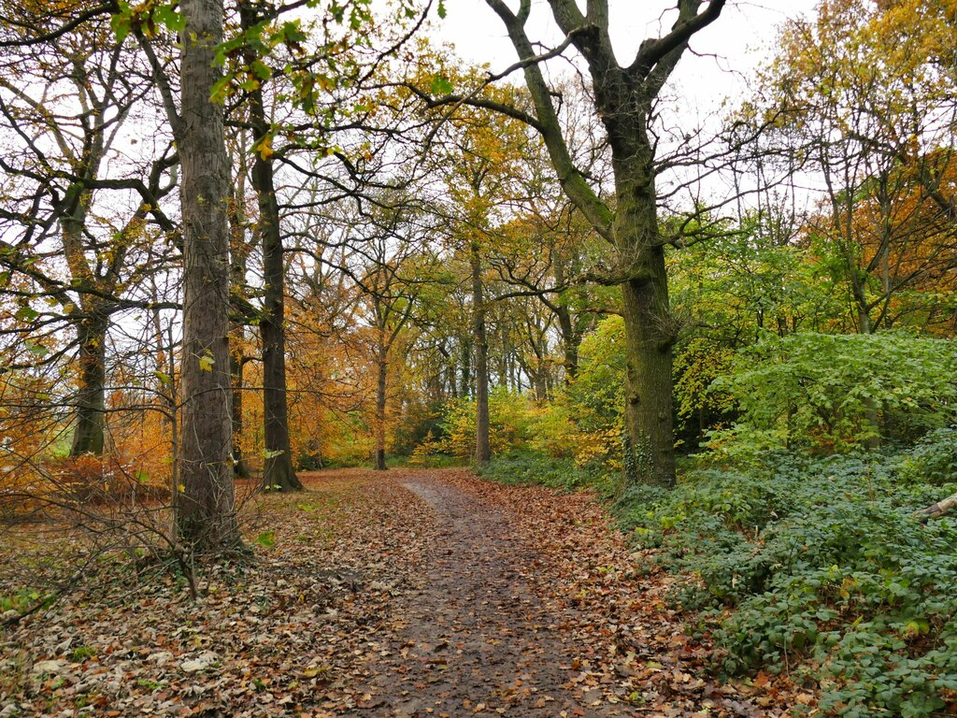

(Roundhay Park, 2023)

Contents
Part 1: A woodland area 3
Part 2: How could the environment be used to develop science and math concepts? 4
Part 3: Risk Benefit Assessment 8
Part 4: With reference to theory and research evaluate how adults working with early years children support and encourage children engage with mathematical and scientific concepts in an outdoor environment 12

Part 1: A woodland area

Part 2: How could the environment be used to develop science and math concepts?
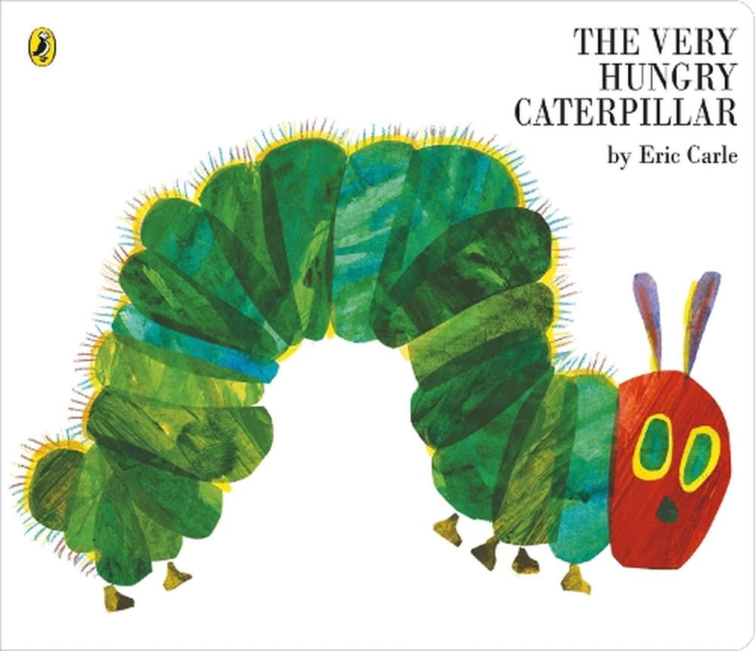
This is an extract from Miss Brooks’ year 2 floor book illustrating the importance of science and maths concepts outside of the classroom.

We begin our walk to the woodland area discussing our book of the week which happened to be ‘The Very Hungry Caterpillar’. The children were really interested about what bugs eat. Child A said “I think bugs eat what we eat! They like pizza and cake like me”. However, Child B argued that “ bugs can’t eat like us because they don’t have shops! Where do they get the food from though Miss Brooks?” That’s a good question my little explorers! We began to discuss food sources and how bugs eat even if there aren’t little shops for them.
Carle, E (2011)
We arrived at the woods, and I told the children that there are 100’s if not 1000’s of different live species who live in out woodland area. The children named some bugs such as beetles, butterflies, centipedes and grasshoppers. “So, my little explorers today we will be learning about natural materials and food chains” explained Miss Brooks.
Food chains in woodlands illustrate how energy and nutrients flow from one organism to another. Theres producers are plants such as shrubs, trees, and grasses which use sunlight to produce energy through photosynthesis.
“Who can say that big word?” asked Miss Brooks.
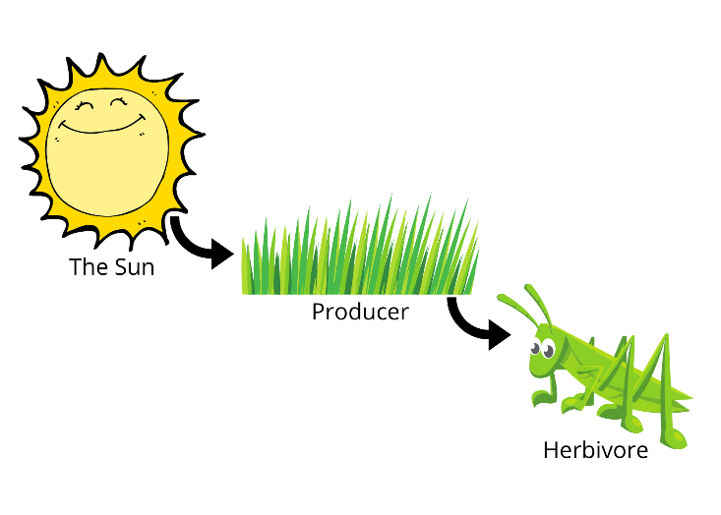
Child C answered “pho-to-syn-the-sis”
Tree Huggin’ Mom (2021)
“Well done! Imagine if plants had a magical kitchen inside them. This kitchen can make food just like how you might use a recipe to make a yummy dish. But instead of using a stove, plants use sunlight! Plants love the sun! They soak up sunlight with their leaves. Think of the leaves as solar panels that catch sunlight. Plants also need water just like us, but they don’t have cups, they drink up through their roots from the ground. Plants breathe in a special gas from the air called carbon dioxide. You can’t see it, but it's there! When plants have sunlight, water, and carbon dioxide, they mix these ingredients together in their magical kitchen. The plant’s leaves are like tiny chefs that make this special recipe. Plants make their own food called glucose. It’s like a sweet treat for them that helps them grow big and strong. Plants also make oxygen, which is a gas that we breathe to stay alive. So, plants are like superheroes because they help us breathe! This illustrates a clear link to progression step 1 of science and technology ‘the world around us is full of living things which depend on each other for survival’(Welsh Government 2020).
Child B laughed and exclaimed “that’s amazing Miss. Brooks I can’t believe that plants are so important for us! But what do the bugs eat?”
“ I will tell you right now my super investigator! In nature, a primary consumer is an animal that eats plants. It’s like the first customer at a picnic table, munching on all the yummy fruits and veggies. In our book we learned that the very hungry caterpillar loved a juicy big leaf, didn’t we?” asked Miss Brooks.
Child F replied shyly “ yes, he ate lots of different foods in the book, but he had a bad belly. The caterpillar needed to eat something healthy and that’s why he needed a big leaf”
“You are absolutely right! If we ate sweets and chocolate all of the time, we would have a bad belly! A caterpillar needs lots of leaves to grow because they give it energy, just like how you need a good meal to play and learn. After eating enough leaves and growing strong, the caterpillar gets ready for a big change. It will turn into a cocoon (or chrysalis) and then, after some time, become a beautiful butterfly!”
Child E screamed “ I love butterflies !”
“Me too! Caterpillars are important for a few reasons! By eating leaves, caterpillars help plants stay healthy. If they didn’t munch on leaves, plants might get too crowded! It is also important for the caterpillar to get big and strong because caterpillars are food for other animals like birds and spiders. So, they help make sure the whole food chain works well. Then there’s secondary consumers like birds who eat caterpillars, gaining energy from the insects they consume. And finally tertiary consumers which might be a Hawk. Hawks might prey on birds, representing a higher level in the food chain. But today we are going to focus on the producers and primary consumers!”
“I want you, my little explorers, to go and find me a producer! I am going to give you ten minutes to go and find as many producers as possible. Here are some bags for you to use to collect your materials ! Remember the golden rules little friends, stay relatively close to me or Mrs Briggs and go and have fun!” said Miss Brooks. Demonstrating a clear link to progression step 2 of science and technology ‘being curious and searching for answers is essential to understanding and predicting phenomena’ (Welsh Government 2020).


(10 minutes later)
“So, what have we collected explorers?” asked Miss Brooks.
Buchanan, B (2015)
Child D answered “ I found some grass! I know it’s a producer because the bugs eat and then my favourite bird, the robin, eats the bugs.”
“Wonderful exploring little friend! Grass is definitely a producer! Did anyone else find something different?” Questioned Miss Brooks.
“I collected some coloured leaves; this is a big green one, and the other is a small brown one. The caterpillar will probably like the green one because it is bigger and looks juicier!” answered child F.
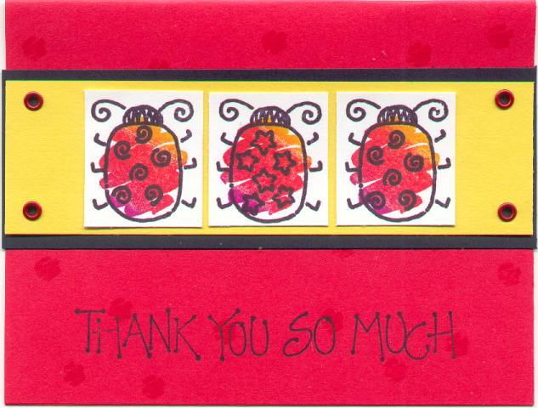
“Amazing work little investigator! Look children can you all see that the green leaf is bigger? Leaves can be all shapes, sizes and colours” explained Miss Brooks.
The children neared closer to filling their bags with a variety of natural materials.
Finally, Miss Brooks and the children put all the natural materials back and made little houses and beds for the bugs using sticks, leaves and pinecones. They said goodbye to the bugs and thanked them for letting them borrow their producers for the morning. Everyone went back to school and the children, still full of excitement, decided to make thankyou cards for their new little bug friends.
Splitcoaststampers (2024)

Part 3: Risk Benefit Assessment
Location / Activity: | Woodland Area | Date: | 05/09/2024
Assessor: | Charis Brooks | Review date:

The boxes in the table below will expand as you type into them; pre-entered text is simply for illustration. You should delete irrelevant items and replace with text relevant to your circumstances.
Your overall risk rating – Low, medium or high – is based on your judgement about whether the BENEFITS of the activity or opportunity outweigh the RISKS.
Experience exploring outdoor space in photograph | How will young people BENEFIT from this activity? | Hazards and associated risks | Who is at risk? | PRECAUTIONS in place to reduce the risk of injury | Overall risk after precautions  RATING: L/M/H
Walking on uneven ground | - Navigating uneven surfaces challenges your balance and coordination, which can strengthen the muscles responsible for stabilizing your body. This can help improve overall stability and reduce the risk of falls.  - Walking on challenging surfaces, triggers the release of endorphins, which can enhance your mood and provide a sense of well-being.  - Stimulate cognitive processes such as focus, spatial awareness, and problem-solving, which can be beneficial for brain health. | - Uneven surfaces can have hidden dips, rocks, or roots that might cause you to trip and fall.  - Navigating uneven terrain requires different muscles to work harder to maintain balance, which can lead to muscle fatigue or strain.  If a fall occurs there is a higher risk of cuts and abrasions becoming infected, especially if the terrain is dirty or contains sharp objects. | The Children and staff | - Wear appropriate footwear with good traction.  - Stay alert of your surroundings and watch where you step.  - Use walking poles or sticks if needed for added stability.  - Whenever possible, stick to marked trails or paths that are designed to be safer for walking.  Ensure essentials such as a mobile phone, first aid kit, and water are packed. A first aid kit can be helpful for treating minor injuries if they occur. | L
Weather conditions | - Sensory experience tuning in to and feeling diverse climate conditions such as the wind, rain, and snow.  - Learning about seasons and the changes that happen within the environment. | If the weather is warm:  - Children are more susceptible to heat-related illnesses.  - Prolonged exposure to the sun can cause sun burn  - High temperatures can lead to dehydration.  If the weather is wet and windy:  - Wet surfaces can be very slippery.  - Being out in the rain can increase the risk of catching a cold or other illnesses.  Strong winds can cause debris to become airborne, posing a risk of injury. | The Children and staff | - Stay hydrated, wear light clothing, and take breaks in the shade.  - Use sunscreen with a high SPF and ensure that children are dressed in protective clothing and hats.  - Encourage frequent water intake and avoid sugary or caffeinated drinks.  - Ensure children wear waterproof, slip-resistant footwear and be cautious around puddles and wet ground.  - Ensure children are dressed in waterproof clothing to stay dry and warm.  - Keep children away from areas where debris might be blown around. | L
Crossing the road | - Teaches the children road safety  - For individuals, especially children and elderly people, successfully crossing a road can enhance a sense of independence and self-efficacy. It builds confidence in their ability to navigate their environment safely.  - Navigating road crossings helps individuals become more aware of traffic patterns and safety rules, improving their ability to make safe decisions in different traffic situations. | - Slippery surfaces due to rain, ice, or snow can increase the risk of slips and falls when crossing the road.  - Reduced visibility during adverse weather conditions can also make crossing more dangerous.  - Pedestrians who are not paying attention—due to distractions like smartphones or earbuds—might not notice oncoming traffic or changes in traffic signals. | The Children and staff | - Always cross at marked crosswalks or pedestrian crossings where drivers expect to see pedestrians.  - Wear bright or reflective clothing, especially in low-light conditions, to increase visibility to drivers.  - Adhere to traffic lights and pedestrian signals. Wait for the "walk" signal before crossing and look both ways.  - Exercise extra caution during poor weather conditions, ensuring that both you and drivers can see each other clearly.  - Stay alert and avoid using smartphones or other distractions while crossing the road.
Collecting natural materials | - Developing curiosity  - Natural materials are important elements of imaginative play  Exploring natural materials enhances a child’s vocabulary. They may discover that a leaf feels crunchy, or a stick feels prickly | - Children could have a misconception about natural materials and collect items such as rubbish and unnatural materials.  - Irritable and poisonous plants. Poisonous plants such as stinging nettles could cause rashes and infections if handled. | The children | - Make children and staff aware of the dangers of poisonous plants and ensure that there are no severe threats present.  - Always supervise children while they are collecting natural materials. This helps ensure they stay safe from potential hazards and make appropriate choices about what to collect.  - Encourage children to wear appropriate clothing, such as long sleeves, long trousers, and gloves, to protect against scratches, insect bites, and potential contact with harmful plants.
Children exploring in an open area | - Open areas provide ample space for running, climbing, jumping, and other forms of physical exercise. This helps children develop strength, coordination, and overall fitness.  - Open spaces often present a variety of stimuli, this environment can spark curiosity and encourage imaginative play and problem-solving.  - Open areas often provide opportunities for children to play with peers, collaborate in games, and develop social skills such as communication, cooperation, and conflict resolution. | - In some cases, children could have an allergic reaction to plants and animals who habituate the area.  - Children may wander off and become lost  - Stepping or falling onto animal faeces. | The Children and staff | - Ensure that the children have a clear sense of boundaries; where they can and cannot go without an adult.  - Ensure staffing ratios are met to account for the safety of the children.  - Survey the area beforehand to ensure it’s a clean and suitable environment.  Ensure that children are aware of “stranger danger” and follow correct protocols when approached by a stranger. | L

Part 4: With reference to theory and research evaluate how adults working with early years children support and encourage children engage with mathematical and scientific concepts in an outdoor environment
(1800 -2000 words).
Piaget (1956 cited in Evans, 2018) considered children as ‘little scientists’ who learn through experimenting and trial and error in their environment during play. Furthermore, Smith (2019) suggests that children develop science and mathematics skills by being provided with stimulating environments that allow children to be curious and discover through active learning. Moreover, Ouvry (2017) and White (2016) suggest that outdoor environments provide for these experiences, where areas such as woodlands, parks and fields are dynamic and include the types of open-ended resources that encourage children to use their imagination and engage in creative thinking, which also supports science and mathematical thinking. Therefore, Evans (2016) suggests adults have a significant role in providing access to the outdoors and the types of environments which have a high play affordance, where children can use the landscape and materials in a variety of innovative ways.
ALISON CLARKE
Consider the key elements in the question
- How adults (role of adults) Support and encourage mathematical and scientific concepts outdoors
- To support your answer you will be making links to any research you have undertaken including journal articles, books, relevant websites, video clips. You will also be recognising where there are appropriate links to relevant theory such as Froebel, Piaget, Malaguzzi, Bruner, Vygotsky in your writing. In this module theory can include Gibson’s affordance theory or Nicholson loose parts theory.
- Be selective, you do not need to refer to every possible theorist. Use theories you feel support your discussion. You may also want to make links to relevant Government documents such as the Curriculum for Wales 2022
- See Moodle and Leganto to read about ideas
- You only have 1800 words, so you must retain focus.
- PIAGET AND LOOSE PARTS
- SUSTAINED SHARED THINKING

When examining curiosity in science and mathematics, especially in outdoor environments, Piaget's theory of cognitive development is pertinent (Lorina, 2020). Four phases of cognitive development were put forth by Piaget, and they represent the growing complexity of children's thinking. Piaget's theory of cognitive development emphasizes the value of active exploration and developmental phases in the learning process. According to Piaget's "Preoperational stage," outdoor settings, which are full of opportunities for practical experiences and applications in everyday life, fit in well with these ideas and encourage curiosity and a deeper comprehension of science and mathematics (LibreTexts, no date).
Children can see and interact with tangible objects in a rich, tactile world when they are outdoors. For example, tracking a plant's growth or looking for patterns in its fallen leaves might pique their interest and assist them in practically applying mathematical principles (Ojose, no date, and Anderson, 1990).
Piaget placed a strong emphasis on the value of interactive learning environments and active investigation. This kind of exploration is naturally encouraged by outside environments. Children's mental models of the world, or schemas, are formed and refined through their interactions with nature, objects, and personal encounters. For example, learning how shadows shift throughout the day can aid in their comprehension of time and geometry concepts (Educational Psychology, 2020).
Piaget suggested that integration is a part of learning. Engaging in outdoor activities frequently tests children's existing frameworks and forces them to adapt their comprehension. For instance, studying the effects of various soil types on plant development might help people comprehend biological and mathematical concepts better and revise what they already know (Gradini, 2013). Lefa (no date) says that Mwamwenda (2009) asserts that using Piaget's theory in the classroom is quite feasible. Piaget has a constructivist stance and thinks that information is not passively acquired by students. According to Piaget's idea, a curriculum that helps children understand concepts and logical sequences will aid in their cognitive growth.

A study by Davies (2019) demonstrated how loose parts improves children’s engagement
The Curriculum for Wales 2022 focuses on a……..

Reference List:
Roundhay Park (2023) Cycle path into Roundhay Park. Available at: Cycle path into Roundhay Park © Stephen Craven :: Geograph Britain and Ireland. Accessed: September 3rd 2024
Carle, E (2011) The Very Hungry Caterpillar (Big Board Book). Available at: The Very Hungry Caterpillar (Big Board Book) by Eric Carle, Hardcover, 9780141338484 | Buy online at The Nile. Accessed: September 3rd 2024
Tree Huggin’ Mom (2021) Food Chains for kids- The Circle of Life. Available at: Food Chains for Kids - The Circle of Life (treehugginmom.com). Accessed: September 3rd 2024
Buchanan, B (2015) Sticks and Leaves. Available at: Sticks and Leaves Photograph by Buck Buchanan - Fine Art America. Accessed: September 3rd 2024
Welsh Government (2020) AREA OF LEARNING AND EXPERIENCE Science and Technology. Available at: Descriptions of learning - Hwb (gov.wales) Accessed: September 3rd 2024
LibreTexts (no date) 3.6: Piaget’s Theory of Cognitive Development. Available at: 3.6: Piaget’s Theory of Cognitive Development - Social Sci LibreTexts. Accessed: 07/09/2024
Lorina (2020) Jean Piaget - Cognitive Development. Available at: Jean Piaget - Cognitive Development - Aussie Childcare Network. Accessed: 07/09/2024
Ojose (no date) Applying Piaget’s Theory of Cognitive Development to Mathematics Instruction. Available at: Microsoft Word - v18n1_48pgs_pc_final.doc (ed.gov). Accessed: 07/09/2024
Educational Psychology (2020) Psychological Constructivism: Piaget’s Theories. Available at: Psychological Constructivism: Piaget’s Theories – Educational Psychology (sunycreate.cloud). Accessed: 07/09/2024
Anderson, J. R. (1990). Cognitive psychology and its implications (3rd ed.). New York: Freeman.
Mwamwenda, T, S.2009. Educational Psychology .An African Perspective:3rd edition.Durban.Heinemann.
Lefa (no date) THE PIAGET THEORY OF COGNITIVE DEVELOPMENT :AN EDUCATIONAL IMPLICATIONS. Available at: (PDF) THE PIAGET THEORY OF COGNITIVE DEVELOPMENT :AN EDUCATIONAL IMPLICATIONS (researchgate.net). Accessed: 07/09/2024
Gradini, E (2013) Teaching Mathematics with Piaget’s Theory. Available at: 0954733c814fa7daee45f06752b59993cce1.pdf (semanticscholar.org). Accessed: 07/09/2024

