Homelessness and the YMCA
By: Lorenzo Ramon

YMCA and their Efforts Against Homelessness
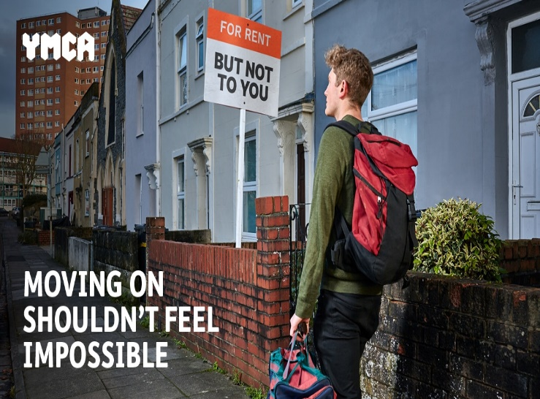
According to the YMCA's most recent research of young people's transitions from homelessness to independent living, 70% of those who were ready to move on stayed in sponsored housing. Only one in every four respondents who were prepared to migrate thought they would be able to do so within the following three months. Providing beds in hotels for rough sleepers has been a top goal for the government at a period of unparalleled crisis and intervention. Young people throughout the country who are ready to leave assisted living and make this much-needed space available are unable to do so due to significant financial and social impediments. According to the findings of the YMCA's extensive research on their experiences, young homeless persons were unable to move on owing to their inability to save, a shortage of cheap housing, and racism in the private renting sector.
When benefits are withdrawn, starting work usually comes with rising debt, and the situation isn't much different for people who are employed. Despite the fact that they were paid later, practically everyone the YMCA spoke to said they went into debt after commencing employment as a result of the abrupt loss of Housing Benefit or Universal Credit. Private renting is not only pricey, but also uncertain for those who can save. Private landlords are frequently reluctant to rent to young people, demanding guarantors and other checks, which may be problematic for those living in supported accommodation. The impacts of this bias are being felt by young people, with 41 percent telling the YMCA that landlords' unwillingness to rent to them is the major reason they are unable to move on, followed by the expense of rent and deposits at 44 percent.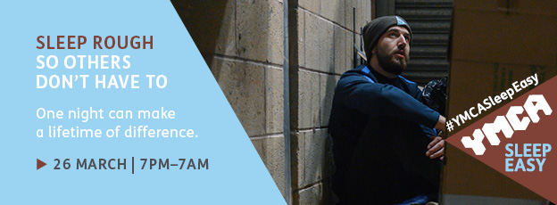
On Friday, December 15, a total of 18 organisations formed the London Homeless Charities Group to combat rough sleeping and homelessness, with a winter campaign endorsed by the Mayor of London. According to official statistics, rough sleeping in London has more than quadrupled since 2010. Changes in aid, rising housing costs, and a scarcity of affordable homes are leaving an increasing number of individuals homeless.
The London Homeless Charities Group, which includes YMCA England & Wales, St Mungos, Crisis, and other organisations, is collaborating with the Mayor on the 'No One Needs To Sleep Rough In London' campaign, which asks the public to join the fight to ensure that people sleeping rough in London this winter have a safe place to sleep.
Since 2010, YMCA Sleep Easy has seen over 7,000 people sleep rough to raise over £1.5 million for local YMCA programmes that help young people rebuild their lives.
YMCAs across England and Wales are urging supporters to sleep rough so that others don't have to. Normally, this would have required groups and people assembling cardboard shelters at a YMCA, spending the night time outside, and sharing the terrible truths of living on the streets. The hurdles of planning an event like this amid the current epidemic are considerable, yet they pale in contrast to the daily struggles that young homeless people confront.
For YMCA Sleep Easy 2022, YMCAs across England and Wales will host hybrid events that will include the return of in-person gatherings as well as providing individuals, families, and organisations with the necessary support to participate at home or at a location of their choosing. The YMCA of England and Wales has also released a briefing note summarising the present state of homelessness in the UK, as well as new insights into how homeless young people perceive the public perception of them.

Blog link - https://bmbm4005.wordpress.com/2021/11/26/homelessness-and-the-ymca/

