Imagined Exhibition
Chloe Wallace
Student Number: 1702996
Word Count: 1228
Tutor: Julia Lockheart

The theme I have chosen for my imagined exhibition highlights people’s ignorance towards war and destruction happening around the world. The attention to materialistic aspects of modern day life has largely increased and concern for other people’s well-being has diminished. This is an important issue to address because as life goes on mankind is becoming more self-absorbed and unaware which could be impactful in the future to human civilisation. Ignorance to death and conflict will lead to worse outcomes for people in war torn countries which is why I want to create an exhibit which broadens the audience’s awareness to horrific events taking place on a day to day basis. Photographers such as Don McCullin and Lee Miller specifically produce images made to shock individuals by forcing the observer to consider how actions affect others. They photograph realistic imagery of conflict, death and grief viewed in the eyes of the victims. The exhibition will incorporate techniques used by these curators to unsettle but empower the audience. The exhibition will not only highlight the personal outcomes of war but the causes. In this case the impact politics, magazines and newspapers have on war and conflict.
There are many questions to be asked as to why people choose to overlook such heart wrenching stories and imagery of death. There are various contributing factors to such ignorance, these include newspapers over publicising terrifying stories. Everyone has their own problems to worry about in life. When they go to the shop to pick up a book or magazine to read they don’t want to be faced with negativity. People look for positive articles to hide away from everyday life struggles by drawing their attention to lighter topics which are irrelevant to the problems in society. Topics that are highly publicised in the media in todays society include celebrity culture and the latest fashion trends. Articles like these are solely aimed towards all members of society by publishing themes which would appeal to all ages and interests therefore more profit is made by the companies and less money is lost. News articles which focus on politics and war are read by a smaller percentage of individuals which is why only certain newspapers decide to publish these types of stories. There are a small number of newspaper publishers such as The Metro and The Guardian are more liberal by publicising controversial articles. When individuals are constantly being fed frightening stories and imagery by the news people choose to ignore the importance of it because it can be intensely upsetting.
People are only concerned about conflict when it is affecting them directly, for instance if it was taking place in their own country. According to Baudrillard (1994:79) We live in a world where there is more information, and less meaning. This statement supports my argument in the way information is shared by the media and its impact on the public. By feeding members of the public too much information it can overwhelm them and the initial meaning may be lost. Somin (2013) states that in making decisions that are likely to have only a small effect people naturally set lower standards of informational adequacy than in making decisions that are likely to make a big difference. I strongly believe that this is due to poorly made decisions being shared with the public through social media by individuals in the public eye such as celebrities and politicians. This has given people a lack of confidence and influence on others to openly share their thoughts and protest their angers towards the world.
I want to address the ignorance shown in today’s society in my exhibition by creating a space which emphasises the effect war has among people all around the world. The intention of the exhibition is to draw attention to the destruction among war torn countries everyday and hopefully change people’s perception of war. In order to achieve this I intend to curate a fashion show in a space set up to look like an area which has just been destroyed by war. The area will not represent any real life events as this could be too distressing for the audience. The fashion show will take place at The Crypt Gallery in London which is an old burial ground designed in 1822. This is an appropriate venue because it is made up of thick stone walls which carry an eerie atmosphere and essence of death within the space. The space is an area with historical importance as death linked to war is of major historical influence. The thick stone walls cool down the temperature of the space giving the audience a physical chill as they walk in which would resemble the feeling a person would experience seeing this sort of devastation for the first time. I want the audience to gain visual and physical stimulations from the exhibition so various pieces of debris and personal belongings will be cluttered around the catwalk area amongst the audience’s seats. The models walking the catwalk will be wearing the latest high-end designer clothes from designers such as Chanel and Gucci. Victims of war are left with nothing, no belongings family or place of residence. The designer clothes will compare between the wealth of individuals living in developed countries to that of un-developed war-torn countries. Lefebvre (1991) states for mental and social to be reconnected, they first have to be clearly distinguished from one another, and the mediations between them re-established. In this case the social factors involved in in the theme of the exhibition are wealth and poverty reflected by the clothes worn by the models and the destruction displayed with rubble and debris. The mental factors are the audience and their reaction to the exhibition. By displaying both the social and mental factors in the exhibition the two factors will hopefully reconnect and be associated with each other changing the way in which the audience perceives the topic of war and conflict.

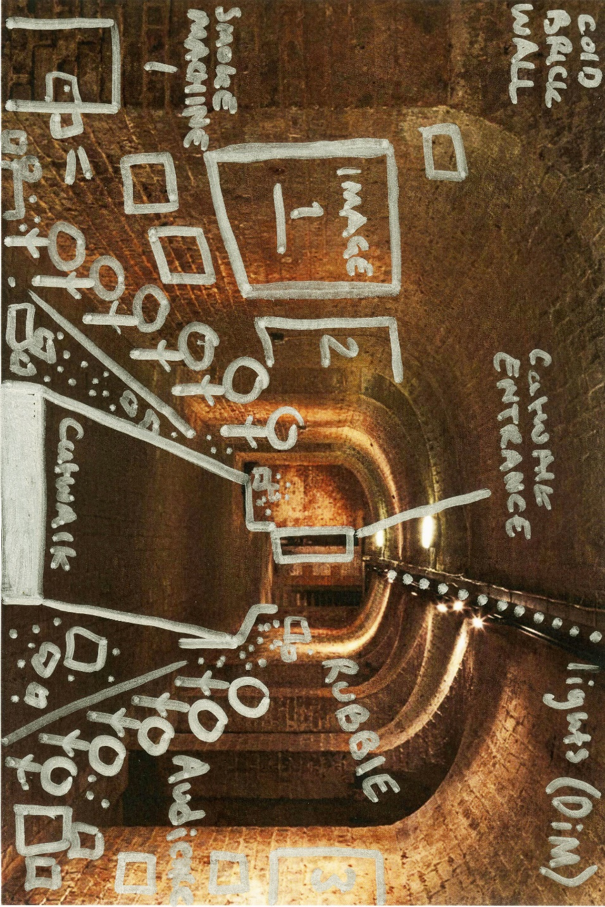
Floor Plan, The Crypt Gallery
Photographs taken by Lee miller and Don McCullin will be scattered along the walls of the space to intensify the nauseating feeling within the space. The lighting will be dark surrounding the catwalk, bright lights will shine directly onto the catwalk and paparazzi regularly taking photographs of the models. The lighting is to ensure the spotlight is on the catwalk not the surroundings to depict ignorance.

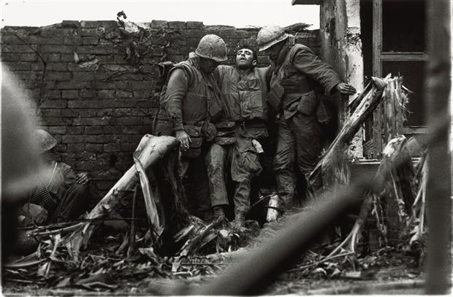 Don McCullin US Marine wounded in the legs, the Citadel, Tet Offensive, Hué, South Vietnam, February 1968
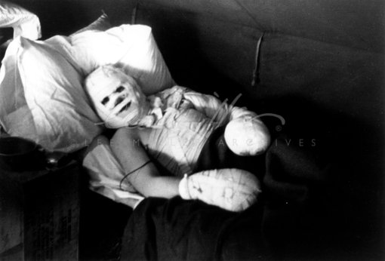
Lee Miller, Bad Burns Case, 1944

These are only two of the images chosen to be displayed on the walls. Both of these images were taken by photographers in different decades, but the decade of the work isn’t relevant because the effects of war are the same regardless of what decade they may occur. Time may be seen as highly important within this topic of conversation because political and religious views are constantly changing as life moves on. A correlation can sometimes be associated with major life events such as war and conflict.
The majority of photographs taken from magazines today are staged. The media give the public an unrealistic depiction of celebrity culture. Photographs taken by Miller and McCullin are an example of imagery which is untouched and true to real life events. According to Calvocoressi (2002:10) photographs in the war cannot be staged because the picture had to be taken quickly, and the subject wasn’t always aware of being photographed. As the subjects weren’t aware of being photographed the photographer captures their natural reactions.

Bibliography
McCullin,D. (1968) US Marine wounded in the legs [photograph] South Vietnam
Miller,L. (1944) Bad Burns Case [photograph] London: Thames and Hudson
Calvocoressi,R. (2002) Lee Miller portraits from a life. London: Thames and Hudson
Baudrillard, J. (1994) Simulacra and Simulation. Translated from French by S. F. Glaser. Michigan:The University of Michigan Press
Lefebvre,H. (1991) The Production of Space. Translated by D.N. Smith. Oxford:Blackwell
Somin, I.(2013) The Conversation.Why (Most) Political Ignorance is Rational and Why it Matters: Reply to Jeffrey Friedman.[Online] Available at: https://www.cato-unbound.org/2013/10/22/ilya-somin/why-most-political-ignorance-rational-why-it-matters-reply-jeffrey-friedman.
(Accessed: 07/05/18)

