FILM AND VISUAL CULTURE
READING VISUAL CULTURE : NARRATIVE AND IDEOLOGY

THE REPRESENTATION AND IDEOLOGY OF MALE AND FEMALE CHARACTERS in
THE WIZARD OF OZ
___
By Dean Cropper
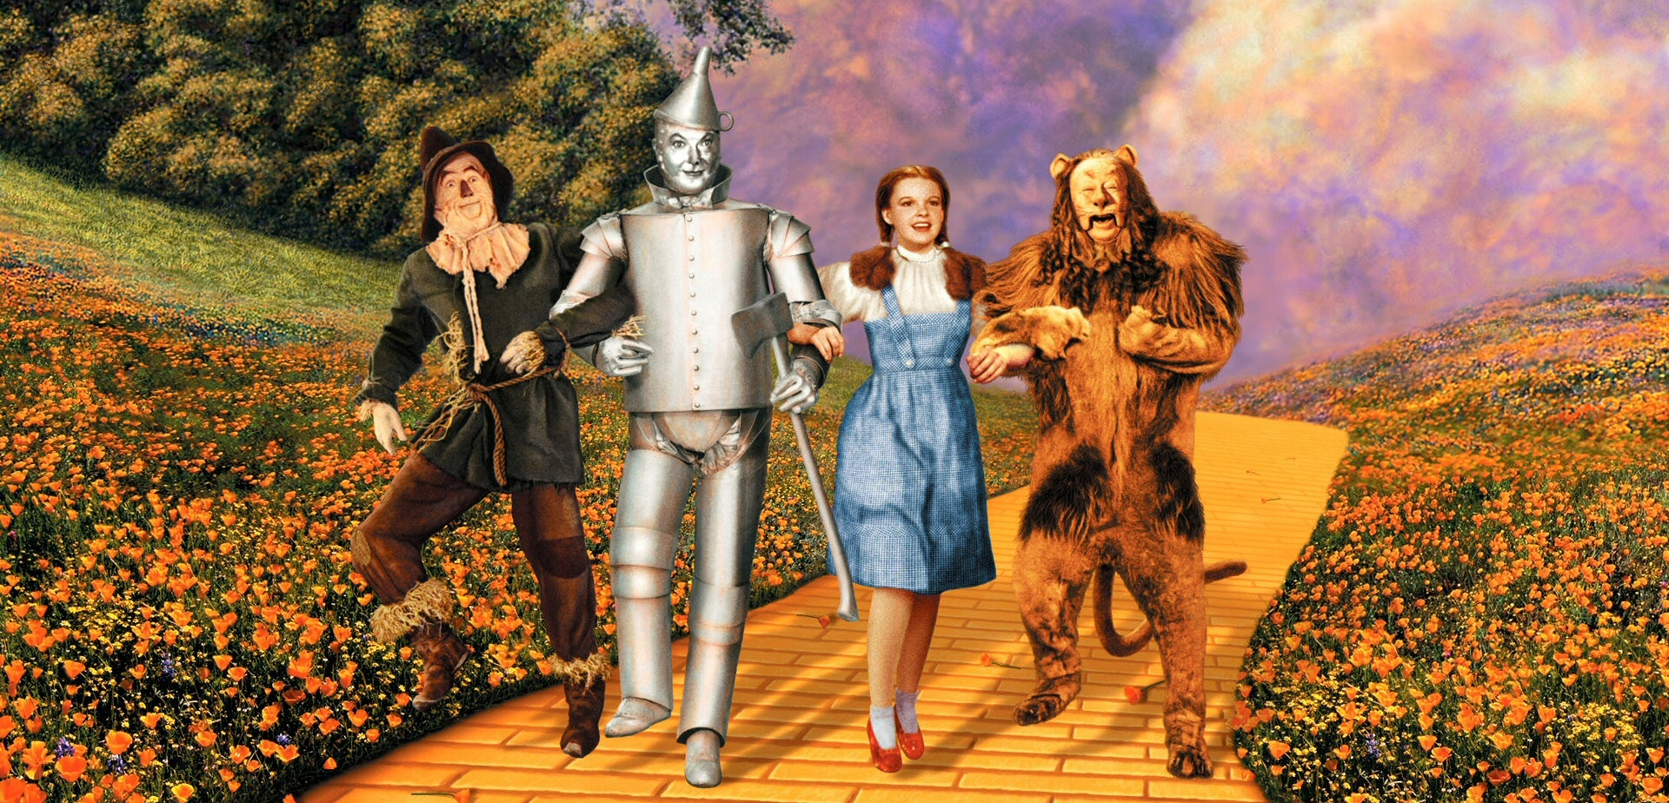

INTRODUCTION
The Wizard of Oz (Fleming, 1939) is one of the first major films to be produced in Technicolor and has been generally received as one of the greatest films of all time.^{[1]} It is based on the children’s book The Wonderful Wizard of Oz (Baum, L. Frank, 1900), which “is now almost universally acknowledged to be the earliest truly feminist American children’s book, because of spunky and tenacious Dorothy.”^{[2]} The film continues to tackle the stereotypes of gender roles and power despite the norms of Hollywood at the time. One of the first ways it does so is that the lead character, Dorothy Gale, is a girl as opposed to a male lead (as many films had and still to this day have), and her name itself suggests strength in spite of the stereotypes of female character; gale being a strong wind or burst of sound.
Throughout the film, in the world of Oz, many of the female characters take power roles whilst male characters are sidekick and/or sideline characters; such as Scarecrow, Tin Man and Cowardly Lion; in contrast to the patriarchal farmstead where Dorothy begins and ends up back at the opening and ending scenes of the film.

Dorothy Gale
As previously mentioned, Dorothy breaks the stereotypes of classical Hollywood lead characters by being a girl as opposed to a male lead. In the opening act of Wizard Dorothy is represented as a weak character, both in the narrative of her interactions with other characters around the farmstead and in the mise-en-scene of the scenes.
The male and adult characters of the farmstead have authority over Dorothy as she is a child and under the care of her aunt and uncle. The theme of Dorothy’s minor status is synonymous with Toto’s; Toto is also disregarded by the farmstead as just a mongrel (another break from Hollywood standard leads due to Toto’s casting as a scruffy crossbreed). Dorothy’s protectiveness and care for Toto contrasts the lack of care for Dorothy.
The mise-en-scene for the farmstead heavily features sharp upright motifs; these traditionally represent a feeling of confinement and being trapped and/or the ideology of phallic dominance; pointing to Dorothy being overshadowed by the male farmhands and wish to escape the farm.
The phallic presence in the mise-en-scene is mainly alluding to Dorothy’s inferiority to males although the authority on the farmstead is presented from two female characters, Aunt Em and Miss Gulch. Whilst Uncle Henry holds authority over the work on the farm and the farmhands, it is Aunt Em that holds authority on the household life, whilst Miss Gulch uses her class, the law and religion to enforce her authority over Dorothy’s family. In the book is written “he [Uncle Henry] worked from morning till night” and “Aunt Em was washing the dishes”^{[i] page 1}, alluding to a traditional gender roles of a suburban homestead of the time period; Uncle Henry, as a patriarchal, labours all day to support his family and has control over the farm whilst Aunt Em is a typical housewife which allows her more indirect control over their lives through her chores of the house. She is also more in control of Dorothy as a mother figure in addition to being female.
Dorothy takes on a much different role and portrayal when she reaches Oz. The accidental act of killing the Wicked Witch of the East causes the Munchkins to regard Dorothy a hero and they praise her as a heroine. It is here that Dorothy is finally acknowledged and heard as more than a naive girl. She begins to develop an authority as she travels through Oz and befriends other minor outcast characters.
In her encounters with Scarecrow, Tin Man and Cowardly Lion (played by the cast of Hunk, Hickory and Zeke) she leads the conversation and becomes their mentor in how to overcome their inhibitions of their inabilities. This is a reversal of the gender stereotype of a damsel-in-distress needing a ‘prince’ to rescue them, as Dorothy is self-reliant, and is a leader and carer for Toto and the Oz outcasts.
The scenario of Dorothy being a damsel-in-distress does occur at the films problem climax when the Wicked Witch of the West kidnaps Dorothy. This, however, does not promote the sexism of the situation but rather focuses on the narrative and ideology of Scarecrow, Tin Man and Lion finding out they had what they thought was missing all along; whilst Scarecrow, Tin Man and Lion, led by Toto, manage to break Dorothy free from her cell, it is Dorothy that ultimately rescues the whole gang when she (accidentally, again) kills the Witch (through her caring actions to save Scarecrow).

The Ideology of Gender Stereotypes in Wizard of Oz
Oz’s power figures are mostly women; the four Witches that possess both authority and magical power over the denizens of Oz. The one male power figure is the Wizard, who is mostly shrouded in mystery and legend, and although regarded the most powerful being of Oz he is revealed at the end to be a fraud, mainly as the people of Oz mistook him to be a wizard and he stayed to embrace the illusion. The authority of male figures in Oz seemingly comes from citizens making them out to be.
The Scarecrow, Tin Man and Cowardly Lion are representative of negative male stereotypes; stupid men, heartless men and cowardly men and all of helpless men. Whilst the Scarecrow can allude to the stereotype that men can be stupid, he also is representative of the mentally challenged. He is made of straw which can be seen as a motif of fragility and weakness, contradicting the stereotype of Hollywood men being strong. He was left in a field clinging to his pole, showing dependency (another trait rarely depicted in male characters).
Tin Man is an allusion to heartless men. He, throughout the film, ends up needing care and attention in the form of oil treatment (as you would care and treat metal mechanisms) showing that is not self-reliant and cannot cope on his own.
Cowardly Lion already breaks the gender stereotype in his name, as men were rarely seen as cowardly in Hollywood, and constantly needs reassurance to continue his journey with the gang and is dependent on Dorothy.
All three are depictions of helpless men, something not often depicted in films and they are all dependent on Dorothy.

Filmography
The Wizard of Oz, 1939 [film]. Directed by Victor FLEMING, King VIDOR, George CUKOR and Norman TAUROG. USA: Metro-Goldwyn-Mayer
Bibliography
[i] Baum, L. F. (1900). The Wonderful Wizard of Oz. Chicago: George M. Hill Company
[1] “AFI’s 100 Years… 100 Movies”, afi.com, 2017-08-09
[2] Saturday Review June 17, 1972, p. 72

