

Cover Page
Module: Changemakers: Building your personal brand for sustainable employment
Module code: 5015
Assignment title: Component 1: Online Portfolio set exercises
Student name: Jacqueline Boahemaa
Student number: 2423860

Task 1 – Personal Brand
My personal brand is how I present myself to others through my personality, skills, strengths, and values. It reflects who I am as an individual and how this makes me different from other people. Personal brand is important to me and my career because it allows me to communicate my qualities to potential employers in which I can then create a positive first impression. The research by Trang et al. (2024) displays how students use personal branding when seeking employment, further showcasing the importance of authentic communication and always presenting a consistent professional image.
In my current brand now, I would like to refer to myself as respectful, responsible and willing to learn, as I understand the importance of listening to others, following instructions and improving my knowledge. Through my education I have developed skills such as communication, organisation, and working independently. Despite this I am still developing my professional identity because I believe there are many things I still need to learn. My experience working as a care assistant has helped me develop a professional identity since my role involves supporting residents and treating them with dignity. My colleagues and employers may see me as someone who takes my responsibilities seriously, arrives at work always prepared and understands the importance of completing tasks correctly.
Although I have developed valuable skills throughout my care assistant role, I believe there are still areas for improvement which I strive to overcome. I believe I could achieve these by asking for constructive feedback always, completing the relevant training and reflecting on my workplace experiences.
Harvard Business School Online (n.d.) Personal branding at work. Available at: https://online.hbs.edu/blog/post/personal-branding-at-work (Accessed: 26 October 2026).
Reissner, S. and Armitage-Chan, E. (2024) ‘Manifestations of professional identity work: an integrative review of research in professional identity formation’, Studies in Higher Education, 49(12), pp. 2707–2722. Available at: https://www.tandfonline.com/doi/full/10.1080/03075079.2024.2322093#abstract (Accessed: 26 October 2026)

Task 2 - Network Map and Rationale
My present network consists of a hybrid network as it combines both close personal ties and broader social relations. The social capital in my network comprises my relatives, close friends, acquaintances and people who I may contact through my community. In case of necessity, this network gives me emotional and advisory support. This type of social capital can be considered as bonding social capital as it consists of strong and trustworthy relationships (Szreter and Woolcock, 2004).
The only limitation in my current network may be my possible over-reliance on the people I know and lack of opportunities for making new contacts and gaining new experience. Thus, there may be some need for developing my bridging social capital that will involve contacts with people beyond my social circles. As Burt (2004) stresses, it is very important to establish connections between different social groups to have access to new experiences and opportunities.
Moreover, I can also improve my linking social capital and create relations with people who can give me valuable advice, assistance or access to helpful information. To improve my network, I can get involved in the work of my community.
The other aspect I must think about is how good my connections are, and not the size of my social network. If I have a big social network, it does not mean that I will be receiving enough support, as there are other factors such as trust and communication. Maintaining regular contact with those who care for me would help me improve the existing connections. Meanwhile, willingness to meet new people could assist me in creating new connections, which would help me to get more comfortable in communicating with people.

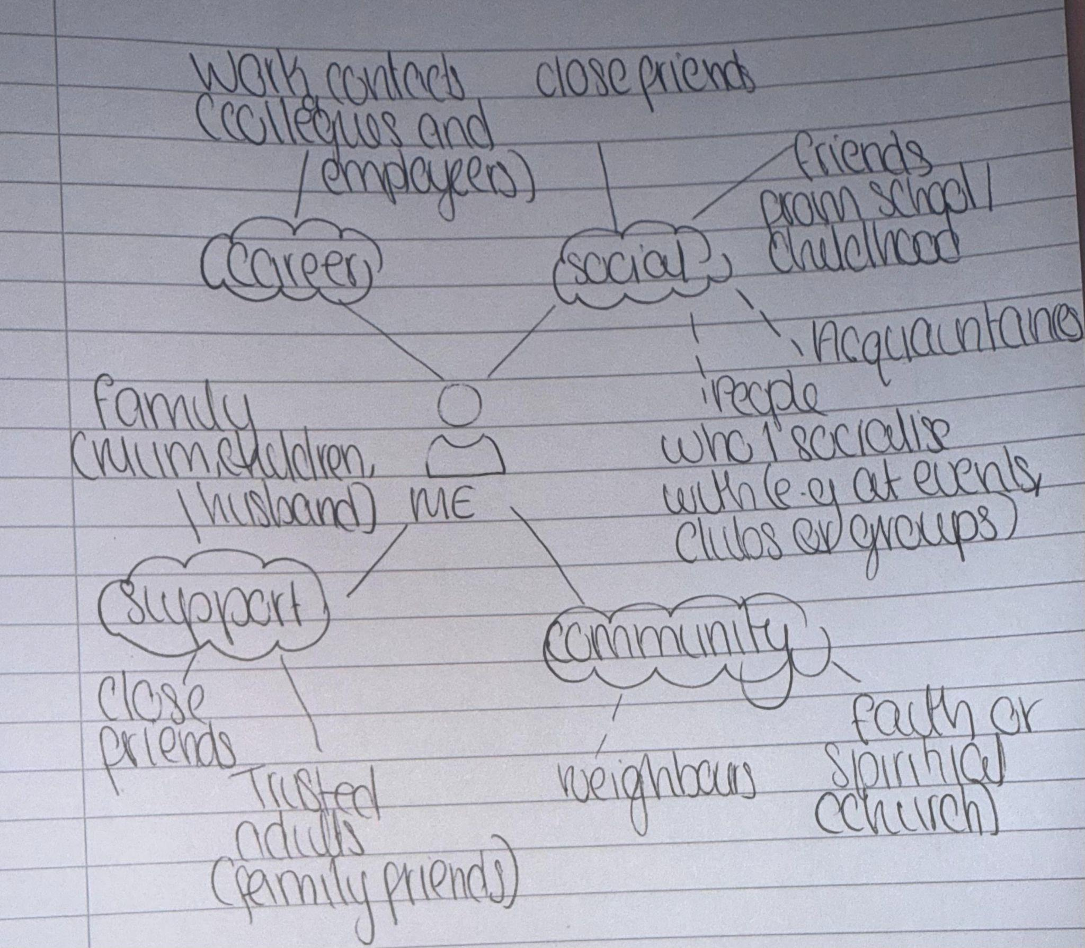

Task 3- Blog
You Don’t Have to Struggle Alone: Mental Health Support for Young Adults
The time of being a young adult is often perceived as challenging yet interesting. There are plenty of issues which can have an impact on your mental health including studying, employment, interpersonal relationships, financial issues and expectations from life. Sometimes stress can be too difficult to cope with and cause depression or anxiety. However, seeking help is never embarrassing and mental health is as important as physical one, and information about it can save someone's life.
Mental health problems are common among young people. NHS England (2023) states that 21.7% of individuals aged 20–25 were suffering from a probable mental disorder in 2023. That is why the availability of relevant services is essential. Lack of proper care can lead to deterioration of sleep patterns, interpersonal relations, academic performance, work productivity and routine daily activities. Being aware of symptoms like constant feeling of despair, anxiety, social isolation, loss of interest in hobbies can help to address difficulties and seek help before it is too late.
Several options are available for a person who wants to receive assistance. One can consult a general practitioner
Although there are available resources, it may not always be easy to access them. Fear of judgment, inability to express one's emotions and lack of know-how could stand in the way of help-seeking young people. Long wait times and differences in local provisions could also present some challenges. Increased awareness, friendly services and information could facilitate help-seeking among young people. It would also be helpful to have supportive friends who listen and persuade one to get professional advice.

It is crucial not to ignore the problem of mental well-being or to think that it is a sign of weakness. It is vital to allow young people to speak up and be listened to. In case of any problem, one should consider speaking to one's trusted person or visiting one's GP. If urgent mental well-being help is required in England, one should contact NHS 111 and select the mental well-being line. In case of emergency, one should contact 999 or visit A&E.
NHS England (2023) One in five children and young people had a probable mental disorder in 2023. Available at:https://www.england.nhs.uk/2023/11/one-in-five-children-and-young-people-had-a-probable-mental-disorder-in-2023/ (Accessed: 24 October 2026).

Task 4- NHS Equality, Diversity and Inclusion Quiz (250 words equivalent)
- What is the primary goal of the NHS Equality, Diversity, and Inclusion Improvement Plan?

The primary aim is the improvement of equality, diversity, and inclusion among the NHS workforce. Such changes will allow staff members to feel valued and included.
- How does the NHS EDI Improvement Plan propose to tackle the gender pay gap?
It is suggested to analyse any pay gaps, determine the reasons behind them and implement improvement measures. Fair recruitment, career advancement, and flexible working are promoted by the plan.
- What is meant by the term ‘intersectionality’ as used in the NHS EDI Improvement Plan?
It refers to the situation where a single person faces multiple forms of discrimination because of various identities, such as being a member of an ethnic minority, disabled and so on.
- Why is it important for the NHS to create a psychologically safe work environment?
Psychological safety is the situation when staff members can express their opinions, concerns, and ask for assistance without the risk of any retaliation and victimization.
- How does the NHS EDI Improvement Plan suggest improving the experience of internationally recruited staff?
The plan suggests that NHS organizations provide relevant information prior to joining the team, offer a good induction program, equal access to career development and training programs and culturally sensitive and diverse workplaces.
- What role does leadership play in advancing EDI objectives according to the NHS Improvement Plan?
It is necessary to set relevant goals for NHS leaders who must demonstrate how EDI objectives are met and what steps they take.

- Identify one way the NHS EDI Improvement Plan aims to reduce health inequalities within the workforce.
One possible approach includes reducing the number of cases of bullying, harassment, and discrimination in addition to improving the overall staff well-being.
- Why does the NHS EDI Improvement Plan emphasise the importance of collecting and analysing data on protected characteristics?
Data collection and analysis enable the NHS to uncover cases of inequality, discrimination, and disparities in terms of payment or career opportunities. Such data enables the organisation to take targeted steps and track changes made.

- Explain how flexible working policies can contribute to equality and inclusion in the NHS workforce.
Flexible working could allow employees to cope with their work-life balance, health and personal issues and make NHS employment more accessible for everyone as well as retaining employees within the job and enabling career development.
- What is one strategy mentioned in the NHS EDI Improvement Plan to combat bullying and harassment in the workplace?
One approach involves the examination of bullying and harassment data in workforce statistics and setting goals for their decrease with further steps to deal with these issues if they occur.

Task 5- A Letter to Yourself
Dear Younger Me,

Please be assured that the tough times you are undergoing at the moment will end sooner or later. It may happen that there would be instances when you will find yourself feeling anxious and stressed out or misunderstood by others. In these situations, you may find it difficult to express your feelings, and hence your mental health will be impacted since you will suppress your feelings inside you without sharing them with anyone. Reflecting upon those times now, I wish I could have dealt with them in a different manner had I known more about emotional intelligence and resilience.

The concept of emotional intelligence refers to the awareness, recognition and management of emotions, along with being aware of how other people feel. Emotional intelligence may have enabled me to be aware of my feelings rather than neglecting them or suppressing them. Emotional intelligence may have also helped me in expressing myself better and getting help from people around me. It is essential to acknowledge one’s emotions in order to be able to deal with the situation in a cool-headed manner.
Moreover, I have also been taught about resilience, which is the ability to overcome difficulties and bounce back from tough situations. Back then, I may have thought that my issues were impossible to handle. But being resilient may have taught me that setbacks are a part of life and do not define failures. Instead, I should have concentrated on finding solutions and remaining optimistic about my situation.

Above all, I want you to understand that seeking help is not a sign of weakness. In fact, I have realized that emotional wellbeing is as important as physical well-being. Therefore, allowing myself to relax, discussing my feelings with someone trustworthy, and treating myself with kindness would have made a huge difference during that hard time.

While I cannot undo what has already been done, I can apply the knowledge that I have gained for future problems. I am glad that I have come such a long way, but I also want you to know that those tough times will make me stronger and more understanding.

Task 6- GANTT Chart
My long-term aspiration is to be a Registered Manager in health and social care where I will manage the team and make sure that service users get safe and high quality care.
The main tasks are to complete my current qualification, obtain necessary work experience, obtain a Level 5 Diploma, prepare my CV and cover letter, obtain management experience, apply for job vacancies and prepare for interviews.
Realistic timeframes will be assigned to each of these tasks. I am going to complete my current qualification by June 2027, obtain work experience by December 2028 and complete my Level 5 Diploma by September 2029.
Some of these tasks can overlap, e.g. studying and obtaining work experience. My milestones are going to be completion of qualifications, gaining management experience, attending interviews and meeting the requirements of CQC for registration as a Registered Manager.

Task | Start Date | End Date | Duration | Dependencies (if any)
Complete Level 5 Diploma in Leadership and Management in Adult Care | September 2027 | September 2028 | 12 months | Develop leadership and management skills
Develop CV and cover letter | June 2028 | September 2028 | 4 months | Prepare for management opportunities
Gain work experience as a senior carer or deputy manager | September 2029 | September 2031 | 2 years | Develop supervisory and management experience
Apply for registered Manager positions | September 2031 | December 2031 | 4 months | Meet the requirements of the role
Complete the Care Quality Commission (CQC) registration process | January 2032 | March 2032 | 2 month | Meet the relevant registration requirements
Begin working as a Registered Manager | April 2032 | Ongoing | Achieve career goal | CV & Cover Letter Complete

Task 7- Making Changes- Report
As the manager of the care home, a change that I would implement is allowing the residents to decorate their bedroom with photos, familiar pieces of furniture, and other personal items. This will enable the residents to be at ease, retain their identity, and adjust to their surroundings (Deeside Care, n.d.).
The implementation of this change will be done through the three stages of Lewin’s change model. In the first stage of unfreezing, the change process and its benefits will be explained to the staff. The second stage of changing will involve the residents and their family in selecting personal items for the rooms while ensuring safety of the rooms.
Leadership, communication, team work and problem solving skills would be required. As a manager, I would communicate the change well and listen to the concerns of the staff and get the opinion of the residents as well. According to Log my Care (n.d.), the following things should be considered while managing the change: communication, staff engagement and tracking progress. Feedbacks will be gathered for identifying any room for improvement.
Some of the barriers might be budget constraint, resistance from the staff and safety issues. Some residents may have furniture which is too big for the room, while others may not have support from the family members. The following measures will help to address the barriers mentioned above: finding affordable solutions, checking the rooms individually and ensuring that belongings are not in the way. I will also try to convince the staff about the benefits of the change for residents.
To conclude, personalizing the bedrooms may enhance the residents' comfort, respect, and feeling of belonging. Through the use of proper leadership, communication, and a change process, I would endeavor to implement the change safely with the residents at the forefront of decision making.
Log my Care (n.d.) Change management in care. Available at: https://www.logmycare.co.uk/blog/change-management-in-care (Accessed 21 October 2026)
Deeside Care (n.d.) Making a care home more homely. Available at: https://www.deesidecare.com/news-events/making-a-care-home-more-homely/ (Accessed 21 October)
Age UK (n.d.) Moving into a care home. Available at: https://www.ageuk.org.uk/information-advice/care/arranging-care/care-homes/moving-into-care-home/? (Accessed 21 October)

