UWTSD

Architecture in your hometown
History and Theory

Iestyn Bentley (1900945)
Architecture

Word Count: 1074
Architecture in your hometown

The two buildings that I have decided to research in my hometown are the Margam Park Discovery Centre and Margam Castle, both pieces of architecture are situated in my local country park, Margam Park.

Historical Background

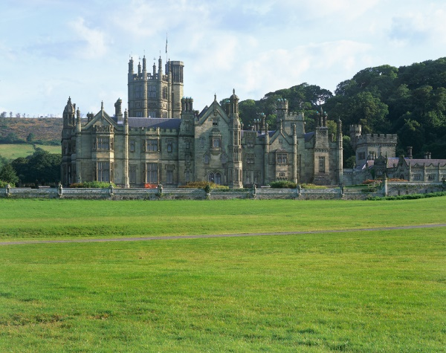
Margam Castle is set in 850 acres of magnificent country parkland that has over 4,000 years of continuous habitation and use. Margam Park is situated two miles east of Port Talbot, its history can be traced back even to pre-historic times, and in fact Bronze Age and Iron Age relics have been found close by, evidence of Roman and Celtic occupation (Wikipedia, Margam Park, 2018). At the start of the 19th Century Margam Park was developed, and the current Margam Castle was designed and built. The Mansel Talbot family had been in possession of the Margam Estate since 1536, however in 1787 Thomas Mansel Talbot had demolished the original mansion house and was replaced by the Orangery which can be seen in the gardens of the country park (Wikipedia, Chris Rice Mansel Talbot, 2019). The present day Margam Castle started being built in 1830 and construction didn’t finish until 1840, the building cost £50,000 using Sandstone from the local quarry; the equivalent of several millions of pounds currently (Margam Country Park). The building was designed in a Tudor Gothic style by English architect Thomas Hopper. Architectural features of the Castle were borrowed from Lacock Abbey in Wiltshire, the abbey was the ancestral home of the Talbot family (Wikipedia, 2019).
RCAHMW Colour Transparencies, 9th August 2005 taken by Iain N. Wright.

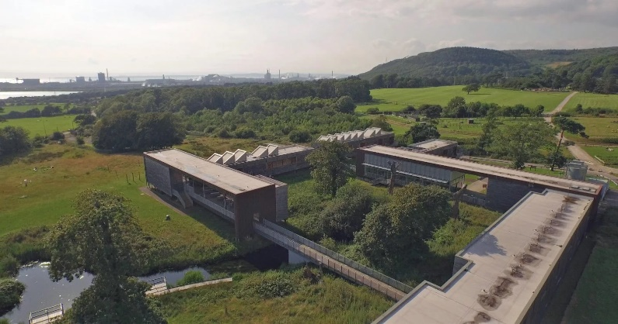
Situated in 850 acres of alluring country parkland is the Margam Park Discovery Centre, the Centre is a sustainable educational, artistic and leisure facility that offers a variety of different activities and facilities to customers. The structure exhibits sustainability and design to users, the building embodies passive design strategies, biomass plant and water recycling. The Discovery Centre provides a station for visitors to explore the rich history and culture of the surrounding parkland. (Loyn+Co, 2009).
FSC Studies, Margam Discovery Centre, 2009

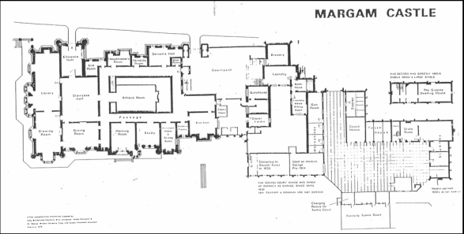
Plans and Drawings
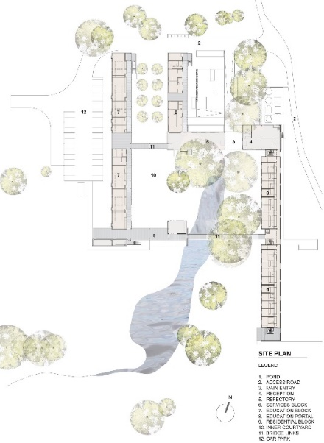

Margam Castle Plan, Forgotten Paranormal

Margam Castle’s ground floor consists of many rooms such as a kitchen, a living area, staircase room and various courtyards. As you go up the stairs the castle splits into many different bedrooms and bathrooms, long corridors link the rooms together.
Margam Discovery Centre Site Plan, Loyn+Co

The Discovery Centre’s Site Plan shows the various rooms that make the building. To the North side of the building there is the service and educational blocks, there is also the access road which leads visitors to the entrance of the Centre. The reception and refectory sit alongside the main entry, the residential block runs along the eastern side of the building. There is a large pond that slightly enters the inner courtyard, a bridge floats over this pond while linking the residential block and the educational portal together. Trees surround the Discovery Centre making it seamlessly blend into the surroundings.

Materials

The exterior of Margam Castle was built using locally sourced Sandstone, however harder stones were used to create the interior of the building. The interiors also used oak and pine for flooring and roof beams, there are also cast-iron railway beams that strengthen the staircase (Britain Express). The stone used in the interior of the castle create a cold atmosphere as you explore the different rooms, there are many pieces of furniture inside made out of stone and when visitors use this cold furniture it enhances the crisp and eerie atmosphere.
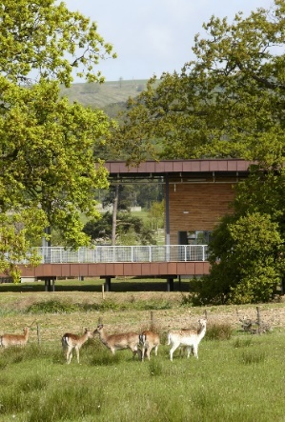
The Margam Discovery Centre is made up of prefabricated timber units that are cladded with UK grown sweet chestnut. The cladding is untreated and will eventually become a silvery colour as they become weathered and old, this effect will make the building blend into the surrounding woodland. The steel-framed portal structures have a copper cladding, this cladding is going to patina over time and will transition from a copper colour to an earth red (DCFW). The use of the natural wood makes the building seamlessly integrate with the surrounding woodland. The anticipation of the materials naturally aging is something that the architects thoroughly thought about, copper will oxidise, however this will end up giving the building a more natural look further adding to the integration of the surrounding area.
Margam Park Discovery Centre, Loyn+Co, 2009
Function

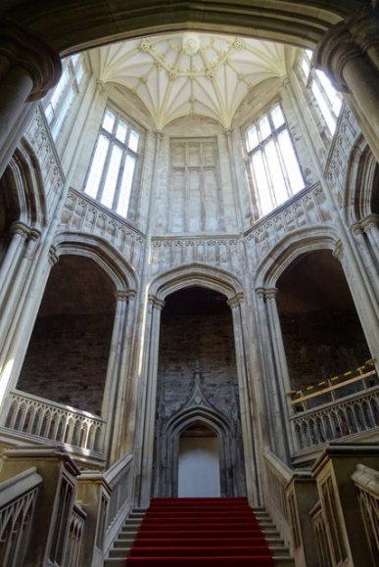
Christopher Rice Mansel Talbot wanted to create a grand residence that would complement the vast and wealthy history of Margam. Talbot encouraged his architect to let his imagination run freely, the castle boasts a myriad of turrets, towers, battlements and cupolas, vast winding staircases, luscious gardens, three courtyards and winding paths (Britain Express). The paths outside the castle lead you on a tour around the exterior of the building allowing the visitor to view the luscious gardens and surrounding parkland. These paths then lead you to the rear exit of the building, as you enter the building you are greeted with a very impressive staircase that rises to the first floor. If the visitor glances up, they can see the octagonal tower, which is a dramatic gothic style tower. This room creates a very powerful atmosphere because of features such as the staircase and the tower.
Staircase tower, Margam Castle, Philip Halling

The Discovery Centre is a high quality educational, developmental and leisure facility which celebrates alliance between culture, and the built and natural surroundings. The buildings function is to promote sustainability and it demonstrates renewable energy and water management to the visitors of Margam Park (DCFW).

Conclusion

In conclusion, Margam Castle is a Gothic Tudor Castle-Mansion that was built in the 19th Century. The Castle was owned by the Mansel Talbot family, the architect that designed the building was Thomas Hopper and he borrowed similar features and designed from the Lacock Abbey which was also owned by the Talbot family.

The Margam Park Discovery is a sustainable facility that ecourages visitors to explore the rich history and culture of the surrounding parkland. The structure also promotes sustainable building and demonstrates renewable energy use, heat, power, and water management.

I feel that I have learned a lot during the research I carried out during this essay, I learned a lot about the rich history and culture involved with my local country park and neighbouring buildings. It has made me think and look at buildings differently, I will now research more about the history and culture of buildings and structures.

Bibliography

https://en.wikipedia.org/wiki/Dissolution_of_the_Monasteries

https://castles.today/en/castles/castles/wales/magram/history/

Reference List

Wikipedia (2018) ‘Margam Park’, Wikipedia, 11th December 2018. Available at: https://en.wikipedia.org/wiki/Margam_Country_Park (Accessed 19th January 2020).

Coflein (2005) ‘RCAHMW Colour Transparencies’, Coflein, 9th August 2005. Available at: https://coflein.gov.uk/en/archive/6169496/details/504 (Accessed 19th January 2020).

Wikipedia (2019) ‘Chris Rice Mansel Talbot’, Wikipedia, 22nd December 2019. Available at: https://en.wikipedia.org/wiki/Christopher_Rice_Mansel_Talbot#cite_note-9 (Accessed 19th January 2020).

Margam Country Park ‘Margam Castle, The 19th Century Tudor Gothic Mansion’. Available at: http://www.margamcountrypark.co.uk/1242 (Accessed 19th January 2020).

Loyn+Co (2009) ‘Margam Park Discovery Centre’. Available at: http://loyn.co.uk/work/margam (Accessed 19th January 2020).
Forgotten Paranormal ‘Margam Castle Plan’. Available at: http://forgottenparanormal.co.uk/Margam%20Castle%20Port%20Talbot.html (Accessed 20th January).

FSC Studies (2009) ‘FSC Margam Discovery Centre’. Available at: https://www.field-studies-council.org/locations/margam/ (Accessed 19th January 2020).

Britain Express ‘Margam Castle’. Available at: https://www.britainexpress.com/attractions.htm?attraction=671 (Accessed 19th January 2020).

Design Commission For Wales ‘Margam Discovery Centre – Port Talbot’. Available at: https://dcfw.org/margam-discovery-centre-port-talbot/ (Accessed 19th January 2020).

Halling P. ‘Staircase tower, Margam Castle’. Available at: https://www.geograph.org.uk/photo/6158879 (Accessed 19th January 2020).

