
Portfolio Of St Agatha
By Jenny Weaver

17 May 2026

Module: Cults, Cures and Canonisation: Saints in the Middle Ages.
Historiographical Materials of St Agatha

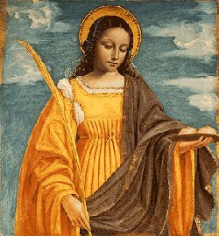
Saint Agatha by Berogne Ambogio Figure 1

St Agatha was one of the early Christian virgin martyrs who died in 251CE aged twenty. She is the patron saint of Sicily, Gallipoli, Molise, Malta and San Marino. Her patronage also extends to sufferers of breast cancer, bellfounders, nurses. wet nurses rape victims, victims of torture, firemen, victims of earthquakes and volcanic eruptions. The story of Agatha has been remembered in many ways, from prose, to paintings, liturgies to relics, feast days to music and even the baking of cakes. All have been vital to her memory and the continuation of her cult.
Agatha was born of a distinguished family and being very beautiful she was pursued by the local senator Quintanus. Having vowed to remain a virgin and following the path of Christ she rebuffed him which resulted in him first sending her to a house of ill repute and then torturing her, notably cutting her breast off which was miraculously cured by St Peter in prison. Following more torture she died and was almost immediately hailed as a Christian martyr worthy of sainthood because of miracles performed notably the healing of her breasts and when her veil was used to prevent the flow of lava from Mount Etna destroying Catania. She was officially canonised by Pope Gregory I in 1228 and is patron saint to Catania, the place of her death which is famous for its celebration of her feast day on Feb 5th and to a lesser extent on the anniversary of the translation of relics from Constantinople back to Catania in August .
Although cults were suppressed in Muslim Sicily, they were revived following its reconquest in 1091 by the Normans and St Agatha’s cult was re-established in the twelfth century although even under Muslim control she had been remembered in the Church S. Agata La Vetere in Catania. There is a great deal written about St Agatha although there is no historical credibility or any written evidence of her existence . However, Robert Bartlett states that this is irrelevant as elaboration of the saints’ stories is the same whether they were fictional or real.
Hagiography is a type of historical literature possibly dating from the second century which comprises the narratives of saints and their miracles for their glorification and enlightenment of their audience. They were written to demonstrate saints’ bravery and nobility and were designed to inspire admiration and devotion. It was important therefore to have hagiographies of saints in order to develop their cults and following. Famous examples of hagiographies of St Agatha are found in Aelfric’s Lives Of Saints written in Old English, and The Golden Legend written in the thirteenth century, which was probably one of the most important collections containing one hundred and fifty three hagiographies written by Jacobus de Verangue which were widely read in Europe. Less well known, Osbern Bokenam a fourteenth century poet included St Agatha in his Legends of Holy Women.
Veneration to Agatha has taken place since very early times with her feast day being recorded in the Martyrologium Hieronymianum which is the oldest Latin martyrology, providing a list of saints and martyrs for every day of the year, and is attributed to St Jerome from the sixth and seventh centuries. At first these were functional texts used to arrange the liturgical year but later they became more detailed narratives which included the saints’ biographies. Liturgy is the series of dates, fixed, feast, or movable dates which provide the basic framework of Christian worship. The celebration of saints is a public act said to be pivotal to church ritual – celebrating with mass and office, and Agatha was one of the seven female martyrs mentioned at every service in prayers in the Canon of the Mass during the sixth century (possibly attributed to Pope Gregory the Great.) However the most elaborate liturgical commemoration would have been on her feast day. This still occurs in Catania between the third and fifth of February where thousands of people celebrate with pilgrimages to the basilica, conferences, sports events, miracle plays and most importantly the parade of her relics through the street. It is the third largest Catholic celebration in the world.
She has many churches dedicated to her name, importantly, two in Catania, the Sant Agata la Vetere which is built over the spot where she faced her trial and the cathedral known as Basilica Catedral Sant Agata where her relics are kept. These relics which are pieces of her body and her veil, constitute a large part of the cult of St Agatha and are housed in a large silver reliquary decorated with enamel, in the shape of a bust statue. Relics were an integral part of the worship of saints as it was either by their shrine or bodily relics that miracles were said to often take place.
Hagiographies can also be visual with many paintings and illustrations of St Agatha in churches, breviaries, books of hours and stained glass. Pope Gregory was responsible for her canonisation and reconsecrated a basilica in Rome Sant Agata dei Goti , which he had decorated with scenes from Agatha’s life. He liked images so that the illiterate could also read her story from the paintings. Images of saints frequently depict the story of their passion illustrating their torture or how they died, Agatha is often depicted carrying a plate holding two breasts (as in the image above.) The manuscript Latin MS5594 contains hagiographies of saints including St Agatha but in the form of illustrations. It depicts the passion of St Agatha and, dating from the late tenth century, is one of the earliest surviving manuscripts of narrative illustrations in existence.
Music also plays a part in commemoration of St Agatha with words that are found on her reliquary having been set to music and sung at her feast day, along with hymns honouring her as a saint, highlighting her virtues. Lastly mention must be made of the pastries known as Agatha bread that are traditionally made in many countries, forming the shape of her breasts to be eaten on her feast day.

Commentary on the Miracle of St Agatha’s Veil Preventing Mount Etna Destroying Catania.

In the same province of the land of Sicily
is a burning mountain, which men call Etna, which
kindled with suqiliur, that is brimstone in English.
The mountain burneth ever, as many others do.
Then befell it, about twelve months
after Agatha's passion, that Etna exploded (lit. blew up)
with a very fearful burning, which ran down the mountain
even like a flood, and the stones melted,
and the earth was burnt up, until it came to the city.
Then ran the heathen to the saint's tomb,
and took up the veil^{[2]} from the saint's tomb,
against the fire which frightened them exceedingly.
Then the fire was quenched, and immediately stood still
for the merits of Agatha, the noble woman;
Six days it burned, and stood still on the day
whereon the blessed Agatha departed to eternal life,
that it might be manifest that the city was delivered
from the peril of fire by Agatha's intercession,
to the praise of the Saviour, who thus honoureth His Saints.
"Wherefore to Him ever be glory to all eternity. AMEN.
Aelfric’s Lives of Saints

This passage is taken from the story of Saint Agatha found in ‘Aelfric’s Lives of Saints’ which was written between 994-998CE by Aelfric of Eynsham, a tenth century monk who was based at Cerne Abbey. This book contains a collection of narratives about the lives, deaths and miracles of saints. In early England the popularity of saints was high, and this work based around the liturgical year was designed to uplift and entertain people while they read or were being read to. His ‘Book of Lives’ concentrated on those saints who were steadfast in their faith and did not display negative emotions wanting them to be examples of an exemplary Christian faith for people to draw strength.
Saint Agatha was a beautiful young Christian woman of noble birth born in 231 CE in Sicily who had been pursued by Quintianus, the Roman governor of Sicily, and who after spurning his advances, was brutally tortured notably by being stretched on a rack, having her breasts cut off, and by being rolled on hot coals and sharp shards, because she had dedicated her virginity to Christ. Agatha’s shorn breasts were miraculously healed by St Peter when he appeared in a vision to her in prison, but she died in prison in 251CE. However, a year after her death, Mount Etna erupted and the townspeople, fearful for the town of Catania, used her veil to invoke her intercession to stop the lava flow which duly happened.
Agatha is described as one of the early virgin martyr saints and although virginity was not an official requirement of sanctity at the time , it had become a highly regarded virtue in early Christianity. Much of her story which is described as a ‘Life’ or vita (biography of a saint,) concentrates on her persecution and subsequent martyrdom, describing her resilience, nobleness and even joy in the face of torture, ‘so greatly I rejoice in these painful torments, ’ which was likened to Jesus’s suffering on the cross. Bartlett describes a ‘Life’ as a written account of why a particular person should be regarded as a saint, and they would very often include miracles performed during life or after death. Thousands of Lives were written, often following similar narratives of persecution, torture and redemption on death, especially those of the martyrs, but Agatha’s miracles involving her breasts being healed and her veil appear to be quite unique.
During Agatha’s last trial by torture, an earthquake occurred, perceived to be due to the injustice of her persecution. This stopped her trial and she later died in prison from her wounds. It is said that after Agatha’s death, a tablet was laid by an unknown man, surrounded by youths at her head inside her tomb who Aelfric states was an angel. The words written on the tablet: -‘A mind spontaneously holy, an honour to the benevolent God , and deliverance to her country’, implied that she would protect Catania. There is no evidence that this plaque existed however it adds to her story and enhances the process of veneration with the presence of angels, which was thought of as miraculous. This and the earthquake during her trial are said to have incited pagans, Jews and Christians to visit the tomb which was decorated with a pall thought to be her veil. It was this cloth that was used to stem the flow from Mount Etna which erupted in 252CE by hanging it in its path. Objects that have been in contact with the saint during their lifetime or their tomb are treated as relics and are as revered as the saint’s body.
Although it was important for hagiographers to write of miracles occurring during and after the life of a saint, Agatha’s life as described by Aelfric does not describe miracles that occurred while she was alive other than the healing of her breasts by St Peter ‘I am His Apostle, and behold now thou art made whole in his name’ However this chosen passage taken from the end of Aelfric’s ‘Life of Agatha’ describes perhaps her most well-known posthumous miracle, that of her veil being used to stem the flow of lava from an eruption of Mount Etna, in 292CE a year to the day following her death.
Although a cult had started developing following her death due to her profound profession of faith, during her torture, eagerly embracing martyrdom, the triumph of her veil against the mighty lava flow seems to be one of the defining aspects of her memory which further enhanced her reputation, meaning her tomb became a place of pilgrimage. Her veil which still exists was alleged to have been white to start with, being a symbol of purity but is now red in colour and is kept at S. Agata la Vetere in Catania where it has been used to intercede when the population have faced further eruptions or earthquakes. Agatha’s close association with Mount Etna means that along with many other patronages, she is also invoked against the eruptions of said volcano and against fire and lightening.
In Aelfric’s description of the eruption of Mount Etna, where he uses words such as ‘burning mountain,’ ‘kindled with suqilar,’ ‘fearful burning,’ ‘like a flood,’ and ‘melting stones’ all which resemble how ‘hell’ is perceived, he even talks about ‘ the heathen’ running to the tomb to collect Agatha’s veil to invoke her help. This use of imagery promotes the idea of people’s religious redemption through her intercession (as well as asking for her help to stop the lava flow.) Also, in this short passage describing the events of the veil, Aelfric uses her name four times: - emphasising to readers, ‘Agatha’s passion’, Agatha’s ‘intercession’, he describes her as ‘Agatha, the noble woman’ and how ‘blessed Agatha departed to eternal life.’ These are all phrases that are synonymous with the description of holy people or saints and are to remind readers of her virtues, therefore an important aspect in the promotion of her cult. His book which is thought by scholars to be a major piece of Anglo- Saxon literature, gives examples of courage, faith and sacrifice all of which were important in the Middle Ages and of which Saint Agatha is a fine example.

Image of St Agatha

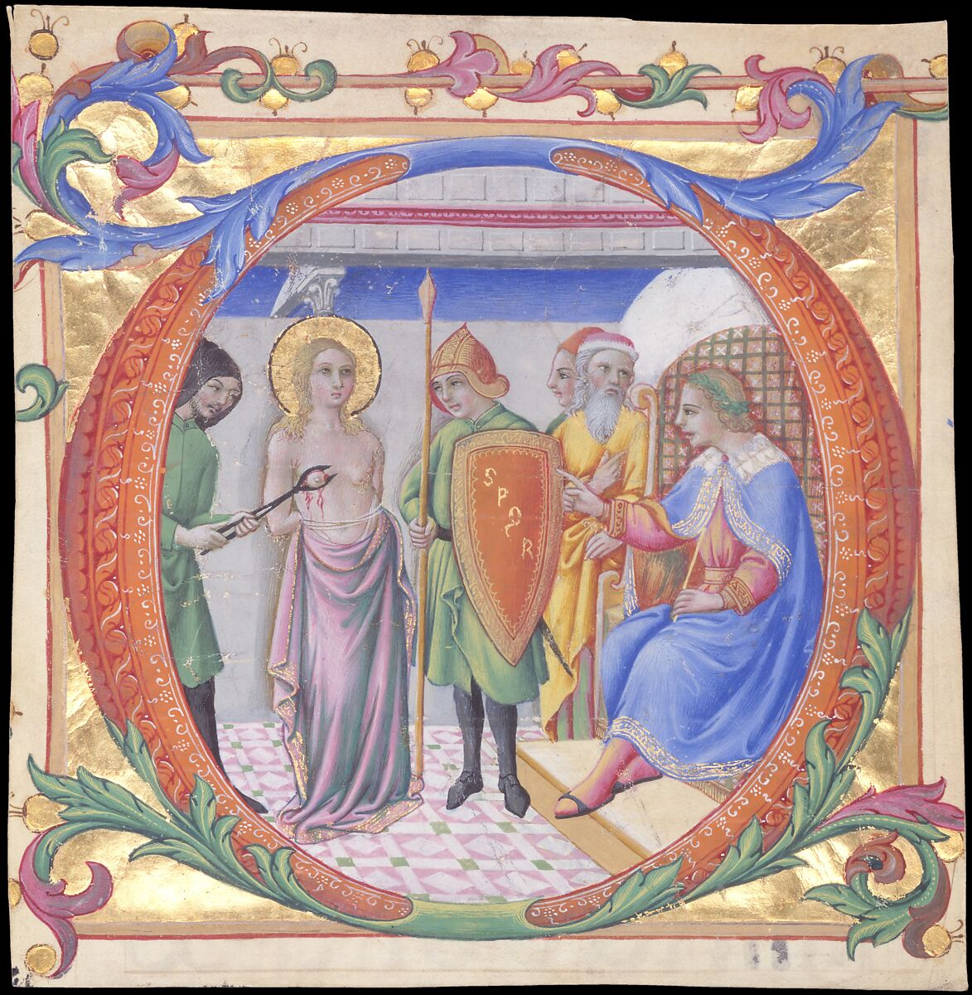
Martydom Of St Agatha Figure 2

This picture is known as ‘Martyrdom of St Agatha in an Initial D,’ and was painted by Sano di Pietro c.1470. Created in Siena Italy during the Early Renaissance, it is an explicit illustration depicting St Agatha in the presence of Quintianus her persecutor (sat down) having her breast cut off with pincers in front of witnesses. The illuminated manuscript was originally part of a choirbook for the Hospital of Santa Maria della Scala in Siena but is now found in the Metropolitan Museum of Art in New York.
Saint Agatha who died in 251CE following many tortures, is most famously known for having her breast cut off and then subsequently her wounds healed by St Peter in prison. Her veil is also known for stopping Mount Etna’s lava flow from destroying Catania, her hometown. She is the patron saint of Catania and Sicily, and as martyrs were invoked against all types of illnesses, often those that were associated with their death, she is patron saint to wet nurses and breast disease (amongst many other patronages). She was one of the early virgin martyrs and is depicted in illustrations found in many manuscripts, psalters, churches in Sicily and a large fresco in the Basilica of St Agatha in Rome. Portraits of St Agatha are usually readily recognised by the presence of her halo demonstrating her saint status, severed breasts, pincers and the palm of martyrdom. However, she is also often depicted carrying her two breasts on a plate. In a similar vein St Lucy carries a tray with her eyes on which she gouged out to discourage a suitor. Most illustrations of martyrs depict their passion scenes therefore although Agatha’s miracles are much venerated it is not usually her miracles but her endurance while suffering on earth that take precedence.
Martyrs were Christians that died for their faith, usually tortured and killed in a public way. Their sacrifices were made on behalf of other Christians, and their last days were usually recorded in Lives or in illustrations. Count Valerian Krasinski stated of martyrs, ‘Nothing can be more deserving of our admiration than the conduct of the Christian martyrs who cheerfully submitted to an ignominious death.’ The virgin martyrs were a category of saint, who having given up worldly pleasures to follow Christ, were persecuted for their Christian beliefs. Images of them were an important aspect of Christian piety. The last few days of these saints’ lives known as passions, very often followed the same pattern, they depicted or described the judicial process, physical violence and there was public spectacle of their death. Hostile Roman officials usually played a key role and their punishments were often the application of pain prior to their death. Agatha’s story is very similar to Saint Eulalia of Merida Spain who was also a teenage virgin martyr, persecuted by Romans for her chastity in the third century. This picture of Agatha is a perfect example of a virgin martyr, in that it encapsulates all these aspects mentioned above but also depicts St Agatha enduring these tortures with a serene expression. Pictures such as these found in manuscripts very often illustrated the martyrs as heroes refusing to give up their faith despite pain and torture.
During these trials, the virgins usually had to undergo some sort of sexual humiliation, at the same time embracing the torture. ‘St Agatha was quoted by Aelfric as saying ‘So greatly I rejoice in these painful torments.’ Martha Easton states that as Quintianus had been sexually rejected, he punished the most visible sign of Agatha’s sexuality, by stripping her and cutting off her breast. The stripping of clothes from a martyr was an important part of the process of humiliation although there is no mention of men being stripped.
All martyrdoms were related to the crucifixion of Jesus as he was seen as the ultimate sacrifice and the martyrs died as witnesses to this. Many pictures of Agatha are associated with crucifixion, with paintings of her hands tied to a post, naked to the waist and prodded with long instruments which equate to the lance in Jesus’s side. Most scenes of martyrs included the tortures the prosecutors had inflicted, this was possibly to heighten the response from the viewer. Pictures of Agatha and other martyrs gave comparisons to Christ’s death thus encouraging religious contemplation.
Agatha is probably remembered mostly because of the amputation of her breasts and their subsequent healing by St Peter in prison. Aelfric quotes her as saying to Quintatus when her breast was cut off ‘O thou most wicked, art thou not ashamed to cut off that which thou thyself hast sucked?’ Although there are many depictions of her torture, illustrated mutilations in Europe rarely appeared until after the twelfth century, this could be because disfigurement of women either through mutilation, accidental injury or disease could evoke strong reactions of either empathy or even shock and repulsion. Bartlett states that the stories of the torture of saints maybe gave ‘sadomasochistic gratification’ especially when writing or depicting a woman, possibly equivocal to pseudo castration so that men could also identify with her. Easton thinks that the images are ‘sensual, sadistic, voyeuristic and violent,’ being a combination of religious and erotic, and this is why saint Agatha’s image was so popular and powerful. However, she also states that they need not have been erotic viewing as the breast was also used for nourishment rather than just for sexual purposes.
Images of the passions of martyrs, were designed to heighten the response of the viewer, inviting religious reflection. Pictures of St Agatha in churches ranged from her being fully dressed, arriving at the gates of heaven with a plate carrying her breasts as found in Saint Agatha of Feltra, to a huge picture of her torture behind the alter in Trasteveres Church in Rome, which may have been somewhat distracting. However, despite graphic images as in the image of St Agatha above, it was the symbolic illustration of faith and purity in the face of humiliation and torture that was intended and that led them to become so popular.

The Relics of Saint Agatha
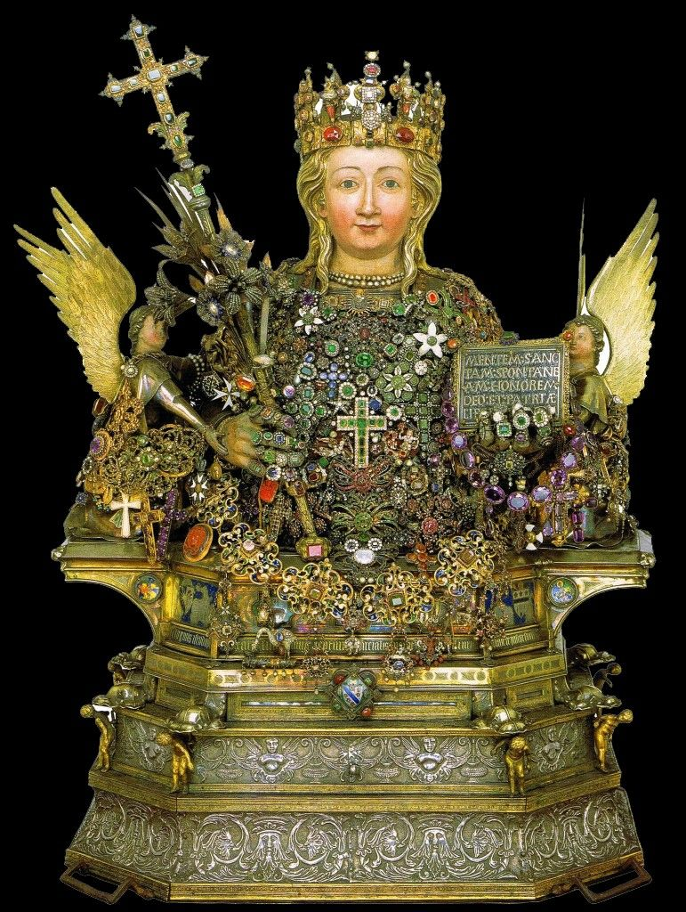
Reliquary of St Agatha Figure 3
Relics are the mortal remains of saints or anything that has come into contact with them and can be found throughout the world. Morris Bishop states that when the soul of a person ascends to heaven, their body remains as ‘a perpetual token of their stay on earth’ with their personal belongings being impregnated with their spirit. Relics of the body were known as corporeal, they may have been the whole body or, as became more popular in the Middle Ages – fragments of the body, these included bones but could be other bodily parts. Of equal importance to corporeal remains, were articles that were associated with the saints which could include objects that had touched the saint during their life or after death as with St Agatha’s veil, or it could be merely something that had touched the tomb .These contact relics ranged from clothes, beds or even dust from their tomb. A common type of relic were cloths placed on top of the tomb, some of which were lowered inside and when brought out were heavier as they were soaked in ‘divine power’. Contact relics were thought to originate from St Paul, from when peoples handkerchiefs that touched him while preaching, were alleged to have healed the sick and exorcised demons. Count Krasinski wrote in Jean Calvin’s Treatise on Relics, ‘it is natural that various objects which had belonged to the martyrs were carefully preserved as interesting mementoes. ’ The worship of relics reached its zenith in the Middle Ages with fragments of the cross being the most venerated. John Calvin wrote that ‘if we were to collect all these pieces of the ‘true cross’ exhibited in various parts, they would form a whole ship’s cargo.’
Relics were believed to have healing properties, and the closer a person was to the relic the more likely they were to be granted a miracle. They provided physical evidence that the saint had lived a life, appearing more accessible to worshippers and therefore were central to a cult. Their shrines being places that could be visited easily by worshippers and growing up with the knowledge of the legend meant that the potency of the cult increased. However they were not just a Christian phenomenon as Buddhists also revered relics of Buddha and associated saints, their relics were very often cremated remain of bodies.
Relics of saints had a special position in medieval society as their connection to the living saint, especially if they were known to have performed miracles, meant that they had great spiritual value. Italy was regarded as a great’ reservoir of saintly bones’ being taken from dilapidated churches and removed to churches where they could be honoured appropriately. Some churches built up collections like St Augustine’s Abbey in Canterbury which had several reliquaries to worship. Some relics were traded and bought and sold for profit, Elizabeth Wiedenheft states that although relics could be valuable, they may only have been valuable in that specific area. There is no evidence of any stealing of St Agatha’s relics- maybe because of the sense of unity within Sicily, but her relics being found in different parts of the world suggest that they were used as a way of spreading her cult.
Bartlett states that cults had three defining elements, public recognition of name and date of death, celebration in writing with literature providing the cement to bring evidence of the saint to communities and the presence of physical objects that can be worshipped. When St Agatha died following her torture, a cult almost immediately started to develop with veneration taking place at her tomb. St Lucy who was martyred fifty years later was meant to have visited her tomb. St Agatha’s adulation was consolidated when her veil, which covered her tomb was used to stem the flow of lava from Mount Etna in 252CE.
St Agatha’s remains were originally placed in a tomb in Sant Agata La Veterre but they were taken to Constantinople in 1040 when they were donated by Byzantine General Giorgio Maniace after temporarily conquering Sicily and as a gift trying to regain royal favour, which indicates how politically important relics could be. Legend states that the Byzantine ship was grounded for three days illustrating Agatha’s displeasure at being removed from Catania. Eighty-six years later they were returned by two soldiers who Agatha had visited in dreams telling them to return them to Catania by stealing them from the church in which they were housed. Theft of relics was often seen not to be a crime, especially as often the saint had given permission to the thief to remove the relics in a dream, but a pious action, maybe to justify the receiving church’s possession. Her body was cut into five pieces, hidden in quivers and covered with rose petals in order to be returned to Catania in August 1126, and she provided a miracle that night where a blind, paralysed woman was suddenly able to see and move. On their arrival to Catania people rushed out in their white nightclothes, such was their joy.
Translation was the ritual movement of relics, which started in the fourth century and continued throughout the Middle Ages. Fragmentation of the body meant that relics could be moved much more easily with the head having most significance, and they could also be sent to different locations thus spreading a cult. It could be short distances such as within a church or large distances such as St Agatha’s return from Constantinople and if this was the case then arrival into the city would be greeted with ceremony and joy.Important translations also received a mention in the Liturgical calendar along with feast days. St Agatha’s day is in August, but the celebration is not so large as her feast day festivities.
While tombs housed whole bodies, reliquaries began to be made to house the fragments of the saints. Some consisted of small caskets while others were made in the shape of what was inside as is the case for St Agatha. Some were made with a window of crystal or glass to allow direct sight, as for her veil. Her reliquary bust is found in the Cathedral of Catania and contains her head and torso, along with two documents confirming the authenticity of the relics. Other parts of her body including her feet, hands, femur and one breast are kept in other reliquaries, in the same church. The reliquary, created between 1373 and 1376 by Giovanni Di Bartol, is made of silver and embossed with jewels and gifts. The crowned bust depicts St Agatha flanked by angels, holding a crucifix and a tablet with the inscription similar to the tablet put into her tomb by an angel, and is decorated with offerings from people such as a ring from Gregory X, the crown has links to Richard I , several crosses from bishops and a cross of the Legion of Honour from Vincenze Bellini (nineteenth century Italian composer). These gifts are an indication of how far her cult had spread not just locally but worldwide.
It is important to mention one of her most important relics, namely her breast which is found in Galatina, and according to legend materialised when St Agatha appeared to a woman in a dream in 1126, telling her that her infant son had an object in his mouth. He wouldn’t let it go until a bishop recited a litany invoking all the saints, and having reached St Agatha’s name the child let it go and it was seen to be her breast, of which the infant suckled sweet milk.
Relics are vital to cults, having a personal and religious significance to the population, but also diplomatic, political and cultural relevance. As St Agatha’s cult developed, she came to the notice of sixth century Pope Gregory I who was responsible for her official canonisation, this most likely is the reason that there are several fragments of her veil in churches in Rome. Agatha’s relics also became politically important during her movement to Constantinople (given as a peace offering) and then her translation back to Catania, as they stopped at several cities in Sicily and distributed some fragments to churches in Palerma, Messina and Ali, which have her arm bones. This can be seen as an act of generosity but can also be seen as a method to increase the prestige and authority of the church in Catania. Maurice Rupert Bishop was a key figure in St Agatha’s translation and was prominent in the promotion of her cult. St Agatha was also supported by a cross section of the community, from the wealthy nobles to peasants, as well as monks and craftsmen. This is illustrated during her feast parade as the Candelora parade represents the local guilds. Nobility was important as moving in higher political circles they were able to disseminate her cult at the highest level.
The return of St Agatha’s relics and her ‘presence’ in Catania, which was becoming an increasingly powerful diocese, was very important in the re-establishment of Christian identity. Oldfield states that St Agatha’s revival in the twelfth century played a significant role in the re- Christianisation of Sicily , with her becoming Sicily’s’ flagship saint’ . As well as being patron saint of Sicily, other patronages include rape victims, breast cancer sufferers, wet nurses, nurses, bellfounders (due to the bells being the same shape as breasts), fire victims and protector against natural disasters. These are all relevant to her life and miracles and the number of patronages indicates how wide her cult has extended.
The spread of her cult brought Sicilians and foreigners to Catania increasing its prestige and wealth, with miracles happening en- route and at the shrine. By the mid twelfth century it had spread throughout the island and into Europe with Sicily developing diplomatic relations with Rome, France and English. During the third crusade the crusaders stopped off in Sicily , with Richard I allegedly donating the crown to the reliquary, strengthening diplomatic links throughout West Europe.
Although the worship of relics is not to the same extent as it was in the Middle Ages, they are still venerated and a part of Roman Catholic devotion, creating a strong affinity with a city or an area and a powerful influence according to how emotionally attached the townspeople are to them. This is thought to be especially the case if that saint has become patron saint to that city or to their country. Fausr states that there is a collective identity linked with St Agatha’s cult, thinking of her almost as a relative and a part of everyday life when walking past the cathedral where her relics are housed.
The most significant event involving St Agatha’ s relics is when her bust is paraded round the streets of Catania on her feast day. This is not a unique occurrence as the procession of relics have been occurring for centuries and were so common that from as early as the seventh century, there were rules on how processions should be conducted. They are paraded twice a year between the third and fifth of February and in a smaller procession to mark the translation of relics in August. The celebrations start with her highly venerated veil (flammeum) which is thought of as a ‘powerful weapon of salvation’ on show from the end of January to the fifth of February , in its own silver reliquary. The first parade on the third of February is called the Candelora and involves a wooden candelabra carried on the shoulders of men and women to represent the guilds in Catania. This is less church focussed and more folkloric but is becoming increasingly popular. On the fourth and fifth of February is the procession of the large reliquary sat on a twenty five ton vehicle pulled with ropes through the streets of Catania by devotees wearing white robes known as sacco, (representing the nightshirts worn by the townspeople when her relics returned from Constantinople,) black hat, cord (representing her chastity,) white gloves (showing respect for St Agatha) and handkerchief to be waved in joy and exaltation in an expression of faith and jubilation. This festival pulls the largest crowd and is run by the church. The service brings a unity to the community, a closeness to the saint and is said to be an initiation rite for the youths with the pulling of the reliquary around the streets. The celebration is for everyone, even the mafia and when the archbishop tried to ban them in 2014, the people of Catania protested saying that nobody should be withheld from the saint regardless of their crimes.
Relics were considered as some of the most powerful objects either for personal worship or for ritual reverence with miracles often occurring at the shrine of the saint. Christians used them to help with their own worship, but they were of fundamental importance to the development and growth of a cult. They brought prestige and authority to towns and cities with St Agatha’s relics gaining political and diplomatic ties throughout Europe, as well as helping with the re-establishment of Christianity in Sicily. They are very much part of Catania’s society and her well attended annual festival brings a great sense of unity and community identity to the city.

Bibliography

Images
Figure 1- Berogne Ambogio, Saint Agatha, < https://www.catholic.org/saints/saint.php?saint_id=14> [accessed 16 May 2026].
Figure 2 Sano di Pitro, Martyrdom Of St Agatha, https://collectionapi.metmuseum.org/api/collection/v1/iiif/461122/913344/main-image [ accessed 17 May 2026].
Figure 3 Giovani Di Bartolo, Reliquary Bust Of St Agatha,(1373), St Agatha Of Sicily, Cavanagh Art, https://www.cavanaghart.com/blog/st-agatha-of-sicily [accessed 16 May 2026].

Primary sources
Aelfric, Aelfrics Lives Of Saints, St Agatha (London: Early English Text Society, 1881), https://archive.org/details/aelfricslivesofs01aelfuoft/page/206/mode/2up [accessed 12 May 2026].

Calvin, John, A Treatise On Relics, (Edinburgh: Johnston. Hunter & Co, 1870), https://archive.org/details/atreatiseonrelic32136gut/page/n3/mode/2up [accessed 16 May 2026].
Voragine, Jacobus de, ‘Saint Agatha’, The Golden Legend, Readings On The Saints, trans, William Granger Ryan (Princeton: Princeton University Press, 1993) < https://research-ebsco-com.uwtsd.idm.oclc.org/c/onvpsy/ebook-viewer/pdf/q5og2sx23b/page/pp_iv?location=https%25253A%25252F%25252Fresearch-ebsco-com.uwtsd.idm.oclc.org%25252Fc%25252Fonvpsy%25252Fsearch%25252Fdetails%25252Fq5og2sx23b%25253Frequest-context%25253Dplink%252526db%25253Dnlebk> [accessed 12 May 2026].
Wikisource, ‘Aelfric’s Lives Of Saints/Of St Agatha’ https://en.wikisource.org/wiki/%C3%86lfric%27s_Lives_of_Saints/Of_Saint_Agatha [accessed 12 May 2026].

Secondary sources
Bartlett, Robert, Why Can The Dead Do Such Great Things? (Oxford: Princeton University Press, 2013).

Bishop, Morris, The Penguin Book Of The Middle Ages ( Norwich: Fletcher And Son Ltd, 1968).

Brazinski, P. and Fryxell, Allegra, ‘The Smell Of Relics: Authenticating Saintly Bones And The Role Of Scent In The Sensory Experience Of Medieval Christian Veneration’, Papers From The Institute Of Archaeology 2, Art. 11 (2013), https://student-journals.ucl.ac.uk/pia/article/id/489/ [accessed 16 May 2026].

Briones, Shaylee, ‘The Power Of Relics And Reliquaries In Byzantine Liturgy And Ritual’, Byzantium: Trade Treasure Tradition (2021) https://digitalcommons.usu.edu/cgi/viewcontent.cgi?article=1024&context=arth3620_2021 [accessed 16 May 2026].

Britannica, Hagiography, < https://www.britannica.com/topic/hagiography> [accessed 11 May 2026]

Carasco, Magdalena Elizabeth, ‘An Early Illustrated Manuscript Of The Passion Of St Agatha (Paris Bibl.Nat., MSlat.5594), The University Of Chicago Press Journals, 24.1(1985) https://www.semanticscholar.org/paper/An-Early-Illustrated-Manuscript-of-the-Passion-of-Carrasco/943253f9fd6ad1b65753b141367b6f33b9f1be23> [accessed 11 May].

Catania, ‘The Relics’, Discover Catania (April 2022), https://turismo.comune.catania.it/en/discover-catania/feast-of-saint-agatha/the-devotion/the-relics/default.aspx [accessed 11 May 2026].

Catania, ‘The Miracle Of The Veil’, Discover Catania,(2022), https://turismo.comune.catania.it/en/discover-catania/feast-of-saint-agatha/the-devotion/the-miracle-of-the-veil/default.aspx [accessed 12 May 2026].

Di Giovanni, Elisabetta, ‘The Religious Feast Of St Agatha: A Modern Initiation Rite In Catania’, Academia.edu. https://www.academia.edu/106243573/The_Religious_Feast_of_St_Agatha_A_Modern_Initiation_Rite_in_Catania [accessed 11 May 2026].

Dpipio, Gregory, ‘The Legend Of St Agatha’, New Liturgical Movement (2022), https://www.newliturgicalmovement.org/2022/02/the-legend-of-st-agatha.html [accessed 11 May 2026].

Faust, Lene,’ Negotiating Sicilian Identities And Social Change Through The Festival Of St Agatha Of Catania’, Italian Studies, 81.1, (2026) pp.84-97 https://doi.org/10.1080/00751634.2025.2605818 [accessed 11 May 2026].
Girolami Cheney, Liana de, ‘The Cult Of St Agatha’, Women’s Art Journal, 17,1 (Spring – Summer, 1996) https://moodle.uwtsd.ac.uk/pluginfile.php/246370/mod_resource/content/0/Cult%20of%20St%20Agatha.pdf [accessed 11 May 2026]

Kehoe, Niamh, ’Aelfric’s “Lives Of Saints” ‘, University Of Oxford, History Of English Language And Literature,(2025),
Lancaster University,’ Seminar VII: Hagiography’, Medieval Primary Sources, https://www.lancaster.ac.uk/staff/haywardp/hist424/seminars/07.htm [accessed 12 May 2026].
Martins, Dr. Julia, `St Agatha: The Sicilian Martyr Honoured With Breast Shaped Pastries’, Living History( 2024) https://juliamartins.co.uk/meet-saint-agatha-sicilys-virgin-martyr-and-dessert-icon [accessed 16 May 2026].

New Advent, ‘St Agatha’, The Catholic Encyclopaedia, https://www.newadvent.org/cathen/01203c.htm [accessed 11 May 2026].

Oldfield, Paul , The Medieval Cult Of St Agatha of Catania And The Consolidation Of Christian Sicily, The Journal Of Ecclesiastical History, 62.3 (2011) pp.439-459. https://www.proquest.com/docview/869981308?accountid=130472&parentSessionId=Bod%2Bgm4cLM61ELEnb4PfPUshGt45vhAXvBaBsER1XJw%3D&pq-origsite=primo&sourcetype=Scholarly%20Journals [accessed 16 May].

Soto- Martinez, Bianca, ‘Sacralised Wounds, Mutilation And Resistance In Christian Martyrs’ Castillian Hagiographies: St Agatha, St Lucy And St Apollonia’, E Humanista Vol 63 , 2025, https://www.academia.edu/144540735/SACRALIZED_WOUNDS_MUTILATION_AND_RESISTANCE_IN_CHRISTIAN_FEMALE_MARTYRS_CASTILIAN_HAGIOGRAPHIES_SAINT_AGATHA_SAINT_LUCY_AND_SAINT_APOLLONIA [accessed 11 May 2025].

Skeat, Rev, Walter W. Aelfrics Lives Of Saints, St Agatha (London: Early English Text Society, 1881) https://archive.org/details/aelfricslivesofs01aelfuoft/page/206/mode/2up [accessed 12 May
2026].

Skinner, Patricia, ‘Marking The Face, Curing The Soul? Reading The Disfigurement Of Women In The Later Middle Ages’, Medicine, Religion and Gender In Medieval Culture [Internet] https://www.ncbi.nlm.nih.gov/books/NBK311275/ [accessed 16 May 2026].

Stracke, Richard, ‘Saint Agatha’, The Iconography https://www.christianiconography.info/agatha.html [accessed 16 may 2026].

Krasinski, Count Valerian , A Treatise On Relics (Edinburgh: Johnston. Hunter & Co, 1870) https://archive.org/details/atreatiseonrelic32136gut/page/n3/mode/2up [accessed 16 May 2026].

Elizabeth Weideheft, ‘Bodies As Commodities: The Medieval Trade In Christian Saints’ Relics’, Economic History Society Blog, 12 October 2017, < https://ehs.org.uk/bodies-as-commodities-the-medieval-trade-in-christian-saints-relics/> [accessed 16 May 2026].

Wikipedia, Castella Di Sant ’Agata, < https://en.wikipedia.org/wiki/Cassatella_di_sant%27Agata> [accessed 11 May 2026].

Berogne Ambogio, Saint Agatha, < https://www.catholic.org/saints/saint.php?saint_id=14> [accessed 16 May 2026].
New Advent, ‘St Agatha’, The Catholic Encyclopaedia, https://www.newadvent.org/cathen/01203c.htm [accessed 11 May 2026].
Paul Oldfield, ‘The Medieval Cult Of St Agatha of Catania And The Consolidation Of Christian Sicily’, The Journal Of Ecclesiastical History, 62.3 (2011) pp.439-459. https://www.proquest.com/docview/869981308?accountid=130472&parentSessionId=Bod%2Bgm4cLM61ELEnb4PfPUshGt45vhAXvBaBsER1XJw%3D&pq-origsite=primo&sourcetype=Scholarly%20Journals
New Advent, ‘St Agatha’.
Robert Bartlett, Why Can The Dead Do Such Great Things? (Oxford: Princeton University Press, 2013), p.204.
Britannica, Hagiography, < https://www.britannica.com/topic/hagiography> [accessed 11 May 2026]
Bianca Soto- Martinez, ‘Sacralised Wounds, Mutilation And Resistance In Christian Martyrs’ Castillian Hagiographies: St Agatha, St Lucy And St Apollonia’, E Humanista Vol 63 , 2025, https://www.academia.edu/144540735/SACRALIZED_WOUNDS_MUTILATION_AND_RESISTANCE_IN_CHRISTIAN_FEMALE_MARTYRS_CASTILIAN_HAGIOGRAPHIES_SAINT_AGATHA_SAINT_LUCY_AND_SAINT_APOLLONIA [accessed 11 May 2025].
Brittanica, Hagiography.
Liana De Girolami Cheney, ‘The Cult Of St Agatha.’ Women’s Art Journal, 17.1(Spring-Summer,1996), JSTOR,pp3-9,p.3 < https://doi.org/10.2307/1358522> [accessed 11 May 2026]..
Martinez, ‘Sacralised Wounds’,
Bartlett, Why Can The Dead , p.113.
Ibid., p.114.
Elisabetta Di Giovanni, ‘The Religious Feast Of St Agatha: A Modern Initiation Rite In Catania’, Academia.edu. p.177 https://www.academia.edu/106243573/The_Religious_Feast_of_St_Agatha_A_Modern_Initiation_Rite_in_Catania [accessed 11 May 2026].
Lene Faust,’ Negotiating Sicilian Identities And Social Change Through The Festival Of St Agatha Of Catania’, Italian Studies, 81.1, (2026) pp.84-97, p.84. https://doi.org/10.1080/00751634.2025.2605818 [accessed 11 May 2026].
Catania, ‘The Relics’, Discover Catania (April 2022), https://turismo.comune.catania.it/en/discover-catania/feast-of-saint-agatha/the-devotion/the-relics/default.aspx [accessed 11 May 2026].
Cheney, ‘The Cult Of St Agatha.’ P.5.
Ibid. p.3.
Magdalena Elizabeth Carasco, ‘An Early Illustrated Manuscript Of The Passion Of St Agatha (Paris Bibl.Nat., MSlat.5594), The University Of Chicago Press Journals, 24.1(1985), p. 24.< https://www.semanticscholar.org/paper/An-Early-Illustrated-Manuscript-of-the-Passion-of-Carrasco/943253f9fd6ad1b65753b141367b6f33b9f1be23> [accessed 11 May].
Gregory Dpipio, ‘The Legend Of St Agatha’, New Liturgical Movement (2022), https://www.newliturgicalmovement.org/2022/02/the-legend-of-st-agatha.html [accessed 11 May 2026].
Casatella Di Sant’Agata, Wikipedia, < https://en.wikipedia.org/wiki/Cassatella_di_sant%27Agata> [accessed 11 May 2026].
Wikisource, ‘Aelfric’s Lives Of Saints/Of St Agatha’ https://en.wikisource.org/wiki/%C3%86lfric%27s_Lives_of_Saints/Of_Saint_Agatha [accessed 12 May 2026].
Niamh Kehoe,’Aelfric’s “Lives Of Saints” ‘, University Of Oxford, History Of English Language And Literature,(2025),
Bartlett, Why Can The Dead’, p.202.
Ibid.
Aelfric, Aelfric’ s Lives Of Saints, St Agatha , Ed Rev. Walter W. Skeat(London: Early English Text Society, 1881), p.203. https://archive.org/details/aelfricslivesofs01aelfuoft/page/206/mode/2up [accessed 12 May 2026].
Bartlett, Why Can The Dead, p.518.
Lancaster University,’ Seminar VII: Hagiography’, Medieval Primary Sources, https://www.lancaster.ac.uk/staff/haywardp/hist424/seminars/07.htm [accessed 12 May 2026].
Jacobus de Voragine, ‘Saint Agatha’, The Golden Legend, Readings On The Saints, trans, William Granger Ryan (Princeton: Princeton University Press, 1993), p.156 < https://research-ebsco-com.uwtsd.idm.oclc.org/c/onvpsy/ebook-viewer/pdf/q5og2sx23b/page/pp_iv?location=https%25253A%25252F%25252Fresearch-ebsco-com.uwtsd.idm.oclc.org%25252Fc%25252Fonvpsy%25252Fsearch%25252Fdetails%25252Fq5og2sx23b%25253Frequest-context%25253Dplink%252526db%25253Dnlebk> [accessed 12 May 2026].
Aelfric, Aelfric’s Lives Of Saints, p.207.
Voragine, ‘Saint Agatha’,The Golden Legend, p.157.
Bartlett, Why Can The Dead, p.239.
Aelfric, Aelfrics Lives Of Saints p.205.
Catania, ‘The Miracle Of The Veil’, Discover Catania,(2022), https://turismo.comune.catania.it/en/discover-catania/feast-of-saint-agatha/the-devotion/the-miracle-of-the-veil/default.aspx [accessed 12 May 2026].
Di Giovanni , The Religious Feast In Catania, p.179.
New Advent, Saint Agatha.
Wikipedia, Aelfric Of Eynsham (2026) https://en.wikipedia.org/wiki/%C3%86lfric_of_Eynsham [accessed 12 May 2026].
37 Sano di Pitro, Martyrdom Of St Agatha, https://collectionapi.metmuseum.org/api/collection/v1/iiif/461122/913344/main-image [ accessed 17 May 2026].
Martha Easton, ‘Saint Agatha And The Sanctification Of Sexual Violence’, Studies In Iconography, 16 (1994) pp83-118, p,85 < https://www.jstor.org/stable/23924093> [accessed 16 May 2026].
Richard Stracke, ‘Saint Agatha’, The Iconography https://www.christianiconography.info/agatha.html [accessed 16 may 2026].
Bartlett, Why Can The Dead, p.3.
Count Valerian Krasinski , A Treatise On Relics (Edinburgh: Johnston. Hunter & Co, 1870) p.7 https://archive.org/details/atreatiseonrelic32136gut/page/n3/mode/2up [accessed 16 May 2026].
Bartlett, Why Can The Dead. p.535.
Ibid. p. 536.
Martinez, ‘Sacralised Wounds’.
Easton, ‘Saint Agatha And The Sanctification’, p. 93.
Bartlett, Why Can The Dead, p.535.
Aelfric, Aelfrics Lives Of Saints, St Agatha (London: Early English Text Society, 1881), p.203. https://archive.org/details/aelfricslivesofs01aelfuoft/page/206/mode/2up [accessed 12 May 2026].
Easton, ‘Saint Agatha And The Sanctification’, p.97’
Ibid. p,97.
Ibid. p.93.
Ibid. p.88.
Ibid. p.93.
Aelfric, Aelfrics Lives Of Saints, p,203.
Cheney, The Cult Of St Agatha, p. 5.
Patricia Skinner, Marking The Face, Curing The Soul? Reading The Disfigurement Of Women In The Later Middle Ages’, Medicine, Religion and Gender In Medieval Culture [Internet] https://www.ncbi.nlm.nih.gov/books/NBK311275/ [accessed 16 May 2026].
Bartlett, How Can The Dead, p.535.
Easton, ‘Saint Agatha And The Sanctification’, p.102.
Easton, ‘Saint Agatha And The Sanctification’ p.84.
Bartlett, How Can The Dead, p.93.
Stracke, ‘St Agatha’, The Iconography.
Giovani Di Bartolo, Reliquary Bust Of St Agatha,(1373), St Agatha Of Sicily, Cavanagh Art, https://www.cavanaghart.com/blog/st-agatha-of-sicily [accessed 16 May 2026].
Morris Bishop, The Penguin Book Of The Middle Ages (Norwich: Fletcher And Son Ltd, 1968), p.171.
Bartlett, Why Can The Dead Live, p. 239.
Ibid. p.249.
Ibid. p.250.
Britannica, Relic < https://www.britannica.com/topic/relic> [accessed 16 May 2026].
Count Vaterian Krasinski, A Treatise On Relics (Edinburgh: Johnston. Hunter & Co, 1870) p.10. https://archive.org/details/atreatiseonrelic32136gut/page/n3/mode/2up [accessed 16 May 2026].
John Calvin, A Treatise On Relics, p.173.
P. Brazinski and Allegra Fryxell, ‘The Smell Of Relics: Authenticating Saintly Bones And The Role Of Scent In The Sensory Experience Of Medieval Christian Veneration’, Papers From The Institute Of Archaeology 2, Art. 11 (2013), https://student-journals.ucl.ac.uk/pia/article/id/489/ [accessed 16 M ay 2026].
Shaylee Briones, ‘The Power Of Relics And Reliquaries In Byzantine Liturgy And Ritual’, Byzantium: Trade Treasure Tradition (2021) https://digitalcommons.usu.edu/cgi/viewcontent.cgi?article=1024&context=arth3620_2021 [accessed 16 May 2026].
Bartlett, Why Can The Dead Live, p. 636.
Ibid. p. 276.
Elizabeth Weideheft, ‘Bodies As Commodities: The Medieval Trade In Christian Saints’ Relics’, Economic History Society Blog, 12 October 2017, < https://ehs.org.uk/bodies-as-commodities-the-medieval-trade-in-christian-saints-relics/> [accessed 16 May 2026].
Bartlett, Why Can The Dead, p. 95.
Dr. Julia Martins, `St Agatha: The Sicilian Martyr Honoured With Breast Shaped Pastries’, Living History( 2024) https://juliamartins.co.uk/meet-saint-agatha-sicilys-virgin-martyr-and-dessert-icon [accessed 16 May 2026].
Catania, ‘The Relics’, Discover Catania (2022), [accessed 16 May 2026].
Ibid.
Ibid.
Bartlett, Why Can The Dead, p. 306.
Catania, ‘The Relics’.
Bartlett, Why Can The Dead, P.240.
Ibid. p.285.
Ibid. p.285.
Ibid. p.267.
Catania,’ The Relics’.
Oldfield, ‘The Medieval Cult’.
Ibid.
Faust, ‘Negotiating Sicilian Identities’.
Oldfield, ‘The Medieval Cult’.
Ibid.
Ibid.
Ibid.
Ibid.
Brazinski and Fryxsel, ‘The Smell Of Relics’,
Faust,’ Negotiating Sicilian Identities’.
Bartlett, Why Can The Dead, p.297.
Di Giovanni, ‘The Religious Feast In Catania’, p.177.
Faust, ‘Negotiating Sicilian Identities’.
Di Giovanni, ‘The Religious Feast In Catania’, p.180.
Ibid.
Faust, ‘Negotiating Sicilian Identities’.

