University of Wales Trinity Saint David
Designing a kiteboard: Structural Design
Thomas Rosser
2214462
Apprenticeship in Mechanical and Manufacturing Engineering (BEng)
4th of November 2024
Structural and Fluid Analysis– ACMA6010
Word Count - 3088


Table of Contents

1. Introduction 3
2. FEA Optimisation techniques 4
2.1 Development of FEA Optimization Techniques 4
2.2 Early Techniques and Parameter-Based Optimization 4
2.3 Advancements in Topological Optimization 4
2.4 Modern Techniques: Shape and Multi-Disciplinary Optimisation 4
2.5 Future Developments in FEA Optimization 5
2.6 Impact on the Design Process 5
3. Kiteboard model with boundary conditions 6
3.1 The use of Design Studio 6
3.2 Initial Set-up 6
3.2.1 Node Selection 6
3.2.1 Magnitude 7
3.3 Steel Kiteboard 7
3.4 Composite Kiteboard Baseline 8
3.4.1 Composite Set up 8
3.4.2 Simulation 8
4. Optimised Structure of kiteboard 9
4.1 Optimisation 9
4.1.2 Optimisation set up 9
4.2 Simulation 9
4.3 Discreet optimisation 11
4.4 Future improvements and variable 11
5. Component prototype and experiment 12
5.1 Experimental Setup 12
5.2 Procedure 12
5.2.1 Preparation and Calibration 12
5.2.2 Data Acquisition 12
5.2.3 Analysis and Data Processing 12
5.3 Comparison with Simulation Data 13
5.3.1 Mapping Experimental Data to Simulation Points 13
5.2.2 Statistical Analysis 13
6. Technical literature relations 14
6.1 FE-Analysis and lay-up strategies for a kiteboard 14
6.2 Analysis, manufacturing, testing, and structural optimization of a novel composite kiteboard design 14
6.3 Guide to Twintip Kiteboard Design, Features and Styles 15
7. Conclusion 15

Table of Figures
Figure 1 - Aerodynamic Analysis (Hatton, 2018) 5
Figure 2 - Kitesurfer (Britishkitesports.org, 2024) 6
Figure 3 - Nodes Reflecting Kitesurfer 6
Figure 4 - Steel Board Displacement 7
Figure 5 - Composite Baseline Displacement 8
Figure 6 - Objective and Constraint Graphs 10
Figure 7 - History Graph 10
Figure 8 - Design Cycle 0 11
Figure 9 - Last Design Cycle 11
Figure 10 - Discreet optimisation 12
Figure 11 - Design of Kiteboard 16
Figure 12 - Deformation of experiment 16
Figure 13 - Real Kiteboard Experiment 17
Figure 14 - Deformation results from experiment 17

Introduction
In this assignment, the use and optimisation of Finite Element Analysis (FEA) in the design of a composite kiteboard was examined. Techniques ranging from early parameter-based methods to modern multidisciplinary optimisations were investigated, focusing on advances such as topological optimisation and machine learning integrations.
The process involved developing a kiteboard model, establishing realistic boundary conditions, and running structural simulations on a steel and composite baseline. Subsequent optimisations targeted ply orientation and thickness, comparing deflection, mass, and thickness to the baseline. The assignment also proposed experimental setups to validate simulation data and discussed relevant technical literature, highlighting the importance of FEA techniques in advanced composite structures.

FEA Optimisation techniques

2.1 Development of FEA Optimization Techniques
Finite Element Analysis (FEA) optimisation techniques have advanced dramatically over the last few decades, playing an important role in improving engineering design processes. FEA was first used as a verification method for structural analysis, assessing the behaviour of components under applied loads (Crahmaliuc, 2015). As computational power and numerical approaches developed, optimisation techniques emerged, allowing designs to be improved and refined rather than just validated (Wright, 2024).

2.2 Early Techniques and Parameter-Based Optimization
Early FEA optimisation techniques frequently used parameter-based methods, in which variables like geometry or material qualities were repeatedly modified to meet desired performance criteria. These methods mainly used linear static analysis, limiting their applicability to simpler issues (Abraham, 2018). Gradient-based methods, such as the steepest descent method, were revolutionary in that they allowed for more efficient searches for optimal solutions. Nevertheless, these methods were often sensitive to initial conditions and local minima, prompting later research into non-gradient-based approaches such as genetic algorithms and simulated annealing (Arora, 2011).

2.3 Advancements in Topological Optimization
Topological optimisation emerged as a significant development in FEA techniques. When first developed in the 1980s, it made it possible to distribute materials in a specific design space in order to attain the best stiffness or strength-to-weight ratios. This method was commonly utilised in the aerospace and automotive industries, where weight reduction while maintaining structural integrity was a critical goal (James, 1999). The technique has been further improved with density-based approaches, such as the Solid Isotropic Material with Penalisation (SIMP) method, which improves topological optimisation accuracy and convergence (Sigmund and Maute, 2013).

2.4 Modern Techniques: Shape and Multi-Disciplinary Optimisation
Shape optimisation and multi-disciplinary optimisation (MDO) have recently emerged as popular methods for integrating multiple design objectives and constraints, such as aerodynamic performance, thermal behaviour, and structural strength (Sigmund and Maute, 2013). This holistic approach allowed for the design of components that met multiple criteria at the same time, making it especially useful in fields such as Formula One racing (Fig. 1) and space exploration, where optimal performance in a variety of conditions was required (Romeo, 2024).

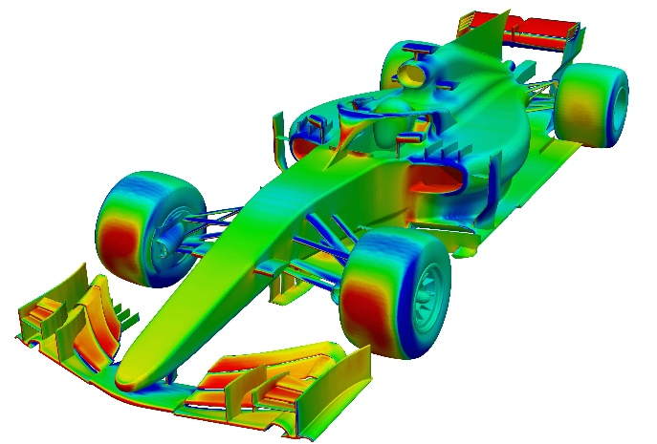
Figure 1 - Aerodynamic Analysis (Hatton, 2018)

2.5 Future Developments in FEA Optimization
FEA optimisation techniques are expected to advance further in the future as machine learning and artificial intelligence (AI) are integrated. These technologies offer the potential to automate some aspects of the optimisation process, saving computational time and improving the ability to locate global rather than local optima. Furthermore, the development of real-time optimisation employing cloud computing and parallel processing may enable on-the-fly design alterations in response to changing operational conditions (N, 2024). Also, Introducing additive manufacturing into the design process is likely to improve topological optimisation by allowing for the development of previously unachievable complicated shapes (Cattenone et al., 2018).

2.6 Impact on the Design Process
Overall, FEA optimisation techniques have streamlined the design process by reducing the need for physical prototypes while also broadening the range of design options. These techniques have made a significant contribution to the sustainability and innovation of engineering solutions by allowing for more efficient material use, weight reduction, and performance enhancement. The evolution of these methods is likely to change engineering design, making highly optimised, adaptive structures the norm across many industries.

Kiteboard model with boundary conditions

3.1 The use of Design Studio
The simulations undertaken in this report are completed within Design Studio. Although the kiteboards model being imported into the Design Studio. Before the simulation of the kiteboards could take place, Conditions reflecting its use needed to be applied.

3.2 Initial Set-up

3.2.1 Node Selection
When kiteboarding the kiteboard is not always in full contact with the surface of the water, for the rider to turn and gain more speed from the kite the board is usually on an angle with the front edge out of the water. To reflect this within the simulation, the grids that the UDL was applied on, were cleared and re-selected using the polygon selection tool. Below shows with how the nodes selected is an attempt to suit real life situations (Fig. 2) (Fig. 3).

Figure 2 - Kitesurfer (Britishkitesports.org, 2024)
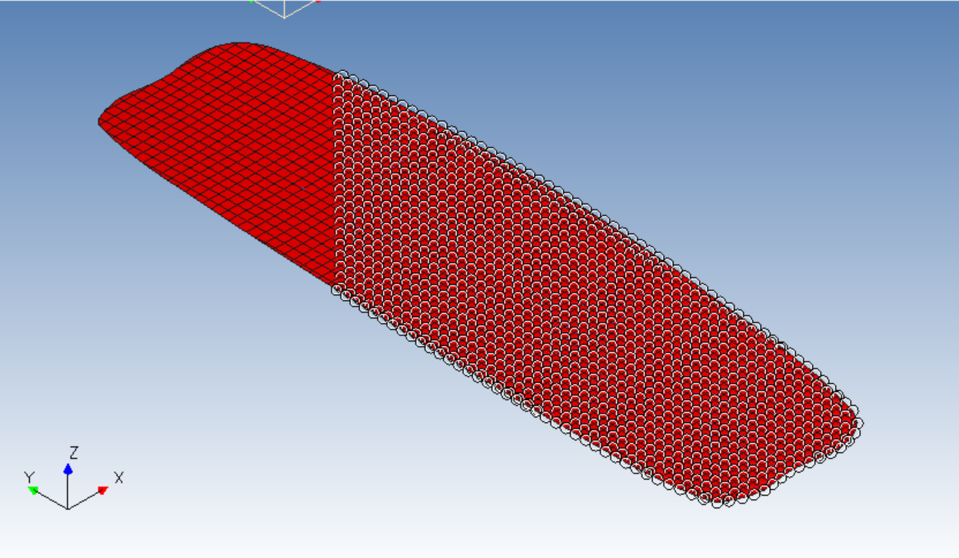
Figure 3 - Nodes Reflecting Kitesurfer

3.2.1 Magnitude
The forces applied the board will be the resultant forces acting upon the board calculated in task 1, these forces assisted in the simulations accuracy of calculating the deflection of the board. To find the magnitude to apply to each grid the force was divided by the total amount of grids. In this case the magnitude was 0.65.

3.3 Steel Kiteboard
Once the Grids were selected and the forces were applied on the 2mm thick steel kiteboard a single genesis was simulated, this can be seen below (Fig. 4).
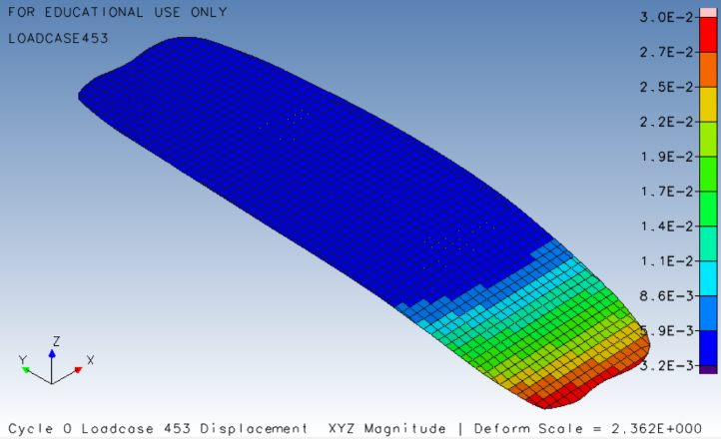
Figure 4 - Steel Board Displacement
From this, multiple important datasets were given (Tab. 1).
Table 1 – Steel Analysis
Material | Thickness(mm) | Displacement(mm) | Mass(Kg)
Steel | 2 | 30 | 8.1

The displacement of the steel board was 30mm, this was how much the board bent when the force was applied. The red end of the board highlighted where the board deflected the most, this is due to the grid selection.
Due to the properties of steel the weight of the board was quite significant for a performance kiteboard.

3.4 Composite Kiteboard Baseline

3.4.1 Composite Set up
The same model was loaded into Design Studio for the Composite Kiteboard, however multiple changes were made to accommodate the board being made of Unidirectional (UD) Carbon fibre Reinforced Plastic (CFRP).
The properties of unidirectional composites were applied to the board, these properties included Mass Density, Poissons Ratio and Youngs modulus which are all important to simulating the data required.
One of the main differences between the steel board and the composite board is that the composite board is constructed of ply’s, these are layers that are laid together to create the overall thickness of the board. The way the plies are laid on the board can have an imposing impact of the forces that the board can withstand.
The Design brief for the kiteboard states that it was required to be made of 25 0.1mm thick plies in different orientations. To ensure all orientations were covered, the thickness of 5 ply’s were allocated to each orientation, being: -90, -45, 0, 45, 90degrees.

3.4.2 Simulation
Once the single analysis of the kiteboard had taken place (Fig. 5), the displacement and other comparative datasets were given (Tab. 2)
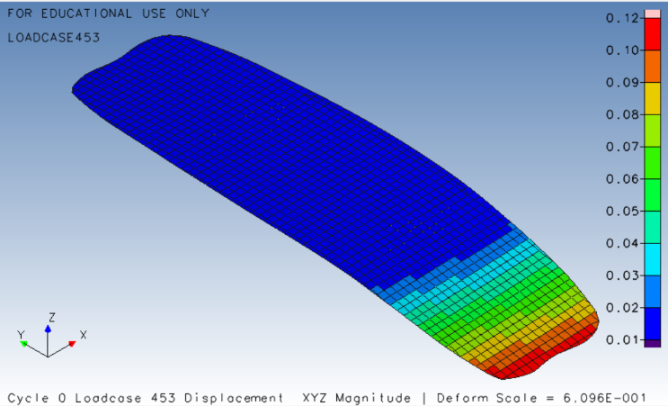
Figure 5 - Composite Baseline Displacement
Table 2 – Composite Baseline Results
Material | Thickness (mm) | Deflection (mm) | Mass (Kg)
Steel | 3 | 30 | 8.1
Composite | 2.5 | 120 | 2.02

This data shows that despite the boards being almost the same thickness, the properties of the boards have the biggest impact on the results. Steel strong but heavy nature is proved in the small deflection and the heavy mass. However, despite composite CFRP being known for its impressive strength to weight ratio the board still deflected a significant amount more than the steel, this is due to the orientation of the ply’s. The optimised orientation of the plies can be configured using Design Studio.

Optimised Structure of kiteboard

4.1 Optimisation
For the composite kiteboard to have the same deflection as the mass but the same mass of the original composite board, it required optimisation in design studio. This tool allows the user to gain the most out of their composite materials by changing the orientation and amount of the ply’s.

4.1.2 Optimisation set up
To begin the optimisation of the composite ply’s, multiple factors needed to be considered:
An objective within the design needed to be applied. This objective was to ensure that the mass of the board was minimised.
A constraint was also applied to the board. This was a displacement constraint, ensuring than when the board was optimised it needed to deflect the same or less than the steel boards displacement.
Design variables were then applied to the board’s ply’s. These variables for the thicknesses of the ply’s ensured that the board could be optimised and still stay within a suitable range of the constraints and objectives.

4.2 Simulation
Once the board was optimised using Genesis the cycle data including graphs relating to the objectives were displayed (Fig. 6)
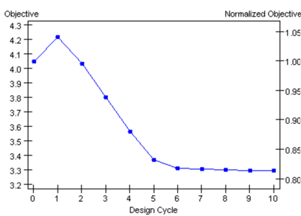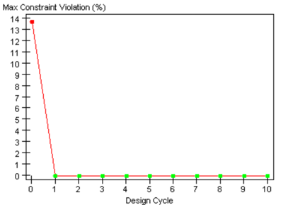
Figure 6 - Objective and Constraint Graphs
These graphs show how each design cycle took into consideration the before cycle with the aim of reducing the mass whilst keeping the deflection the same. The historical change data from this optimisation was them imported into Design Studio and used to create a graph displaying the ply thickness changed during the cycles (Fig. 7)
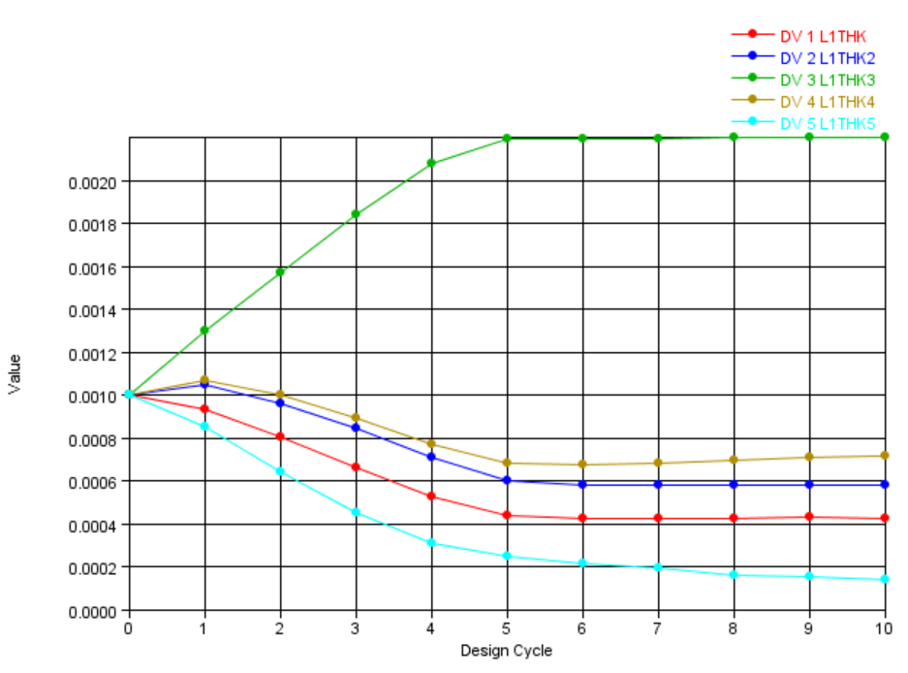
Figure 7 - History Graph

The graph shows that the middle plys at 0 degrees is the thickest ply after optimisation, this is due to the vectors of the board points 0 degrees in the Y direction. The plys at +/-90 have reduced to a minimum and the plys at +/-45 are slightly thicker to achieve the deflection constraint.
A more thorough observation of the design cycles was assessed by importing the history data into WordPad. From this there are two main cycles, cycle 0 (Baseline) and the last (Optimised).
Cycle 0 (Fig.8) which is the baseline shows the data that the optimisation starts with, which is the mass of the board, each layer thickness and the maximum violation. The maximum violation is how much over the objective is of reaching its goal, is this case it was 13.7%.
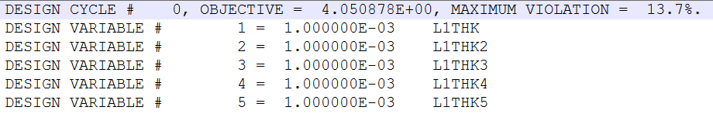
Figure 8 - Design Cycle 0
Following to the last cycle (Fig. 9) which shows the optimised board. From this, the layer thickness graphs data can be seen in the layers of the board. The total mass of 3.29kg can be seen as the objective and the max violation is 0% showing that the board has been optimised to reach its target.
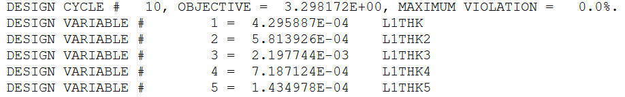
Figure 9 - Last Design Cycle
The thickness was checked using the method previously used for the baseline, by selecting the DISP data for the last cycle which showed the board and its deflection. In comparison to the baseline composite kiteboard, it has been significantly improved. This can be seen in the table below (Tab. 3).
Table 3 – Optimised Composite Data
Material | Thickness (mm) | Deflection (mm) | Mass (Kg)
Steel | 2 | 30 | 8.1
Composite Baseline | 2.5 | 120 | 2.02
Composite Optimised | 4.07 | 29 | 3.29

4.3 Discreet optimisation
Theoretically the board after optimisation is in its most efficient state, however, this is without taking into consideration the manufacturing of the kiteboard. To ensure the kiteboard was able to be manufactured discreet variables were introduced which only allowed steps of layer thicknesses in steps if 0.1mm.
An optimisation was then run again to see how this would affect the data (Fig. 10)
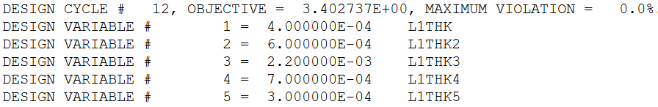
Figure 10 - Discreet optimisation
The data from the optimised composite can be seen below (Tab. 4)
Table 4 – Discreet Optimisation Data
Material | Thickness (mm) | Deflection (mm) | Mass (Kg)
Steel | 2 | 30 | 8.1
Composite Baseline | 2.5 | 120 | 2.02
Composite Optimised | 4.07 | 29 | 3.29
Composite Discreet | 4.2 | 28 | 3.4

From this data the ply lay-up can be easily calculated and machined (Tab. 5)
Table 5 – Ply Lay-up
Layer | Plys
1 | 4
2 | 6
3 | 22
4 | 7
5 | 3

The data shows, as expected that the board was effect by the introduction of discreet variables by making the board slightly thicker and heavier. However, with a total 42plys, these changes in data are very little in comparison to the improvement made by optimisation.

4.4 Future improvements and variable
Despite the use of design studio being a success by optimising a kiteboard to reduce mass and defection. There are still a number of variable that should be taken into account that may have prevented the simulations from being as accurate as possible. These are
The forces used for this simulation were from previous calculations, these calculations may have been inaccurate cause the deflection to not reflect real life circumstances. To eliminate this, resultant forces could be researched from reputable sources.
The boards forces was applied as a UDL. However, the water that the board is assumed to be riding on is turbulent which mean that the water is choppy resulting in not the whole board being in contact with the water. In future the simulation could be assumed in a laminar flow condition.
After research the average kiteboard is 20mm thick (Anon, 2023), however the steel board which is being used as a comparison is only 2mm thick. The data provided may be more applicable if this thickness was used.

Component prototype and experiment
To evaluate the deformation behaviour of a prototype board under force, a structured laboratory experiment would be planned. This experiment would seek to simulate the board's loading conditions, monitor the resulting deformations and validate the simulation results by comparing empirical data to predicted values.

5.1 Experimental Setup
The prototype board would be built using the same materials and dimensions as specified in the simulation model. In this case, Carbon Fibre Reinforced Plastic (CFRP). The setup would require equipment such as force application and measurement systems, such as a universal testing machine (UTM), which can apply controlled forces to the board (Liu and Dai, 2021). The test fixture should securely hold the prototype while applying force to the board as applied in the simulation.
Strain gauges would be strategically placed on the prototype at critical points identified by the simulation as high deformation areas. These points would be the along the end of the board up to where the force applied ends (Liu and Dai, 2021). The strain gauges would provide localised data on how the board material stretches or compresses in response to applied force. Laser displacement sensors or high-resolution cameras could be placed throughout the prototype to monitor and record real-time deformation and deflection, allowing for a thorough analysis of the board's response to applied forces (KATO, 2019).

5.2 Procedure

5.2.1 Preparation and Calibration
Before beginning the test, all measurement equipment (strain gauges, UTM, cameras) would be calibrated to ensure reliability and accuracy of the results (Magnus Schlsser, 2014). The board would be mounted onto the testing fixture which would take the shape of where the feet of the rider would be positioned, with careful alignment to avoid skewed results. The Baseline data for the prototype's original, unloaded dimensions would be collected to serve as a reference for measuring deformation.

5.2.2 Data Acquisition
Strain gauge readings would provide quantitative data on localised deformation, demonstrating strain distribution over various sections of the board. Displacement sensors or camera data would track overall deflection and recognise bending or other deformation patterns. This data would record the three-dimensional displacement and deformation of the board's surface, allowing for a more comprehensive understanding of the prototype’s structural behaviour.

5.2.3 Analysis and Data Processing
Following data collection, strain and deformation values from would be analysed. This step would include comparing the strain gauge readings to the displacement data from the sensors in order to ensure measurement consistency and accuracy. The data would be processed to provide load vs. deformation and stress vs. strain graphs, which could then be utilised to make visual comparisons with simulation data.

5.3 Comparison with Simulation Data
The experimental data would be compared to the simulation results to determine the accuracy of the model employed in Task 3 using design studio. The following actions would help with this comparison:

5.3.1 Mapping Experimental Data to Simulation Points
Strain gauge and displacement data would be aligned with the values from the simulation at the appropriate points on the board for direct comparison. The deformation profiles from the experiment and simulation will be compared at various load levels.

5.2.2 Statistical Analysis
Statistical approaches would be used to quantify the differences between experimental and simulated data. Calculating percentage error, root-mean-square deviation (RMSD), or mean absolute error (MAE) would provide for a numerical evaluation of accuracy (Bryant, 1966). Discrepancies in the data could indicate possibilities for improvements in the simulation as commented previously.
All things considered, this experimental method would offer a comprehensive understanding of the prototype's mechanical response to applied forces and validate the accuracy of the simulation in simulating these circumstances.

Technical literature relations

6.1 FE-Analysis and lay-up strategies for a kiteboard
Jan Stefani and Prof. Marcs Sieberts investigation “FE-Analysis and lay-up strategies for a kiteboard” relates very strongly to this report in multiple aspects. Firstly, the overall design of the kiteboard (Fig. 10)
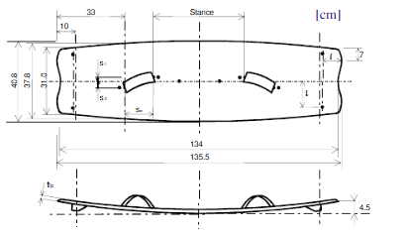
Figure 11 - Design of Kiteboard
This paper further elaborates on a deformation model in a simulation software. The image below (Fig. 11) shows how similar their model is to the one created in this report.
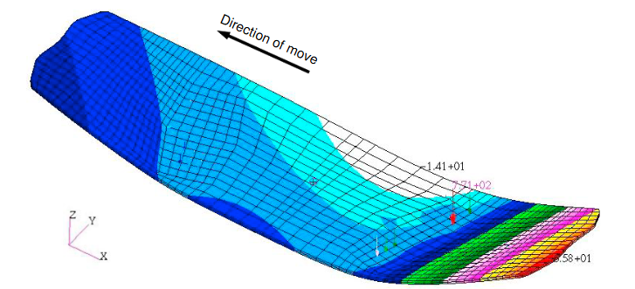
Figure 12 - Deformation of experiment
The deformation of this model is 66mm, which is a similar result to the deformation in this report at 47mm.
Jan Stefani and Prof. Marcs Sieberts report under “perspectives” states how the verification of their data could be handled. Some examples in the report explained are flex tests, the use of compression measurement systems and water road tests.

6.2 Analysis, manufacturing, testing, and structural optimization of a novel composite kiteboard design
This journal written by Bertram Stier, Torben Böddeker, Raphael Springmann, Jaan W Simon, and Stefanie Reese. Conducts a thorough analysis on a composite kiteboard which relates to the simulations in this report. Within this report, comment are made regarding the ply lay-up of the composites and the importance of optimisation to ensure the strength of the layup is as efficient as possible.
Another key aspect of this report is that they ran an experiment on a kiteboard to compare with their data. The experiment can be shown in the photo below, where they have applied a load to the centre of the board.
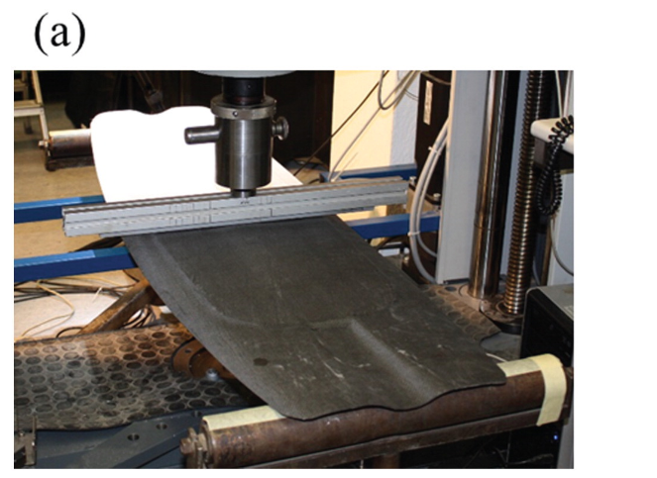
Figure 13 - Real Kiteboard Experiment
The data from this experiment produced similar results as simulate in this report. As seen from their deformation graph (Fig. 12), at the force of 700N the deformation is 50mm, which are similar results 650 to 28mm.
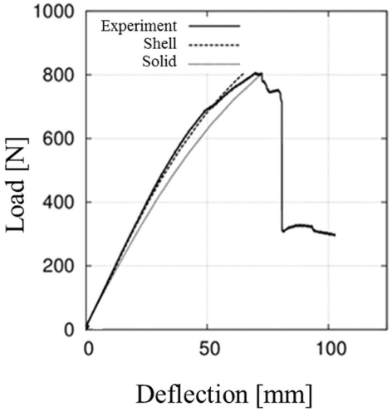
Figure 14 - Deformation results from experiment

6.3 Guide to Twin-tip Kiteboard Design, Features and Styles
This Article written by Samina Laurinaityte details the technicalities of the design of a kiteboard. From this article the design of the kiteboard can be categorised, begging with the outline. The curved outline of the board enables improved carving ability. The board length used for this example is determined as a “short board” which is used for lighter rider or strong winds.
These assumptions made from this technical article can assist categorising design of kiteboards. By categorising, different forces can be applied for their optimisation to ensure the board is best suited for the conditions.

Conclusion
This report demonstrated the value of Finite Element Analysis (FEA) optimisation in creating a high-performance kiteboard. Key insights into deflection, mass, and thickness were obtained by tracing the evolution of FEA and analysing steel and composite models under realistic boundary conditions. Optimising the composite model's ply orientation resulted in weight reduction while maintaining performance, demonstrating the importance of composite lay-ups.
The proposed experimental validations highlighted the importance of real-world testing for accuracy. Overall, FEA was critical in improving structural designs, allowing engineers to meet complex performance demands while increasing material efficiency and promoting sustainability in composite manufacturing.

References
Abraham, J. (2018). FINITE ELEMENT ANALYSIS. [online] Available at: https://www.asme.org/getmedia/a654522d-a9dc-4b8a-8ef2-513826294668/fea-brochure-final-submitted.pdf [Accessed 28 Oct. 2024].

Anon, (2023). Choosing the Perfect Kiteboard Size: 6 Easy Steps. [online] Available at: https://www.custom-wetsuits.com/blog/kiteboard-size/.

Arora, J. (2011). Introduction to Optimum Design. Academic Press.

Britishkitesports.org. (2024). British Kitesurfing Association | Official website and the home of kitesurfing in the UK. [online] Available at: https://britishkitesports.org/.

Bryant, E.C. (1966). Statistical analysis. New York Etc.: Mcgraw-Hill.

Cattenone, A., Morganti, S., Alaimo, G. and Auricchio, F. (2018). Finite Element Analysis of Additive Manufacturing Based on Fused Deposition Modeling: Distortions Prediction and Comparison With Experimental Data. Journal of Manufacturing Science and Engineering, 141(1). doi:https://doi.org/10.1115/1.4041626.

Crahmaliuc, R. (2015). 75 Years of the Finite Element Method | SimScale Blog. [online] SimScale. Available at: https://www.simscale.com/blog/75-years-of-the-finite-element-method-fem/.

Hatton, G. (2018). SimScale Webinar | Optimising racecars with CFD. [online] Racecar Engineering. Available at: https://www.racecar-engineering.com/articles/simscale-webinar-optimising-racecars-with-cfd/ [Accessed 4 Nov. 2024].

James, I.M. (1999). History of topology. Amsterdam ; New York: Elsevier Science B.V.

KATO, Y. (2019). Study on Finite Strain Measurements using Image Analysis. The Proceedings of Mechanical Engineering Congress, Japan, 2019(0), p.J04227. doi:https://doi.org/10.1299/jsmemecj.2019.j04227.

Liu, Y. and Dai, F. (2021). A review of experimental and theoretical research on the deformation and failure behavior of rocks subjected to cyclic loading. Journal of Rock Mechanics and Geotechnical Engineering. doi:https://doi.org/10.1016/j.jrmge.2021.03.012.

Magnus Schlsser (2014). Accurate calibration of raman systems : at the karlsruhe tritium neutrino experiment. Cham ; New York: Springer.

N, V. (2024). Potential Use Cases of AI in Finite Element Analysis – FEAssistant. [online] Feassistant.com. Available at: https://feassistant.com/potential-use-cases-of-ai-in-finite-element-analysis/ [Accessed 28 Oct. 2024].

Romeo, J. (2024). Formula 1 By Design - Digital Engineering. [online] Digital Engineering. Available at: https://www.digitalengineering247.com/article/formula-1-by-design [Accessed 28 Oct. 2024].

Sigmund, O. and Maute, K. (2013). Topology optimization approaches. Structural and Multidisciplinary Optimization, [online] 48(6), pp.1031–1055. doi:https://doi.org/10.1007/s00158-013-0978-6.

Stefani, J. and Siebert, M. (2010). FE-Analysis and lay-up strategies for a kiteboard. Procedia Engineering, 2(2), pp.3311–3316. doi:https://doi.org/10.1016/j.proeng.2010.04.150.

Stier, B., Bednarcyk, B.A., Böddeker, T., Springmann, R., Simon, J.W. and Reese, S. (2015). Analysis, manufacturing, testing, and structural optimization of a novel composite kiteboard design. Proceedings of the Institution of Mechanical Engineers, Part P: Journal of Sports Engineering and Technology, 229(4), pp.248–265. doi:https://doi.org/10.1177/1754337115584874.

Wright, S. (2024). Optimization - The simplex method. [online] Encyclopedia Britannica. Available at: https://www.britannica.com/science/optimization/The-simplex-method.

