“Community heritage is anything that makes your area unique and worth celebrating” (Community Heritage, 2018) which is what this essay is focusing, on using the example of Carew Cheriton Control tower to try to understand what it is and how it is practised in Britain today.
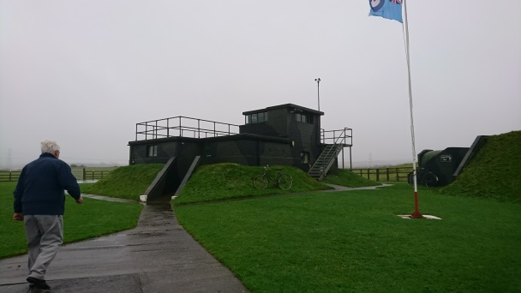
Carew Cheriton control tower (Refer to figure 1) sits on the old Royal Air Force (RAF) Carew Cheriton site during the Second World War (WW2) before this it was Royal Naval Air Station (RAS) Pembroke during World War One (WW1) of which the control tower is the only remaining original structure alongside “large areas of the three runways, perimeter track and hardstanding “(Carew Cheriton (Milton) (Pembroke), 2016) This is a museum solely run by volunteers and the tower was also restored to its 1940s layout by volunteers with the aid of personnel who worked in the control tower during this time. The volunteers stripped the walls back (they had been whitewashed) by hand to avoid any damage and then repainted them to the original scheme (paint shards had been found underneath). The Carew Cheriton control tower group was formed in 2000 since then they have restored the control tower (which had been used as a cowshed until they took over), reconstructed a Stanton air shelter and developed the museum alongside a shed to restore the Avro Anson plane (a plane that flew from the site). They restored this site using private grants and with some funding from the government (although they now run on private donations, people raising money and also donating artefacts). The group got initial funding from the Welsh Assembly under a scheme called ‘Defence of the Realm’ aiming to show “Pembrokeshire’s strategic importance to the defence of Great Britain as a whole” (Chapel bay fort, May 12 2010). The site has also received funding from Pembrokeshire Association of Voluntary Services (PAVS) and, for example, Spittal School raised money for them by holding a tea party after a trip to the Control Tower raising £227. This shows how community heritage is practised in the fact that funding for these sites is often not from the government but from private sources maybe even from fundraisers by the public and it is done through volunteers who are often local. It also demonstrates how important a good relationship with the local community is for heritage projects because it keeps visitors coming (because without visitors then a site cannot function) and also keeps open the possibility of funding from the local community. One can use this argument because often small local museums or sites are run by locals as they are the people who best know the site and also may have stories about the place which would not be widely known otherwise possibly due to the fact they were passed down orally. In the case of Carew Cheriton, this is true as the volunteers who ran the site nearly all have connections to the site (mostly through living in the area during WW2) or have been connected to the armed forces in some way (one of the volunteers used to be a technician in the RAF). It is important to highlight that this site was preserved for what it meant to the community (in terms of jobs it bought to the area and the whole new set of people it bought to the area) but also because the control tower is of a unique design; the unique design is that it has a bay window facing out onto the airfield, therefore, making it worth preserving. The structure is surrounded by an earth blast mound (designed to help protect against bombs) over locally made bricks and was a replacement of the original tower. This structure was “the wheelhouse that came from the ship “Montrose”” (Carew Cheriton, 2000) which is associated with the infamous Dr Crippen who was captured on board the ship. Therefore showing why the whole site is important not just the control tower because it has many links to Britain’s history as a whole, not just that specifically of Wales.
Figure 1: Picture of Carew Cheriton control tower. Photo: Courtesy of myself 6/12/2018
This site was not only home to British squadrons (that escorted ships or looked for U-boats) but also “Dutch squadrons 320 and 321” (RAF Carew Cheriton War graves, 2018) so this means that they regularly get overseas visitors who have connections to the site, visiting to see where their family where stationed (some are also buried in the nearby cemetery). There were also airmen from all over the Commonwealth (like Canada and New Zealand) at RAF Carew Cheriton even some from Poland and the Netherlands. This shows that community heritage in Britain is not just about those who are British but people who visit or are stationed here especially during either one of the wars when so many people from all over the world were stationed in the United Kingdom. This illustrates that community heritage in Britain is practised through welcoming not only the local community but also international visitors especially those who have connections to Britain. It also shows that community can encompass people from many countries not just a small area around a specific site if they share a common history especially something as powerful as a global war.
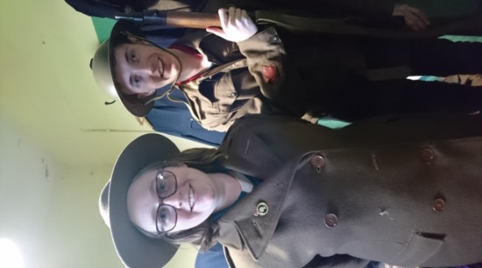
The museums is not open all week instead it has certain public open days then Sundays, as well as Bank holiday Mondays from July through to September 10, am till 3 pm. However, they are open year round to groups (particularly schools) by prior booking. The volunteers during my visit there showed us what they do for the groups that visit the site. They guide them through the museum, control tower and air raid shelter accompanied by lots of stories, trying costumes some of which are authentic to the period on (Refer to figure 2) and even a bit of singing (the songs of the era) with the visits tailored to the group that is visiting. Overall it is about making the visit fun and the history come to life for the children especially as many of the schools that visit are local so therefore this is allowing them to gain a better connection with their own history. This is a common theme in community heritage practice in Britain as shown through groups for children to specifically learn about archaeology such as Young Archaeologist club (YAC). This is a club that is all over the United Kingdom which children aged 8-16 that allows children to get hands-on with archaeology and heritage. This is community heritage in practice because it is all about engaging the children to infuse them with a lifelong love of history and potentially those who will look after our heritage in the future. It is also practised through history societies who take it upon themselves to learn more about the history of the area and often actually support local sites for example by raising money for them. This shows that community heritage is practised in Britain today but people educating themselves about history not just relying on traditional methods such as through the education system.
Figure 2: A photo of myself and Anthony Macdonald trying on uniforms. Photo courtesy of myself 6th/12/2018
They also run a big event called ‘Wings over Carew’ which is a ticketed event that involves fly pasts, vintage military vehicles, and various re-enactments as well as some current military; this again demonstrates how community heritage is practised in Britain is through re-enactment as a way to engage the public. Big events like this allow the sites to be able to raise a lot of money in one event (after costs) and therefore show community heritage in Britain is practised through the day to day activity but also big events like ‘Wings over Carew’. Re-enactment is used throughout the heritage sector particularly in locations like castles as it is a more active engagement from the public than just reading display boards it also allows for visitors who have sight impairments to engage with the site. To further extend this point it also helps bring to life the history especially for children where they can see how aspects of history really work like cooking or fighting. This illustrates that community heritage in Britain is about engaging the public in a way that is fun and interactive especially for the children or those whose learn in a more active way. It also demonstrates that community heritage is practised with a focus on the stories of the local area in which the site is situated to help engage visitors from children right through to those with sight impairments or learning barriers. Not only this but re-enactment groups may be construed as practising community heritage because it is public facing and teaching people about history. This is especially true of the groups who specifically focus on certain areas of the United Kingdom as they really are focusing on the history of a community, for example, the group ‘Scots in the Great War living history’ which is a group that is “dedicated to the memory, study and appreciation” (Scots in the Great War, 2018) of Scotland during the Great War.
The site of RAF Carew Cheriton is not only used by the Control tower museum but also by a number of businesses such as a caravan park and also as a Sunday marketplace. This shows that community heritage in Britain is not always about telling the history of a site but ensuring that it continues to be used in some form or another and therefore does not completely disappear; as in this case the hardstanding remains but if it was not in use undoubtedly this would not remain in place. It also reveals that community heritage in Britain is not always that cherished. It could also demonstrate that community heritage projects focuses mostly on one single place like the Control Tower rather than a site as the whole (Carew Cheriton airfield at its height was 600 acres) because it is much more manageable in terms of maintenance, cost, and manpower needed to run the site. Demonstrating that practising community heritage in Britain is often limited by cost (in terms of maintenance as previously mentioned and also commencing the project in the first place) and also manpower needed to run the site in terms of staffing etc.
One could contrast this site to Carew castle which is less than a mile away from the control tower. The castle is privately owned but is leased by the National Park Authority and is very different to the Control tower museum. The first thing one could mention is that it is leased by a public body, therefore, has a lot more money to support it and help restore the castle. It also has more facilities in terms of a visitor centre with toilets, café, and a shop. So, therefore, one could argue it is not really a community heritage site because it is leased and run by a government body. However, as it is so small the case for it being a community heritage site could be argued and therefore it shows some sites are better developed in terms of visitor services. Compared to Carew Cheriton Control Tower museum the visitor in the castle is more left to explore for themselves; so one could argue that community heritage sites are a lot more personal as they allow people to hear the stories of the area from enthusiastic volunteers. The visitors' experience is also more personal as they can get to actually see displays and information about the site whereas there is not as much information at the castle. A way that these two sites are similar is that they both tell different accepts of Wales’ history which is not only an aspect of community heritage but of heritage in general.
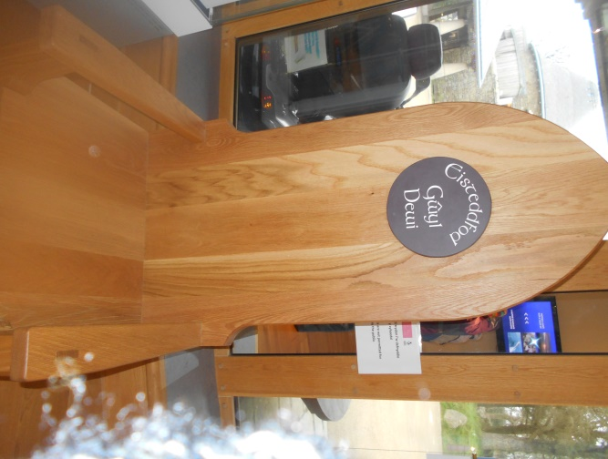
However “community is a multi-layered and politically charged concept…” (Waterton E and Watson S, 2013) therefore showing that community is not just locals coming together to support their local history but also groups of people and their history such as the LGBTQ+ community celebrating pride. Another example is the Welsh festival, Eisteddfod which is a celebration of music, drama, art and literature in the Welsh language. It is also competition based and one of the competitions is for “best poem written in a traditional form of Welsh verse” (S. Williams, 2013). This culminates in the chairing of the bard which is a chair made by a local craftsperson (refer to figure 3). There are multiple Eisteddfodau (the plural of Eisteddfod) including local ones; therefore showing that community heritage is not only the tangible artefacts like Carew Cheriton control tower but the intangible like the Welsh language and celebrating the culture surrounding this. There is also Eisteddfod yr Urdd which is aimed at people between 7-24 years old and is “…one of the largest youth festivals in Europe” (S. Williams, 2013) showing that community heritage in the sense of groups of peoples is not just for the older generation but for the young as well so it unites the generations. The Eisteddfod also shows that community heritage in Britain is practised through celebrating the history of an area and the thing that makes it unique like the Welsh language makes Wales unique. This could also demonstrate how community heritage could be politically charged because often communities with their own language can be fiercely protective of ensuring it survives; this is demonstrated by the fact that in Wales they have the Welsh Language Act 1993 and Welsh Language Measure 2011. These regulations ensure that the Welsh language is on par with the English language in conducting business so, for example, all the university’s official communications are bilingual. This then can be used to support the point that community heritage projects have to be sensitive to the needs of the community around it to ensure it keeps support and also so that it stays relevant to its community.
Figure 3: A photo of the Eisteddfod chair. Photo courtesy of myself 4th/12th/2018
Although the original concept of the Eisteddfod is that the whole festival in the Welsh language a few non-Welsh speaking communities have adopted the idea of the Eisteddfod. One example is the Jersey Eisteddfod which was started by the Dean of Jersey who thought the competition aspect was a way the “speech, presentation and musical standard of his fellow islanders”(The history of the Eisteddfod, 2018)) could be improved. This shows that community heritage is possibly a concept as well as a place because it is all about celebrating the history of their specific area and that the concept of celebrating this in terms of festivals is a way it is practised throughout Britain not just in Wales. It could also show that community heritage is not one set concept but rather something that evolves over time as the community grows and changes so that is better encompasses what the community wants. It illustrates that community heritage projects like Eisteddfod need to ensure they keep evolving otherwise it is likely that they will not survive and therefore a community will lose something that helped keep it unique. It would also mean that a festival about the community is no longer that it is merely a relic of the past.
So overall community heritage in Britain is about the local communities coming together to support their local sites and to keep the stories of their local area alive. The community can also be a wider group of people than just those surrounding a specific site. It is practised through knowledgeable and enthusiastic volunteers who help the history coming to life by teaching the next generation and hopefully fostering in them a lifelong love of history. Community heritage is also about the shared history and culture of a group of people like the Welsh celebrating their language through the Eisteddfodau, not only celebrating it but protecting it for example through legislation. Community heritage is clearly an ever-evolving concept that needs to be continually re-evaluated to ensure that it stays relevant to the community. So at the heart of the community heritage, it is about the people (both local and international) and very often it is practiced by the local volunteers as well as being supported by local peopl

Bibliography
Community Heritage 2018-last update. Available: https://www.hlf.org.uk/looking-funding/what-we-fund/community-heritage [14/12/, 2018].
The history of the Eisteddfod2018-last update. Available: https://www.jerseyeisteddfod.org.je/about-the-eisteddfod/the-history-of-the-eisteddfod/?fbclid=IwAR1DI6HVSzb2fFwuPgFDdf1le7ZIx2q_QHXwpmVBebd7FusU7ytFtq4xz6c [12/12/18, .
RAF Carew Cheriton War graves2018-last update. Available: https://www.wwwmp.co.uk/pembrokeshire-memorials/carew-cheriton-raf-burials/ [30/11/, 2018].
Scots in the Great War2018-last update. Available: https://www.scotsinthegreatwar.com/ [21/12/, 2018].
Carew Cheriton (Milton) (Pembroke)2016-last update. Available: http://www.abct.org.uk/airfields/airfield-finder/carew-cheriton-milton-pembroke/ [1/12/18, .
Welsh language&nbsp;2016-last update. Available: http://law.gov.wales/culture/welsh-language/?lang=en#/culture/welsh-language/?tab=overview&lang=en [20/12/, 2018].
Chapel Bay Fort, Angle; Carew Cheriton airfield and Dale to benefit from £500,000 Defence of the Realm Welsh Assembly fundingMay 12, 2010-last update. Available: https://www.westerntelegraph.co.uk/news/8161229.pembrokeshires-military-history-sites-to-benefit-from-500000-funding/ [19/12/18, .
Carew Cheriton2000-last update. Available: http://www.controltowers.co.uk/C/Carew_Cheriton.htm [6/12/, 2018].
EDDLESTON, J., 2018-last update, The notorious case of Dr Crippen. Available: https://www.thehistorypress.co.uk/articles/the-notorious-case-of-dr-crippen/ [21/12/, 2018].
HEMS, A AND BLOCKLEY M, 2006. Heritage interpretation Abingdon: Routledge.
WATERTON, E. and WATSON, S., 2013. Heritage and community engagement : collaboration or contestation? S.l.]: S.l. : Routledge.
WILLIAMS, S., 2013-last update, Druids, Bards and rituals:What is an Eisteddfod. Available: http://www.bbc.co.uk/guides/ztbk87h [10/11/, 2018].2018].

