Alanis Fletcher
1702904
Dissertation Proposal

The three keywords I have chosen are: Sensory, Colour, and Workplace Wellbeing. I have chosen these as they link to my future interests in working with sensory objects in corporate spaces. Through my recent live briefs at St Fagans and Orangebox I have become interested in giving surface pattern further levels of interaction through sensory, tactile and sonic encounters. This gives an interior piece more than simply the aspect of looking. I feel the brain needs to be interacted with more and pieces need more than signals for the eyes to gain. I will begin with sensory as this is the starting point for where I began thinking about the senses and interactivity. Next I will discuss Colour and how it effects mood and finally, Workplace Wellbeing because I feel wellbeing links all of my keywords together and I feel it needs more focus.

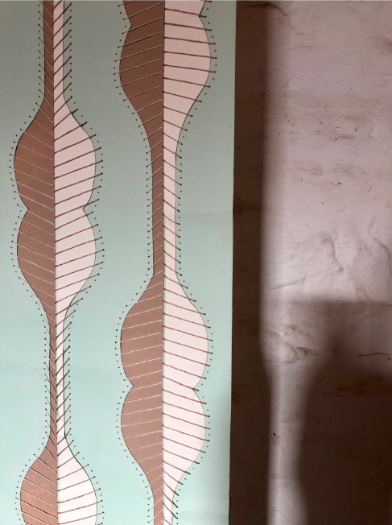
Following the St Fagans exhibition, I chose ‘sensory’ as one of my keywords, because it highlighted the 3D element of design. According to the Shorter Oxford English Dictionary (1973, p. 1941) Sensory is “belonging to sensation; carrying or transmitting sensation”. This means sensory is the action of your brain trying to process different senses and sending signals to your nervous system. Psychologically, our sub-conscious thoughts have already let us know how something would feel. According to Mitchell (2012, p.7), “Through the senses, touch and utterance share common origins in the neural system and in the pattern of synaptic, electrochemical connections between neurons”. This can be seen in books specially designed for small children so that they can start to become familiar with textures and sounds. However, it can be overwhelming for some with sensory processing issues when dealing with an overload of signals, this can make their everyday life a big struggle (Cater, 2016, p. 25). I want to try and help those who struggle with sensory processing issues in any way that I can and make people interact more and appreciate the touch of textiles as I feel they are important to connect with.

Figure 1 : St Fagans Wallpaper

Since my St Fagans project and investigating into older wallpaper, I have become interested in how most were textured in some form. It made me want to promote using more than the sense of sight throughout my work as “the sense of sight has been, historically, the most privileged, whilst touch, with its implication of earth and base matter has been less well served.”(Mitchell, 2012, p7) This immediately made me want to give a modern texture to my designs so they had that extra element so that it was not just a flat pattern to look at. This can then interest and stimulate a person more with the interaction of touch.

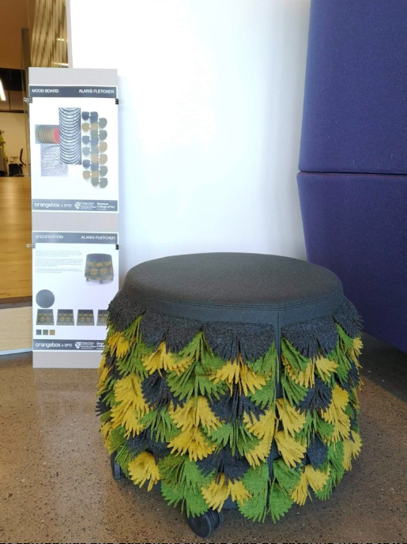
As defined by the Collins English Dictionary, Fidget is the action “to move about restlessly” (2014, p. 724). It’s the action people tend to do when dealt with feelings of nerves or impatience.
The largest groups of people that fall under this category are people who suffer with anxiety and ADHD. Popular ways that people fidget is with items that surround them the most, “ready-to-hand objects like paper clips, USB thumb drives, headphone earbuds and sticky tape.” (Isbister, 2017). All items that you would find in an office space or classroom. People find that “fidgeting with an object in the hand helps them to stay focused” (Isbister, 2017) when dealing with a particularly difficult task. The simple repetitive nature of fidgeting can help center the mind to concentrate on the task. Eventually we saw the huge rise in fidget toys becoming a trend. In May 2017 “every one of the top 10 best-selling toys on Amazon was a form of the hand-held toy.”(Isbister, 2017). This started the conversation for taking others into consideration for coping mechanisms and about wellbeing in the workplace or classroom.

Figure 2: Orangebox Interactive Stool

In my Orangebox project, I looked into manipulating my fabric in order to give an interactive element to help with fidgeting people in the workplace. I wanted to focus around the idea of enticing the viewer to interact, “these fabrics beg to be mobilized by a viewer/reader” (Harper, 2012, p. 29). I knew with the fabrics being 3D and textural it would bring the response of touch that I wanted and the enjoyment of stroking as an interactive way of engaging with the stool. I feel it suited the brief with it being focused around office based furniture and the company ethos on wellbeing.

Through these two projects it has made me realise that interiors need more to interest the viewer because, how we look and interact with a piece, can give two different aspects.
I feel that companies and designers should also be catering more towards those with mental health issues and autism, by focusing on the senses of their product. This will help by acting as a remedy, for example for those that suffer with anxiety, having something like a cushion with interactive textures to help with them fidgeting could help reduce levels of stress.

COLOUR
- Can effect mood
- Colour > light > energy

Why > is it important to my work, strengthen an image, effects mood
When > would you use colour/
How >
Where > colour can be applied anywhere, the surfaces, the lighting
Who >
What >

Colour theory
Goethe
Newton
Itten

After my visit to the Orangebox Factory and Offices, I chose “Workplace Wellbeing” as keywords because of the new act by the Welsh Government and the awareness of mental health becoming more noticeable. According to the Collins English Dictionary (2014, p.2243) Wellbeing is “The condition of being contented, healthy or successful” and Workspace is “An area set aside for work” (2014, p.2275). Joining these together, it stands for a comfortable and happy environment, where work can be done concentrated and with a healthy mindset.

With Wales ahead of the game and leading the world on recognizing the concern for how to help nourish our needs without risking our futures. They have created an act which “aims to put sustainable development at the center of decision-making.” (Corbyn,2018, p.1) It helps with the concerns about the environment currently and ensures that a change is being made before it is too late.

I feel that employers are now tuning in to their employee’s wellbeing and making their workplace a better environment to work in. “We aim to create a happy environment, where everyone is treated respectfully and enjoys coming to work.”(Orangebox, 2019) This was demonstrated by the design of the work environment in Orangebox. It was an environment that was cheerful and calm, the acoustic panels on the walls and surrounding the desks was keeping the space serene and peaceful, a place you could easily focus and work. It was clear that promoting “good health and well-being for everyone” (Corbyn,2018, p.5) was a main priority in their ethos as fitness was encouraged throughout work by standing with their sit/stand desks or working on a balance board. Biophilia was also mentioned throughout with natural sunlight coming in and plants surrounding for healthy oxygen. “A society in which people’s physical and mental well-being is maximized and in which choices and behaviors that benefit health are understood” (Corbyn,2018, p.2) Orangebox clearly promote this throughout their workspaces and how much they’d considered their employees throughout the design. Wellbeing immediately struck me as they explained each detail surrounding the employees in their workspace.

I feel Orangebox also wanted to keep the culture alive throughout the officeplace, “A society that promotes and protects culture, heritage” (Corbyn,2018, p.2) There were different elements of cultural items throughout with live video of the outside area which was also for the biophilia element, and there were also Welsh woods like Poplar and Larch.

After speaking with the orange box team and listening to their brief, with wellbeing being so big I wanted to create a stool cover that would help with people who fidget, the stool was created with the wellbeing aspect of the office spaces in mind and their sustainability awareness and how to utilize their waste in a good way

Why is wellbeing important
Benefits of happier workplace productivity is better work is done to a higher standard

Bibliography

Cater, K. (2016) Small shifts, big changes: changing the story for students with Sensory Processing Sensitivity (SPS) in International Journal for Transformative Research (De Gruyter Open). 3(2): 24-31
Corbyn, C. (2018) The Well-being of Future Generations Act [Internet Webpage] Available from: <http://www.assembly.wales/research%20documents/18-033/18-033-web-english.pdf> [Accessed May 8th, 2019]

Dictionaries, C (2014) Collins English Dictionary 12th Edition. Glasgow: HarperCollins Publishers
Hemmings, J. (2012) The Textile Reader. London: Berg Publishers

Isbister, K. (2017). Fidget Toys Aren’t Just Hype [Internet Webpage] Available from: <https://www.scientificamerican.com/article/fidget-toys-arent-just-hype/> [Accessed May 8th, 2019]
Orangebox. (2019) Careers at Orangebox [Internet Webpage] Available from: <https://www.orangebox.com/about/jobs> [Accessed May 8th, 2019]
Shorter Oxford English Dictionary (The) (1973).Oxford: Oxford University Press

RELATIONSHIP BETWEEN COLOR AND EMOTION: A STUDY OF COLLEGE STUDENTS.

Kaya, Naz ; Epps, Helen H. ;

The art of color : the subjective experience and objective rationale of color

Johannes Itten 1889-1967. Ernst van Hagen

COLOUR THEORIES OF KLEE , ITTEN AND KANDINSKY AS A PARADOX OF AESTHETIC SHARING IN BAUHAUS.
Katinaitė, Deima ;

COLOUR THEORY
Turner, Christopher

Colour Theory
Parker, Duncan

The Degree to Which Colors (Hues) Are Associated with Mood-Tones.
Wexner, Lois B. ;

Can Colors Make Me Happy? The Effect Of Color On Mood: A Meta-Analysis.
Hyodo, Jamie ;

*Aron & Aron Scale

