


White Box Penetration testing of a Home PC
by
Ryan Andrew Jones (2009252)
Supervisor: Carlene Campbell

Project submitted as part of the requirements for the award of BSc (Hons) Cyber Security and Networks.

July 2025

Declaration of originality

I, Ryan Andrew Jones declare that I am the sole author of this Project; that all references cited have been consulted; that I have conducted all work of which this is a record, and that the finished work lies within the prescribed word limits.

This work has not previously been accepted as part of any other degree submission.

Signed: R. A. Jones
Date : ...............................................

Form of consent

I Ryan Andrew Jones hereby consent that my Project, submitted in candidature for the BSc (Hons) Cyber Security and Networks, if successful, may be made available for inter-library loan or photocopying (subject to the law of copyright), and that the title and abstract may be made available to outside organisations.

Signed : R. A. Jones
Date : ...............................................

Copyright Acknowledgement

I acknowledge that the copyright of this project report, and any product developed as part of the project, belong to University of Wales Trinity Saint David, Swansea.

Contents
Declaration of originality 2
Form of consent 2
List of figures 5
Chapter 1
1.1 Introduction 8
1.2 Aim 9
1.3 Objectives 9
1.4 Structure of the project 10
Chapter 2 Literature review 12
2.1 Introduction to Research 12
2.2 Definition and Importance of Penetration Testing 12
2.3 Methodologies in Penetration Testing 13
2.4 Tools Used in Penetration Testing 17
2.5 Categories and Types of Penetration Testing 19
2.6 Challenges in Penetration Testing 25
2.7 Related Work 26
2.8 Conclusion 29
Chapter 3 RESEARCH METHODOLOGY 30
3.1 Introduction 30
3.2 Research process 30
3.2.1 System Profiling and Configuration Review 31
3.2.2 Static and Dynamic Analysis 32
3.2.3 Vulnerability Scanning 32
3.2.4 Reporting and remediation 32
3.2.5 Retesting and hardening 32
3.3 Research methodology 33
3.3.1 Methodological Choice 34
3.3.2 Philosophy 35
3.3.3 Approach 36
3.3.4 Strategies 37
3.5 Risks and limitations 39
3.6 Research Considerations 39
3.7 Resources and planning 40
3.7.1 Hardware Resources 40
3.7.2 Software Resources 40
3.7.3 Information Resources 40
3.8 Project plan 40
3.9 Conclusion 41
Chapter 4 Design & Implementation 42
4.1 Introduction 42
4.2 Problem formulation 43
4.3 Design 43
4.4 Penetration testing lifecycle 46
4.5 Implementation 48
4.5.1 Host PC 48
4.5.2 Host PC and VirtualBox Setup 49
4.5.3 Installation of Virtual Machines 49
4.5.4 Nessus Setup on the Home PC 51
4.5.5 Network configuration and Testing 52
4.6 Conclusion 55
Chapter 5 Testing and Evaluation 56
5.1 Introduction 56
5.2 Nessus Findings and Analysis 56
5.2.1 Nessus: Home PC Overview 56
5.2.2 Nessus: Vulnerabilities 56
5.2.3 Nessus Critical Vulnerabilities 58
5.2.4 Nessus High Vulnerability 59
5.2.5 Nessus Medium Vulnerabilities 61
5.3 Nessus vulnerability mitigation 62
5.3.1 Nessus Windows Update 62
5.3.2 .Net Framework 65
5.3.3 SSL certificate / TLS 65
5.3.4 Register Keys 65
‌5.4 Nessus Mitigation Scan - post mitigation 66
5.5 Nmap 67
5.5.1 Nmap: Checking for Firewall 67
5.5.2 Nmap: Port scanning 69
5.5.3 Nmap: Applying Mitigation 70
5.6 Results: Validate or Reject Hypothesis 72
5.7 Best practice 73
5.8 Conclusion 73
CHAPTER 6 CONCLUSIONS AND RECOMMENDATIONS 75
6.1 Summary 75
6.2 Conclusion 75
6.3 Recommendations for further research 76
Chapter 7 Personal Reflection 78
References 80
Appendices 90
Appendix 1 90
Appendix 2 90
Appendix 3 90

List of figures

Figure 1 Phases of penetration test [302] 15
Figure 2 Penetration Testing Execution Standard [297] 15
Figure 3 Logical model of a penetration test process [302] 16
Figure 4 Plan- Do-Check-Act (PDCA) model [302] 17
Figure 5 Penetration testing methods [302] 20
Figure 6 Different forms of black box testing techniques [309] 20
Figure 7 Different forms of white box testing techniques [309] 21
Figure 8 Different forms of grey box testing techniques [309] 22
Figure 9 A Summary of Black-Box vs Grey-Box vs White-Box [306] 23
Figure 10 Penetration overview [296] 25
Figure 11 The research Process [330] 32
Figure 12 The Research Onion [331] 34
Figure 13 Research Philosophy [700] 36
Figure 14 Philosophical Approaches [332] 37
Figure 15 Experiment Design Flow chart 46
Figure 16 Penetration Testing Process 48
Figure 17 Host PC System 50
Figure 18 Oracle Virtual box 50
Figure 19 Shows the Home Pc (Win 11) installation on Oracle 51
Figure 20 Shows the Linux Ubuntu install on Oracle VM 51
Figure 21 Installing Nessus on the Home PC 52
Figure 22 Creating an account on Nessus 53
Figure 23 The IP address of the Home PC 169.254.90.99 53
Figure 24 The IP address of Linux 169.254.128.160 54
Figure 25 Pinging from Home PC to Linux 55
Figure 26 Pining from Linux to Home PC 55
Figure 27 Summary of vulnerability colour coded 58
Figure 28 Nessus report breakdown 58
Figure 29 Home PC Windows Patch List 64
Figure 30 Home PC performing Windows Update 65
Figure 31 Home PC Update History 65
Figure 32 Mitigation summary of vulnerability colour coded 67
Figure 33 Nessus mitigation report breakdown 67
Figure 34 Results of fire wall status 69
Figure 35 Open port and services 70
Figure 36 Home Pc Firewall active 71
Figure 37 Status change from Unfiltered to Filtered 72
Figure 38 No open port showing 73

Chapter 1

1.1 Introduction

With the growing dependence on digital infrastructure in both personal and professional settings, the security of home and office networks has become a critical issue. Cyber threats, including malware infections, unauthorized access, and data breaches, pose significant risks not only to corporate environments but also to individuals managing personal networks. As networks become more interconnected and increasingly reliant on cloud and Internet of Things (IoT) technologies, the line between personal and enterprise cybersecurity is becoming less distinct [1].

Penetration testing, commonly known as pen testing, is a proactive cybersecurity practice aimed at identifying and addressing vulnerabilities before malicious actors can exploit them. By simulating real-world cyberattacks, penetration testing offers a realistic evaluation of a system’s security posture, highlighting potential weaknesses in configuration, software, and user behaviour. The primary aim of penetration testing is to identify vulnerabilities, assess potential impacts, and recommend actions to mitigate risks.

In office networks, where sensitive corporate data and critical operations are at risk, security breaches can lead to financial losses, legal repercussions, and damage to reputation [2]. However, home networks, which are often neglected in formal security assessments, are becoming increasingly complex and high-risk. This is largely due to the widespread use of smart devices and the rise of remote work environments [3].

Modern home networks typically include wireless routers, personal computers, smartphones, smart TVs, IoT enabled appliances, printers, and surveillance systems. Many of these components are set up with default or insufficient security settings, which increases the potential for attacks. The rise of IoT devices has introduced various vulnerabilities, largely due to inconsistent firmware updates, weak authentication methods, and a lack of centralized management [4]. Despite these risks, residential networks often receive little attention regarding security, making them attractive targets for attackers who seek to compromise personal data or use the home network as a pathway into larger systems [5].

This project aims to explore penetration testing as a vital tool for assessing and enhancing the security of home and office networks. Tools such as Nmap, Nessus, Wireshark, and Burp Suite, will be considered in this research to simulate various cyberattacks, including brute-force authentication attempts, port scanning, service enumeration, and resource exhaustion tests. The methodology combines passive reconnaissance, active scanning, and controlled exploitation to identify misconfigurations and evaluate vulnerabilities based on performance.

The study highlights the educational and preventative benefits of penetration testing in residential settings. As remote work and digital learning increasingly merge personal and organizational networks, home networks have become crucial in the realm of cybersecurity. Therefore, both individuals and organizations need to understand the risks associated with personal network configurations, especially for those relying on secure remote access solutions.

1.2 Aim

The main aim of this project is to assess the security posture of a typical home network by conducting a structured penetration test, namely White Box Penetration Testing. The outcome of the penetration test goal is to identify potential vulnerabilities and to undertake mitigation to address these security risks to assess its effectiveness.

1.3 Objectives

- To conduct a comprehensive literature review to identify the main theories and related work.
- To outline the research methodology that will be used.
- To detect and identify vulnerabilities in network services and configurations using White Penetration Testing tools.
- To test and evaluate the effectiveness of White Penetration Testing to eliminate vulnerabilities in a home computer system.
- To provide a written report about the effectiveness of White Penetration testing and propose improvements/recommendations, taking into account any need to further to mitigate any risks associated with the vulnerabilities identified.

1.4 Structure of the project

Chapter 1: Introduction
This chapter provides an overview of the project’s background, the growing importance of penetration testing in the context of modern cybersecurity, and the project’s specific aim and objectives. It also explains the motivation for undertaking this research and outlines the structure of the report, offering a roadmap for the reader.

Chapter 2: Research and Review of Literature
This chapter provides a comprehensive overview of the existing literature, which includes academic research, industry standards, and case studies on penetration testing. The chapter delves into fundamental concepts, techniques, and approaches such as vulnerability assessment, ethical hacking, and exploit development [6], [7]. It identifies research gaps and demonstrates the importance of this effort in solving current cybersecurity concerns.

Chapter 3: Research Methodology
This chapter outlines the research approach used for the project, including penetration testing strategies and ethical considerations [8]. The methodology section describes the tool choices (such as Nmap), as well as the testing environment setup, data gathering process, and reasoning for using a structured testing framework.

Chapter 4: Design & Implementation
This chapter outlines the workflow for penetration testing, which includes threat modelling, reconnaissance, vulnerability scanning, exploitation, and post-exploitation analysis [9]. The implementation section documents the hands-on processes used to carry out the tests, ensuring that the testing process is repeatable and ethical.

Chapter 5: Testing and Evaluation.
This chapter focuses on the execution and outcomes of penetration testing exercises. Test scenarios are evaluated against stated objectives, and found vulnerabilities are investigated and rated according to risk levels using industry standards like CVSS (Common Vulnerability Scoring System) [10]. The chapter also discusses the efficacy of Nessus and Nmap.

Chapter 6: Conclusions and Recommendations
This chapter summarizes the project's general findings and gives conclusions based on test data and observations. Recommendations for strengthening system security posture, as well as proposals for future study, are made considering current cybersecurity trends [11].

Chapter 7: Reflections
This chapter provides a reflective account of personal and academic improvement that occurred during the project. It highlights problem-solving tactics, obstacles experienced, lessons learned, and professional skills acquired through ethical and systematic penetration testing. Refection is considered as particularly important to make sense of fundamental issues and help us make sense of what is most effective [12].

Chapter 2 Literature review

2.1 Introduction to Research

In today's ever-changing digital landscape, firms that want to protect sensitive data and retain operational integrity must prioritize information security. Cyber-attacks have expanded in complexity and frequency, emphasizing the importance of proactive security strategies rather than just reactive defences. One of the most successful preventive approaches used in modern cybersecurity is penetration testing (pen testing), also known as ethical hacking. This is a controlled and methodical procedure for evaluating an information system's security posture by simulating real-world attacks [13] and has become an essential element in the field of cybersecurity.
The need for robust security testing methods becomes more pronounced in line with the increasingly dependence on digital systems within organisations. Penetration testing involves simulating cyberattacks on a system, application, or network to identify security vulnerabilities that could be exploited.
This literature review explores the current body of knowledge surrounding penetration testing, focusing on methodologies, tools, applications, and challenges within modern IT infrastructures with the goal of better understanding how systematic evaluations might boost system security. The study also looks at how penetration testing fits into the larger picture of security frameworks and risk management processes in both enterprise and residential network settings [14].

2.2 Definition and Importance of Penetration Testing

The significance of penetration testing lies in its ability to proactively identify and address security flaws before they can be exploited by attackers. It identifies security vulnerabilities under controlled circumstances so that they can be eliminated before there is any opportunity for them to be exploited [15]. By simulating real-world attack scenarios, pen testing provides valuable insights into the effectiveness of existing security measures and helps organizations implement necessary improvements. According to Chacko and Hayajneh [16], penetration testing assists organizations identifying security flaws in software configurations, flaws with system setups, and potential user behaviour that may compromise security. It provides valuable insights that inform the development of better defence mechanisms. This approach is essential for maintaining the integrity, confidentiality, and availability of sensitive data [17].
The role of penetration testing in security compliance and governance is viewed as significant. The concept of penetration testing is well-documented in academic and professional literature as a critical component of information security. It is a proactive approach that also assists organizations in demonstrating compliance with security regulations [15]. According to Scarfone and Souppaya et al [18], penetration testing enhances traditional security procedures by providing practical validation of system vulnerabilities under actual situations. Their research underlines the need of penetration tests as both diagnostic and preventive measures, providing security professionals with actionable knowledge. Organizations subject to regulatory requirements such as PCI DSS, HIPAA, and ISO/IEC 27001 often rely on penetration testing to meet audit requirements and demonstrate due diligence in protecting sensitive data [18].
Historically, penetration testing gained prominence in the 1990s when organizations began to formalize information security programs. Since then, it has become a best practice for organizations subject to regulatory standards such as HIPAA, PCI DSS, ISO/IEC 27001, and NIST guidelines [18]. These frameworks often mandate or recommend periodic penetration testing as part of risk management and security assessment strategies. Organizations that neglect security assessments risk financial losses, reputational damage, and legal consequences. Studies indicate that cybercrime is projected to cost the global economy over $10 trillion annually by 2025, underscoring the necessity of proactive security measures, including penetration testing [19].

2.3 Methodologies in Penetration Testing

A cyber penetration process is a complex activity with standards, frameworks, tools, and techniques that varies from enterprise to enterprise [20]. When carrying out penetration testing of any sort, a systematic approach needs to be applied to document the outcomes and supply the findings to the relevant departments within any organisation [15]. The process of penetration testing typically follows structured methodologies to ensure consistency and thoroughness. One widely adopted framework is the Penetration Testing Execution Standard (PTES), which outlines seven stages: pre-engagement interactions, intelligence gathering, threat modelling, vulnerability analysis, exploitation, post-exploitation, and reporting [21]. PTES emphasizes clear communication between testers and clients and ensures that engagements are tailored to specific business objective [22].
Another popular methodology is the Open-Source Security Testing Methodology Manual (OSSTMM), which emphasizes measurable and repeatable processes. It provides a scientific approach to penetration testing by categorizing tests into five operational security areas: human, physical, wireless, telecommunications, and data networks, enabling testers to evaluate the complete security posture of an organization [23]. The NIST SP 800-115 guide also contributes to standardizing security assessments, offering a comprehensive methodology providing recommendations for planning, executing, and analysing penetration tests in federal information systems [18].
Research analysis highlighted in [22] shows when comparing automated and manual penetration testing methodologies such as Penetration Testing Execution Standard (PTES), (OSSTMM), (NIST), results show that automated testing is the easiest way to figure out whole vulnerabilities in the system by implementing a tool that has some patterns to find the vulnerabilities. Outlined by [24] Figure 1 highlights the three stages to penetration testing:
- Test preparation
- Test implementation
- Test analysis

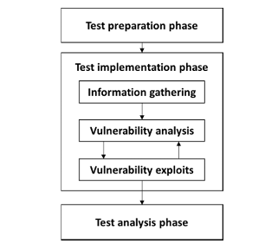
Figure 1 Phases of penetration test [15].

Other methodologies highlighted in Figure 2 utilised such as PTES outline different phases, but the similarities are observed.
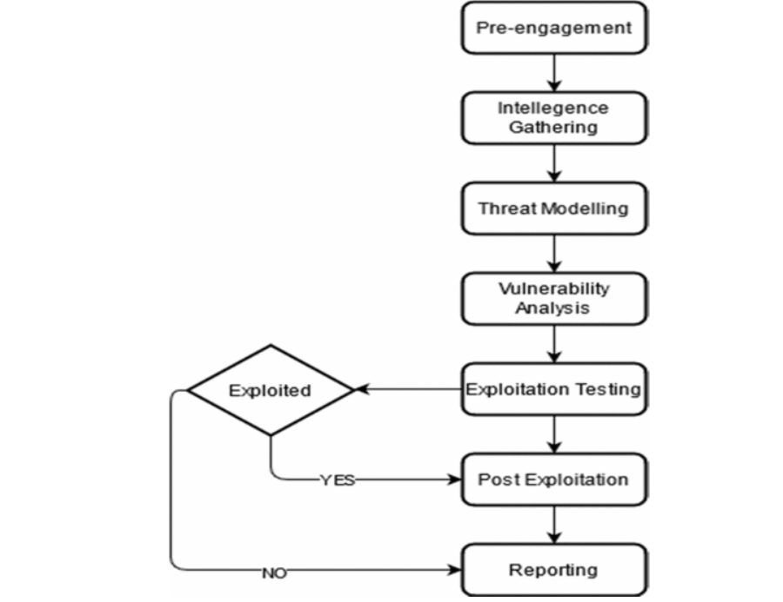
Figure 2 Penetration Testing Execution Standard [22]

In test preparation the relevant documents are collected, finalised and legal documentation are signed by both parties. Within this stage things such as the objective of the test, duration and times are identified [15]. This is like the pre-engagement stage in PTES which highlights it is in this stage of pre-engagement that the tools to be used are prepared [22].
The second stage of the test implementation phase has 3 steps. Information gathering which identifies all relevant information to identify vulnerabilities and can be undertaken by using automated or manual testing tools, or both [15]. Like the intelligence gathering and threat modelling stage outlined in the PTES model [22].
The vulnerability step within this phase involves the tester receiving the challenge to evaluate and detect security defects from the target. Particular attention is required to ensure all steps are followed and this model of penetration testing can expand into two main procedures, namely code analysis to find security flaws by source code and vulnerability analysis which will educate those to learn how to detect, eliminate and potentially avoid vulnerabilities within software products prior to shipping [15]. This is the exploitation phase in PTES model [22] and will highlight vulnerabilities contained. The post-exploitation stage explores the exploitation process even deeper and can utilise vulnerabilities such as password guessing, which is a simple method when hackers know something about those who have access [22].
Fig 3 provides a model which encompasses the principle included in whichever model is applied:
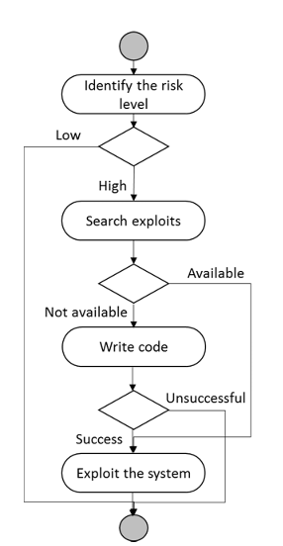
Figure 3 Logical model of a penetration test process [15].

This comprehensive approach to penetration testing to protect systems is based on Code analysis in addition to Vulnerability analysis equalling the total vulnerability [15].
The final step being exploitation looks to take advantage of vulnerabilities discovered in the analysis step [15]. This step can help evaluate solutions and the impact of vulnerabilities and can require further analysis depending on any unintended behaviour which may occur, Denial of Service (DoS) being a prime example.
The final stage consists of completing reports which outline a summary, assessment findings, an indication of risk level, advisories, cost and timescales [15]. This information is likely to be shared with technical staff in addition to management. The report needs to have three major sections so that the relevant section can be shared with the relevant personnel [24].
These methodologies standardize the pen testing process and improve the reliability and reproducibility of findings. Figure 4 highlights The Pan Do Check Model, which is applied and highlighted by [15] to ensure that there is structure to the process and how information is weaknesses and then inform the risk assessment and recommendations.
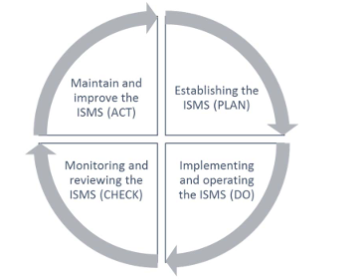
Figure 4 Plan- Do-Check-Act (PDCA) model [15].

2.4 Tools Used in Penetration Testing

A wide array of tools exists to support penetration testing across various platforms. Penetration testers employ a variety of tools, both open-source and commercial, to conduct assessments. The selection depends on the testing scope and environment. Tools such as Metasploit, Nmap, Wireshark, Burp Suite, and Nessus are frequently cited in academic and industry literature. The penetration tester needs to utilise appropriate and updated tools to review the vulnerabilities [20].
Tools for penetration testing:
- NMAP – also referred to as Network Mapper which develops network services and maps. This tool sends crafted packs to the target host and then provides an analysis of the found responses [15]. As it is used to discover hosts and services on a computer network, it also aids reconnaissance and enumeration phases.

- BoEF - which is the Browser Exploitation Framework which focuses on the web browser and investigates web browsers in terms of its exploitability [15].

- Metasploit - is used for testing weaknesses in operating systems and applications, running a set of codes on the target [15]. Metasploit is a widely used penetration testing framework that provides a suite of exploits and payloads for testing system vulnerabilities [25].

- Nessus - A vulnerability scanner evaluates systems for misconfigurations and known vulnerabilities [26]. This tool acts as a remote security scanner and is classed as the world’s most popular scanner as it provides a lot of control compared to others [15].

- Cain and Abel - a tool used for password cracking, utilising various attacks methods exclusively for Microsoft operating systems. Password cracking penetration targets an individual’s profile and applies various tools to break password protected files [15].

- Wireshark - an open-source application used for network traffic inspection, helping testers detect anomalies and insecure protocols. As a tool it can capture Ethernet live-data and inspect USB data [20].

- KaliLinux - In most cases, it is considered as a default penetration. OS is a reliable pen-testing tool on the platforms of desktops, mobile devices, virtual machines, Docker, and Windows or Linux-based subsystems. This tool supports vulnerability scanning and digital forensics operations and can be used as a sniffing tool for LAN and WAN. In addition, it is used for 16-bit brute force password cracking [20].

- Intruder - is another common tool used in the banking and government sector to scan vulnerabilities of the system. Highted by [20] it performs auto analysis and develops a vulnerability list based on the risk priority and it can work with cloud systems: AWS, Google Cloud, and Azure.

Other specialized tools include Hydra (for brute-force attacks), SQLmap (for SQL injection), Nikto (for web server vulnerabilities), and OWASP ZAP (for dynamic application security testing) [27]. Whilst the choice of tool is guided by the testing phase and target system, most professionals use a combination of reconnaissance, scanning, exploitation, and post-exploitation tools.

2.5 Categories and Types of Penetration Testing
Penetration testing is a valued assurance assessment tool that benefits both businesses and its operations. When undertaking penetration testing, consideration to both strategy and type is needed. Penetration tests are categorized based on scope and access level. Figure 5 highlights the three types of penetration strategies: black box, white box and gey box [28] outlined in the available literature.
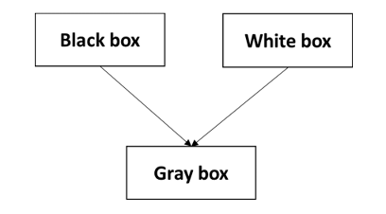
Figure 5 Penetration testing methods [15].
These models of Penetration testing encompass various approaches tailored to specific security needs based on knowledge scope:
- Black Box Testing: According to Jayasuryapal [29], in black box testing, testers simulate an attack without any information about the infrastructure. In this way, the testers discover all vulnerabilities using their methods and tools. This means that the testers use several real attack techniques such as social engineering and remote access. For example, the testers obtain the IP address of the network without any other information. Then, the testers simulate all attack techniques to find all known and unknown vulnerabilities in the network. This approach helps identify vulnerabilities that an outsider might exploit and is similar to the blind test strategy [15]. As this strategy simulates an external attack with no prior knowledge of the internal network, it essentially tests how well a system defends against an outsider [30]. Figure 6 shows some important black box testing techniques.
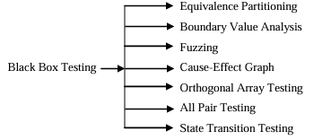
Figure 6 Different forms of black box testing techniques [30].
Some of the techniques such as equivalence partitioning allow data to be separated to determine test cases, whilst cause and effect enable visual data results to establish cause and effect of the four basic symbols [30].
- White Box Testing: The tester has complete access to the system's architecture, source code, and network details, allowing for an in-depth security evaluation [15]. The testers simulate the attack with complete information about the infrastructure, operating system details, IP address, and some passwords. It is designed to allow the testers to perform the attack using familiar knowledge about the target system of organizations such as the personal details of an internal employee. This preserves the integrity of the organization’s network infrastructure and reduces the risk of an internal attacker, such as a disgruntled employee [29]. It is considered most effective when internal documentation and code are available, allowing for a more thorough search for system defects and is also known as targeted testing due to the collaboration of the tester and the organisation [15]. It essentially provides full access to internal structures and source code, allowing testers to find deeper vulnerabilities [26]. Figure 7 shows some important techniques of white box testing are illustrated below.

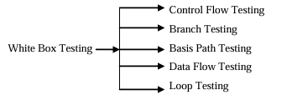
Figure 7 Different forms of white box testing techniques [30].
Figure 7 highlights how the use of control flow testing associated with white box testing allows the testing to opt for a simpler path, whist branch testing allows a true or false option to every test option [30].
- Gray Box Testing: A hybrid approach where the tester has partial knowledge of the system, replicating an insider threat with limited access to sensitive information. This approach often requiring additional information prior to testing being able to be conducted [15]. Gray box testing eliminates the internal or external security issues that can be exploited by attackers [31]. This strategy offers partial knowledge and is often used to simulate insider threats [27]. Figure 8 shows some important testing techniques associated with grey box testing.

Figure 8 Different forms of grey box testing techniques [30].
Matrix testing techniques for example show the status report of the project and pattern testing verifies the positive application of the architecture and design [30].
In terms of application, penetration testing can be network-based, application-based, physical, or social engineering-focused. For example, application penetration testing targets the security of web and mobile apps, while network penetration testing evaluates the strength of internal and external network defences [32]. The aim of the penetration testing will determine the type of testing applied given the benefits and limitations highlighted below. Some of these features are summarised in Figure 9, highlighting the advantages and limitations of each technique.
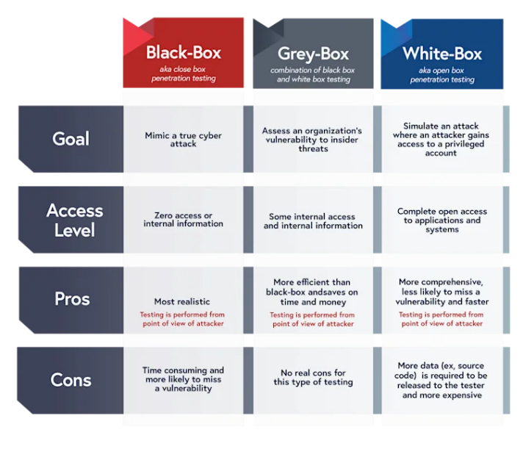
Figure 9 A Summary of Black-Box vs Grey-Box vs White-Box [31].

Depending upon what the objective of the testing relates would determine whether internal or external testing strategies are utilised [15]. Should it wish to be known how far an outside attacker can get once access is gained then external testing is utilised. Outlined by [33] this usually starts with accessing publicly available information before targeting externally visible services and network devices such as firewall or Web servers.

Internal testing strategies are performed within the technical environment inside a system, and as outlined by [33] involves imitating an attack that could be undertaken by an authorised user and described as the “what if” scenario for a network. Its focus is establishing an understanding of the consequences of an authorised user and the potential damage caused for certain access privileges [15].

Blind test strategies aim at simulating an attack in a real time environment [33]. As highlighted by [15] this is similar to the black box testing as the tester is supplied with either no or very limited information and needs to use the information available in the public domain. The Double-Blind Pen testing strategy us an extended version of this strategy however as outlined by [33], only a few people within the organisation will be aware of the testing activity.

Targeted Pen testing involves the organisation’s IT department and as a result it can be cost effective and enable a greater focus on the aspects of the network design. This strategy is often beneficial if relation to time and resource costs [33].

As established the testing focus often determines the strategy which is adopted. Some of the testing focuses are detailed as follows:

- Network Pen Testing: Evaluates LANs, WANs, firewalls, routers, and wireless access points [34]. When using firewall penetration, it will reveal any vulnerabilities across the firewall security software, configuration settings and operating system [15]. This will assist in assessing the effectiveness of how well security policies are implemented within organizations and eliminate any as necessary. There is also application penetration to consider that check for code related or back-end vulnerabilities [15].
- Web Application Pen Testing: Targets web applications to find flaws like XSS, CSRF, and authentication issues [35].
- Mobile Application Pen Testing: Focuses on Android/iOS apps, analysing client-side storage, APIs, and transport security [36].
- Social Engineering Testing: Evaluates human susceptibility to phishing, baiting, and impersonation [32]. Social engineering is an attack that occurs due solely to human error, often argued one of the most dangerous attacks due to them being less predictable [15].
- Physical Pen Testing: Tests physical security measures like locks, access control, and surveillance systems [37].
Routers are used to direct network traffic, therefore router penetration tests the misconfiguration of the router for any vulnerabilities, as any compromise will impact the entire network traffic [15]. Intrusion Detection System penetration (IDS) attempts to penetrate from both inside and outside to take advantage of weak security policies. The strategy applied in this instance bypasses the common IDS configuration which should help identify loopholes [15]. As the research shows, Penetration includes different tools and techniques for examining the vulnerabilities of the physical environment, client-side machines, Wi-Fi architecture, devices, web applications, and network services, as well as peripheral devices and media [20].

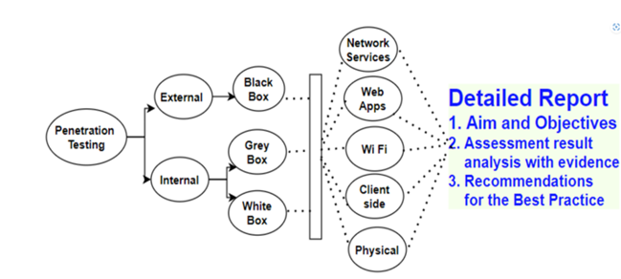
Figure 10 Penetration overview [20].

Figure 10 demonstrates how the strategies and tools are applied, dependant on the initial goal of the penetration test and how the different strategies can be applied to the various environments. The outcome being a published report of the findings and recommendations reviewing existing security measures and how an organization can implement necessary improvements to reduce their vulnerabilities.

Organisations of all types and sizes are required to adhere to standards of information security management (ISMS). The aim being to minimise assets risks and ensure business continuity [38]. Organisations select testing types based on asset criticality, compliance mandates, and threat landscape.

2.6 Challenges in Penetration Testing

Despite its benefits, penetration testing has several limitations and challenges. One concern is the potential for system disruption during testing. Improperly executed tests may crash systems, corrupt data, or expose sensitive information [34].
Another issue lies in the scope and frequency of testing. Limited budgets often restrict organizations from conducting frequent and comprehensive penetration tests. A penetration test will never identify all the vulnerabilities within an environment- tool limitations, bounded scopes, and time boxed testing all play into this [24]. Additionally, the dynamic nature of IT infrastructures, especially with the rise of cloud computing, mobile platforms, and IoT devices, mean the demands continue to require more agile and adaptable testing methodologies and knowledge of the tester [24].

There is specific code of conduct to follow laid by professional bodies and to assist with decision making there are often additional ethical and technical training required [15]. In addition, there are professional standards, the common ones being the EC council 2010 or ISC2 code of ethics, and any testers are required to keep up to date knowledge. Such Ethical and legal considerations present challenges. Testers must obtain proper authorization and ensure data privacy and integrity throughout the testing process [36]. Recent development has sought to improve Industry standards and testing focus on integration with DevSecOps pipelines, enabling continuous security testing throughout software development lifecycles [32], OWASP Testing Guide [39] and NIST guidelines [18], have codified the stages of penetration testing, which include information collecting, threat modelling, vulnerability finding, exploitation, and reporting. Tools like Gauntlt and OWASP ZAP can be integrated into CI/CD workflows to automate scans and enforce security checks [32]. These resources emphasise the need of an organised approach to penetration testing, which ensures reproducibility, accuracy, and legal compliance.

Automation in penetration testing has emerged as a response to the increasing scale and complexity of digital infrastructures. Automated tools can accelerate reconnaissance, scanning, and vulnerability assessment. AI and machine learning (ML) are now enhancing penetration testing tools by identifying patterns in threat behaviour and adapting attack strategies dynamically. Kotenko and Ulanov proposed an AI-driven multi-agent system that simulates adversarial behaviour and evolves during engagement [40]. In a study by Antunes and Vieira [39], vulnerability assessment technologies were compared to manual penetration testing to determine their usefulness in real-world circumstances. The authors found that, while automated techniques are useful for finding known vulnerabilities, manual penetration testing is required to detect complicated logic problems, privilege escalation vectors, and zero-day exploits. The results showed that whilst automated testing is the easiest way to figure out whole vulnerabilities in the system, implementing a tool that has some patterns to find the vulnerabilities is advantageous. Cloud-native penetration testing is another growing area, addressing the unique vulnerabilities in cloud environments. Researchers have highlighted the need for tailored testing strategies that align with shared responsibility models and account for platform-specific configurations [24].

2.7 Related Work
Among the various penetration testing methodologies, white-box testing stands out for its structured and thorough approach. This is due to the fact it allows the tester comprehensive knowledge of the internal systems, including architecture, source code, and configuration files [13].
White-box penetration testing in home networks involves comprehensive security assessments where the tester possesses complete access to the system’s internal architecture. This includes router configurations, firmware, settings of IoT device, firewall regulations, and credentials for any connected endpoint. In addition to allowing the tester comprehensive knowledge, this methodology facilitates a deeper analysis of vulnerabilities compared to external testing models. The advantages of which is that it is particularly effective for uncovering concealed threats can be identified in the increasingly intricate landscape of smart home environments that might remain hidden in black-box or grey-box approaches.

Yaacoub et al. [41] argue that ethical hacking techniques, particularly white-box testing, are essential for safeguarding personal networks and their research emphasises that white-box testing enables testers to simulate insider threats with high precision. Due to an increasing number of households adopting IoT and remote-access technologies, users frequently misconfigure routers or utilise outdated firmware, rendering white-box testing a useful method for identifying vulnerabilities that black-box methods would overlook. However, they also note that this method requires significant resources and expertise.

Vandolph [42] proposes a structured guideline for conducting white-box penetration testing in secured wired environments, which is particularly relevant and applicable to home networks where static devices (such as desktops, smart TVs, and NAS systems) are prevalent. His framework encompasses physical access assessment, device enumeration, and firmware scrutiny, providing a model that can be tailored to residential networks.

From a software perspective Pei et al. [43] introduced DeepXplore, a white-box testing framework designed for deep learning systems, highlighting that as AI-based devices (like smart assistants such as Alexa or Google Home) become more popular within home networks, they too require internal testing. White-box strategies facilitate testing that extend beyond mere network-level scanning, diving into algorithmic behaviours and system interactions. Software testing is also highlight as necessary by [44] acknowledging we all make mistakes. White box testing is considered as a thorough method due to covering all paths of code and this study advocates this approach being used in the initial stages and throughout the development of software application. However, the concerns surrounding availability of skilled testers and the preparation costs are acknowledged. It also highlights if the test is large then exhaustive testing will not be possible.

In the context of application-level testing, Belhadi et al. [45] highlighted that in their evaluation of contemporary API’s embedded in smart home hubs, both white-box and black-box fuzzing were employed to GraphQL APIs. Their research illustrates that familiarity with the API’s schema and internal logic and demonstrated that white-box techniques achieved higher code coverage and significantly improved fault detection—a valuable technique when assessing smart home applications linked to lighting, HVAC, or security systems.

From an industry perspective white-box methods are particularly effective for validating firmware, access control policies, and wireless encryption schemes in home routers and IoT devices. The white box testing approach historically had limited uptake in industry as its usefulness in a practical sense was queried. Whilst there is evidence to indicate it leads to clear improvements within quality metrics such as code coverage and tools such as static code analysers and configuration validators. These are deemed most effective when system credentials and access paths are fully known, research undertaken by [46] indicates that improvements are necessary before such methods can be widely adopted and concluded that whilst generating high coverage test cases will not automatically result in an improvement in the ability to test software.

Sahi et al. [47] map various testing approaches and conclude that automated tools integrating white-box principles (e.g., source code and configuration analysis) are highly effective for environments with repetitive device types, as in home automation setups. These tools can help non-expert users identify misconfigurations and outdated protocols. Their research highlighted whilst these tools offer faster turnaround times and reduce human error, though they may struggle with interpreting more complex business logic.

On the academic front, Akinyemi et al. [48] emphasize that white-box methods are vital in regulated domains with research consisting of a systematic literature review whereby over 50 penetration testing papers where synthesized, resulting in white-box methods being highlighted as best suited for regulated environments such as healthcare and finance due to their auditability and detailed reporting features. That said, their benefits can extend to private settings where users seek enhanced control and understanding of their own digital environments. Home users can simulate insider attacks—such as guests accessing private data or children bypassing content filters—more realistically with full access testing.
Risk analysis is done based on the threat modelling results. Research undertaken by [49] demonstrates how penetration testing with threat modelling frameworks like STRIDE (Spoofing, Tampering, Repudiation, Information disclosure, Denial of service, Elevation of privilege) can be beneficial. Their findings suggest that threat-informed testing greatly improves vulnerability prioritization. In a white-box context, this means assessing not only exposure to external threats but also flaws in device trust boundaries and default configurations.

While powerful, white-box testing does present challenges in the home network space. Happe and Cito [50] note that it requires a higher level of technical skill from testers, which may be a barrier for average consumers unless simplified tools or professional services are used. Their research also highlights other practical challenges—such as outdated documentation, limited automation tools, and confidentiality concerns. All of which can hinder the adoption of white box testing in agile environments.

The literature available provides a consensus that white-box testing provides more accurate and comprehensive results, especially when used alongside other testing models. However, its resource-intensive nature often restricts its use to high-security environments or during development stages when full access to systems is available.

2.8 Conclusion

Penetration testing, specifically White Box Penetration Testing, provides a critical means of identifying and mitigating vulnerabilities before they can be exploited. Through a range of methodologies, tools, and testing types, penetration testing continues to evolve alongside emerging technologies. The reviewed literature strongly supports penetration testing as a necessary and evolving practice for securing modern networks and applications. As cyber threats become more sophisticated, ongoing research and innovation in penetration testing will play a pivotal role in maintaining robust security postures. This is essential to adapt to changing threat landscape. Penetration testing is a cornerstone of modern cybersecurity strategy, although challenges persist, particularly in scalability, automation, and legal compliance, the practice remains indispensable in protecting digital infrastructure.

Chapter 3 RESEARCH METHODOLOGY

3.1 Introduction

White box penetration testing of a home computer involves a structured security evaluation using full access to the operating system, network configuration settings, installed applications, network behaviour, firmware, and credentials. This method aims to uncover vulnerabilities and misconfigurations that could lead to compromising the system's security. This methodology is particularly relevant for identifying exploitable flaws that may exist due to default settings, unpatched firmware, or a misconfigured firewall.

People undertake research to find things out in a systematic way, thereby increasing their knowledge [51]. Research usually starts with an observation, which is further explored to enhance understanding or reach an explanation, leading to a conclusion, thus furthering one’s own knowledge or skill base. As discussed by Kumer [52], it is more than a skill set, it is a way of thinking.

3.2 Research process

There are 5 key stages of the research process identified by [53]; however, even when the process steps vary, most research typically follows a similar process and includes the main headings. This project follows a similar cycle to that shown in figure 11 [54], which outlines a typical research process involving 6 steps.
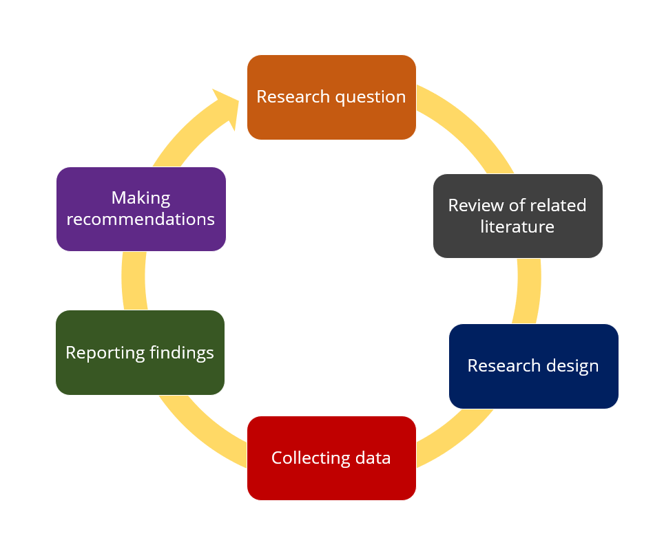
Figure 11 The research Process [54]

The stages can be broken down more explicitly into specific sections to better understand requirements following the project aims, around white box testing techniques for a home computer network.

3.2.1 System Profiling and Configuration Review
The initial step in white box testing of a home computer will be undertaking a full inventory of the computer’s hardware, software and operating system version and user accounts. Next stage will be defining the scope and objectives, which will include identifying both the services and devices on the home computer. Configuration files are then required to be examined to identify weak security practices such as disabled firewalls, lack of antivirus protection, or administrator accounts without passwords [55]. Full documentation of firmware versions and network topology, and credentials are then collected [56]. This initial step will be undertaken within this research project.

3.2.2 Static and Dynamic Analysis
With access to the system, static analysis tools like Nmap (for Linux) and (NESSUS) Windows are used to assess system security posture. Additionally, dynamic monitoring tools such as Wireshark are employed to observe real-time behaviour, including unauthorized outbound connections or privilege escalation attempts [57]. Similar assessments for system security are tools will be emulated within this project as the tools identified for use include both Nmap and NESSUS.

3.2.3 Vulnerability Scanning
Automated vulnerability scanners such as OpenVAS or NESSUS are configured with administrative credentials to undertake authenticated scans. These tools can identify patching gaps, open ports, insecure services (e.g., SMBv1, Telnet), and known vulnerabilities like EternalBlue (CVE-2017-0144) that target unpatched Windows systems [58]. White box testing eliminates the need for traditional strategy as detailed internal information is already available. This allows for direct inventory of open ports, enabled services (e.g., UPnP, SSH, HTTP), and wireless configurations (e.g., WPA2, MAC filtering) [59]. Tools such as Nmap and Fing are then utilised alongside router interface data to identify insecure services or outdated firmware [60]. Vulnerability scanning will be undertaken as part of this research to identify the vulnerabilities outlined with the use of the tool Nmap to provide details on all existing vulnerabilities found. NESSUS will be used to undertake authenticated scans.

3.2.4 Reporting and remediation
After the testing phase is completed, all vulnerabilities found will be categorized by severity rating, likelihood of exploitation, and impact. This enables recommendations to be tailored and may include firmware updates, password hardening, service disabling [57]. This process step will be followed within this research process as it will contribute to testing the hypothesis and the effectiveness of white pen testing on a home computer system. The vulnerabilities found will be categorized by using the Common Vulnerability Scoring system (CVSS).

3.2.5 Retesting and hardening
After remediation steps are applied to address the vulnerabilities, retesting is conducted. This is an important stage to verify that patches or mitigations are effective and that no new issues have been introduced. This step ensures the system is secured against previously identified threats and the risks are mitigated. Finally, the network is then hardened. This can be undertaken in various way examples of which could be the application of firewall rule, disabling remote administration interfaces, enforcing strong passwords, updating software and disabling unused services [57]. This process step will be undertaken as part of this research design as it will be an important step in providing data when assessing the efficiency in line with testing the hypothesis.
Such research processes can be expanded into fuller frameworks to achieve quality results and link research process to research philosophy which is explored further in the next section. Figure 12 referred to as the ‘The Research Onion’ illustrates this link.
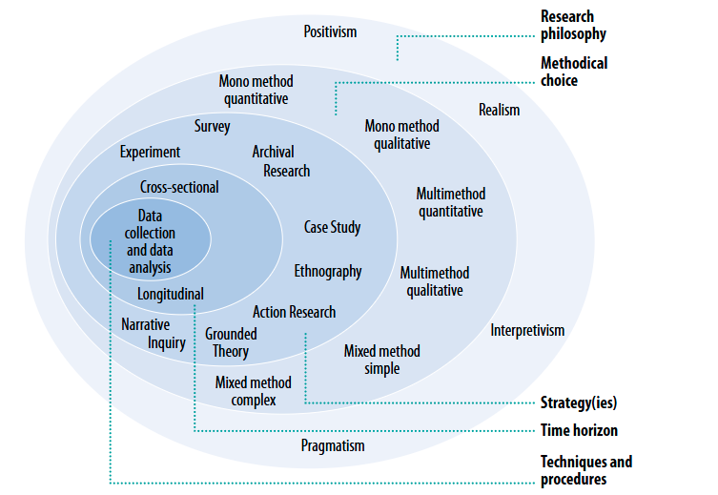
Figure 12 The Research Onion [61].

3.3 Research methodology

Research methodology is a systematic way to solve a problem [62]. Essentially, the procedures by which researchers go about their work of describing, explaining and predicting phenomena are called research methodology. Research methodology refers to the step-by-step research process; the selection of the most efficient ways to collect, analyse and present data whilst maintaining academic rigour. When deciding on a methodology you will need to select the following:

  - A philosophy
  - An approach
  - Strategies

3.3.1 Methodological Choice
The are two main research methodologies which can be applied to research. These methodological choices are, qualitative and quantitative.

- Qualitative- Qualitative research is concerned with qualitative phenomenon
involving quality. It is non-numerical, descriptive, applies reasoning and uses
words [63]. It involves the collection of (soft) data that are open to interpretation, for example, people’s opinions which cannot be generalised in numerical terms to understand the “why and “How”.

- Quantitative-is based on the measurement of quantity or amount. Here a process is expressed or described in terms of one or more quantities [63]. Research that produces statistics (hard data) allowing the researcher to understand the “What” and “How”.

Regardless of the choice, the data collected as a result are analysed for meaning. A mixed methodology can be applied to research when the research spans both quantitative and qualitative methodologies.

The methodical choice used in this project is quantitative since white box testing of a home computer will generate statistical data for analysis by following the steps outlined in the previous process section.

3.3.2 Philosophy
Depending upon the data you generate for analysis the research philosophy will be determined as shown in Figure 13 [64].

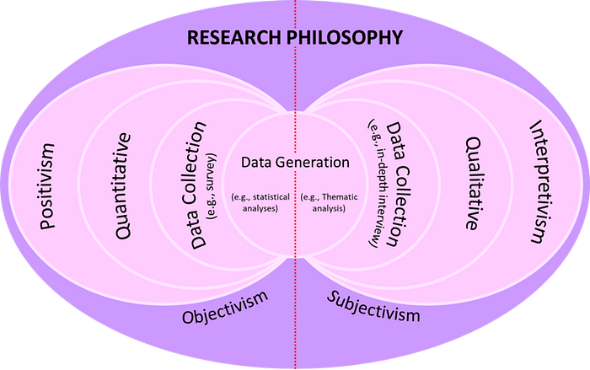
Figure 13 Research Philosophy [64]

Due to this project generating statistical analysis, a Positivist philosophy is adopted as an objective experiment being performed to observe these phenomena. The quantitative paradigm is based on positivism.

Four Modern philosophical approaches can be seen in Figure 14 detailing a brief description of what each approach aligns.

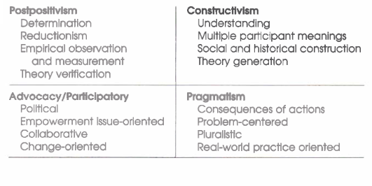
Figure 14 Philosophical Approaches [65].

Science is characterized by empirical research: all phenomena can be reduced to empirical indicators representing the truth [62]. The methodological choice of data collection for statistical analysis which is relevant to this research aligns with post-positivism. This is because it will test hypothesis and enable theory to be applied to practice. It will also determine the approach applied, which is outlined in the following section.

3.3.3 Approach
There are two main approaches which can be applied. These are:

- Deduction- involves developing a theory and hypothesis and designing a research strategy to test that hypothesis. It is considered a scientific method whereby the conclusions are built from an initial premises. It is considered the most reliable approach [66].

- Induction- This involves collecting data, analysing it, then developing theory. Considered the opposite to Deduction in that general conclusions are drawn, whereby the findings are only considered probable as opposed to factual [66].

A deductive approach will be employed within this project, beginning with a review of existing literature of White Box Penetration testing, followed by the development of a specific hypothesis or framework tailored to test vulnerabilities. The research will then test this hypothesis through the implementation and evaluation of the proposed testing method and collating quantitative data. The deductive approach is chosen for its structured nature, allowing for a clear progression from theory to practice [67].

3.3.4 Strategies
This research will employ two primary strategies: a literature review and an experiment.

- Literature Review

Undertaking a Literature review to build your research on existing knowledge is argued by [68] to be the starting point for all research activity and should be a priority for the researcher. The literature review for this project will focus on identifying existing research and theories of Penetration testing, with a particular focus on White Box Penetration Testing to ensure any findings can support or contradict previous studies undertaken. This will act as a foundation for building knowledge and applying theory to practice [68].

- Experiment

Experimentation examines the relationship between two factors (or variables) by manipulating one whilst measuring changes in the other. Experiments are used to determine if a causal relationship exists by testing a Hypothesis, measuring the effectiveness of White Box Penetration testing in identifying and addressing vulnerabilities in a home computer system.

The Independent variable (IV), as referred to by [69], is what the researcher changes or manipulates or the changes that occur independently. In the case of the experiment being undertaken as part of this project, this refers to the software that will be applied to test for vulnerabilities within the system and the mitigation that is applied as a result.

Dependent variable (DV) is effectively the changes that occur because of the changes of the IV. This is referred to by [69] as the ‘response variable”. The effect of the changes is what is going to be measured to capture the effectiveness of the applied mitigation and how many vulnerabilities that exist in the software following any re-test undertaken.

The changes applied in the software (IV) will likely vary the outcome measured in DV.

3.4 Data collection, Research Design and Evaluation
Data in this project will be collated from an experiment running vulnerability tests on a home computer system.

The Hypothesis in this research is:
- White Box Penetration is an effective way of mitigating over 90% of vulnerabilities found on a home computer system.

The test to prove or disprove this hypothesis will be:
- To apply White Box penetration techniques to identify: patch testing. open ports and insecure services to reveal vulnerabilities.
- Measure outcomes using a scoring system to identify vulnerabilities found.
- Compare results following remediation steps. This will validate or reject the hypothesis.

The data will be collated following the use of a vulnerability scanning platform, namely NESSUS. Once the vulnerability scanning is completed a report will be produced, detailing each vulnerability identified [59] and providing a scoring indicating the severity of each vulnerability by using a colour coding and CVSS [57].

Nmap scanning tool will be used in this research as a tool to identify open ports which indicate services which are potentially accessible and therefore vulnerable. This does not generate a report in the same way NESSUS does but gives an instant notification detailing this information.

The statistical data analysis generated from using both NESSUS and Nmap will be captured as screenshots to demonstrate each process followed within the experiment process.

The vulnerabilities identified will then be mitigated by taking various actions appropriate in resolving said vulnerabilities. This again will be demonstrated via the use of screen shots to demonstrate the steps taken.

Once the mitigation has been applied then the scanning will be re-run to test the home computer. This will evidence any further issues identified but will also highlight how effective the white pen testing techniques have been in identifying vulnerabilities and effecting solutions to resolve and mitigate them [57].

To prove or disapprove the hypothesis a percentage will be calculated and reported as a measure of the success of white pen testing. Recommendations and future work will be suggested considering any results in a written analysis.

3.5 Risks and limitations

There is an assumption that individuals will seek to confirm their hypothesis [70]. To overcome this, it is important to undertake thorough research and actively consider all evidence available. Logging all actions as they are completed will help mitigate these risks. Researchers often fall in love with the data- rich results and assume that the results are projectable. The results will not provide researchers with definitive conclusions, but only with enough information to establish a firm basis for decision making [62]. It is important to recognise that home systems typically contain fewer components and are less complex in their architecture, so therefore the results may only generate low level security concerns. The fact that a virtual machine is being used within this research will minimise a lot of the security and privacy risks associated with this method.

3.6 Research Considerations

Ethically there are no considerations in relation to this research project. There are no privacy or confidentiality rights to adhere to. This experiment will be undertaken on a virtual machine and whilst the results could be generalised to personal and business use, there is no identified organisational data breach or reputational risk to consider.

The research will document all processes and methodologies in detail, allowing other researchers to replicate the study in similar contexts. Reliability will be ensured by using standardized data collection and analysis procedures, which will allow the research to be replicated which will result in a different researcher being likely to generate the same results.

3.7 Resources and planning

3.7.1 Hardware Resources
The research will use a virtual machine to enable the required scanning and fixes to be applied to ensure the relevant findings can be produced. No specialized hardware is anticipated to be required.

3.7.2 Software Resources
The research will utilise Microsoft Windows operating system as the base for testing and running the experiment for data analysis. Specialized software in the tools identified, namely NESSUS and Linux to run Nmap network scan will be used.

3.7.3 Information Resources
Data will be sourced form academic journal articles, and case studies. These resources will be accessed through online databases such as IEEE Xplore, ACM Digital Library, and Google Scholar [71]. This has assisted in determining research process steps and which scanning tools to use. Further research will be accessed if required to enable appropriate solutions and mitigation to be applied.

3.8 Project plan
The project plan was broken down into key phases of the research, including planning & Proposal, Research & Review of Literature, Research Methodology, Design and Implementation, Testing & Evaluation, Reflection, Submission and Final Viva. Milestones include the submission of interim reports in May, the completion of data collection, the final report submission in July and the final viva in September. This is illustrated using a Gantt chart and proposed timeline as shown in Appendix 1.
This approach ensures that the project remains on track and allows for any adjustments based on the progress and any challenges encountered. Should any delays be encountered, a revised chart will be produced.

3.9 Conclusion

This research project follows a typical process which outlines the key steps. It demonstrates by systematically applying a structured methodology—from system profiling to retesting—the experiment will seek to validate the hypothesis that white box testing can address over 90% of security issues identified during the initial assessment. Tools such as Nmap and NESSUS will be utilised in the research to uncover a range of vulnerabilities, including open ports, unpatched software, and insecure services. These will then be resolved through tailored remediation steps and re-evaluated to confirm mitigation effectiveness.

The use of a quantitative methodology, underpinned by a positivist philosophy and deductive approach, provides a robust framework for empirical analysis. The experiment will not only measure the immediate impact of remediation but will also highlight the broader applicability of white box testing for personal and small office security practices. Importantly, the research will adhere to ethical standards; by operating within a virtual machine environment risk will be minimised and the research can be replicated through detailed documentation.
While the limited scope of a home system may constrain the generalisability of results to more complex enterprise networks, the findings strongly support the utility of white box testing as a preventive security measure and reinforces the value of proactive security assessments.

Chapter 4 Design & Implementation

4.1 Introduction

In an increasingly connected digital world, ensuring the security of the home PC has become critically important. With the continued increase of smart devices and the reliance on remote access, the potential entry points for exploitation and therefore potential cyber threats continues to expand [72]. This project simulates a basic penetration testing scenario using a virtual environment to identify potential vulnerabilities in a home PC setup.
Within this experiment a laptop is used as the host machine, on which virtualization software is installed to create two virtual machines: a home PC (Windows 11) and a Linux. The virtual home PC mimics a typical home PC, and Linux with cybersecurity tools, namely Nmap. The vulnerability assessment process begins with the installation of the cyber security tool Nessus onto the home PC. Nessus, a widely used vulnerability scanner, performs a comprehensive analysis to detect software flaws, misconfigurations, and outdated components [73]. Subsequently, Nmap, a powerful network scanning tool, is used from the Linux environment to perform initial checks and port scanning. This allows the identification of open ports, running services, and potential security weaknesses that could be exploited [74].

Once vulnerabilities are discovered through Nessus and Nmap, appropriate mitigation strategies will be implemented to secure the home PC. These may include patching outdated software, closing unnecessary ports, disabling vulnerable services, and strengthening configuration settings. This proactive approach ensures that the identified threats are addressed, reducing the attack opportunities and enhancing the overall security of the system [75].
This controlled environment serves as a practical exercise in understanding the vulnerabilities that attackers can exploit to gain unauthorized access. It highlights the importance of regular vulnerability assessments and network monitoring to maintain a secure computing environment. By combining active and passive scanning techniques, the experiment underscores the necessity of implementing proactive cybersecurity strategies, even on a small scale.

4.2 Problem formulation

The problem formulation for white box penetration testing on a home PC involves analysing the network structure, detecting possible vulnerabilities, and employing testing methods that utilize in-depth knowledge of the system’s internal components and software mechanisms. White box penetration testing is essential as it not only assesses the system's external defences but also seeks to identify flaws within source code or configuration settings that may be exploited by malicious users. As previously outlined, this comprehensive approach allows testers to gain insights that are not visible during black-box testing, which only considers external behaviours [76], [77].
Given the increasing prevalence of cyber threats, ensuring a home PC's security through such rigorous testing is paramount. Many white box techniques directly correlate with contemporary practices in software testing, which advocate for automated test generation to adequately cover code and validate security controls [78], [77]. Conducting a structured white box penetration test allows for systematic identification and remediation of vulnerabilities, ultimately strengthening the overall security of the home PC. This then enables a percentage to be obtained to measure the effectives of addressing the vulnerabilities highlighted through the testing employed.

4.3 Design

The process begins with a “Host PC”, which serves as the main system for running virtual environments. An Oracle Virtual Machine (VM) is deployed on the host system to simulate different operating systems for testing and vulnerability assessment. This virtual environment includes two VMs: one running “Home PC “and the other running Linux.
On the “Home PC” VM, Nessus is installed and used for vulnerability scanning. Nessus is a widely used vulnerability assessment tool that can identify vulnerabilities that could be exploited by malicious actors to gain unauthorized access to networked systems, operating systems, applications, and devices connected to the network. It scans the system and generates alerts if it finds weaknesses that attackers could exploit [73].
Nessus conducts in-depth vulnerability scans, systematically probing target systems for known security misconfigurations, missing patches, default credentials, and other exploitable weaknesses. Upon discovering vulnerabilities, Nessus generates alerts, providing critical insights into the security posture of the scanned PC. Nessus is known for its ability to scan computers and raise alerts upon discovering vulnerabilities that could be exploited by attackers [73].
Nmap operates from the Linux environment, Nmap provides the initial understanding of "what's out there" in terms of active hosts, open ports, and services [74], which then guides Nessus in asking "what specific vulnerabilities do these identified services or hosts possess?" This represents a standard and logical workflow in security assessments, where scanning naturally precedes deeper analysis.
The deployment of Nmap on Linux and Nessus on Home PC is not random but reflects common operational considerations. Linux is frequently the preferred operating system for network utility tools and command-line operations, aligning well with Nmap's capabilities. Conversely, Windows OS is a prevalent platform for graphical user interface (GUI)-based security tools like Nessus, and it also represents a common target environment for which Nessus is highly effective. This strategic placement of tools demonstrates practical deployment strategies which can then be simulated and considered in real-world security operations. The bidirectional arrow between the home PC and Linux VMs shown in Figure 15 confirms that these systems are networked, enabling cross-platform scanning activities.
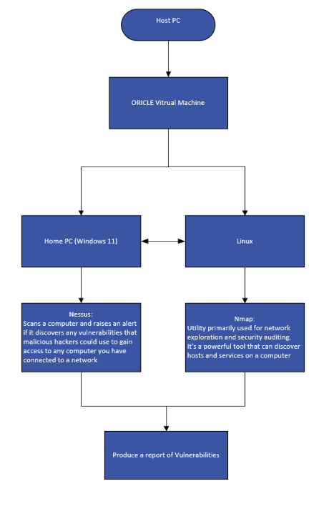
Figure 15 Experiment Design Flow chart.
This combined use of tools, each with its distinct strengths—Nmap for broad network mapping and service identification [73], [28], and Nessus for deep, specific vulnerability checks [74], [26]—ensures a more thorough and accurate assessment than either tool could achieve alone. This multi-tool approach provides a more complete picture of the security posture of the virtualized network.
The culmination of the experimental process, following the execution of Nmap and Nessus scans, is the generation of a "Report of Vulnerabilities" is highlighted in Figure 15. This report represents the tangible and most critical outcome of the entire assessment. It serves as a consolidated document, detailing the identified weaknesses, their assessed severity, and often includes recommendations for their remediation.
The production of a comprehensive report is paramount for transforming the raw scan data into information that action can be taken to address the noted vulnerabilities. It functions as a formal record of the assessment, enabling the user of the home PC to clearly understand the security posture of the scanned system. This understanding is vital for prioritizing remediation efforts and allocating resources effectively.
This final step underscores that vulnerability assessment extends beyond merely identifying flaws; it is fundamentally about effectively communicating those findings to facilitate corrective action and ultimately enhance the security of the home PC. The report is the ultimate deliverable, translating technical findings into practical security improvements [28]. This report will be vital in testing the hypothesis and determining the effectiveness of white box penetration testing on a home PC.

4.4 Penetration testing lifecycle

The penetration testing lifecycle can be visualized in a structured manner as demonstrated in Figure 16. The process begins with information gathering, a phase aimed at collecting data relevant to the target system or network. Tools such as Nmap and Nessus are often utilized to perform this task, helping identify open ports, running services, firewall configurations, and vendor-specific information [74], [73].
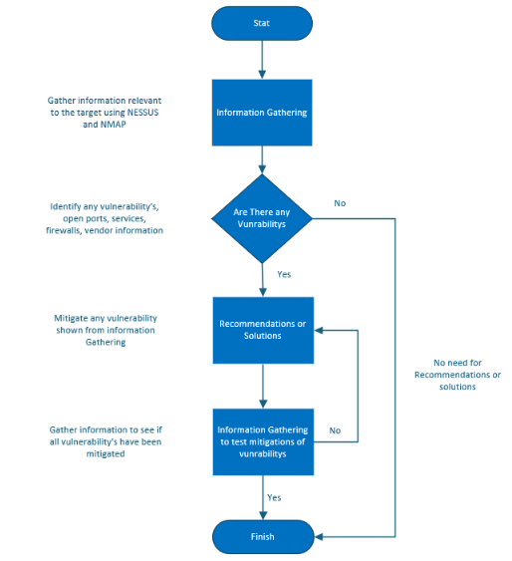
Figure 16 Penetration Testing Life Cycle
Once sufficient information is gathered, the next step involves vulnerability assessment, where the home user analyses the collected data to determine if any exploitable vulnerabilities exist. This analysis includes reviewing potential misconfigurations, outdated software versions, and weak protocols [26]. If no vulnerabilities are identified, the process concludes with no further action needed.
However, if vulnerabilities are detected, the process proceeds to recommendation or solution development, where suitable mitigation strategies are proposed. These may include patching systems, disabling vulnerable services, or reconfiguring security parameters [79].
Following the implementation of the mitigation measures, the tester must verify the effectiveness of these solutions. This is accomplished by conducting a second round of information gathering, essentially repeating the initial assessment to check whether the vulnerabilities have been successfully resolved or not.
In a real-world scenario if vulnerabilities persist, the cycle returns to the recommendation phase for further adjustments. This loop would continue until all identified vulnerabilities are mitigated, upon which the process reaches the termination stage. This iterative approach ensures continuous improvement and verification of security posture, aligning with industry best practices for proactive cybersecurity management.
It is important to note for the purposes of the experiment being conducted as part of this research project, the process will conclude after a second vulnerability scan in order to test the hypothesis.

4.5 Implementation

The primary objective in the implementation stage is to simulate real-world cybersecurity scenarios using virtual machines to assess vulnerabilities on a home PC setup.
A Windows 11 virtual machine was deployed to represent the target system (Home PC), while a Linux Ubuntu virtual machine was used to conduct testing procedures such as network scanning and vulnerability detection, Nessus was installed on the (Home PC) to identify security flaws, and connectivity between the two systems was established using IP-based communication.
This implementation lays the groundwork for further testing and evaluation, providing a secure and functional environment to execute penetration testing tasks in line with the project's objectives.

4.5.1 Host PC
The process involved setting up a controlled virtual environment to conduct vulnerability scanning activities. This began with configuring a Host PC, this was equipped with the necessary resources to support virtualization as shown in Figure 17.
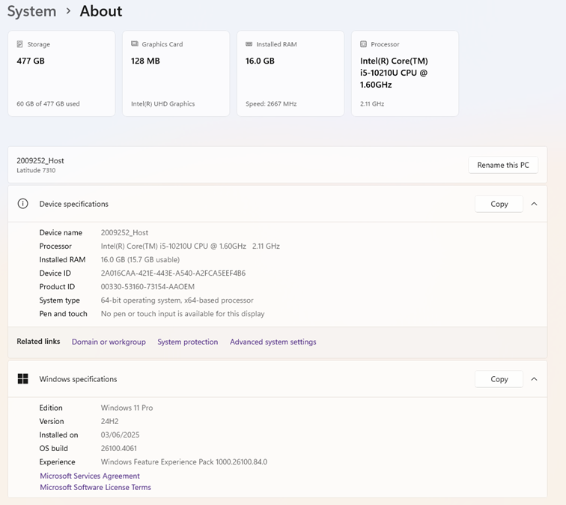
Figure 17 Host PC System

4.5.2 Host PC and VirtualBox Setup
Oracle VirtualBox was installed on the Host PC as per Figure 18, providing the platform necessary to run multiple virtual machines concurrently.

Figure 18 Oracle Virtual box

4.5.3 Installation of Virtual Machines
Two virtual machines were created using VirtualBox:
- A Windows 11 VM, representing the Home PC, this shows the necessary resources to support virtualization as highlighted in Figure 19.
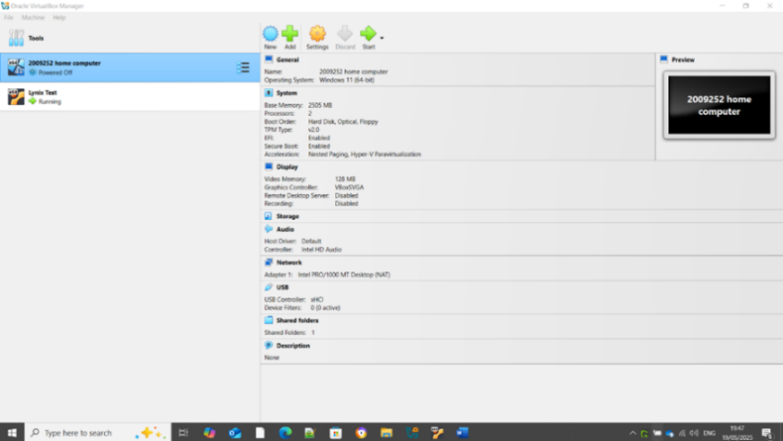
Figure 19 Shows the Home Pc (Win 11) installation on Oracle
- A Linux Ubuntu VM, used to test ports and service and Figure 20 shows the necessary resources to support virtualization.
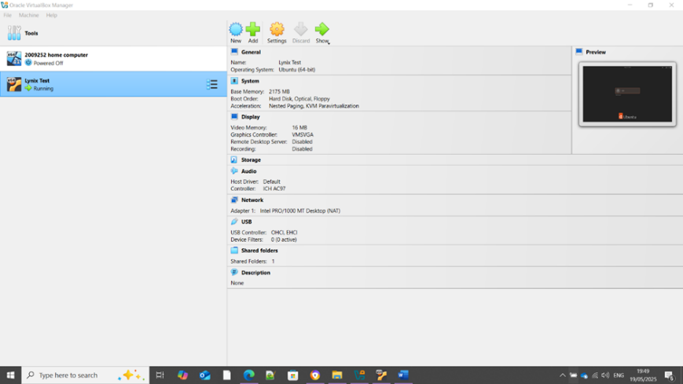
Figure 20 Shows the Linux Ubuntu install on Oracle VM

4.5.4 Nessus Setup on the Home PC
Nessus was installed on the Windows 11 Home PC as shown in Figure 21.
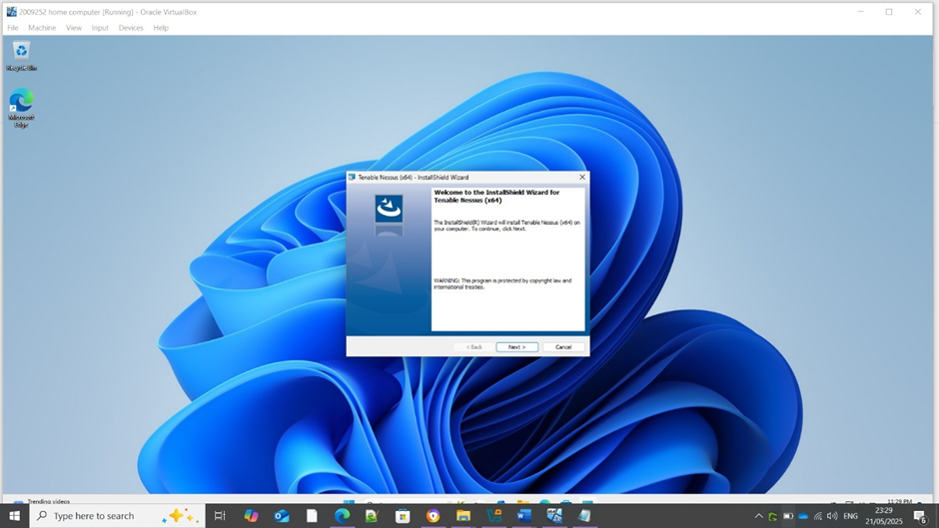
Figure 21 Installing Nessus on the Home PC
An account was created to activate and use Nessus as illustrated in Figure 22. This tool enables comprehensive scanning to detect vulnerabilities in the system.
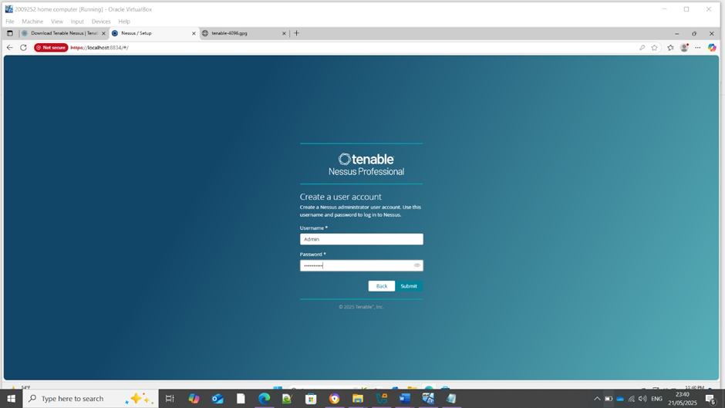
Figure 22 Creating an account on Nessus

4.5.5 Network configuration and Testing
Each VM was assigned a unique IP address:
- Windows 11 (Home PC): 169.254.90.99 as seen in Figure 23.
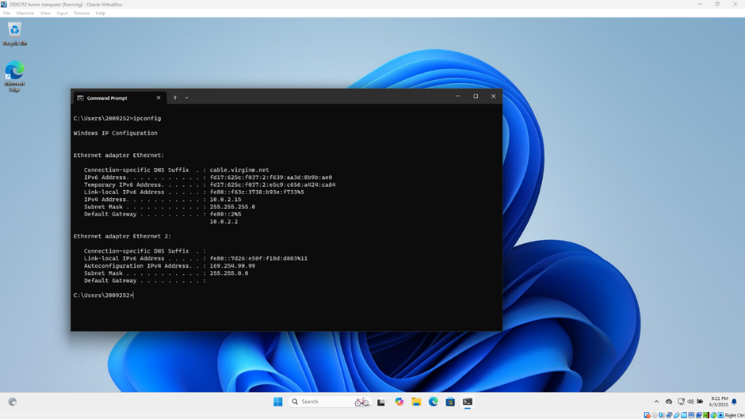
Figure 23 The IP address of the Home PC 169.254.90.99
- Ubuntu (Linux): 169.254.128.160 as seen in Figure 24.
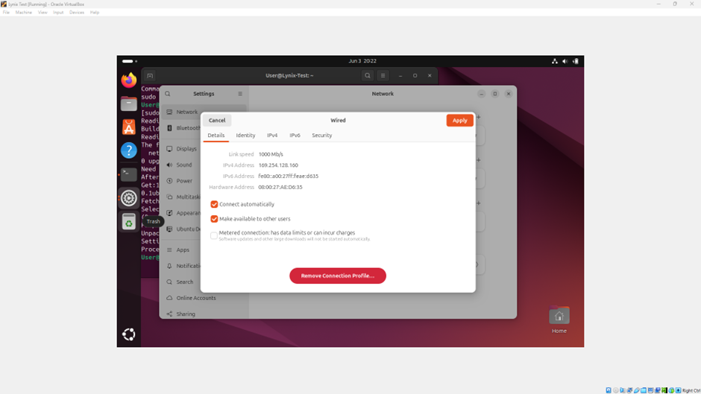
Figure 24 The IP address of Linux 169.254.128.160
Both VMs were configured to operate on the same virtual network to enable direct communication.
To ensure proper network connectivity, the Home PC successfully pinged the Linux system Figure 25.
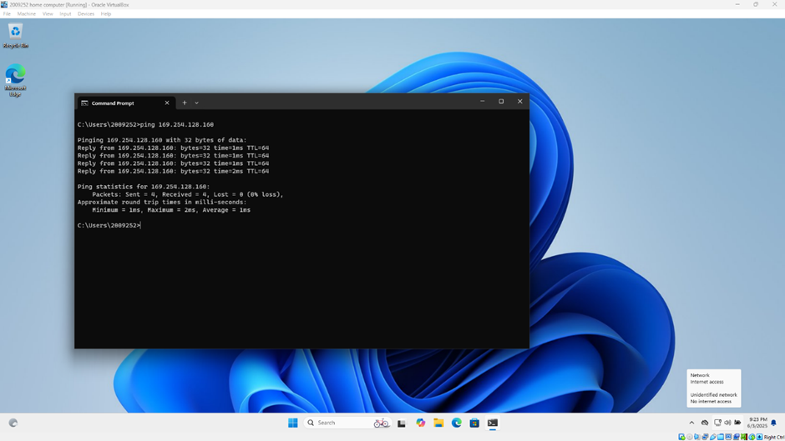
Figure 25 Pinging from Home PC to Linux
Figure 26 shows that the Linux system returned the communication by pinging the Home PC.
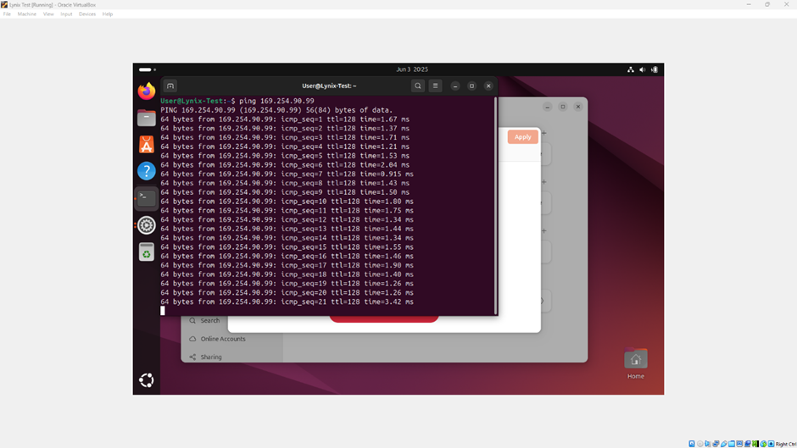
Figure 26 Pining from Linux to Home PC
Confirming that both machines were on the same network and could interact is a prerequisite for vulnerability testing. With both systems operational and networked, the implementation phase was considered complete, setting the stage for initiating the vulnerability assessment and penetration testing.

4.6 Conclusion
This demonstrates what needs to be in place to simulate a basic white-box penetration testing scenario on a home PC within a virtualized environment to identify potential vulnerabilities. By utilizing a Host PC to run a Windows 11 virtual machine (Home PC) and a Linux virtual machine, the setup allowed for the application of specialized cybersecurity tools like Nessus and Nmap.

The problem formulation emphasized the importance of white-box testing, which goes beyond external defences to examine vulnerabilities and configuration settings, offering insights not visible in black-box testing [41]. Detailed knowledge of the software system architecture proved crucial for simulating various attacks and revealing deeper vulnerabilities in addition to ensuring the approach is robust.
The design involved deploying Nessus on the Home PC for in-depth vulnerability scanning, identifying misconfigurations, missing patches, and exploitable weaknesses. Nmap, operating from the Linux environment, provided initial network mapping and service identification, guiding Nessus's deeper analysis. This combined, multi-tool approach ensured a more thorough assessment of the virtualized network's security posture [13], [42].
The penetration testing lifecycle is an incremental process that begins with information gathering, proceeds to vulnerability assessment, and if vulnerabilities are found, moves to recommendation development and verification of solutions. The generation of a report is highlighted as a critical outcome of the process as it will translate technical findings into actionable intelligence. This will allow for home user to prioritize remediation efforts and enhance overall security.
Ultimately, the successful implementation stages demonstrated a practical, proactive approach which will enable the identification and subsequent mitigation of security weaknesses within a controlled environment in line with the aims of objectives of this experiment.

Chapter 5 Testing and Evaluation

5.1 Introduction
As cyber threats continue to evolve, maintaining updated systems is crucial for mitigating risks associated with software vulnerabilities. Penetration testing can assist in identifying such vulnerabilities and ensuring mitigation is then applied. With the necessary software now installed, testing of the hypothesis to assess the effectiveness of white box penetration testing on a home PC can commence.

Following the initial vulnerability scan carried out the home PC (IP: 169.254.90.99), several critical security patches were observed. The vulnerability assessment was carried out using Nessus, which was configured to perform an advanced scan of the home PC. The results identified missing Microsoft updates and associated common vulnerabilities and exposures. Nmap was then used to scan for ports and other vulnerabilities on the home PC. The results following use of both tools will be reported on and the findings following the suggested mitigation will also be reported. This essentially will prove or disprove the hypothesis.

5.2 Nessus Findings and Analysis
The first penetration testing tool to be run on the Home PC was Nessus. Nessus undertakes an in—depth scan for vulnerabilities and generates a report to indicate any vulnerabilities that could be exploited [73].

5.2.1 Nessus: Home PC Overview
The report details an overview of the home PC, providing these initial details of the operating systems and network identifiers as below:
Host Name: HOME-COMPUTER
HP Address: 169.254.90.99
Operating System: Microsoft Windows 11 Education Build 26100
MAC Address: 08:00:27:3D:BB:B9 / 08:00:27:7D:FA:AD

5.2.2 Nessus: Vulnerabilities
The report provides a breakdown in accordance with severity of the vulnerabilities found. This is displayed in table and colour coded form as detailed in Figure 27.

Severity Count
Critical 3
High 8
Medium 6
Low 0
Info 217

In addition to colour coding the vulnerabilities are distinguished on severity rating and the report also references findings for information purposes which require less attention.

Figure 27 Summary of vulnerability colour coded
When selecting the Host, a further break down of the report is shown in Figure 28 below. This enables detailed information to be obtained around what each vulnerability relates to.
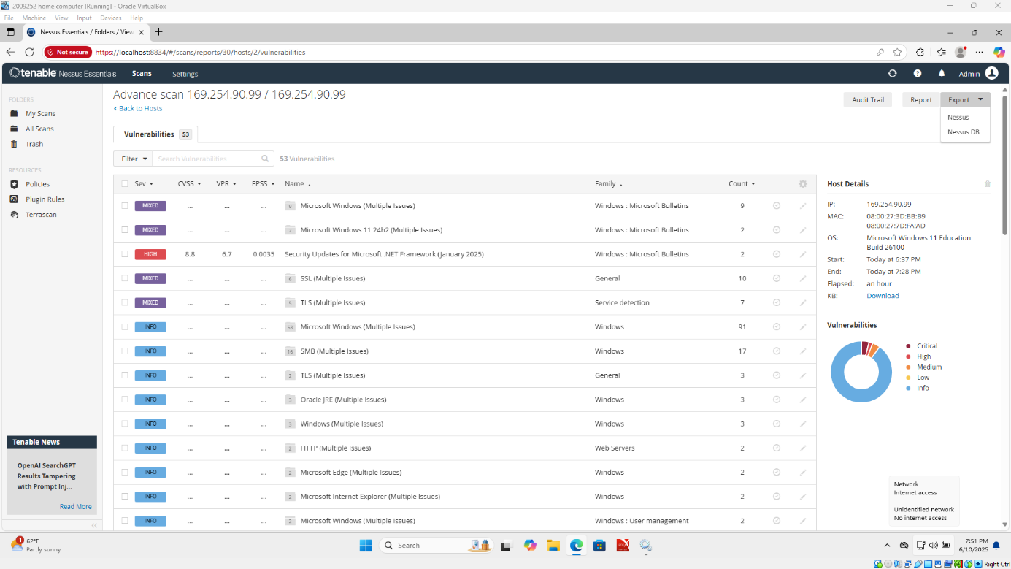
Figure 28 Nessus report breakdown
The vulnerability scan conducted on the Home PC identified several security risks that required immediate attention, this being those classified as Critical, High and Medium. Below is an overview based on these described severity ratings:
    - Nessus Critical Vulnerabilities
- 210851 - KB5046617: Windows 11 Version 24H2 / Windows Server 2025 Security Update (November 2024).
This highlights the absence of security updates (KB5046617 and Hot Patch 5046696) on Windows 11 Version 24H2 and Windows Server 2025, which exposes the system to several vulnerabilities. Specifically, it outlines the vulnerabilities related to Windows Kerberos, NT OS Kernel, and Telephony Service that could lead to remote code execution and elevation of privilege attacks, as identified by their CVE listings detailed within Appendix 2. The report indicates that a security update 5046617 or Hot Patch 5046696 needs to be applied as a solution to the identified vulnerability.
- 212224 - KB5048667: Windows 11 Version 24H2 / Windows Server 2025 Security Update (December 2024)
The Home PC is missing security update 5048667 or hot patch 5048794. It is, therefore, affected by multiple vulnerabilities. This highlights the significance of security update KB5048667 for Windows 11 Version 24H2 and Windows Server 2025, which addresses critical vulnerabilities, including remote code execution and privilege escalation. The vulnerabilities listed in Appendix 2, such as CVE-2024-49079, CVE-2024-49090, and CVE-2024-49112, emphasize the importance of patching systems to mitigate security risks. The recommended mitigation is to apply Security Update 5048667 or hotpatch 5048794.
- 214124 - KB5050009: Windows 11 Version 24H2 / Windows Server 2025 Security Update (January 2025)
The necessity for applying security update KB5050009 for Windows 11 Version 24H2 and Windows Server 2025 is due to multiple identified vulnerabilities. Specifically, it highlights critical issues outlined in Appendix 2 such as remote code execution and elevation of privilege vulnerabilities, as well as information disclosure risks associated with Windows BitLocker.

5.2.4 Nessus High Vulnerability
- 208302 - KB5044284: Windows 11 Version 24H2 / Windows Server 2025 Security Update (October 2024)
Provides a contextual basis for understanding the security implications of the vulnerabilities listed in the update KB5044284 for Windows 11 Version 24H2 and Windows Server 2025. The Home PC is missing security update 5044284. It is, therefore, affected by multiple vulnerabilities. Appendix 2 highlights the nature of these vulnerabilities, including issues related to the ASN1 parser in libcurl (CVE-2024-6197) and the Remote Desktop Client (CVE-2024-43599), which can potentially lead to remote code execution and system compromise. By mentioning the exploitation indicators and the consequences of these vulnerabilities, the reference emphasizes the urgency for users to apply the security update to mitigate risks associated with their exploitation.
- 216132 - KB5051987: Windows 11 Version 24H2 / Windows Server 2025 Security Update (February 2025)
The report indicates that the remote Windows is affected by multiple vulnerabilities due to missing security update 5051987 or hotpatch 5052105. It provides information that underscores the significance of the security update 5051987, which addresses critical vulnerabilities affecting Windows 11 and Windows Server 2025. These vulnerabilities include multiple Remote Code Execution (RCE) exploits related to the Windows Routing and Remote Access Service and the Windows Telephony Service. The mention of various references (MSFT, CISA, and IAVA) in Appendix 2 suggests a recognition of these vulnerabilities in known exploit databases, highlighting their relevance in cybersecurity discourse.
- 232616 - KB5053598: Windows 11 Version 24H2 / Windows Server 2025 Security Update (March 2025)
This supports the summary of security vulnerabilities related to Windows 11 and Windows Server 2025 associated with update KB5053598. It highlights the consequences of missing the update, which exposes the systems to various threats including unauthorized code execution and privilege escalation. Specifically, it addresses the unauthorized access risks in Remote Desktop Client (CVE-2025-26645) and the vulnerabilities in Remote Desktop Services (CVE-2025-24035, CVE-2025-24045). Moreover, it signifies that the listed issues should be addressed as the affected Synaptics audio drivers are at End-of-Life status, emphasizing the importance of moving systems to supported products to enhance security as detailed in Appendix 2.
- 234033 - KB5055523: Windows 11 Version 24H2 / Windows Server 2025 Security Update (April 2025)
Security updates relevant to Windows 11 Version 24H2 and Windows Server 2025, specifically address vulnerabilities that might affect the system if the update KB5055523 is not applied. The report outlines significant risks, including a privilege escalation vulnerability (CVE-2025-26687) and issues with remote code execution (CVE-2025-27481), as well as another elevation of privilege vulnerability (CVE-2025-27740) as outlined in Appendix 2.
- 235839 - KB5058411: Windows 11 Version 24H2 / Windows Server 2025 Security Update (May 2025)
Such an update supports the task by providing official identifiers and classifications related to the vulnerabilities described in the summary detailed within Appendix 2. It links to known exploited vulnerabilities and additional advisories, thus validating the identified issues in the Windows 11 update. This context reinforces the urgency of addressing the vulnerabilities associated to security update 5058411 and highlights ongoing security risks associated with unaddressed software flaws present in the specified systems.
- 193266 - Security Updates Outlook for Windows (April 2024)
This highlights the critical security update needed for Microsoft Outlook on Windows, which addresses a spoofing vulnerability that could allow attackers to exploit users by manipulating email connections to untrusted locations. Appendix 2 shows how this can result in leaking sensitive Net-NTLMv2 hashes, enabling authentication impersonation of victims by attackers [80].
- 214274 - Security Updates for Microsoft .NET Framework (January 2025)
This indicates that the Microsoft .NET Framework installation is missing a vital security update as of January 2025, which exposes it to various denial of service vulnerabilities, specifically a remote code execution issue (CVE-2025-21176) as outlined in Appendix 2. This information highlights that attackers could exploit the vulnerability to execute unauthorized code.

5.2.5 Nessus Medium Vulnerabilities
The scan detected a high number of medium-risk vulnerabilities that exist due to outdated software, missing patches, and insecure configurations. These may not pose immediate threats but could be exploited in conjunction with more severe issues.
- 51192 - SSL Certificate Cannot Be Trusted
The report shows that the server's X.509 certificate cannot be trusted. This situation can occur in three different ways, in which the chain of trust can be broken. Durumeric et al. [81] addresses these three critical issues related to SSL certificate trustworthiness. These include unrecognized certificates, invalid time frames, and unverifiable signatures. Any break in the chain not only hinder user verification of a web server's authenticity but also expose the server to potential man-in-the-middle attacks, thereby requiring immediate remediation to ensure security compliance as detailed in Appendix 2.
- 57582 - SSL Self-Signed Certificate
SSL certificates that are self-signed or issued by unrecognized certificate authorities have associated security implications. As highlighted in Appendix 2, such certificates can lead to vulnerabilities like man-in-the-middle attacks, particularly if the service is publicly accessible in a production environment [82]. The mention of various identifiers suggests it relates to recognized security advisories or updates, underscoring the importance of employing valid, trusted certificates to mitigate these risks.
- 104743 - TLS Version 1.0 Protocol Detection
The vulnerabilities associated with TLS 1.0 and the broader context of security compliance regarding cryptographic protocols highlights that TLS 1.0 has inherent cryptographic design flaws and that the migration to TLS 1.2 or 1.3 is essential for improved security [82]. Additionally, the reference underscores regulatory requirements, stipulating that TLS 1.0 must be disabled to comply with PCI DSS standards as of June 30, 2018, except for certain exceptions. Appendix 2 emphasises that this supports the task by highlighting the need for updated security measures and the implications of outdated protocols on service functionality with modern web browsers.
- 157288 - TLS Version 1.1 Deprecated Protocol
This highlights the deprecation of TLS 1.1 due to its inability to support modern cipher suites, and the risks associated with its continued use, as outlined in Appendix 2. Specifically, it indicates that as of March 31, 2020, endpoints not upgraded to TLS 1.2 or higher will face compatibility issues with major web browsers and vendors, underscoring the urgency for updates to secure connections effectively [82].
- 166555 - WinVerifyTrust Signature Validation CVE-2013-3900 Mitigation (EnableCertPaddingCheck)
This risk highlights that the remote system may be in a vulnerable state to CVE-2013-3900 due to a missing or misconfigured registry keys.
The mitigation for the CVE-2013-3900 vulnerability, specifically emphasizing the importance of the configuration settings related to the EnableCertPaddingCheck registry entries. As detailed in Appendix 2, the absence or improper configuration of these settings can expose a system to exploitation by an unauthenticated remote attacker who could execute arbitrary code. Furthermore, while the reference provides various links and information regarding the exploitation risks, it underscores that tools like Nessus have not verified these vulnerabilities through testing but rather depend on the application's reported version, highlighting critical gaps in vulnerability assessment methods.

5.3 Nessus vulnerability mitigation
The Nessus report not only indicates and scores the vulnerabilities found but also provides the mitigation and solutions that are required to secure the home PC as detailed in Appendix 2. The below recommendations were referred to mitigate those vulnerabilities that were scored critical, high or medium:
- Windows Update.
- .NET Framework.
- SSL certificate / TLS.
- Add Registry keys

5.3.1 Nessus Windows Update
Patching a PC is a critical component of cybersecurity and system maintenance, aimed at addressing known vulnerabilities, enhancing functionality, and ensuring system stability. Security patches are typically released by software developers in response to known flaws that could be exploited by others to gain unauthorized access, deploy malware, or disrupt services. Failure to regularly apply patches leaves systems exposed to known threats and increases the risk of successful cyberattacks. According to research, over 60% of security breaches result from unpatched vulnerabilities that had available fixes, demonstrating the urgent need for timely patch management [83]. Moreover, patching not only mitigates security risks but also improves performance and compatibility with other software and hardware. It plays a foundational role in regulatory compliance and is a best practice endorsed by security frameworks such as NIST. Therefore, it is argued that regular patching is essential for maintaining the integrity, confidentiality, and availability of computer systems in both home and enterprise environments.
By opening the DOS prompt and typing in “wmic qfe list brief” it displays the hotfixes currently installed on the home PC. Figure 29 shows all the hotfixes currently installed on the home PC.
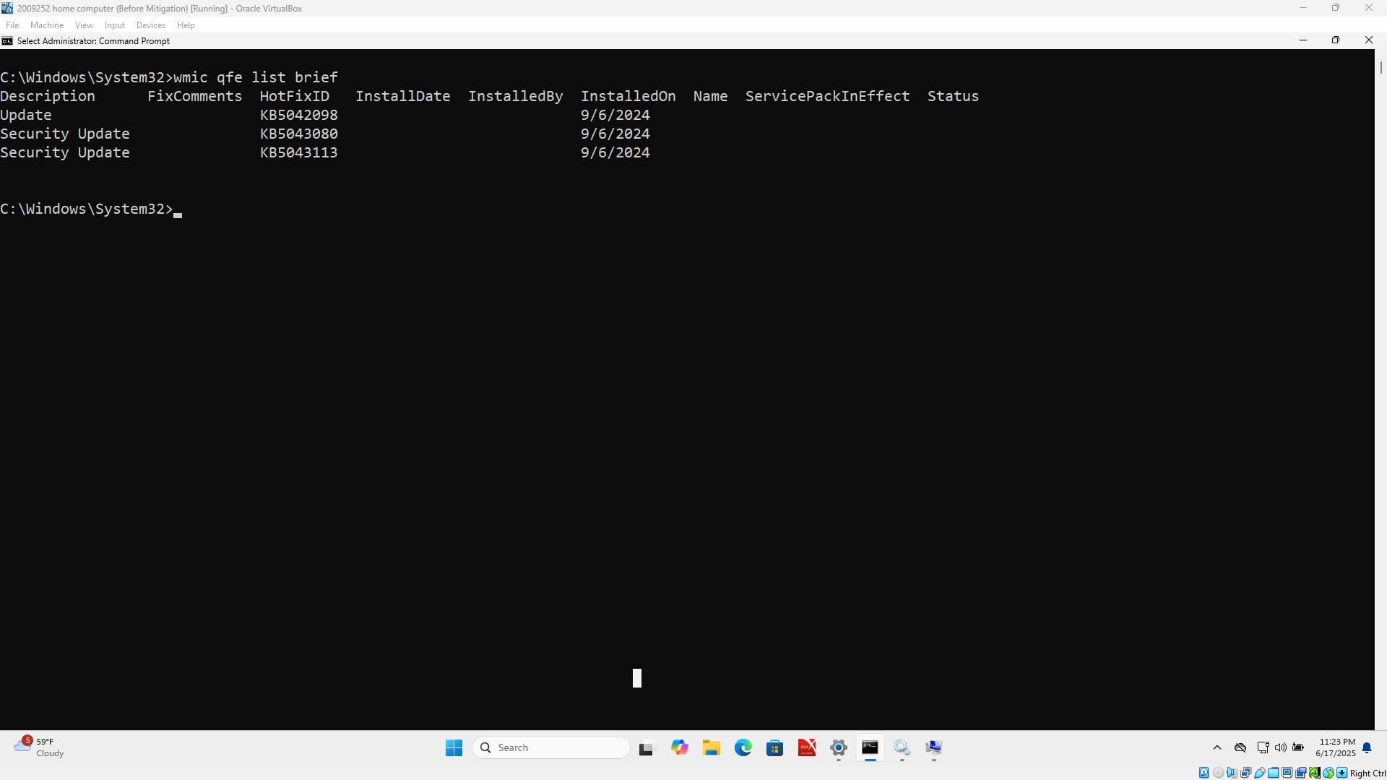
Figure 29 Home PC Windows Patch List
As seen in the diagram above Figure 29, and as outlined in the vulnerabilities detailed in Appendix 2, the home PC is lacking a Windows update /patching. Based on the research outlining it essential to mitigate such a risk, this will need to be addressed. Enabling the Windows update is best practice for any home PC that is committed to cybersecurity and operational integrity. To apply this mitigation the "Check for update" tab was selected enabling the relevant updates to be downloaded and installed as outlined in Figure 30.
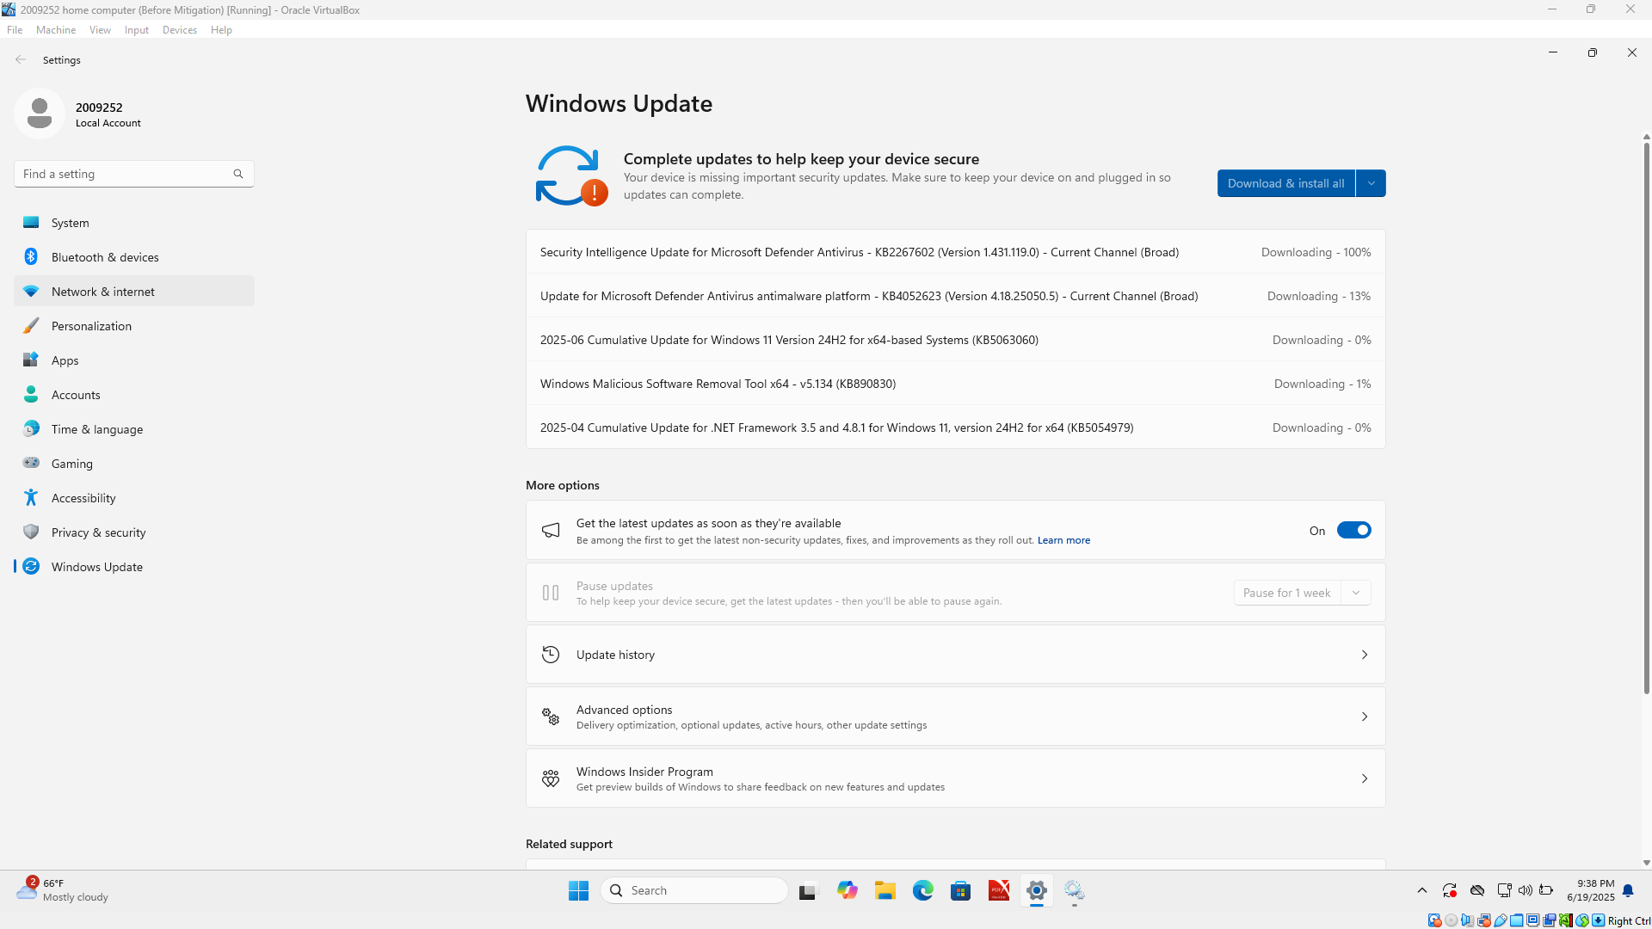
Figure 30 Home PC performing Windows Update
After running the windows update, a history of what has been installed is shown in Figure 31. This demonstrates successful installation of the suggested updates required.

Figure 31 Home PC Update History

5.3.2 .Net Framework
The .NET Framework is important because it provides a consistent, language-independent platform for building robust and scalable Windows applications across various domains, including desktop, web, and cloud-based services [84]. Moreover, the .NET Framework enhances security and performance by utilizing managed code execution, automatic memory management which help prevent common issues such as memory leaks [84]. The platform also simplifies deployment and versioning [85]. These characteristics have made the .NET Framework a vital technology for enterprise software, ensuring that critical business applications are stable, maintainable, and easily integrated into diverse IT ecosystems [84], [85]. Such features are also required for security in Home PCs.

5.3.3 SSL certificate / TLS
An SSL certificate is important because it enables secure, encrypted communication between a Home PC and a server. It protects sensitive data — such as login credentials and payment details and does so by preventing eavesdropping and data tampering during transmission [86]. Furthermore, SSL certificates authenticate a server's identity, ensuring that users connect to the intended and legitimate website rather than a malicious impersonator [87]. They also enhance user trust, as browsers often mark websites without a valid SSL certificate as “Not Secure,” potentially deterring visitors and reducing credibility [86]. Finally, adherence to data security regulations and standards (e.g., GDPR, PCI DSS) often requires proper encryption through SSL certificates, making them vital for legal compliance and safeguarding personal data [87]. OpenSSL was downloaded and installed in order to create a certificate as part of the suggested mitigation.

5.3.4 Register Keys
An attacker could add a malicious code to a signed file without invalidating its signature and then trick a user into executing it. Successful exploitation could allow full control of the home PC. Strict verification behaviour can help protect against this but must be enabled manually [88].
As indicated by the Appendix 2 these tow keys were added to the registry.
- HKEY_LOCAL_MACHINE\Software\Microsoft\Cryptography\Wintrust\Config\EnableCertPaddingCheck
- KEY_LOCAL_MACHINE\Software\Wow6432Node\Microsoft\Cryptography\Wintrust\Config\EnableCertPaddingCheck

‌5.4 Nessus Mitigation Scan - post mitigation
Below is the screen shot of the Nessus report after the above mitigation was applied Figure 32, for the number of vulnerabilities found in accordance with severity category and in colour coded format.
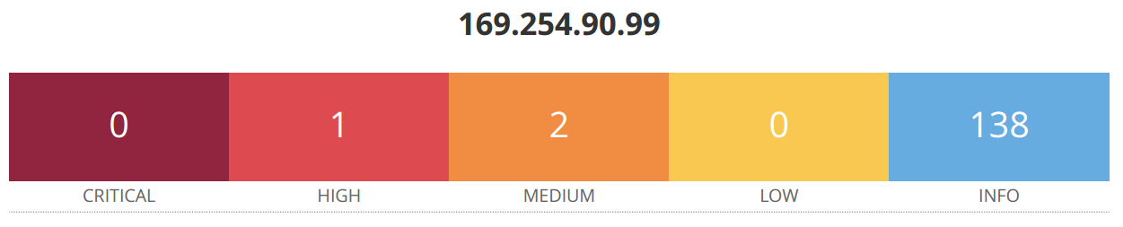
Figure 32 Mitigation summary of vulnerability colour coded
This provides a further break down of the mitigation report as seen in Figure 33. This enables detailed information to be obtained around what each vulnerability relates to as shown in Appendix 3.
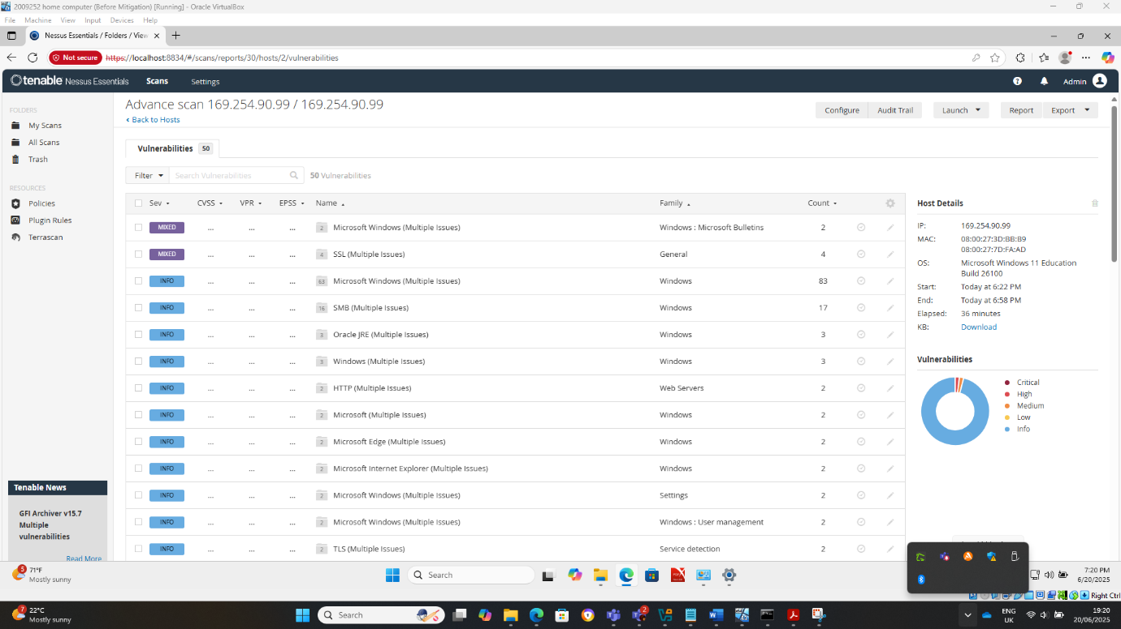
Figure 33 Nessus mitigation report breakdown

- Windows Update - This vulnerability was mitigated by performing windows update.
- .NET Framework - This vulnerability was mitigated by performing windows update.
- Registry keys – It was not possible to mitigate the vulnerability despite manually adding the two keys into the system registry.
- SSL / TLS – The vulnerability was not mitigated despite downloading and installing OpenSSL and creating a certificate.

In determining how effect the mitigation has been it is necessary to measure its success in line with the hypothesis. Nessus alone had 17 vulnerabilities classified as critical, high or medium in the first instance. Following mitigation being applied Nessus had only 3 vulnerabilities within these categories. As a percentage this shows Nessus as being a successful tool in reducing vulnerabilities by 82.35%.

5.5 Nmap
Nmap scanning tool is utilised as part of this research as a tool to identify open ports. This indicates services which are potentially accessible and therefore vulnerable and will enable possible mitigation to be applied to address such vulnerabilities and make the Home PC secure [74].

5.5.1 Nmap: Checking for Firewall
With the advancement in networking services, network security contributed significantly to the home PC. The term network security constitutes prevention of network and network resources by ceaseless monitoring and thereby denying certain services from unauthorized users [89]. Firewalls are one such network security system that monitors the inbound and outbound traffic of the network, this observation relies on two principal factors, Stateless and Stateful firewalls [89].
The Stateless firewalls track the source and destination address of every incoming and outgoing data packets, whereas the Stateful firewalls track each packet in the network by reading the entire header and thus it can read the type of data being transmitted [89].
When using Nmap to scan for a firewall status of the home PC the following command was used:
Sudo Nmap -sA 192.254.90.99.
Figure 34, the output of the command is showing as “unfiltered”. This suggests no filtering, meaning packets pass through freely there is no firewall active on the Home PC.
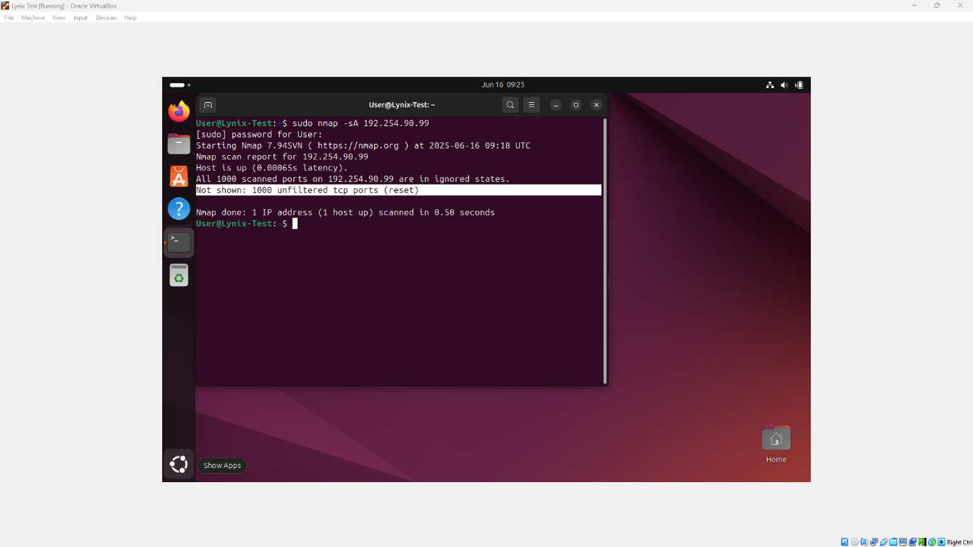
Figure 34 Results of fire wall status
The absence of a firewall exposes a system or network to unauthorized access, malware infections, and various cyberattacks. To resolve this issue, it is crucial to deploy and properly configure a firewall suited to the network environment. Administrators should install either a host-based firewall on individual devices or a network-based firewall at the perimeter of the network. Configuration should include defining rules that allow only necessary traffic while blocking unauthorized connections. Furthermore, regular updates and audits of firewall policies are essential to adapt to evolving security threats. As highlighted by S. Krit et al., implementing an effective firewall solution significantly reduces attack surfaces and enhances the overall security posture by enforcing strict access controls and monitoring traffic for anomalies [89].

5.5.2 Nmap: Port scanning
Port scanning is a technique used to identify open ports and services on a target system or network by systematically sending packets to specific ports and analysing the responses. It is commonly employed in both security assessments and by malicious attackers to discover potential points of entry for exploitation.
Port scanning provides insight into the network's exposure and helps administrators identify unnecessary services that may pose security risks. Techniques such as TCP connect scans, SYN scans (half-open scans), and UDP scans are frequently used depending on the level of stealth and detail required. Port scanning is argued to be an integral part of the information gathering phase in penetration testing and vulnerability assessment, offering a preliminary map of the system's accessible services and possible vulnerabilities [90].
When using Nmap to scan for Ports on the home PC the following command was used:
Nmap -p- 169.254.90.99 –min-rate 1000 -v
Figure 35, demonstrates how this generates information on the open port listed and services on the home PC.
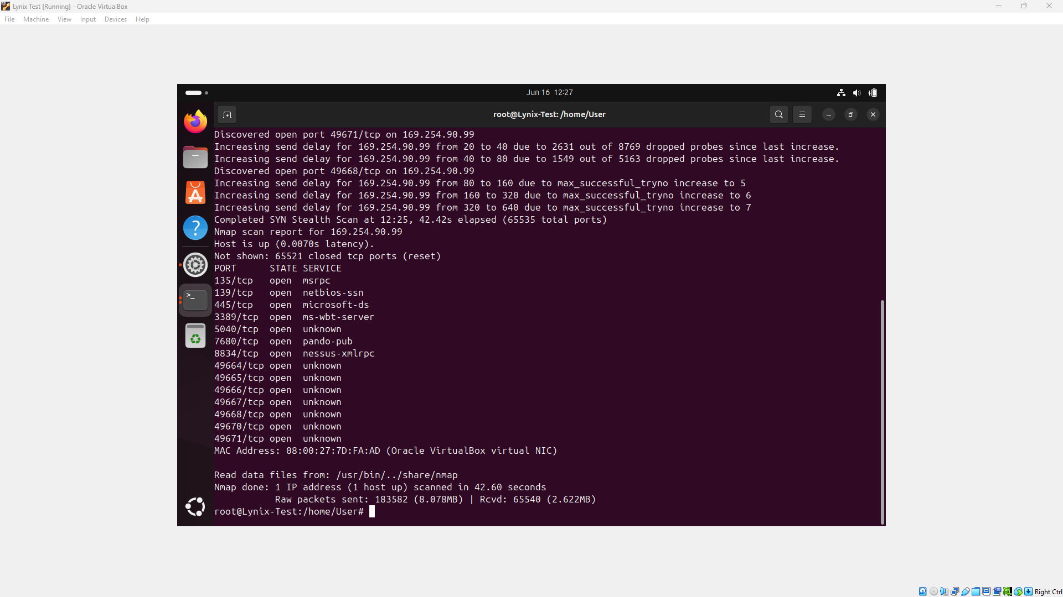
Figure 35 Open port and services
As seen above, the scan shows SMB & Remote Access Weaknesses which would need to be resolved to reduce vulnerabilities on the Home PC successfully.

5.5.3 Nmap: Applying Mitigation
To apply mitigation in relation to the Firewall vulnerabilities found, it was necessary to enable Fire wall settings within the Home PC Figure 36.
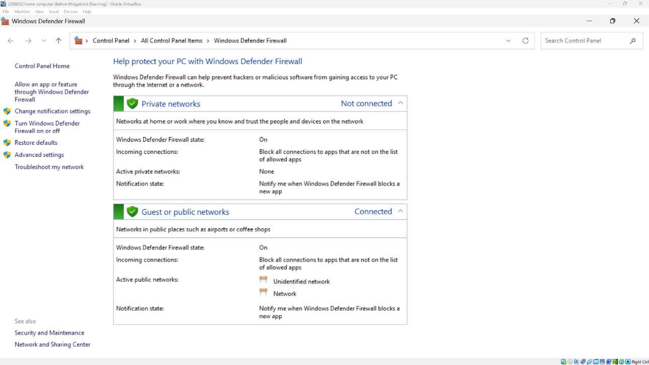
Figure 36 Home Pc Firewall active
To check whether mitigation had been effective, Nmap to scan for a firewall status of the home PC was re-run using the same command:
Sudo Nmap -sA 192.254.90.99.
Figure 37 shows how the status has changed from unfiltered to filtered, indicating the mitigation applied was successful in addressing the vulnerability in this instance.
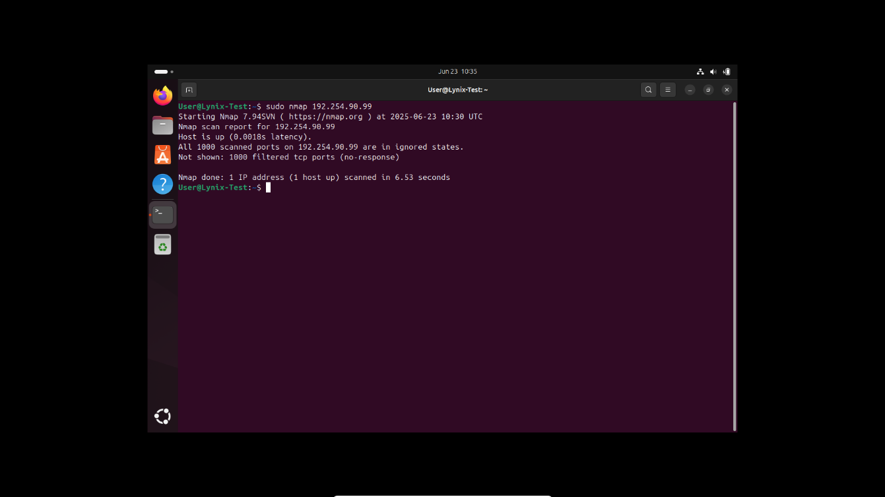
Figure 37 Status change from Unfiltered to Filtered
To address the vulnerabilities found in relation to open ports the following steps were applied:
- Disable SMB
- Disable Netbios
- Firewall rule to block the following port 135, 445, 7680, 49668.
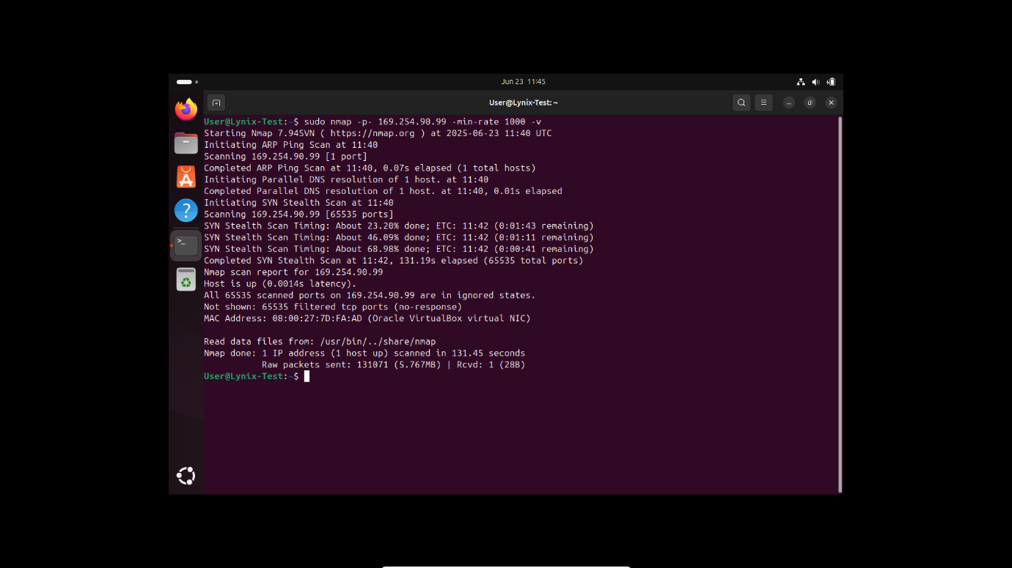
Figure 38 No open port showing
Figure 38 highlights that by applying the suggested mitigation, Nmap did not identify any open ports, indicating that this had been successful in addressing potential vulnerabilities associated with open ports should they have remained.
Nmap as a tool successfully highlighted vulnerabilities within the Home PC. The applied mitigation was 100% effective in addressing these.

5.6 Results: Validate or Reject Hypothesis
The experiment was seeking to prove or disprove whether the white box penetration testing was as an effective way of mitigating over 90% of vulnerabilities found on a home computer system.
The steps taken to prove or disprove this hypothesis has included applying White Box penetration techniques, namely Nessus and Nmap to identify patch testing. open ports and insecure services to reveal vulnerabilities. Outcomes have been measured by using a scoring system in the case of Nessus to identify vulnerabilities found and then scoring vulnerabilities found following mitigation by the same scoring system which has shown to successfully address and mitigate 82.35% of the vulnerabilities found. Nmap has identified open ports and a firewall which mitigation has in this instance been 100% successful. A combined average of the White Box Penetration tools applied as a percentage is 91.17%. Therefore, the results following the remediation steps validate the hypothesis.

5.7 Best practice
White box penetration testing, which provides the tester with full access to the internal structure and components of the target system, is a crucial approach for comprehensively assessing the security status of a home PC [91]. Best practices for effective white box testing begin with maintaining a detailed inventory of all software, hardware, and network configurations installed on the home system [91]. This step has been followed as part of this experiment by detailing an overview of the Home PC which ensures the tester has an accurate understanding of the attack surface before commencing the assessment. Additionally, the tester should not solely rely on self-reported version information provided by applications, as this can lead to overlooking potential vulnerabilities [91]. Instead, a combination of automated scanning tools and manual verification techniques should be employed to validate the findings and identify any discrepancies. This best practice principle has been applied by using Nessus and Nmap.
Furthermore, the white box testing process should go beyond just generating a catalogue of known vulnerabilities but should also evaluate the exploitability of the system's configurations, permissions, and network settings [91]. This holistic approach can uncover security flaws that may have been missed by more narrowly focused assessments. Finally, thorough documentation of the testing process and its limitations is essential to provide clear guidance for remediation efforts and inform future security improvements [91]. By integrating these best practices, individuals can enhance the effectiveness of white box penetration testing on their home PCs, leading to a more secure and resilient computing environment.

5.8 Conclusion
The findings from the white box penetration testing on the Home PC highlight the critical need for ongoing vulnerability assessment and mitigation. The use of Nessus revealed multiple high and critical vulnerabilities caused by missing security patches and misconfigurations, such as untrusted SSL certificates and the absence of registry settings that protect against known exploits like CVE-2013-3900 detailed within Appendix 2. Similarly, the Nmap scans identified a lack of firewall protections and open ports vulnerable to SMB and remote access-based threats, demonstrating the ease with which attackers can exploit improperly secured endpoints [89].
Mitigation efforts showed partial success. Windows and .NET Framework vulnerabilities were resolved through updates [83], [84], yet SSL/TLS-related issues and registry key mitigations remained unresolved, emphasizing the complexity of securing all aspects of a system. These challenges affirm that while automated tools like Nessus offer valuable insights, they must be supported by manual validation and best practices such as disabling legacy protocols (e.g., TLS 1.0/1.1) and enforcing strong network segmentation policies [82], [87].
Moreover, the testing supports the value of white box penetration testing, which offers comprehensive visibility into the system’s structure, enabling deeper analysis beyond what black box or grey box methods allow [91]. It was evident that a combination of structured documentation, regular patch management, and layered defence mechanisms forms the cornerstone of a resilient security setup. Whilst in this instance it was applied to a Home PC, this approach aligns with industry best practices and regulatory expectations, reinforcing that white box testing is a powerful tool for both detecting and reducing attack surfaces in home environments [91], [83].
In conclusion, this evaluation confirmed that consistent application of white box penetration testing principles significantly strengthens system security, mitigates exploitable vulnerabilities, and ensures better preparedness against emerging threats. This is evidenced by the results validating the hypothesis and demonstrating the effectiveness of White Box Penetration testing as an effective way of mitigating over 90% of vulnerabilities found on a home computer system.

CHAPTER 6 CONCLUSIONS AND RECOMMENDATIONS

6.1 Summary
The research conducted affirms the critical role of white box penetration testing in enhancing cybersecurity, particularly within home and small office environments. The literature review findings reinforce how Penetration testing remains a fundamental strategy for identifying and mitigating vulnerabilities prior to exploitation, which evolves in line with emerging threats and technologies. Despite challenges relating to scalability, automation, and regulatory compliance, it is widely endorsed within literature as indispensable to modern security frameworks.
This research applied a structured methodological approach, guided by a positivist philosophy and deductive reasoning, wherein tools such as Nessus and Nmap were employed to detect security flaws including open ports, outdated software, and insecure services to test the hypothesis. The research design clearly outlined the experimental setup within a virtualized environment, illustrating how white box testing—through its internal visibility—enabled deeper vulnerability discovery compared to traditional black box techniques whilst ensuring that the testing process was both ethical and documented to ensure others can accurately replicate the desired outcome or action.
Finally, the testing outcomes were presented, which revealed multiple critical vulnerabilities due to missing updates and insecure configurations. While mitigation efforts successfully addressed some issues, others, particularly those involving SSL/TLS and registry settings, remained unresolved, highlighting the complexity of comprehensive system security.
Collectively, the findings underscore that white box penetration testing, when implemented through a rigorous and ethical framework, serves as an effective mechanism for proactively strengthening system defenses and mitigating the evolving landscape of cyber threats.

6.2 Conclusion
In conclusion, this research has demonstrated the critical importance of white box penetration testing as an effective strategy for enhancing the security posture of home computing environments. Building upon the theoretical foundation outlined in the Literature Review, which emphasized the evolving relevance of penetration testing in the face of increasingly sophisticated cyber threats, the study employed a structured methodology grounded in quantitative analysis.
The implementation phase successfully simulated real-world scenarios within a virtualized environment, utilizing tools, namely Nessus and Nmap, to uncover a range of system vulnerabilities. These tools enabled comprehensive vulnerability discovery, particularly relating to outdated software, insecure services, and configuration weaknesses.
The findings were presented, confirming the presence of critical vulnerabilities using a standardized scoring system with recommended remediation. Having applied the necessary mitigation, the test results demonstrated partial success in remediation efforts, thus validating the hypothesis that white box testing can address a significant proportion of security issues.
Whilst some limitations were observed, especially in addressing SSL/TLS and registry-based vulnerabilities, the results affirm that white box penetration testing, when applied systematically, offers deep visibility into system weaknesses and provides actionable insights for remediation.
This study not only supports the practical value of white box testing for individual users but also reinforces its broader applicability as a proactive and essential component of modern cybersecurity strategies.

6.3 Recommendations for further research
While this study has demonstrated the effectiveness of white box penetration testing in identifying and mitigating vulnerabilities within a home computing environment, several areas merit further exploration. First, future research should expand the scope beyond single-system configurations to include more complex home networks comprising multiple devices, IoT systems, and wireless routers to assess scalability and interoperability of penetration testing methodologies.
Further investigation is needed into the integration and automation of remediation processes, particularly for unresolved vulnerabilities such as SSL/TLS misconfigurations and registry key exploits, which remained persistent despite manual efforts. Research could also explore the comparative effectiveness of white box testing versus black box and grey box methods across diverse threat scenarios, thereby enhancing the generalizability of findings to enterprise environments.
Given the ethical and legal challenges noted in the literature, a comprehensive study into frameworks that balance effective penetration testing with data protection and legal compliance in residential contexts would be valuable. Finally, in line with emerging technology incorporating machine learning-based vulnerability detection or AI-assisted scanning tools may offer enhanced accuracy and predictive capabilities, thus presenting a promising direction for future cybersecurity research.

Chapter 7 Personal Reflection
At the outset of this project, I experienced a degree of uncertainty regarding the selection of a suitable research topic. Through liaison with individuals aligned to support me in this research project and some guided reflection, ideas for possible focus were generated. I eventually decided the focus would be on penetration testing; this was as an area of particular interest and the possible area most aligned to the subject topic. Due to work-related limitations that prevented access to a real-world environment for testing, I was required to adapt my approach and design an experiment independently. This led to the decision to focus specifically on White Box Penetration Testing, which aligned well with both the available resources and the scope of the study.
Once the project aim had been clearly established, namely assessing the security of a home PC using white box techniques and evaluating the effectiveness of identifying and mitigating vulnerabilities, the pathway became more defined. Developing appropriate objectives, however, required further consideration, particularly in aligning the methodology with feasible steps that would enable the successful completion of the aim.
The literature review proved to be the most demanding section of the project, largely due to the vast quantity of academic and industry sources available on the subject. While this abundance of literature was beneficial in terms of theoretical grounding, it required significant effort to identify, interpret, and apply the most relevant and credible sources to the project’s specific focus on white box testing in a home network environment. Despite being time-consuming, this process provided valuable insights and contributed significantly to the academic foundation of the research.
The literature review helped support and inform the methodology utilised within the project and these were clearly identified in line with undertaking the experiment and focus of this research. The design phase was more intuitive. With a clear understanding of the experiment’s intended flow, I was able to draft an initial structure that was later refined into a logical and efficient testing cycle. This included the development of scanning procedures and experiment flowcharts, informed by both practical requirements and academic research.
Technical limitations presented a significant early challenge. My personal laptop, with only 8GB of RAM, was insufficient for running multiple virtual machines. To overcome this issue, I was fortunately able to loan a work-issued laptop with greater capabilities. However, since it was a corporate device, I had to reinstall Windows to prepare the system for the VMware environment. Once this was resolved, the installation of the necessary tools—including VMware, Nessus, and Linux—was straightforward. While I was already familiar with Nessus, I needed to undertake additional research to effectively use Nmap. This was achieved by engaging with online tutorials and documentation, which enhanced my technical understanding and practical capability with the tool.
Running the experiment itself went smoothly. The virtual environment was stable, and the tools functioned as intended. The data collection and vulnerability scans were completed without major issues. A notable limitation arose during the remediation of SSL/TLS vulnerabilities. Despite researching the use of digital certificates and viewing relevant tutorials, I was unable to fully resolve this issue. This area has been earmarked for future research and development to enhance my competence.
Overall, I assess the project to be a success in that it met the aims and objectives set out and the hypothesis could be tested effectively. I found undertaking this project to be rewarding on an intellectual and personal level. It has been challenging to undertake around full-time employment and a busy home life. Having to ensure I secured sufficient time to complete this work and apply my learning has strengthened my ability to plan, design, and implement a structured cybersecurity experiment within a controlled environment. Furthermore, it has deepened my understanding of white box penetration testing and enhanced my confidence in using industry-standard tools such as Nessus and Nmap. The challenges encountered, particularly those relating to resource limitations and technical troubleshooting, have provided valuable learning experiences. This project has not only contributed to my academic and personal development but has also enhanced my practical skill set on a professional level in preparation for future roles within the cybersecurity domain.

References
[1] S. Singh, Y.-S. Jeong, and J. park, “A Survey on Cloud Computing Security: Issues, Threats, and Solutions,” vol. 75, Sep. 2016, doi: 10.1016/j.jnca.2016.09.002. Available: https://www.researchgate.net/publication/308012933_A_Survey_on_Cloud_Computing_Security_Issues_Threats_and_Solutions. [Accessed: Apr. 10, 2025]
[2] A. K. Y. Yanamala, “Emerging challenges in cloud computing security: A comprehensive review,” vol. 1, no. 4, pp. 448–479, 2024
[3] M. Zolanvari, M. A. Teixeira, L. Gupta, K. M. Khan, and R. Jain, “Machine Learning-Based Network Vulnerability Analysis of Industrial Internet of Things,” vol. 6, no. 4, pp. 6822–6834, Aug. 2019, doi: 10.1109/JIOT.2019.2912022. Available: https://ieeexplore.ieee.org/abstract/document/8693904. [Accessed: Apr. 10, 2025]
[4] A. Mosenia and N. K. Jha, “A Comprehensive Study of Security of Internet-of-Things,” vol. 5, no. 4, pp. 586–602, Oct. 2017, doi: 10.1109/TETC.2016.2606384. Available: https://ieeexplore.ieee.org/abstract/document/7562568. [Accessed: Apr. 25, 2025]
[5] A. Kott, C. Wang, and R. F. Erbacher, Cyber defense and situational awareness. Springer, 2014.
[6] S. Karen and M. Peter, “Guide to Intrusion Detection and Prevention Systems (IDPS)ed”, Available: https://nvlpubs.nist.gov/nistpubs/legacy/sp/nistspecialpublication800-94.pdf. [Accessed: Apr. 11, 2025]
[7] J. Erickson, Hacking: The Art of Exploitation, 1st ed. San Francisco: No Starch Press, Incorporated, 2003 [Accessed: Apr. 25, 2025]
[8] R. J. Anderson, Security engineering: a guide to building dependable distributed systems. John Wiley & Sons, 2010.
[9] K. David, O. Jim, K. Devon, and A. Mati, “PRAISE FOR METASPLOIT: THE PENETRATION TESTER’S GUIDE”, Available: https://www.kea.nu/files/textbooks/humblesec/metasploit_apenetrationtestersguide.pdf. [Accessed: Apr. 11, 2025]
[10] M. Peter, S. Karen, and R. Sasha, “A Complete Guide to the Common Vulnerability Scoring System Version 2.0,” 2007, Available: https://tsapps.nist.gov/publication/get_pdf.cfm?pub_id=51198. [Accessed: Apr. 12, 2025]
[11] M. E. Whitman and H. J. Mattord, Principles of information security. Thomson Course Technology Boston, MA, 2009.
[12] J. Fook, V. Collington, F. Ross, G. Ruch, and L. West, Researching Critical Reflection. Routledge, 2015.
[13] P. Engebretson, The basics of hacking and penetration testing : ethical hacking and penetration testing made easy. Waltham, Ma, Usa: Syngress, 2013.
[14] W. Stallings, Network Security Essentials: Applications and Standards, 6th ed. Boston, MA, USA: Pearson, 2017.
[15] H. M. Z. A. Shebli and B. D. Beheshti, “A study on penetration testing process and tools,” May 2018, pp. 1–7. doi: 10.1109/LISAT.2018.8378035. Available: https://ieeexplore.ieee.org/abstract/document/8378035. [Accessed: Apr. 21, 2025]
[16] A. Chacko and T. Hayajneh, “Security and privacy issues with IoT in healthcare,” vol. 4, no. 14, 2018.
[17] M. Alhamed and M. M. H. Rahman, “A Systematic Literature Review on Penetration Testing in Networks: Future Research Directions,” vol. 13, no. 12, p. 6986, 2023, doi: 10.3390/app13126986. Available: https://www.mdpi.com/2076-3417/13/12/6986. [Accessed: Apr. 20, 2025]
[18] K. Scarfone, M. Souppaya, A. Cody, and A. Orebaugh, “Technical guide to information security testing and assessment,” vol. 800, no. 115, pp. 2–25, 2008.
[19] “Cybersecurity Awareness in IP Access Control | Free Guide | 2N.” Available: https://www.2n.com/en-GB/about-2n/cybersecurity/cybersecurity-awareness-ebook/. [Accessed: Apr. 24, 2025]
[20] K. U. Sarker, F. Yunus, and A. Deraman, “Penetration Taxonomy: A Systematic Review on the Penetration Process, Framework, Standards, Tools, and Scoring Methods,” vol. 15, no. 13, p. 10471, 2023, doi: 10.3390/su151310471. Available: https://www.mdpi.com/2071-1050/15/13/10471. [Accessed: Apr. 24, 2025]
[21] H. S. Al-Sinani, C. J. Mitchell, N. Sahli, and M. Al-Siyabi, “Unleashing AI in ethical hacking,” presented at the International Workshop on Security and Trust Management, Springer, 2024, pp. 140–151.
[22] A. I. Kusumarini and H. B. Seta, “Information System Security Analysis to Determine Server Security Vulnerability with Penetration Testing Execution Standard (PTES) Method at VWX University,” Oct. 2021, pp. 7–12. doi: 10.1109/ICIMCIS53775.2021.9699285. Available: https://ieeexplore.ieee.org/abstract/document/9699285. [Accessed: Apr. 21, 2025]
[23] “Open-Source Security Testing Methodology Manual - an overview | ScienceDirect Topics”, Available: https://www.sciencedirect.com/topics/computer-science/open-source-security-testing-methodology-manual. [Accessed: Apr. 24, 2025]
[24] P. Ami and As. Hasan, “Seven Phrase Penetration Testing Model,” no. 5, Dec. 2012, Available: https://citeseerx.ist.psu.edu/document?repid=rep1&type=pdf&doi=85ba0fd1090a2438d694ee5be72d301924bae2bf. [Accessed: Apr. 24, 2025]
[25] D. Maynor, Metasploit toolkit for penetration testing, exploit development, and vulnerability research. Burlington, MA: Syngress, 2007. [Accessed: Apr. 21, 2025]
[26] N. Antunes and M. Vieira, “Comparing the Effectiveness of Penetration Testing and Static Code Analysis on the Detection of SQL Injection Vulnerabilities in Web Services,” Dec. 2009, pp. 301–306. doi: 10.1109/PRDC.2009.54. Available: https://www.researchgate.net/publication/224095815_Comparing_the_Effectiveness_of_Penetration_Testing_and_Static_Code_Analysis_on_the_Detection_of_SQL_Injection_Vulnerabilities_in_Web_Services. [Accessed: Apr. 20, 2025]
[27] M. Bishop, “What is computer security?,” IEEE Security & Privacy, vol. 1, no. 1, pp. 67–69, Jan. 2003, doi: https://doi.org/10.1109/msecp.2003.1176998.
[28] H. M. Z. A. Shebli and B. D. Beheshti, “A study on penetration testing process and tools,” May 2018, pp. 1–7. doi: 10.1109/LISAT.2018.8378035. Available: https://ieeexplore.ieee.org/abstract/document/8378035. [Accessed: Apr. 22, 2025]
[29] G. Jayasuryapal, P. M. Pranay, and H. Kaur, “A Survey on Network Penetration Testing,” Apr. 2021, pp. 373–378. doi: 10.1109/ICIEM51511.2021.9445321. Available: https://ieeexplore.ieee.org/abstract/document/9445321. [Accessed: Apr. 24, 2025]
[30] khan Mohd and K. Farmeena, “A Comparative Study of White Box, Black Box and Grey Box Testing Techniques”, [Accessed: Apr. 24, 2025].
[31] “Black-Box vs Grey-Box vs White-Box Penetration Testing,” Apr. 19, 2022. Available: https://packetlabs.net/post/types-of-penetration-testing. [Accessed: Apr. 23, 2025]
[32] “OWASP Developer Guide | ASVS requirements | OWASP Foundation,” Owasp.org, 2025. https://owasp.org/www-project-developer-guide/release-ja/requirements/asvs/
[33] P. Vats, M. Mandot, and A. Gosain, “A Comprehensive Literature Review of Penetration Testing & Its Applications,” Jun. 2020, pp. 674–680. doi: 10.1109/ICRITO48877.2020.9197961. Available: https://ieeexplore.ieee.org/abstract/document/9197961. [Accessed: Apr. 21, 2025]
[34] A. Alshamrani, “A Survey on Advanced Persistent Threats: Techniques, Solutions, Challenges, and Research Opportunitiesuntitled”, Available: https://ieeexplore.ieee.org/ielaam/9739/8727625/8606252-aam.pdf. [Accessed: Apr. 24, 2025]
[35] A. Al-Ahmad, B. A. Ata, and A. Wahbeh, “Pen Testing for Web Applications,” vol. 7, no. 3, pp. 1–13, 2012, doi: 10.4018/jitwe.2012070101. Available: https://www.igi-global.com/article/content/www.igi-global.com/article/content/72989. [Accessed: Apr. 23, 2025]
[36] C. P. Pfleeger and S. L. Pfleeger, Security in Computing, Prentice Hall, 2012.
[37] Wil Allsopp, Unauthorised access : physical penetration testing for IT security teams. Chichester: Wiley, 2009.
[38] M. Z. Hasan, M. Z. Hussain, and M. Chughtai, Penetration Testing In System Administration. 2017. Available: https://www.researchgate.net/profile/Muhammad-Zulkifl-Hasan-2/publication/319876508_Penetration_Testing_In_System_Administration/links/59bf7cedaca272aff2e1b8de/Penetration-Testing-In-System-Administration.pdf. [Accessed: Apr. 22, 2025]
[39] N. Antunes and M. Vieira, “Benchmarking Vulnerability Detection Tools for Web Services,” presented at the 2010 IEEE International Conference on Web Services, 2010, pp. 203–210. doi: 10.1109/ICWS.2010.76
[40] I. Kotenko and A. Ulanov, “Agent-based simulation of cyberattacks for security analysis,” in Proc. IEEE European Symposium on Security and Privacy, 2017, pp. 1–6.
[41] J.-P. A. Yaacoub, H. N. Noura, O. Salman, and A. Chehab, “A Survey on Ethical Hacking: Issues and Challenges,” Mar. 28, 2021. Available: http://arxiv.org/abs/2103.15072. [Accessed: Apr. 28, 2025].
[42] D. Le Vandolph, “Guidelines for White Box Penetration Testing Wired Devices in Secure Network Environment,” Univeristy if Skovde, 2023. Available: https://www.diva-portal.org/smash/get/diva2:1781017/FULLTEXT01.pdf. [Accessed: Apr. 27, 2025]
[43] K. Pei, Y. Cao, J. Yang, and S. Jana, “DeepXplore: Automated Whitebox Testing of Deep Learning Systems,” no. 11, Nov. 2019, doi: 10.1145/3361566. Available: https://dl.acm.org/doi/pdf/10.1145/3361566. [Accessed: Apr. 26, 2025]
[44] M. Kumar, K. Santosh, Singh, and R. Dwivedi, “International Journal of Advance Research in Computer Science and Management Studies A Comparative Study of Black Box Testing and White Box Testing Techniques.” Accessed: May 1, 2025. [Online]. Available: https://www.vbu.ac.in/ftpwebapps/vbu/resources/vbu_web/dept/mca/A%20Comparative%20Study%20of%20Black%20Box%20Testing%20and%20White%20Box%20Testing%20Techniques.pdf#page=9.18
[45] A. Belhadi, M. Zhang, and A. Arcuri, “White-Box and Black-Box Fuzzing for GraphQL APIs,” Sep. 13, 2022. Available: http://arxiv.org/abs/2209.05833. [Accessed: Apr. 29, 2025]
[46] G. Fraser, M. Staats, P. McMinn, A. Arcuri, and F. Padberg, “Does Automated Unit Test Generation Really Help Software Testers? A Controlled Empirical Study,” ACM Transactions on Software Engineering and Methodology, vol. 24, no. 4, pp. 1–49, Sep. 2015, doi: https://doi.org/10.1145/2699688.
[47] S. Sahi et al., "Security Testing of Web Applications: A Systematic Mapping," J. King Saud Univ. – Comput. Inf. Sci., 2022.
[48] M. Alhamed and M. M. H. Rahman, “A Systematic Literature Review on Penetration Testing in Networks: Future Research Directions,” vol. 13, no. 12, p. 6986, 2023, doi: 10.3390/app13126986. Available: https://www.mdpi.com/2076-3417/13/12/6986. [Accessed: May. 1, 2025]
[49] M. Palanivel and K. Selvadurai, “Risk-driven security testing using risk analysis with threat modeling approach,” vol. 3, no. 1, p. 754, Dec. 2014, doi: 10.1186/2193-1801-3-754. Available: https://doi.org/10.1186/2193-1801-3-754. [Accessed: May 10, 2025]
[50] Happe Andreas and C. Jurgen, “Understanding Hackers’ Work: An Empirical Study of Offensive Security Practitioners | Proceedings of the 31st ACM Joint European Software Engineering Conference and Symposium on the Foundations of Software Engineering,” Nov. 2023, Available: https://dl.acm.org/doi/abs/10.1145/3611643.3613900. [Accessed: May 04, 2025]
[51] Jankowicz, Business research projects. London: International Thomson Business Press, 1998.
[52] Ranjit Kumar, Research Methodology, 5th edition. 2019
[53] M. Baimyrzaeva, “Beginners’ guide for applied research process: What is it, and why and how to do it,” vol. 4, no. 8, pp. 1–42, 2018.
[54] L. Townsend, “The Research Process,” Aug. 2022, Available: https://pressbooks.openeducationalberta.ca/researchasconversationandcommunication/chapter/chapter-1/. [Accessed: May 05, 2025]
[55] A. T. Nguyen and J. D. Holt, "Assessing endpoint security: A white box penetration testing approach," 2021 IEEE International Conference on Cyber Security and Resilience (CSR), Rhodes, Greece, 2021, pp. 155–162. doi: 10.1109/CSR51186.2021.9527973.
[56] D. Chapman, "Security testing in smart home environments: A white-box approach," 2020 International Conference on Cybersecurity and Protection of Digital Services (Cyber Security), Dublin, Ireland, 2020, pp. 1–6. doi: 10.1109/CyberSecPODS49078.2020.9133976.
[57] C. E. Landwehr, “Computer security,” International Journal of Information Security, vol. 1, no. 1, pp. 3–13, Aug. 2001, doi: https://doi.org/10.1007/s102070100003.
[58] Tenable, “Nessus Product Family,” Tenable®, 2023. https://www.tenable.com/products/nessus
[59] J. T. Santoso and B. Raharjo, “PERFORMANCE EVALUATION OF PENETRATION TESTING TOOLS IN DIVERSE COMPUTER SYSTEM SECURITY SCENARIOS,” vol. 13, no. 2, pp. 132–159, Sep. 2022, doi: 10.51903/jtikp.v13i2.851. Available: https://ejurnal.provisi.ac.id/index.php/JTIKP/article/view/851. [Accessed: May 16, 2025]
[60] M. Ochoa and R. Robles, "Home network security challenges and threats," International Journal of Smart Home, vol. 8, no. 2, pp. 21–30, 2014
[61] M. Saunders and P. Tosey, “The layers of Research Design,” 2011, Available: https://d1wqtxts1xzle7.cloudfront.net/32495174/Research_30_-_Research_Onion_Layers_58-libre.pdf?1391223129=&response-content-disposition=inline%3B+filename%3DThe_Layers_of_Research_Design.pdf&Expires=1746404792&Signature=XJAXbzkLb980EFZvdqMwOnXr-Iz5MPiQJFWJ8yFLHD82dkEGf~YgTx3EKoU7SkcJFo6l36uD8O8tkX-3lbEV7lO~9tC8CW3isBY~~UEvyfuGezvGbmAHpaDZXkKoB2tZgo08dknHQxU9JrD~2uHcSfSNlNyFhQ~9BRkocvpllvQRke1ZcnZl8fN12KOm-eci-MYUjUkx-kLLJRDWmgdgxc84SvJPqXOpxRh~xK~2qWXDist3uUPQe9qGr2GPbSdIr3vcEIodlzXNavON2FEMI99twDrU~J6Bir4J~FoLQA828mMr8NcS4DL8pZoAA54VjZ2ZaxiZFcmqr5gTFnRXEQ__&Key-Pair-Id=APKAJLOHF5GGSLRBV4ZA. [Accessed: May 17, 2025]
[62] S. Goundar, “Research Methodology and Research Method,” May 2012, Available: https://prallagon.com/wp-content/uploads/2021/05/Research-Methodology-A2.pdf. [Accessed: May 04, 2025]
[63] OWASP, “IoT Security Testing Guide,” Open Web Application Security Project, 2018. [Online]. Available: https://owasp.org/www-project-internet-of-things/
[64] “Research Philosophy,” 2023. [Online]. Available: https://medium.com/@kingbradleyfoo/research-philosophy-a9780d2346f3. [Accessed: May 17, 2025]
[65] J. W. Creswell, RESEARCH DESIGN Qualitative, Quantitative, and Mixed Methods Approaches. Sage Publications, Inc, 2003. Available: https://cumming.ucalgary.ca/sites/default/files/teams/82/communications/Creswell%202003%20-%20Research%20Design%20-%20Qualitative,%20Quantitative%20and%20Mixed%20Methods.pdf. [Accessed: May 05, 2025]
[66] R. Sabah, M. Hassan, and S. Qadri, “Research Process and Steps Involved in Data Analysis,” vol. 16, no. 3, 2022, doi: https://doi.org/10.37896/jxu16.3/001. Available: https://d1wqtxts1xzle7.cloudfront.net/87702743/Research_Process_and_Steps_Involved_in_Data_Analysis- [Accessed: May 13, 2025]
[67] Saunders, M., Lewis, P., & Thornhill, A. (2019). Research Methods for Business Students. Pearson Education.
[68] H. Snyder, “Literature review as a research methodology: An overview and guidelines,” Journal of Business Research, vol. 104, no. 1, pp. 333–339, Nov. 2019, doi: https://doi.org/10.1016/j.jbusres.2019.07.039.
[69] K. Okoye and S. Hosseini, Understanding Dependent and Independent Variables in Research Experiments and Hypothesis Testing. in R Programming: Statistical Data Analysis in Research. Singapore: Springer Nature, 2024, pp. 99–107. Available: https://doi.org/10.1007/978-981-97-3385-9_5. [Accessed: May 14, 2025]
[70] J. Smith and H. Noble, “Bias in research,” vol. 17, no. 4, pp. 100–101, 2014, doi: 10.1136/eb-2014-101946. [Online]. Available: https://ebn.bmj.com/content/17/4/100. [Accessed: 15-May-2025]
[71] Rowley, J., & Slack, F. (2004). Conducting a literature review. Management Research News, 27(6), 31-39.
[72] A. Rashid and A. Chitchyan, "Security as a cross-cutting concern: a survey of requirements engineering approaches," ACM Computing Surveys, vol. 50, no. 6, pp. 1–39, Jan. 2017. Microsoft Word - WER 05
[73] “What is the Nessus vulnerability scanning platform? | Definition from TechTarget.” Available: https://www.techtarget.com/searchnetworking/definition/Nessus. [Accessed: June 11, 2025]
[74] G. Lyon, “Nmap Network Scanning: The Official Nmap Project Guide to Network Discovery and Security Scanning,” Insecure.Org, 2009. Nmap Network Scanning: The Official Nmap Project Guide to Network Discovery and Security Scanning: Amazon.co.uk: Lyon, Gordon Fyodor: 8601404706585: Books
[75] Computer Networks [Guest editor's introduction] | IEEE Journals & Magazine | IEEE Xplore
[76] Pirdaus, D. and Hidayana, R. (2024). Analysis testing black box and white box on application to-do list based web. IJMSC, 2(2), 68-75. https://doi.org/10.46336/ijmsc.v2i2.95
[77 ] A. Martin-Lopez, A. Arcuri, S. Segura, & A. Ruiz–Cortés, "Black-box and white-box test case generation for restful apis: enemies or allies?",, p. 231-241, 2021. https://doi.org/10.1109/issre52982.2021.00034
[78] Z. Wang, M. Zhang, J. Yang, B. Shao, & M. Zhang, "Maft: efficient model-agnostic fairness testing for deep neural networks via zero-order gradient search",, p. 1-12, 2024. https://doi.org/10.1145/3597503.3639181
[79] M. E. Whitman and H. J. Mattord, Principles of information security, 7th ed. Boston, Mass.: Cengage Learning, 2022.
[80] F. Qi, Z. Tang, G. Wang, and J. Wu, “SSL-enabled trusted communication: Spoofing and protecting the non-cautious users,” Security and Communication Networks, vol. 4, no. 4, pp. 372–383, Mar. 2011, doi: https://doi.org/10.1002/sec.159.
[81] Z. Durumeric, J. Kasten, M. Bailey, and J. A. Halderman, “Analysis of the HTTPS certificate ecosystem,” Proceedings of the 2013 conference on Internet measurement conference - IMC ’13, 2013, doi: https://doi.org/10.1145/2504730.2504755.
[82] W. Mayer, A. Zauner, M. Schmiedecker, and M. Huber, “No Need for Black Chambers: Testing TLS in the E-mail Ecosystem at Large,” 2016 11th International Conference on Availability, Reliability and Security (ARES), Aug. 2016, doi: https://doi.org/10.1109/ares.2016.11.
[83] A. Souri and R. Hosseini, “A state-of-the-art survey of malware detection approaches using data mining techniques,” Human-centric Computing and Information Sciences, vol. 8, no. 1, Jan. 2018, doi: https://doi.org/10.1186/s13673-018-0125-x
[84] gewarren, “Overview of .NET Framework - .NET Framework,” learn.microsoft.com. https://learn.microsoft.com/en-us/dotnet/framework/get-started/overview
[85] A. B. Whinston, “Journal of Organizational Computing and Electronic Commerce,” 2001.
[86] “RFC2818: HTTP Over TLS | Guide books”, Available: https://dl.acm.org/doi/abs/10.17487/RFC2818. [Accessed: Jun. 20, 2025
[87] E. Rescorla, SSL and TLS : designing and building secure systems. Boston: Addison-Wesley, 2004.
[88] “NVD - CVE-2013-3900”, Available: https://nvd.nist.gov/vuln/detail/CVE-2013-3900. [Accessed: Jun. 20, 2025]
[89] S. Krit and E. Haimoud, “Overview of firewalls: Types and policies: Managing windows embedded firewall programmatically,” presented at the 2017 international conference on engineering & MIS (ICEMIS), IEEE, 2017, pp. 1–7.
[90] P. Boyanov, "A comprehensive scanning for open, closed and filtered ports in the computer systems and networks", Journal Scientific and Applied Research, vol. 23, no. 1, p. 85-98, 2022. https://doi.org/10.46687/jsar.v23i1.356
[91] "XREF MSFT:MS24-5046696 XREF CISA-KNOWN-EXPLOITED:2024/12/03 XREF IAVA:2024-A-0729-S XREF IAVA:2024-A-0730-S"

Appendices

Appendix 1
Project management the proposed timeline:
Tasks Month
- Planning & Proposal (Jan - Feb)
- Research & Review of Literature (Feb - July)
- First Viva (May)
- Research Methodology (May - Jun)
- Design & Implementation (May - July)
- Testing & Evaluation (June - July)
- Reflection (July)
- Submission (July)
- Final Viva (Sept)
Gantt chart using this timeline: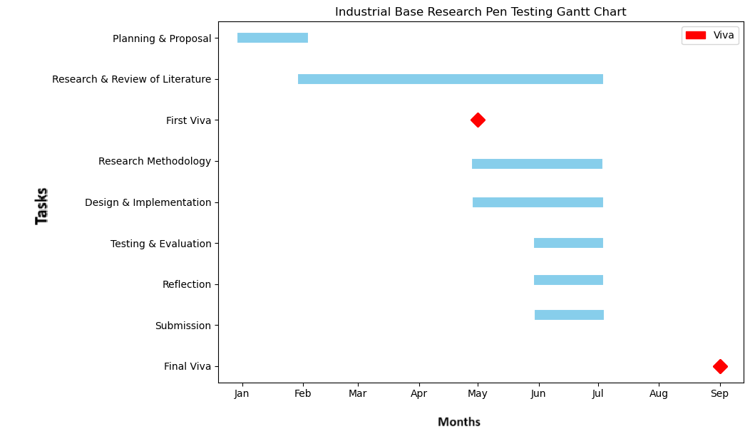

Appendix 2
Nessus vulnerability Report. Vulnerability Operations Report

Appendix 3
Nessus Mitigation Report: Nessus Mitigation Report
Appendix 4
Ethics Form

