Critically examine the literary and artistic representations of chthonic deities from Greco-Roman world.

In this essay I will be analysing the literary and artistic representations of chthonic deities from Greco-Roman mythology and religion. To do this I will be identifying exactly what a chthonic deity is and using a variety of different sources to examine how these gods are depicted in both appearance and personality.

There have been some discrepancies in regards to the definition of the word ‘chthonic’.
It is derived from the Greek word ‘chthonios’ which means in, of or under the earth and as such this word could be considered to be in direct reference to agricultural gods and goddesses such as Demeter as they are connected to the earth themselves.
Alternatively however, ‘chthonios’ supposedly also gets its meaning from a contrast with the ‘heavenly’ gods, the Olympians and so it is typically the deities linked to what lays beneath the earth (such the underworld) that are most often referred to as chthonic.
Due to this, for the sake of this essay I will be utilising its most simple form being its ‘deities of the underworld’ definition, thus discounting such gods as Demeter. Even Hermes who was known as the “appointed messenger to Hades” and guided the souls of the dead to the underworld will not be taking consideration as he was considered primarily to be an Olympian.

There are a plethora of deities connected to the underworld, from its ruler Hades, to the Erinyes (also known as the furies and goddesses of vengeance) and even to the three demi-god judges of the dead, Rhadamanthys, Minos and Aiakos.
Due to the amount of ‘chthonic’ gods I will be narrowing my focus onto 7 whom I consider to be the main influences in the underworld: Hades, Persephone, Nyx, Hecate, Hypnos, Thanatos and Charon.

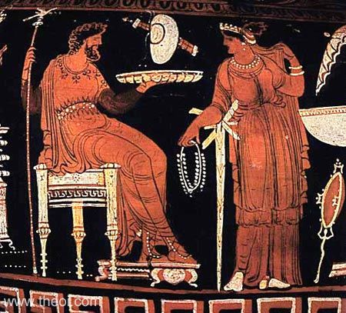
Amongst the Greeks, the ruler of the underworld was known by many names notably Hades/Haides and Aidoneaus. Born from the union between Rhea and Cronos, he had been swallowed by his fearful father as had his many siblings save for Zeus.
In regards to literature not much is provided as to his appearance other than that he has a ‘grim’ countenance however as for classical artwork Hades is often depicted as a regal, bearded and dark-haired god, holding a bird tipped sceptre.
Figure 1.1
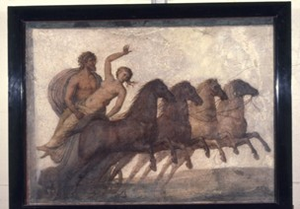
The tale and often images depicting the story of the goddess Persephone’s abduction are often described as ‘the rape of Persephone’; I believe this to be a misnomer as it is actually a demonstration of what would have been considered a typical marriage arrangement amongst the Greeks in this time frame. In ancient Greece it was common practice for a father to choose a husband for his daughter and as it was a patriarchal society female relatives most likely would not have been able to refuse the head of their household outright.
Figure 1.2

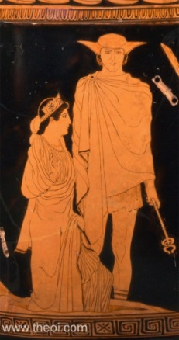
Moreover, whilst Hades does demonstrate his more dishonest side when tricking (or even in some stories forcing) Persephone to consume pomegranate seeds to bind her to the underworld and thus to himself, he doesn’t do so maliciously as he actually allows her to return to her mother periodically in order to make her happy.

Personality-wise Hesiod claims that Persephone is “shy” and when analysing her interactions with her mother, she is also portrayed as almost child-like in her actions. This could be very fitting as she is also known as Kore (the maiden) which in itself suggests a sense of naivety.
In artwork this is demonstrated through her depiction as a youthful woman who in literature is often described as being beautiful and ‘fair-faced’ .

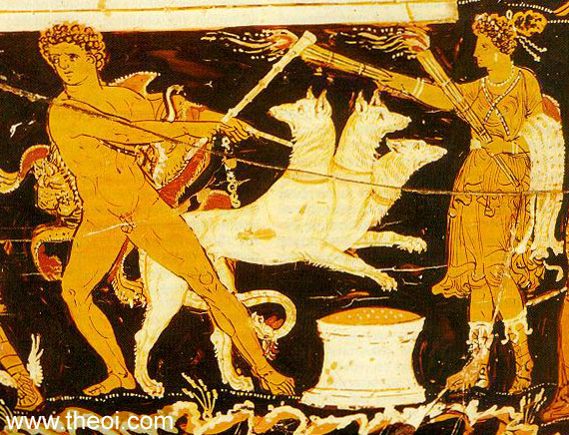
Hecate was the chthonic goddess of magic, witchcraft, ghosts and necromancy. Despite the negative connotations that usually go with these crafts Hecate herself was described as “bright-coiffed” and “tender hearted”. This is strongly shown in ‘The Homeric Hymn: To Demeter’ as she hears Demeter’s grief-filled summons for help and she does what she can to assist; in doing so she becomes the minister and constant companion to Persephone. She was often depicted as a female holding two flaming torches or in regards to her statues even in ‘triple form’ to demonstrate her status as the goddess of the crossroads. Furthermore, as the picture to the left demonstrates she was often shown in artwork garbed similar to the moon goddess Artemis; wearing a “knee length maiden’s skirt and hunting boots” .
Figure 1.4
Figure 1.3

In artwork however it can sometimes be difficult to determine exactly who is depicted without looking into the context and other characters shown. For example the pictures below demonstrate that Hecate was not the only goddess represented in classical artwork holding torches. The image to the left shows Persephone holding an Eleusinian torch as she is stood with her mother Demeter. In the image to the right however we can identify Nyx (the night) holding twin torches as she is being chased away by Eos (the dawn).
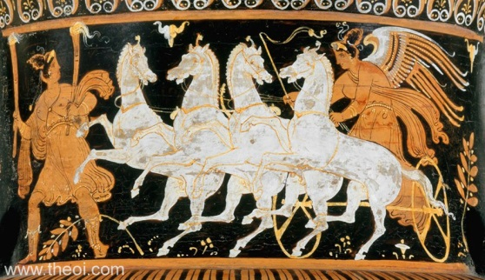
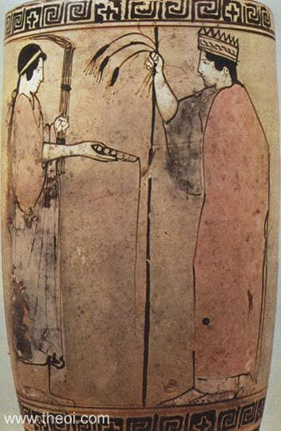

Figure 1.6

Figure 1.5

Daughter of Khaos, Nyx was one of the protogenoi (primordial gods who emerged as the dawn of creation) and the personification/goddess of the night. She was often depicted as either a winged goddess or charioteer, sometimes crowned with an aureole of dark mist.
As for literary descriptors there isn’t much in the way of details of her appearance, the authors choosing instead to apply epithets such as “murky” and “deadly”. Even Pausanias who refers to the illustrations carved on the chest of Cypselus at Olympia merely refers to Nyx holding two children of opposing colours (Hypnos and Thanatos) and gives no details as to her visage.

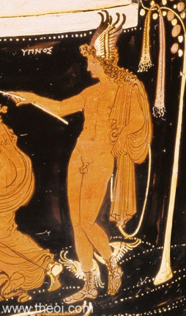
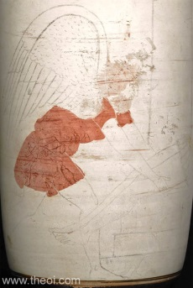
Thanatos and Hypnos are the twin sons of Nyx and as such are the daimons (spirit personifications) of non-violent deaths and sleep respectively. Thanatos was often depicted in artwork as an older winged, dark-haired man whilst his brother Hypnos is often represented as a young man with wings on either his brow or shoulders.
The two are very prominent in the legend of Sarpedon, one of the any sons of Zeus. I mention this in particular to demonstrate that although Thanatos is the embodiment of ‘non-violent death’, playing the counterpart to his sisters the Keres (spirits of slaughter and disease), there have been cases in which he has been tasked with attending to those who have died bloody and in battle.
Figure 1.8
Figure 1.7

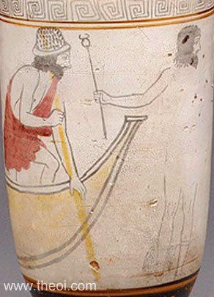
Although many of Nyx’s progeny could in fact be defined as chthonic gods/deities, such as the aforementioned Keres, I will only go into detail about one more. Charon, the ferryman of the dead was depicted as having been a decrepit, ugly man, with a hooked nose and donning a conical hat. Strangly although it appears as though more information was provided in regards to Charon’s physical appearance and manor of dress than almost any of the other gods, almost nothing has been provided as to attest for this personality. More often than not literature that include reference to the ferryman (such as Vergil’s Aeneid and Georgica or Ovid’s Metamorphosis) portray him as a repulsive creature with no motive, agenda or even individual thought as if he himself was a shade.
Figure 1.9

In conclusion, I believe that though their seems to be a vague general consensus as to how certain chthonic gods appear, there isn’t however enough surviving evidence to truly get a complete view on each particular god or goddess. Moreover, despite their being many literary references to the gods there is often very little information as to the visage of the individual.

Bibliography
Author | Abbreviation | Work
Anonymous | H.Hom 2 | Homeric Hymns: To Demeter
 | H.Hom 4 | Homeric Hymns: To Hermes
Apollodorus | Apollod. | The Library
Hesiod | Hes. Theog. | Theogony
Homer | Hom. Il | The Iliad
Pausanias | Paus. V. | Descriptions of Greece: Book V.
Plato | Plt. Grg. | Gorgias
Vergil | Verg. Aen. | Aeneid

Ancient
Anonymous, Homeric Hymns. Hugh H. Evelyn-White (trans.) 1914. Cambridge, MA., Harvard University Press; London, William Heinemann Ltd.
Apollodorus, The Library. 1921. Sir James George Fraser (trans.). Cambridge, MA, Harvard University Press; London, William Heinemann Ltd.
Hesiod, Theogony. 1914. Hugh G. Evelyn-White (trans.). Cambridge, MA, Harvard University Press; London, William Heinemann Ltd.
Homer, The Iliad. 1924. A.T. Murray (trans.). Cambridge, MA, Harvard University Press; London, William Heinemann Ltd.
Pausanias, Description of Greece (Book V.). 2015. W.H.S. Jones & H.A. Ormerod (trans.). Cambridge; Harvard University Press.
Plato, Gorgias. W.R.M. Lamb (trans.) 1967. Cambridge, MA, Harvard University Press; London, William Heinemann Ltd.
Vergil, Aeneid. Theodore C. Williams (trans.) 1910. Boston; Houghton Mifflin Co.

Modern
Astma, A. J. 2017. Theoi Project. https://www.theoi.com/greek-mythology/underworld-gods.html [Accessed 22.05.2019]
Fischer, A. 2010. Chthonic Gods. The Oxford Encyclopaedia of Ancient Greece and Rome. Oxford; Oxford University Press. Retrieved from https://www-oxfordreference-com.ezproxy.uwtsd.ac.uk/view/10.1093/acref/9780195170726.001.0001/acref-9780195170726-e-249?rskey=egGNv4&result=1 [Accessed 22.05.2019]
Lovén, L. L., Strömberg Agneta, et al. 2010. Ancient marriage in Myth and Reality. Cambridge; Cambridge Scholars Publishing.
Parker, R. 2012. Chthonian gods. The Oxford Classical Dictionary. Oxford; Oxford University Press. Retrieved from https://www-oxfordreference-com.ezproxy.uwtsd.ac.uk/view/10.1093/acref/9780199545568.001.0001/acref-9780199545568-e-1568?rskey=8Msqiq&result=2 [Accessed 22.05.2019]
Pomeroy, S., & American Council of Learned Societies. (1995). Goddesses, whores, wives, and slaves women in classical antiquity (ACLS Humanities E-Book). New York: Schocken Books.
Stevenson, A. 2010. Chthonic. Oxford Dictionary of English. Oxford; Oxford University Press. Retrieved from https://www-oxfordreference-com.ezproxy.uwtsd.ac.uk/view/10.1093/acref/9780199571123.001.0001/m_en_gb0148590?rskey=egGNv4&result=2 [Accessed 22.05.2019]

Appendix - Images
  - Hades and Persephone. Ca. 340 – 330 BCE. Apulian Red Figure. Amphora. British Museum. Retrieved from https://www.theoi.com/Gallery/K14.4.html [Accessed 29.05.2019]
  - The Rape of Proserpine. 2nd- 3rd C. Roman Tomb Wall Painting. British Museum. Retrieved from https://www.britishmuseum.org/research/collection_online/collection_object_details.aspx?objectId=427884&partId=1&searchText=hades+and+persephone&page=1?bibId=4259?bibId=4259 [Accessed 29.05.2019]
  - Hermes escorts Persephone from the Underworld. Ca. 440 BCE. Attic Red Figure bell krater. Metropolitan Museum of Art, New York. Retrieved from https://www.theoi.com/Gallery/K14.9.html [Accessed 29.05.2019]
  - Heracles’ journey to the underworld. Ca. 330-310 BCE. Apulian Red figure volute Krater. Staatliche Antikensammlungen, Munich. Retrieved from https://www.theoi.com/Gallery/T16.2.html [Accessed 28.05.2019]
  - Persephone and Demeter. Ca. 450-425 BCE. Attic Red Figure (White Ground) Lekythos. National Archeology Museum, Athens. Retrieved from https://www.theoi.com/Gallery/K3.2.html [Accessed 31.05.2019]
  - Nyx (Night) and Eos (Dawn) . Ca. 320-310 BCE. Apulian Red Figure krater. Metropolitan Museum of Art. Retrieved from https://www.theoi.com/Gallery/T19.13.html [Accessed 03.06.2019]
  - Thanatos and the body of Sarpedon. Athenian Red Figure lekythos. Ca. 470 – 440 BCE. British Museum, London. Retrieved from https://www.theoi.com/Gallery/N12.2.html [Accessed 05.06.2019]
  - Hypnos god of sleep. Apulian Red Figure vase. Ca. 350 – 340 BCE. The J. Paul Getty Museum, Malibu. Retrieved from https://www.theoi.com/Gallery/N13.1.html [Accessed 05.06.2019]
  - Charon and Hermes Psychopomp. Athenian red figure lekythos. Ca. 5th Century BCE. Metropolitan Museum of Art, New York. Retrieved from https://www.theoi.com/Gallery/N11.2.html. [Accessed 05.06.2019]

Fischer. 2010.
Parker. 2012
Fischer. 2010.
Stevenson. 2010.
H. Hom. 4. 568a
Verg. Aen. 12. 848
Plt. Grg. 524a
Hes. Theog. 455
H. Hom. 2. 80-85
Hes. Theog. 455-460
Lovén, Strömberg, et al. 2010. Pp. 3-4.
Pomeroy. 1995
H. Hom. 2. 410-415
Apollod. 1. 2 .1
H. Hom. 2. 330-405
H. Hom. 2. 435-450
H. Hom. 2. 60-65
Astma. 2017. Hecate
Astma. 2017. Nyx
Hes. Theog. 211-225
Paus.V.485.
Astma. 2017. Hypnos-Thanatos
Hom. Il. 16. 450-455.
Astma. 2017. Charon

