ANALYSIS OF THE IMPACT OF EMPLOYEE TRAINING AND DEVELOPMENT ON GUEST SATISFACTION: A CASE STUDY OF HILTON PUCKRUP HALL, TEWKESBURY

Student: Alexandra-Andreea Anghel (2226451)
Tutor: Kathryn Flynn

I confirm that I have not used any AI tools in the research and creation of this assignment. I confirm that I have not presented any AI generated materials as my own work. I confirm I have copies of my drafts, notes, and other resources I used, which I may be asked to provide in evidence.

Abstract

The primary aim of the project is to analyze the effect of employee training and development programs on the quality of the service and satisfaction of guests in the setting of the hospitality industry, as a case study of Hilton Puckrup Hall, Tewkesbury. In this placement project, the researcher intended to explore the scope and effectiveness of the currently employed training and development programs, feedback received from the guests from online review platforms and benchmark the training and development approach of Hilton Puckrup Hall against reputed four-star hotels in the UK. This research project has outlined the methodology which has been adopted to explore the impact of employee training and development on guest satisfaction at Hilton Puckrup Hall, Tewkesbury. A case study approach was adopted as it provides an in-depth understanding of the organisational practice in the context of a real-world setting. The secondary qualitative data were gathered through the reviews of TripAdvisor and Booking.com guests and were supported by company reports and industry reports. Besides, that observations made during the placements has been considered to understand how the existing employee training program is beneficial for their employees. The chosen methodology facilitated in-depth and contextually informed understanding, notwithstanding the flaws in the potential for bias and decreased generalisability, which were acknowledged. In essence, the findings have revealed that while the training programs have impacted performance positively, areas of weakness in training modes adopted and coordination across departments exist. Besides that, from the online reviews, it can be inferred that employees in the kitchen are performing well, even the employees at the reception has been helpful and guided the guests well. However, there has been instances pointed out by the guests where the young employees did not cooperate and has been extremely rude. Through benchmarking, it was found that the other UK four-star hotels utilize digital and experiential learning as a method of improving engagement. The project has reached a conclusion that the employee training activities in Hilton Puckrup Hall strongly influence the quality of the service and the level of consumer satisfaction; nevertheless, incorporation with digital activities will guarantee improvement. The implication is that long-term investment in employee development is extremely crucial in guaranteeing high levels of service as well as a competitive advantage. All the findings of the research can be incorporated by the human resource department in order to achieve a greater service level and satisfy the guests. In a precise manner, the HR department can bring in leadership development and cross-departmental collaboration to ensure uniform service standards, followed establishing a feedback mechanism. In the future, researchers can come up with new plans to explore the topic, that is, by relying on primary data like research techniques to comprehend how employees perceive and benefit from the training programs employed.

Table of Contents
Chapter 1: Introduction 6
1.1 Research Background 6
1.2 Overview of Hilton Puckrup Hall, Tewkesbury 6
1.3 Rationale 7
1.4 Research Aim 8
1.5 Research Objectives 8
1.6 Research Questions 8
Chapter 2 Literature Review 9
2.1 Introduction 9
2.2 Conceptual Overview of Employee Training and Development 9
2.3 Guest Satisfaction in the Hospitality Industry 11
2.4 Relationship Between Employee Training and Guest Satisfaction 12
2.5 Best Practice Models of Training and Development in Four-Star Hotels 12
2.6 Theoretical Underpinning 13
2.7 Literature Gaps 14
2.8 Summary 15
Chapter 3 Methods 16
3.1 Introduction 16
3.2 Research Approach 16
3.3 Research Design 16
3.4 Research Strategy 17
3.5 Data Collection Methods 17
3.6 Data Analysis 18
3.7 Limitations of the Methodology 18
3.8 Summary 19
Chapter 4 Findings and Discussion 20
4.1 Introduction 20
4.2 Findings 20
4.2.1 Theme 1: Employee Training Programs Are Effective at Hilton Puckrup Hall 20
4.2.2 Theme 2: Mix Reviews About Service Quality and Staff Performance 21
4.2.3 Theme 3: Benchmarking Hilton Puckrup Hall’s Training Approach Against UK Four-Star Hotel Practices 26
4.2.4 Theme 4: Suggestions for Enhancing Training and Guest Satisfaction 27
4.3 Discussion 28
4.3.1 Linking Findings with Existing Literature 28
4.3.2 Interpretation of Findings by Objective 28
4.3.3 Implications for Hilton Puckrup Hall 30
4.3.4 Limitations of the Findings 30
4.3.5 Areas for Further Research 30
4.4 Chapter Summary 30
Chapter 5 Conclusion and Recommendations 32
5.1 Introduction 32
5.2 Conclusion 32
5.2.1 Summary of Key Findings 32
5.2.2 Discussion of Implications 33
5.2.3 Reflection on Research Process 33
5.3 Recommendations 34
5.4 Chapter Summary 35
References 36

Chapter 1: Introduction

1.1 Research Background
The hospitality sector is fundamentally built on human experiences of comfort, service and care, thereby a hotel focus on creating memorable experiences for its guests. It is not a secret that a highly skilled, motivated, and customer-oriented workforce is beneficial to a hotel since it can still provide its customers with a consistent and memorable experience (Cho, and Choi 2021; Hassanein and Özgit 2022; Rahaman et al. 2023). Since the expectations of the guests are constantly evolving in connection with the growth of awareness and digitalisation, it is imperative to include training and development programs, which can become a key strategic instrument to achieve the quality of service, implement a higher level of operational efficiency and make the company capable of supporting its competitive edge. As per the observations of Elshaer et al. (2025), it can be understood that the training program tends to equip the staff with both technical and internal skills, as they are required to flourish within the hospitality sector. On top of that, employees tend to become confident as they learn new skills and gain knowledge, making them stay committed to organisational goals (Jia-Jun, Z. and Hua-Ming 2022).

1.2 Overview of Hilton Puckrup Hall, Tewkesbury
Hilton Puckrup Hall is a famous four-star hotel, which is located in Tewkesbury, to be more precise, in the Cotswolds borders in Gloucestershire, England. This popularity can be explained by the fact that it is a brand part of a globally recognised brand, Hilton Hotels and Resorts (Hilton 2025).
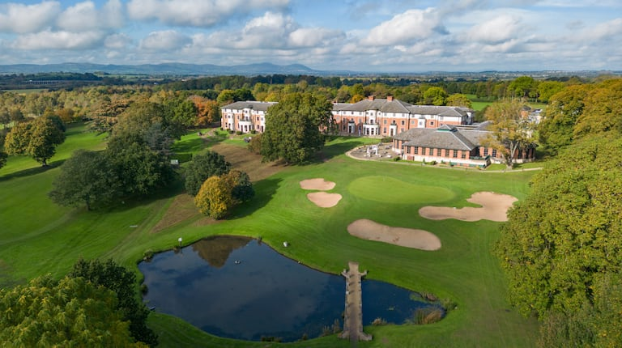
Figure 1.1: Hilton Puckrup Hall, Tewkesbury
(Source: Hilton 2025)

After the major shifts happening in the tourism sector, the company has expanded its services to accommodate the needs of leisure and business travellers, as they are becoming popular across the industry (Orîndaru et al. 2021).

1.3 Rationale
The rationale of the research project stems from the pivotal role of employees that they have within the hospitality sector and how their individual performance shapes guest experiences and satisfaction. Hotels such as Hilton Puckrup Hall are mostly relying on a motivated and well-trained workforce. Previous research studies have pinpointed that the hospitality sector of the UK is facing a labour shortage, which is having a negative impact on the service quality offered (Innerhofer, Nasta and Zehrer 2024; Ntounis et al. 2022). In the same context, employees, when exposed to a workplace environment where career advancement is prioritised, a sense of belonging is established among them, and they continue to stay connected with the firm (Watson et al. 2025). For this reason, understanding more about the training initiatives by the hotel and how they are actually improving, motivating, and learning needs is important, as it has direct impacts on service quality.

1.4 Research Aim
The focal point of the project is to determine the effect of employee training and development programs on the quality of the service and satisfaction of guests in the setting of the hospitality industry, as a case study of Hilton Puckrup Hall, Tewkesbury.

1.5 Research Objectives
RO1: To explore the scope and effectiveness of the training and development programs observed during the placement at Hilton Puckrup Hall and based on relevant secondary hospitality sources
RO2: To analyse the feedback received from the guests from online review platforms such as TripAdvisor and Booking.com to identify the recurring themes associated with staff performance and service delivery
RO3: To benchmark the training and development approach of Hilton Puckrup Hall against the current academic research and best practice models adopted by reputed four-star hotels in the UK
RO4: To provide actionable suggestions that can help the Hilton Puckrup Hall improve the performance of staff members and promote guest satisfaction, while operating in a competitive business environment

1.6 Research Questions
RQ1: In what ways are the existing training and development programs at Hilton Puckrup Hall contributing to the quality services delivered?
RQ2: What are the themes and patterns observed by analysing the guest reviews in relation to employee performance and delivery of services?
RQ3: How effectively does Hilton Puckrup Hall execute its employee training and development programs, when compared with the initiatives taken by other four-star hotels in the UK?
RQ4: What are the suggested recommendations that are capable of assisting the hotel to enhance the output of personnel members and foster client satisfaction, even within the competitive business climate?

Chapter 2 Literature Review

2.1 Introduction
The primary intent of the chapter is to critically examine the secondary sources, that is, research papers, journals, articles and conference papers on the key variables. Different perspectives and opinions of past scholars and academicians are reviewed and represented concisely in order to develop a thorough understanding of employee training and development and its influence on guest satisfaction within the hospitality industry. Besides that, key theoretical perspectives, concepts, and empirical findings in relation to employee training and guest satisfaction in the hospitality sector have been outlined to establish the foundation for the research.

2.2 Conceptual Overview of Employee Training and Development
Employee training and development is defined as any activities that aid employees to expand their knowledge and skill set, contributing to their career advancement. As opined by Urbancová et al. (2021), employee training programs act as a strategic function that works both at the individual and organisational level, since it modifies attitudes, knowledge, or skills through learning experiences. Development, on the other hand, is all about fostering long-term personal and professional growth that aligns with the future organisational goals. With the aid of an ongoing, continuous process, a company is able to prepare employee for new responsibilities, enhance their daily performance and foster strategic thinking. In contrast, as stated by Mikołajczyk (2022), training and development programs organised by a company are often viewed as an investment in human capital, rather than a part of their operational expense. Within the hospitality sector of the UK, the quality of services offered as well as the timely delivery of the services are the aspects that heavily shape guest experience (Olorunsola et al. 2024; Holz et al. 2024). In cases when the management is well aware of the gaps and accordingly designs the training and development programs, it is considered beneficial (Guan et al. 2021).
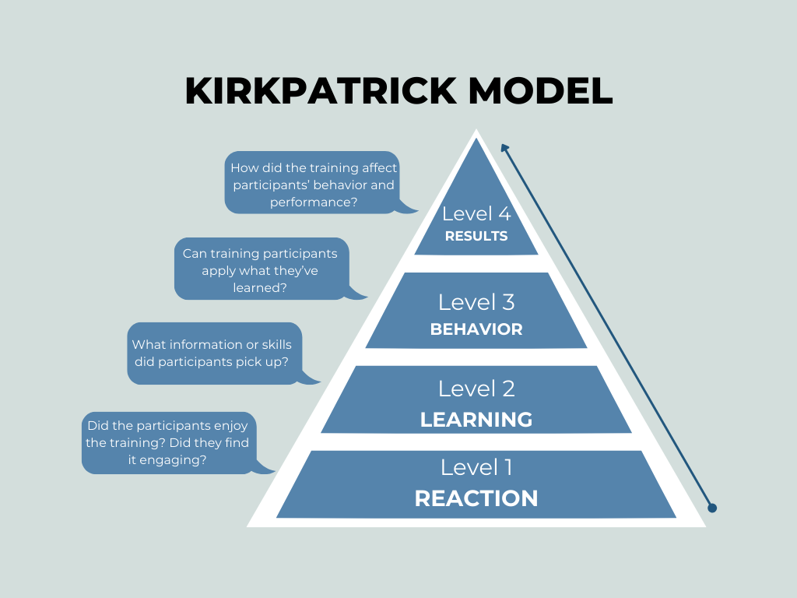
Figure 2.1: Kirkpatrick’s Four-Level Model
(Source: Ambu-Saidi et al. 2024)
Conversely, according to Al-Tit et al. (2022), most organisations have a defined training and development program for all their employees, which is ineffective and leads to low employee morale and participation. A successful training and development program entails conducting a needs assessment, which companies that do not carry out this process rather instead stick to their old training program are not able to transfer knowledge and improve the capabilities of the employees (Markaki etal. 2021; Nazaretsky et al. 2022; Yimam 2022). It is imperative to mention that training can only be effective when it is aligned with organisational objectives, the learning culture and managerial support. In a similar way, as per Ambu-Saidi et al. (2024), evaluation mechanisms like Kirkpatrick’s Four-Level Model are considered reliable to assess the outcomes of training in terms of reaction, learning, behaviour, and results. Within the premises of the Hilton Puckrup Hall, the human resource management has been conducting training programs and workshops that need to be assessed at each level, as shown by Figure 2.1, presented above. A detailed assessment has been conducted by the hotel to compared how the training strategy is being perceived by employees, by adhering to components like tier initial reactions, learning, changes in behaviour and measurable results, such as enhanced guest satisfaction. In contrast to this, the model has not taken into consideration all of the contextual factors which play a crucial role in driving employee performance each hour, that is, motivation or workplace culture, which also has an influence on the success of a training preform in the hospitality sector. Overall, it can be deduced from the literature that having well-designed training and development programmes acts as a bridge between employee competence and service quality, making them critical to sustaining guest satisfaction in competitive hotel markets.

2.3 Guest Satisfaction in the Hospitality Industry
As per the views of Ali et al. (2021), in the hospitality sector, guest satisfaction is the measure of how well a hotel is meeting the expectations of customers for amenities and services against the prior experience. Broadly, a guest evaluates the quality of service provided against multiple dimensions, which includes cleanliness, employee behaviour, food offered, responsiveness, and the overall ambience (Bichler, Pikkemaat and Peters 2021; Ali et al. 2023; Olorunsola et al. 2024). With a high level of guest satisfaction, there is an increased likelihood that the guests are going to return and engage with the services. Besides, positive word-of-mouth is another aspect that uplifts the brand image and influences their family, close ones and friends to engage with the hotel, resulting in increased profits. Contrary to this, as commented by Barthélemy, Graf and Karaburun (2021), guest satisfaction is not solely dependent on the outcome of the delivered services, rather also on the process by which the service is delivered. Based on the findings of the SERVQUAL model, it can be understood that the five key dimensions collecting shape perceived service quality are “tangibles, reliability, responsiveness, assurance, and empathy” (Ramadhani and Utomo 2025). The framework can be applied in the hospitality sector, where the behaviour, responsiveness, and courtesy of the employees to meet guest needs and professionalism have a significant impact on consumer perceptions.
In contrast, as stated by Yu et al. (2022), emotional and experiential factors are often observed to be increasingly dominating guest satisfaction, especially in upscale hotels. In addition to functional performance, a memorable experience is usually desired by guests and is fuelled by customised attention as well as emotional affinity. It is anticipated in this regard that a hotel will educate its workers and that they can communicate empathy, cultural sensitivity and problem-solving (Peng and Kueh 2022; Lajante et al. 2023; Gkintoni, E., Halkiopoulos and Antonopoulou 2022). Consequently, this allows the hotels to enhance the level of satisfaction among the guests, which does not just involve measuring the level of tangible service standards, but also determining the effect of employee development initiatives on service delivery.

2.4 Relationship Between Employee Training and Guest Satisfaction
Employee training is all about equipping the employees with the necessary knowledge, skills and attitudes that make them job-ready and they can meet, or exceed the guest's expectations. As mentioned by Lepistö, Saunila and Ukko (2024), within the hospitality sector, a common sight is that service encounters are central to customer experience. This is because well-trained employees demonstrate professionalism, empathy, and problem-solving capabilities that ensure queries and problems of the guests are handled in less time. With well-structured and up-to-date training programs, there is consistency in service delivery and a significant reduction in errors, all of which contribute to positive customer perceptions. Contrarily, according to Balinado et al. (2021), there is no linear relationship between training and guest satisfaction, as factors like employee morale, managerial support, and the opportunity to apply newly acquired skills interfere. Largely, the factors stated by the research paper highlight how support from the senior leaders and the organisational culture are the ones fostering a continuous learning environment, where employees tend to thrive. In either case, when the company does not support employee training to have a poor organisational culture, it translates to employee performance and negative outcomes are noted (Kim and Jung 2022; Iskamto 2023; Zacharias, Rahawarin and Yusriadi 2021). In contrast to this, as opined by Hosen et al. (2024), employee engagement does have a mediating role between the variables, training and guest satisfaction. When employees actively engage with the training program, they become component as well as feel valued by the company. Having a positive feeling about their workplace inspires them to contribute towards their growth and influences their service behaviour and customer interactions.

2.5 Best Practice Models of Training and Development in Four-Star Hotels
Across the hospitality sector, there are different employee training models used and employed to gain the maximum outcome. According to the views of Barile et al. (2023), a training program works best when it is grounded in strategic alignment, continuous learning, and performance evaluation. It is a known fact that an effective training program in a hotel is one that is in line with long-term organisational objectives and ensures service delivery meets brand standards and guest expectations. For instance, four-star hotels of the UK adopt competency-based training frameworks that identify the specific skills that are required for each role, and the learning interventions are designed accordingly (James and Gregory 2021; Meilianti et al. 2021). On the contrary, as per Babapour et al. (2021), relying on the program design does not improve its outcomes; rather, the organisational environment needs to be taken into consideration. Without post-training reinforcement or follow-up evaluation, it becomes difficult to assess the effectiveness of well-designed training programs and how they yield long-term behavioural change. Therefore, it is necessary for the human resource management to develop strategies that include all the key elements of training, that is, “mentoring, feedback mechanisms, and reward system” to recognise the application of the skill learned in the workplace.

2.6 Theoretical Underpinning
On the basis of the postulates of the Human Capital Theory, it can be deduced that organisations invest in expanding employee skills, competencies and knowledge, since it is considered an economic asset (Aman-Ullah et al. 2022). As per the views of Carlbäck, Nygren and Hägglund (2024), the Human Capital Theory has outlined that decisions regarding investing in resources through training and education are based on expected returns. The theory is applicable in the context of Hilton Puckrup Hall, Tewkesbury, to describe how constant investment in training (customer service workshops, development of communication skills and development of leadership) leads to greater guest experiences.
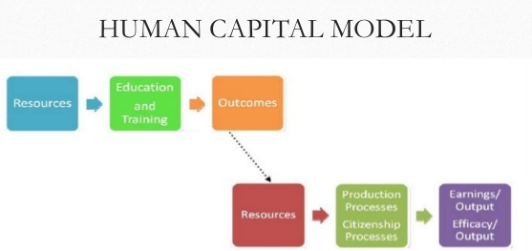
Figure 2.2: Human Capital Theory
(Source: Aman-Ullah et al. 2022)
Within the premises of the Hilton Puckrup Hall, the human resource management has taken up the responsibility to integrate a well-structured training program for the newly joined ones, such that they remain a fit with the company’s culture, and bring value to the consumers. Through these training sessions, the hotel tends to align with the principle of the theory, that is, employees are considered human assets (Sebola 2023). From Figure 2.2, it can be deduced that education/training is the key that often leads to efficacy/earning output, further illustrating how investing in building skilled human resources can translate to improved guest satisfaction and financial gains. Contrary to this, the limitation of the theory is that it assumes that a company would get direct returns on training, without even considering attributes like staff morale or creativity, and how hard they are to quantify. Therefore, the actions taken by the hotel as in favor as well as tests the posits of the theory, since it also links investing in learning opportunities to enhanced service excellence and performance outcomes.

2.7 Literature Gaps
Although several works have been conducted on the significance of employee training and guest satisfaction in the hospitality industry, little research has been conducted on the relationship between the two in the UK four-star hotel scenario. The available literature tends to make generalisations among the various categories of hotels or regions and neglects the effects of organisational culture, training assessment and employee participation in service quality delivery. In addition, not many studies have investigated the direct implications of structured training at the property level, like what has been introduced by the Hilton Puckrup Hall, on the guest experiences and satisfaction ratings. Henceforth, this research work has been developed in a way that fills the existing contextual gaps and contributes to the field of research on the hospitality sector.

2.8 Summary
In summary, the chapter has examined major literature on training and development of employees, guest satisfaction and their interaction in the hospitality industry. It has brought out the role that training plays in the competence of employees, motivation, and quality of services delivered by employees to guests, all of which determine satisfaction and loyalty of guests. The review also recognised divergent opinions on the effectiveness of training based on the hotel’s brand image and guest satisfaction.

Chapter 3 Methods

3.1 Introduction
Research methodology, refers to a systematic plan that is used by all researchers and the academic community to derive information, staying in line with the objectives. The chapter has explicitly outlined the methods and procedures that are adopted to gather large and suitable data sets, in order to answer the research questions. A detailed overview of the data collection methods, that is, what steps were implemented to derive meaningful data and achieve the larger research goal. Further to this, the data analysis technique and steps followed to conclude have been covered in this chapter.

3.2 Research Approach
A research approach is often described as a particular process through which researchers glean information pertinent to certain topics and process it in a manner that enables them to learn more about the certain topics. Deductive and inductive are two research approaches that can be mostly applied in a project by scholars and the academic community. Deductive approach, according to the opinion of Flick (2022), is entirely about gathering objective data and subjecting them to testing to lead to insightful inferences. Contrary to this, the inductive approach is flexible and helps to understand the situation or phenomenon under study more deeply. The researcher chose to proceed with an inductive approach that dwells on experience and views of individuals, and then assists the researcher in a comprehensive understanding of the impact of employee training and development on the satisfaction of guests in Hilton Puckrup Hall, Tewkesbury.

3.3 Research Design
Research design is considered the blueprint as it provides direction to the researcher on how to conduct a project such that objectives are met. According to the viewpoints of Verma, Verma and Abhishek (2024), the most commonly used and reliable research designs are qualitative, quantitative and mixed methods. In order to explore the impact of employee training on guest satisfaction at Hilton Puckrup Hall, the researcher decided to employ a qualitative design. Investigating in depth is the prime intent of this research project, which aligns with the characteristics of qualitative research. Largely, qualitative research designs enable the researcher to gain in-depth insights into human perceptions, attitudes, and behaviours, particularly important to explore the perception of guests (Dubey and Kothari 2022). Unlike quantitative strategies that strongly emphasise measurement, qualitative methods are considered flexible and allow information to emerge organically through textual and thematic exploration. In addition, the selected design is suitable for examining subjective elements such as staff performance, communication, and guest satisfaction narratives.

3.4 Research Strategy
Research strategies are the building blocks that are undertaken by the researcher to gather valid data sets to drive meaningful results. In light of this project, a case study strategy has been implemented, which primarily focuses on Hilton Puckrup Hall, Tewkesbury, to examine how employee training and development influence guest satisfaction. As per Mtisi (2024), what differentiates a case study strategy is its ability to explore complex social phenomena within real-life contexts. Here, relying on multiple evidence sources such as organisational data and guest feedback is helpful in comprehending the interplay between organisational practices and customer experiences. Another key advantage of this case study strategy is that it enables the project to generate rich, contextual insights that are specific to the hotel’s environment.

3.5 Data Collection Methods
Data collection is one of the most important steps in research methodology, since the accuracy of the results to address the research questions and the relevance of the findings are dependent on the quality of the information gathered (Islam and Aldaihani 2022). In this research project, the secondary data sources are used, which include online guest reviews and organisational information gained during the placement. In addition to this, observations made during the placements are being used to understand how effective are the current employee training programs. The opinions of platforms like TripAdvisor, Booking.com, and Google Reviews are genuine reviews by guests about the quality of services, professionalism of the staff, and their satisfaction rates. The simple reason behind choosing the online portals is that online consumer discourse enables a researcher to seize data about real-life experiences actually experienced. Findings are going to be put within a broader context using secondary information through the official site of Hilton, employee development reports, and publications in the industry. The selection of reviews has been determined by relevance, time period, and detail, and the reviews have been filtered by verifying the stay to give credibility; that is, the guests posting images of their stay, the food, and services they liked are the ones prioritised (Cheong et al. 2023).

3.6 Data Analysis
All the data obtained through the use of secondary sources is revised in detail to determine the general trends or patterns associated with gusset satisfaction. Re-reading data is the first step, followed by transcribing the initial codes is done by the researcher (Braun and Clarke 2023). This step is of critical importance since it enables the researcher to be conversant with the data. In addition, the researcher combines all the identified codes and combines them to formulate the relevant themes, which are also consistent with the objectives of the research. According to Braun and Clarke (2023), the most crucial step in the thematic analysis is the creation of names and definitions because it assists in comprehending the set of collected data. Lastly, the researcher summarises each of the themes and continues with the analysis of the information concerning the impact of employee training on the satisfaction of guests in Hilton Puckrup Hall.

3.7 Limitations of the Methodology
Although a robust qualitative case study methodology has been adopted, there are some methodological shortcomings that are mentioned in this section. To begin with, the use of secondary data, including online reviews, restricts the ability to control the authenticity of data and the bias of the researcher (Jordan et al. 2024). The fact that feedback on sites such as TripAdvisor and Booking.com is a personal experience might not entirely capture the entire population of guests. Secondly, the results may not be generalizable to other hotels or contexts as the current study is devoted to one case, Hilton Puckrup Hall. Also, qualitative analysis is interpretative and thus presents a risk of researcher bias when interpreting data, along with the level of data triangulation is also restricted by time (Alshehri et al. 2021). However, these disadvantages are addressed by means of selecting the data carefully, conducting the analytical processes in a transparent manner, and cross-referencing various credible sources in order to achieve validity and reliability.

3.8 Summary
A case study strategy was chosen because it allows gaining a profound insight into the organisational practice in the setting of a real-life context. The secondary qualitative data were collected using the reviews of guests of TripAdvisor and Booking.com, and supplemented by company reports and industry reports. The selected method aided in-depth and contextual understanding, despite the weaknesses of the possible bias and reduced generalisability, which were recognised.

Chapter 4 Findings and Discussion

4.1 Introduction
The fourth chapter presents the findings derived from the collected data, concerning the impact of employee training and development on guest satisfaction at Hilton Puckrup Hall, Tewkesbury. To be precise, a thematic analysis has been done in this section, where four recurring themes identified from the gathered data have been reported and supported with secondary information. Along with that, the section discusses the findings by aligning them with previous literature and how far they meet the research objectives.

4.2 Findings

4.2.1 Theme 1: Employee Training Programs Are Effective at Hilton Puckrup Hall
Hilton Puckrup Hall implemented employee training and development programs that have been at the core of keeping the high reputation that the company is known for in terms of quality service delivery and customer satisfaction. It is observed during the placement that the hotel has taken a systematic approach in terms of staff development since it works on both technical and interpersonal competencies. Specifically, the recruited employees must go through an induction program, after which a brief training program must be undertaken. They are also involved in technical skills in this program, which are specific to the job position and which guarantee that each individual meets the health and safety regulations and departmental expectations set. Conversely, they train these employees in the soft skills such as customer interaction, problem-solving and teamwork, which are aimed at making sure that the guest experience is not affected in any way, and every employee, regardless of the department, knows how to match the needs of the guests. In this regard, the management recently started cross-departmental training, such that employees grow to have a wider grasp of the operation of the hotel and enhance the effectiveness of collaboration between front-of-house and back-of-house employees.
The hotel has ensured to align with the UK government regulations on employment standards and health and safety while designing the program. Besides that, inflationary pressures have been a prominent challenge for the company, though it has continued to implement the training program instead of eliminating it as a cost-cutting measure (Nugraha et al. 2024). Conversely, the hotel has viewed employee training as a part of its long-term strategy, as it enables them to maintain service quality amidst operational cost challenges (Papademetriou, Anastasiadou and Papalexandris 2024).
From a social perspective, the training modules have included perspectives of guests from different cultural backgrounds, such that personalized, inclusive, and culturally sensitive service is provided to the guests. Along with that, the hotel has included technical skills-related modules where newly hired employees learn through e-learning platforms, and they develop knowledge about digital tools. The modules also cover legal aspects, such as data protection, workplace equality, and hospitality-specific certification requirements to ensure that any staff can easily respond to the guests when asked (Oni 2025). Lastly, the employee training program has included concepts of sustainability and how employees can use those strategies to reduce environmental degradation. In essence, the existing employee training program that has been introduced is effective and covers all the aspects that promote high-quality services and standards throughout.

4.2.2 Theme 2: Mix Reviews About Service Quality and Staff Performance
Having analysed the reviews posted by guests on TripAdvisor and Booking.com, a closer look at the extent to which employee training and development initiatives at Hilton Puckrup Hall convert into customer satisfaction and quality of service will be taken. The Hilton Puckrup Hall has been rated an average of 3.9/5.0 on TripAdvisor, upon which over 2500 individuals have posted their experience with the members of the hotel, the facilities of the hotel, and other related factors (TripAdvisor 2025). Based on the feedback provided, it may be concluded that the services at breakfast and the professionals in the reception were active, responsive and assisted the guests with all their queries or concerns. TripAdvisor and Booking.com have had several favourable reviews, with staff members receiving compliments based on their politeness, friendliness and observance of other staff members, implying that customer service and people communication training is functional. Such honest remarks as the crew in the hotel gave us an amazing experience and stunned us at all touchpoints, as well as the reception team was polite and professional, showing that the hotel had a strong culture of hospitality and teamwork and trained employees on the basis of problem-solving skills, which is reflected in figures 4.2 and 4.3 (TripAdvisor 2025).

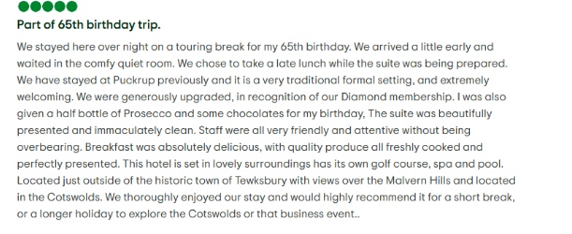Figure 4.1: Positive Review by a Guest
(Source: TripAdvisor 2025)
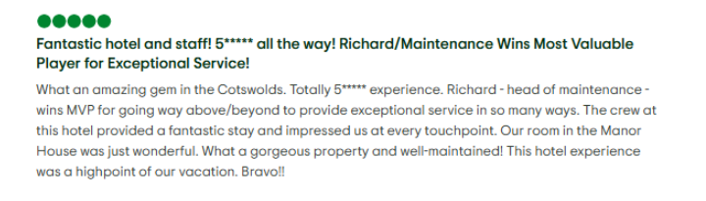
Figure 4.2: Positive Review by a Guest
(Source: TripAdvisor 2025)
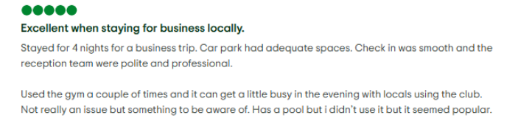Figure 4.3: Positive Review by a Guest
(Source: TripAdvisor 2025)

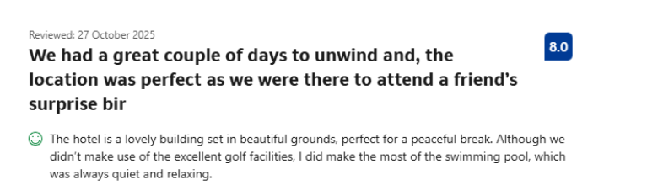
Figure 4.4: Positive Review by a Guest
(Source: Booking.com 2025)
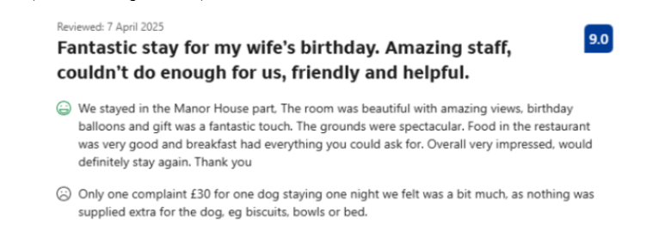
Figure 4.5: Positive Review by a Guest
(Source: Booking.com 2025)

On the contrary, there has been a few negative feedbacks from the guests as well, which has been presented below. One of the guests has reported that the receptionist cut the call when the guest added changes about their booking, though there was no discussion or argument, as observed in Figure 4.7. Besides that, a few young staff members have failed to have a good impression on the guests as they have been disrespectful and did not abide by the service standards promised by the hotel, as depicted in figures 6 and 4.8 (TripAdvisor 2025). A similar view was noted when guests posted their experiences on Booking, where quite a few reviews out how the staff members could not meet their expectations and their stay was not pleasant. Nonetheless, the overall rating of staff performance of this hotel is 8.7 on Booking, which reflects that performance in some cases has not been up to the mark, and attention from the management is required (Booking.com 2025).
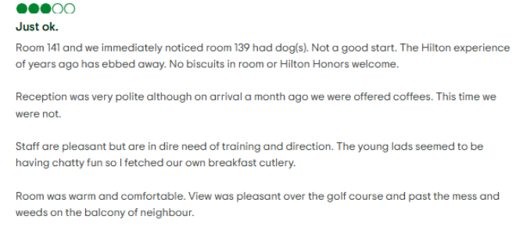
Figure 4.6: Negative Review by a Guest
(Source: TripAdvisor 2025)

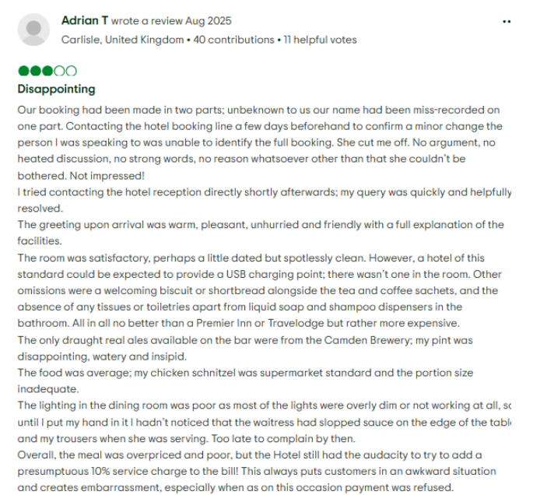
Figure 4.7: Negative Review by a Guest
(Source: TripAdvisor 2025)

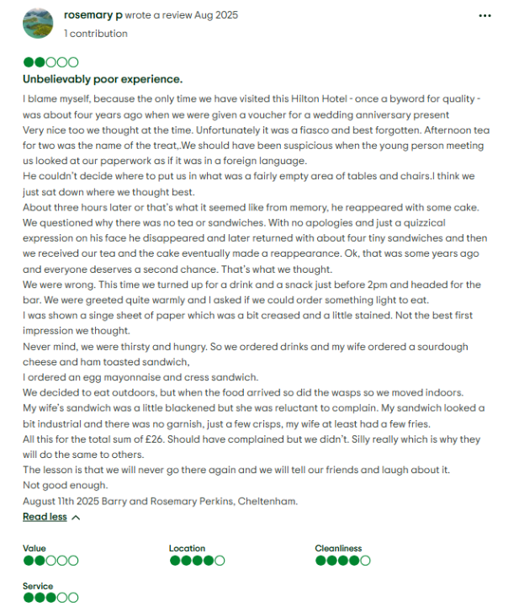
Figure 4.8: Negative Review by a Guest
(Source: TripAdvisor 2025)

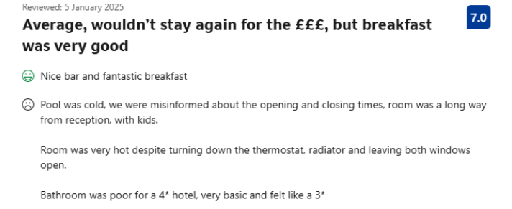
Figure 4.9: Negative Review by a Guest
(Source: Booking.com 2025)
Overall, the combined review data from different sources has pointed out that training programs have positively affected the guest experiences at Hilton Puckrup Hall, However, there have been occasions events where the service were not up to the mark, followed by the presence of departmental inconsistencies, indicating the need for continuous skills reinforcement and more cross-departmental coordination to sustain a uniformly high service standard across all guest touchpoints.

4.2.3 Theme 3: Benchmarking Hilton Puckrup Hall’s Training Approach Against UK Four-Star Hotel Practices
The induction and service training programs at Hilton are well organised such that the staff recognise brand values, operating procedures and customer care ethics. The hotel has been working on its strengths, like adopting the well-established global training framework that has been emphasising aspects like brand standards, service quality, and leadership development. However, the weaknesses of the company involve limited coordination between departments and time constraints, which are affecting the training sessions offered to the fresher. Besides, the company’s lack of investment in digital tools and opting for the traditional way of employing a training program is limiting its effectiveness. Nevertheless, other rival hotels have been shifting towards new approaches of innovative, technologically advanced, and experiential learning that can be adapted by Hilton to improve staff performance and motivation.
As an illustration, the Radisson Blu Hotel in Manchester Airport is using training simulations based on the VR experience to enable front-desk and housekeeping employees to rehearse real-life service situations in a stress-free setting to enhance confidence and response time (Aruvr 2025). Likewise, The Marriott Grosvenor Square in London employs the Marriott Global Source, which is an interactive digital system that provides multilingual modules on leadership, sustainability and customer relations so that employees are able to learn at their convenience and monitor their progress (Ziprecruiter 2025). The Malmaison Hotel Group also facilitates a program named Learn and Grow, which is aimed at advancing career development through mentoring and moving around functions, better retention and cross-functional knowledge. Based on the discussion, it can be deduced that Hilton can adopt innovative training approaches used by competitors. Like employing virtual reality (VR) simulations and integrating e-learning platforms to provide flexible skill development modules. However, the company can witness high industry turnover and growing competition from boutique hotels; therefore, investing in learning opportunities can ensure services offered exceed the expectations of guests and retain them, followed by instilling a sense of belonging among employees.

4.2.4 Theme 4: Suggestions for Enhancing Training and Guest Satisfaction
As per the above discussion on employee training, it is important to increase the number of training sessions as there are young employees failing to align with guest expectations, which leads to the satisfaction of guests in Hilton Puckrup Hall. To begin with, the hotel must undertake more regular cross-departmental training in order to maintain the same quality of service, especially when the hotel is in peak hours. The inclusion of digital learning technology, including mobile-based micro learning or virtual simulation, would enable the staff to receive training in a flexible manner that would not interfere with the operations (Al-Zahrani 2024).
The training cycle should also incorporate frequent performance feedback in order to detect any skill deficiencies in an earlier stage and maintain motivation. Broadly, the guest feedback has shown issues like young staff members behaving rudely or aligning the services with their demands, all of which need to be monitored, and feedback needs to be provided to the employees every week (Booyens et al. 2022). Lastly, the implementation of modules on emotional intelligence, sustainability practices, and cultural sensitivity would keep Hilton Puckrup Hall in line with the changing demands of the guests and industry trends.

4.3 Discussion

4.3.1 Linking Findings with Existing Literature
The results from the online review websites and observations have pointed out that the employee training program is a structured one, which enables employees to learn both technical and soft skills. In a similar way, Section 2.2 of the literature review has explained that a successful training program is one that requires a company to carry out a needs assessment, then design the program and include an evaluation mechanism, thereby the findings in the literature.
Based on the online reviews, it can be inferred that the staff performance has been up to the mark for most cases, as there are numerous positive comments. As mentioned in the 2.3 section of the literature review, a guest tends to evaluate “the quality of service provided against multiple dimensions, which are cleanliness, employee behaviour, food offered, responsiveness, and the overall ambience”. However, the presence of comments regarding one or two not performing their duties well, not all, aligning with guest needs and being rude, reflects that the initial training program has not been fruitful. These findings strongly align with section 2.4 of the literature review, which states that there is no “linear relationship between training and guest satisfaction, as factors like employee morale, managerial support, and the opportunity to apply newly acquired skills interfere”.
Section 2.5 has mentioned that the best model for employee training programs needs to be strategically aligned, and support from the firm or managers is important to witness positive outcomes. However, the findings have stressed that digital tools and advanced technologies like VR are aspects that uplift the learning process and ensure employees can have access to information anytime required. Therefore, it can be deduced that the findings are contradictory to the literature explained in the previous chapter.

4.3.2 Interpretation of Findings by Objective
RO1: To explore the scope and effectiveness of the training and development programs observed during the placement at Hilton Puckrup Hall, and based on relevant secondary hospitality sources
The findings from the observations and during placement, and secondary sources revealed that the hotel has a structured training and development program mainly for the newly joined ones. The program covers both technical and soft skills, due to their importance within the hospitality sector and enables the firm to enhance guest experiences; however, there are no training programs meant for future leaders.
RO2: To analyse the feedback received from the guests from online review platforms such as TripAdvisor and Booking.com to identify the recurring themes associated with staff performance and service delivery
Going through the guest feedback and the review section of TripAdvisor and Booking, it can be understood that guests are having a good experience while engaging with the services of Hilton Puckrup Hall. Contrary to this, there is a scope for improvement when it comes to staff performance, as a few guests have pointed out that ow young employees are not aligning with their expectations, and occasionally, employees have been rude. It can be inferred that mixed reviews are noted when it comes to staff performance; therefore, the hotel needs to identify the areas of improvement and skills gaps, and accordingly modify the training programs (Hu, Trivedi and Teichert 2022).
RO3: To benchmark the training and development approach of Hilton Puckrup Hall against the current academic research and best practice models adopted by reputed four-star hotels in the UK
The findings reveal that four-star hotels in the UK, like Radisson Blu Hotel and Marriott Grosvenor Square, are integrating VR and e-learning platforms in their employee training programs. Both hotels have ratings higher than that of Hilton Puckrup Hall, which reflects that their employee training is a benchmark that can be considered by Hilton to improve staff performance and service quality.
RO4: To provide actionable suggestions that can help the Hilton Puckrup Hall improve the performance of staff members and promote guest satisfaction, while operating in a competitive business environment
Based on the findings, the suggested strategies for the hotel are more regular cross-departmental training, inclusion of digital learning technology, frequent performance feedback, and implementation of modules on emotional intelligence, sustainability practices, and cultural sensitivity.

4.3.3 Implications for Hilton Puckrup Hall
From the above findings, it can be implied that the training program by Hilton Puckrup Hall needs to be refined, mainly for the young employees, in order to achieve a greater service level and satisfy the guests, since inconsistencies have been noted. In the context, it is the responsibility of the management to bring in leadership development and cross-departmental collaboration to ensure uniform service standards, along with strengthening the feedback mechanism (Zuefle, Rennpferdt and Krause 2021). Lastly, the inclusion of digital learning is equally important to foster a learning culture that ensures all the desires of guests are fulfilled.

4.3.4 Limitations of the Findings
The results, as discussed in the previous sections, are grounded on the small sample size of observations of one hotel location and might not be representative of all Hilton hotels and the overall industry dynamics. The analysis is partially based on online guest reviews that can be subjective and not contextually in-depth, and the lack of quantitative employee feedback also limits the accuracy of correlating the training outcomes and the performance (Walther et al. 2025).

4.3.5 Areas for Further Research
For future researchers, opting for a comparative study between Hilton’s training model and other international hotel chains, by relying on primary data, would provide deeper insights into best practices and performance outcomes. Besides, relying on survey research techniques would be beneficial to comprehend how employees perceive and benefit from the training programs employed.

4.4 Chapter Summary
In summary, the results have shown that although the training programs have influenced performance positively, there are areas of weakness in training modes adopted and cross-departmental coordination. Through benchmarking, it was discovered that the other four-star hotels in the UK use digital and experiential learning as a way of enhancing engagement. Suggestions were made to include e-learning, VR simulation, emotional intelligence, and regular feedback.

Chapter 5 Conclusion and Recommendations

5.1 Introduction
In the fifth chapter of the project, a detailed overview of the findings has been provided, along with the conclusion drawn from them. Besides that, the chapter discusses the implications of the findings and provides recommendations that can help the hotel refine its employee training strategies, which are necessary to improve staff performance and ensure guests are satisfied with the services.

5.2 Conclusion

5.2.1 Summary of Key Findings
The research project reveals that employee training programs act as a cornerstone at Hilton Puckrup Hall since they uplift the overall brand reputation by offering exceptional service quality and customer satisfaction. The training initiatives in today’s times follow a particular structure as they focus on both technical and soft skill development. In the meantime, induction programs are being integrated for the new employees that enable them to learn deeply about brand values, service protocols, and operational safety. Besides that, the adoption of cross-departmental training has not only promoted collaboration but also ensured a cohesive user experience (Wipulanusat, Sunkpho and Stewart 2021; Sunnemark et al. 2024).
Despite the positive reviews floated across the websites, there are limitations like inconsistencies in staff performance scores, and due to incidents taking place are worrisome for the hotel. Moreover, the hotel relied on traditional training models, whereas most of its competitors have adopted digital tools to help employees learn new, updated modules and effective training, setting a benchmark for others to follow (Handrich and Otterbach 2024).
The analysis of online reviews collected from TripAdvisor and Booking.com verified inconsistent outcomes on the quality of service. Although the majority of guests have admitted that the staff were friendly, professional, and responsive, some of them have mentioned cases of poor service and irresponsibility among younger employees. The comparison with other four-star hotels, including Radisson Blu and Marriott, showed that Hilton Puckrup Hall might need to consider the implementation of VR-based simulations, e-learning platforms, and constant learning platforms. Henceforth, it can be deduced that the hotel needs to put in efforts to address the existing gaps in its training program and establish a feedback loop that can remind employees how to align with the service standards.

5.2.2 Discussion of Implications
Taking the findings into consideration, it is required for the hotel to refine the existing training strategy, that is, by integrating digital learning platforms, such as e-learning modules or mobile-based micro learning, as they can enhance the engagement of the employees due to increased accessibility. Besides, in-person training is another aspect that needs to be considered by the human resource department, since findings have pointed out inconsistencies in staff performance scores. Moreover, delay in services from the receptionist on some days require intervention from the management, followed by promoting cross-departmental coordination that can be strengthened through rotational programs to foster teamwork and shared accountability (Lin et al. 2025; Saechang 2024). Lastly, having mixed reviews, including staff performance, indicates that staff members are doing well in certain areas while struggling in others. In this context, the inclusion of modules related to behavioural aspects and interpersonal relations is extremely important so that no guest complaints of arrogance or uncooperative behaviours.

5.2.3 Reflection on Research Process
The first-hand experience as a result of the placement allowed a first-hand look at the training process and the culture of operation at Hilton Puckrup Hall and a genuine assessment of their performance. The review of the commentary on the guest feedback platforms and observational analysis allowed a balanced approach to be achieved, to have a thorough understanding of staff performance. The capacity of the research to bind together the theory with the practice, which is the association of frameworks, such as SWOT and benchmarking, with actual practice, was one of its strengths. On the contrary, limited time meant that only a limited amount of data could be collected from the staff members, and the use of secondary data, like online reviews, could have led to subjective bias. Despite the constraints noted, the research project has helped in building critical thinking, data analysis, and reflective learning skills, all of which are important and contribute to future managerial effectiveness.

5.3 Recommendations
On the basis of the findings, a list of suggestions has been provided for the hotel such that they fill the gaps and ensure all the employees are aligned with service standards:
Recommendations 1
The integration of digital tools in order to modernise training delivery is a strategy that the hotel can use to allow staff members to engage with real-life scenarios, such as guest complaints or emergency responses. Besides that, digital learning platforms enable them to have access to the modules and other information at any time, which they can use to address complex challenges in day-to-day activities (Ubaydullaeva et al. 2024; Culajara et al. 2022).
From a practical standpoint, the financial resources required in the early days would be high since the integration of digital tools is expensive, more precisely, 15,000 GBP can be required; also, it is a time-consuming process. This is because the organization needs to integrate the tools, run pilot tests and then confirm how they are aligning with the company’s objectives. The steps required to successfully implement this user suggestion section of the most appropriate platform, forcing customization of the module, training the staff on how to use these tools and rolling out the platforms for everyone.
Recommendations 2
The second suggestion would be to conduct weekly or biweekly performance feedback sessions that can help identify the gaps in customer service delivery early. Managers would be the ones providing constructive feedback by taking into account the complaints or feedback from guests, with the aim of maintaining consistency and reinforcing accountability (Kitsios et al. 2021; Vo et al. 2022)
A very minimal cost is required for this suggestion, besides that, providing detailed reports and reviews can be time-consuming, mainly for the managers or leaders of the hotel. The implementation steps are simple, which include scheduling weekly sessions, followed by providing feedback and monitoring employees on how they are performing after the feedback.
Recommendations 3
Rotational shadowing programs are another strategy that can be integrated by the hotel for employees to appreciate operational interdependencies and improve teamwork during peak periods.
The implementation of this suggestion is an extensive one when peak periods are being witnessed by the hotel, as employees are to get involved in multiple roles, fulfil the needs and ensure the expectations of guests are met. However, from the cost perspective, the hotel needs an approximate of 500 GBP for the logistics purposes, to proceed with the development of a rotation schedule, assigning a mentor and giving them a small incentive and evaluating the effectiveness of each cycle.
Recommendations 4
Rewards and recognition are another key strategy that can be introduced by the firm, such that employees align with the service standard and willingly participate in the training program. To be precise, providing small incentives and digital badges can boost the morale of staff members and create a culture where everyone is engaged with learning nd improve their capabilities (Hartnett 2021; Rusin and Szandała 2025).
The hotel can decide on a small amount (approx. 500-1,000 GBP) as incentives for the employees are wholeheartedly participating in the training program, a step that can help the hotel encourage other employees as well. It can be anticipated that the suggestion is an easy-to-implement one, which comprises steps like deciding on the type of rewards that can have a greater impact on employees, creating clear criteria and communicating that to the employees, rolling out the program and tracking how employees are responding to this strategy and their performance.

5.4 Chapter Summary
The chapter has concluded that the employee training activities of Hilton Puckrup Hall have a strong impact on the quality of the service and the consumer satisfaction; however, integration with digital activities can ensure improvement. The implication is that long-term investment in employee growth is highly important in ensuring high service levels and a competitive edge. The analysis of the research process made it evident that the placement-based approach has its advantages and disadvantages. Besides that, suggestions like the inclusion of rewards and recognition, weekly or biweekly performance feedback sessions, rotational shadowing programs, and digital tools can help the hotel improve its training program.

References
Ali, B.J., Gardi, B., Othman, B.J., Ahmed, S.A., Ismael, N.B., Hamza, P.A., Aziz, H.M., Sabir, B.Y., Sorguli, S. and Anwar, G., 2021. Hotel service quality: The impact of service quality on customer satisfaction in hospitality. International Journal of Engineering, Business and Management, 5(3), pp.14-28.
Ali, U., Arasli, H., Arasli, F., Saydam, M.B., Capkiner, E., Aksoy, E. and Atai, G., 2023. Determinants and impacts of quality attributes on guest perceptions in Norwegian green hotels. Sustainability, 15(6), p.5512.
Alshehri, T., Abokhodair, N., Kirkham, R. and Olivier, P., 2021, May. Qualitative secondary analysis as an alternative approach for cross-cultural design: A case study with Saudi transnationals. In Proceedings of the 2021 CHI Conference on Human Factors in Computing Systems (pp. 1-15).
Al-Tit, A.A., Al-Ayed, S., Alhammadi, A., Hunitie, M., Alsarayreh, A. and Albassam, W., 2022. The impact of employee development practices on human capital and social capital: the mediating contribution of knowledge management. Journal of Open Innovation: Technology, Market, and Complexity, 8(4), p.218.
Al-Zahrani, A.M., 2024. Enhancing postgraduate students’ learning outcomes through Flipped Mobile-Based Microlearning. Research in Learning Technology, 32.
Aman-Ullah, A., Mehmood, W., Amin, S. and Abbas, Y.A., 2022. Human capital and organizational performance: A moderation study through innovative leadership. Journal of innovation & knowledge, 7(4), p.100261.
Ambu-Saidi, B., Fung, C.Y., Turner, K. and Lim, A.S.S., 2024. A critical review on training evaluation models: a search for future agenda. Journal of Cognitive Sciences and Human Development. Vol, 10(1).
Aruvr 2025 TOURISM & HOSPITALITY Available at: https://aruvr.com/industries/tourism-hospitality/#:~:text=Last%20year%2C%20a%20British%2DGerman,even%20faster%20and%20increase%20productivity.%E2%80%9D&text=With%20ARuVR's%20Real%2DTime%20Sessions,improve%20operational%20efficiency%20and%20accuracy.%22
Babapour Chafi, M., Hultberg, A. and Bozic Yams, N., 2021. Post-pandemic office work: Perceived challenges and opportunities for a sustainable work environment. Sustainability, 14(1), p.294.
Balinado, J.R., Prasetyo, Y.T., Young, M.N., Persada, S.F., Miraja, B.A. and Redi, A.A.N.P., 2021. The effect of service quality on customer satisfaction in an automotive after-sales service. Journal of Open Innovation: Technology, Market, and Complexity, 7(2), p.116.
Barile, S., Ciasullo, M.V., Testa, M. and La Sala, A., 2023. An integrated learning framework of corporate training system: a grounded theory approach. The TQM Journal, 35(5), pp.1106-1134.
Barthélemy, J., Graf, N. and Karaburun, R., 2021. Good but not so great: The impact of chain affiliation on guest satisfaction and guest satisfaction extremeness. International Journal of Hospitality Management, 94, p.102828.
Bichler, B.F., Pikkemaat, B. and Peters, M., 2021. Exploring the role of service quality, atmosphere and food for revisits in restaurants by using a e-mystery guest approach. Journal of Hospitality and Tourism Insights, 4(3), pp.351-369.
Booking.com 2025 Guest reviews for Hilton Puckrup Hall Hotel & Golf Club, Tewkesbury Available at: https://www.booking.com/hotel/gb/hilton-puckrup-hall-golf-club.en-gb.html?aid=318615&label=Low_CPA_English_EN_IN_21456997105-hJ4rUEGS3eGv9fzrUDj3NgS634117823733%3Apl%3Ata%3Ap1%3Ap2%3Aac%3Aap%3Aneg%3Afi%3Atidsa-64415224945%3Alp9061815%3Ali%3Adec%3Adm%3Aag21456997105%3Acmp339861625&sid=91c8f228ebb38b7b061d3cfb988f5e1c&dest_id=-2597215&dest_type=city&dist=0&group_adults=2&group_children=0&hapos=1&hpos=1&no_rooms=1&req_adults=2&req_children=0&room1=A%2CA&sb_price_type=total&sr_order=popularity&srepoch=1761723260&srpvid=7c173538de6c007b&type=total&ucfs=1&#tab-reviews [Accessed 21st October 2025]
Booyens, I., Hadjisolomou, A., Nickson, D., Cunningham, T. and Baum, T., 2022. ‘It’s not a big deal’: customer misbehaviour and social washing in hospitality. International Journal of Contemporary Hospitality Management, 34(11), pp.4123-4141.
Carlbäck, M., Nygren, T. and Hägglund, P., 2024. Human resource development in restaurants in Western Sweden–a human capital theory perspective. Journal of Human Resources in Hospitality & Tourism, 23(2), pp.289-314.
Cheong, H.I., Lyons, A., Houghton, R. and Majumdar, A., 2023. Secondary qualitative research methodology using online data within the context of social sciences. International Journal of Qualitative Methods, 22, p.16094069231180160.
Cho, Y. and Choi, Y., 2021. When and how does sustainable HRM improve customer orientation of frontline employees? Satisfaction, empowerment, and communication. Sustainability, 13(7), p.3693.
Culajara, C.J., Culajara, J.P.M., Portos, O. and Villapando, M.K., 2022. Digitalization of modules and learning tasks for flexible, convenient, and safe learning experience of students. International Journal of Social Learning (IJSL), 2(3), pp.350-365.
Dubey, U.K.B. and Kothari, D.P., 2022. Research methodology: Techniques and trends. Chapman and Hall/CRC.
Elshaer, I.A., Azazz, A.M., Mohammad, A.A. and Fayyad, S., 2025. Decoding Success: The Role of E-Learning Readiness in Linking Technological Skills and Employability in Hospitality Management Graduates. Information, 16(1), p.47.
Flick, U., 2022. Revitalising triangulation for designing multi-perspective qualitative research. The SAGE handbook of qualitative research design, pp.652-664.
Gkintoni, E., Halkiopoulos, C. and Antonopoulou, H., 2022. Neuroleadership an asset in educational settings: An overview. Emerging Science Journal. Emerging Science Journal, 6(4), pp.893-904.
Guan, J., Wang, W., Guo, Z., Chan, J.H. and Qi, X., 2021. Customer experience and brand loyalty in the full-service hotel sector: the role of brand affect. International Journal of Contemporary Hospitality Management, 33(5), pp.1620-1645.
Handrich, M. and Otterbach, M., 2024. Digital Employee Training With Digital Adoption Platforms Boost Learning and Knowledge Management of Corporate IT Systems. International Journal of Knowledge Management (IJKM), 20(1), pp.1-19.
Hartnett, M.K., 2021. How and why are digital badges being used in higher education in New Zealand?. Australasian Journal of Educational Technology, 37(3), pp.104-118.
Hassanein, F. and Özgit, H., 2022. Sustaining human resources through talent management strategies and employee engagement in the Middle East hotel industry. Sustainability, 14(22), p.15365.
Hilton 2025 Hilton Puckrup Hall Hotel & Golf Club, Tewkesbury Available at: https://www.hilton.com/en/hotels/bhxphhn-hilton-puckrup-hall-hotel-and-golf-club-tewkesbury/ [Accessed 21st October 2025]
Holz, H.F., Becker, M., Blut, M. and Paluch, S., 2024. Eliminating customer experience pain points in complex customer journeys through smart service solutions. Psychology & Marketing, 41(3), pp.592-609.
Hosen, S., Hamzah, S.R.A., Ismail, I.A., Alias, S.N. and Abd Aziz, M.F., 2024. The role of training and development, employee engagement in work performance: organizational commitment as a mediator. Journal of Entrepreneurship, Business and Economics, 12(2), pp.28-68.
Hu, F., Trivedi, R. and Teichert, T., 2022. Using hotel reviews to assess hotel frontline employees’ roles and performances. International Journal of Contemporary Hospitality Management, 34(5), pp.1796-1822.
Innerhofer, J., Nasta, L. and Zehrer, A., 2024. Antecedents of labor shortage in the rural hospitality industry: A comparative study of employees and employers. Journal of Hospitality and Tourism Insights, 7(1), pp.28-55.
Iskamto, D., 2023. Organizational culture and its impact on employee performance. International Journal of Management and Digital Business, 2(1), pp.47-55.
Islam, M.A. and Aldaihani, F.M.F., 2022. Justification for adopting qualitative research method, research approaches, sampling strategy, sample size, interview method, saturation, and data analysis. Journal of International Business and Management, 5(1), pp.01-11.
James, H.K. and Gregory, R.J., 2021. The dawn of a new competency-based training era: a 70-year perspective on post-graduate training reform in trauma and orthopaedic surgery. Bone & Joint Open, 2(3), pp.181-190.
Jia-Jun, Z. and Hua-Ming, S., 2022. The impact of career growth on knowledge-based employee engagement: The mediating role of affective commitment and the moderating role of perceived organizational support. Frontiers in Psychology, 13, p.805208.
Jordan, S., Matusovich, H., Case, J., Benson, L., Delaine, D., Kajfez, R., Lord, S., Paretti, M., Young, E. and Zastavker, Y.V., 2024. Share: A framework for secondary qualitative data analysis. Studies in Engineering Education, 5(1), p.125.
Kim, J. and Jung, H.S., 2022. The effect of employee competency and organizational culture on employees’ perceived stress for better workplace. International journal of environmental research and public health, 19(8), p.4428.
Kitsios, F., Kamariotou, M., Karanikolas, P. and Grigoroudis, E., 2021. Digital marketing platforms and customer satisfaction: Identifying eWOM using big data and text mining. Applied Sciences, 11(17), p.8032.
Lajante, M., Del Prete, M., Sasseville, B., Rouleau, G., Gagnon, M.P. and Pelletier, N., 2023. Empathy training for service employees: A mixed-methods systematic review. Plos one, 18(8), p.e0289793.
Lepistö, K., Saunila, M. and Ukko, J., 2024. Enhancing customer satisfaction, personnel satisfaction and company reputation with total quality management: combining traditional and new views. Benchmarking: An International Journal, 31(1), pp.75-97.
Lin, Y., Lin, H., Tang, N., Hu, M., Dai, Q. and Shi, X., 2025. Digital innovation in ophthalmic admissions: Impact on hospital quality in China. Digital Health, 11, p.20552076251341149.
Markaki, A., Malhotra, S., Billings, R. and Theus, L., 2021. Training needs assessment: tool utilization and global impact. BMC medical education, 21(1), p.310.
Meilianti, S., Smith, F., Bader, L., Himawan, R. and Bates, I., 2021. Competency-based education: developing an advanced competency framework for Indonesian pharmacists. Frontiers in Medicine, 8, p.769326.
Mikołajczyk, K., 2022. Changes in the approach to employee development in organisations as a result of the COVID-19 pandemic. European Journal of Training and Development, 46(5-6), pp.544-562.
Mtisi, S., 2022. The qualitative case study research strategy as applied on a rural enterprise development doctoral research project. International Journal of Qualitative Methods, 21, p.16094069221145849.
Nazaretsky, T., Ariely, M., Cukurova, M. and Alexandron, G., 2022. Teachers' trust in AI‐powered educational technology and a professional development program to improve it. British journal of educational technology, 53(4), pp.914-931.
Ntounis, N., Parker, C., Skinner, H., Steadman, C. and Warnaby, G., 2022. Tourism and Hospitality industry resilience during the Covid-19 pandemic: Evidence from England. Current Issues in Tourism, 25(1), pp.46-59.
Nugraha, O.N.R.A.C., Sari, R.A., Riyanto, V.R.A., Isnaini, M. and Ifriana, F., 2024. Ensuring sustainable hospitality: A case study on occupational health and safety governance at Ros-In Hotel. ASEAN Journal on Hospitality and Tourism, 22(1), pp.41-52.
Olorunsola, V.O., Saydam, M.B., Arasli, H. and Sulu, D., 2024. Guest service experience in eco-centric hotels: a content analysis. International Hospitality Review, 38(1), pp.81-100.
Oni, D., 2025. Hospitality industry resilience strengthened through US government partnerships supporting tourism infrastructure, workforce training, and emergency preparedness. World Journal of Advanced Research and Reviews, 27(3), pp.1388-1403.
Orîndaru, A., Popescu, M.F., Alexoaei, A.P., Căescu, Ș.C., Florescu, M.S. and Orzan, A.O., 2021. Tourism in a post-COVID-19 era: Sustainable strategies for industry’s recovery. Sustainability, 13(12), p.6781.
Papademetriou, C., Anastasiadou, S. and Papalexandris, S., 2023. The effect of sustainable human resource management practices on customer satisfaction, service quality, and institutional performance in hotel businesses. Sustainability, 15(10), p.8251.
Peng, F. and Kueh, C., 2022. Integration of design thinking with cultural intelligence in higher education for a socially complex environment. International Journal of Art & Design Education, 41(2), pp.341-354.
Rahaman, H.S., Kwan, H.K., Babalola, M.T. and Chen, H., 2023. Putting customer service at risk: Why and when family ostracism relates to customer-oriented behaviors. International Journal of Hospitality Management, 109, p.103390.
Ramadhani, Z.N. and Utomo, L.T., 2025. Analysis of the Effect of Service Quality Using the SERV-QUAL Method on Customer Satisfaction at Jendela Wisata Travel. Journal of Artificial Intelligence and Engineering Applications (JAIEA), 5(1), pp.116-120.
Rusin, N. and Szandała, T., 2025. The power of peer recognition points: does it really boost employee engagement?. Strategic HR Review, 24(1), pp.2-10.
Saechang, O., 2024. How Do Digital Technologies Enhance Public Service? A Review of the Governmental Administrative Reform in China. Local Administration Journal, 17(1), pp.1-16.
Sebola, M.P., 2023. South Africa’s public higher education institutions, university research outputs, and contribution to national human capital. Human Resource Development International, 26(2), pp.217-231.
Sunnemark, F., Lundqvist Westin, W., Al Saad, T. and Assmo, P., 2024. Exploring barriers and facilitators to knowledge transfer and learning processes through a cross-departmental collaborative project in a municipal organization. The Learning Organization, 31(3), pp.358-374.
TripAdvisor 2025 Hilton Puckrup Hall Hotel & Golf Club, Tewkesbury Available at: https://www.tripadvisor.in/Hotel_Review-g187060-d192984-Reviews-Hilton_Puckrup_Hall_Hotel_Golf_Club_Tewkesbury-Tewkesbury_Cotswolds_England.html [Accessed 21st October 2025]
TripAdvisor 2025 Hilton Puckrup Hall Hotel & Golf Club, Tewkesbury Available at: https://www.tripadvisor.in/Hotel_Review-g187060-d192984-Reviews-Hilton_Puckrup_Hall_Hotel_Golf_Club_Tewkesbury-Tewkesbury_Cotswolds_England.html [Accessed 21st October 2025]
TripAdvisor 2025 Hilton Puckrup Hall Hotel & Golf Club, Tewkesbury Available at: https://www.tripadvisor.in/Hotel_Review-g187060-d192984-Reviews-Hilton_Puckrup_Hall_Hotel_Golf_Club_Tewkesbury-Tewkesbury_Cotswolds_England.html [Accessed 21st October 2025]
Ubaydullaeva, S., Umurova, G., Botirova, S., Yakhshiev, A., Mavlyanova, U., Nazirova, S., Khalova, M. and Kim, O., 2024. Modular Web-based Learning Model to Address Underdeveloped ICT Infrastructure for Smart E-learning Education System. Journal of Internet Services and Information Security, 14(4), pp.450-461.
Urbancová, H., Vrabcová, P., Hudáková, M. and Petrů, G.J., 2021. Effective training evaluation: The role of factors influencing the evaluation of effectiveness of employee training and development. Sustainability, 13(5), p.2721.
Verma, R., Verma, S. and Abhishek, K., 2024. Research methodology. Booksclinic Publishing.
Vo, N.T., Hung, V.V., Tuckova, Z., Pham, N.T. and Nguyen, L.H., 2022. Guest online review: an extraordinary focus on hotel users’ satisfaction, engagement, and loyalty. Journal of Quality Assurance in Hospitality & Tourism, 23(4), pp.913-944.
Walther, M., Watson, S., Boden, A. and Stel, M., 2025. A grounded theory of how consumers determine the veracity of online user reviews. Behaviour & Information Technology, pp.1-17.
Watson, K., Mahatmya, D., Ali, S., Nicpon, M.F. and Assouline, S., 2025. Understanding factors that influence students' sense of belonging and engagement in a career exploration program: A mixed methods study. The Career development quarterly, 73(1), pp.32-47.
Wipulanusat, W., Sunkpho, J. and Stewart, R.A., 2021. Effect of cross-departmental collaboration on performance: Evidence from the Federal Highway Administration. Sustainability, 13(11), p.6024.
Yimam, M.H., 2022. Impact of training on employees performance: A case study of Bahir Dar university, Ethiopia. Cogent Education
Yu, M., Cheng, M., Yang, L. and Yu, Z., 2022. Hotel guest satisfaction during COVID-19 outbreak: The moderating role of crisis response strategy. Tourism Management, 93, p.10461
Zacharias, T., Rahawarin, M.A. and Yusriadi, Y., 2021. Cultural reconstruction and organization environment for employee performance. Journal of Ethnic and Cultural Studies, 8(2), pp.296-315.

Ziprecruiter 2025 Marriott Global Source Login Jobs in New York Available at: https://www.ziprecruiter.com/Jobs/Marriott-Global-Source-Login/--in-New-York#:~:text=What%20is%20Marriott%20Global%20Source,activities%20of%20Marriott 's%20global%20workforce
Zuefle, M., Rennpferdt, C. and Krause, D., 2021. Cross-departmental and cross-disciplinary product development–An industry survey on the necessity and future development of cross-departmental and cross-disciplinary perspectives. Procedia CIRP, 100, pp.625-630.

