You are helping a local food business called FreshBite Meals.
They want to update their digital menu for the start of the new term.
You are given a list of menu items and prices.
Create a one page digital menu that looks clear and attractive.

Product | Units sold | Price per unit | Total sales
Fresh fruit bowl | 30 | £2.50 | 75
Porridge bowl | 18 | £3.80 | 68.4
Breakfast wrap | 28 | £4.20 | 117.6
Soup of the day | 46 | £3.90 | 179.4
Veggie pasta bowl | 32 | £5.50 | 176
Chicken salad box | 10 | £6.00 | 60
Granola bar | 14 | £1.80 | 25.2
Greek yogurt cup | 16 | £2.20 | 35.2
Banana bread slice | 35 | £2.50 | 87.5
Herbal tea | 9 | £2.00 | 18
Fresh orange juice | 20 | £2.80 | 56
Iced coffee | 23 | £3.20 | 73.6

Explanation
1. Why I chose my log ?
This chart shows that breakfast wrap sells the most and herbal tea sells the least.
I chose Microsoft word because it easy to use and it helps to organise information. it is very easy to use, and it helps you to make easy to read tables, having an accurate formula for anything you chose to create and helps you to turn data into clear charts. It keeps all your data in one place; makes it look very professional and it is very easy to amend price lists or Figueres.

2. What information I use ?
I used the weekly scenario from the business report then I added the units sold, price per unit and the total sales.

3. How I created my artefact ?
- The first thing I did was I drew out my chart in a piece of paper so I can have an idea of how it would look like.
- Then I used my calculator to add the total of the sales that was made.
- I then used the Microsoft page to help me to help me with my pie chart as I did not quite understand.

4. What changes I made ?
- The very first thing I did was I chose the stacked column as I found it was easier to read and more manageable than the clustered column and I tried different templates until I was satisfied with the last option.
- I was not too sure which number of units I wanted to do at first but after making all the calculations I was able to decide the accurate number of unit that I was happy with at the end.
- I made the headings bigger as they were too small to see on the menu and I was not content until it looked professional.

5. Feeback I used
My teacher Caroline has given me feedback, and she told me I did not need to do the table and graph and this is also the very first time I have used adobe express. I feel very proud of myself as this is something I have never used before and my teacher was very pleased with the effort I made.

6. Final explanation
This record shows the restaurant what makes the most money and it demonstrates how word/adobe can also be used to put data together and create an effective guide for businesses.

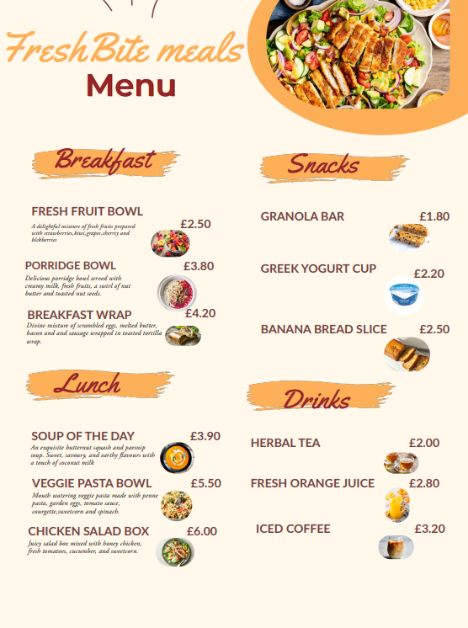

https://www.inspiredtaste.net/54459/peanut-butter-granola-bars/

https://www.rowanglen.com/products/greek-style-natural-yogurt-150g/

https://www.allrecipes.com/recipe/17066/janets-rich-banana-bread/

https://tealeavz.com/blogs/tea-talk/herbal-tea-and-caffeine-free-tea-what-is-the-difference?srsltid=AfmBOoot9tDLT53vj10I9ZnfccumUowCvkeUmbK9hUtztAAiSLM8QWRh

https://www.knowyourproduce.com/homemade-orangeade-recipe-fresh-squeezed-orange-juice/
https://www.olivemagazine.com/drink/how-to-make-iced-coffee/
https://www.onceuponachef.com/recipes/breakfast-burritos.html
https://www.bbcgoodfood.com/recipes/collection/healthy-porridge-recipes
https://www.olivemagazine.com/recipes/collection/best-easy-soup-recipes/
https://thehiddenveggies.com/creamy-veggie-pasta/
https://www.ukposters.co.uk/fresh-fruit-salad-in-the-bowl-f112642319?srsltid=AfmBOopQKp-vwqafAxrzhdEYOaYkYKHFyFeqy4BeWVmrlNNgYfT-sIEi
https://www.epicurious.com/recipes/food/views/grilled-chicken-salad-with-creamy-any-pickle-dressing

