Programme: Certificate of Higher Education Skills for the Workplace (Health and Social Care)
Module: Introduction to Public Health
Module code: LCHS 4008
Lecturer: Vivian Osuchukwu
Assignment Title: Polio: Measurement, Control and Community Impact
Student Name: Cristina Nicoleta Stoiculescu
Student ID: 2519903

Table of Contents
Introduction 3
Main body 4
Approaches used to measure and monitor polio 4
How polio is controlled 6
Consequences for individuals and communities 6
Health and social care support required 7
Conclusion 8
References 9

Introduction
Poliomyelitis, commonly known as polio, is a highly contagious disease, which is caused by poliovirus. It is spread mainly faecal/oral and can invade the nervous system, especially in poorly-elevated areas. Majority do not show symptoms of infection (Bandyopadhyay et al., 2024). Those who do get sick will have a fever, feel tired, headache, will vomit, may have a stiff neck and legs with pain. The symptoms of severe disease are quick onset of muscle weakness, permanent paralysis, difficulty breathing and death. About 1 in 200 infections can lead to permanent paralysis and 5-10% of those who are paralysed can die if the respiratory muscles are affected (World Health Organization, 2025).
The number of cases worldwide has more than 99% since 1988 when there were about 350,000 cases annually. However, on 15 July 2026, the data reported by Global Polio Eradication Initiative (GPEI) indicated 14 cases of wild poliovirus type 1 for 2026, in Afghanistan (11) and in Pakistan (3). This was updated to incorporate 21 cases in Afghanistan and 31 cases in Pakistan in 2025 (GPEI, 2026). No cases of domestically-acquired polio paralysing have been seen in the UK since 1984, but it is possible that vaccine-derived poliovirus (VDPV) could be found in wastewater (NHS, 2026a).
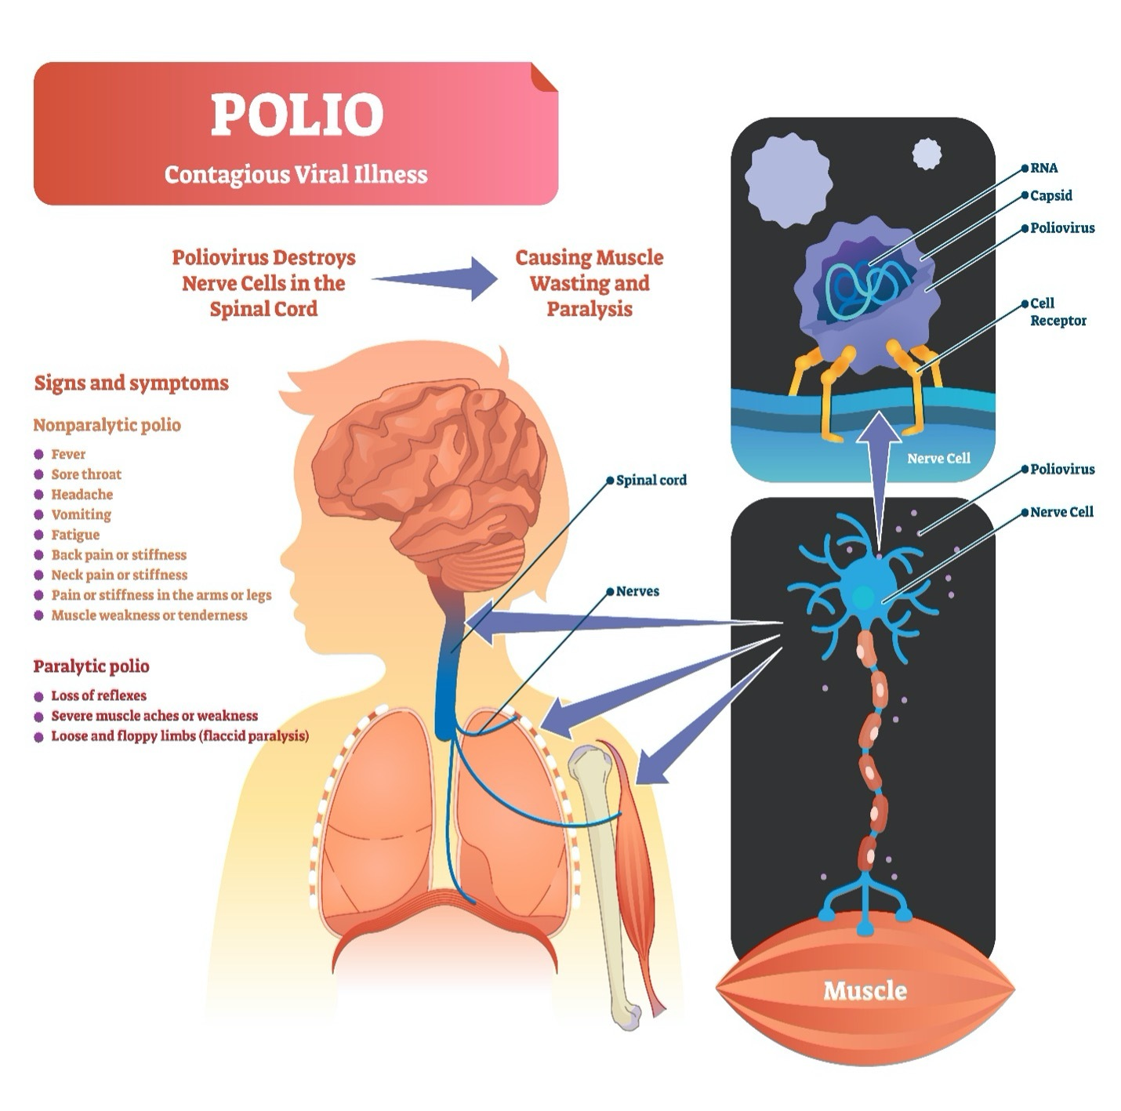
Figure: Post-Polio Syndrome ( National Paralysis Resource Center, 2026)

Main body

Approaches used to measure and monitor polio
Counting diagnosed polio cases is insufficient for surveillance because most are asymptomatic or can transmit polio. International surveillance is the key strategy for acute flaccid paralysis (AFP). All rapid onset of limp weakness in children under 15 years old with suspected poliomyelitis should be referred for investigation by health experts. Two stool samples should be taken 24 hours apart but within 14 days after paralysis. Samples are sent to accredited labs for virus isolation, molecular testing, and genomic sequencing to determine wild-type, vaccine-type, or vaccine-like virus and connect detections. AFP rates, investigation time, and specimen quality indicate surveillance sensitivity (GPEI, 2025).
A good alternative environmental-monitoring tool is available. Routine sewage testing can actually identify virus shed by people who do not have symptoms, enabling public health measures to be taken before symptoms of paralysis become apparent. During the 2022 London incident, sewage samples revealed 118 genetically related type 2 isolates from 21/52 samples. Sequencing was utilized to find community transmission and identify targeted boroughs for the next outreach of expanded surveillance and vaccination (Klapsa et al., 2022). Following this, there have been further vdPV2 cases in November and December of 2024 in London, Leeds and West Sussex. No sites were observed on any of the monitoring approaches by 23rd January 2025 (UKHSA, 2025a). However, the sewage testing does not actually provide any indication of the severity of an individual's illness or the ill individual.
Statutory notification, enterovirus surveillance and sampling of contacts, immunodeficiency surveillance, and vaccine coverage surveillance, can also be used for outbreak investigation. Polio should be notified in England and Wales if it is suspected, there is a UK Health Security Agency process to help with rapid referral to specialist laboratories. The COVER programme, Child Health Information Systems and GP data are used to obtain vaccine uptake. This is below the public-health target of 95%, with 90.5% of children in England having completed the primary 6-in-1 course at 12 months between 1 October 2025 and 1 December 2025. There was a stark difference in children covered in the least deprived 30 upper tier local authorities (UTLAs) compared to the most deprived 30 UTLAs (92.9% to 86.2%), which demonstrates how monitoring coverage can be used to identify vulnerable communities (UKHSA, 2025b; UKHSA, 2026a).
Use them together for optimal results. AFP detects disease, but not silent cases; sewage detects circulation, but not infection; vaccination records detect immunisation gaps. Genomic sequencing can link these evidences to the same transmission chain. Serological surveys estimate immunity but are expensive and don't represent current transmission. Low counts should be interpreted with caution because one paralysis case may indicate several undiagnosed infections. Thus, surveillance quality, geographical reach, and reporting time are as important as confirmed instances (GPEI, 2025).

How polio is controlled
Vaccination (there is no curative antiviral treatment) is central control measure. IPV (inactivated poliovirus vaccine) is a very good immunizing vaccine and cannot cause vaccine-type infection. Oral poliovirus vaccine (OPV) offers greater intestinal immunity; is easily administered during mass campaigns and is significant if transmission is ongoing. However, its weakened virus can be spread and undergo genetic change in the non-immunised population. It does not therefore mean that the community immunity is so low that it is time to stop vaccination when circulating vaccine derived poliovirus is detected in the community. Supplementary campaigns are based on timely and high coverage with campaigns to combat outbreaks, and with the rising incidence of novel oral polio vaccine type 2 with routine immunisation an alternative vaccine strategy might be required (GPEI, n.d.).
IPV is routinely used in the UK schedule. Polio is a vaccine that is given to children at 8, 12 and 16 weeks and at 18 months, 3 years and 4 months and again when they are around 14 years (NHS, 2026a). Records should be examined, and recall notices issued; catch up doses delivered and culturally appropriate and translated information given. After the wastewater detections in London in 2022 there was a targeted IPV booster campaign for children between 1 and 9 years. Vaccination programmes are effective when it is easy to make the appointment; when trusted advice is given and services are designed to overcome deprivation related uptake gaps and not to blame parents. (Uwishema et al., 2024).
Safe water, safe sanitation, hand washing, quick AFP investigation and infection-control measures and risk communication are other controls. Visitors to impacted nations ought to make sure that they have all of their vaccinations completed. The Poliovirus needs to be properly quarantined in facilities and laboratories where polio vaccine is made. Importation can also happen when transmission is occurring anywhere, and so the UK needs to have surveillance in place at all times where clinical incidence is zero. Public-health teams need to have an outbreak plan, stocks of vaccines, to be clinically vigilant and have good communication (UKHSA, 2025c).

Consequences for individuals and communities
Acute polio can cause irreversible paralysis, deformity, limited movement, breathing and swallowing problems, and respiratory failure. Child needs long-term hospitalisation, surgery, orthotics, mobility aids, and rehabilitation. Caregiving and appointments may disrupt learning and cost families money. When schools or buildings are inaccessible or stigmatised, disability can have a greater impact than the disability itself. Emergency immunisations, testing, and community staff mobilisation cost money (Hill et al, 2022).
Many UK residents afflicted decades ago are still alive and suffering from late symptoms of the virus. UKHSA predicts that 120,000 former polio patients may develop post-polio syndrome, with up to 80% at risk. New-onset muscle weakness, excessive weariness, decreased stamina, muscle soreness, muscle atrophy, cold sensitivity, and breathing, sleeping, and swallowing problems are symptoms (UKHSA, 2026b). These concerns can change and diminish independence and engagement in education, career, family, and community life. Unrecognised symptoms can lead to anxiety, depression, and isolation.
But the ‘ripple effect' is not equal. Poverty, shattered healthcare networks, war, migration, inadequate sanitation, misinformation and challenges of accessibility to vaccines are conducive to the transmission of disease and delay care. Lower vaccine coverage in deprived regions of the UK emphasizes that deprived social circumstances continue to play a part in vaccine protection. Community responses should encompass transport, appointment times, language, trust and availability of primary care, and disease control provision and health equity (Singanayagam et al., 2023).

Health and social care support required
All cases of suspected acute polio warrant prompt assessment in the hospital and infectious-disease assessment; notification to public-health teams and specialist laboratory testing. Treatment is supportive, such as positioning, nutrition, preventing complications, rehabilitations and respiratory and pain supports. Early planning for discharge should be started and include person & family (UKHSA, 2026b).
Multidisciplinary, goal-oriented support is needed for paralysis and post-polio syndrome patients. GPs may refer patients to neurology or rehab medicine. To avoid overuse fatigue, physiotherapists should measure strength, mobility, and fall risk and propose gradual, controlled activity. Occupational therapists can analyse home, school, and work environments and teach energy conservation. Orthotists, wheelchair services, and podiatrists provide braces, seats, and mobility assistance. Speech and language therapists, dietitians, and respiratory specialists help patients swallow and eat, treat sleep disordered breathing, and cough. For chronic pain, anxiety, adjustment, and isolation, psychological help is available (Lang et al., 2020).
The NHS national clinical guideline for rehabilitation for chronic neurological disorders includes post polio syndrome and emphasises assessing, coordinating, reviewing, and having a single point of contact (NICE, 2025). Social workers should consider personal care, respite, direct payments, housing adjustments, and carer support. Schools and organisations often need to make reasonable adaptations to accessible transportation and flexible schedules. The British Polio Fellowship, a voluntary organisation, may inform, assist, and advocate for survivors, their families, and NHS personnel (NHS, 2026b). NHS, local government, and community services collaborate.

Conclusion
As with polio, public-health initiatives must continue even when incidence is low. Worldwide immunisation has reduced wild poliovirus by almost 99 percent, and the UK has not had a domestic polio case since 1984. Cases still occur in Afghanistan and Pakistan, and vaccine-derived outbreaks and UK wastewater detection suggest importation and quiet transmission. Measurements should include AFP reporting, rapid lab diagnosis, genomic sequencing, sewage monitoring, and vaccine coverage. Complete routine immunisation, targeted catch-up efforts, cleanliness, outbreak preparedness, and community participation are vital to control.
The effects can be lifelong, including paralysis, weariness, pain, respiratory problems, loss of independence, and social isolation. Thus, community services must include infectious disease management, person-centered long-term rehabilitation, and social services. Polio survivors must receive coordinated services and high and equitable immunisation coverage to protect their health and prevent new cases.

References
Bandyopadhyay, A.S., Cavestany, R.L., Blake, I.M., Macklin, G., Cooper, L., Grassly, N., dos Santos Nery, A.L.M. and Mach, O. (2024) Use of inactivated poliovirus vaccine for poliovirus outbreak response. The Lancet Infectious Diseases, 24(5), pp.e328-e342. https://www.thelancet.com/journals/laninf/article/PIIS1473-3099(23)00505-4/abstract
Global Polio Eradication Initiative (GPEI) (2025) Global Polio Surveillance Action Plan 2025–2026. Geneva: World Health Organization. Available at: https://polioeradication.org/wp-content/uploads/2025/01/Global-Polio-Surveillance-Action-Plan-2025-2026.pdf (Accessed: 18 July 2026).
Global Polio Eradication Initiative (GPEI) (2026) Polio this week. Available at: https://polioeradication.org/about-polio/polio-this-week/ (Accessed: 18 July 2026).
Global Polio Eradication Initiative (GPEI) (n.d.) Vaccine-derived polioviruses. Available at: https://polioeradication.org/about-polio/the-virus/vaccine-derived-polioviruses/ (Accessed: 18 July 2026).
Hill, M., Bandyopadhyay, A.S. and Pollard, A.J. (2022) Emergence of vaccine-derived poliovirus in high-income settings in the absence of oral polio vaccine use. The Lancet, 400(10354), pp.713-715. https://www.thelancet.com/journals/lancet/article/PIIS0140-6736(22)01582-3/abstract
Klapsa, D., Wilton, T., Zealand, A., Bujaki, E., Saxentoff, E., Troman, C., Shaw, A.G., Tedcastle, A., Majumdar, M., Mate, R., Akello, J.O., Huseynov, S., Zeb, A., Zambon, M., Bell, A., Hagan, J., Wade, M.J., Ramsay, M., Grassly, N.C., Saliba, V. and Martin, J. (2022) ‘Sustained detection of type 2 poliovirus in London sewage between February and July 2022 by enhanced environmental surveillance’, The Lancet, 400(10362), pp. 1531–1538. Available at: https://doi.org/10.1016/S0140-6736(22)01804-9 (Accessed: 18 July 2026).
Lang, S., Loving, S., McCarthy, N.D., Ramsay, M.E., Salisbury, D. and Pollard, A.J. (2020) Two centuries of immunisation in the UK (part II). Archives of disease in childhood, 105(3), pp.216-222. https://adc.bmj.com/content/105/3/216.abstract
National Health Service (NHS) (2026a) Polio. Available at: https://www.nhs.uk/conditions/polio/ (Accessed: 18 July 2026).
National Health Service (NHS) (2026b) The British Polio Fellowship. Available at: https://www.nhs.uk/services/service-directory/the-british-polio-fellowship/N10498815 (Accessed: 18 July 2026).
National Institute for Health and Care Excellence (NICE) (2025) Rehabilitation for chronic neurological disorders including acquired brain injury: NICE guideline NG252. Available at: https://www.nice.org.uk/guidance/ng252 (Accessed: 18 July 2026).
National Paralysis Resource Center. (2026). Post-Polio syndrome | living with paralysis | reeve foundation [Review of Post-Polio syndrome | living with paralysis | reeve foundation]. Christopher & Dana Reeve Foundation. https://www.christopherreeve.org/todays-care/living-with-paralysis/health/causes-of-paralysis/post-polio-syndrome-poliomyelitis/
NHS 111 Wales (n.d.) Post-polio syndrome. Available at: https://111.wales.nhs.uk/Postpoliosyndrome/ (Accessed: 18 July 2026).
Singanayagam, A., Klapsa, D., Burton-Fanning, S., Hand, J., Wilton, T., Stephens, L., Mate, R., Shillitoe, B., Celma, C., Slatter, M. and Flood, T. (2023) Asymptomatic immunodeficiency-associated vaccine-derived poliovirus infections in two UK children. Nature Communications, 14(1), p.3413. https://www.nature.com/articles/s41467-023-39094-0
UK Health Security Agency (UKHSA) (2025a) Poliovirus detected in routine sewage surveillance from Leeds, London and West Sussex: An update. Available at: https://www.gov.uk/government/publications/health-protection-report-volume-19-2025/hpr-volume-18-issue-1-news-23-january-2025 (Accessed: 18 July 2026).
UK Health Security Agency (UKHSA) (2025b) 6-in-1 vaccine coverage by year: Metrics documentation. Available at: https://ukhsa-dashboard.data.gov.uk/metrics-documentation/6-in-1-coverage-by-year (Accessed: 18 July 2026).
UK Health Security Agency (UKHSA) (2025c) Polio: Guidance, vaccination, data and analysis. Available at: https://www.gov.uk/government/collections/polio-guidance-data-and-analysis (Accessed: 18 July 2026).
UK Health Security Agency (UKHSA) (2026a) Quarterly vaccination coverage statistics for children aged up to five years in the UK: October to December 2025. Available at: https://www.gov.uk/government/statistics/cover-of-vaccination-evaluated-rapidly-cover-programme-2025-to-2026-quarterly-data/quarterly-vaccination-coverage-statistics-for-children-aged-up-to-5-years-in-the-uk-cover-programme-october-to-december-2025 (Accessed: 18 July 2026).
UK Health Security Agency (UKHSA) (2026b) Poliomyelitis and post-polio syndrome: Migrant health guide. Available at: https://www.gov.uk/guidance/poliomyelitis-and-post-polio-syndrome-migrant-health-guide (Accessed: 18 July 2026).
Uwishema, O., Eneh, S.C., El Jurdi, E., Olanrewaju, O.F., Abbass, Z., Jolayemi, M.M., Mina, N., Kseiry, L., Adanur, I., Onyeaka, H. and Wellington FGMS, J. (2022) Poliovirus returns to the UK after nearly 40 years: current efforts and future recommendations. Postgraduate medical journal, 98(1165), pp.816-819. https://academic.oup.com/pmj/article-abstract/98/1165/816/7097163
World Health Organization (WHO) (2025) Poliomyelitis. Available at: https://www.who.int/news-room/fact-sheets/detail/poliomyelitis (Accessed: 18 July 2026).

