Design & implementation of a relational database system
Introduction to Web & Database Concepts (ACCA4023)

Table of Contents
Task 1 – Scenario Analysis 2
Overview 2
Main Entities + Their Attributes & Relationships 2
Summary of Relationships (Cardinality) 5
2. Entity-Relationship Diagram (ERD) 6
3. Data Structure Development 7
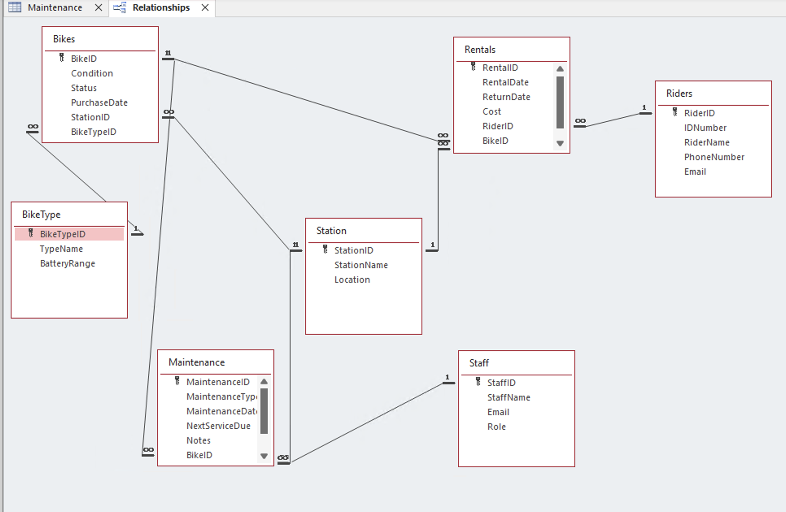 7
Task 4 – Normalization Compliance 8
Task 5 – Sample Data Population 10
Task 6 – Query Development 11
Query 1 – Bikes currently on Rental 11
Query 2 – Bikes available at each station 11
Query 3 – Most frequently used bikes 12
Query 4 – Rentals by a particular rider 12
Query 5 – Maintenance records for a specific bike 13
Task 7 - Evaluation & Validation and Testing 14
Entity Selection 14
Database Structure and Relationships 14
Normalisation 15
Summary of System Implementation 15
Summary of Validation and Testing 15
Evaluating Progress and Future Advancements 16
Issues Encountered 16
Proposed Future Upgrades 16
Bibliography 17

Task 1 – Scenario Analysis

Overview
Eco_Ride is an electric bike rental scheme operating across multiple public locations like parks, train stations, and university campuses. Riders scan an ID to rent a bike from one station and can return it to any other station. Due to the current reliance on manual records, accurate tracking of riders, bikes, rentals, maintenance, and staff activity has become challenging. This scenario forms the basis for designing a structured database system to support efficient operation and analysis of the service.

Main Entities + Their Attributes & Relationships
1) Rider
People who are registered to use Eco_Ride bikes.
Key attributes:
- RiderID (PK) – unique system identifier
- FullName
- Email
- PhoneNumber
- IDNumber (Unique) – scanned ID used at rental points
- DateRegistered
- Status (e.g., Active/Suspended)
Relationships:
- A Rider can make many Rentals (1 to many)

2) Station (Rental Point / Location)
Public locations where bikes can be collected or returned (parks, train stations, campuses).
Key attributes:
- StationID (PK)
- StationName
- LocationDescription / Address
- (Optional) Latitude, Longitude
- ActiveFlag
Relationships:
- A Station can hold many Bikes (1 to many)
A Station can be used in many Rentals as a pickup and/or drop-off location (1 to many)

3) Bike
Each physical electric bike owned by Eco_Ride.
Key attributes:
- BikeID (PK)
- SerialNumber (Unique)
- BikeTypeID (FK)
- CurrentStationID (FK)
- Status (Available / In Use / Maintenance / Retired / Lost)
- ConditionScore (e.g., 1–5)
- PurchasedDate
Relationships:
- A Bike can be involved in many Rentals over time (1 to many)
- A Bike can have many Maintenance records (1 to many)
- Each Bike is currently assigned to one Station (many bikes to one station)

4) BikeType
Defines categories/specifications of bikes (e.g., commuter, cargo). This avoids repeating the same type details for every bike.
Key attributes:
- BikeTypeID (PK)
- TypeName
- BatteryRange / Notes (optional)
Relationships:
- A BikeType can apply to many Bikes (1 to many)

5) Rental (Rental Transaction)
Records each instance of a rider renting a bike, including times, stations, and cost.
Key attributes:
- RentalID (PK)
- RiderID (FK)
- BikeID (FK)
- PickupStationID (FK)
- DropoffStationID (FK, nullable until returned)
- RentDateTime
- ReturnDateTime (nullable if not returned yet)
- Cost
- PaymentStatus
Relationships:
- Each Rental belongs to one Rider (many rentals to one rider)
- Each Rental involves one Bike (many rentals to one bike)
- Each Rental has one pickup Station and one drop-off Station (many rentals to one station)
- Business rule identified from the scenario:
- A bike must not have more than one active (unreturned) rental at the same time (prevents double-booking)

6) Staff
Employees responsible for servicing and inspecting bikes.
Key attributes:
- StaffID (PK)
- FullName
- Email
- PhoneNumber
- Role (Technician/Inspector/etc.)
- ActiveFlag
Relationships:
- A Staff member can complete many Maintenance logs (1 to many)

7) MaintenanceLog (Service / Inspection Record)
Records maintenance and inspections for bikes, including what was done and which staff member performed it.
Key attributes:
- MaintenanceID (PK)
- BikeID (FK)
- StaffID (FK)
- StationID (FK) (where the work happened)
- LogType (Inspection/Repair/Service/etc.)
- ReportedAt
- WorkStartedAt, WorkEndedAt
- ActionTaken / Notes
- ConditionBefore, ConditionAfter
- NextServiceDueDate
Relationships:
- A Bike can have many MaintenanceLogs (1 to many)
- A Staff member can create many MaintenanceLogs (1 to many)
- A Station can be associated with many MaintenanceLogs (1 to many)

Summary of Relationships (Cardinality)
- Rider 1 → many Rental
- Bike 1 → many Rental
- Station 1 → many Bike
- Station 1 → many Rental (Pickup)
- Station 1 → many Rental (Drop-off)
- BikeType 1 → many Bike
- Bike 1 → many MaintenanceLog
- Staff 1 → many MaintenanceLog
- Station 1 → many MaintenanceLog

Task 2 - Entity-Relationship Diagram (ERD)
This is the Entity-Relationship Diagram created for the Eco_Ride database which shows entities, keys and relationships with appropriate cardinality.
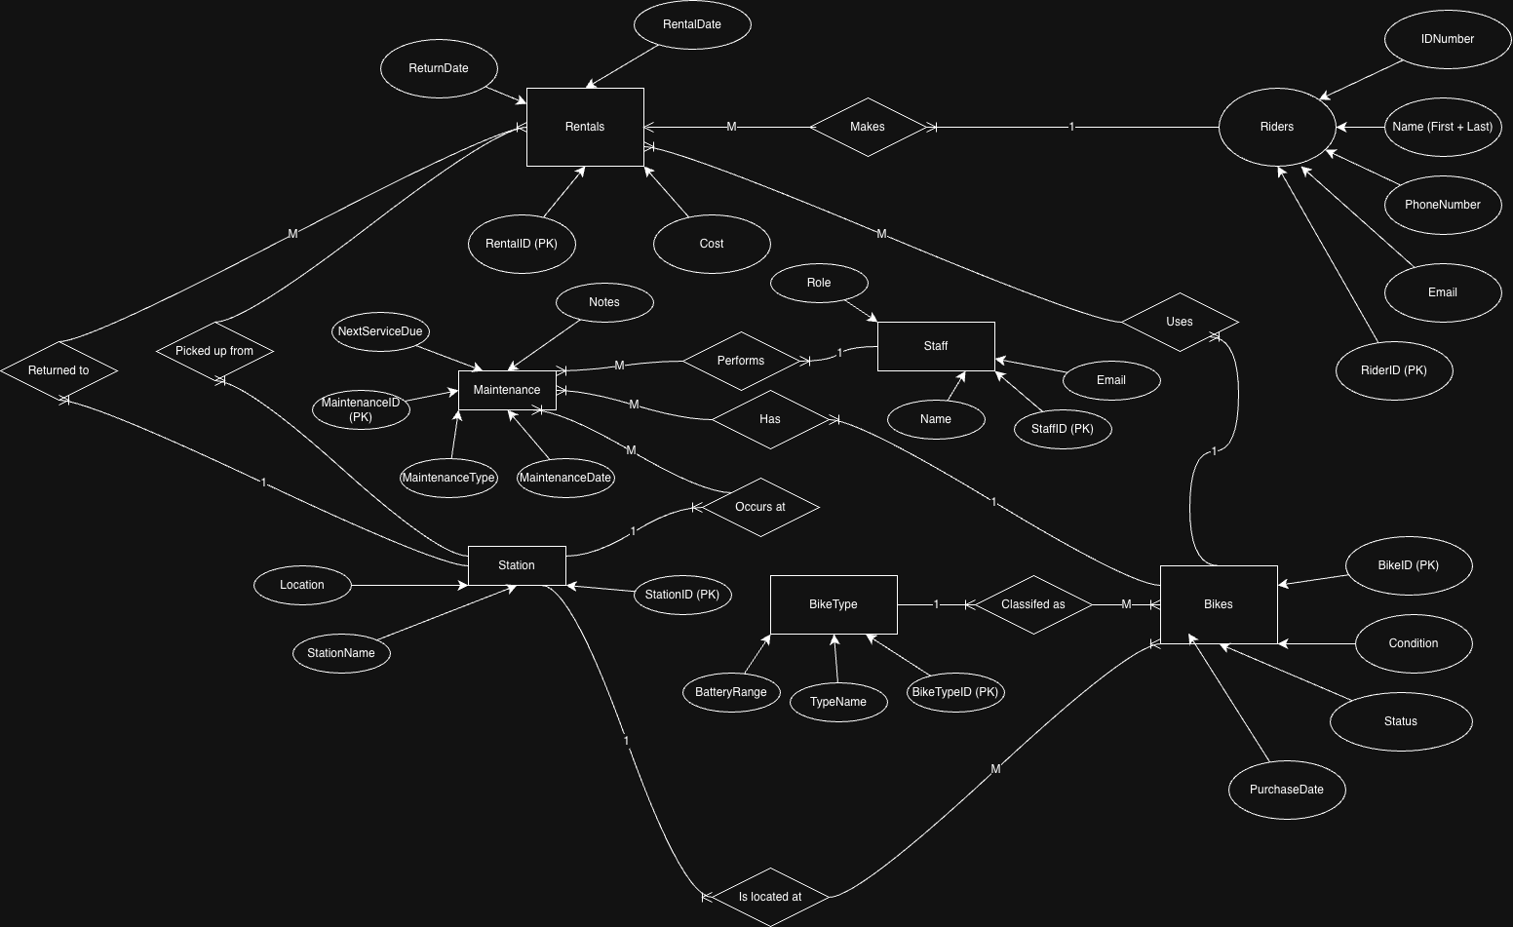

Task 3 - Data Structure Development
The database tables were added in Microsoft Access based on the ERD. Primary keys, foreign keys and referential integrity limitations were added to ensure data integrity.

Task 4 – Normalization Compliance
The design of the Eco_Ride system database has been normalized up to Third Normal Form. (3NF)
First Normal Form (1NF) is completed since there are atomic attributes in all tables and there are no repeating groups. There is a clearly specified primary key for each entity and attributes like the rental period are not stored in the database.
Second Normal Form (2NF) is done since every table in this database has a single-attribute primary key, this rule is automatically satisfied. Therefore, there are no cases of partial dependency and every non-key attribute depends solely on its respective table’s primary key.
Third Normal Form (3NF) is achieved through the elimination of transitive dependencies by the use of multiple entities. This is because details about bike types are stored in the BikeType table rather than in the Bike table itself. Similarly, details about the location of stations are stored in the Station table. Maintenance details are also stored in the Maintenance table. This is because in 3NF, non-key attributes are dependent only on the primary key.

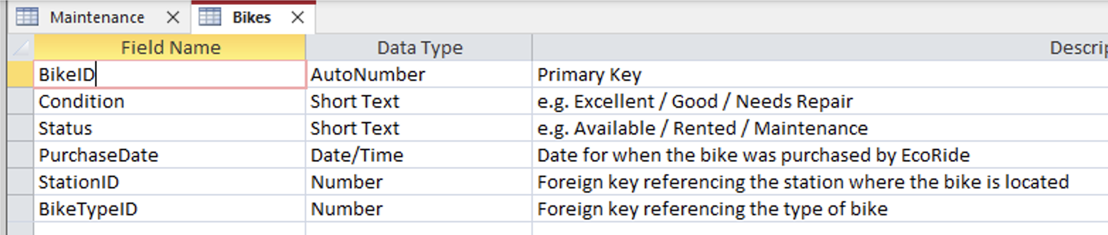
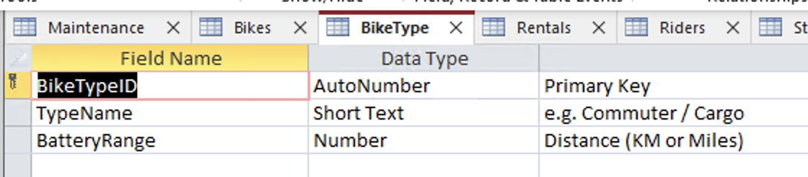
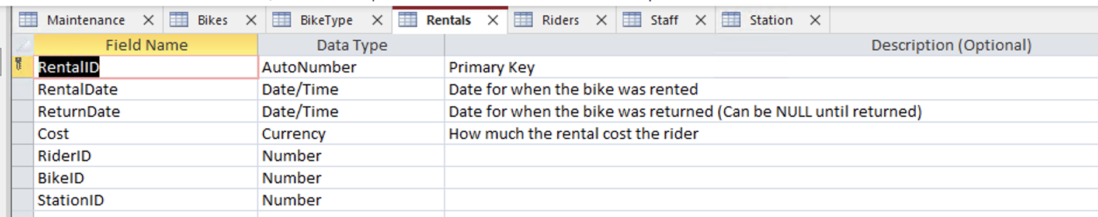
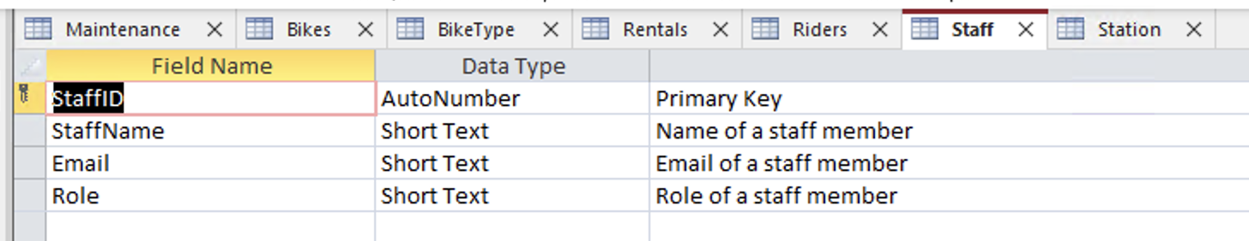
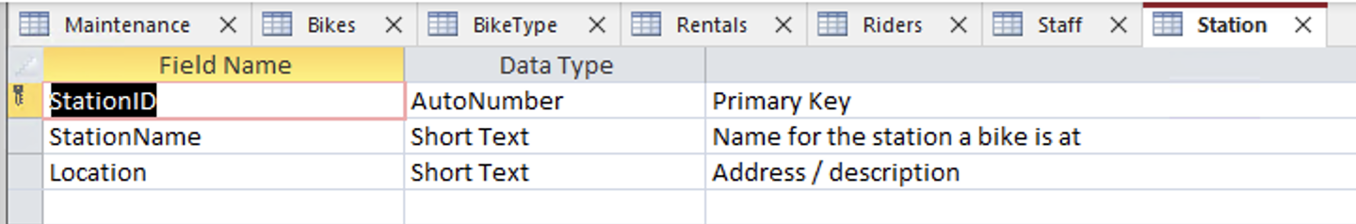
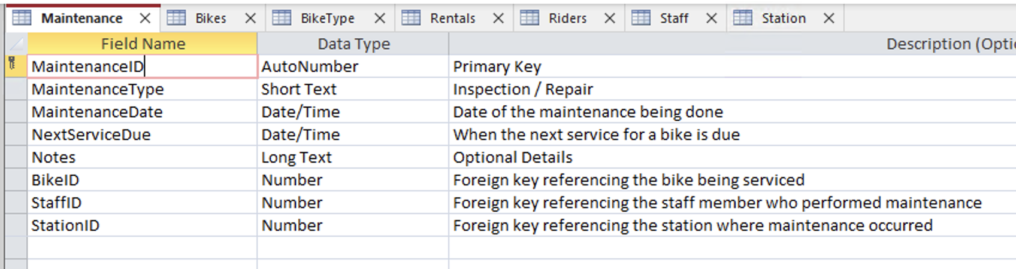
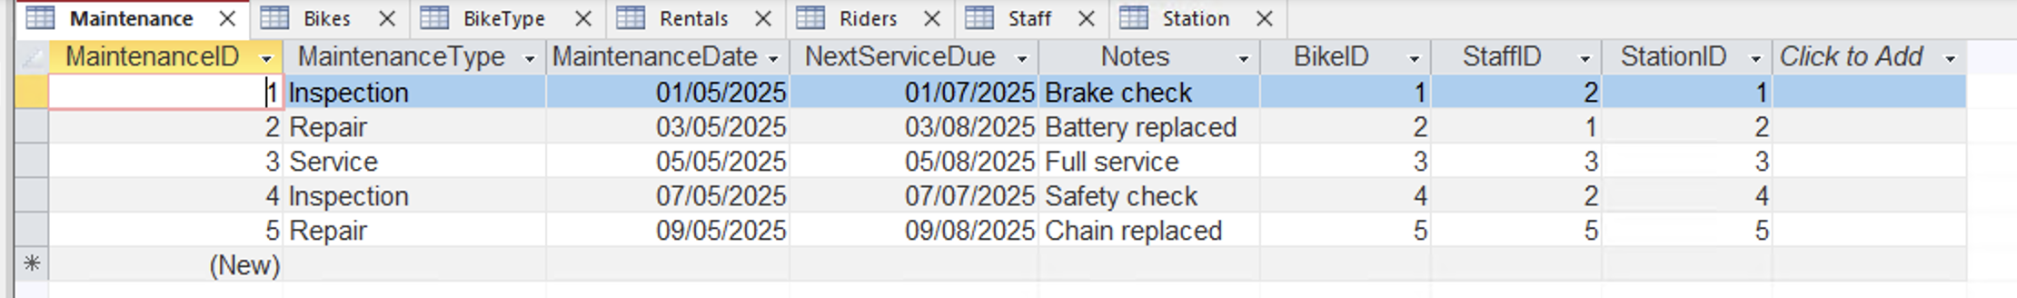

Task 5 – Sample Data Population
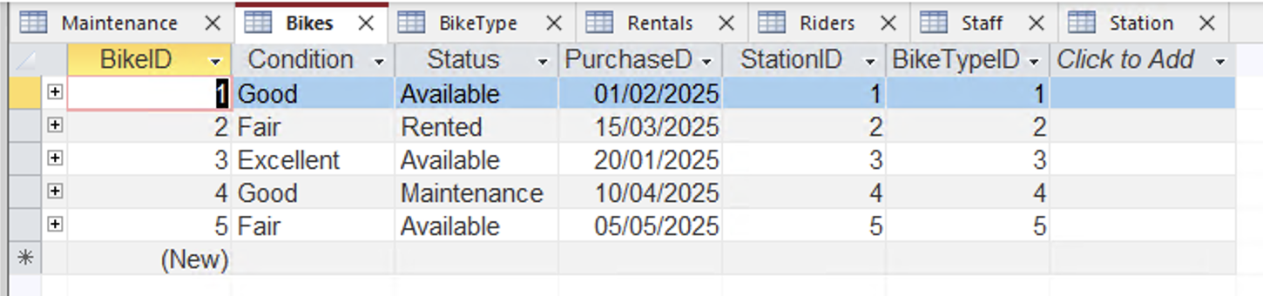
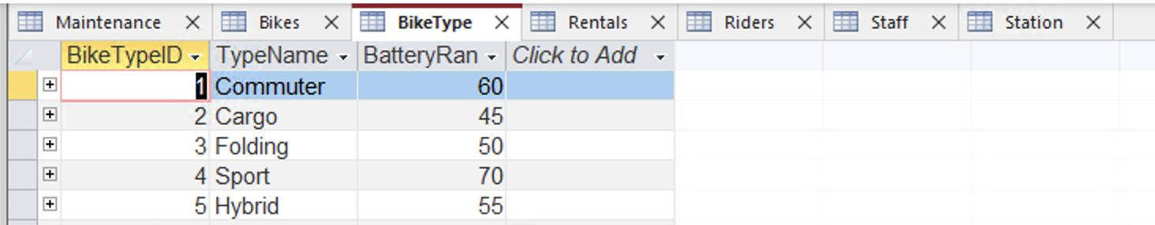
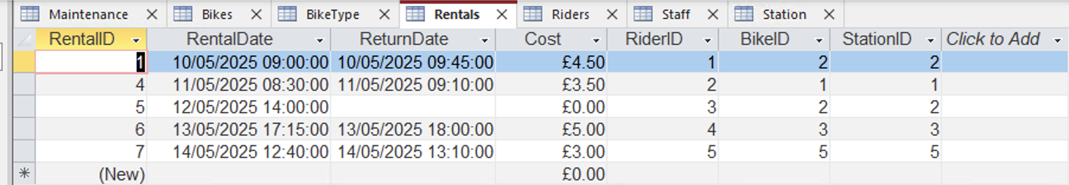
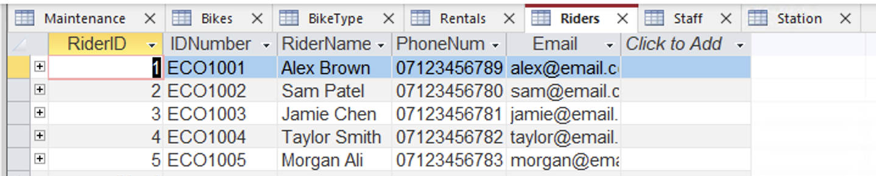
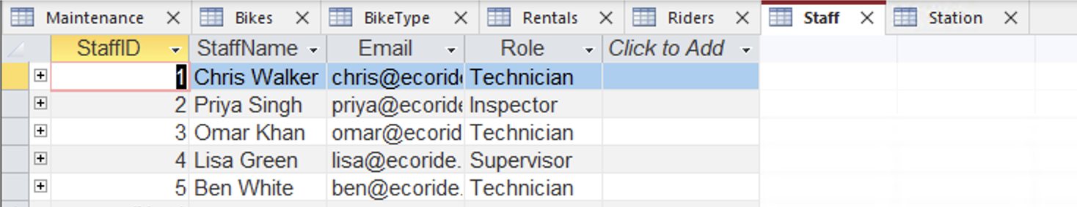
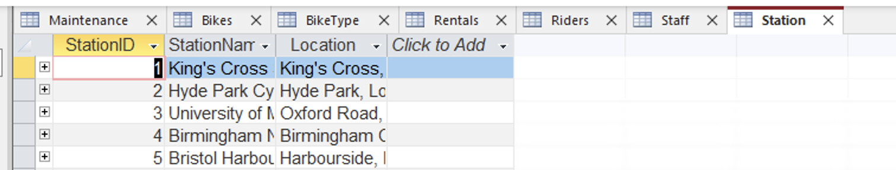

Task 6 – Query Development

Query 1 – Bikes currently on Rental
This query finds all bikes that are currently rented out and have not yet been returned and allows staff to quickly see which bikes are in use and helps prevent issues like double-booking or unreturned bikes.
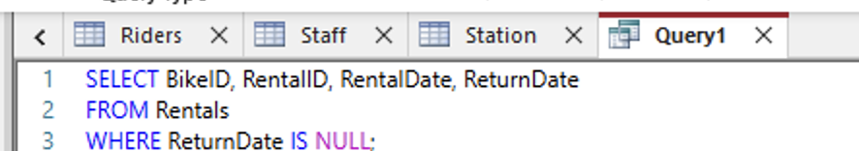
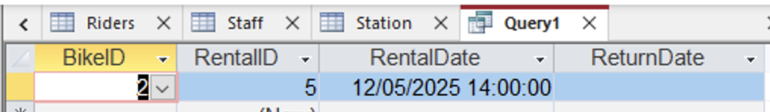

Query 2 – Bikes available at each station
This query displays the number of available bikes at each Eco Ride station and helps the staff see where bikes are currently available and where rebalancing may be needed.
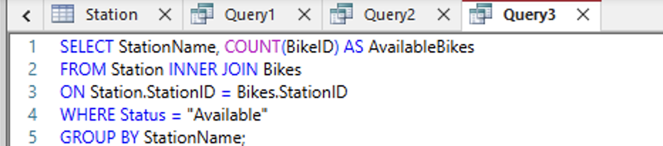
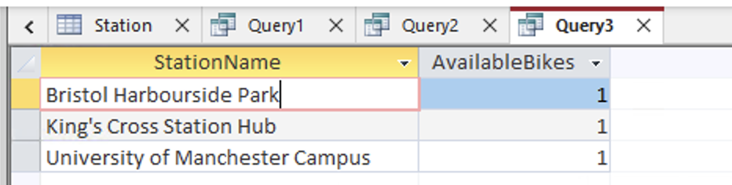

Query 3 – Most frequently used bikes
This query calculates how many times each bike has been rented and helps find the most frequently used bikes which can help with maintenance scheduling and replacing bikes in the future.
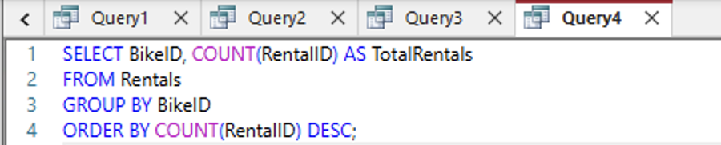
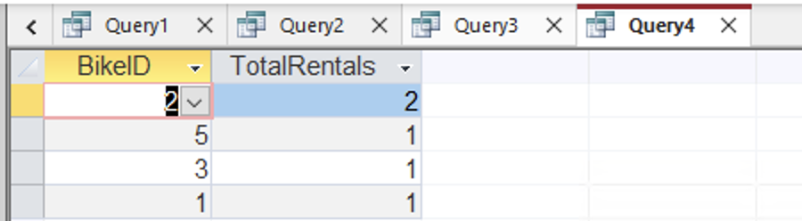

Query 4 – Rentals by a particular rider
This query grabs the rental history of a specific ride using their ID number and allows the system to review individual user activity which will help customer service and usage analysis.
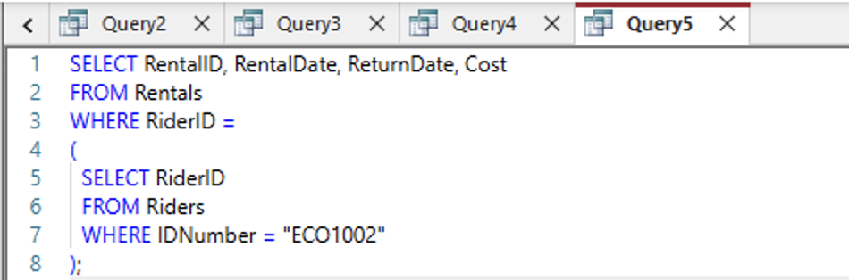
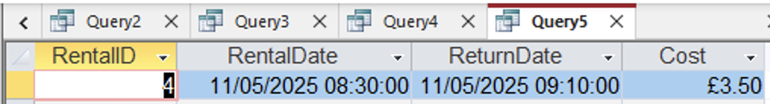

Query 5 – Maintenance records for a specific bike
This query lists all maintenance records associated with a specific bike and gives a clear maintenance history, allowing staff to track servicing, inspectors and see if a bike may need attention.
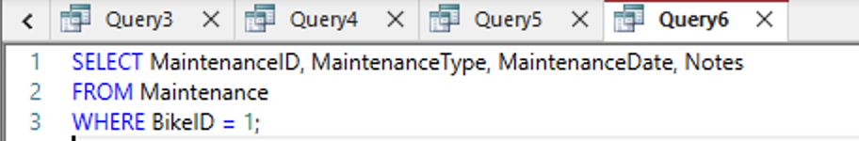
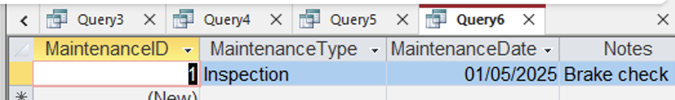

Task 7 - Evaluation & Validation and Testing

Entity Selection
The entities that were determined based on the recommendations included:
- Riders
- Bikes
- Rentals
- Staff
- Maintenance
Because the entities represent actual components of Eco_Ride and how their business operates (workflow), they have been used to create a database structure that will support these operational work processes, thereby providing better usability. [1]

Database Structure and Relationships
The foundation of the database model was built on the relational database model because of the ability of relational databases to enforce strong data integrity through primary and foreign key constraints when used. Relational database systems also offer structure for storing data, maintain the accuracy of information by providing consistent transactions, and are therefore well-suited to be used as an operational information system for time sharing rental platforms. [2]
Relationships between entities were designed as follows:
One rider → Many Rentals
One bike → Many Rentals
One bike → Many Maintenance Records
One staff member → Many Maintenance Records
The accuracy of tracking rentals, bike use and service history allows for improved operational management and more effective strategic decision making.

Normalisation
To remove redundancy and to prevent insertion, update, and deletion anomalies, the database was normalised to Third Normal Form (3NF). Normalisation ensures that each data item is stored only once, and that all non-key attributes only depend on the primary key and nothing else, improving the reliability of the data. [3]
The tables in the system contain data that is directly related to the entity contained in that table. By following this structure, transitive dependencies have been removed, and duplication of data has been reduced. This structure allows the most efficient use of storage space, and makes maintenance easier and more efficient, consistent with the principles of relational database design. [2] [4]

Summary of System Implementation
The implementation of the system is using structured SQL tables with enforced data integrity through imposed constraints. The key elements of functionality include:
- Secure rider registration
- Accurate tracking of bikes' condition and location.
- Complete logging of all rental transactions.
- All recorded maintenance histories associated with maintenance staff.
Example data has been inserted to create realistic scenarios based on expected usage of the system, and SQL queries were created to support:
- Monitoring the availability of bikes
- Identifying bikes requiring scheduled maintenance services
- Analyzing rider activity
- Monitoring workload on maintenance staff.
In this manner, the system will provide the necessary data to manage the daily activities and report on management's effectiveness.

Summary of Validation and Testing
Validation of the system was accomplished through functional testing methods for all requirements of the system through realistic use cases.
The validation of the following items was confirmed by the results of testing.
- Accurate storage of both rider and bike information.
- Accurate rider-to-bike connection when a rider rents a bike.
- Accurate recording of maintenance history associated with maintenance staff.
- Accurate operational data returned from query results.
Foreign key constraints have been validated and confirmed to prevent any entry of invalid data and ensure reliability and consistency of data in the system.
In summary, the results of testing confirm that the system meets all functional requirements and meets the operational needs of Eco_Ride.

Evaluating Progress and Future Advancements

Issues Encountered
The project’s biggest challenge occurred while creating relationships that accurately characterise the behaviour of physical entities in a normalised database environment, ensuring that the database structure remains as cleanly defined as possible, while minimally affecting performance.
The biggest challenge was to meet the needs for simplicity versus functionality, where the design needed to be simple enough for customers to view it in a meaningful way. Conversely, the design needs to also provide customers with advanced functionality including service usability and tracking functionality.

Proposed Future Upgrades
Many features will be considered for inclusion in the next version of this application.
- Implementing database triggers to generate automated updates to the availability of bikes
- Creating a user authentication system to restrict access to staff working within a given company
- Providing real-time dashboard reporting of bike usage through Business Intelligence Tools
- Integrating Mobile Applications and QR Scanning Systems
- Predictive maintenance analytics through analysing past service data.
All future enhancements will enhance customer satisfaction and increase both efficiency and scalability.

Bibliography
[1] T. Connolly and C. Begg, Database Systems: A Practical Approach to Design, Implementation and Management, 6th ed. Harlow: Pearson, 2015.
[2] C. J. Date, An Introduction to Database Systems, 8th ed. Boston: Pearson, 2019.
[3] R. Elmasri and S. Navathe, Fundamentals of Database Systems, 7th ed. Harlow: Pearson, 2016.
[4] C. Coronel and S. Morris, Database Systems: Design, Implementation, and Management, 13th ed. Boston: Cengage Learning, 2019.

