Luke Morgan Change makers assessment task 2:
Logo design:


Adverts;

728-90:

320-50:



300-250:

336-280:



300-600:

Mind map:
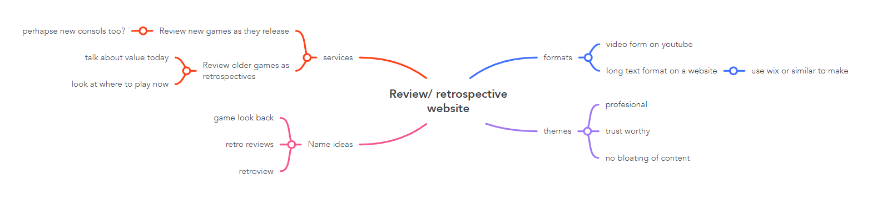
Motion graphic:
https://youtu.be/zuPUL3nIW58

