Module: LCBB4001 - Accounting fundamentals
Assignment title: Essay on accounting fundamentals
Student: Alexandra Lucia Simici
Student ID: 2129707

Table of contents

Introduction.........................................................................................................3
Cost accounting..................................................................................................4
Basic principles of accounting..........................................................................5
Financial statements..........................................................................................7
Conclusion........................................................................................................14
References........................................................................................................15

Introduction

This report is going to discuss the basic principles of accounting, the cost accounting concept and the financial statements at a general glance and for the company Amazon specifically. Amazon.com first entered the US e-commerce retail scene in 1995 under the ownership of Jeff Bezos and, like many others, operates from the comfort of home. As part of its emerging growth strategy, Amazon has expanded at breakneck speed in a decade, penetrating markets in multiple countries, establishing fulfillment centers in the U.S., Europe and Asia to manage the process of product distribution from supplier to consumer.

Cost accounting

Cost accounting is a process that involves collecting, measuring, analyzing, interpreting and reporting cost information for internal and external decision-making purposes. It determines the cost of something through direct measurement, systematic and reasonable or arbitrary attribution (Collier, 2015). Cost accounting is often discussed in the accounting literature as a distinct branch of accounting - however, it is best viewed as a bridge or overlap between financial accounting and managerial accounting, as it addresses the needs of both branches of accounting.
The origins of modern cost accounting can be traced back to the Industrial Revolution. During this time, managers realized that the complexities of managing large operations required developing systems to capture and track costs in order to make better decisions. In the early days of the Industrial Age, variable costs tended to dominate managers' interests. Over time, however, managers began to realize that fixed costs were just as important in decision-making. Today, modern cost accounting is no longer seen as a number - in fact, cost accounting has become an important factor in business decisions.
In theory, accounting is generally divided into three main branches: financial accounting, management accounting and cost accounting. Financial accounting deals with the measurement and recording of business transactions to prepare financial statements for external decision-making, while operational accounting deals with the measurement and reporting of financial and non-financial information for internal decision-making. In contrast, cost accounting informs internal and external decision-making. It provides information for external parties to make investment and credit decisions, and for internal parties to manage and control ongoing operations and plan for the future (Collier, 2015).
Cost accounting is divided into three broad areas: (1) measurement of costs (eg, acquisition cost vs. market value vs. present value, standard vs. actual cost); (2) allocation of costs over accounting periods (eg, accrual accounting vs. Cash Basis Accounting); (3) Mapping costs to cost objectives (eg, determining whether costs should be classified as direct or indirect costs, determining cost pools and their allocation basis). Therefore, cost accounting can be viewed as a part of financial and operational accounting that collects and analyzes cost information.
In the accounting literature, cost accounting principles, procedures, and practices are often discussed in the context of a manufacturing company. However, cost accounting is critical to the efficient operation of all business sectors: large and small, public and private, for-profit and not-for-profit, and manufacturing, trade and service. In today's rapidly changing global environment, reliable and timely cost information is the key to business success. Therefore, companies rely heavily on cost accounting to generate knowledge and wisdom about the company's operations. Cost accounting can inform various types of decisions, such as differences between actual and standard costs, and more.
Regardless of size, industry or trade, all companies need a good cost accounting information system to manage, track and improve their business processes. Many manufacturing companies are still using the traditional costing system - full costing. With this method, all manufacturing costs are included in the product cost. More recently, however, various service, manufacturing, and non-profit organizations have embraced the use of activity-based costing. This method assigns costs to specific activities (eg, manufacturing, engineering) (Baron and Harris, 2003). Other innovative approaches to managing and improving business processes include methods such as Lean Manufacturing, Theory of Constraints, and Six Sigma. Lean manufacturing is based on the logic that production should respond to customer orders and constantly strive for perfection. The theory of constraints is based on the observation that every organization has at least one constraint that should be managed effectively to be successful. Finally, Six Sigma relies on customer feedback and fact-based data collection to drive process improvement (Hall, 2008).
There are many cost accounting methods available to businesses today. However, it is important to note that information provided for financial accounting purposes must be developed in accordance with generally accepted accounting principles (GAAP) (Kinney, Prather-Kinsey and Raiborn, 2006). Conversely, the information provided for management accounting need not conform to generally accepted accounting principles. Regardless, the two main bodies, the Institute of Management Accountants and the Canadian Institute of Management Accountants, publish cost accounting standards. Although these guidelines are neither mandatory nor legally binding, they are still useful in ensuring compliance with high-quality accounting practices. A third body, the Cost Accounting Standards Board, has also developed a set of standards to help ensure consistency and consistency in government procurement. The agency was established by the U.S. Congress in 1970 (Hall, 2008).

Basic principles of accounting

Accounting, post-processing, recycling, sketches, and various reports and information tests, indicating the recording of financial transactions. As well as preparing for the official liquidation of these works, including those with a mission. Accounting Principles The rules and guidelines that companies must follow when reporting financial information. Common accounting principles are (VanDerbeck, 2005):
- demarcation principle
- Conservative principle
- consistency principle
- cost principle
- principle of economic unity
- full disclosure going concern principle
- proper principle
- monetary unit principle.
Accounting software is a computer program that performs accounting functions. The software has now largely replaced the old paper-based accounting system. The software can be packaged or written specifically to meet a company's unique needs. Accounting modules include General Ledger, Accounts Receivable, Accounts Payable, Payroll, Inventory, and Fixed Assets, and integrated accounting software typically ties together many of these modules. Data from one module is transferred to another; for example, updating Accounts Payable automatically updates the General Ledger (Hall, 2008).
The general ledger module is the core of the entire accounting system. Small businesses may find a general ledger engine suitable. The general ledger module typically generates charts of accounts, journals, trial balances, general ledger, and financial statements. The Accounts Receivable module is required when processing a large number of sales transactions. The Accounts Receivable module supports cash flow and credit policies. Accounts receivable from customers are tracked, reconciled, invoiced and due. The Accounts Payable module is only required when issuing a large number of checks. The frequency of the system can be weekly, semi-monthly or monthly, depending on the availability of cash discounts and the number of transactions. Accounts Payable Package issues checks to accounts payable, ensures rebates are received, and prepares for debt aging (Collier, 2015).
Payroll software helps determine payroll and provide necessary payroll data when filing taxes. A good fixed asset package can provide description and classification of assets; asset quantity; cost, life and residual value of property, plant and equipment; consideration of different depreciation methods; prorated depreciation calculation and fixed asset cost center.
Compatibility, efficiency, integration, and cost are all considerations when purchasing accounting software. It's best to get individual modules from one vendor. At the low end, commercial programs can cost around $100. Inexpensive accounting software programs focus on cash flow and profitability that small business owners care about most. Intuit's Quickbooks and Peachtree products are two examples of affordable accounting software for small businesses. They are scalable products that can be updated as the business grows. For companies with less than $10 million in annual revenue and fewer than 100 employees, low-end accounting software can be a good accounting information system solution (Horngren, Datar and Foster, 2003).
As transaction processing needs and complexity increase, mid-range packages may be a better solution. Some examples are Microsoft's Dynamics GP and Sage Software's MAS 90, Everest and Accpac. In these programs, each module costs hundreds of dollars and is usually sold separately. Many international companies operate globally and require software to process transactions in multiple currencies. The software can convert transactions from one currency to another and even write checks in foreign currencies. Another example of a special feature that might be included in high-end accounting software is the ability to distribute commissions among multiple sellers (Hall, 2008).
The number of transactions processed per month is an important factor when choosing between low-end and high-end software. If a business processes only a small number of accounts receivable transactions per day, the low-cost package should handle that processing satisfactorily. Portability is also important: employees may have to re-enter all transaction data each time the software is changed. Cost savings can be significant when software vendors offer programs that can automatically import data into high-end products (Collier, 2015).

Financial statements

Financial statements are records of a company's financial position and activities during a specific period. Financial statements show the financial performance and strength of a company. The three core financial statements are the income statement, the balance sheet, and the cash flow statement. The three reports are linked together to create a three-statement financial model. Financial statement analysis can help analysts assess a company's profitability and liquidity. Financial statements are complex (Garrison, Noreen and Brewer, 2008).

Fig. 1 – Cash flow statement for Amazon
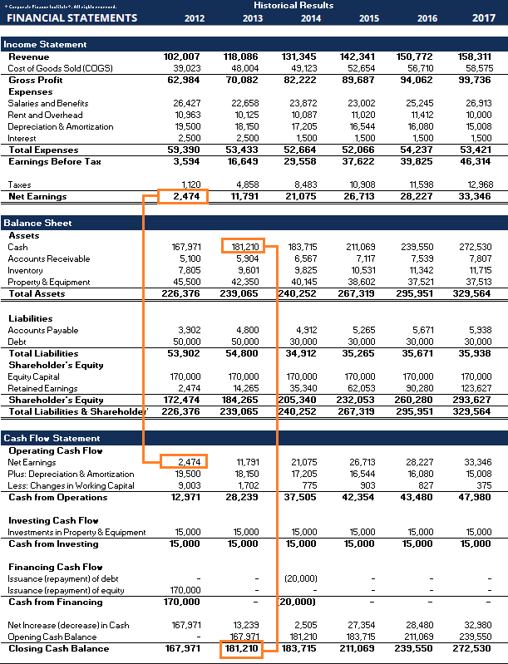

The cash flow statement shows the changes in a company's liquidity during a financial year. The cash flow statement uses the net income figure from the income statement and adjusts it for non-cash expenses. This is done to find out the change in cash from the beginning to the end of the period. Most companies' financial statements begin with an income statement. However, Amazon (NASDAQ: AMZN) begins its financial reporting section in its annual 10-K report with a cash flow statement (Hall, 2008).

Fig. 2 – Annual 10K report for Amazon
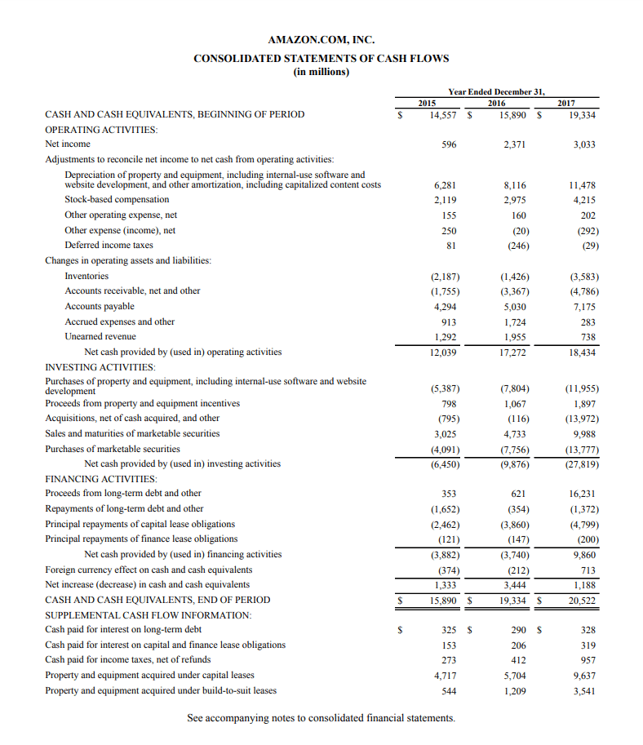
The cash flow statement begins with annual earnings and is adjusted for non-cash expenses, balance sheet changes, and other uses of funds and income. The adjustment is divided into operating activities, investment activities and financing activities (Garrison, Noreen and Brewer, 2008).

Fig. 3 – Operating activities
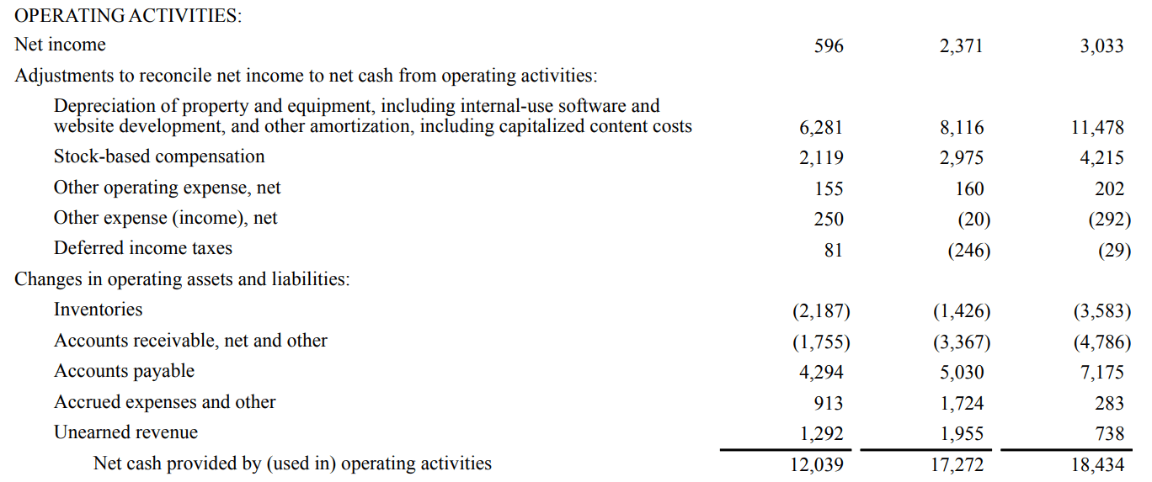

Depreciation of property, plant and equipment (…): A non-cash expense that represents the deterioration of assets such as equipment.
Stock-Based Compensation: An in-kind expense because a company grants employees stock options or other forms of stock-based compensation as part of its compensation and compensation arrangements.
Other operating expenses, net: Non-cash charges primarily related to the amortization of Amazon's intangible assets.
Other Expenses (Income), Net: Non-cash charges related to foreign currency and stock warrant valuations.
Deferred income tax: Temporary difference between book income tax and actual income tax. The amount of tax a company pays may not be the same as the amount of tax it owes.
Changes in business assets and liabilities: Non-cash changes in business assets or liabilities. For example, an increase in accounts receivable is a sales or revenue stream in which actual funds are not received, resulting in a deduction. Conversely, the increase in accounts payable is the proceeds of the purchase or use of unused actual cash, resulting in an increase in net cash (Garrison, Noreen and Brewer, 2008).

Fig. 4 – Investing activities
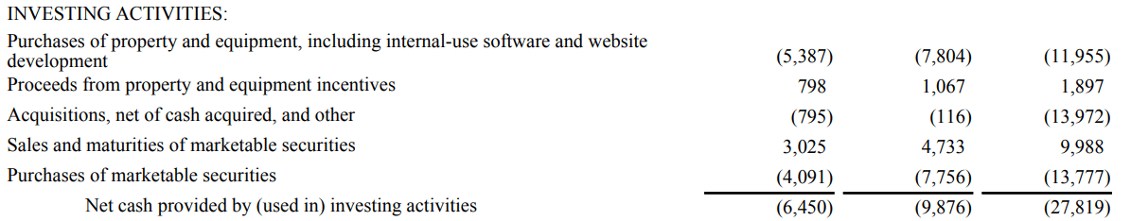

Purchase of tangible assets (…): The purchase of fixed, tangible and tangible assets is with cash. Deducted from net cash.
Real Estate and Equipment Incentive Earnings: This row was added to provide more details on Amazon's real estate and equipment purchases. Incentives received from real estate and equipment sellers were recorded as lower Amazon costs and therefore lower cash burn.
Acquisitions, minus cash received and others: Cash used to acquire other businesses, less cash received from acquisitions. Deducted from net cash.
Sales and Maturity of Marketable Securities: The sale or proceeds of holding marketable securities (short-term financial instruments that mature within one year) to maturity. Supplement to web checkout (Garrison, Noreen and Brewer, 2008).
Buying Marketable Securities: Buying marketable securities. Deducted from net cash.

Fig. 5 – Financing activities
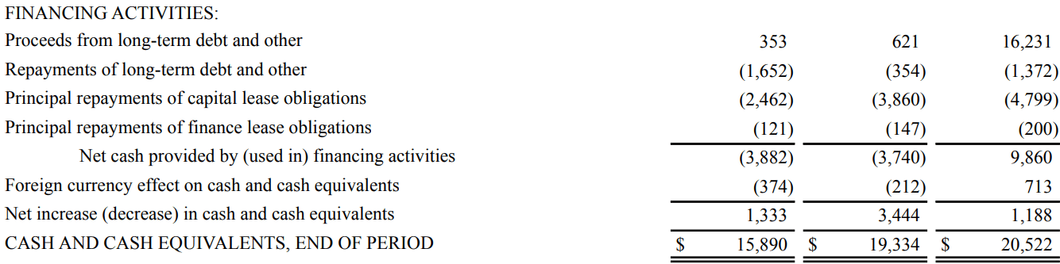

Long-Term Debt and Other Earnings: Cash obtained by raising funds by issuing long-term debt. Supplement to web checkout.
Pay off long-term debt and others: Cash used to pay off long-term debt. Deducted from net cash.
Principal Payments on Capital Lease Obligations: Cash used to repay the principal of capital lease obligations. Deducted from net cash.
Finance lease liability principal payment: cash used to repay the principal of finance lease liability. Deducted from net cash.
Effect of foreign currency on cash and cash equivalents: The effect of exchange rates on cash held in foreign currency.

Fig. 6 – Supplemental cash flow information
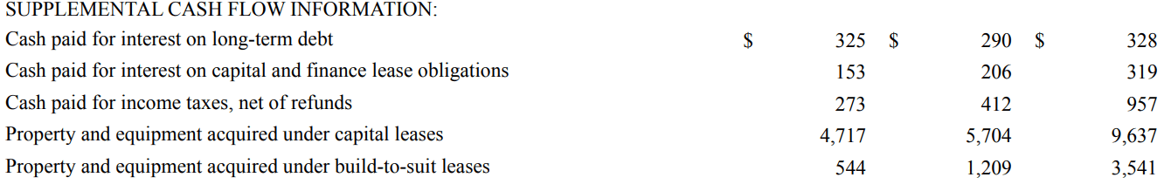
Cash on Long-Term Debt Interest Payments: Use cash to pay accumulated interest on long-term debt.
Cash Payments of Interest on Capital and Finance Lease Obligations: Use cash to pay accrued interest on capital and finance lease obligations. Income tax payment in cash, minus refunds: Use cash to pay income tax.
Property, plant and equipment acquired under finance leases: The value of property, plant and equipment acquired under new finance leases during the current financial year.
Property, Plant and Equipment Acquired Under Custom Leases: The value of property, plant and equipment acquired under custom leases during the fiscal year.

Fig. 7 – Amazon Financial Statement
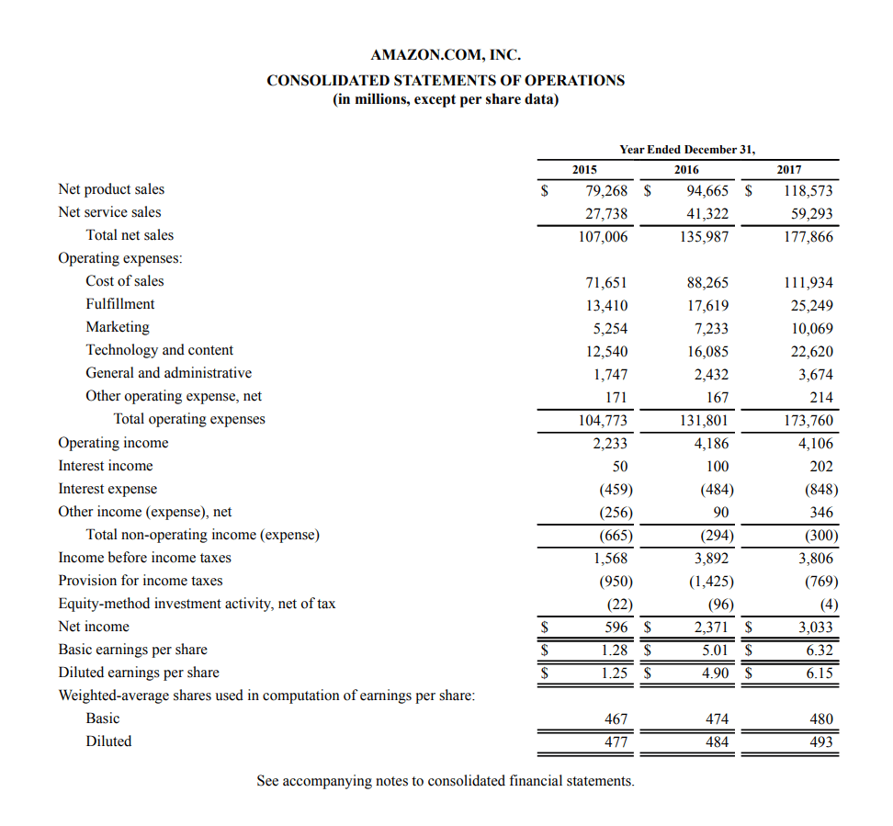

The income statement provides insight into a company's financial performance over a period of time (usually a fiscal quarter or year). As shown above, this period is usually stated at the top of the statement. The income statement contains information about sales, cost of sales, operating costs, and other expenses.

Conclusion

Record keeping is an important part of any business, big or small. Records help businesses track progress, find sources of income, and prepare financial statements and tax returns. Additionally, good record keeping helps improve the likelihood of success across the business, enabling the business to operate efficiently and avoid legal issues, meet tax requirements, protect its rights as a business, and generate meaningful reports. Many companies use electronic accounting software because it is easier to use and eliminates the human error that can arise from handwritten records.

References



