

BA (Hons) International Hotel Management
Module Handbook Autumn Term 2025
Hotel Placement – Managing Food and Beverage
Operations
BMIH6002
Level 6
Module Lead
Jessica Newport BA (Hons), MBA
Student name: Ana Maria Stoica
Student number: 2245028

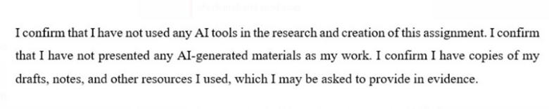

Table of Contents
Reflection Learning Journal: Hampton by Hilton Luton Airport. 3
1 Introduction 3
2 Description 3
3 Feelings 3
4 Evaluation 4
5 Analysis 4
6 Conclusion (Gibbs’ Stage 5) 5
7 Action Plan 6
9 References 7

Reflection Learning Journal: Hampton by Hilton Luton Airport.

Introduction
My current placement is Hampton by Hilton Luton Airport, where I have been working in the Kitchen Department under Fabio, along with the other workers, Anna, Salma, and Demie. This will be a position that involves food preparation, hygiene, and supporting breakfast and dinner processes, enabling me to work in the practical aspects of food and beverage (F&B) management. Since I have already done my Level 4 placement in the F&B department, this new opportunity has expanded my knowledge on the operations in the back of the house, teamwork, and quality of service. This reflection is based on the Reflective Cycle by Gibbs (1988), which consists of six steps, namely description, feelings, evaluation, analysis, conclusion, and action plan. This reflection aims at critically analyzing how professional and personal competencies have developed at Level 4, Level 6 due to being exposed to practical experiences, theoretical implementation, and teamwork. The reflection also shows how the core theories, like Total Quality Management (TQM), the Motivation-Hygiene Theory by Herzberg, helped me to make professional judgments in the course of the placement (Anon, 2010).

Description
My main duty during the placement was to help with food preparation, food stock, hygiene compliance, and assist with the breakfast buffet. A particular experience was to prepare and serve hot food items over the high season on weekends and still adhere to the Hiltons Travel with Purpose 2030 sustainability strategy (Hilton, 2023). With the support of Fabio, I organized with Anna and Demie to keep track of the buffet display and replenishment of products, and Salma took care of the dishwashing area to ensure the continuous process. The other important incident was the introduction of new waste-segregations by the management as a means of waste minimization in food. Fabio motivated me to manage waste documentation and report the team's improvements. This provided me with practical experience in operational sustainability, and my leadership and communication capabilities in a multicultural team were reinforced.

Feelings

The first experience was that I was anxious dealing with kitchen duties, unlike my previous position as a front-line server during the Level 4 F&B placement. I was not sure that I could cope with multitasking under high-pressure conditions in a kitchen. Nevertheless, the supportive contribution of Fabio in instructing me and the group of Anna, Salma, and Demie helped me gain confidence. As the process progressed, I gradually learned to value the team spirit in the kitchen and realized that efficiency and safety were impossible without effective communication and respect towards each other. I was more responsible for operational outcomes in Level 6 than in Level 4. This feeling of responsibility caused me pride, as well as an understanding of the problems of being sustainable and consistent in-service delivery under time pressure.

Evaluation
When looking back on these experiences, several good things come out. To begin with, the Hilton culture promotes inclusivity, dialogue, and collaboration, which boosted morale and engagement. Secondly, the environmental accountability of the company was achieved through sustainability practices, including the separation of organic and recyclable waste. Nevertheless, difficulties also existed. The quantity of food waste caused was not regular since the number of guests was unpredictable, which Fabio admitted as being a common problem owing to the varying flight timetables. Also, due to the morning rush, it was occasionally possible to create a gap in communication between the staff of the kitchen and the service, which influenced speed and coordination (Johnston et al., 2012). In contrast to my Level 4 placement, I observed that my operational stress management skills and collaboration grew significantly. My independence and confidence were reflected at Level 4, since at Level 6, I was more inclined to make initiatives, resolve issues, and suggest improvements.

Analysis
This experience is consistent with the theories of Level 4 modules, especially the Service Operations Management and Sustainability in the Hospitality Industry (Rutherford et al., 2007). Johnston et al. (2012) also state that the requirement to balance capacity, demand, and quality is the key to effective service operations. The principles were implemented in the kitchen department during the busiest breakfast times to ensure that there was no stockout. However, the little forecasting tools made waste management challenging, which can be associated with the operational problems that Jones and Hillier (2021) have discussed in the context of data-driven demand management in the hospitality industry. Using Total Quality Management (TQM) concepts, I realized that continuous improvement is essential with the help of staff feedback and standardization. Fabio has used the same method of implementing short daily meetings on the day of breakfast service, which reflects the TQM concepts of communication and collective responsibility (Wood, 2021). Motivation-Hygiene Theory, according to Herzberg (Kusluvan et al., 2021), was practiced in a motivational context. The motivators were recognition, teamwork, and learning opportunities, whereas poor equipment or heavy workload were the hygiene factors (Hagg, 2013). The appreciation of team effort by Fabio, as shown through post-busy shifts, boosted motivation and commitment, which confirms Herzberg's assertion that non-financial rewards are better at increasing job satisfaction. I also used the ideas of the SERVQUAL model (Parasuraman et al., 1988) to assess the consistency of the service. The hotel did well in reliability, assurance, but it had weaknesses in responsiveness at peak periods. Walker (2021) suggests addressing such by training their staff or implementing a pre-order system online, which can make the operations more sustainable and efficient. Moreover, green activities within the kitchen contribute to the fact that Hilton is in line with the Sustainable Food Strategy 20232030 by the UK Government (DEFRA, 2023), which focuses on waste minimization and responsible consumption. Nonetheless, I noticed that labels on garbage containers were not clear, and this lowered the compliance. The adoption of a circular waste management strategy and more effective communication might improve performance, which is also suggested by Dias (2024). All in all, these experiences consolidated the convergences between theoretical frameworks like TQM, the theory by Herzberg, and sustainability management in hospitality operations. I have a better insight that sustainable and high-quality service does not only rely on the process but on people, good leadership, motivation, and culture.

Conclusion (Gibbs’ Stage 5)
This position enhanced my knowledge of back-of-house activities and the importance of teamwork, sustainability, and communication. I am now more confident, proactive, and a problem-solver, compared to my experience at Level 4. My interpersonal and operational skills were enhanced by observing the leadership style of Fabio and the joint working of Anna, Salma, and Demie. I also understood that sustainability is not a one-time notion but a part of the day-to-day activities, which can take the form of portion control and energy saving. The experience substantiated the idea that the process of professional development in hospitality presupposes the capability to bridge theory and practice in the sense that one is able to think critically concerning the operational processes, and that it is necessary to appreciate teamwork and guest satisfaction.

Action Plan
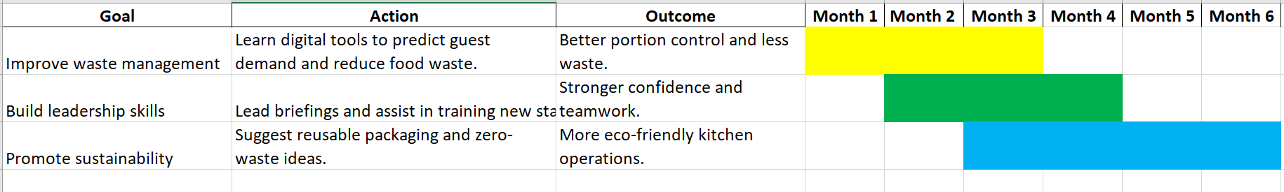

References
Andersen, V., Lelieveld, H.L.M., and Motarjemi, Y. (2023). Food Safety Management: A Practical Guide for the Food Industry. 2nd edn. Amsterdam: Elsevier.
Anon (2010) A Good Practice Guide for Placement and Other Work-based Learning Opportunities in Higher Education – Good Practice for Placements Guides – Volume 2. 52 (4). doi:10.1108/et.2010.00452dab.013.
DEFRA (2023) Sustainable Food Strategy 2023–2030. Available at: https://www.gov.uk/defra (Accessed: 20 October 2025).
Dias, A.L. (2024). Cases on Innovation and Sustainability in Tourism. Hershey, PA: IGI Global.
Hagg, E. (2013). Internship Guide: Work Placements Step by Step. 5th Ed. The Hague: Eleven International Publishing.
Hilton (2023) Travel with Purpose 2030: Progress Report. Available at: https://esg.hilton.com (Accessed: 20 October 2025).
Johnston, R., Clark, G. & Shulver, M. (2012). Service Operations Management: Improving Service Delivery. 5th Ed. London: Pearson.
Johnston, R., Clark, G. and Shulver, M. (2012) Service Operations Management: Improving Service Delivery. 5th edn. London: Pearson.
Jones, P. and Hillier, D. (2021) ‘Sustainability in hotel food service operations: Reducing waste and enhancing efficiency’, International Journal of Hospitality Management, 92, 102707.
Kusluvan, S., Kusluvan, Z., Ilhan, I. and Buyruk, L. (2021) ‘Employee motivation in the post-pandemic hospitality industry’, Journal of Tourism Management Research, 8(2), pp. 45–59.
Rutherford, D, G & O’Fallon, M J (eds.) (2007) Hotel management and operations. 4th ed. Hoboken, N.J, John Wiley.
Walker, J.C. (2021). Introduction to Hospitality. 8th Ed. Harlow: Pearson Education Limited.
Wood, R.C. (2021). Key Concepts in Hospitality Management. 2nd edn. London: Sage Publications.

