In depth discussion of the application of Alfred Gells ‘Art and Agency’ in analysing ancient artwork

Throughout this semester, I have come to realise there are several perspectives from which we can analyse ancient artistic material – for me the applicable theoretical approach is dependent on the material and our interpretations should thusly be guided by it. To constrain my writing I have stuck to deconstructing one theoretical approach, but have used multiple material examples to strengthen the versatility I believe can be found within the theory. As much as the varying degrees of agency Gell mentioned could be used on one tangible example I think comparative material emphasises the fluidity of agency. I have also found a necessity in inter-disciplinary theories when looking at ancient art, there is no ‘one’ way to view or consume the image. It is an extremely precarious academic form merely interpreting this material from a modern temporality. The limitation lies within the subconscious social knowledge we obtain due to circumstances beyond our control, that ultimately shape how we understand art, as well as how and why we value it.
Trying to facilitate progress in anthropology, the approach that I found particularly interesting is that of art and agency, first penned by Alfred Gell with the book published posthumously in 1998. The basis of the theory stems from an anthropological background, firstly reminding me of the precautionary tale of Maurice Blochs attempt to find esoteric meanings within Malagasy wood carvings, that ultimately proved that there is not always a complex belief system behind all man made and manipulated material. (Bloch,1995) This has instilled within me a sense of hesitancy when interpreting material as to not impose meanings I have derived of my own volition onto something so far removed from my experience. Outlining the principles of art and agency – it is of my opinion that Gell did his own work a large disservice by ascribing his own syntax to the subject matter, that fortunately has not persisted within the subsequent literature. It is still noteworthy, and to make this more accessible I will use his framework to put the concepts into my own words, as well as in relation to case studies. To preface any case studies, I will state that they are all examples of tangible art forms, as much as I believe there are intangible forms of art that are subsequently missing from any sort of archaeological record I find this to be a fascinating topic that I unfortunately do not have sufficient evidence to include in this paper.
Key aspects of the theory are largely based on the philosophical Peircean triad, which then made me question why Gell chose to make his own triad instead of using a pre-existing one. (Atkin, 2013) There are differences between the two and Gells definitions are much more centred around art however the Peircean triad on ‘signs’ still seems applicable, pragmatically functional and simpler in its notions. The three components in the Peircean triad are the ‘signs’ – the ‘object’ – and the ‘interpretant’. To summarise the overarching principle of the triad briefly by quoting Atkin, “The meaning of a sign is manifest in the interpretation it generates” and to me this is achieved through the objects, that indicate to a sign that the interpretant then defines, because of the objects. This version does not include all the complicated terminology that Peirce used hence why it is so manageable and applicable to that outside of artistic material culture. In the realm of Gells agency we have ‘index’ and ‘sign’ which are both a result of social agency. Index is referencing the art object, and the sign to Gell was a separate body which the viewer can refer to casually. What we understand as the audience or viewer Gell labelled as ‘The Patient’, who is a social agent affected by the actions (or existence) of the index. Abduction is how we extract information from indices, and this process ascribes them (the indices) with predictability – similar to the Peircean relationship between signs and objects- wherein objects act as predictors or indicators of signs. These reactions are recursive and therefore not separate from the interpretant or patient, but rather dependent on them. For me, the main difference is that in Peirces theory the interpretation is the conclusion and is partially limited to the rigid structure, whilst Gells theory is much more lenient in which component is the affecter/ affected with no clear ‘end’ to the transferal of agency. I do think the language used is largely unnatural for the subject, as linguistically it is well established what a viewer or audience pertains to, yet the use of patient feels far to clinical, unintentionally creating dissonance between the two agents. Interpretant seems more individual, and reflects how intimate interpretation is, especially of something as subjective as art. When looking at ancient art, at least from an archaeological background I find my interpretations guided by the literature and material I have already encountered, however someone could have this same knowledge as me and reach completely different conclusions and a step further removed from this someone with no understanding of ancient art could look at an object and through their own abduction deem it to have no artistic value or find something extremely relatable within the material. Which is why it is admirable that Gell tried to establish a foundation to work from as it is not an easy task trying to provide a linguistic framework in which scholars can interpret art and I still believe the one Gell has offered to be useable, but to those not versed in his writing it imposes an unnecessary barrier.
The fact the theory behind art and agency was influenced by a philosophical idea to begin with shows how interdisciplinary research proves fruitful and makes ones interpretations considerably richer, with the caveat that one can be pulled in too many directions to give a succinct argument. When looking at ancient art specifically there are many boundaries that modern interpreters face, so it only makes sense that the broader the perspective you have to begin with the less limitations you will have to overcome. Personally the examples I will discuss later I have aimed to approach with influences from anthropological, archaeological, artistic and philosophical discourses. If we are to approach something for purely aesthetic reason I do not think it necessary for ‘viewing’. For me the value in this approach lies in the exploration of human-material relationships, which can go overlooked with art objects as the tendency is to place all value on the finished product that we can view. Arguably it seems necessary to look at the interactions that determined the material to the object/image we have been left with. More often than not the art we look at from ancient cultures depicts humans in situations that appear unfamiliar, due to the aesthetic that varies from our modern preconceptions of how people are to be represented. However, we forget the communality in creative expression, perhaps the art we make as individuals is not of the highest grade, and yet we still have the innate desire to make things and we find frustration when we cannot translate the beautiful ideas in our mind to the material – possibly explaining peoples appreciation for art that requires a high level of specialism. To add to this enchantment provided through art, ancient artworks or objects we have defined as of artistic intentions, have a veil of mysticism to their form as they have persisted for thousands of years, as well as being technologically intricate.
Relating to one of the many avenues that agency is expressed, Gell posited the concept of agency being inscribed and embedded in objects from the agents that use them. Not just the artists or people who make the objects but anyone involved in the network of interactions that the object has gone through. (Gell,1998) As when we think of a contemporary object and how many different hands or owners it will see in its lifetime, along with all the other interactions it will have outside of the immediate circle. For instance if I said I bought a candle, the candle exists alone as an object, but also as a possession once I attribute it to myself – It then becomes ‘Amys new candle’ not just a new candle, if I say this in conversation without it physically present it suddenly has agency within that setting. (Kopytoff,1986) More importantly it has agency irrespective of my presence, if I place the candle where people frequent – to put it in Peircean terms – it would be an object on behalf of me (the sign) for an interpretant, in this example a family member, as when they walk past the candle or smell it this will indicate to my existence even if I am not physically there because I am being perceived to some extent my existence is legitimised. (Atkin,2013) Similarly, art objects allow for the legitimisation of a person or deities existence, an infinite image. (Baharani,2014)
My first example of material that I believe encompasses ascribed agency is the Tell Asmar hoard of votive figurines. Material that I believe is acting on the behalf of an individual, not necessarily the person who made the figurine, rather the devotee who left the statue in their stead. (Evans, 2012) For this example I want to acknowledge that archaeological influence from … in that, I believe this group of figures should be interpreted as a collective rather than singular figures although each displays an individual identity. I would argue it is becoming more common for archaeologists to take holistic approaches to material, that translates to the literature however a large extent of finds warrant in depth research as stand alone objects, a practice which favours arguably the most fantastical pieces of material that scholars can extrapolate deep esoteric symbolism from or artefacts that are visually appealing. How beautiful something is, thankfully does not have a unit of measure and is recognised as being highly subjective, and yet easily influenced by the external social world in which a person is situated. (Winter, 2009) An idea I believe to have some traction, is that of art being a fluid state – steering ideas away from finished ‘products’ and rather looking at the process as part of the whole of the creation. Something that ties in nicely to the concepts of art and agency as this looks at the intricacies of human interaction that lead to art pieces, whilst providing the material itself with an avenue to influence humans in a recursive relationship. At least Gell aimed to acknowledge this aspect of art. The Tell Asmar hoard is a culmination of twelve statuettes, found in an early dynastic temple dated somewhere between 2900-2350 BCE, provenanced to ancient Mesopotamia (modern day Iraq). (Evans,2021) The statuettes are not particularly realistic, yet from the standardised features they share we can clearly visualise the separate components of the body. They are rather static in form but perhaps that is a subsidiary affect of standardisation, the variation that provides these figure with their main sense of character are the faces. Likely because our faces make up our most recognisable physical features. (Evans, 2021) Notably, amongst this collection of figures we can see the eyes are exaggerated out of proportion to a slightly disturbing degree, especially on the larger statuettes, which I will come back to later.
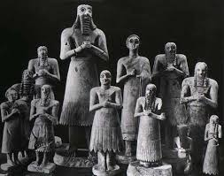
Image of the Tell Asmar Hoard of Votive Figurines from Evans 2012
What is interesting about the hoard is that the photograph which has been their ‘face’ is not typical for a photograph of archaeological finds, rather it is composed and staged in a dynamic way. (Evans, 2012) To me this is where we see This may have helped with its artistic reception in the 20th century, as if these figures had been placed side by side with the intention to demonstrate the variation in height the uniformity would supress the agency they exude. The purpose of the statues, or more applicably their role has partially influenced my opinion that they are representative of distributive agency rather than agents; as votives are there on behalf of the donor to maintain a relationship with the divine as an act of reverence or through this material world in a constant state of supplication. (Evans,2012) The crucial idea here being ‘maintenance’ as material is cleverly utilised for provisions, so that living people can carry on daily routine, knowing they are appeasing the gods via the presence of their devotee. These figures to me provide a strong sense of dedication – not just to the divine – but that people had such strong belief in their religion and gods that they not only found but made this material ideal for themselves, as a way to show the gods they were committed, but to unequivocally provide themselves with a sense of relief and peace for when the cannot dedicate time to adoration. (Neumann and Thomason, 2021)
These figures were found in a temple, which is a very specific that eludes to very specific connotations, so interpreting these figures as simply art objects would be short sighted, however it is hard to abduct the extent of their religiosity from just the material. It is accepted that the gesture signifies a religious purpose like an act of devotion in this Neo-Sumerian art and is ethnographically comparable to religious gestures when people engage in prayer. Nadali describes these temple figures in a state of tableaux vivants a static scene (despite translating to living picture) with multiple models. (Nadali, 2019) Often associated with visual theatre, so I found the application of it strange at first. Upon looking at these votives in further detail, I am unaware of how they originally would have been displayed, so in terms of display I only perceive this staged composition as credited to the included photograph. Which as an image has agency in that it projects a narrative of these figures as a hoard, again referring back to Nadali agentivity is not synonymous with narrativity, but this image displays a group posed in a way that is associated with ritual action. From this narratives can be derived, as I stated they took the place of an individual, so from that we have a collection of twelve specific people, whose genders we can recognise by the stylised hair and dress. We can also see that great care has been put in to the moulding of the gypsum figures as there is a clear gap between the arms and bodies, extending the gesture even further. We also see that the eyes are inlaid with either precious stone or bitumen, that gives them an abstract sense of vitality. The eyes dominate the facial expression of the hoard and though it is hard to tell from the image of them altogether, the appear to be looking up with their chins slightly tilted back, again a pose associated with religion, relating to divine communication. (Osborne, 2004)
An object that I believe exudes agency by itself is one that I believe to a degree provides the viewer with recognisability or a sense of personhood and identity is embedded in the materials physical properties. (Winter, 2009) This is an object that is not merely shaped ‘like’ a person, but one in which you can see or feel them. Art after all is a sensory experience and shouldn’t be represented by images that only visually stimulate the viewer, art can be extremely tactile and provocative to the other senses. I therefore want to provide an example of an object that I believe has agency that is not dependent on the material presenting us with a human identity; rather how it is to be used has created a life for the object completely based on the human engagement and social situations it has mediated. (Kopytoff, 1986) I am not stating that in these social situations it is secondary to the human actors but rather equal to them by mediating their relations the same way a third party person would. This Lapis-Lazuli cup from the royal treasures at Ur is contextually fascinating to me and holds agentive qualities. As the lapis was most likely sourced from Afghanistan, and usually was crafted into much smaller items such as beads. (Horn,1998)
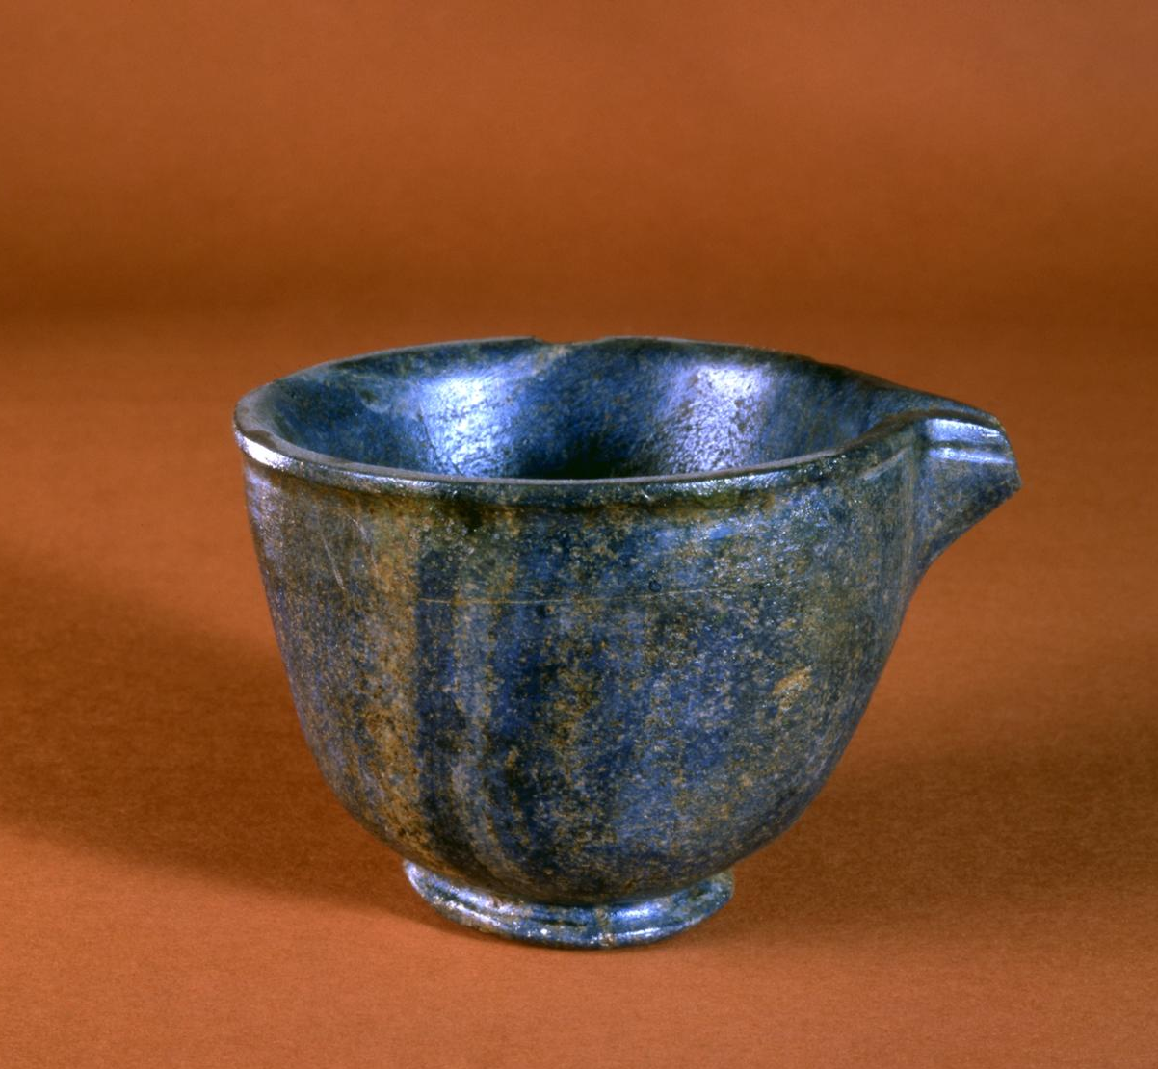
Image of Lapis-Lazuli Cup from Ur, Museum number B17167, Penn Museum (1998)
Here we have a small cup that must have been sat waiting within a large singular piece of the stone, to be shaped into a dainty and delicate cup, with an extraordinarily refined trough-spout.(Horn, 1998) The cup looks particularly smoothed and well-polished highlighting the natural mineral veins, that seems to flow with the roundness of the cup. This cup alone warrants interpretations through theories of object biography, technologies of enchantment as well as through art and agency. I have chosen agency however as this is a unique find to the site, and more over because to viewers it can appear to have been bound to a typically mundane and stagnant role as ‘tableware’. However, it has royal associations and I imagine if you were hosting foreign dignitaries using this cup, made of a lustrous semi-precious stone in the evening so it can reflect light from fire or lamps it would look magical. Especially as natural blue pigments are so rare. Regardless of what liquid was placed inside the cup, it would then appear darker to the holder. As an object, this has such a situational presence, it could add an intensity (not necessarily a negative kind) if the host used it as a way to indicate wealth and power over their guests. If placed and not used that would have the same effect to a much more subtle degree. Yet if the host were to offer this cup to a guest, that would indicate a high level of trust, whilst also enforcing responsible behaviour as not to break or risk the cups form. This is a powerful object and could hypothetically be used in very influential ways amongst people. Even before the cup was finished somebody was given a significant chunk of lapis and managed to carve this cup, and yet when I see this cup I get no sense of the craftsmen behind it.
I could argue if this was a royal commission that it was intentional no external agency from the crafter was inscribed within the cup as to allow its use to create its identity, perhaps not totally irrespective of the ruler it would belong to. There is no strong sense to me that this cup has even been worked it looks so complete and effortless, that I imagine it just being and belonging as if it moulded itself as I cannot perceive how such an object could be manifested and teased out of stone. For some objects there is value in questioning the processes undertaken for its creation, but for something that could arguably be written off as just a cup and not an object of artistic significance I think the final product here still speaks for itself, thousands of years later. This item could be deemed valuable for modern audiences due to its aforementioned qualities, with royal ownership, precious material and the fact its survived since the third millennium. (Horn,1998)
To summarise, I think it is evident that art objects can encapsulate varying degrees of agency; either through the human processes that surround their creation and subsequent display in the modern contexts they appear now; right the way to the contrasting end of this spectrum with objects being their own agents and having external influence over our world (which is arguably, very much theirs). When talking about these agentive pieces it is extremely hard to not personify the material, as it is so ingrained within us that humans are agents, but I believe the examples given demonstrate that objects have as much effect as we do. As stated in my introduction I view agency as a very fluid concept, with material and people fluctuating between states of being agents or the affected. If viewed as a linear structure with the assumption that the human will hold the most agency, I think this greatly detracts from the recognition that material deserves. A human-centric focus has historically dominated academics, and still with how we value and approach ancient material – a significant subset of determinate value is dependent on the individuals who owned, crafted or are represented by the material image. Overall, I think Gells approach is useful and has allowed for further discussion of art in multiple contexts, however the language should be reassessed, unfortunately this cannot be undertaken by Gell himself and thus the challenge remains open for current and future scholars to embark on. I think there is an alternative in the Peircean triad, but this could be seen as outdated or not directly related to art as much as is needed. The result we have from these two works alone has left a fairly extensive vocabulary to utilise when analysing art, they do however leave plenty of room for very valid criticisms, with reviews of my own on his writing stated relatively early in this paper. As in this essay I have tried to ‘translate’ the ideas of Peirce and Gell in a concise way to better my own understanding, by providing my own examples to make the concept and process easy to grasp, and even if I am not entirely right this is how I have taken their structures for interpretations. Ultimately, I do not think it necessary to create a new syntax for interpretations as I hope for works to be accessible to those outside or unfamiliar to the discourse and generic language is more than applicable with relevant subject specific terminology; but if this is to be included it should be explained clearly to the readers and not written with the assumption they know what it is to mean already, which is my greatest problem with art and agency as a whole. Perhaps, I feel confident in my stance only because of writers like Gell, who tried to provide literary guidelines in which I can share said opinions as a student.

References
Atkin, A,. 2013. "Peirce's Theory of Signs", The Stanford Encyclopedia of Philosophy, Edward N. Zalta [online] <https://plato.stanford.edu/archives/sum2013/entries/peirce-semiotics/>.
Bahrani, Z. (2014) The Infinite Image: Art, Time and the Aesthetic Dimension in Antiquity. Reaktion Books, London. Pp. 14-48
Bloch, M., 1995. In Hodder, Interpreting Archaeology: Finding Meaning in the Past. Questions not to ask of Malagasy carvings. Routledge. Pp 21
Evans, J.M,. 2012. “Introduction” in The Lives of Sumerian Sculpture: An Archaeology of the Early Dynastic Temple. Cambridge University Press. [online] doi:10.1017/CBO9781139084147.001. Pp.1-14.
Evans, J.M. 2021. In Critical Approaches to Ancient Near Eastern Art: The Tell Asmar Hoard and Rituals of Early Dynastic Sculpture. EBSCO Publishing. [online] Available at: https;//www.ebsco.com. Pp 645-662
Gell, A. 1998. Art and Agency: an Anthropological Approach. Oxford University Press, New York.
Horn, L., 1998. Expedition vol 40, issue 2. Pennsylvania Museum [online] Available at: https://www.penn.museum/sites/expedition/ur-and-its-treasures/
Kopytoff, I., 1986. The Cultural Biography Of Things: Commodification As Process. Cambridge University Press, pp.64-91.
Nadali, D. 2019. Image-Narration-Context: Visual narration in cultures and societies of the old world. Freiburger Studien zur Archaologie und visuellen Kultur. Published by Propylaeum [online] Available at https://doi.org/10/11588/proplaeum.399. Pp 63-74
Neumann, K. and Thomason, A. (2021) The Routledge Handbook of the Senses in the Ancient near East. Milton: Taylor & Francis Group. Pp. 530-545
Osborne, R., 2004. Hoards, votives, offerings: the archaeology of the dedicated object. World Archaeology, 36(1), pp.1-10.
Winters, I. 2009. What/When Is a Portrait? Royal Images of the Ancient near East: Proceedings of the American Philosophical Society, Vol. 153, No. 3, Published by: American Philosophical Society, Pp. 254-270 [online]: http://www.jstor.org/stable/40541670

