Student Name: Valentina Matei  Student ID: 2221642  Module Title: Foreign Languages & Cultural Awareness  Module Code: BMIH5003  Lecturer: Lisa Bassler  Heidi Prosser  Date: 9.02.2024 | 
ASSIGNMENT 1: PORTFOLIO

(4 Components)

Component 1: Professional Reflection

Cultural misunderstanding refers to miscommunication or misconception of an area or individuals that may be created due to their lack of understanding or difficulty in understanding customs and culture, the type of communicating styles, etc. It is a global factor and it may occur in any place or among any people (DEBAENE, 2013).
Among all the cultural misunderstandings, language differences are a common problem. Different countries use different languages and their style of expression their emotions are different, too. This creates a great problem if anyone cannot able to understand another's language and also the reason for miscommunication. For example, a gesture or simple way of welcoming others can be different from the other country or culture. Non-verbal communication is another reason for this type of miscommunication. The meaning of body language, eye contact, facial expressions, and gestures are usually different from one culture to another. Such as, in some regions, eye contact means to make friends or focus on a topic whereas in some other places, it means disrespect to make eye contact with an older or respectable one (Mertler, 2018).
Sometimes, different miscommunications or cultural misunderstandings may create a great problem among people and may also be the reason for chaos.
I have completed my internship in the Premier Inn and faced many problems of cultural misunderstanding while working. As it is a famous hotel, people come here from different places of different cultures and languages. As I am from a European culture and language, it was pretty hard for me to understand another language as well as their culture. Some people come there who do not understand English and in this case, I have to use my bilingualism skills to understand their language. It becomes a hassle when they order according to their cultural habit (Wierzbicka, 2020). Sometimes, it was really difficult for me to understand what they wanted. Some others also wanted to know about the process of food or other facilities of the hotel according to their preferences but in their language. Then it becomes challenging for me to understand different languages at the same time. As I do not have the skill of multilingualism, it was challenging for me to understand their language. Sometimes it was also tough for me to understand their order and customers could not express clearly what they wanted to order, In this case, I faced many problems in the workplace. It created problems with the prices of the food and drinks. Due to the reason of different languages, it is also a hassle to make orders hotel bookings, make appointments, and transport anything from one place to another. While giving directions to the hotel, providing them with the offers and facilities of the hotel arrangement and other information. Sometimes, customers also face problems staying in the hotel because of there because the hotel requirements do not fulfil their cultural needs and support. Cultural misunderstanding does not seem to be a great issue but it may create a great problem in the international working place (Mertler, 2018).

References
DEBAENE, V. (2013) ‘A case of cultural misunderstanding: French anthropology in a comparative perspective’, Cultural Anthropology, 28(4), pp. 647–669. doi:10.1111/cuan.12031.
Mertler, C.A. (2018) Action research communities: Professional learning, empowerment, and improvement through Collaborative Action Research. Abingdon, Oxon: Routledge.
Wierzbicka, A. (2020) ‘Cross-cultural communication and miscommunication: The Role of Cultural Keywords’, Intercultural Pragmatics, 7(1), pp. 1–23. doi:10.1515/iprg.2010.001.

Component 2: Training Plan

Identified cultural misunderstanding
In the international workplace, cultural misunderstanding is a very common issue. This may be different according to the individual or their cultural expectations, such as verbal communication, body language, gestures, etc. This cultural misunderstanding occurs when people of different social norms and etiquette meet together in any international place like a hotel or tourism industry. Different countries use different signs or bad languages that are usually different from another country and also their type of expression are different. As it is an issue of attitude and communication, so, everyone must be careful while working in any place where people of different cultures and Crist meet together. If there is any problem, people should raise cultural awareness to resolve this issue (Dolan, 2015).
Training plan
While completing my internship at the Premier Inn, I faced many challenges due to cultural misunderstandings, especially in using a foreign language. This enables my multilingualism and also develops my management skills according to different situations. As I have completed my internship there, I can suggest to my fellow learners and coworkers. I can make a training plan for them so that they can benefit from it and overcome any challenges in the workplace.
Developing communication skills: To grow effective communication with the customer, it is essential to develop using different languages. In this case, a person that able to speak different languages of different countries can grow his career more developed. This is called multilingualism which is very effective in the international workplace. So, I made a training plan with multilingualism and also a basic European English Training Course so that anyone can grab the opportunity and understand the needs of the customers. There are different online courses on this and also anyone can use the App for language transfer to make their task easier (Hildebrandt, 2019).
Raising Cultural Awareness: I will also make a plan of raising cultural awareness among my learners so that understand the necessity of culture in their workplace and also provide appropriate expression according to different cultures. It is also important to make them introduce to different cultures so that they gain proper knowledge of different cultural activities along with the cultural habits of the individuals. This training will help them to understand their food habit and also their living style in the hotel and they can provide correct services (Dolan, 2015).
Cultural Celebrations and Restrictions: Some various cultural habits or rules are acceptable in one country but forbidden in another. In this case, I will include it in my training plan so that my fellow learners can understand the differences between the dos and don'ts. This will help them to identify the problems of the customers in the hotel and also they can help their customers to sort out different problems to avoid cultural misunderstandings. It will also be effective for them to arrange different cultural programs (Thomas, 2020).

Teamwork: Teamwork is always the best way of learning and group work. I will make a team to train them and also encourage them to work together in the workplace. It will help them to identify the problem and face any challenges together.

References
Dolan, S.L. and Kawamura, K.M. (2015) Cross Cultural Competence: A field guide for developing global leaders and managers. Bingley, United Kingdom: Emerald Group Publishing Limited.
Hildebrandt, T. et al. (2019) Training plan: Draft. Thompson, Man.: New Careers Program.
Thomas, T.E. (2020) A growing gap of misunderstanding: Social resistance among students. Regina, Sask.

Component 3: Student Self-Reflection

Raising cultural awareness is very effective in reducing cultural misunderstanding among people according to different situations. It is essential to avoid cultural conflict among the people of different countries as well as different cultures. To develop my cultural awareness, I developed a self-reflection plan that can enable my insight to grow with more knowledge and also help me to work in the international working field (McMillan, 2014). With the knowledge of cultural awareness, I can identify my weaknesses in the specific field that are hindering the growth of my career and resolve any challenges in the workplace. I can follow a self-reflection model that can be easier to approach and also effective for me. In this case, I prefer Gibb's self-reflective model with six stages that are very easy and effective for me.
Description: This is the first stage of Gibb's reflective model and in this part, I can describe the knowledge and experiences that I gathered during my internship. This also helps to know what I gained during my working time, the challenges I have faced, and the approaches I sort out the problems along with the efficiency. In a word, this stage is helpful for me to understand the actual learning from my experiences.
Feelings: This is the second part of Gibb's reflective model and this part is necessary to express the feelings about the experiences that I gathered during my internship. This stage will help me to make a self-reflection plan according to my feelings of right or wrong, different challenges that I faced due to various reasons, and also the feelings of overcoming them with proper decisions. This part will help me to make a plan for making decisions in further situations.
Evaluation: The third stage of Gibb's model is also important to make a self-reflection plan because this part helps me to think about the good and bad side of the experience or task that I have done during the internship. As I completed my internship in the hotel, I met a lot of people of different cultures and also provided them with services according to their needs. I also faced problems due to cultural misunderstandings as they were from different languages. So, it was pretty hard to understand their order and I have both the good and bad experiences about it (Blomberg, 2016).
Analysis: According to the fourth part of Gibb's reflective model, I made a self-plan and that is I must raise my cultural awareness to fulfil the needs of the customers and to provide them with appropriate services. With the help of this stage, I also analyse my strengths and weaknesses so that I can focus on specific areas to develop my skills in the workplace (Blomberg, 2016).
Conclusion: In this stage, I make a plan for the approaches to develop my skills of communication by learning different languages to understand the languages of different people and also avoid cultural misunderstanding (Scott, 2017).

Action Plan: This is the final stage of my self-reflection plan and in this stage. I will make a plan to take action according to the plan. At this stage, I will turn my thoughts into reality and also implement the ideas to develop my knowledge and skills to raise cultural awareness.

References
Blomberg, I.E. (2016) Goal setting. Waterford, CT: Bureau of Business Practice.
McMillan, J.H. (2014) Classroom assessment: Principles and practice for effective standards-based instruction. Boston: Pearson.
Scott, K.A. (2017) Self evaluation: Its relationship to substance use in native adolescents. Ottawa: National Library of Canada.

Component 4: Training Presentation

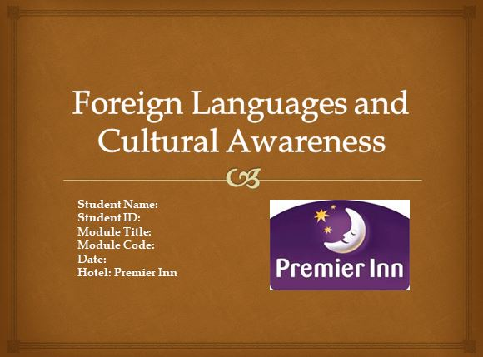

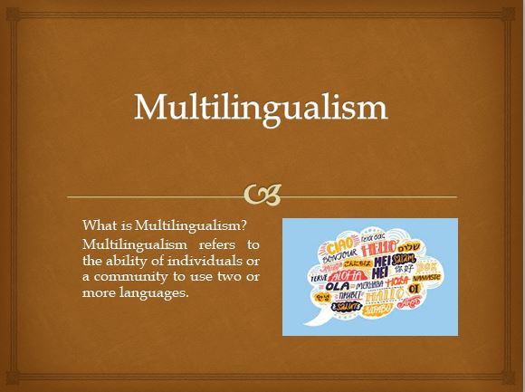
NOTES: Multilingualism
Multilingualism is the matter of the ability of an individual or community to use two or more languages. It is also a matter of using different types of languages for a person in respective different areas in the workplace. Anyone can apply his multilingualism skills in any place if needed. Usually, it is widely used in the international workplace, such as international hotels or the tourism sector. It is also considered a plus in various career-growing skills (Schmorrow, 2013).
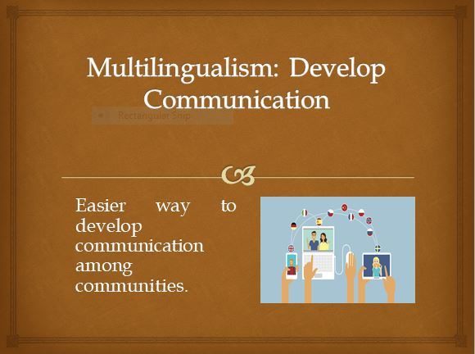
NOTES: Multilingualism: Develop Communication
The skill of multilingualism is very essential for the staffs who work in any international workplace. For example, in international hotels, different people come from different countries and it is not mandatory that they have to know English as an international language. In this case, the staff of the hotel, especially in the management department must be able to speak multiple languages otherwise the reputation of the hotel may fall. The customers will also fail to fulfill their needs. Every customer wants to get services according to their preferences so it is necessary to understand their language (Stavans, 2015).
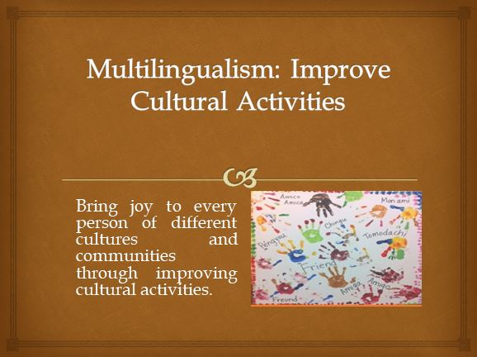
NOTES: Multilingualism: Improve Cultural Activities
The term multilingualism is very effective in developing cultural activities and also increasing communication among different communities as well as countries. It is also essential to welcome people in the hotels and tourist areas. Customers feel comfortable in their staying place while traveling and also the hotel can get more attraction. The lack of the skill of multilingualism helps to reduce hassle in the workplace between customers and staff. It is easier for the staff with multilingualism to understand the requirements of the customers (McCreary, 2023).
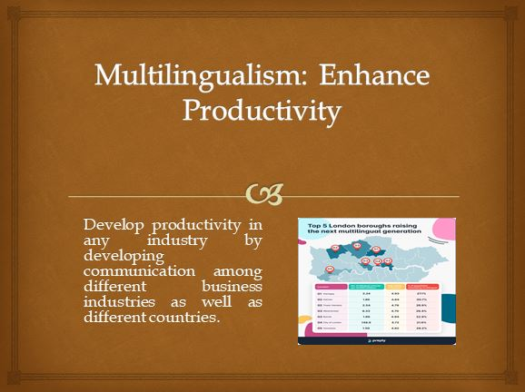
NOTES: Multilingualism: Enhance Productivity
Practicing multilingualism helps to develop the staff's productivity as well as customer satisfaction. It is also effective in increasing the reputation of the hotel by understanding the culture of individuals. These all are necessary to develop personal growth and skills. In addition, the skill of multilingualism helps to grow further career of the staff. Some international hotels and other workplaces appoint a person who knows multiple languages and in this case, the educational background can be relaxed. Though European English is also an international language, everybody doesn't need to know it (Kruger, 2021).
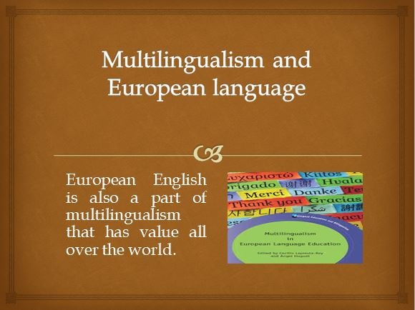
NOTES: Multilingualism and European language
It is essential to know multiple languages so that anyone can feel easy to communicate and also able to share their feelings about their cultural needs. In my opinion, different international hotels and tourism sectors should arrange training on multilingualism to strengthen their reputation in the marketplace (Braunmüller, 2023).

References
Braunmüller, K. and Ferraresi, G. (2023) Aspects of multilingualism in European language history. Amsterdam: Benjamins.
Kruger, D. (2021) ‘Adaptive learning technology to enhance self-directed learning’, NWU Self-Directed Learning Series, pp. 93–116. doi:10.4102/aosis.2020.bk210.03.
McCreary, G. (2023) How to develop good communication skills (with pictures), wikiHow. Available at: https://www.wikihow.com/Develop-Good-Communication-Skills (Accessed: 24 January 2024).
Schmorrow, D.D. and Schmorrow, D. (2013) Advances in design for cross-cultural activities. Boca Raton, FL: Taylor & Francis.
Stavans, A. and Hoffmann, C. (2015) Multilingualism. Cambridge: Cambridge University Press.

