Module Name: Marketing Essentials
Module Code: BMIH4005

Title: A Comparison of The Marketing Methods of Two Multinational Hotel Brand
Student Name: Faruque Ahmed
Student Id: 2235171
Lecturer Name: Luciana Suardi
Word Count:1650

(Hilton Hotel and Accor Hotel)

Introduction
Hilton hotels
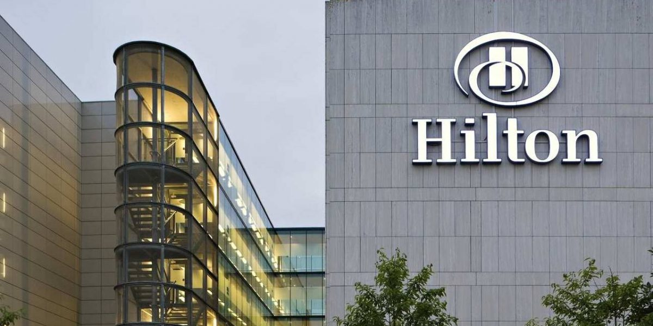
One of the most popular hotel brands all across the world is Hilton Hotels & Resorts, which serves as Hilton's flagship. On May 31, 1919, Conrad Hilton founded Hilton Hotels & Resorts, which is the most popular hotel and resort owned by Hilton all across the world the hotel has more than 570 locations scattered over 85 nations and territories on 6 continents (Chang et. al. 2019). All of these businesses are either contracted by Hilton itself or by independent business proprietors.
Figure 1: Hilton Hotels
(Source: LamDa, 2022)
Accor Hotel
The Accor hotel management operates various markets like higher level market, Luxury, midscale, and budgeted hotels which are part of the franchisees (Damnjanović, et. al.2020). The firm operates hotels underneath a variety of brand names; consist of Novotel Suites, Grand Mercure, Ibis, Ibis Styles, and many others. The business operates in around 5298 sites spread throughout 110 countries, including those in Europe, America, Asia-Pacific and Middle East.
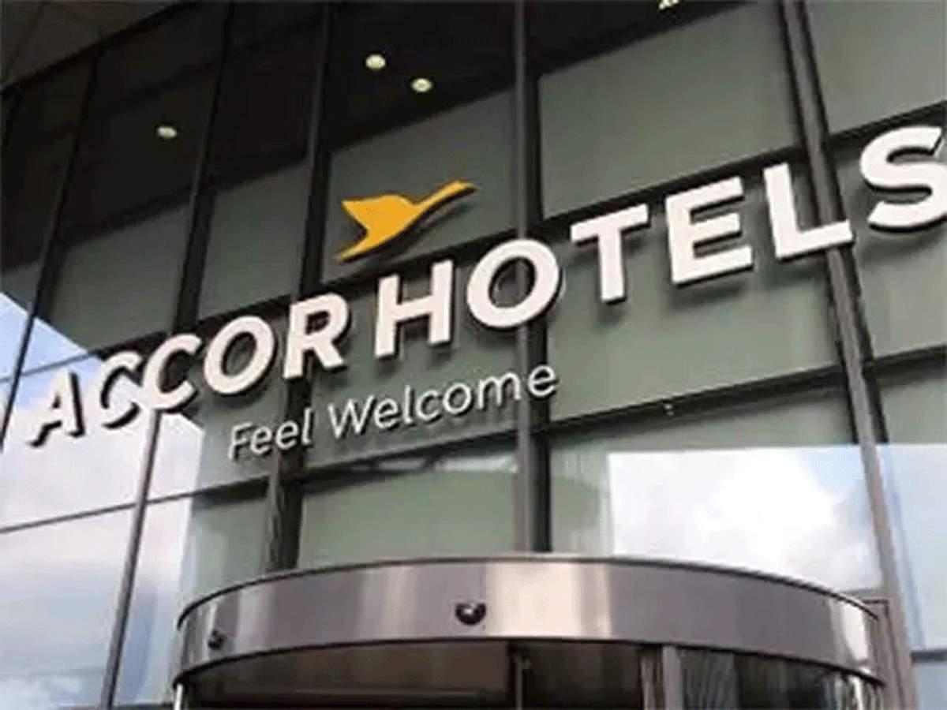
(Source: The Economic Times, 2022)
Figure 2: Accor Hotels

Main body
- Market Approach
The major objective of this marketing strategy of the company is to achieve its goals and be the market leader. The Hilton Marketing Strategy & Mix is to develop an analysis of its product, pricing, promotion and distribution strategies:
Hilton Marketing Mix
Product - Hilton provides products that are specially made for satisfying customers of the company and every individual needs and requirements of customer of the company. Hilton Hotels offers a wide variety of products and unparalleled customized service, and the company also guarantees every customer to provide a unique and special experience that will be memorable for them.
Place - Hilton hotels are easily accessed by the customers through various media platforms like websites, or other travel booking websites. The company provides customer care services which are always available to respond to clients' queries regarding booking or any other issues regarding services offered by the company (Leung et. al. 2015).
Price - The Hilton hotel’s offered products and services of exclusive and exclusive quality and the prices of these products replicate their positive characteristics. The price strategy implemented by the company is based on its client’s tastes and preferences, the clients of these hotels are mainly from the higher-income class of society.
Promotional Strategy - The hotel is involved in publishing advertisements in chosen areas and media. The company also participate in several business exhibitions in various parts of the world, at this places the customer representative tries to sell company’s products to potential buyers (Husainet. al. 2016). The company is associated with Airlines Company and tour and travel companies to promote products
Recent changes in marketing approaches of the company
The marketing strategy of the company is focused on positioning Hilton hotel as a place where the company becomes the leader in the hotel industry to provide excellent service to its clients. The strategy adopted by the company focuses on producing and maintaining strong and good customer relationships, which will result in maintaining loyalty.
Accor Hotels
The marketing mix of Accor Hotels' marketing strategy leads to the company's achievement in the marketplace. The marketing plan for Accor Hotels assists the company participating in a viable market and accomplishing its goals and objectives.
The Accor Hotels Marketing Mix
Product –Accor hotels provides a variety of luxury hotels and other amenities under several well-known global brands. The following are the products that the brand sells:
  - Luxury Hotels
  - Midscale Hotel
  - Economy Hotels
The company also provides a scintillating and mesmerizing offering that includes over 9000 restaurants and bars which are involved in serving over 200 million appetites every year (Demirçiftçi, and KIZILIRMAK, 2016).
Price –It is intensely Luxurious foreign hotels but it is also includes mid to low-valued local competitors. Company is part of market where the focus concentrates on the quality and satisfaction of the consumer. The Accor Hotels has a variety of superior and luxury hotels which contend for business.
Place – The Accor Hotels began its existence with the Novotel in France and eventually grew to over 100 countries on six continents. The globally famous tour locations, consist of places like Paris, Bali, Shanghai, Dubai, Cairo, Mumbai, Toronto, etc. This is home country for the Accor Hotel.
Promotion –Le Club Accor Hotels is the brand's specialized loyalty program that is structured on the standard loyalty scoring structure (Damnjanović, et. al.2020). Points are collected whenever the customer stay at hotels, and they might be redeemed for purchasing guestrooms and services of any kind at group's facilities.
Recent changes in marketing approaches of the company
The company has a planned program for waste minimization and efficiency, is a contributor to the UN COP-21 Programme on climate change is a participant of the UN's Women Empowerment Council. With regionally specific YouTube, Twitter, and Instagram pages as well as a Facebook page with 1.8 million likes, the group has a substantial online presence.
- Current market position
Hilton hotels
- Target market –The hotel's management, is involved a wide range of customer which includes business travellers, conference attendees, vacationers, actors, chiefs of state, and artists are all target audiences of the company (Dardeeret. al. 2017)
- Segmentation- For the Hilton hotels the primary goal of the geographic segmentation approach is to build the hotels in location in where the target market is properly represented. The demographic segment, the middle-age and elder authorities with high incomes who represent the greatest social class make up Hilton's potential customer sector.
- Positioning –Hotels is the company's global brand name and operates 572 hotels and resorts in 85 territories and countries on six continents (Reidhead, 2020). The company today has 10,000 owners, 76% of whom are repeat customers.
- Marketing communication – To express luxury to its clientele, Hilton Holdings Inc. still mostly uses traditional marketing communication tactics. To express the sophistication of the company in front of the client groups, marketing communication strategy of company includes print which is mixed with sales promotion, public relations, media advertising, direct marketing, and social events (Choiet. al. 2016).
Accor Hotel
- Target market- Travelers from the premium, upmarket, mid-market, and economy classes who are also on business trips are the targeted audience of the company.
- Segmentation- Accor Group operates in each of these market groups; it also employs a mixed segmentation approach. For example the Ibis hotels, includes the lower end of the market, but the Sebel and Fairmont are part of luxury hotels with distinct clientele.
- Positioning- The market penetration approach used by Accor Group concentrates on improving goods to draw clients from current markets. Accor Group is active in all significant market categories and also looking to launch any new items (Sen, and Kaushik, 2016).
- Marketing communication- The Company has a beautifully designed webpage wherein they promote all its brands underneath different price choices and reservations. The webpage of the hotels and resorts individually offers information about the existing contracts and programs.

- Marketing consideration (regarding sustainability/social/geopolitical/contemporary issues)
Hilton Hotel
- Sustainability issues - The hotel's waste management practices and pollution have a huge impact on the sustainability of the hotel, this issue leaves a devastating impact on biodiversity and the environment.
- Social issues–Hilton Hotels has announced its CSR programs which focus on improving its performance towards societies. Hilton is providing University employees with 5 million hours of study and 2 million courses and the company’s integrity and anti-corruption education was joined by 14,000 managers (Tark, and Oh, 2021).
- Geopolitical issues – as it is very well known that Hilton hotels are spread all over the world, which also attract various international issues, for overcoming these geopolitical issues company is working with the host countries for offering them the best results.
- Contemporary issues – there are several contemporary issues in the hotel company and in the case of Hilton Hotels there are various issues of them are as human resources, increasing competition in the market, and technology updating.
Accor Hotels
- Sustainability issues - release of carbon dioxide and trash emissions are the major sustainability issue in the case of Accor hotels, the hotel has played an important role in climate change as the carbon dioxide released from the hotel affect the climate.
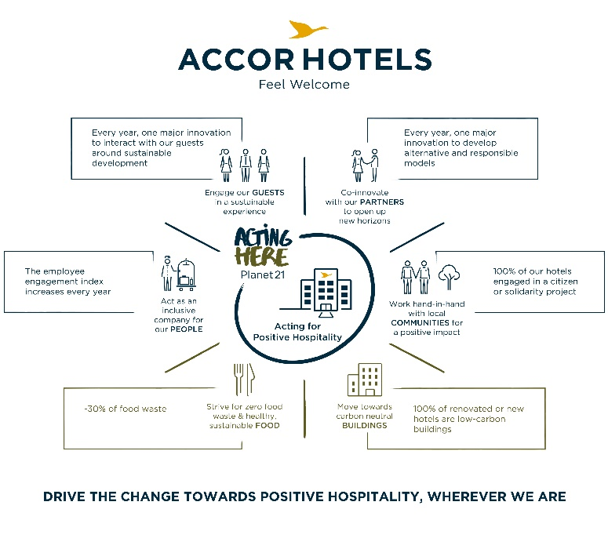
- Social issues –for fulfilling its corporate social responsibility company has Launched Planet 21 which is organized in four areas of society which includes employees, customers, partners, and local communities (Camelia et. al. 2019). The major focus of this plan is to provide food and beverages and building to all.
Figure 3: Plan 21 Accor Hotel

- Geopolitical issues –by being an international brand there company has faced so many geopolitical issues the major examples are pandemics and war, so for facing these challenges company is looking forward to working with the situation by providing the best services to its customers.
- Contemporary issues –some of the major factors which affect the company the most are unskilled staff, operational issues, and changes in customer demand (Tambunan, 2023).

- Marketing amendment
Hilton Hotel
The quality assurance teams, which are dispersed across the world, are developing a plan outlining how the hotel can uphold high standards in its operations. The hotel is looking forward to offering services that give each customer the highest level of comfort, to make him or her feel at home.
Accor Hotels
The Accor Hotels is improving its marketing strategy and attracting customers. The Group has announced the introduction of a new lifestyle loyalty program called ALL, Accor Live Limitless, a fully integrated worldwide platform that combines digital, loyalty, brands, and partnerships (Ningrum, and SEMM, 2023).

Conclusion
From the above essay the comparison and differentiation is made between Hilton Hotel and Accor Hotel. Both the hotels have their own strategies the essay highlights this through Approaches, marketing mix, targeting and segmentation. At last it is concluded that Hilton Hotel consider major environmental planning and working on controlling waste management. Whereas Accor Hotel consider the major issue of sustainability through working on its reducing its carbon footprint.

References

Accor Hotels, 2016. AccorHotels takes its corporate responsibility to the next level with bold new CSR commitments looking. (Online). :<https://press.accor.com/accorhotels-takes-its-corporate-responsibility-to-the-next-level-with-bold-new-csr-commitments-looking/?lang=en>. (Accessed on 5/2/2023).
Camelia, G., Ioana-Valentina-Alexandra, M. and Larisa-Andreea, N., 2019. Organizational culture: A case study of the impact of ethical organizational culture on the efficiency of Accor Hotels. Romanian Economic and Business Review, 14(2), pp.86-96.
Chang, Y.C., Ku, C.H. and Chen, C.H., 2019. Social media analytics: Extracting and visualizing Hilton hotel ratings and reviews from TripAdvisor. International Journal of Information Management, 48, pp.263-279.
Choi, E.K., Fowler, D., Goh, B. and Yuan, J., 2016. Social media marketing: applying the uses and gratifications theory in the hotel industry. Journal of Hospitality Marketing & Management, 25(7), pp.771-796.
Damnjanović, V., Lončarić, D. and Dlačić, J., 2020. Digital marketing strategy of Accor Hotels: shaping the future of hospitality. Tourism and Hospitality Management, 26(1), pp.233-244.
Damnjanović, V., Lončarić, D. and Dlačić, J., 2020. TEACHING CASE STUDY: Digital marketing strategy of Accor Hotels: shaping the future of hospitality. Tourism and hospitality management, 26(1), pp.233-244.
Dardeer, M., Tag-Eldeen, A. and Salem, I., 2017. The influence of physical work environment on hotel back-of-the-house employees’ satisfaction and productivity: A Case Study on Hilton Hotels. Journal Of Tourism Research, 5(18), pp.45-64.
Demirçiftçi, T. and KIZILIRMAK, İ., 2016. Strategic branding in hospitality: Case of Accor Hotels. Journal of Tourismology, 2(1), pp.50-64.
Economic Times, 2019. India a land of opportunities: Sébastien Bazin, chairman and CEO, AccorHotels. (Online). :<https://economictimes.indiatimes.com/industry/services/hotels-/-restaurants/india-a-land-of-opportunities-sbastien-bazin-chairman-and-ceo-accorhotels/articleshow/68715257.cms?from=mdr>. (Accessed on 6/2/2023).
Husain, S., Ghufran, A. and Chaubey, D.S., 2016. Relevance of social media in marketing and advertising. Splint International Journal of Professionals, 3(7), pp.21-28.
LamDa, 2022. The over-100 years journey of growth of Hilton Hotels & Resorts. (Online). :<https://destination-review.com/en/the-over-100-years-journey-of-growth-of-hilton-hotels-resorts/>. (accessed on 6/2/2023).
Leung, X.Y., Bai, B. and Stahura, K.A., 2015. The marketing effectiveness of social media in the hotel industry: A comparison of Facebook and Twitter. Journal of Hospitality & Tourism Research, 39(2), pp.147-169.
Ningrum, R.A. and SEMM, N.K.H., 2023. THE INFLUENCE OF SOCIAL MEDIA MARKETING ACTIVITY ON BRAND LOYALTY THROUGH CUSTOMER ENGAGEMENT IN 4-STAR ACCOR HOTEL TANGERANG. SGU Online Thesis Submission.
Reidhead, C., 2020. Impact of organizational culture on employee satisfaction: A case of Hilton hotel, United Kingdom. Journal of Economics and Business, 3(1).
Sen, K. and Kaushik, T., 2016. Recent innovative measures across different functions in the Indian hospitality industry: A case study from Accor Hotels. Worldwide Hospitality and Tourism Themes, 8(4), pp.481-489.
Tambunan, S.E., 2023. THE EFFECT OF CUSTOMER BASED REPUTATION ON CUSTOMER LOYALTY, CUSTOMER COMMITMENT TOWARDS IMPROVEMENT CUSTOMER CITIZENSHIP BEHAVIOR AT ACCOR HOTELS CLUSTER TANGERANG. SGU Online Thesis Submission.
Tark, J. and Oh, W.Y., 2021. Hilton Faces Greenwashing Challenge. In Social and Sustainability Marketing (pp. 865-868). Productivity Press.

Appendices
Accor Hotels
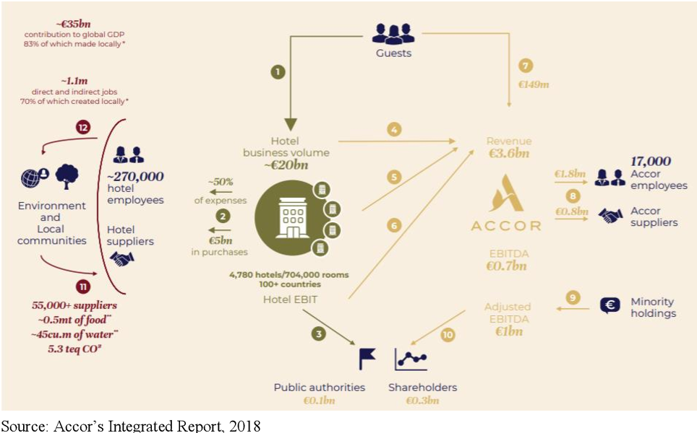

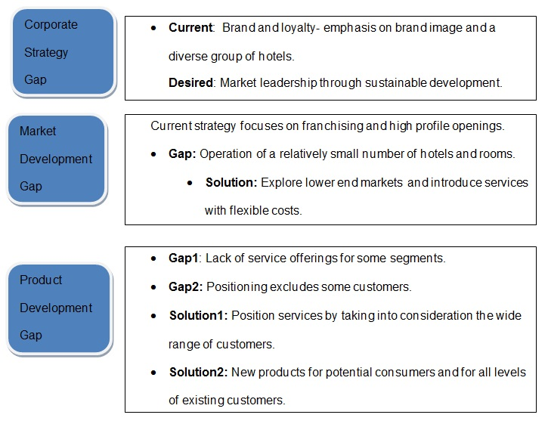

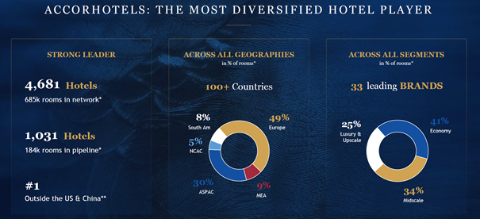

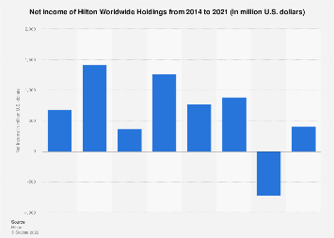
Hilton Hotels



