BMSW4006
Managing Enterprise in the 21st Century
Lecturer name: Mohammad Rahman

Business Plan

for

Pets R Us

Dog Walking Services

- Ibrahim Youdjel Gazi (2018574)
- Everton Asselmoth White (2019929)
- Apostol Sotirov Sabahov (2019598)
- Georgel Marian David (2018709)
- Ramila Nilesh Ramji (2020127)

Table of Contents

Table of Contents 2
Executive Summary – Ibrahim 3
Business Description and History 4
Company Management Structure 5
Ownership Background 6
PESTLE & SWOT Analysis 7
Marketing - Everton 10
Operations - Apostol 20
Technology and Corporate Social Responsibility (CRS) – Georgel 23
Finance – Ramila 28
Conclusion 33
References 34
Power Point Presentation Copy 39

Executive Summary – Ibrahim

Pets R Us Dog Walking Services aspires to be a licenced dog walking business and a one-stop pet company that provides comprehensive pet care services for dogs and other animals.
Pets R Us Dog Walking Services is a business that believes in providing dogs and pets with the necessary care to enable them to perform their assigned roles as defined by the owner; we will ensure that any dog or pet in our care is well taken care of and that we are committed to excellence and financial success through uncompromising service and integrity, which is why we have decided to venture into dog walking.
Within the first five years of operations, our overall business goal is to position our dog walking services business as the leading dog walking brand in the pet industry throughout London and the United Kingdom, as well as to rank among the top ten dog walking services and pet related businesses in the United Kingdom.
This may appear to be a pipe dream, but we are optimistic that it will come true because we have conducted our due diligence and feasibility studies and are enthusiastic and confident that London is the best location for our dog walking services and pet related business.
As the business grows and expands, licenced veterinarians and dog trainers will be hired, and business partnerships with other veterinarians and grooming companies will be formed.

Business Description and History

Pets R Us Dog Walking Services was founded by five friends (Ibrahim, Everton, Apostal, Georgel, and Ramila) who will manage various aspects of the business in which they each have expertise. The passion for all animals is the driving force behind the success of this business and the common bond that all friends share.
We are confident that our values will help us grow the business to enviable heights and attract the required number of clients on a timely basis.
Our clients' overall best interests will always come first at Pets R Us Dog Walking Services, and everything we do will be guided by our values and professional ethics. We will ensure that we hire professional dog trainers, veterinarians, and others who are skilled and enthusiastic about imparting knowledge and skills to dogs at various levels of learning.
Pets R Us Dog Walking Services will always demonstrate a commitment to sustainability, both personally and as a business, by actively participating in our communities and incorporating sustainable business practises wherever possible.
We will ensure that we maintain the highest standards of accountability by meeting our clients' needs precisely and completely. We will foster an environment that promotes a humane and sustainable approach to earning a living and living in our world for our partners, employees, and clients.
Because the business is so new, a great deal of effort and hard work is still required to make the dream a reality. The idea for us to start a dog walking business came about as a result of our shared interest in animals, as well as the amount of attention we pay to every detail in ensuring that all animals are cared for and loved. The business itself will feel less like a business and more like a hobby, because when you do what you love, it never feels like work or a business, and success will naturally follow.
We all have experience working with animals but will be pursuing the necessary qualifications to enable us to take a more active role in the business and not rely as heavily on third-party contracts.
The business will initially focus exclusively on dog walking, but as we establish a customer base, additional products and services will be offered.
DOG WALKING - We will collect the dog from the location specified by the customer (home, office, relatives, etc.), take her/him on a minimum one-hour walk in the park, which will include plenty of playing, cuddling, and fun and exercise, and then return. We understand that each dog is unique, which is why we treat them individually and tailor our walks to their specific needs. Additionally, we never walk dogs in large groups, ensuring that your four-legged friend receives plenty of attention. Dogs may be walked on or off leash, depending on the situation.

Additionally, as the business grows and expands, we intend to offer the following services.
- HOUSE SITTING - If you're going away, we can live-in and care for your pets in their own home. This service is recommended for puppies, kittens, and senior pets.
- Pet MOT - This service will be available to pet owners who lack the time necessary to schedule the routine veterinary examinations that all pets require.
- Grooming - This service will be available to pet owners who lack the time necessary to schedule the grooming that all pets require.

Company Management Structure

All business owners will have a hand on management as the business is new, once the business picks up, we plan to hire managers for the relevant departments.
Operations manager will be Apostal, HR & Finance will be managed by Ramila, Customer service and IT by Georgel, Admin by Ibrahim & Marketing will be handled by Everton.

Company Management Structure Diagram

Company Ownership Structure
The company will be structured as a corporation.

Ownership Background

- Ibrahim Gazi (shareholder):
Experienced in working with animals due to background in working for ZOO. Required training booked to become a professional dog handler and walker with the relevant licence.

- Everton White (shareholder):
Experienced in working with animals due to background in working for ZOO. Required training booked to become a professional dog handler and walker with the relevant licence.

- Ramila Ramji (shareholder):
Experienced in working with animals due to background in working for ZOO. Required training booked to become a professional dog handler and walker with the relevant licence.

- Georgel David (shareholder):
Experienced in working with animals at pet’s store. Required training booked to become a professional dog handler and walker with the relevant licence.

- Apostol Sabahov (shareholder):
Experienced in working with animals due to having pets for years and helping friend ‘s and family's train their pets. Required training booked to become a professional dog handler and walker with the relevant licence.

Staffing
The staffing for now will be mainly the business owners, as the business picks up, we plan to hire school leaver as interns and build on from this.

PESTLE & SWOT Analysis

For strategic planning purposes, we employed PESTLE & SWOT analysis to assist us identify and mitigate business risks. We will gain significant benefits from a thorough examination of the political, economic, social, technological, legal, and environmental aspects of the situation. These advantages assisted us in the ideation phase, business development, business launching, content marketing techniques, and other aspects of our success that contributed to our overall success and growth. PESTLE analysis has several advantages, including being cost-effective, offering a greater understanding of our business, increasing our awareness of dangers, and providing a technique for exploiting possibilities.
Below is the completed chart/diagram for our PESTLE and SWOT analysis.
PESTLE analysis
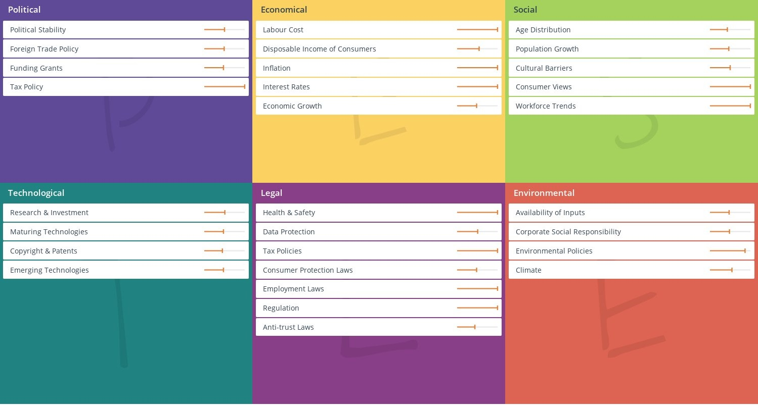
SWOT Analysis
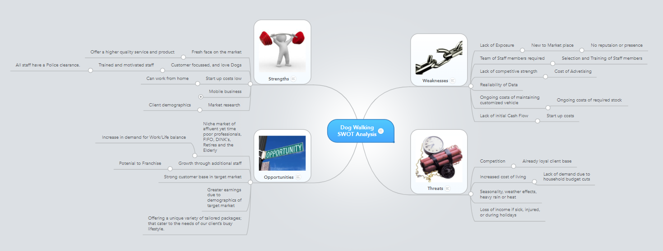

Organisational Timeline
Our overall business goal is to establish our dog walking services business as the leading dog walking brand in the pet industry throughout London and the United Kingdom within the first five years of operations, as well as to rank among the top ten dog walking services and pet related businesses in the United Kingdom.
Company Assets
We all have a Van each, so we have 5 vans in total with total value of £25k.
Supplier / Relationships
We came up with the idea of working with other business to build working business relationships so as a result, we've been talking to other businesses in the industry and negotiating so that we may benefit from one another's services and work together as partners to support and share our respective businesses in various parts of the country. Possessing a stake in all aspects of a corporation will assist in expanding our brand recognition and establishing long-term commercial partnerships.
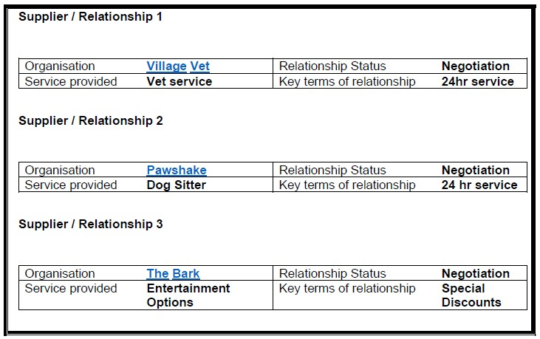

Company Business Insurance Plan B Option
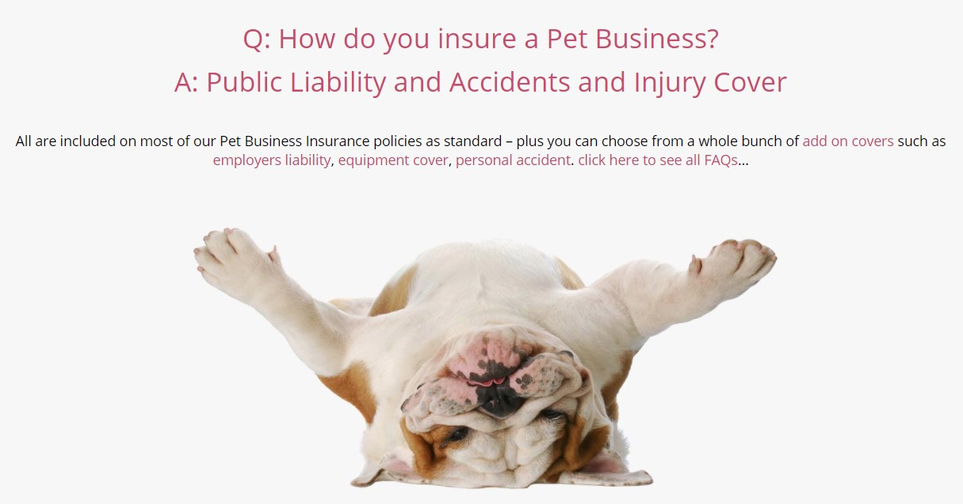
Pet Business Insurance
Insurance we have a few options and one of them is with Pet Business Insurance company who specialise in insuring businesses like ours in the pet industry, insurance would cover the following areas:
Insurance cover breakdown:
Public Liability Accidents | Employers Liability Insurance
Loss of Boarding Licence | Personal Accident Insurance
Event Insurance | Business Interruption Insurance
Loss of Money | Professional Indemnity Insurance
Travel Costs Insurance | Buildings Insurance
Equipment Insurance | Glass Insurance
Loss of Keys | Legal Expenses Cover
Injury Insurance | Animal Illness Insurance

Marketing – Everton

The Pet R Us dog walking service
Dog walking service – Dogs are picked up from customer homes by our dog walkers. They are either let in by our customers or, by way of a key safe (a product we will offer and install at a little cost to the customer) walked in local parks and green spaces. There will be a maximum of five dogs per walker or less if Council regulations do not permit.
All dog walkers will wear a video camera on their body when walking the dogs. This will enable owners to log onto a live video feed of their dog being walked. This will contribute to owners having high degree of trust in our service.
The business will begin by focusing on South-East London (London Boroughs of Southwark, Lambeth, Lewisham, Greenwich). The model will then be gradually rolled out over a two-year period to encompass all London boroughs.
Once the business has been established and the relevant training/certification has been administered to all dog walkers and other employees, additional services will be offered. These will include
- Grooming, claw clipping and dental care
- Overnight stays in the homes of walkers and other carefully vetted dog lovers
- Installation of key safe service [ provided and carried out by our company Pets Rus].
- Dog behaviour training
- Pet Hotel accommodation [future venture]

Market Analysis and Needs

London has the smallest percentage of dog ownership per household in the UK, however, 9% of London households have a dog. There are 251,000 households in London with a dog, they have on average 1.4 dogs per household (Alexander, 2020). The Pet Food Manufacturers’ Association found in a recent survey that 35% of young people aged 24 - 35 had either got a new pet or were planning to get one. With Londoners being the most likely to acquire a new pet. This is potentially enthusiastic news for a business such as ours.
10% of dog owners have paid for dog walking, rising to 20% of dog owners aged 16 – 24. 7% of dog owners have paid for pet sitting (Pickwick, 2018).
The potential market for dog walking in the London area is therefore 25,000 households. Our prospective target customers are young, affluent professionals with disposable income. My research has shown that this demographic is leading others in the purchase of dogs and are likely to use our dog walking and potentially our other product and service. The covid 19 pandemic has caused an increase in pet ownership.
“People are increasingly treating their pets as humans, relying on them for companionship and gaining a sense of fulfilment from needing to be needed as they look after their pets. They want their pets to feel cared-for, comfortable and mentally stimulated. So, there is driving demand for added-value products, often mirroring mainstream human styling and healthcare trends. As a result, people are prepared to pay more for their pet care products and to replace them more often.”
Jane Westgarth, Senior Market Analyst, Mintel 2015 (Anon., 2021)

The market and competitors

I have researched other dog walking companies to look at the size of the market and scrutinize the competition. Also, to find what type of services, they offer, both in terms of similarities and differences, to see what we could learn from these companies. This research has been extremely useful for information and SWOT analysis for our business, and our competitors.

Surveys & questionnaires

A survey was created using Survey Monkey. It was distributed on Next Door a hyperlocal social media site for neighbourhoods as well as on Facebook and WhatsApp.
The questions asked were as follows.
Dog Walking survey
Thank you for taking part in this short survey. It should take about 2 minutes to complete, and all answers are anonymous and confidential. Your help is very much appreciated.
(On reflection because my survey was presented on social media. I could have worded the questionnaire differently. Allowing it to be directed specifically at dog owners).
- How often might you use a dog walking service?
The thought behind this question was to establish and get a clearer indication of how many times in a week potential customer would use our service. Also, to see how we can plan our marketing strategy for budgeting purposes.
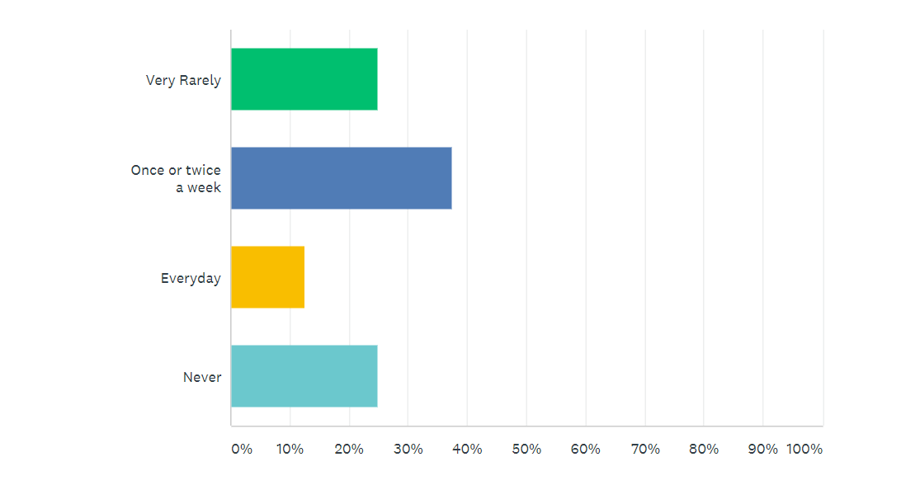
To get an indication for budgeting and strategic purposes I added this question. This enabled us to get an idea on how often potential customers may use this service.
- How much would you be prepared to pay, per one-hour walk?
Many other dog walking services have different pricing per hourly rate. With the information I retrieved from the survey we can have a more informed estimate of how to, budget, pricing and cashflow forecasting.

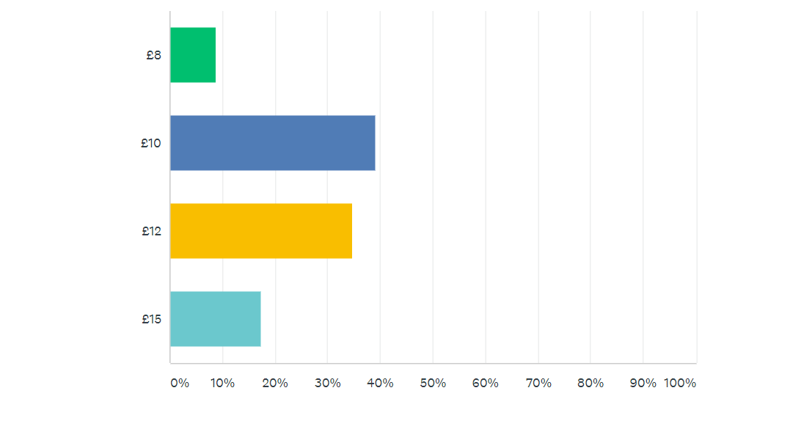

- Would you be happy to give a key to a dog walking service?
The question above relate to access to the dog or dogs. Because one of the services we offer will be installation of a “lock box” or key safe. We would like to know how and who to market this product and service too.
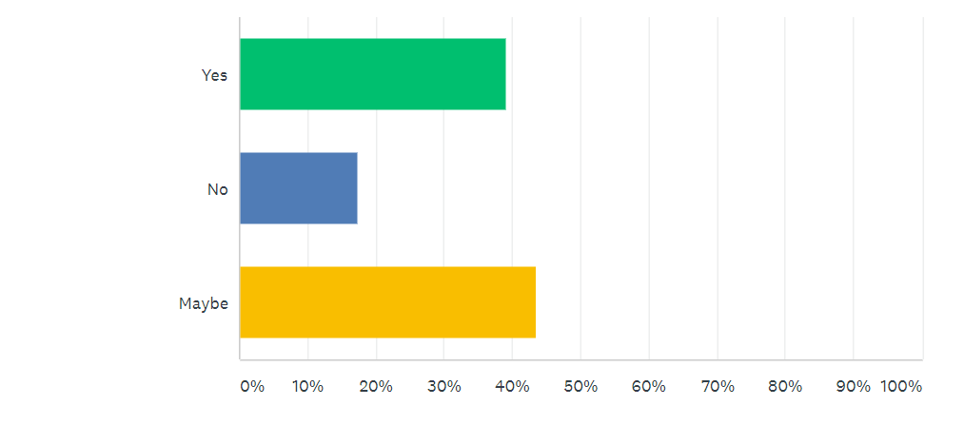
4. Please list below any concerns you might have with using a dog walking service.
My research shows that many prospective users of the service have few concerns however, I have listed below some of the issues they have expressed. These include.
Dog safety is our number one priority as some dogs are of pedigree and very expensive to buy
Insurance and appropriate dog training certificates
Mistreating my dog, allowing my dog to hurt someone
How much experience or training the dog walker has
- Does your dog have any special requirements?
Yes, he is not sociable with other dogs and needs behaviour support
NO food or treats not given by me
Nervous dog
Always needs to be on a leash
The following questions on age and gender will give us more understanding of our potential clients.
The age bracket is important to us because we can target our potential customers through social media and localised marketing i.e. community notice boards, leafleting.

6. Please tick your age bracket
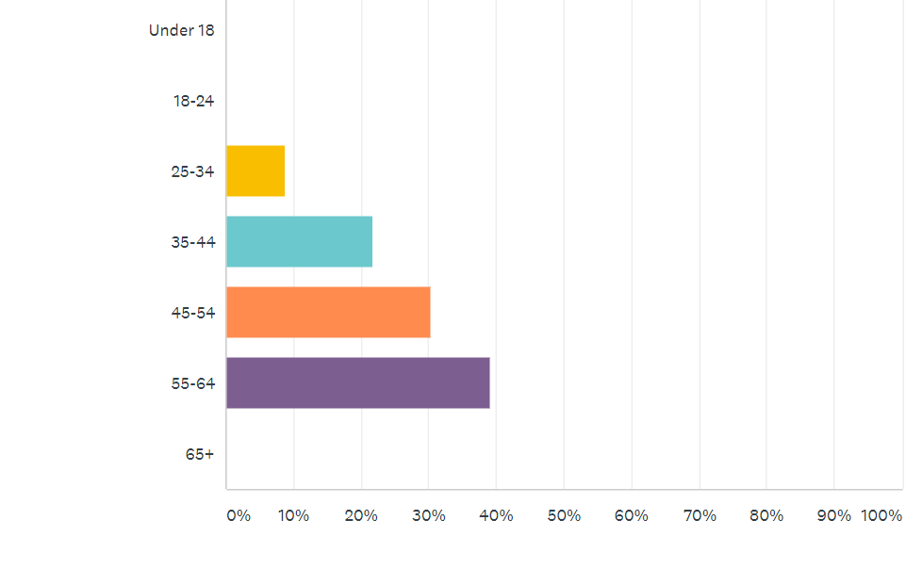
7. Please tick your gender
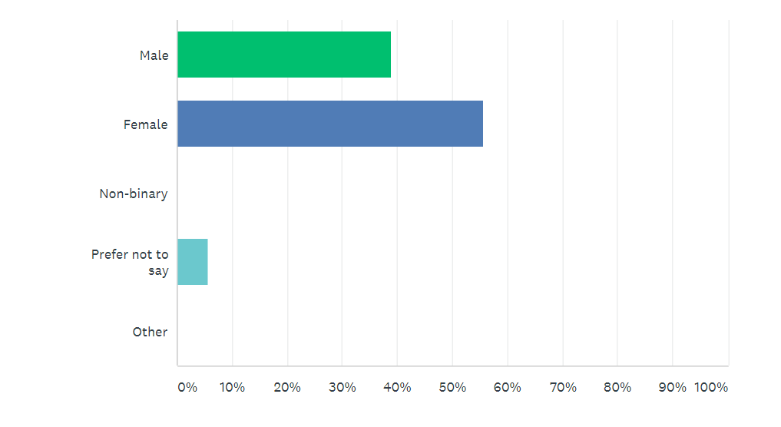

Competitor analysis using the swot analysis

Competitor 1
Rover.com platforms
STRENGTHS  There are low overheads as they provide a platform for dog walkers to advertise i.e., an app, but don’t provide the service directly.  Individual dog walks mean more attention per dog.  The dog walkers are self-employed.  Lots of walkers and capacity.  Offer range of services.  Cover all Greater London. | WEEKNESS  There is no corporate consistency as your contract is with an individual walker.  Quality control limited.  They say they complete background checks but it's not clear what this means.  Some areas might not have a dog walker.  This company’s dog walkers need to provide their own insurance.
OPPORTUNITY  People are returning to the office and therefore needing dog walking.  With Brexit, a lot of people have moved and are still moving away from England back to other parts of Europe. | THREATS  Freelance dog walker may lose dogs or other public relation disasters.  Dog gets injured during a walk or may be entangled in a flight for example.

Competitor 2
https://pawsapp.co/
STRENGTHS  Attractive graphics on website.  Low investment model.  Individual dog walks mean more attention per dog. | WEAKNESS  Very few walkers.  Not very clear website, hard to read text.  Many areas will not have a dog walker.
OPPORTUNITY  People are returning to the office and therefore increasing the need for a dog walking service  There is a pool of people wanting casual freelance work. | THREATS  They fail to sign up sufficient new dog walkers in the area dog lives.

Our Company
Pet R Us
STRENGTHS  Body cams worn by walkers means owners get instant feedback on walks.  Corporate image with uniforms and visible colours and logo.  All licences and insurance policy in place.  In touch with local authority regulations.  Salaried dog walkers mean more reliability, control, consistency. | WEAKNESS  After the first year our overheads will increase and a great deal higher than a lot of our competitors.  Not so flexible in terms of geographic area.  Business is more region specific.
OPPORTUNITY  Increased demand as people return to work outside of the home.  Since covid there has been a rise in dog and pet ownership. | THREATS  Business fai that people are using to find out about your business offering one second once I've got I've just gotta get a pen arcals to raise sufficient investment.  Insufficient promotion and advertising would mean fewer customers.

Situational analysis

Research showed that there has been a substantial increase in dog ownership amongst young people who are now return to work in offices and other places of employment. This is our target customer.
It is important to find out which media is being consumed by our target customer. This allows us to reach them effectively while not wasting money by reaching people that have no interest in our service, for example people who have no dogs (Blythe, 2011).
We know that this young demographic are big users of social media. Instagram and TikToc are the platforms most used by this group, although Facebook and Twitter are still an important part of the social media mix consumed by this group. This type of advertising will enable the company to have a larger profile and reach out to a targeted demographic. Whilst making constant changes to our profile, keeping our ads up to date and relevant.
The young demographic we are targeting are confident internet users and when looking for a service such as dog walking will use Google to find a company or service.
YouTube is often consumed more than the main TV channels by young people. This offers the possibility of making short videos on subjects that appeal to potential customers, that include promotional material.
Print media is not that important to this group, however, for older potential customers local newspapers may be a way to reach them
Leafleting local areas and will inform clients you live in the areas we are working to our business. Many councils don't allow leafleting in local parks. However, leafleting will be carried wherever possible and business cards will be handed out to people who ask and whilst selling the business to possible suppliers and prospective clients.
Advertising in dog journals, events, and dog exhibitions like the Kennel Club [Crufts]. Placing notices up in pet shops and supermarket noticeboards etc. Advertising [print, radio, and local Newspapers]
Objectives

The marketing objectives are:
- Make dog owners in the area we are operating aware of the dog walking service
- Make dog owners feel comfortable and secure about leaving their pet in our hand (and in some case their key)
- Make dog owners feel that the service offers good value for money and that it is a service they can afford
- Promoting the business so that it grows across London boroughs over time

Budget

Media | Monthly budget | Annual budget
Google ads | £200 | £2400
TikTok ads | £100 | £1200
Instagram ads | £100 | £1200
Facebook ads | £100 | £1200
Flyers printing and distribution | £500 | £6000
Sponsorship of local events e.g., school fairs | £300 | £2400
Ads in dog journals | £100 | £1200
TOTAL | £1400 | £16,800

Strategy

We will start with leafleting in the areas where we are starting our dog walking service. This very local focus will ensure we are best placed to be able to collect dogs. We will then follow this up with a social media campaign that is focused on target locations and individuals who have a known interest in dogs.
By introducing vouchers or discount codes on different advertising platforms, it is possible to track which platforms are generating the largest response to our advertising. Social media sites such as Facebook, Instagram, YouTube, Tik-Tok and Twitter, etc. have the facility that enables us measure ‘click-through’ and can see the amount of people engaging or linking through to our website. Allowing us to track the success of our campaign or see where it can be improved. (Blythe, 2011)

Sample Promotional calendar
January | Launch of service in Lambeth  Leafleting in local area
February | Social media campaign focused on individuals interested in dogs in Lambeth
March | Launch of newsletter on website, aim to grow number of subscribers to 200 by May
April | Launch of service in Southwark  Leafleting in local area
May | Social media campaign focused on individuals interested in dogs in Southwark
June | Launch of YouTube channel with dog training tips short videos with link to website
July | Launch of service in Greenwich  Leafleting in local area
August | Social media campaign focused on individuals interested in dogs in Greenwich

Operations - Apostol

The first and most important relation we are aiming at in our business is with the local community and particularly working dog owners knowing about us and rely on our service.
One way to achieve that is thru advertising in local newspaper or in social media or local radio. Another efficient way as the business grow is to develop mobile application that will allow us to take payments and provide services and allow customers to access us much easier and convenient.
Having dog at home is one of the best things, but in today extremely busy daily routine is something that turn joy of owning dog to something annoying and displeasure when need to walk it at the evenings after long and stressful day at work.
Our goal is to create and develop service that will take the experience of owning dog to next level.
Taking away not so pleasant long walks from owners which have no time for that, making sure the dog receives all the exercise he needs, also all that done in convenient time for the owner and without sacrificing evenings or other time when dog can be with his owner.
Building trust in our service is the most important goal for us as many dog owners, if not all, do not see them dogs as pets, but as family members. Taking diligent care and making everything possible for dog to feel happy will give the owners piece of mind and will lead to more customers starting to use our service.
In this type of business, the best recommendation is the one given from happy dog owner to another who is not so familiar with us yet. We are relying on friends telling friends, parents telling children and work colleagues recommend us to each other.

Second but not less important is comfort and wellbeing of the dogs, as every one of the dogs has different personality. We as a company will provide personnel that is well trained and fully committed to the best for the dogs. Taking in consideration all circumstances and individual needs of the dog, also breed, temper and age of every dog and work for best result.
For example, German shepherd will require a long walk and a lot of exercise, on opposite French bulldog will need to be watched carefully to not overheat and much less walk is enough for him. All that knowledge in dog breeds will guaranty that our company will succeed in business we are starting.
Picking up the dog from home and transporting it to the playground is another one of our services we are going to offer. Well-equipped small vans will be used for the safe transport of the dogs. All our drivers will be checked for clean driving licence with no offences on the road.
In case that owner will require long day of dog exercise or just he need the dog to be away for a day for some reason we will provide that service at additional cost as this will bring some extra expenses for us. In the future, as the business grow, taking dogs for overnight stay will be another addition on what we offering as service, so day stay of dogs is natural transition to that.

The insurance we are gone need as start of business is by PETPLAN, and it is quite easy to obtain. As it is saying in the policy:
Petplan Sanctuary dog walking insurance provides £5m of public liability cover; £100,000 of professional indemnity as standard; £10,000 of key cover; £1,250 of insurance for dogs in your care, custody, and control and £10,000 in respect of negligence claims (known as custodial responsibility).
One of the benefits of the Petplan Sanctuary policy is that you do not have to be sued by a pet's owner for the policy to pay out, any communication from the owner claiming negligence can be forwarded for consideration.
There is also the option to add £10m of Employer's Liability cover for an additional premium.
The annual cost for our dog walker is £129.80 - or £12.98 per month over 10 monthly interest-free payments.
The price rises to £185.80 when you add £10m of Employer's Liability insurance covering up to 10 people as standard.

Source: Pet plan sanctuary (2021)

Another important operation we need to establish it is supply of quality food and treats for dogs as everyday need of that is vital for our business.
Dog food suppliers are going to be local and established as reliable and trustworthy. We need our supplier to be on time and correct with deliveries, as our business is very sensitive in that matter. Being local supplier will guarantee us we will not paying large amounts of money for deliveries, and we will have option to immediately fill out any shortages that happened unexpectedly.
Quality and choice of different dog food will give us advantage to our competitors as we will offer healthy diets and any requirements from owners can be met, even the ones that’s been rejected by competing dog walking companies. We need to do that to build customer base and happy and satisfied dog owners. Having dogs on special diet and strict daily intake is something we will look at very seriously and responsively. All our dog walkers will be briefed by us after owner issue us his requirement about the dog needs and diet.
Daily prestart briefings with all staff will be held to avoid any mistakes and misunderstandings, and to be sure every dog will receive the care he will need during daily exercise. Having that in place and no mix up happened ensure dogs are well looked after and at the end of the day or just walk they will be returned home safe and in good health.
As the business grow and we can afford larger premises and significant office staff and computing power, we will have data base in place for our existing customers; their requirements, dog specific needs, dogs’ diet and any other additional information that can help our business grow and make our customers happier with service we provide.
Knowing all previous practises and learning from past experiences, will help us understand and analyse future market and possibilities to expand our venture.
We explain advertising, practises, insurance, and the way we going to operate, adding to all that our commitment to be the best in business we also can offer to our customers some not so popular but needed and demanded by smaller group of wealthier dog owners such as: in house dog care when owners are away on holyday or business trips, special training for guard dogs, grooming and even preparation on healthy diet for the dog .
As the owners wish the best for them dogs, and todays understanding of healthy eating, composing diet that is good for your pet and if you can afford it also, is one side of the business that can be significant profit making for us.
That will require us hiring nutritionist, but that will guarantee to us no diet is done inappropriate and it will be complete and right for every individual dog.
We also cover emergency pickups and dog staying overnights as in life there is so many occasions when dog owner has some emergency and there is no one to live the dog to. As dog cannot take care of themselves, we are going to be the one that our customers can rely upon. That service being emergency also will give us some extra income at higher rates.
Almost all advertising on internet about overnight stay did not specify prises as is saying price on request. This is one very sough after service and very profitable segment of business. We will charge more owners which are not our customers, but we will have special price for existing customers.
Using all financial motivation tools available, we can offer different price packs for service we provide. More hours, less hourly rate. More different aspects of our plans used, less for any additional one.
As standard we can establish monthly fee for certain hours of walking and depend on how many hours, the fee will be higher for more and lower for less hours walking the dog. In this case we will have guaranteed income from the fees on which base suppliers and staff can regularly be paid from these funds available. Also, we will know all our customers paying the monthly fee are satisfied and happy to continue with our service. Having the money in advance will help immensely to business at the beginning and guarantee there will not be any service and walk not paid for.
Using the fee system allow us to understand the pattern of our clients’ habits and needs, and we can create even better and efficient way of work, which will help our company to grow faster and more efficiently. Minimizing unnecessary expenses and waste of time and money it what we are aiming for, as any start up business can suffer or even go bust if money shortage become issue.
In the process of crowing as business we will invest in improved premises and very well maintained and structured organisation of work process adding more staff and expanding beyond area, we start our venture. That will allow us to gain more customers and will increase income, but also better organisation will be needed.
All our dog walkers will be trained and will be holding license needed for the job. Only the ones with good recommendations and proved to be exceptional in them work will be hired by us. Our goal is to provide the best service at the best price and that dictate best work force in place. Understanding what the goals of the company are and being loyal and trustworthy, accomplish every walk and bringing happy and healthy dog home is something every one of our dog walkers should aim and achieve every day. The walkers also will hold dog walking first aid diploma as the accidents happened and we need to be sure all dogs can be helped in the best possible way.

Technology and Corporate Social Responsibility (CRS) – Georgel

Business plan for a company dog walking business has been discussed in this assignment. However, this business has great aims and some objectives, by which it will be the richest pet industry in the UK. Thus, the start-up expenses of the business for next 3 years have been forecasted. Based on this, the company will provide the services and offers to the customers. Proper technological plans, management and organizational plan and CSR need to be maintained, by which dog walking companies can create proper B-plans for the future. Thus, the market trend and market strategies need to be followed for becoming the greatest services provider. However, with competitive edges, employees’ salaries as well as financial requirements have been discussed, which will be required for the B-plan of dog walking business in the UK.
Technology plan

A technology plan is a specific type of strategy plan that lets an organization know where they are now and where they want to be some time in the future with regard to the technology and infrastructure in their organization. It often consists of the following sections
To be able to keep up with the fast-developing technology and people needs, Dog Walking will implement different technological strategies for their customers:
- Create a business website, with easy access and smooth navigation for all the visitors interested in Dog Walking.
- Develop a tailored App that will be easy to download on any smart device, easy to navigate and make bookings and payments. This will also include customers account with safe stored personal details and preferences.
- Create business accounts on Social Media platforms, to reach a wider audience and keep the followers updated on the latest services and events.


Based on the analysis, it can be observed that various kinds of significant marketing strategies need to be used by the businessperson of the dog walking business. However, according to this analysis, it can be observed that this dog walking business want to provide high quality services to the customers of UK, who are literally dog lovers and use dogs for professional purposes. As well as there are some customers who want to care about their dogs, however they have too busy schedules and health issues, by which they cannot provide proper training to their dogs. However, this dog walking company will use various significant technologies, by which they can reach their customers to provide quality service (Fichter and Tiemann, 2020).
This dog walking company needs to create their “own business websites' ', in which they are able to provide online services to the customers. A positive impression can be achieved, which will make the business more successful. At those websites, the company can provide their company details along with their services details, by which visitors and customers can easily connect with the company for getting services. In simple words, through this “business websites' ', the dog walking company is able to engage with their potential and target customers digitally. Customers can book their appointment with the company due to various purposes just like dog training, exercising and others through using the “tailored mobile app” (Jiaet al.2021). This app is too effective for increasing the service efficiency as well as scalability. Mobile apps are too flexible for maintaining and tracking all services. It will also be effective for receiving customer feedback about their service quality, which can attract new customers in coming days.
Thus, it has been recommended to the dog walking company for opening the “social media business accounts” for connecting with the potential customers. The social awareness will be increased about the services and immense potentiality. Advertising can be easy due to these social media accounts, by which the engagement of potential customers can be increased through offering various company offers, according to the analysis, it can be said that the pet industry has increased tremendously in the last few years, the “dog walking business “can be consistently enhanced as well as its services. Thus, through disturbing the research of the UK pet industry, the “dog walking services” are the most successful services in the UK.

Management and Organization Plan

The success of our company depends on the business structure of the organization and the people who occupy the available business, will build a solid business structure that can support the growth of our dog walking services. We will work hard to ensure that we only attract people with the right mindset to help us achieve our business goals and objectives in record time. Below is the business structure that we will use to build our dog walking company:

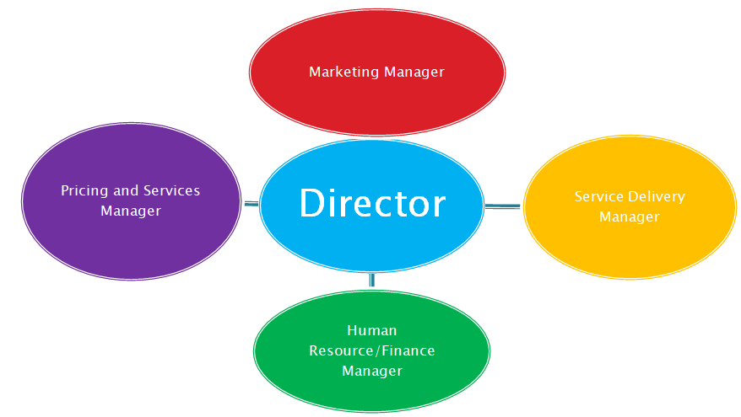

Director – Ibrahim: make the strategy and operational decisions of the company and responsible for ensuring that the company meets statutory obligations.
Marketing Manager – Everton: helps to increase sales and growth for the company, handles general merchandize of pet related products (pet foods, shampoos, dog chains).
Prices and Services Manager – Apostal: Identify the best pricing for the company product or service offerings, analyze industry trend and current events.
Service Delivery Manager – Georgel: focuses on keeping clients satisfied with the company’s services through fixing any reliability issues and helping lead the professionals responsible for getting services delivered to the clients.
Human Resources/Finance Manager -Ramila: responsible for overseeing the smooth running of HR and administrative tasks, regularly hold meetings with key stakeholders (client and member of the organization’s board) to review the effectiveness of the company.

Management

UK market analysis is important for making the plan for management and organization. According to this analysis, the organizational structure if dog walking company will be cleared. Through those structural entails, the active and significant person, who will play a great role in the Business plan of the dog walking business can be informed. According to the analysis, it can be known that there are various level managers and front-line staff, who will be involved in this Business plan of dog walking. However, those managers are just like: Marketing managers, Pricing and services managers, service delivery managers, financial management and human resource managers, who will play key roles in adequate management, proper reputation management and financial forecasting for appraising the start-up funds and expenses.
Through their involvement, a plan needs to be made, by which the strengths, weaknesses, opportunities, and threats of the company will be identified. In simple words, the objectives of the dog walking company will be cleared, by which the activities of the B-plan can be prioritized easily, and the goals of the plan can be achieved. Thus, through this management plan, they have the aim to provide quality and excellent services to the customers through online or walk to customers home, who will not come to the center for various purposes (mitre.org, 2021). Thus, to fulfill this plan, they need to make a proper financial plan and financial requirements plan, by which the sales profit, all maintenance costs and next 3 years profit will be forecasted properly. Due to this plan, the dog walking business can profit £ 20K per month and sales of the company will increase by 15% per year.
The “dog walking services' ' of the company has the target to provide services to those customers, who generally remain on a busy schedule. Apart from these, there are many customers, they cannot go to the company due to their health issues (Vidal, 2017). This company will provide the services to walk to the customers home, by which the dogs of customers can get proper training, “exercising, feeding, and other veterinary services”.
Social Responsibility and Sustainability (SRS)
Corporate Social Responsibility (CSR)
Definition: The self-made business model that will help Dog Walking business be socially responsible towards its customers, its employees and all people involved within the business (Investopedia, 2021).
CSR importance: Dog Walking will be socially responsible by operating in ways that the community and the environment will not be affected but benefit from its services (Investopedia, 2021).
Why to implement CSR: Many companies view CSR as an integral part of their brand image, believing that the customers will be more likely to do business with brands that they perceive to be more ethical. In this sense, CSR activities can be an important component of corporate public relations, at the same time, some company founders are also motivated to engage in CSR due to their personal convictions.
Sustainable development is important and best for dog walking companies. This development can impact on the economy of the company in a significant way. It indicates the dog walking business needs to use the “Self-made business model”, by which the dog walking business can become socially responsible and beneficial, by which customers can get the quality services. According to this business transformation and “sustainable approach” the management of the
The dog walking business can be beneficial. Due to this social responsibility, the dog walking business can achieve “long-term value”. Those are just as follows:

- Implement an ethical business model: this will encourage all employees to act on issues such as ethics, values of the business, the planet, diversity, respect for each other and promote a great customer service.
- Create a Health and Safety plan for the business: that has set clear requirements from the employees so that work environment is safe for the staff and the customers. It will also comply with the legal business requirements.
- Use marketing strategies that bring social responsibility awareness to the audience and employees: avoid averts that could be misinterpreted, manipulative and damaging to the public and the planet. Respect any social responsibilities outlined for Dog Walking company to avoid criticism and reputation damage.
- Environmental business commitments: adopt and promote different policies and practices within the business activity that are environmentally friendly: sustainability report, use recycled materials, not use paper, use electronic systems only, manage wastage.
- Through maintaining these CSR strategies, the dog walking business will be effective in resource management, by which the amount of operations cost can be redacted and maintained.
- The company will be effective in risk management also along with the issues of economic, environmental, and social.
- The modern challenges as well as potential threats can be reduced through following this CSR strategy, by which sustainability of the company can be increased and the company will be socially responsible and prove beneficial services.
- Select suppliers that are CSR friendly: only get materials from suppliers that have social responsibilities that they follow, are using recycled materials and goods, are environmentally friendly, clarify Dog walking business expectations.
- Consider B Corp certification: B Corps companies have a reputation of being beneficial companies as they bring revenue and other benefits to the community within. They are transparent and take accountability for their services and action and have a positive impact on the public and the environment (BDC, 2021).

Finance – Ramila

Concept and objectives of the business
The business concept of Pets R Us Dog was developed to provide service to the customers for their dogs. According to our market research, during pandemic, lots of people bought pets to keep them occupied and entertained. Now the pandemic is coming to an end and whoever bought pets need a home for them to look after and walk them while these people go back to work. Puppy visits are based on the duration and offered to dogs who are fully completed all their vaccinations, without completing the vaccines dogs can’t join any walking groups or even have contact with other dogs (Johnson, Beck, and McCune, 2011). We also offer service where we come to your own house for the day to look after your dog and that would include 2 to 3 walks during the day and basic training will also be given.
Objectives
Short Term objectives of the Pets R Us Dog Walking services are to develop some service in the new industry of dog walking.
We wanted to increase the usage of dog walking with the local community.
We ensure different services at low costs.
Long term objectives: we will focus on their long-term business reputation and want to create a brand in the UK market. Some other objectives are as follows-
We establish their branches in different locations in the UK.
we will focus on improving the market shares.
We will provide 24/7-hour service for their customers.
Sources of Finance
Sources of finance is an important aspect of a business and refers to various sources of funds for intimating and incorporating the business properly. The sources of funds are two types one is internal source and external source. Here we will discuss the source of funds in an accompanying way-
Internal sources- These are the main motivation to start and operate a business properly when people have savings and initial capitals to start a new business, we can start with screening some ideas. Internal sources include the owner’s savings, cash and other resources that can be used as funds for the organization. Pets R US Dog Service has its own £100,000 for the business.
External sources of funds- Besides the owner’s savings, cash and other resources as funds, organizations can use external sources to collect funds and capital for the business. External sources of capital need to pay interest against the amount collected. Here we will explain some external sources we used in Pets R US Dogs walking services.
Borrowing from Banks- When the business operates in the market, we can borrow short term and long-term loans from different banks. We collected a loan from investment banks of £1.000
Investors Investment- When the business can successfully execute its plans and market receives its services positively, we will get large investors. They help start-up new ventures by providing capitals and management services with some control. They provide a large amount for the organization.
Products/ services of the company
This business is based on experience, with professional and very friendly employees they are fully insured, and police checked with the canine first aid certification. Pet 'R Us Dog offers services that are high quality, professional services is friendly in the UK for their customers. If customer satisfaction level is very high and service range is also large in comparison to other competitors. The services of Pets R Us Dog walking services are as follows:
Dog Walking and Sitting- Dogs love walking, and we make sure the dogs can stretch their legs effectively while we have them (Johnson, and Meadows, 2010). We provide group walking, dog sitting collection and delivery services for the customers, our services are undoubtedly reliable and professional.
Dog Day care- We have a nice dog day care centre for our customer’s. We leave dogs to occupy themselves with other dogs while out on their walks (Thorpe, Christian, and McCune, 2011). A structured day is arranged in our secured park, and they will enjoy the woods and have lots of playtime in the countryside.
Vision and vision statement of the company
The vision is long term target of the business organization and specifies the company’s target after a long time of operation. The vision of Pets R US Dog walking Service is to establish its brand in the market of the UK as it serves local customers. These services are not very popular to all the citizens of the UK and the company is now trying to reach out to large number of customers to give their dog all the services related to them. The service offered by Pet R Us Dog are very effective to the people who works and wants to travel on the weekends.
Vision statement- companies operate their business with a vision statement that attracts customers. We also have a vision statement that attracts customers to give us their dogs and we care for them effectively with low cost compared to other companies. The primary vision statement is to provide all the facilities to your dog and bring you happiness in their leisure. This statement tells us the basic type of services and features our company offers, in short.
Skills and Experiences of our employees
We established our company 2021 with 5 partners who are experts in different fields. We all have an equal share of 16% in the company and our aim to get another investor for another 16% share which equals to £8,500. We have a range of services that give people opportunities to see how our service work in the comfort of their own place, as well as parks. Our employees have training, skills and provide a suitable and caring environment for dogs. Here we will discuss employee’s skills and experiences in an accompanying way-
Chief operating office- The main role played by an operating officer is to manage all the departments and they combine all the actions of departments for achieving the objectives of the business. The owner of the business has experience doing these kinds of jobs.
Finance and Management- Finance department is the leading part of maintaining the finance and flow of cash of Pets R Us dog walking service. Management and finance department would merge their tasks for the manpower in their first year.
Target Customers
Target Customers of Pet R Us Dog walking service, are limited and we offer most services that are offered in the UK.

Personal survival Budget
To be an effective entrepreneur and business planner, must have some kind of skills and a large number of experiences. There will help me to figure out problems and prospects in my business operations. The personal survival budget of mine will show the surplus or deficit after completing one financial year. When I started the business as Pets r Us dog walking services, I had to leave my job and fully concentrate on my business (Richards, and troped, 2013). The business from starting will not provide me with earnings. Thus, my living costs will be given to my savings and cash on hand. The personal survival budget shows the owners personal oncomes and expenditure except from the business’s income and expenditures. As a person the owner a have some expenditure such as family expenditures, children school fees, and medical, communication and utility bills and so on. Thus, all the expenditures for the owners are subtracted from the earnings of the owners. As a manager of a business, we will get salaries beyond the profits of the business and we also have other earnings sources, the total amount will be £100,000.
Operation plans
The operation plans are needed to ensure different physical necessities of the business and it is concerned for the business operation such as operation management, cash management, TQM and supplier management.
Operation management- The operation management of Pet R US Dog walking service is strictly managed by management and CEO oversees all the activities properly. All application and tracker system for the operation and supply and distribution channels are tracked by management.
Total Quality management - The quality of the service needs to be managed by the quality manager. They develop new service and qualify the managers. They need to ensure the quality of service and raw materials, machines and tools and other necessary things.
Cash management - Finance department of the company manages the cash for operating and covering the liquidity effectively. Company spends huge amounts in advertising to reach a large number of customers and become popular to the people of the UK. They efficiently manage the capital and cash for facing the future challenges.
Break even Analysis
BEP is a term in accounting that mainly refers to the financial situation where our company’s revenue and expenses are equal within a specific time period. Where no profits or losses occurs for the organization. Pet R Us Dog Walking Service Company is planned to enter the market with its capital, employees, borrowings, and other resources that are helpful to the success of the organization, but future is always uncertain. The business plan is developed by making market research for the products market gains (Kampf, Majerčák, and Švagr, 2016). The skilled and trained employees will make it within very short possible time. Within 1 years of operations, it will reach break-even point as sales forecast saying it generally has sales from 3 major services amounted 90,000. That means it will take 1 year to reach break-even point.
Sales Forecast
According to our market research, during pandemic, lots of people bought pets to keep them occupied and entertained. Now the pandemic is coming to an end and whoever bought pets need a home for them to look after and walk them while these people go to work. Based on this research I have forecasted my revenue to go up by £150.000 and we are going to employee more to balance with the workload and out projected cost will be £15.000.
In the first year we loss £11.000 and according to my prediction, we are going to break even by mid of 2022 and we are to make a profit of £11.000 at the end of the year.
According to my cashflow, I have a positive cashflow at the end of the year which put us in a great position.
According to the projected profit and loss account, we will have a net profit before tax £200.000 which would be added to our share capital of £50.000. So, the total equity of the whole business will be £250,000 in 2025.
We are working together with our local community as we have very good social responsibility and sustainability plan set out by my HR department. By looking at our marketing strategies and operations plans of my colleagues, we are a good company with great ideas and plans. Our projected budget plans are based on actual market research and its forecasts 30%-35% net profit by the end of 2025. We are going to take into consideration, government tax rebate plan for small businesses.
Our long-term goal is to expend the business and become a reputed company in the U.K. I therefore, would like to invite you to invest in our company to benefit both parties in this business.
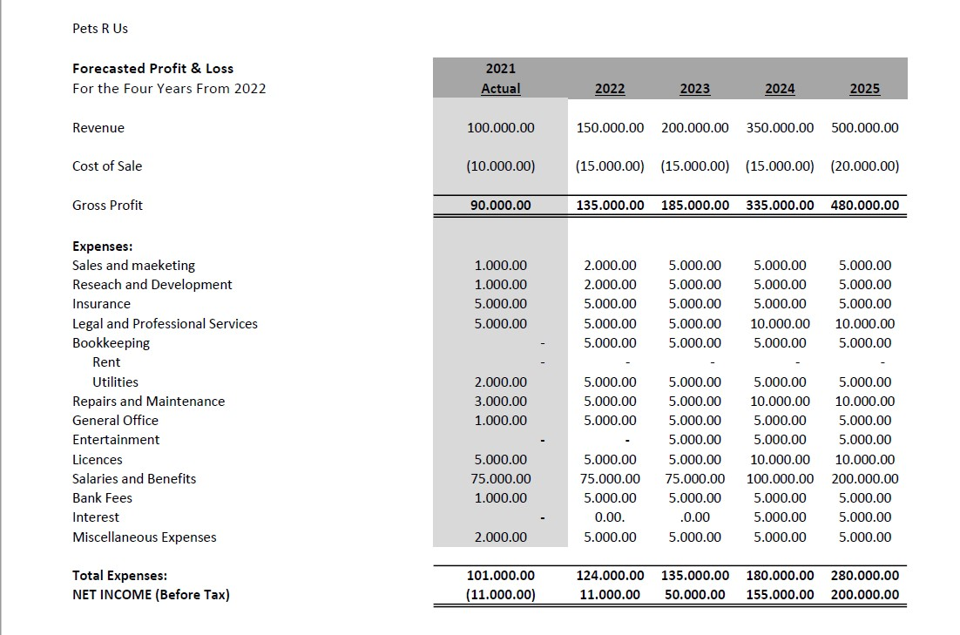

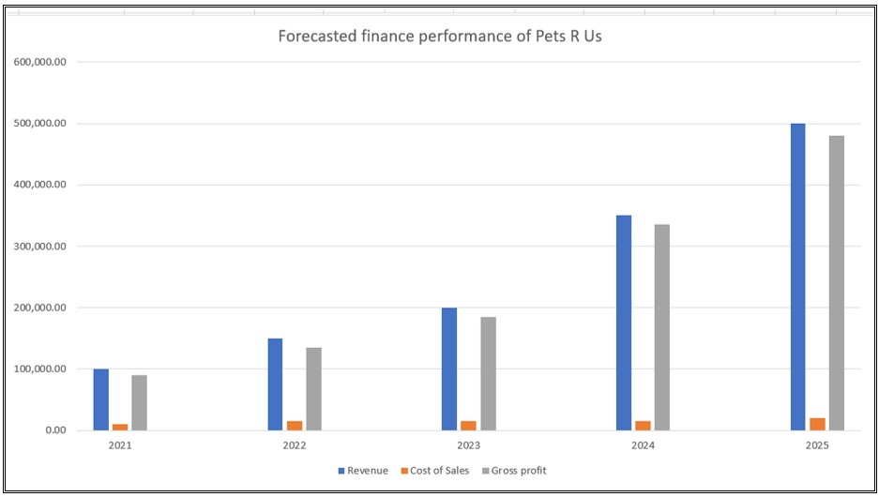

Concepts and Objectives of the Business
Pets R Us Dog Walking Services is a business the concept and allows people to offer a range of services for their dogs such as walking and home sitting them.
These services help people to go on vacation and travel without having tension for their dogs (Thomas, Christian, and McCune,2001).
We offer situation and duration basic services to the customers.
The business plan is developed to increase the interest of people to increase the usage of dogs in their house.

Sources of Funds
Internal sources - We collect funds from internal sources such as savings and cash on hand of the owners.
External sources - Large numbers of external sources are available to invest in the business and want interest as well as ownership by getting shares.
Bank Loans - It is a common and highly used source of funds for the business organization.
Investor’s investment- Investors invest their money, resources, and management capability into a business by getting management and controlling rights.

Conclusion

To summarise, if we organise and adhere to our business strategy precisely, we have a good chance of succeeding and prospering as a firm. Organizing all the various elements and operations will require staff and management to perform at their best, but will ensure that the business not only survives, but also expands, since our service will be one of the best in the trade and very competitive in the price market.
The business plan is the fundamental part that demonstrates to the businessman where to go, how to get there, and where we are. We require a business strategy to achieve success by combining our talents with those of our employees and establishing ourselves as a market leader. In this research, we examined several parts of a business plan that are critical for starting and growing a business. Funds, marketing analysis, a personal survival plan, and a break-even point are all critical components, and successfully executing these plans will result in market success. Advertising, structuring, personnel management, and every other aspect of our company policy will be of the highest quality, and all of the above is something that everyone of us as partners will strive for. Each of us will be responsible for a particular area inside our organisation, ensuring that no task is left unfinished or neglected.
Dog walking is a task that requires passion throughout the day, as dogs are treated as family members by most of our customers, who will want only the very best for their pets.
As said previously, our firm is here to remain and expand, to ensure the success of all partners, to provide some consistent revenue, and to allow each of us to achieve what we want as a business.

References

References – Ibrahim
- CIPD (2020) Pestle analysis. Available at: PESTLE Analysis (Accessed: 17 August 2021).
- CIPD (2020) SWOT analysis. Available at: SWOT Analysis (Accessed: 17 August 2021).
- Pawshake (2021) Dog sitting and Pet Sitting. Available at: Pawshake.co.uk (Accessed: 18 August 2021).
- Pet Business Insurance (2021) #1’s for Dog Walking & More. Available at: Pet Business Insurance (Accessed: 16 August 2021).
- The Bark (2021) Dog Is My Co-Pilot. Available at: The Bark (Accessed: 17 August 2021).
- Village Vet (2021) Special vets for special pets. Available at: Village Vet (Accessed: 18 August 2021).

References – Everton
- Alexander, I., 2020. Pet Magnet. [Online]
Available at: https://petsmagnet.co.uk/blogs/news/pet-dog-population-in-the-united-kingdom-of-great-britain-and-northern-ireland?_pos=1&_sid=110393cf4&_ss=r
[Accessed 26th July 2021].
- Alexander, I., 2020. Pets Magnet. [Online]
Available at: https://petsmagnet.co.uk/blogs/news/pet-dog-population-in-the-united-kingdom-of-great-britain-and-northern-ireland?_pos=1&_sid=110393cf4&_s
[Accessed 26th July 2021].
- Anon., 2021. Groom Arts. [Online]
Available at: https://groomarts.com/student-advice/marketing-insights
[Accessed 26th July 2021].
- Blythe, J., 2011. Essentials of marketing communications. s.l.:FT Prentice Hall.
- Pickwick, K., 2018. Pet Business World. [Online]
Available at: https://www.petbusinessworld.co.uk/news/feed/pet-market-set-to-smash--2bn-barrier
[Accessed 26 July 2021].

References – Apostol
- Business plan for dog walking company template. Available at: Dog Walking Service Business Plan Sample Template (startupback.com) . (Assessed on 31.08.2021)
- Dog walking services. Available at : How To Use Go Walkies App – GoWalkies.(Assessed on 29.08.2021)
- Dog walking application. Available at : How To Use Go Walkies App – GoWalkies .(Assessed on 29.08.2021)
- Dog walking insurance. Available at: Dog Walking Insurance | Petplan Sanctuary .(Assessed on 28.08.2021)
- Dog walking license. Available at : Animal Care Courses | New Skills Academy . (Assessed on 30.08.2021)
- How to start dog walking company. Available at : How To Start A Dog Walking Business | Mint Formations . (Assessed on 31.08.2021)
- How to do advertising and best ranking in advertisement online. Available at: Helping You Get More Local Customers - Ranking Academy . (Assessed on 31.08.2021)

References – Georgel
- “Corporate social responsibility definition”. Available at URL: https://www.investopedia.com/terms/c/corp-social-responsibility.asp. [Accessed on the 15th of August 2021].
- Cotton, M.M. and Dark, G., 2017. Use of technology in tax administrations 1: developing an information technology strategic plan (ITSP). United States: SA International Monetary Fund.
- Ferreira, F.M. and Pinheiro, C.R.M.S., 2018. Circular Business Plan: entrepreneurship teaching instrument and development of the entrepreneurial profile. Gestao&Producao, 25, pp.854-865.
- Ferreras-Garcia, R., Hernández-Lara, A.B. and Serradell-López, E., 2019. Entrepreneurial competences in a higher education business plan course. Education+ Training. Available at https://www.emerald.com/insight/content/doi/10.1108/ET-04-2018-0090/full/html [Accessed on 18.8.2021]
- Fichter, K. and Tiemann, I., 2020. Impacts of promoting sustainable entrepreneurship in generic business plan competitions. Journal of Cleaner Production, 267, p.122076. Available at https://www.sciencedirect.com/science/article/pii/S0959652620321235 [Accessed on 18.8.2021]
- Jia, C., Ding, H., Zhang, C. and Zhang, X., 2021. Design of a dynamic key management plan for intelligent building energy management system based on wireless sensor network and blockchain technology. Alexandria Engineering Journal, 60(1), pp.337-346. Available at https://www.sciencedirect.com/science/article/pii/S1110016820304063 [Accessed on 18.8.2021]
- Mateu, M., Cobo, C. and Moravec, J., 2018. Plan Ceibal 2020: future scenarios for technology and education—the case of the Uruguayan public education system. European Journal of Futures Research, 6(1), pp.1-12. Available at https://eujournalfuturesresearch.springeropen.com/articles/10.1186/s40309-018-0134-z [Accessed on 18.8.2021]
- Technology plan for dog walking businesses”. Available at URL: https://sitstay.com/blogs/good-dog-blog/adding-technology-to-dog-walking. [Accessed on the 15th August 2021].
- Vidal, D., 2017. Fail to Plan, Plan to Fail: How to Create Your School’s Education Technology Strategic Plan. United States: Rowman& Littlefield.
- www.profitableventure.com

References – Ramila
- Apte, and Davis, (2019). Sharing economy services: Business model generation. California Management Review, 61(2), pp.104-131.
- Cafferky, (2010). Breakeven Analysis: The definitive guide to cost-volume-profit analysis. Business Expert Press.
- Christian, Giles-Corti, and Knuiman, (2010). “I'm just a'-walking the dog” correlates of regular dog walking. Family & Community Health, 33(1), pp.44-52.
- Chung, Niu, and Sriskandarajah, (2012). A Sales Forecast Model for Short‐Life‐Cycle Products: New Releases at Blockbuster. Production and Operations Management, 21(5), pp.851-873.
- Cui, Hastak, and Halpin, (2010). Systems analysis of project cash flow management strategies. Construction Management and Economics, 28(4), pp.361-376.
- Dickinson, (2011). Cash flow patterns as a proxy for firm life cycle. The Accounting Review, 86(6), pp.1969-1994.
- Johnson, and Meadows, (2010). Dog-walking: motivation for adherence to a walking program. Clinical nursing research, 19(4), pp.387-402.
- Johnson, Beck, and McCune, (2011). The health benefits of dog walking for pets and people: Evidence and case studies. Purdue University Press.
- Kampf, Majerčák, and Švagr, (2016). Application of break-even point analysis. NAŠE MORE: znanstveni časopis za more i pomorstvo, 63(3 Special Issue), pp.126-128.
- Richards, and Troped, (2013). Psychosocial and environmental factors associated with dog-walking. International Journal of Health Promotion and Education, 51(4), pp.198-211.
- Thorpe, Christian, and McCune, (2011). Dog walking as physical activity for older adults. The health benefits of dog walking for pets and people. Purdue Univ. Press, West Lafayette, Indiana, pp.75-88.

Power Point Presentation Copy



