Financial Management for the Hotel Industry
Finanacial assessement for Jury’s Inn

Name:POONAM KC
Student ID Number:2012450
Course: Financial management for hotel industry
Course code: BMIH50017
Lecturer's Name: DALE CLARKE
Date:16/02/2022

Table of Contents
Task-1 3
(a) 3
Jurys Inn P/L Account 3
As of 2018: 9
Current Assets = £2152000 9
Current Liabilities = £888000 9
Inventory = £750000 9
Quick ratio = £2152000 - £888000/£750000 = 1.6853 9
(iii) Cash Ratio 9
Financial leverage ratios 10
b) Discuss why an understanding of ratios and their fluctuations is essential for Hotel management in analyzing the information seen in their financial statements. 11
c) Discuss the benefits and limitations of using ratio analysis to aid decision making within the hotel and tourism industry 11
References 12

Task-1

Jurys Inn P/L Account
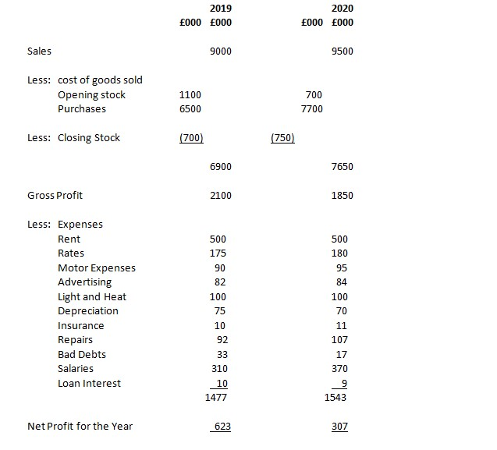
Balance Sheet at 30th May

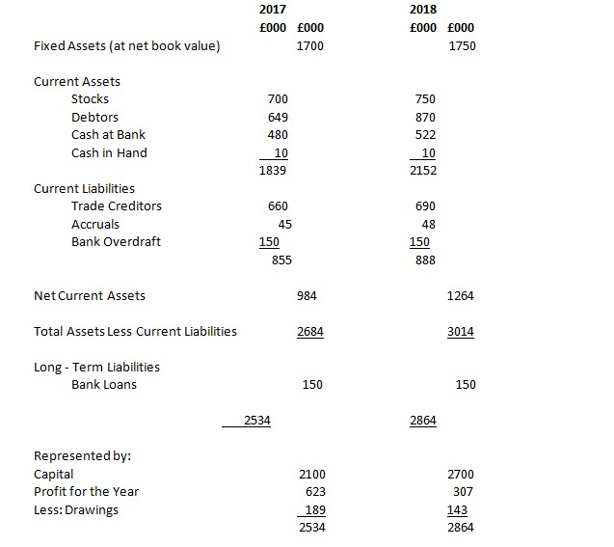
Ratios and calculations
Formula | Ratio | 2019 | 2020
Gross Profit/Sales * 100 | Gross Profit Ratio | 5050/5500*100=91.82 | 5150/5000*100=85.83
Net Profit of the year/Sales * 100 | Net Profit Ratio | 4008/5500*100=72.87 | 4073/6000*100=68
Net Profit of the year+Loan Interest/Total Assets Less Current Liability * 100 | ROCE Ratio | (4000+20)/6226*100=65 | (4073+18)/6274*100=65.21
Sales/Total Assets Less Current Liability | Total Assets Turnover Ratio | 5500/6226=0.88 Days | 6000/6274=0.95 Days
Sales/Net Profit Assets | Working Capital Turnover Ratio | 5500/1726=3.19 | 6000/1624=3.70
Current Assets Total/Current Liabilities Total | Current Ratio | 3065/1339=2.29 | 3240/1616=2
Current Assets Total- Stock/Current Labilities Total | Quick Ratio | (3065-1450)/1339=1.20 | (3240-1420)/1616=1.13
Debtors * 365 days of the year/Sales | Debtor Days Ratio | 1600*365/5500=106 days | 1800*365/6000=129 days
Trade Creditors * 365 days/ purchases | Creditors Days Ratio | 800*365/500=584 days | 870*365/850=373 days
(Total Current Liabilites + Bank Loan)/(Total Current Assets+Fixed Assets)/Divided By Another One | Debt Days Ratio | (1339+150)/(3065+4500)=0.20days | (1616+145)/(3240+1650)=0.22 days
Net Profit of the year + Cash in hand/Loan Interest | Interest Cover Ratio | (4008+5)/20=200.65 | (4073+5)/18=226.58

(i) Profitability ratios:

Net Profit Margin = R – cost of goods sold – E – I – T × 100/R
= Net Income × 100/R
Where:
R = Revenu.
E = Operating and other expenses
I = Interest
T = Taxes
According to Jurys Inn’s 2019-20 P/L account

As of 2019:
Revenue (Net sales) = £9000000
The cost of goods sold = £6900000
Operating and other expenses = £1467000
Interest = £10000
Therefore, R – COGS – E – I – T = £9000000 - £6900000 - £1467000 - £10000
Net Income (Net Profit) = £623000
Hence, Net Profit Margin = £623000 × 100 = 6.92%
£9000000
As of 2020:
Revenue (Net sales) = £9500000
COGS = £7650000
Operating and other expenses = £1534000
I = £9000
Therefore, R – COGS – E – I – T = £9500000 - £7650000 - £1534000 - £9000
Net Income (Net Profit) = £307000
Hence, Net Profit Margin = £307000 × 100/£9500000 = 3.23%

Net profit is calculated by deducting all of the company's expenses from its total revenue. For 2019, the net profit margin was 6.92 percent, while for 2020, it was 3.23 percent. Profit in 2020 (£9500000) is larger than 2019 (£9000000), although the cost of products sold (from £6900000 to £7650000) has increased from the former to the latter. In 2020, gross profit is expected to fall from £2100000 in 2019 to $1850000 in 2020.
Inefficient management in 2020 and inadequate pricing tactics from 2019 to 2020 are to blame for the Jurys Inn hotel company's 3.69 percent decline in net profit margin. Jury Inn's profitability is expected to diminish from 2019 to 2020 as a result of this dip.

(ii) Gross Profit Ratio
Gross Profit Margin = R − COGS × 100/ R
= Gross income × 100/R
Where:
R = Revenue
COGS = The cost of goods sold According to Jurys Inn’s Profit and Loss account;
As of 2019:
Revenue (Net sales) = £9000000
The cost of goods sold = £6900000
Therefore, R – COGS = £9000000 - £6900000 =
Gross profit = £2100000
Hence, Gross Profit Ratio = £2100000 × 100/£9000000 = 23.33%

As of 2020:
Revenue (Net sales) = £9500000
The cost of goods sold = £7650000
Therefore, R – COGS = £9500000 - £7650000
Gross Profit = £1850000
Hence, Gross Profit Ratio = £1850000 × 100/As of 2020:
Revenue (Net sales) = £9500000
The cost of goods sold = £7650000
Therefore, R – COGS = £9500000 - £7650000
Gross Profit = £1850000
Hence, Gross Profit Ratio = £1850000 × 100/As of 2020:
Revenue (Net sales) = £9500000
The cost of goods sold = £7650000
Therefore, R – COGS = £9500000 - £7650000
Gross Profit = £1850000
Hence, Gross Profit Ratio = £1850000 × 100/£9500000 = 19.47%
The net revenue is subtracted from the cost of goods sold (COGS) to arrive at the gross profit margin percentage of a business. Divided by net sales, the gross profit margin is expressed as a percentage. For 2019, gross profit margin was 23.33%, and for 2020, it will be 19.47%. Because of bad management, this volatility has occurred. Alternatively, operational changes to the hotel business model might have been to blame. For instance, in 2020, purchases are expected to rise from £6500000 in 2019 to £7700000. A new business strategy that calls for greater stock or even speculative acquisitions owing to predicted shortages may have led to this surge.

(iii) Operating Ratio
Operating Ratio = OE + COGS × 100/R
According to Jurys Inn’s P/L account;
As of 2019
The cost of goods sold = £6900000
Net sales = £9000000
Operating Expenses = £1467000
Therefore, OE + COGS = £1467000 + £6900000/£9000000 × 100
Operating ratio = 92.97%
As of 2020:
Revenue (Net sales) = £9500000
The cost of goods sold = £7650000
Operating Expenses = £1534000
Therefore, OE + COGS/R = £1534000 + £7650000/£9500000 × 100
Operating ratio = 96.67%
Managers and analysts can look at the operational ratio to see if the company is good at controlling its costs and making money overall. In 2019, operating expenses will make up 92.97 percent of Jury Inn's net sales, and in 2020, they will make up 96.67 percent of net sales. Both of these percentages should make you think twice about what you're going to do. These two ratios show that the company's costs are higher than its ability to make enough money, so it may be called inefficient. It's clear that the company is on the verge of bankruptcy because this measure is a typical way to figure out how well it manages its money and resources. The rise in operating ratio from 2019 to 2020 shows that the hotel chain's finances are getting worse.

Liquidity ratios

Current Ratio = Current Assets/Current Liabilities.
According to Jurys Inn’s Balance Sheet
As of 2017:
Current Assets = £1839000
Current Liabilities = £855000
Current Ratio = £1839000/£855000 = 2.1509
As of 2018:
Current Assets = £2152000
Current Liabilities = £888000
Current Ratio = £2152000/£888000 = 2.4234
This is a common way to measure how much money you have. In other words, it tells you if the company has enough money now to pay its debts for the next year. If you look at the current ratio, you can see how much "cover" the company has for every dollar that it owes money to other people. In 2017, the Jury's Inn retail chain had £2.1509 in current assets to cover every £1 in debt. In 2018, that number rose to £2.4234, which is more than twice as much. It's possible that a low current ratio (less than 1.0-1.5) means that the company can't pay its bills. If you need to pay off debt, you might need to borrow more money or make the repayment period longer. The current ratio of a company should be between 1.7 and 2.0 to be seen as good. It means that the company has enough money to pay its bills, but not so much that it can't be reinvested or given to shareholders. Is there a perfect current ratio? No, not at this point. When the Jury Inn hotel retail chain has enough money from its current assets to invest, reinvest, or give to its stockholders, this is an example of how it can do that It is able to do so because of where it is right now.

(ii) Quick Ratio/Acid-Test Ratio
Quick Ratio = Current assets – Inventory/ Current Liabilities
According to Jurys Inn’s Balance Sheet;
As of 2017:
Current assets = £1839000
Current Liabilities = £855000
Inventory = £700000
Quick ratio = £1839000 - £855000/£700000 = 1.4057

As of 2018:

Current Assets = £2152000

Current Liabilities = £888000

Inventory = £750000

Quick ratio = £2152000 - £888000/£750000 = 1.6853

It's easy to see how well a company meets its current obligations without having to sell more products or raise more money. If this indicator is positive, an organisation has enough short-term assets to pay its current debts. This means that if the ratio is £1 or more, the company can meet all of its upcoming financial obligations. This means that in 2017, a company had £1.4057 worth of current assets for every $1 worth of debt. This year, the quick ratio is £1.6853, which means that a company has £1.6793 in current assets for every $1 it owes in the short term. In this way, the network will be able to pay off the retailer's creditors.

(iii) Cash Ratio
Cash Ratio = Cash and Cash Equivalents/ Current Liabilities
According to Jurys Inn’s Balance Sheet
As of 2017:
Current Liabilities = £855000
Cash and Cash Equivalents = £490000
Cash ratio = £490000/£855000 = 0.5731
As of 2018:
Current Liabilities = £888000
Cash and Cash Equivalents = £532000
Cash ratio = £532000/£888000 = 0.5991
The cash ratio is the most common way to measure a company's ability to pay its debts. This is a sign that a company can pay all of its current creditors without having to sell or liquidate any more assets. For a ratio of 1, the company can start paying off its debts with the same amount of money and money equivalents it has now. In both years, the Jury inn's ratio for cash and cash equivalents is less than 1. It shows that short-term debt can't be paid back. As long as the company's financial statements aren't distorted by things like long-term credit terms with suppliers, well-managed inventory, and limited consumer credit, these things might be good for the company.

Financial leverage ratios
(i) Debt Ratio.
Debt Ratio = Total Liabilities/ Total assets
According to Jurys Inn’s Balance Sheet
As of 2017:
Total liabilities = £1005000
Total assets = £3539000
Debt ratio = £1005000/£3539000 = 0.284
As of 2018:
Total liabilities = £1038000
Total assets = £3902000
Debt ratio = £1038000/£3902000 = 0.266
A debt ratio is a financial measure that shows how much debt a company has. The debt-to-asset ratio of a business is what we're talking about here. To put it another way, it means that the company has more obligations than assets if its assets to debts ratio is greater than one. In some cases, a company with a lot of debt may be forced to stop paying its debts. In a company with a low equity-to-debt ratio, like Jury Inn, the stockholders fund more of the assets.

b) Discuss why an understanding of ratios and their fluctuations is essential for Hotel management in analyzing the information seen in their financial statements.
Financial ratios can be used to look at a company's debt, liquidity, and profitability. If you want to compare businesses in the hospitality industry, it's hard because there are so many different types of businesses in this field. A few examples of these are hotels, tourist attractions, and event venues. When comparing financial ratios, you can do this in the following ways.
(i) Through an analysis, we can figure out how efficient hospitability businesses are.
If you have this information, you can compare the performance of your company to that of other businesses in your field. It looks at how well a company's assets can make money. Efficiency ratios are very important because they show how profitable a business is, which is why they are so important ( Brigham & Houston 2021).
(ii) Financial reports and data are looked at and interpreted in this way.
Understanding a company's financial statements as a going concern is important for everyone who works for an organisation. Because not everyone involved has a lot of experience with finance, financial statements may be hard to read and understand. With the help of efficiency ratios, problems can be solved now (Mueller & Sensini, 2021). These financial ratios make a lot of information easier to read and understand.
(iii) Identifying the parts of hotel businesses that are financially risky.
Companies can use ratio analysis to figure out how much money they need from outside sources and whether or not they can pay back the loan with their own money. It is possible for analysts and investors to see a pattern and use it to make predictions about what will happen in the near future. People outside the company, like investors, can also use it to make important decisions.

c) Discuss the benefits and limitations of using ratio analysis to aid decision making within the hotel and tourism industry

Advantages
Allows the company to plan for the long term. Ratio analysis helps you understand and predict how a company will make money and be successful in the future (Titman & Keown, 2018). There are ratios that can be used to predict the company's future financial statements, budgets, and operations by looking at previous financial statements. These ratios can be used to figure out what the company will do next.
- Hotel and tourism businesses are compared in a report.You can use ratio analysis to compare the strengths and weaknesses of different businesses. In order to see if the company has made progress, the ratios may be compared to the company's previous ratios.
- Determines the profitability and liquidity of the company.Financial measures are used to show how well a business can make money. Also, they show how quickly a company's assets or securities can be sold for cash. With this information, you can see how the company's income changes because of its fixed costs and debt.

Limitations
(i) Oversimplifies financial facts in a way that isn't correct.One number or several numbers may not be enough to put in context or compare across time or sectors if they are used on their own.
(ii) Inadequate attention to other important factors.You may not think about important things like a company's brand, connections, abilities or corporate culture if you use ratio analysis to figure out how well it is doing. For long-term success, it is important to think about things that aren't usually included in financial records.

References
Brigham, E. F., & Houston, J. F. (2021). Fundamentals of financial management. Cengage Learning.
Mueller, A., & Sensini, L. (2021). Determinants of Financing Decisions of SMEs: Evidence from Hotel Industry. International Journal of Business and Management, 16(3), 117-127.
Titman, S., & Keown, A. J. (2018). Financial management: Principles and applications. Pearson Education, Inc..
Vivel-Búa, Milagros, Rubén Lado-Sestayo, and Luis Otero-González. "Risk determinants in the hotel sector: Risk credit in MSMEs." International Journal of Hospitality Management 70 (2018): 110-119.

