Impact of Virtual Learning Environment (VLE) – Moodle on the Learning Experience of Students at the University Of Wales Trinity Saint David London Campus

DSRM Component 2

Name:Mohammed Ashraful Mowla
Identification Number: 1922118
Module Name: Digital Skills and Research Methods
Module Code: BMSW4003
Lecturer:Husam Alharahshed

Submission Date:05/01/2021

Abstract
This research aims to measure the VLE’s impact principally Moodle on the students’ learning procedure at the University of Wales Trinity Saint David London Campus. For measuring the effect, primary and secondary research has been used. For the primary research, information is accumulated through a random sampling procedure from the London Campus’s 60 students. This information was evaluated through data visualization instruments. For secondary research, data are collected from relevant journals, articles, various books, etc. Primary and secondary research shows that VLE has a major effect on the students’ learning experiences. These platforms raise the flexibility, accessibilities plus assist the learning in the traditional ways. Though VLE platforms faced many difficulties it can be handled by putting additional discipline plus methods in place to raise the students’ learning experiences.

Table of Contents
Abstract ii
Introduction 1
Research Preliminaries 2
Aims and objectives of the research 2
Research Questions 2
Rationales of the Research 2
Scope of the Research 3
Literature review 4
Research Methodology 5
Ethical Issues 5
Primary Data Analysis 6
Benefits plus challenges analysing 6
Questionnaire analysis 7
Conclusion 11
References 12
Appendix 13

Introduction
VLE or Virtual Learning Environment is a technology for education that is an internet-based platform because of the digital perspective of the study’s course, generally within the organisation of the education. Curriculum maps, communication medium, learning tracker, content management, materials which are supported by the online, etc. are included in the tools of the VLE (Becnel, 2019). Virtual Learning Environments generally offer some specific functions which are discussed here
- Planning as well as supervising the lessons by the curriculum maps’ aid.
- The study providing various digital resolutions such as; animation, documentation, etc.
- Discussion with the team and get an actual opinion on the lesson.
- Submit the assignments, tasks, etc. online.
- Arranging many live conferences.
- Recording the performance of the students.
In the abstract, it is said that the report aims to measure the VLE’s impact principally Moodle on the students’ learning procedure at the University of Wales Trinity Saint David London Campus. Moodle is principally a VLE platform based on the pedagogical principles which provides the opportunities of the e-learning together with a customary learning platform for the students(Almpanis, 2009).

Research Preliminaries

Aims and objectives of the research
This research report is made based on various specific plus general objectives. The key objective is to measure the VLE’s impact on the students’ learning experiences. This research takes an attempt to identify the respondents’ perceptions of the advantages as well as challenges about the platform of the e-learning. Without this, there has other research aims to acquire the following objectives.
- Recognizing the various VLE platforms’ aspects, VLE platforms’ activities as well as the procedure where universities work along with these platforms for providing the e-learning opportunities to their learners.
- Improving the managing knowledge of the data, for example; collecting the data, research, analysing, etc. through doing the primary research.
- Analysing the present literature for identifying the research on the VLE as well as improving these understanding.
- Generating new skills and knowledge about e-learning as well as fulfil the gaps in the present literature.

Research Questions
Based on the research objectives, this report gives the answers to some particular questions;
- Whether the platforms of the VLE, for example- there has a positive effect on the University of Wales Trinity Saint David London Campus students’ learning experiences.
- Whether these platforms provide an efficient opportunity for learning without any difficulties in any unexpected situation, such as; coronavirus pandemic.
- Whether there is s progress in the whole procedure of the e-learning.

Rationales of the Research
In recent times, virtual learning is a famous platform for higher education. This platform permits the students to design the procedure of the self-learning as well as provides various tactics to involve students and also makes sure their involvement in this learning procedure (Shandilay, 2018). This research tries to measure the VLEs’ efficiency chiefly incases the Moodle as well as the University of Wales Trinity Saint David London Campus. For the coronavirus pandemic, in the state, everything is a lockdown. So using these platforms are ensuring learning without any interruption for the learners. So it is required to measure whether Moodle provides an efficient opportunity for learning without any difficulties to the students.

Scope of the Research
In recent times, there have various VLE platforms but this research is conducted based on Moodle, an open-source VLE platform as well as the University of Wales Trinity Saint David London Campus’s students. This research directed is investigative nature’s theoretic social research on the VLE’s effect. Although the research has some limited scope, it is wished-for filling up the gap in the present literature as well as improves the supplementary research scope on the specific subject matter. It is identical research because there has not much research about Moodle’s impact on the students’ experience of learning at the University of Wales Trinity Saint David London Campus.

Literature review
VLE or Virtual Learning Environment is a technology for education that is an internet-based platform because of the digital perspective of the study’s course, generally within the organisation of the education. It is a portion of an organisation’s learning management system, extra customary learning in the classroom through leveraging the technologies (Becnel, 2019).
Gerrard(2007) examined the VLE’s trends as well as find out that traditional learning plus improvement attempts lacked the engagement’s quality. In the present time, the VLE platforms provide various opportunities plus tactics for engaging the students. Such as; learning based on the video, micro-learning, webinars, etc. and here LMS like Moodle provides various benefits- flexibilities, accessibilities, involvements, etc.(Panconesi and Guida, 2017).
Almpanies (2009) said that VLEs provide effortless entrée to the educational resources and also aids an interchange among learners and trainers through the assists of dialogue forums. Also, VLE aids to make the learners’ multicultural community by providing a range of extraordinary online courses.
Cole and Waston (2013) identify various challenges about VLE platforms. They said that, although VLEs provide plenty of flexibility, self-discipline shortage plus feeble inspiration can destroy the learning procedure. From the study, it is identified that using VLEs enhanced the students’ deceitful mentalities by 35%.
Iqbal, Saleem, Naseer, and Kim (2017) administrated research on a range of universities’ students and collected their opinions on the VLE platforms’ impact as like Blackboard, Moodle, etc. the result of the research is that almost 87% of the respondents identified that VLEs is more suitable because it is more flexible and easily accessible. 45% of respondents are outsiders and doing the job part-time. They graded flexibility and according to them, it is the most significant VLEs’ benefits.
Deng, Sun, Chen, and Yang (2019) administrated research where they identified that students of various universities thought that VLEs are not anti-social rather than they raised the social place inside the classroom through simulating commitment. As said by, VLEs are the unlimited interlinked educational assets’ centre and together they provided a pathway for formulating links, exchange contents for joint advantages.

Research Methodology
The research procedure is allocated into two portions- primary plus secondary research. Various books, journals, articles, etc. are accumulated plus assessed online and offline both for the secondary research. The secondary research’s outcomes are described in the part of the literature review.
Alternatively, primary research concentrated on the replies of the London campus’s students. Caused by the coronavirus pandemic and lockdown it is not possible to collect data physically. The data was accumulated online through Google forms assistance from the 60 students of the University of Wales Trinity Saint David London Campus.
Sampling methods: The information was collecting through the random sampling method. The sample size was 60 and they were students of the London Campus. For the survey, Google forms were uploaded in various groups, students’ forums and any classification was not present here.
Data Analysis: The collecting information was assessed through data visualization instruments. All the information is represented with the assists of graphs and also charts. Respondents were requested to rate Moodle’s challenges plus benefits that they thought very necessary.

Ethical Issues
This research was lead for retaining the subscript matters in mind for certifying the honesty.
- No persuasion such as; monetary or psychical was created in the data collection procedure.
- The procedure for collecting data was neutral.
- The collection of the data and their assessment were subjective. There have no biasness in the full research procedure.

Primary Data Analysis

Benefits plus challenges analysing
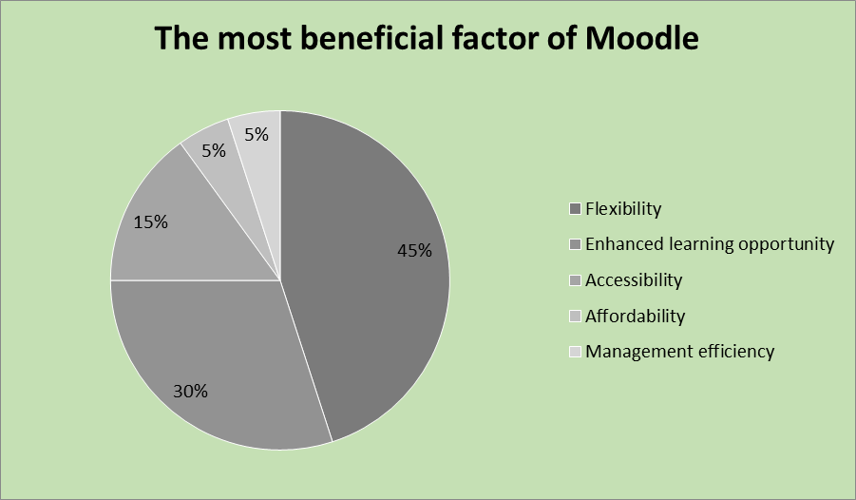
Figure 1: The most beneficial factor of Moodle, (Based on own analysis)
For rating the factors, there are used a 1-5 rating scale. Rating no 1 is least important and rating no 5 is most important. 45% of respondents have rated flexibility and 30% are rated to enhance the learning opportunities. It demonstrates that students are more interested to exercise Moodle for saving their time as well as to acquire the latest things in MOOCs plus another platform.
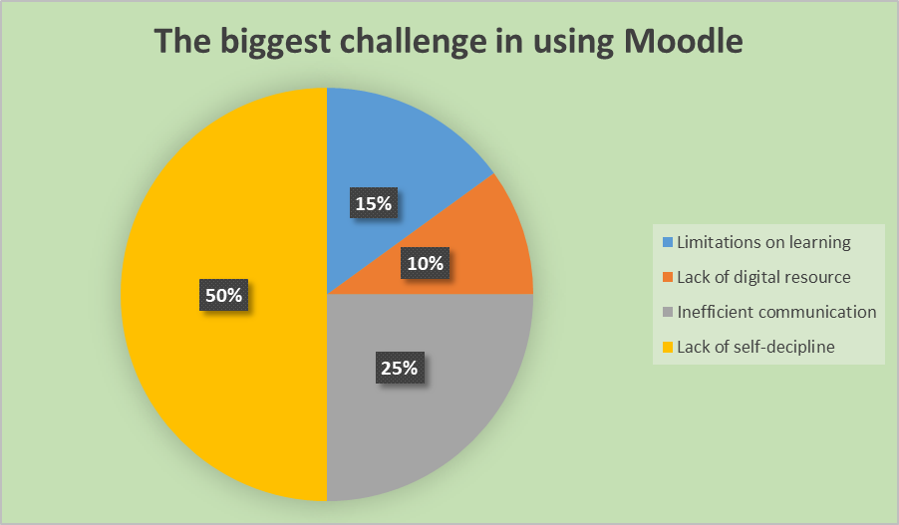
Figure 2: The biggest challenge in using Moodle, (Based on own analysis)
Conversely, the respondents have rated the factors about the challenges which are using in VLEs such as Moodle. 50% of the respondents are thought that lack of self-discipline plus weak inspiration is the most crucial challenge. 25% of respondents also thought that communication inefficiently plus the shortage of actual time opinions is another most crucial challenges.

Questionnaire analysis
10 statements are provided in the Google form where the respondents were requested for providing their opinions choosing an option within the 5 ranging from strongly agree to strongly disagree. Selected fundamental statements plus their evaluation are provided here and others are provided in a table as the summary.
Moodle provides Flexibility plus saves time for Students and Instructors both
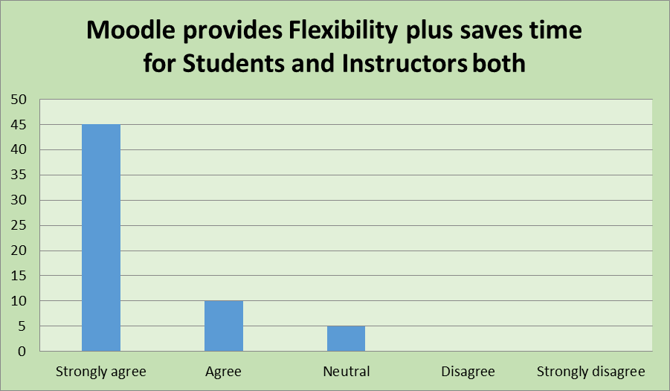
Figure 3: Moodleprovides Flexibility plus saves time, (Based on own research)
45 students from 60 students strongly agree that Moodle provides Flexibility plus saves time for students and instructors. Of 60 students, 10 students agree and 5 students are neutral about this statement. That means almost 92% of respondents are thought that Moodle provides flexibilities.
Moodle gives access to course-related Digital Resources effortlessly
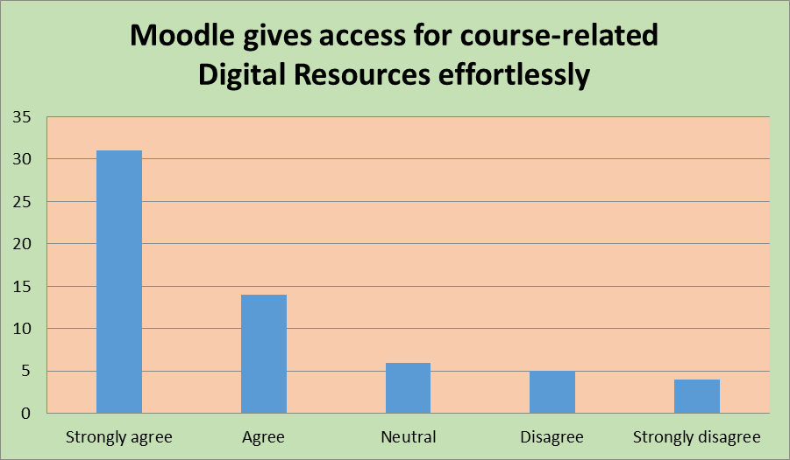
Figure 4:Moodle gives access to course-related Digital Resources effortlessly, (Based on own research)
Among 60 respondents, 31 respondents are strongly agreed about the statement that Moodle gives access to course-related digital resources effortlessly. 14 respondents are agreed and 6 are neutral about this statement where 9 respondents disagree about this statement.
The accessibility of the Moodle is easy
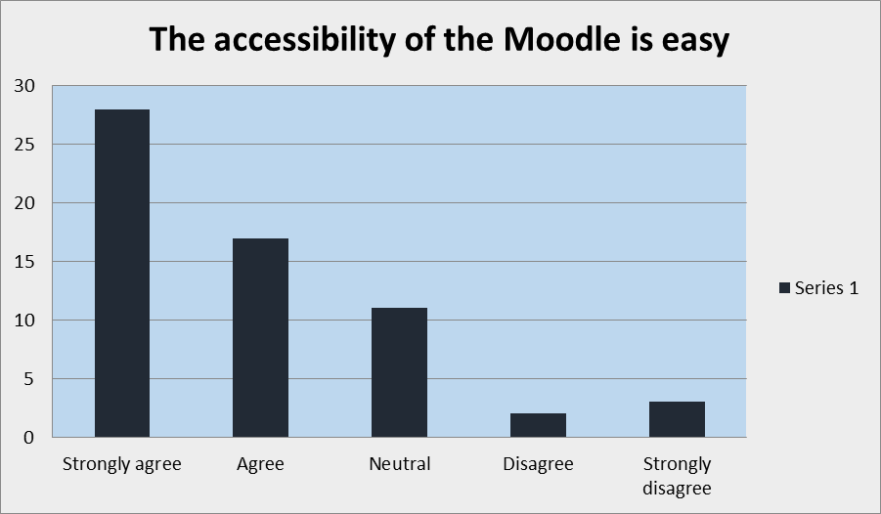
Figure 5: The accessibility of the Moodle is easy, (Based on own research)
Almost 74% of respondents are thought that the accessibility of Moodle is easy. Almost 9% of respondents are thought that the accessibility of Moodle is not easy.

There have an opportunity to cheat in a VLE as like Moodle
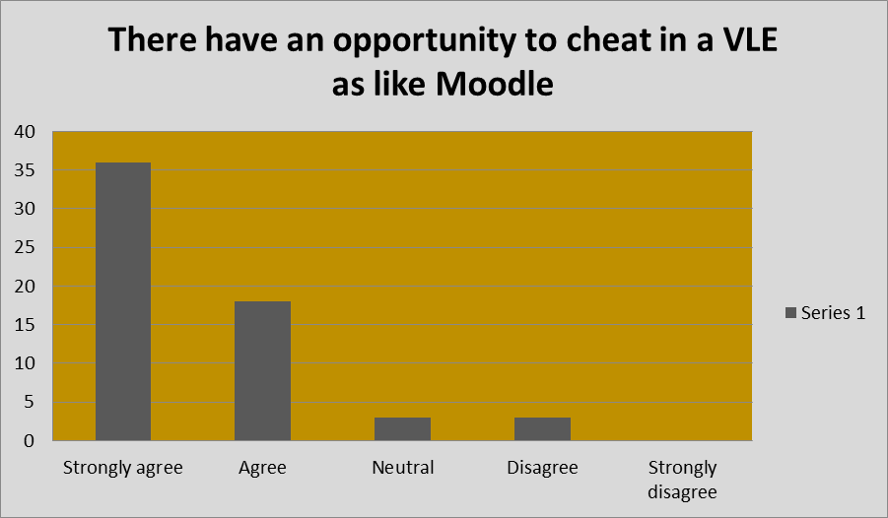
Figure 6:There has an opportunity to cheat in a VLE as like Moodle, (Based on own research)
In the statement, there have an opportunity to cheat in a VLE like Moodle, most of the respondents are supported this statement. 90% of respondents are thought that there has an opportunity to cheat, such as; performance plus activities tracing is somewhat unsuccessful.
Using Moodle diminishes the cooperation plus group mentality within the students
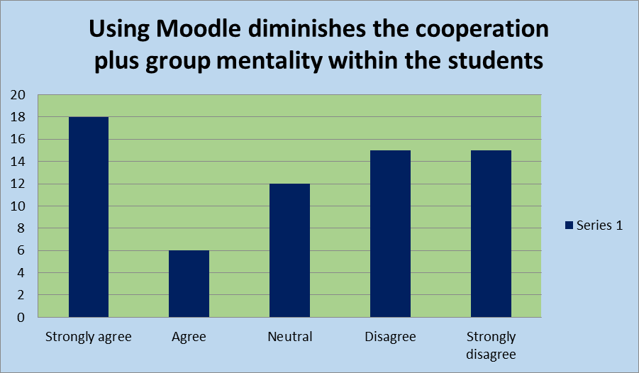
Figure 7: Using Moodle diminishes the cooperation plus group mentality, (Based on own research)
A total of 24 respondents thought that using Moodle diminishes the cooperation plus group mentality within the students where 12 respondents provide a neutral opinion. But 30 respondents directly disagree about this statement. They thought that using Moodle does not diminish the cooperation plus group mentality within the students
Moodle can improve essential technological skill
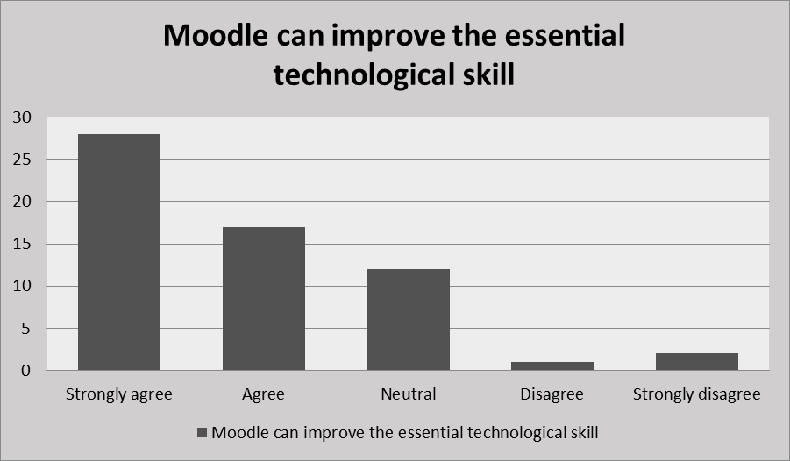
Figure 8: Moodle can improve essential technological skill, (Based on own research)
Most of the respondents thought that Moodle can improve their essential technological skills where 12 respondents are neutral about this statement.
The results of another 4 questions are shown in the table as the summary form
Questions | Strongly Agree | Agree | Neutral | Disagree | Strongly Disagree
Moodle has an affluent database for learning elements | 27 | 21 | 8 | 4 | 0
Moodle serves like an effective MOOC | 18 | 12 | 3 | 21 | 6
Moodle is efficient for tracking students’ performance plus conduct | 9 | 11 | 5 | 24 | 11
A VLE as like Moodle provides successful communication plus actual-time opinions | 33 | 15 | 9 | 3 | 0
Table 1: Findings of the last four statements (Based on own research)

Conclusion
After exploration of the primary plus secondary sources of data, limited facts can be created concerning the VLE’s impact- Moodle on the students’ learning experiences AND these are-
- The analysis of the primary data on the University of Wales Trinity Saint David London Campus’ students assists the secondary sources’ outcomes. The analysis identifies that flexibility plus learning support are the very crucial VLEs’ benefits (Gerrard, 2007). Also, identifies that lacking self-discipline plus weak inspiration are the major challenges in the procedure of the learning.
- After the analysis, it is identified that there is a combined review concerning the social plus communication conjunction VLEs’ impact. Though this difficulty can be resolved through involving the students in the online conversation forums, tracing performance plus offering an instant opinion (Deng, Sun, Chen, and Yang, 2019).
- VLEs are created very reasonable plus affluent in terms of substances such as; Moodle is prepared for offering MOOC privileges to the students as Coursera, Edx, etc. and the latest techniques might be formulated to consist of Moodle’s digital resolutions in the customary learning procedure. It will raise the students’ skills plus inspirations(Chou and Liu, 2005).
- Successful tactics should be formulated to monitor the behaviour of the students in the platforms of the VLE. Strong monitoring methods should be offered to track plus observing the performance (Cole and Watson, 2013). Such as; the student can be offered to video interview excepting course task submission for ensuring that they acquire a superior topic matter’s understanding.
Though this analysis was prepared within a limited scope, this covers the paths for again analysis of the VLEs’ learning tactics, environments plus challenges.

References
Almpanis, T., 2009. Virtual Learning Environments (Vles) In Higher Education. 1st ed. Saarbrücken: VDM Verlag Dr. Müller.
Becnel, K., 2019. Emerging Technologies In Virtual Learning Environments. 1st ed. IGI Global.
Chou, S., and Liu, C., 2005. Learning effectiveness in a Web-based virtual learning environment: a learner control perspective. Journal of Computer Assisted Learning, 21(1), pp.65-76.
Deng, Y., Sun, W., Chen, M., and Yang, Y., 2019. Knowledge management and e-learning in virtual learning community based on social network analysis. Library Hi Tech, 37(4), pp.906-917.
Gerrard, C., 2007. Virtual learning environments. Campus-Wide Information Systems, 24(3), pp.199-206.
Iqbal, M., Saleem, Y., Naseer, K., and Kim, M., 2017. Multimedia based student-teacher smart interaction framework using multi-agents in eLearning. Multimedia Tools and Applications, 77(4), pp.5003-5026.
Shandilay, D., 2018. Virtual Learning Environment Scenario in Higher Education (Web-based Learning). International Journal Of Management And Economics Invention, 04(05).

Appendix
Link of the Google form: https://docs.google.com/forms/d/19BxbtCCCo4IFAcrCNIpAbjF1rAW0AWpAF_N-DkFz-yw/edit


