Jamie Ellis
ACCA7002 p1101941
Database systems

Contents
Analysing wHole Bus Company 3
Depot 3
Route 3
Bus 3
Training 3
Staff 4
Drivers 4
Cleaners 4
Salary 5
The Tables 5
Depot 5
Route 6
Bus 6
Training 7
Driver training 7
CPC 7
Exam 8
Staffexam 8
Salary 8
Licence 9
Staff Licence 9
Staff 10
Bus rota 10
Driver rota 11
Cleaner rota 11
ERD 12
3rd normal form 13

Figure 1- Salary scale 5
Figure 2- Depot table 5
Figure 3- Route table 6
Figure 4- Bus table 6
Figure 5- Training table 7
Figure 6- Driver training table 7
Figure 7- CPC table 7
Figure 8- Exam table 8
Figure 9- Staffexam table 8
Figure 10- Salary table 8
Figure 11- Licence table 9
Figure 12- Stafflicence table 9
Figure 13- Staff table 10
Figure 14- Bus rota table 10
Figure 15- Driver rota table 11
Figure 16- Cleaner rota table 11
Figure 17- ERD diagram of wHole Bus Company 12
Figure 18- Normalisation of tables 13

Analysing wHole Bus Company

This part of the report will look into areas of the Bus Company and the business rules put in place for that area.

Depot

wHole Bus Company have 5 depots currently – Swansea, Cardiff, Newport, Brecon and Aberystwyth. Each Depot must have at least 2 different Bus types (Double Decker, Single etc). A Depot will have Staff that are designated to them and they will drive on the routes that are available for that area. A depot would have many bay numbers that certain buses would be placed depending on the sizes of the bays and the buses.
Route
Each Depot will have different routes specialised to that area, these route would have stops to pick up customers. There will be restrictions on certain routes due to bridges in the area so buses chosen for routes would need meet a Height and Width requirement. The requirements would be measured in millimetres.
Bus
The Bus Company have 5 different types of buses that they can use with different seat capacity, height and width to each other. These are:
- Double Decker
- Single Decker
- Minibus
- Small Coach
- Large Coach
The company may want to purchase other varieties of buses if they were to expand their business in the future. A bus rota could be made to keep track of the buses in the company and what depot they’re assigned to.
Training
Training is provided for staff for the types of buses they can drive. They will need to have training on at least one bus type. A Driver would be available to these training, if another staff member wanted to have access to these training then it can be assumed that they would have to apply to become a driver or maybe special circumstances can be made for other staff members with qualifications to cover when needed and get paid the difference in pay. Provisional drivers are offered a training course to learn too.
Training is also provided for the routes in each Depot, a driver must complete a training on the route before they can be assigned to that route.

Staff
Staff members in the company would differ from Drivers to Cleaners and people working on finances etc. However, there are 2 staff roles that are going to be talked about in this report – Drivers and Cleaners.
Drivers
There are two things that a driver must have. Drivers must have a CPC qualification to be able to drive for the company. Some drivers will already have a CPC while others will come into the company without one, they would need to complete 4 exams provided by the company to gain the certificate. All drivers are required to complete 35 hours of training every 5 years to keep their CPC.
Drivers must also have a full Car driving licence. The company would not offer a course or exam for a car licence however, drivers do not require experience with driving a bus as a provisional bus licence is available for new drivers.
Drivers would need a rota to be provided to them for the week to assign them to a bus in the depots they are assigned to.
Cleaners
Cleaners, just like drivers will be assigned to depots locally to them. They would be assigned to a bus at the depot. After the end of the day, the buses would pull up in their bays and the cleaners would come in and clean the buses and the depots ready for the next morning.
A rota would be required for the cleaners with knowledge to the bus they are cleaning and the bay number the bus is placed in.

Salary
Staff members will be placed on a pay scale as show below.

Scale Number | Wage
1 | £10000
2 | £12000
3 | £15000
4 | £18000
4 | £20000
5 | £23000
6 | £28000
7 | £32000
8 | £36000
9 | £40000
10 | £50000
Figure 1- Salary scale
Provisional drivers are placed on scale number 5 with room to move up once qualified to pay scale 6. They can only reach a pay scale of 6 once they have a full bus licence and a full CPC. The more qualified and experienced the driver then the higher they be in the pay scale. Cleaners would start on a pay scale 1 with the opportunity to move up to pay scale 2 with experience.
If a staff member was to cover a job that was out of their pay scale, then they would be compensated for the time they would be doing the job.

The Tables

Depot

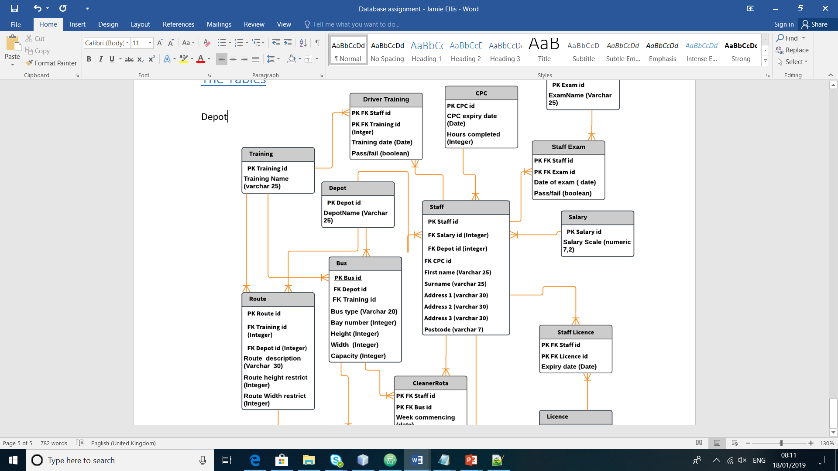
Figure 2- Depot table
Primary key – Depotid
Foreign key – None
Check constraint – None

Route

Figure 3- Route table
Primary key – Routeid
Foreign key – Trainingid, Depotid
Check constraint – Foreign keys cannot be entered as zero.

Bus

Figure 4- Bus table
Primary key – Busid
Foreign key – Depotid, Trainingid
Check constraints – Foreign keys entered cannot be zero, Height and width cannot be entered as zero. Baynumber cannot be entered as zero.

Training
Figure 5- Training table
Primary key – Trainingid
Foreign key – None
Check constraints – None

Driver training

Figure 6- Driver training table
Primary key – StaffTrainingid
Foreign key – Staffid, Trainingid
Check constraints – Foreign keys cannot be zero.

CPC

Figure 7- CPC table
Primary key – CPCid
Foreign key - none
Check constraint – Hours completed must not be greater than 35.

Exam

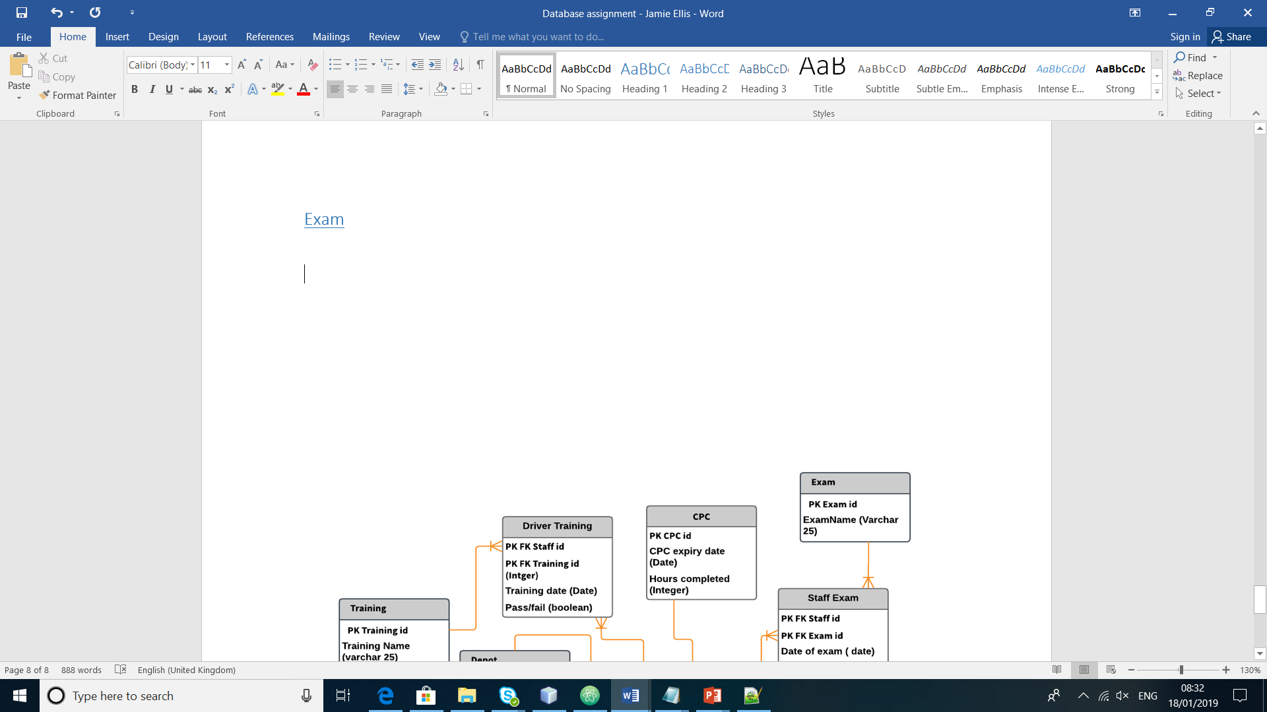
Figure 8- Exam table
Primary key – Examid
Foreign key – None
Check constraint – None

Staffexam

Figure 9- Staffexam table
Primary key – Staffexamid
Foreign – Staffid, Examid
Check constraints – Foreign keys cannot be zero.

Salary

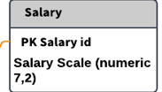
Figure 10- Salary table
Primary key – Salaryid
Foreign key – None
Check constraint- None

Licence

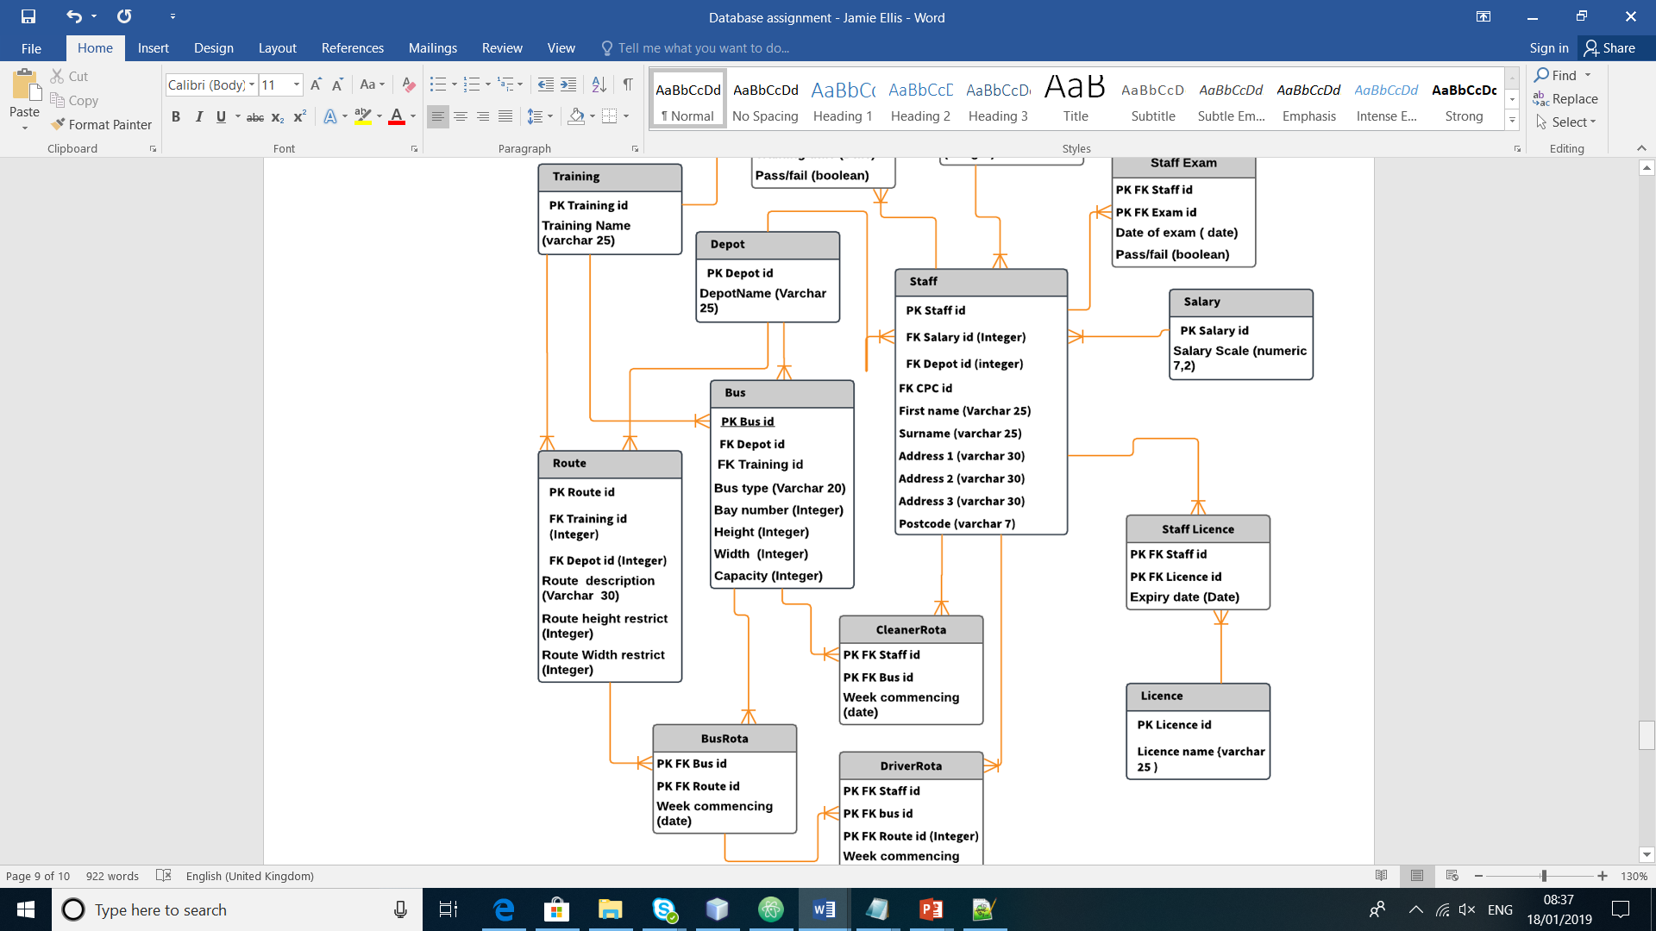
Figure 11- Licence table
Primary key – Licenceid
Foreign key – None
Check constraint – None

Staff Licence

Figure 12- Stafflicence table
Primary key – Stafflicenceid
Foreign key – Staffid, Licenceid
Check constraints - Foreign keys cannot be zero.

Staff

Figure 13- Staff table
Primary key – Staffid
Foreign key – Salaryid, Depotid, CPCid
Check constraints – Foreign keys must be entered as zero, if age was to be added- Age greater than 16.

Bus rota

Figure 14- Bus rota table
Primary key – Busrouteid
Foreign key – Busid, Routeid
Check constraint – Foreign keys must be zero.

Driver rota

Figure 15- Driver rota table
Primary key – Staffbusrouteid
Foreign key – Staffid, Busid, Routeid
Check constraints – Foreign keys must not be zero, Staffid matching driver must be added.

Cleaner rota

Figure 16- Cleaner rota table
Primary key – Staffbusid
Foreign key – Staffid, Busid
Check constraint – Foreign key must not be zero, Staffid added must match a cleaner.

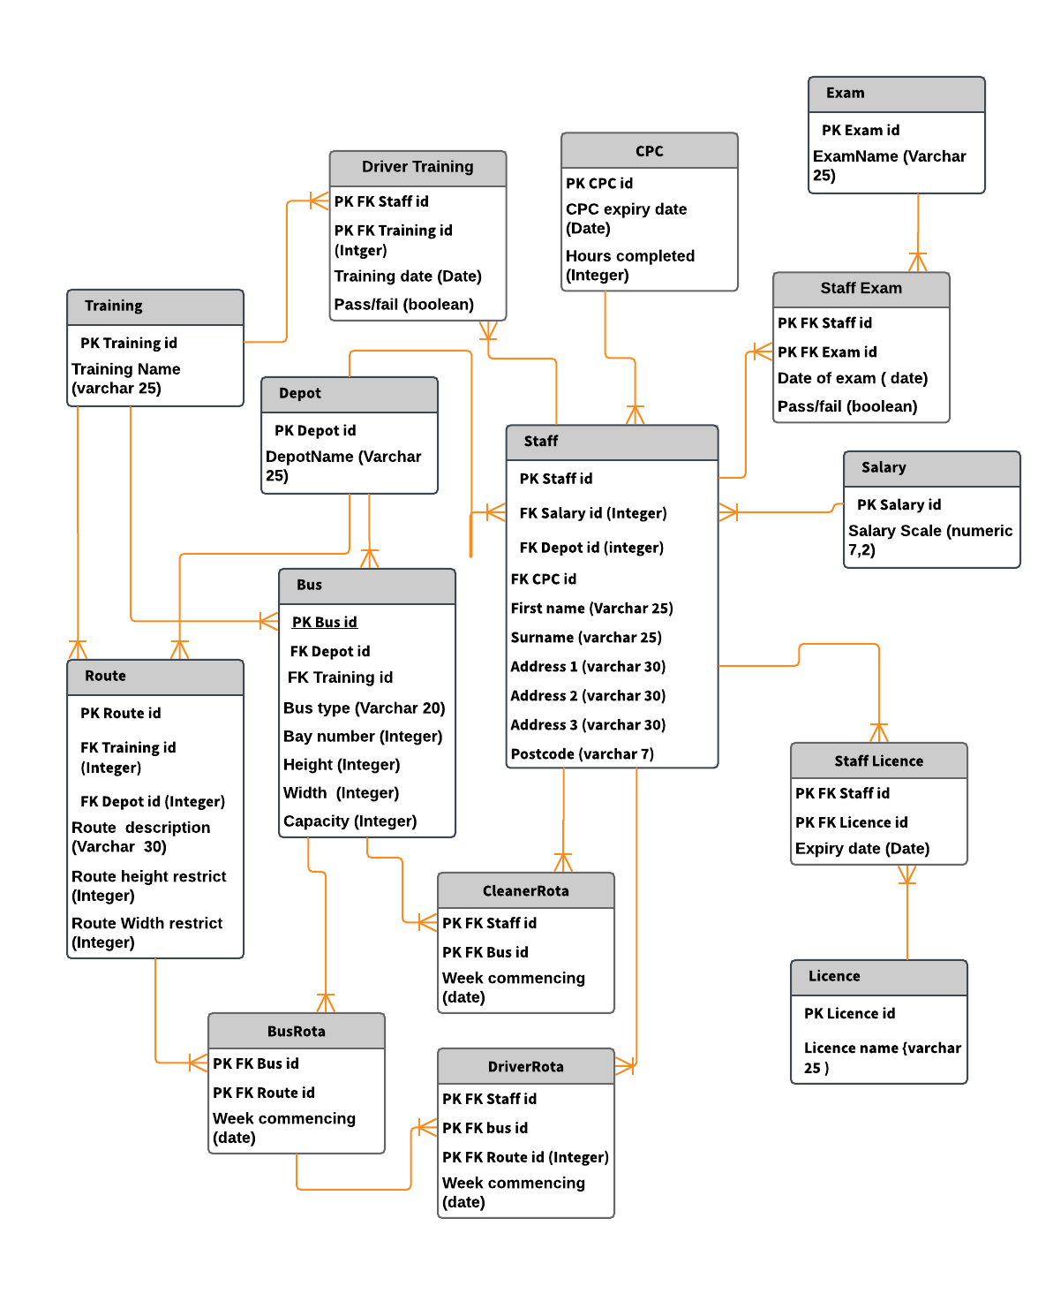
ERD

Figure 17- ERD diagram of wHole Bus Company

3rd normal form

Key
- Primary key (Bold)
- Foreign key (Underline)
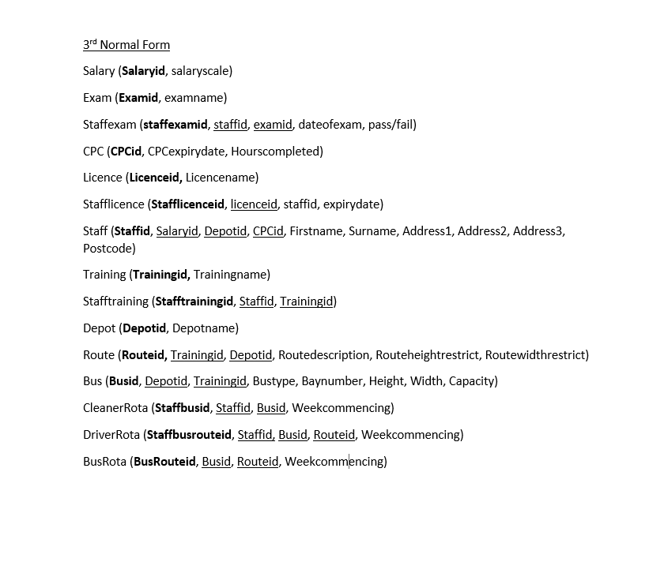

Figure 18- Normalisation of tables

