

EFFECTIVE TEAM WORKING AND COMMUNICATION - TERM 1

STUDENT NAME : ANTHONY JHEFF PORTARO
STUDENT ID : 1906501
MODULE NAME : EFFECTIVE TEAM WORKING ……………………………………………………………………………………………………………………………………………………………………………………………………………………………………………………………………………………………………………………………………………………………………………………………………………………………………………………….AND COMMUNICATION
MODULE N : BMSW4002_LON
LECTURE NAME: LLOYD BEHARRY
DATE: 25 – 08 - 2020

ACKNOWLEDGEMENTS

My thanks to all the people who have helped me during this transition and for giving me the opportunity to do this essay, to my teacher, for teaching me with patience and enthusiasm to use each tool, technique that we have learned and used during this course in each class.

CONTENTS

1 INTRODUCTION

2 TYPES COMMUNICATION

3 THEORIES OF COMMUNICATION

4 CONCLUSION

5 REFERENCES

- INTRODUCTION

I want to collect in this report the information that has been obtained day by day during this first quarter. Searching and translating with facts to explain the questions and accentuate my experience during all this time.

Teamwork

For me, the definition of teamwork is a working model of people with the same intent, which is used as a method for enhancing productivity in work. In essence, teamwork involves a group of persons to operate, operating with a strong common of community. It is important learn how to work together in order to accept the different ideas which in this case, through good communication.

Communication
Is a very important tool to work like a team. Communication is the method of exchanging information between two or more entities, a " Sender " and the "Receiver " who transmits a "Message" via the medium. Often the information found in the message may be skewed or misleading because of the context or communication medium conveying the message.

- TYPES OF COMMUNICATION

Information overload prevails every day in this world where we live in, where there is often more noise or disruption than a good quality of content and new technologies has given way to a rupture, value-free, and constantly confusing communication framework. Typically, we use four main modes of communication, meaning that we use them every day, like:
Oral, written, non-verbal, and visual. Let's take another look at each of these modes of communication, why they are important, and how you can help us to improve our goals.

VERBAL COMMUNICATION

For me, verbal communication means using sounds and words to convey oneself directly, particularly in contrast to the use of gestures and the use of non-verbal corporal communication language.

ORAL COMMUNICATION
It takes place between two or more individuals, allowing us to express meaning through speech. It is considered a basic part of our everyday life; it is a feature of oral speech that distinguishes humans from animals who can gesticulate language. The constituent sections of oral communication are:
Network, code, sender, addressee, mail.

WRITTEN COMMUNICATION
Correspondence can be circulated through various means, written correspondence is already considerably expanded today, by newsletters, journals, social platforms (networks) and also books. It is an essential kind of communication for people who have difficulty communicating verbally.

The message can extend an undetermined number of people, it can be considered as permanent as this medium of communication, as it does not fade like words.

As an example of written correspondence in my workplace, security writes their reports on a computer programme at the end of each working day, while transmitting the reports received in the main office is immediately printed
on paper from each of the workers.

NON VERBAL COMMUNICATION

This type of communication non-verbal, is a communication who works a crucial role in our day-to-day emphasis on anything that we cannot communicate through spoken or written communication.
Non-verbal forms of communication can include:

Facial gestures
Language of the body
Touch with the eye
Appearances
Postures:

We can relay several messages via non-verbal communication, but it's not always the message we want to communicate with. We can give an incorrect message, for example, by holding an eye contact that can place us in a difficult situation.

In my workplace the nonverbal communication will be our dress code and we have to dress formally so which we try to express an environment of security and trust to our clients, in all the places where we work such as sports events, concerts, public spaces and private events.

- THEORIES OF COMMUNICATION

The different communications models we have developed in this term are as follows:
- Shannon-Weaver Relationship Model
- The Contact Model of Berlos
- sympathies with the contact paradigm of Schramm

SHANNON - WEAVER MODEL COMMUNICATION

This model splits the sender, and the receiver model appears to interact in a realistic way. It's not a conventional model.
It may happen between oneself or two people; each person acts as both sender and recipient, and thus uses interpretation. It's taking place simultaneously. Encoding, reading and decoding.

Information source: Conforming the collection of the word set to form the message being transmitted.
A technical, looking transmitter that modifies the code of the packet.
A means, platform to transmit messages to the receiver.
Receiver, The part that decodes and transcribes the transmitted message.
The receiver: the primary receiver of the communication process.
Noise, A collection of disruptions that affect the transmission of messages.
Medium, mode of transmission of messages as a means of communication
There are three styles of these:

-- Means face-to - face.
-- Distributed media.
-- Mechanical.

We notice the three problems of this model, as well as the technical ones, the main problem of which is the lack of precision in the transmission of the communication symbols.
Then we have issues with semantics, in which we notice a lack of precision of the symbol and meaning. And the third and last are the difficulties in which which we can explain the manner in which we view or perceive and the interpretation the receive.

USED AT THE WORKPLACE

Let's talk about the transmitter of the person who gives notice by radio is the source of knowledge, the message is the sounds that come out of the mouth of that person. The microphone used is called the transmitter of the message where the waves from the microphone are the signals from the patrol radio is the target of the receiver, the patrol driver who listens to the radio and receives the warning.


BERLOS MODEL OF COMMUNICATION

The Berlo model is not unique to any specific use and is not exclusive to any particular use.
Some organisations use this communication model to teach communication, and this communication approach is very close to the Shannon Weaver model since it has been studied and tested by researcher David K.

The model of berlos that has tried to solve many of the problems of the Shannon and Weaver model to be able to apply it to communication with humans. With the elements of the contact model that are:

The source is the individual or group of people who have a common communication objective.

The message- Root intent to move something on.
The channel- It carries the message that we will use to be able to the connection.
The receiver- person or group of individuals located on the other end of the line.



SCHRAMMS MODEL COMMUNICATION

Osgood Schramm communication is one of the circular procedures in which a sender encodes a message and a receiver will decode it.
He has been one of the few who felt like a communications expert and began to think about communication after the Second World War.

The strongest example of a communication model is the way that Schramm's communication model is used. It is like a more standard way of sending cards but different to the way this works is when a person sends a card. Then the other person who decodes and then the other person writes his opinion on the letters he has received. It is a send and received.

The Schramm model is one of the most used models and contains three different different elements that are

• Encode
• Interpretation
• To decode

There are three main different types of communication models into which all other communication models are also classified.

  - Group Transactional exchange models
  - Group the Collaborative Communication Model
  - No, the helical curve of dance synchronization
  - The conceptual model of Westley and Mac Leans.

USED AT THE WORKPLACE

Before opening the stadium doors, the event manager invites his team to a small meeting to discuss some of the important aspects of the preparation of the event during the game. The work team listens closely to the message and interprets it individually.

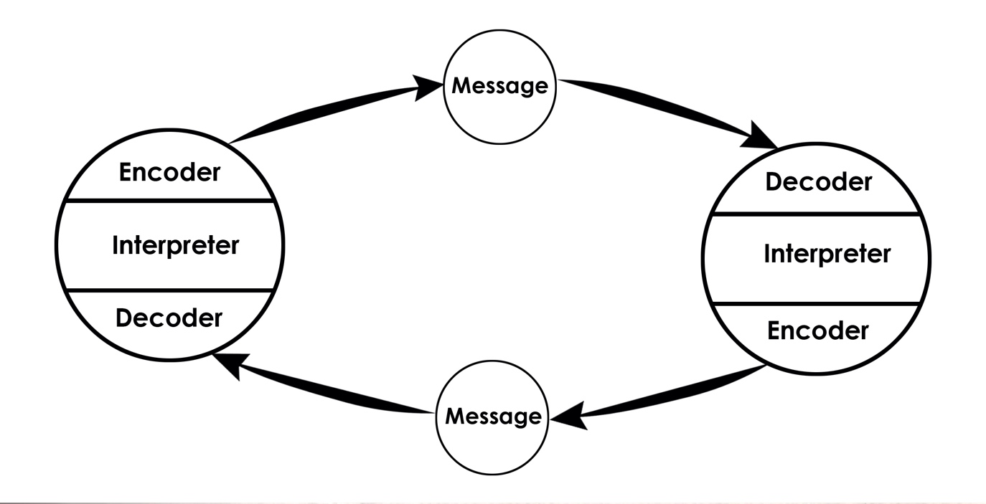

- CONCLUSION

To conclude and with this conclusion of what is stated in my work, the basis of every Society is communication, it is a central and very important point of our Culture, it has been changing due to different aspects and due to technological advances.

Our participation shows us in our work environment and helps us to create compassion for our surroundings or around so that our work and our personal and interpersonal relationships are not affected in a negative way.

Within the different modes of communication that I have studied, we have been able to send the different types of signals in a more positive way to make us understand the message much better.
We've studied three communication theories, which are really interesting and have many aspects in common.

- REFERENCES

- Yourdictionary.com. 2020. Verbal-Communication Dictionary Definition | Verbal-Communication Defined. [online] Available at: <https://www.yourdictionary.com/verbal-communication> [Accessed 1 September 2020].

- The Balance Careers. 2020. Nonverbal Communication Skills List And Examples. [online] Available at: <https://www.thebalancecareers.com/nonverbal-communication-skills-2059693> [Accessed 1 September 2020].

- Managementstudyguide.com. 2020. Communication Theory - Meaning And Examples. [online] Available at: <https://www.managementstudyguide.com/communication-theory.htm> [Accessed 1 September 2020].

- Managementstudyguide.com. 2020. Communication Theory - Meaning And Examples. [online] Available at: <https://www.managementstudyguide.com/communication-theory.htm> [Accessed 1 September 2020].

- Communication Theory. 2020. BERLO's SMCR MODEL OF COMMUNICATION. [online] Available at: <https://www.communicationtheory.org/berlos-smcr-model-of-communication/> [Accessed 1 September 2020].

- Communication Theory. 2020. BERLO's SMCR MODEL OF COMMUNICATION. [online] Available at: <https://www.communicationtheory.org/berlos-smcr-model-of-communication/> [Accessed 1 September 2020].



EFFECTIVE TEAM WORKING AND COMMUNICATION - TERM 2

MODULE NAME EFFECTIVE TEAM WORKING AND COMMUNICATION
MODULE N BMSW4002
STUDENT NAME ANTHONY JHEFF PORTARO
STUDENT NUMBER 1906501
LECTURER NAME LLOYD BEHARRY
DATE 28 – 08 -2020

TABLE OF CONTENTS

- INTRODUCTION

- SLIDES

- REFERENCES

- INTRODUCTION

Working in the healthcare industry is particularly rigorous and responsible. Every staff member has to be aware of all changes and procedures within and be updated. To be updated all departments must collaborate and interact. All workers are one unit to accomplish the greatest mission- meeting the needs of the citizen.

- SLIDES

BENEFITS OF TEAM WORKING (Hersey and Blanchard´s Leadership Roles)

Slide 1.

Work

In a Care home is very challenging and responsible. Every member of staff must to be aware and informed about all changes and processes inside. All departments must to cooperate and communicate to be updated. All employees are one unit to achieve the biggest task – satisfy resident’s needs. Therefore, departments are unique teams and is important to understand the main benefits of working together.
Slide 2.

Team

Is a collective of people with different skills and responsibilities, working together on a shared project, programme, or goal, with role meshing and mutual support. Morgan, P. (2017). Working as one team requires constant contact between generated team members, the key advantages of working at home care team.

Communication

Offers a clearer understanding of the job, and effective communication can solve the problem in case of conflict of interest to continue working together without confusion and dissatisfaction to achieve common goal. Effective communication offers one more advantage to what synergy is. As described by Managements Study guide (2020). Synergy is group relation, interaction, help and absolute collaboration to obtain a collective outcome which is better than operating individually. It is crucial to get group spirit where participants are able to trust each other.

Slide 3.

Hersey and Blanchard - Support

Developed the theory, that suggests that the situations in which leader find themselves influence the most successful leadership style.

In a team, the support network is provided, which means providing assistance and assistance to participants in the event of tension or in tough and stressful times when appropriate. It gives the opportunity to get advice and to rely on each other to minimise work stress and uncertainty. And allow the tasks to be carried out in an acceptable manner. When support is given and workers understand, trust and communicate without a barrier with a good relationship are formed where each member of the team feels secure.

Productivity

As soon as consensus was achieved and coordination with co-workers took place, the team members became more flexible. Workplace versatility is beneficial, since staff with the same skills and abilities can help each other. This means that they can set out certain personal responsibilities that are relevant without sacrificing the activities of the company.

Working as a team in this scenario helps to improve productivity by ensuring the best on time assistance. If the amount of work is allocated and distributed equally to each individual, their skills and abilities, the tasks are performed more efficiently and precisely with the resulting high productivity.

Slide 4.

- REFERENCES

- B2U - Business-to-you.com. 2020. Hersey And Blanchard Situational Leadership Model EXPLAINED | B2U. [online] Available at: <https://www.business-to-you.com/hersey-blanchard-situational-leadership-model/> [Accessed 31 August 2020].

- Managementstudyguide.com. 2020. Team Models - Different Types Of Teams. [online] Available at: <https://www.managementstudyguide.com/team-models.htm> [Accessed 31 August 2020].

- Morgan, P. (2017) The Business Student’s Guide to Study and Employability. London: SAGE.

