Food & Beverage Operations
BMIH4002


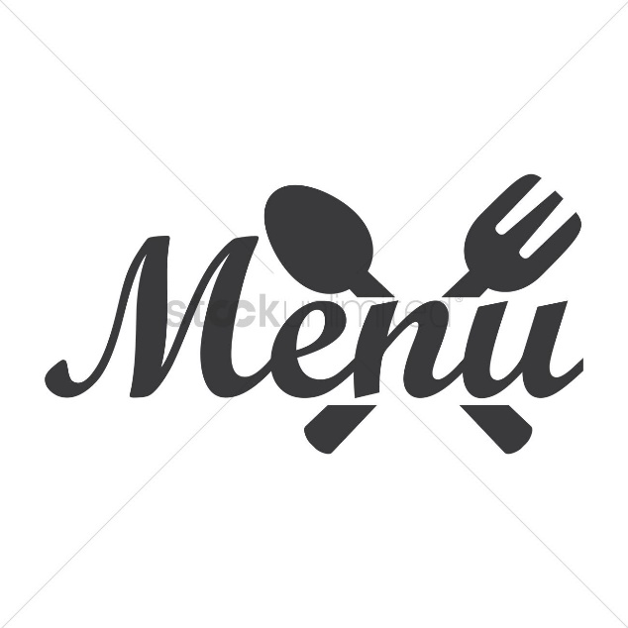

Breakfast:
The Complete English Breakfast
The traditional British breakfast consists of fried meats, eggs, beans, tomatoes, mushrooms, and bread.
Bagel with smoked salmon:
An assortment of capers, red onion, cream cheese, and smoked salmon over a toasted bagel.
Burrito with huevos vegetarians
Tacos made with a flour tortilla, scrambled eggs, cheese, roasted veggies (such bell peppers, onions, and zucchini), and salsa.
Crepes smothered with maple syrup
Pancakes that are light as air and come with a side of fresh berries and maple syrup.
Toast with Avocado
Avocado toast with feta cheese, cherry tomatoes, and cracked black pepper on toasted sourdough bread.
A parfait with Greek yoghurt
Greek yoghurt, honey, granola, and mixed berries stacked in layers for a healthy and refreshing morning meal.

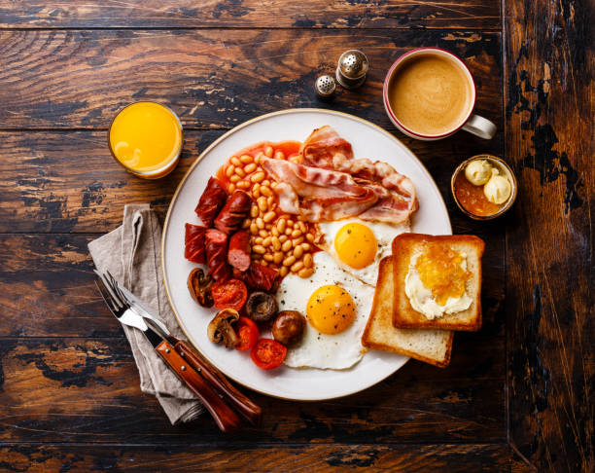
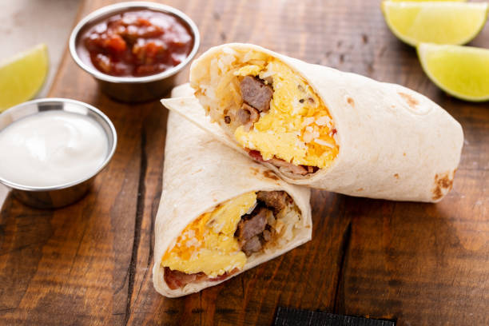
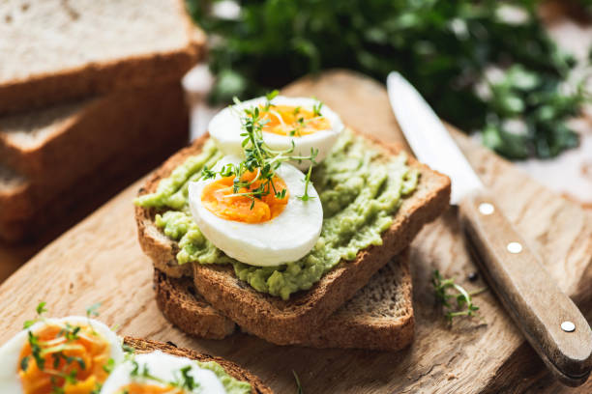
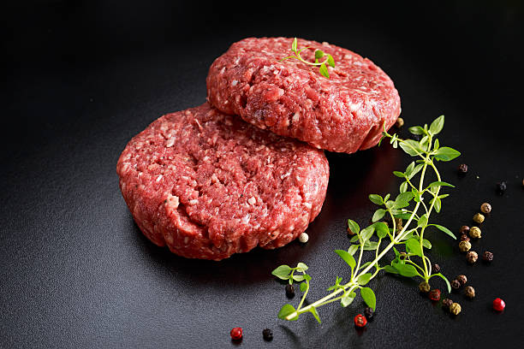
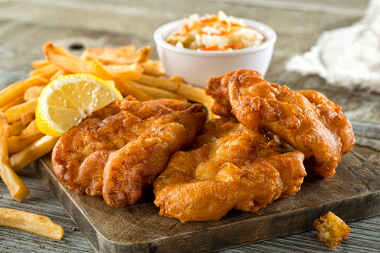
£20
£20
£20
£10
£18
£20
£45
£40
£40
£30
£35
£70

Lunch:
Chips and fish
Batter-coated fish or haddock is served with thick-cut chips (fries) and mushy peas in this classic British meal.
Chopped Chicken Caesar Salad
A Caesar salad with grilled chicken, Parmesan cheese, and croutons on a bed of crisp romaine lettuce dressed in a creamy Caesar dressing.
Beef Patty
Fries, lettuce, tomato, onion, cheddar, and a selection of sauces on a brioche bread with a delicious beef patty.
Curried Vegetables
Cooked in a fragrant curry sauce, seasonal veggies are served with basmati rice and naan bread.
Pane Caprese
Layers of fresh mozzarella cheese, juicy tomatoes, and basil leaves, topped with a balsamic sauce and sandwiched between two pieces of crusty bread.
French-style quiche
Served with a green salad, this delicious pastry is stuffed with eggs, cream, bacon, and cheese.

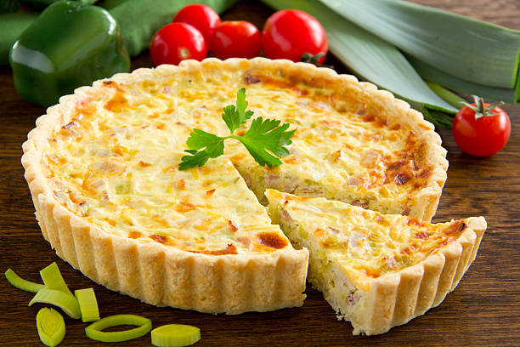

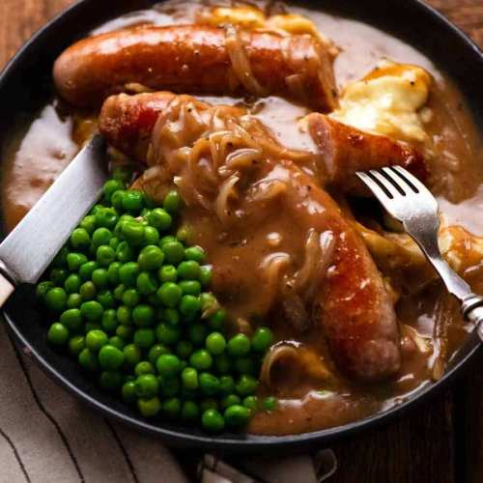
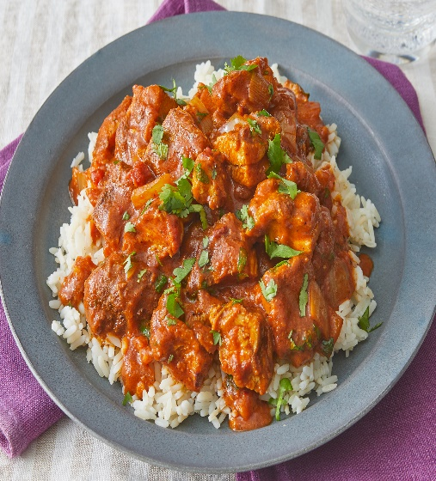
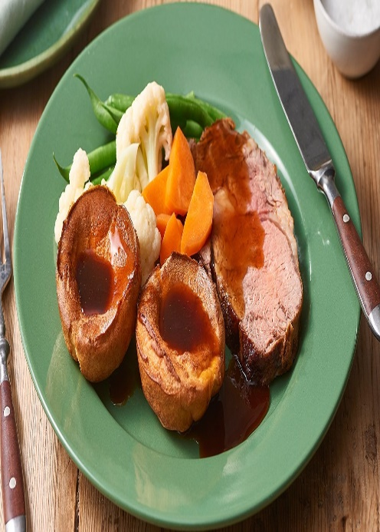
£60
£120
£60
£80
£120

Dinner
Roast beef served with Yorkshire pudding
Beef that has been slowly roasted and served with Yorkshire puddings that are crisp, roast potatoes, vegetables in season, and thick gravy.
Salmon brushed with lemon butter and grilled
A salmon fillet that has been grilled and served with a butter sauce that has the flavor of lemon, along with roasted asparagus and mashed potatoes.
Chicken Tikka Masala
Served with aromatic basmati rice and garlic naan bread, this dish consists of tender chicken chunks that have been cooked in a spicy tomato-based sauce.
Risotto with Mushrooms
A dish consisting of creamy Arborio rice that has been cooked with mushrooms, onions, garlic, Parmesan cheese, and white wine, then topped with fresh herbs.
Bangers and Mash:
A classic meal from the United Kingdom, the sausage and mash consists of sausages, mashed potatoes, peas, and onion gravy made with caramelized onions.
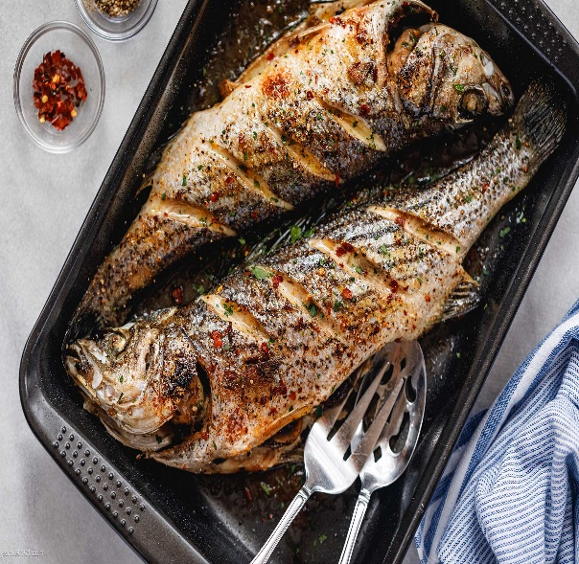
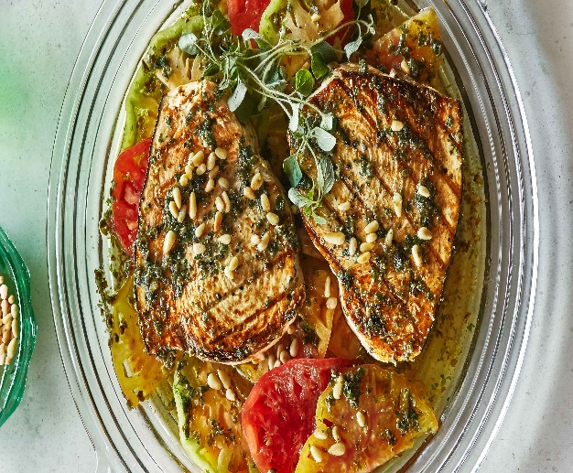
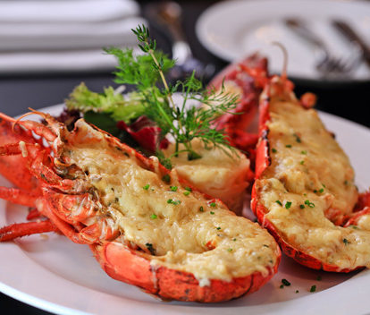
£250
£80
£150
£120
£90

Seafood Menu
Sea bass cooked on the grill
A succulent fillet of sea bass that has been marinated in herbs and lemon juice, grilled to perfection, and served with veggies that have been sautéed.
Linguine with Seafood
A combination of seafood, including shrimp, mussels, and calamari, mixed with linguine pasta and covered in a sauce made of garlic and white wine.
Prawns in a Creamy Garlic Sauce
Prawns prepared in a creamy garlic sauce, served with crusty bread for dipping. These prawns are succulent and flavorful.
Thermidor de homard: lobster
A traditional French meal consisting of lobster flesh that has been cooked in a rich creamy sauce that also contains white wine, mustard, and Gruyere cheese. It is served over fresh potatoes that have been buttered.
Steak of Swordfish Prepared on the Grill
A succulent swordfish steak that has been seasoned with herbs and then grilled, accompanied with a lemon butter sauce and a side of fresh greens from the season.

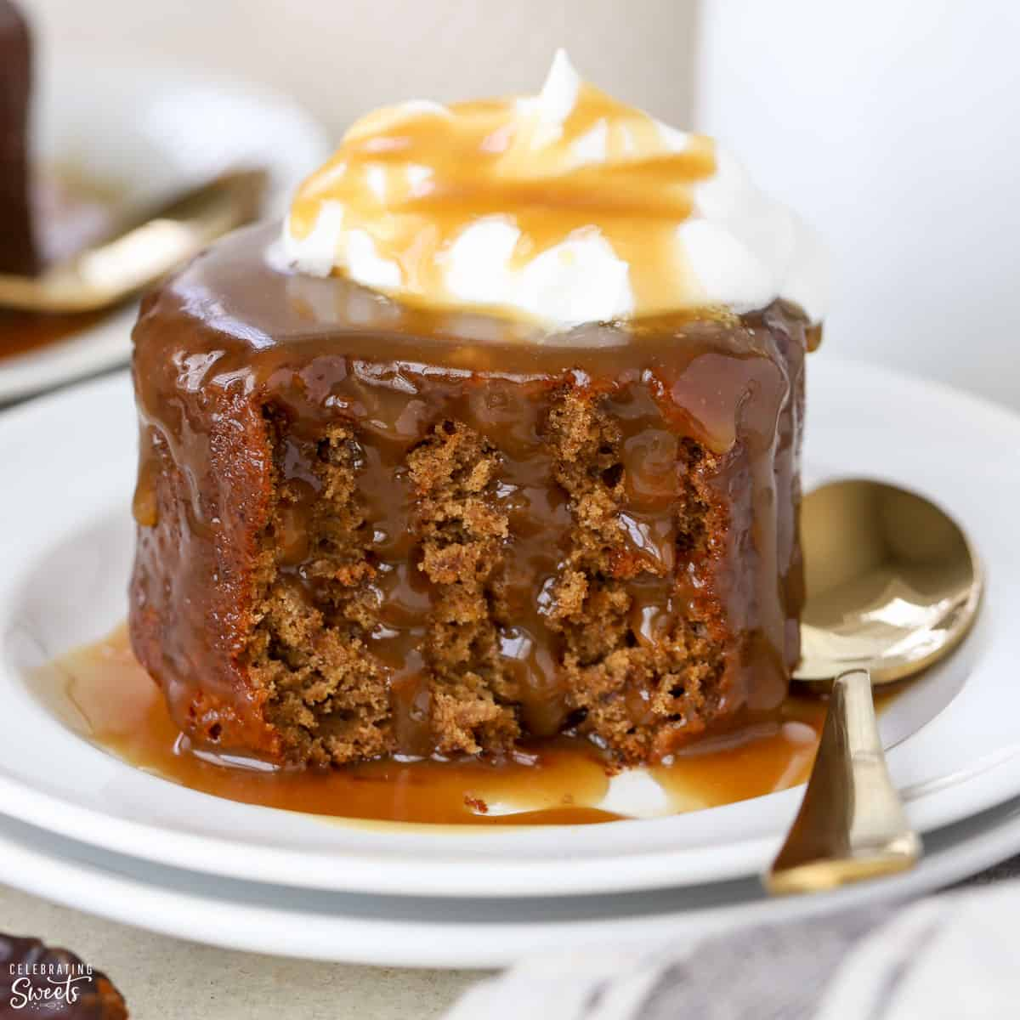
£30

Desserts
Dessert called Sticky Toffee Pudding
A scoop of vanilla ice cream is served beside a cake that resembles a soft sponge and is soaked in toffee sauce.
Apple Crumble
Apples that have been baked and covered with a sweet and crumbly oat coating are served with either custard or ice cream as a dessert option.
Sundae made with Chocolate Brownie
Warm chocolate brownie pieces topped with a layer of vanilla ice cream, a layer of chocolate sauce, a layer of whipped cream, and a cherry on top.
Lemon Tart
A tart lemon custard filling that is cooked inside of a buttery pastry shell and then topped with powdered sugar before serving.
The Eton Mess
A delectable delicacy made by combining smashed meringue, whipped cream, and fresh berries to make a mixture that is both light and decadent.
Gingerbread with a Sticky Topping
A dense and fragrant gingerbread cake that is often served warm with a scoop of whipped cream or vanilla ice cream.

£40

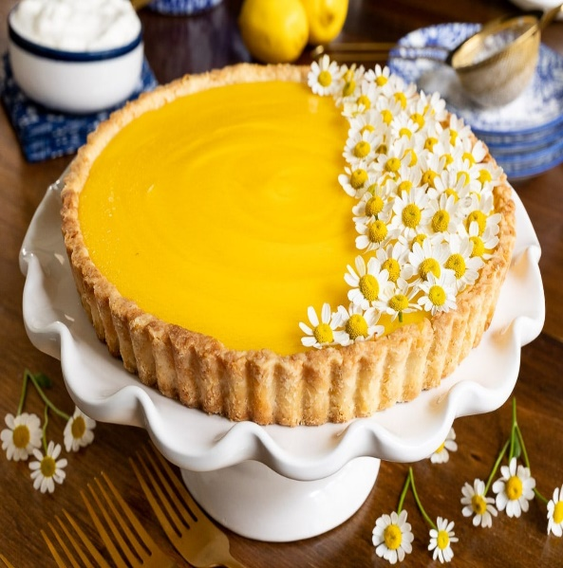
£20

£15

£25
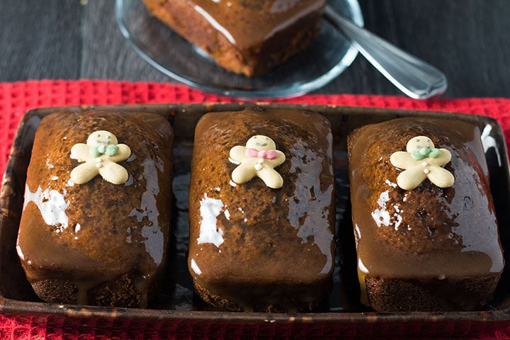

£20

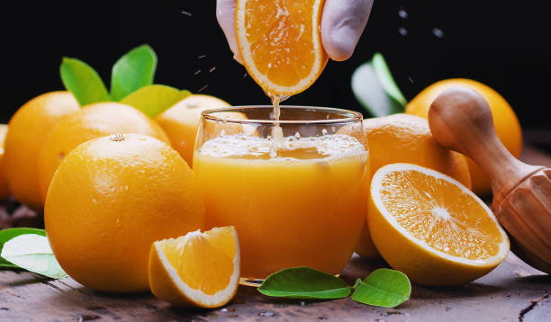
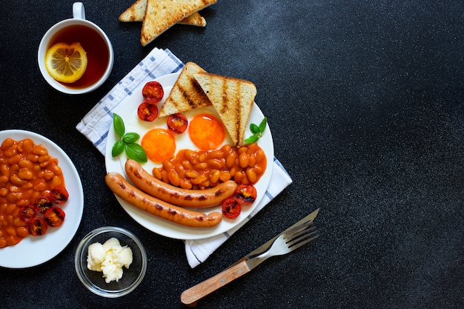
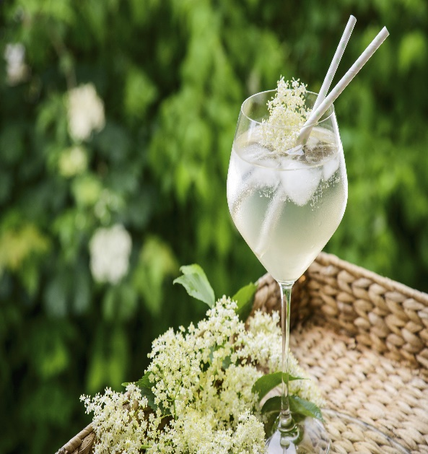
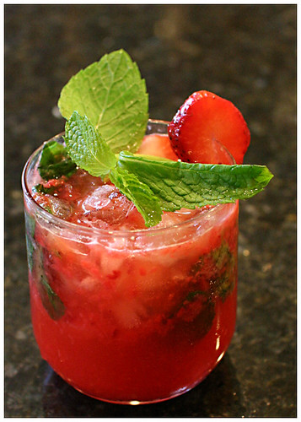
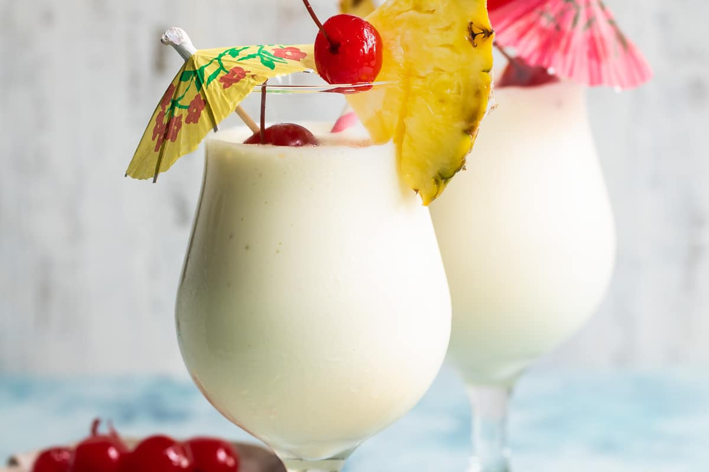
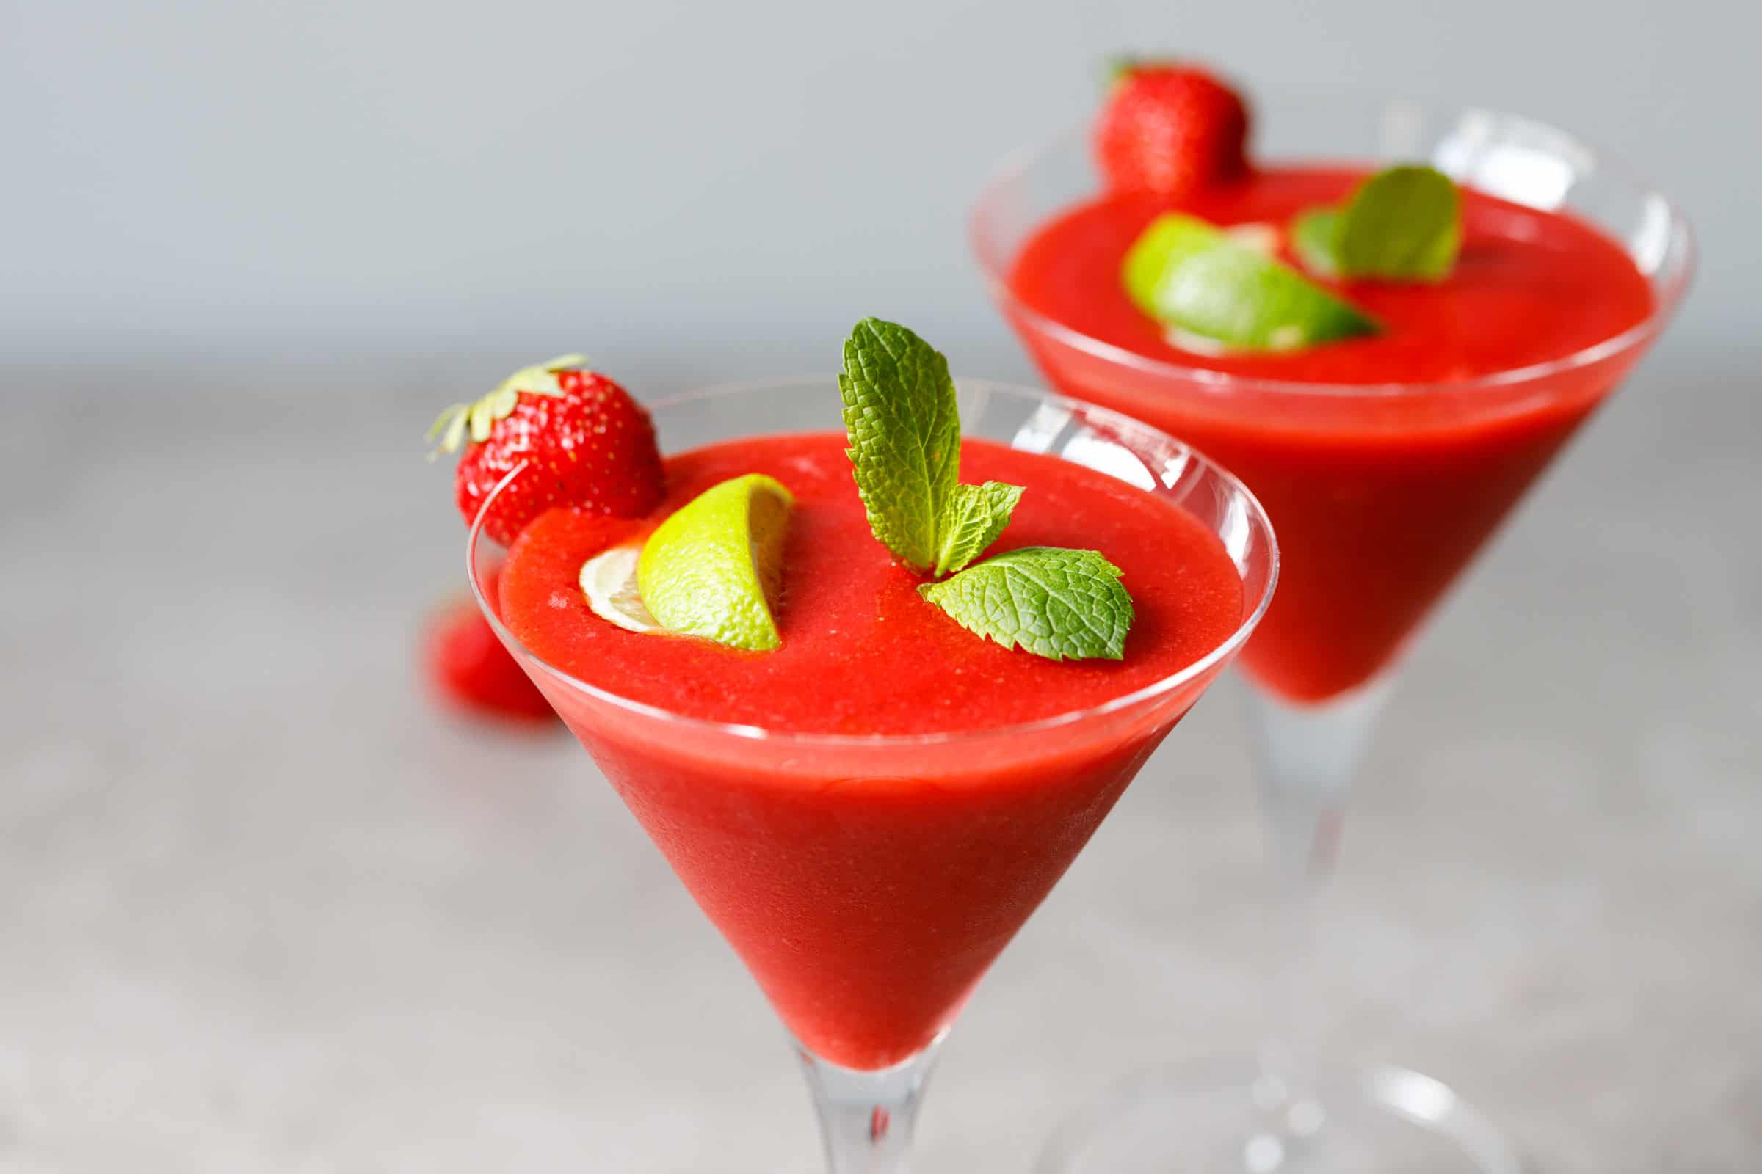
£20
£30
£30
£15
£20
£10

Beverages
Tea Served with the English Breakfast
A typical black tea mix, which is customarily prepared by adding milk and sugar to the cup.
Tea Made with Earl Grey
A flavorful black tea with the essence of bergamot infused into it; this is the ideal beverage for anyone who like drinking tea.
Cappuccino
Espresso served with heated milk and frothy milk foam on top, often coated with cocoa powder or cinnamon, and served in a tall glass.
Orange Juice Obtained From Fresh Squeezed Oranges
Orange juice created from freshly squeezed oranges that is both reviving and abundant in nutritional content.
Smoothie made with strawberry and banana
A beverage that is both delicious and creamy, made by blending fresh strawberries, ripe bananas, yogurt, and just a touch of honey together.
Sparkling Elderflower Presse
A non-alcoholic beverage that is served over ice and garnished with a slice of lemon and contains elderflower cordial that has been mixed with carbonated water.

£30
£20
£25
£30
£50
£40

Drinks
Mojito
A drink that is created with rum, lime juice, fresh mint leaves, sugar, and soda water, and is intended to be refreshing.
The Pina Colada
Served in a pineapple and cherry-topped glass, this tropical drink is made with rum, pineapple juice, and coconut cream.
Margarita
Tequila, lime juice, and triple sec are the classic ingredients for this cocktail, which is served in a salt-rimmed glass.
The Time-Tested Method
A traditional whiskey cocktail made with sugar, bitters, whiskey, and the rind of an orange or lemon.
Daiquiri with Strawberry Puree
This refreshing drink is made by mixing rum, fresh strawberries, lime juice, and simple syrup with ice and shaking it.
Mojito made with pure sugar cane juice
Mix lime juice, mint leaves, sugar, carbonated water, and a splash of citrus juice to create a mocktail that resembles the classic mojito but does not include any alcohol.

