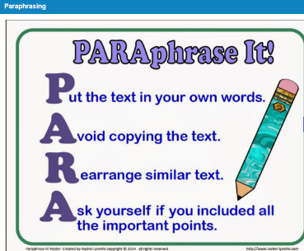
The essential skills that will be pivotal to me succeeding with my studies are related to construction of assignments and other marked tasks. Paraphrasing will be a useful skill to master in order to pack further sources into my work without losing valuable word count. Paraphrasing will allow me to convey my own thoughts using what I have already learned. See [1] for Paraphrasing Guidance.
The most important skill to my studies will be referencing. I will be adopting the IEEE standards, see bibliography [2]. Referencing can be the difference between a high or low mark, failure to reference can have serious consequences. Referencing is important as it’ll allow the reader to access resources I have. Whilst giving credit to the source it also allows the discipline specific wider community the opportunity to check the research. When researching its good practice to evaluate the resource to ensure it isn’t ‘Fake News’. This ensures only valid information is included in my work.
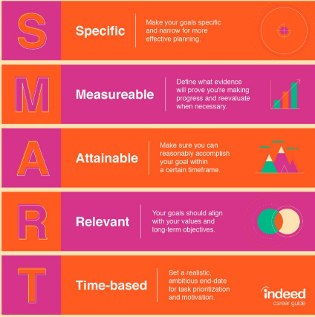
Time management is essential not only for Studying, but during fulltime Employment too. Three main issues that affect individuals in the classroom, and the workplace too are procrastination, planning and perfectionism. Excellent planning coupled with perfectionism, whilst minimising procrastination will lead to success.
Another essential skill is goal setting. By setting goals it allows us to identify tasks/goals that are short and medium term that will need completing in order to achieve the overall goal. Following SMART principles ensures only tasks contributing to goals are completed. [3]

Bibliography/References
Figure [1] – De La Salle Library Guide, “7th Grade: Paraphrasing & Citing: Paraphrasing” [Online]. Available:
https://lasalle-academy.libguides.com/c.php?g=596216&p=4124834 [Accessed Oct. 18, 2020]
Figure [2] - University of Wales Trinity Saint David, “Referencing Handbook IEEE”v1.2, [Online]. Available:
https://uwtsd.ac.uk/media/uwtsd-website/content-assets/documents/library-and-learning-resources/infoskills/IEEE-eng_v.1.2.pdf [Accessed Oct. 18, 2020]
Figure [3] – Indeed.com, “SMART Goals: Definition and Examples”, Sep. 21, 2020 [Online]. Available:
https://www.indeed.com/career-advice/career-development/smart-goals [Accessed Oct. 18, 2020]

