Report on project management for the Vintners Antiques

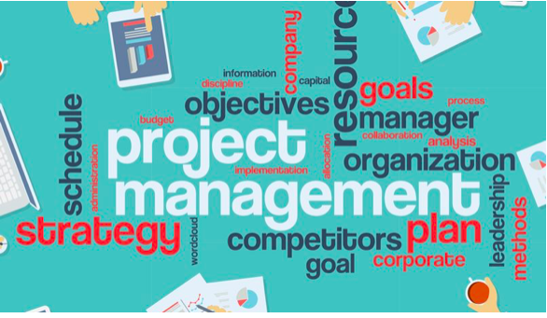

Name: Salma Bibi
Module name and code:
Project Planning and Management in Workplace
BMSW5104
Modul Tutor: Paul Ranson

Learner Group: 3

Table of Contents
Introduction 3
Describe the organisation of that the project is being developed for 4
Provide a critical assessment of the risks associated with the project. 5
Describe the project management tools and techniques being used in the case study. 6
Show how the project plans will be communicated to the stakeholders 8
Provide a personal reflection of your own ability of managing the project with future recommendation and self-development plan to improve own performance. 9
References 10
Appendices 11
Appendix 1 Product project technique 11
Appendix 2 Project steering group 12
Appendix 3 User stories 13
Appendix 4 Gantt chart 14
Appendix 5 Project life cycle 15
Appendix 6 Chevron 16
Appendix 7 The Iron triangle 17

Introduction

This report will critically evaluate a team’s ability of managing a project using project management tools and techniques within an organisation. The project team (Light Solutions Ltd) will organize the transfer for the Vintner’s; from their Shirley based shop to the Spark hill warehouse which will be transformed into their new office. The project team will use the necessary tools to identify and manage the risk. A Gantt chart will be used to monitor the project providing live updates to the Vintners of the jobs being completed by the team with accurate estimation of time scales using Prince2 methodology for project management (Rastogi, 2015). The processes (tool and techniques) to manage these events effectively, will be discussed in the report.

Describe the organisation of that the project is being developed for

The project is being developed for the Vintners antiques. This is a family business which has been operating over 30 years. The family store which is based in Shirley was originally bought and managed by the grandfather. However, the shop has now had an offer from Tesco’s to buy them outright; the family were very happy once the offer came through because the sales have dropped in their business recently. The Vintners also own a warehouse in Spark hill which is very basic and based for storage only. It is simply just a huge empty space with four walls, roof and a concrete floor without any gas or electricity in the building.
The company is managed by 5 individuals who are the third-generation dealers of the business who are Doreen, Denis, Suha, Omar and Paul. Doreen has been operating the shop for 10 years as an accountant, whereas Denis has the role of driving around different cities finding valuable antique goods for the shop. Omar works as the handyman who repairs and cleans goods which Denis buys for the shop. Suha works in the office who communicates with customers on a face-to-face level or over the phone. Lastly Paul is the keeper of all the information which goes on in the organization.

Provide a critical assessment of the risks associated with the project.

There are many uncertain events which can occur with the project and this can have a great effect on the project’s objectives. These uncertain events can be identified in the project plan;
any changes which occur in the triple constraint for instance, the scope, cost, time, can not only impact each other but they could interject risk for other areas of the project. Other factors which may interject risk are the following; new competitors entering the market, natural disasters, changes to government policy as well as staff sickness, theft and events such as technical or equipment failure. Projects which are poorly managed with no formal strategies or methods and project managers who lack training or experience. For this case; as the business is operated by the family, friction may arise between individuals and lack of effective communication between stakeholders can cause the project to fail.

Other areas which may include risks may be the product project technique (Appendix1) this technique allows us to allocate a time frame of the work which needs to be carried out (Roberts, 2012). Roberts used this table for estimates where he mentions that the estimates can be extremely accurate as long as both the size and the complexity of the task are measurable (Roberts, 2012). This table invented and used by professionals in the past allows us to follow their instructions. However, the estimated guesses can be totally wrong therefore there is a risk here also.

Describe the project management tools and techniques being used in the case study.

The project life cycle (Appendix 5) diagram was developed using SmartArt (Roberts, 2012) these phases represent the path a project takes from the beginning to its end (Biggins at el, 2016).
The project has a steering group, where major decisions will be made by the sponsor Doreen Vintner, which will then be assessed by the fellow steering group members who are Denis Vintner, Omar King and Suha Madani (Appendix 2). After it has been approved by the steering group, the project will be handed to the project manager (Light Solutions Limited) who will then allocate the task.

User stories (Appendix 3) were one of the primary tools operated by brown paper planning; writing down simple descriptions on post it notes of what will be required for the project of the Vintners construction. This was formed by brainstorming ideas to make decisions and take further actions. User Stories have been designed to build shared understanding between the Customer Team and the Developer Team. While the number and importance of stories can differ as per the stakeholders, a project manager prioritizes the one that holds the most significance for the completion of the project. This project plan builds incredible team ownership, it documents the activities in swim lanes (Berteig, 2019).

Microsoft planner is a digital version of user stories also known as the MoSCoW/CHEVRON (Appendix 6) method, where all the information on the ‘post it notes are transferred to. This helped us put it in to groups and prioritize the must haves from want to have and nice to have. This is a more detailed format of user stories on Microsoft planner and helps us be more professional and organized as well as not losing the sticky notes (Heagney & Lewis, 2016).

The iron triangle consists of three key elements that are crucial to deliver the final results on a project which are Scope, Time and Cost (Appendix 7). Once a scope has been chosen to meet ones needs as well as the cost being measured and a complete estimate of time and how long it will take to deliver then you have locked together the three corners of the triangle and it is now in balance. As a project manager it is important to manage and moderate the triple constraints as well as other effected factors to prevent slippages during the course of the project and to have quality results delivered (Locke, 2007).

Product project technique (Appendix 1) allows us to allocate a time frame of the work which needs to be carried out (Roberts, 2012, p.119). This table allows us to determine the complexity and size of the job as well as figuring out how many man days it will take for the job to be completed (Appendix1). Moreover, we used the Delphi approach where more accuracy was introduced into our estimates. “The Delphi technique is a useful tool for developing group consensus” (Thangaratinam & Redman, 2005). It is believed to get collective information (wisdom of the crowd) instead of just an individual estimated guess.

We used the excel spreadsheet to create a digital Gantt chart (Appendix 4); a timeline with the milestones that have passed and the milestones that are still to come. It illustrates the sequence of individual tasks and allows the stakeholders to view expected completion dates for each task “live”.

Show how the project plans will be communicated to the stakeholders

User stories (Appendix 3) and Gantt chart (Appendix 4) will be used for scheduling and communicating to the stakeholders at each stage of the project plan. These are the most powerful project planning tools to help the project team think through the plan to communicate and to monitor during delivery.
User Stories have been designed to build shared understanding between the Customer Team and the Developer Team. They are conversations that lead to an agreement on what to build and their format helps teams to keep the focus on delivering features valuable to businesses and users. The collection of all the user stories makes developers aware of what the users require from the product that they will be creating.
The Gantt chart represents the project plan by making each task into a bar and putting those bars onto a time schedule. All the tasks (user stories) which need to be completed and the timescale are listed on the Gantt chart; this is used to accomplish the project. Equal units of distance along the horizontal axis represents equal units of time; the length of the bar represents the duration of the task. Furthermore, each task is dependent upon the completion of the predecessor tasks to get started and the Gantt chart is usually shaded in a different colour once the task is complete. There is an online version of the Gantt chart which is “live”, where the relevant stakeholders can visualise accurate information at each stage any time of the day. (CMI, 2002; Weaver, 2012)
Furthermore, stand up meetings will be carried out which will develop a good communication channel to the team delivering the project; this will also be an opportunity to encourage team building as well as improving collaboration where colleagues will be encouraged to bring up any issues they are having which will help improve the shared understanding of tasks and goals.
There are three core questions which are used in a stand-up meeting; each individual member tells the team what they “accomplished yesterday”, “how they plan to work today” and “if they have any obstacles” which will delay their progress. This daily face-to-face stand up meeting focuses on enabling the completion of each user story.

Provide a personal reflection of your own ability of managing the project with future recommendation and self-development plan to improve own performance.

During our first lesson in project management we were given a task to build a Lego village. We were set this task to work within a team and to understand what happens in the real world of a company who undertakes a project. This mini project gave us an opportunity to feel the pressure of satisfying the needs of a project manager by producing the house in the village.

The thing that went wrong in the process is that while managing the project I did not get clear instructions from the project manager; all I heard was “get the job done quick, the quicker we finish the more money we will get”. So, as a team we ended up making 18 gable-ends where we only needed three, as there were only enough building blocks to build three houses in total between all four groups in the class. The paper instructions which was given to us was also incorrect and not up to date so the teams who were following the paper instructions were building it all wrong; whereas the online instructions were an updated and accurate version. This made me realise that paper-based documents may easily get damaged and misguide individuals and electronic documents are stored securely giving steps that must be followed. We just did what was asked and didn’t ask any questions to the management. Therefore, I believe because of the lack of communication specially with the other teams we failed the project.

The ways of improving this situation for further projects and for self-development is to communicate with the other teams and follow instructions. There are many techniques and tools which can be applied in a project such as user stories, Gantt chart and chevron. Using the Prince2 methodology means each stage of the process is clearly structured, this will help me broaden my experience. For my career development path, I would like to achieve a Prince2 qualification because the framework used in a project is more organised. By gaining a prince2 certificate will help me to improve my project management skillset (Turkey, 2009)

References

- Berteig, M. (2019). User Stories and Story Splitting - Agile Advice. [online] Agile Advice. Available at; http://www.agileadvice.com/2014/03/06/referenceinformation/user-stories-and-story-splitting/
- Biggins at el. (2016). Applying a life cycle approach to project management methods. Available at; http://eprints.bournemouth.ac.uk/23753/2/Biggins%20D%20-%20Applying%20a%20life%20cycle%20approach%20to%20project%20management%20methods.pdf
- CMI, (2002). Henry Laurence Gantt, The Gant Chart Thinker 022. Available at; https://www.managers.org.uk/~/media/Campus%20Resources/Henry%20Laurence%20Gantt%20-%20The%20Gantt%20Chart
- Heagney, J. and Lewis, J. (2016). Fundamentals of project management. New York: Amacom, American Management Association.
- Locke, D. (2007). Project Management. 9th ed. Aldershot: Gower Publishing Limited, p.21.
- Rastogi, D. (2015). Mind Mapping to Gantt Charts. International Journal of Scientific and Research Publications. Available at; http://www.ijsrp.org/research-paper-0815/ijsrp-p4497.pdf Volume 5, Issue 8, ISSN 2250-3153
- Roberts, P. (2012). Effective Project Management. London UK: Kogan Page 8.
- Roberts, P. (2012). Effective project management. London, U.K.: Kogan Page 119
- Thangaratinam, S & Redman, C. (2005). The Delphi Technique. Available at; https://obgyn.onlinelibrary.wiley.com/doi/pdf/10.1576/toag.7.2.120.27071
- Turkey, F. (2009). An Introduction to PRINCE2. Available at; https://www.projectsmart.co.uk/docs/prince2-introduction-ps.pdf
- Weaver, P. (2012). Available at; https://mosaicprojects.com.au/PDF_Papers/P158_Henry_L_Gantt.pdf p.1-17

Appendices

Appendix 1 Product project technique

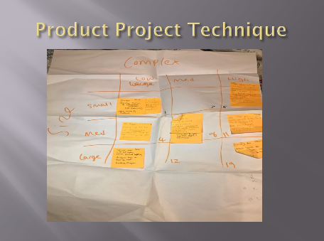
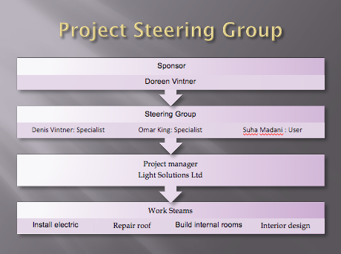

Appendix 2 Project steering group

Appendix 3 User stories

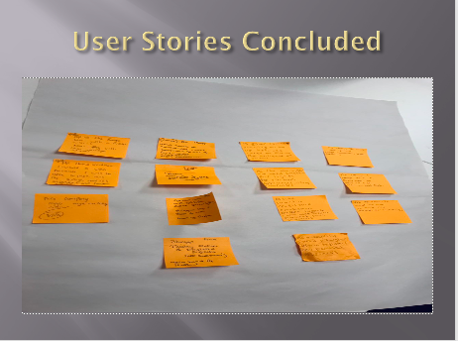

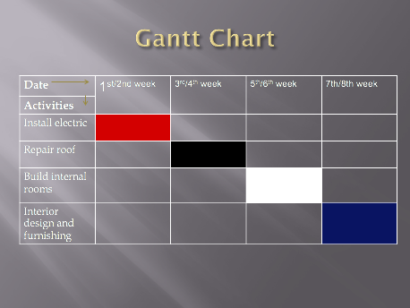

Appendix 4 Gantt chart

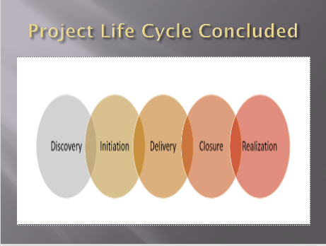

Appendix 5 Project life cycle

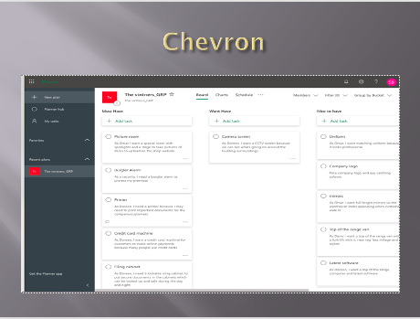

Appendix 6 Chevron

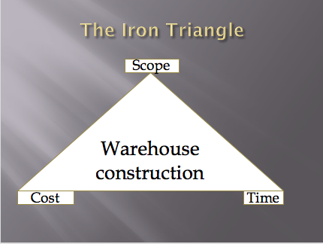

Appendix 7 The Iron triangle

