Student Name: Masod Karim

Student Number: 2227092

Module: Usability Engineering

Module Code: ACCB6017

Assignment Title: Full Interfaces & Testing

Lecturer: Dr Nassir Ibrahim

Internal Verifier: Dr Sana Jokhio

Submission Deadline: 14th November 2025 @ 14:00 (2PM)



Table of Contents.

Introduction………………………………………………………………………….1
Final Colour Storyboards: Design Development and User Testing..2
Analysis of Key Screen Revisions and User Testing Insights…………3
How to Play Screen………………………………………………………………..4
Choose a Detective Screen…………………………………………………….5
Search and Interrogate: Detective Interaction Screen………………..6
Investigate the Crime Scene…………………………………………………..7
Decode the Clues………………………………………………………………….8
Select the Code…………………………………………………………………….9
Clue Decoded: Prize Revealed………………………………………………..10
Case Closed…………………………………………………………………………11
Feedback Collection Process and Summary……………………………..12
Data Gathering Strategy for a Live Application…………………………..13
Ethical Considerations and GDPR Compliance………………………….14
Conclusions…………………………………………………………………………15
Reference list……………………………………………………………………….16
Appendix: Summary of Core Screens – Mystery Murder Game……..17

Introductions.
After completing the wireframing stages, this report examines how a conceptual mystery murder mobile game was developed into a fully functional and immersive interface. The project focused on the challenge of crafting a design that could effectively support investigative gameplay and narrative depth while staying accessible, engaging, and emotionally compelling for a wide range of players. A user-centred design approach, [5] guided by four carefully developed personas, was employed to test and refine each screen. Through the application of interaction design principles [4] and continuous user feedback, the interface evolved to achieve a balance between storytelling tension, visual accessibility, and cognitive comfort. The aim of this report is to present the final colour storyboards, explain the major design adjustments made in response to user testing, outline the feedback collection methods, and reflect on how combining usability theory with user involvement shaped the final interactive experience.
Final Colour Storyboards: Design Development and User Testing.
This section presents the final full-colour storyboards for the UWTSD-themed mystery murder game, which were developed from the original wireframes. Each stage of the design process was guided by key usability principles [3] with iterative adjustments and enhancements made based on direct usability testing involving participants representing the four defined personas.

Analysis of Key Screen Revisions and User Testing Insights.
The transition from wireframes to the final full-colour storyboards for the UWTSD-themed mystery murder game was guided by user feedback focused on improving usability, accessibility, and emotional immersion [1], [2]. During usability testing, feedback from visually impaired users and casual players highlighted the need for stronger visual contrast and a clearer starting point on the main home screen. In response, the design was refined by incorporating high-contrast UWTSD-inspired visual elements, introducing a large, easily tappable “Begin Investigation” button, and adding a prominent sound control icon. These adjustments enhanced the initial user interaction, reduced cognitive load, and aligned the interface with established accessibility and interaction design principles [4], [5] .

How to Play Screen.
In the initial wireframe, the “How to Play” page consisted of static written instructions explaining the gameplay. User testing showed that this format felt dense and uninviting, making it harder for players to quickly grasp the main objectives. To improve clarity and engagement, the screen was redesigned to feature an interactive tutorial with animated visuals and icon-based guidance. This approach allows users to learn the game mechanics through hands-on interaction, making the experience more intuitive and enjoyable. The update reflects Nielsen’s usability heuristics [2], of promoting recognition over recall and maintaining a minimalist, user-friendly design, ensuring the instructions are accessible and easy to navigate for all players.
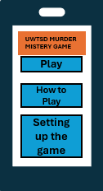

Figure 1
Choose a Detective Screen.
In the mystery murder game, the original wireframe for the Detective Selection Screen featured static buttons for choosing a character. Usability testing revealed that this layout felt outdated and cluttered, making it difficult for players to browse and select their preferred detective. In response, the design was updated to include a swipe able avatar carousel, allowing players to scroll smoothly through a range of detective profiles 2]. This modernized interaction makes more effective use of screen space and enhances user engagement. The redesign aligns with Nielsen’s heuristic principles of flexibility and efficiency of use, ensuring that the interaction feels natural, fluid, and comfortable—particularly on touch-based devices

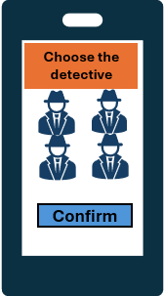

Figure 2

Search and Interrogate: Detective Interaction Screen.
The Search and Talk to Detective screen allows players to explore the game environment and engage directly with their chosen detective. Players can examine clues, ask questions, and gather information critical to solving the mystery. Usability testing highlighted the importance of clear interactive elements and intuitive dialogue options [3], so the interface was refined to include highlighted objects, tappable clues, and dialogue prompts that guide the player naturally through investigations. This design supports cognitive ease and accessibility, enabling players to focus on problem-solving while maintaining immersion in the narrative. By combining exploratory gameplay with structured interaction, the screen reinforces engagement, encourages logical deduction, and deepens the player’s connection to their detective character.
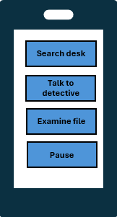

Figure 3
Investigate the Crime Scene.

The Investigate the Scene screen allows players to closely examine locations where the mystery unfolds, searching for clues and evidence that are essential for solving the case. Usability testing highlighted the need for clear visual cues and interactive hotspots to prevent players from feeling overwhelmed or confused. In response, the interface was refined to include tappable objects, magnification options, and subtle animations that draw attention to key evidence while maintaining immersion. This design supports cognitive clarity and accessibility, enabling players to methodically gather information without disrupting the narrative flow. By encouraging careful observation and logical reasoning, this screen strengthens engagement and ensures that players feel actively involved in the investigative process [1].

Figure 4
Decode the Clues.
The Decode the Clues screen enables players to analyse evidence collected from crime scenes and piece together critical information to advance the investigation. User testing revealed that players needed clear visual feedback and interactive tools [7] to interpret clues effectively without becoming frustrated or confused. In response, the interface was designed to include drag-and-drop elements, highlighting patterns, and contextual hints that guide players through the decoding process. This approach promotes cognitive engagement and accessibility, allowing users of varying experience levels to solve puzzles confidently. By combining problem-solving mechanics with narrative progression, this screen deepens player involvement and reinforces the investigative challenge central to the mystery murder game.
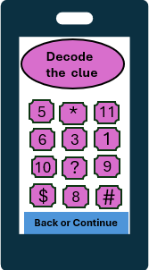

Figure 5
Select the Code.

The Select the Code screen challenges players to use clues they have gathered to unlock hidden information or secure access to critical areas within the investigation. Usability testing highlighted the need for clear input methods and immediate feedback [7] to ensure players could confidently enter or adjust their code without confusion. In response, the interface was refined to include touch-friendly keypads, visual confirmation of entries, and subtle hints to guide players when needed. This design supports accuracy, cognitive ease, and accessibility, allowing players to focus on problem-solving rather than struggling with the interface. By integrating interactive code selection with the broader narrative, this screen strengthens engagement and reinforces the logical deduction central to solving the murder mystery.

Figure 6

Clue Decoded: Prize Revealed.
The Clue Decoded – Prize Revealed screen celebrates the player’s success in deciphering a critical piece of evidence, providing a sense of achievement and progression within the game. Usability testing emphasized the importance of clear visual rewards and positive feedback to maintain engagement and motivation. In response, the interface was designed to include animated reveals, highlighted clues, and narrative commentary that reinforce the significance of the decoded clue. This approach supports emotional satisfaction and cognitive reinforcement, encouraging players to continue the investigation while feeling rewarded for their problem-solving efforts. By linking tangible in-game prizes to successful clue decoding, this screen enhances player immersion and reinforces the investigative challenge central to the mystery murder game [8].
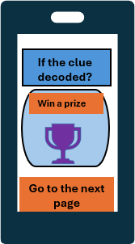

Figure 7
Case Closed.
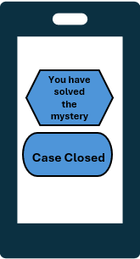
The Case Closed screen marks the conclusion of the investigation, providing players with a summary of their progress, solved clues, and the outcome of the mystery. Usability testing highlighted the importance of clear, concise feedback and a sense of narrative closure, so the interface was designed to include visual summaries, score or achievement indicators, and story resolution text. This approach ensures cognitive clarity and emotional satisfaction, allowing players to reflect on their deductions and accomplishments. By combining narrative closure with tangible rewards and feedback, this screen reinforces the player’s sense of achievement, encourages replay ability, and provides a satisfying conclusion to the murder mystery experience [7].

Figure 8

Feedback Collection Process and Summary.
A persona-driven approach [5] was used to collect feedback on the final storyboard prototypes of the murder mystery game, ensuring that the design effectively addressed the needs of a diverse player base.
Feedback Collection Process.
The process employed a combination of qualitative and quantitative methods to gain a complete understanding of user experience. Participants were selected to match the characteristics of the four defined personas. A pre-session questionnaire verified participant profiles and captured their initial expectations. During guided usability sessions, players interacted with a high-fidelity, clickable prototype of the full-colour storyboards. Each participant completed persona-specific tasks while their on-screen actions and verbalised thoughts were recorded. Immediately afterwards, users completed a brief survey to rate task difficulty and their emotional responses. A semi-structured interview then explored why users found certain tasks easy or challenging, providing deeper insights into their experience.
Summary of Feedback.
Analysis of the feedback revealed key themes, highlighting both strengths and areas for improvement.
Positive Feedback
- Immersive visual theme: Players appreciated the mysterious, detective-focused aesthetic, finding it intriguing rather than frightening.
- Rewarding mechanics: Points, badges, and progress indicators provided a sense of achievement and motivation.
- Safe and approachable design: Colour choices and character designs were praised for being welcoming and non-threatening.
- Customisation and accessibility: The ability to select avatars and adjust accessibility settings made players feel supported and connected.
Negative Feedback
- Misleading initial tone: Some new users initially expected a horror game before interacting with the mystery narrative.
- Flat emotional progression: Early prototypes lacked dynamic feedback, leaving players feeling less engaged before animations and rewards were added.
- Overstimulating elements: Fast animations and sounds initially overwhelmed some neurodiverse players, prompting the addition of a cognitive-friendly mode.
- Limited positive reinforcement: The original design did not provide sufficient encouragement after failed attempts, making errors feel punitive rather than educational.
This structured feedback process was essential for validating design choices, pinpointing usability challenges, and guiding improvements. It ensured the final interface was accessible, engaging, and narratively immersive, meeting the needs of a wide variety of players while maintaining the investigative focus central to the murder mystery game.
.

Data Gathering Strategy for a Live Application.
If the murder mystery game were to be developed and released, ongoing data collection would be crucial for supporting iterative improvements, identifying and fixing bugs, and maintaining long-term player engagement. The strategy would combine automated usage analytics with direct user feedback, capturing both quantitative and qualitative insights into player behaviour and experience. All data collection would be conducted in strict compliance with ethical and legal standards, ensuring user privacy and adherence to regulations such as GDPR [6], [8].

Ethical Considerations and GDPR Compliance.

The collection and use of player data in the murder mystery game would adhere to strict ethical standards and full compliance with the General Data Protection Regulation (GDPR) [6]. The central principle is user trust. At first launch, players would be presented with a clear and accessible privacy policy and would be required to provide explicit, informed consent before any data collection occurs. All automatically collected gameplay data would be anonymised, using randomly generated user IDs that cannot be traced back to individual players, ensuring confidentiality.
Under GDPR, the lawful basis for processing data would be user consent. The principle of data minimisation would be applied, meaning only information strictly necessary to improve the game experience would be collected. Sensitive data, such as location or contact information, would never be requested. Players would retain full control over their data, including rights to access, erase, or permanently delete their account and all associated information. Data security would be prioritised, with robust technical safeguards in place to prevent unauthorised access and ensure that player information remains always protected.

Conclusion.
The design process from initial wireframes to fully developed colour storyboards for the mystery murder mobile game has highlighted the essential role of a user-centred approach [1], [2], [3] in crafting an engaging and inclusive interactive experience. Every stage of design, testing, and refinement—driven by persona-based feedback—proved crucial in meeting the project’s objectives. This iterative process enabled the precise identification and resolution of usability challenges, resulting in significant improvements to navigation flow, visual clarity, and accessibility. Key enhancements, such as the interactive tutorial and cognitively supportive interface mode, were direct outcomes of responding to diverse user needs and feedback. The project reaffirmed that a successful game interface is not built in isolation but emerges through active collaboration and dialogue with its players. The final storyboards establish a strong and considered foundation for future development, achieving a balance between functional efficiency and narrative immersion that sustains player engagement and replay ability. Furthermore, the design adheres to an ethical framework that supports responsible data collection and future updates under GDPR [6] compliance, ensuring readiness for a smooth transition into a live, evolving product.

Reference list.

[1] D. Norman, The Design of Everyday Things, Revised and Expanded Edition. New York, NY, USA: Basic Books, 2013.
[2] J. Nielsen and R. Molich, “Heuristic evaluation of user interfaces,” in Proc. ACM CHI’90 Conf., Seattle, WA, USA, 1990, pp. 249–256.
[3] J. Nielsen, Usability Engineering. Boston, MA, USA: Morgan Kaufmann, 1993.
[4] A. Dix, J. Finlay, G. Abowd, and R. Beale, Human-Computer Interaction, 3rd ed. Harlow, UK: Pearson, 2004.
[5] International Organization for Standardization, “ISO 9241-210:2019 – Ergonomics of human-system interaction – Part 210: Human-centred design for interactive systems,” ISO, Geneva, Switzerland, 2019.
[6] General Data Protection Regulation (GDPR), Regulation (EU) 2016/679 of the European Parliament and of the Council, 2016.
[7] M. Green, R. Pearson, and S. Roberts, Game Usability: Advancing the Player Experience. Boca Raton, FL, USA: CRC Press, 2019.
[8] M. Fullerton, Game Design Workshop: A Playcentric Approach to Creating Innovative Games, 4th ed. Boca Raton, FL, USA: CRC Press, 2018.
[9] S. Jordan, Designing Pleasurable Products: An Introduction to the New Human Factors. London, UK: Taylor & Francis, 2000.
[10] T. Tullis and B. Albert, Measuring the User Experience: Collecting, Analyzing, and Presenting Usability Metrics, 2nd ed. Burlington, MA, USA: Morgan Kaufmann, 2013.

Appendix: Summary of Core Screens – Mystery Murder Game.
1. Welcome Screen.
Purpose: Introduces players to the mystery murder game while featuring UWTSD visual branding to establish the game’s theme and identity.
Key Actions: Players can start the investigation, access the tutorial section, or open accessibility options to adjust the interface to their needs.
Navigation: Once initiated, the screen transitions to the Player Setup Screen.

2. Player Setup Screen.
Purpose: Allows players to input their name and choose an investigator avatar, creating a personalized profile before gameplay begins.
Features: Developed with a focus on diversity and accessibility, offering inclusive avatar choices and adaptable display settings.
Navigation: Directs users to the Game Mode Selection Screen upon confirmation of their setup.

3. Game Mode Selection Screen.
Purpose: Provides options to play in Solo, AI-assisted, or Multiplayer modes, catering to different player preferences and levels of challenge.
Refinements: In response to user testing, tooltip icons were incorporated to clarify the purpose and rules of each mode, improving usability.
Navigation: Offers an optional instructional pop-up or proceeds directly to the Main Game Interface to begin solving the myster
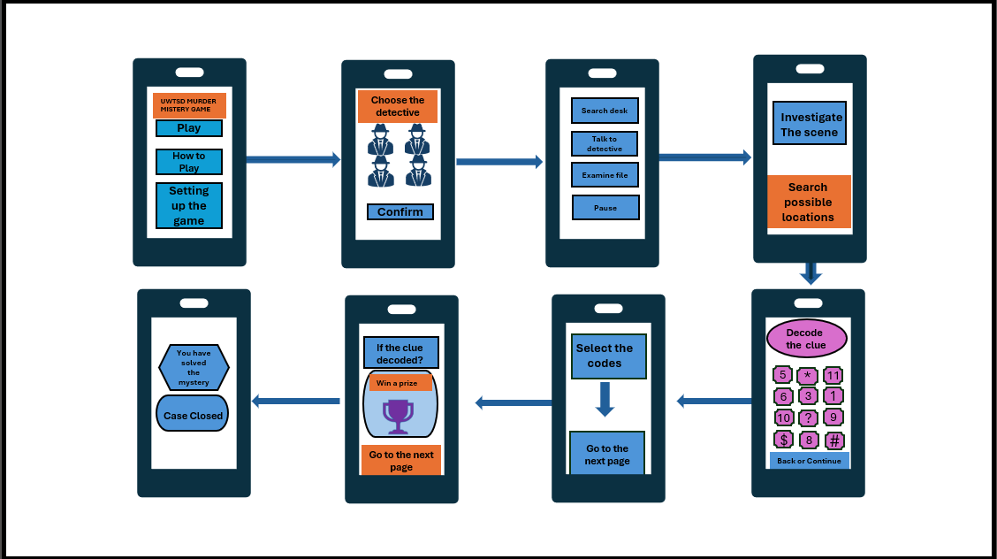

Figure 9

