Case study Information Sheet:
Izzy Davies
Age: 18
Izzy lives at home with her family (parents and two younger brothers) in a terraced house with a large back garden in Northampton. She is in the final stages of completing her A’levels at a local school (exams in 6 months time).
The school she attends is three miles away and so she gets a lift with one of her parents each day. Izzy usually has a busy week of lessons and after school activities (music and drama).
Izzy feels that she has put on weight over the last year due to a lack of activity and poor eating habits, as she sprained her ankle badly which took a few months to fully heal. She has started feeling self conscious about her appearance and is aware that many of her friends attend the gym or play sport in their free time. Izzy has said that she would like to be more active
She previously enjoyed PE in school when this was part of the timetable, however she is not required to do this in the sixth form. Izzy does not want to do a competitive sport as she feels she is not fit enough to cope with this. Evenings are usually spent socialising online and chatting with friends.
Izzy enjoys spending time with her friends (some of whom do exercise) either at their houses or in town. She is usually up late either completing homework or chatting online and so rarely gets to sleep prior to 11pm. She gets up at 8am each morning in the week, however does not get up until about 11am on the weekend.

Other information:
- When she is not doing school work she likes to spend time with her friends.
- Izzy likes to go out with her friends to socialise on weekend, however she does not enjoy drinking alcohol and will drink a maximum of 3 drinks in an evening.
- She does not smoke or vape.
- Izzy has never been a member of a gym, however she used to take part in swimming lessons / club up until the age of 14.
- She regularly feels stressed due to school assessments and upcoming exams.
- She has previously used the ‘step up’ app and averaged around 6k steps per day.
- Izzy eats a cereal bar in the morning, does not usually have lunch, has snacks in the afternoon and a healthy cooked meal in the evening.
- Izzy is very sociable and likes the idea of group-based exercise.
- Any activities suggested would need to take place during the early evening or on a Saturday / Sunday (not early morning).

Questions to answer:
- What stage of change (from the Transtheoretical Model) is Izzy currently at? What makes you think she is at this stage?
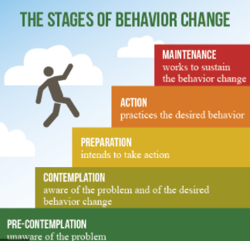
- Based on the information you have been given and what you have covered in the module, identify the benefits that Izzy is likely to obtain from exercising regularly?
Benefits:
- What barriers do you think are preventing Izzy from exercising / being generally more physically active?
Barriers:

- You have been asked to work with Izzy to encourage her to exercise regularly. What initial approach would you take to this?

- What three activities would you recommend for Izzy?
Activity 1:
Rationale for this choice:

Activity 2:
Rationale for this choice:

Activity 3:
Rationale for this choice:

Remember to link your ideas to research / theory where possible.

