CHANGE & STABILITY MANAGEMENT
APPLE INC.

Name: LE THI HUE
Student No.: 2213163
Program: MBA
Module: Change & Stability Management
Module code: BMMB 7000

Table of Content
1. Introduction 5
2. Drivers for Change Management in Apple Inc. 6
2.1 External and Internal Drivers 6
2.2 Leadership 6
2.3 Culture 7
3. Internal and External Environment 8
3.1 PESTEL 8
3.2 SWOT 10
3.3 Stakeholder Analysis 11
4. Resistance to Change 13
5. Power and Politics 15
6. Change Management Implementation in Apple Inc. 16
7. Effectiveness of Change Management Process 20
8. Conclusion 21
9. Recommendations 22
10. References 24
11. Appendix 28

List of Figures
Figure 2-1: Drivers for change 6
Figure 2-2: Leadership factors 7
Figure 3-1: PESTEL Analysis 8
Figure 3-2: PESTEL Analysis 9
Figure 3-3: Explanation of the Stakeholders in Apple Inc. 11
Figure 3-4: Stakeholder analysis in Apple Inc example 11
Figure 5-1: Power and Politics in organizations 13
Figure 6-1: Change Management Model 14
Figure 6-2: Kurt Lewin Change model 14
Figure 6-3: Where devices are manufactured 17

List of Tables
Table 3-1: SWOT Analysis of Apple Inc 10
Table 4-1: Overcoming resistance 12
Table 6-1: Kurt Lewin Change Management application for Apple Inc. 15

Introduction
Change management is one of the most critical tasks for organizations. There are various reasons that requires firms to implement change (Bashori, et al., 2020). Change management is an undertaking to develop or change the processes, which aims to promote the development of innovations, the application of technologies, or market expansions. In such a contemporary world, firms can experience various changes within the organization, and it is important for leaders to handle such change effectively.
Apple Inc. is a well-known organization that designs, develops, and sells electronic products, which was founded in 1976. Apple has suppliers all over the world while the majority of its manufacturing is undertaken in China. China is chosen as the major manufacturing location due to the availability of facilities as well as labour at a low cost (Apple Inc, 2023). Still, COVID 19 has restricted many operational actions at Apple Inc. The restriction has resulted in different problems within the organization such as the disruption of the global supply chain of Apple.
Accordingly, this study aims to examine how Apple has managed to handle such changes in the environment to maintain its business performance. To reach such objective, this essay will first identify the drivers of change management in the Apple by considering the external and internal business environment as well as requirements from relevant stakeholders present in the organization. Further, the implementation of change management in Apple will be explained by using Kurt Lewin’s change management model. Force Field analysis was also undertaken to test the drivers and resistances to the change's implementation. Finally, a comprehensive conclusion and recommendation will be provided to explain the change management process application and development within the organization.

Drivers for Change Management in Apple Inc.
The change in Apple Inc is driven by both external and internal factors, which are provided as follows.

External and Internal Drivers
There are several external and internal factors that makes the change management easy with in the organization. These are provided as follows (Apple Inc, 2023).

Figure 2-1: Drivers for change
Source: Author created

Leadership
Currently, Apple Inc. is perceived to employ democratic leadership among both past leaders and current leaders. One of the strengths of democratic leaders is their ability to listen to other's ideas and input, which is necessary for change management (Podolny & Hansen, 2020). Moreover, Podolny and Hansen (2020) also suggests that succesful delivery of change management requires brainstorming, discussion facilitation and contribution from all members towards the final decisions. All these are present in the Apple Inc. leadership style. Further, following are presented in the leadership that supports the change management.
Figure 2-2: Leadership factors
Source: Author created

Culture
Apple Inc’s culture can be described by two factors: innovation and creativity. According to Pathiranage et al (2020), Apple Inc needs to conduct various types of innovation each year. Accordingly, change management is necessary for ensuring the success of applying creative and innovative practices within the firm. According to Podolny and Hansen (2020), a positive environment in the organization can support employees to adapt to changes as well as to provide more insight to the change management process. In the case of Apple Inc, the firm has a culture to promote employee development, which helps employees gain career developments as well as encouraging them to adopt to change management practices.

Internal and External Environment
To examine the external environment for Apple and how it requires Apple Inc to apply changes, PESTLE analysis is conducted. In term of internal environment, SWOT analysis is applied to assess how changes should be managed and applied.

PESTEL
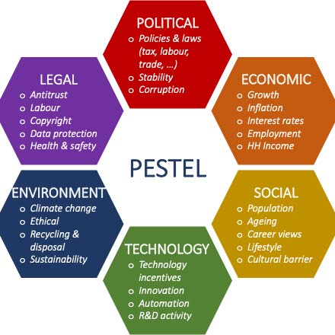
PESTEL analysis is explaining the external factors that are necessary in understanding the behavior of the organizations. Six factors are considered here. These are Political, Economic, Social, Technological, Environmental and Legal. PESTEL analysis is graphically showing as follows (Song, et al., 2017).
Figure 3-1: PESTEL Analysis
Source: (Khan, et al., 2015)

The PESTLE analysis for the shifting of the factory from China to India is presented in the table below:
Political | - Apple has manufacturing plants in different countries, such as China, India, Korea, Ireland and Cork. While the US has a stable political environment, China and India has low ranking in term of corruption and political transparency.  - The Chinese government's response to the COVID-19 pandemic has been praised for its efficiency and effectiveness, which could help to stabilize the political environment in the country.
Economic | - China is one of the world's largest economies and a critical market for Apple, both as a supplier and a consumer.  - The pandemic has disrupted global supply chains, and any further disruptions could impact Apple's ability to manufacture and sell products.  - India's infrastructure is still developing, which could result in logistical challenges for Apple.  - The cost of labor in India is lower than in many other countries, which could result in lower production costs for Apple.
Social | - There could be cultural barriers and differences in change of work culture that could impact Apple's operations, especially when Apple shift its manufacturing plants from China to India  - India is a diverse country with a rich culture and history, which could provide Apple with new ideas and insights for product development.
Technological | - India has a growing technology industry, which could provide Apple with access to skilled workers and new technologies.  - Both China and India have strong technology system. India also has a growing startup culture that focuses on innovation and entrepreneurship, and a favorable regulatory environment. Apple may be able to leverage this ecosystem to drive innovation and develop new technologies and products
Legal | - India has strict labor laws to protect workers, which could increase the costs and complexity of manufacturing operations for Apple.  - The legal system in India is less developed and could be challenging for Apple to resolve any disputes
Environment | India’s infrastructure and regulatory framework may not be fully developed to support sustainable manufacturing practices.
Figure 3-2: PESTEL Analysis
Source: Author Created

The COVID-19 pandemic has highlighted the risks of relying heavily on a single location for manufacturing, and India's growing infrastructure, skilled labor pool, and favorable regulatory environment may provide opportunities for Apple to diversify its operations and mitigate risks. However, there are also challenges to consider, such as the differences in the political, economic, social, technological, legal, and environmental factors between the two countries. Apple will need to carefully evaluate and manage these factors to ensure a successful transition to manufacturing in India.

3.2. SWOT
SWOT is one of the famous tools that is using in understanding the internal strengths and weaknesses of the organization and external threats and opportunities. SWOT is used by many organizations to understand the environment effectively. Following gives the SWOT analysis for Apple Inc (Khan, et al., 2015; Li, 2021).

Table 3-1: SWOT Analysis of Apple Inc
Source: Author Created

Stakeholder Analysis
In term of the movement of the factory from China to India, the related stakeholders are identified in this study as followed:
Stakeholder | Description | Strategy | Means of Communication
Employees | Apple's employees in China and India will be affected by the decision to move the factory. | Communicate clearly with its employees and provide support during the transition to ensure a smooth and successful move. | Email
Shareholders | Shareholders may be interested in Apple's decision to move its factory to India, as it may impact the company's profitability and long-term growth prospects. | Communicate the change purpose and change plan. Receive feedback and gain approval from relevant shareholders | Email, Online of Direct Meetings
Suppliers | Apple's suppliers in China and India will be impacted by the decision to move the factory. | Work closely with its suppliers to ensure continuity of supply and maintain quality standards during the transition. | Email, Phone Calls, Online Meetings
Customers | The movement of factory may affect the current supply chain, which results in a shortage of supply of products for customers | Public announcement and direct communication with current customers to let them understand the situation. | Email, Public Announcement
Local Communities | The move to India will also have an impact on the local communities where Apple operates. | Engage with the local community through a targeted public meetings or informational sessions. This can help inform the community about the project and address any concerns. | Public Announcement via newspaper, local authority
India & China Government | Apple will need to work closely with the governments and regulators in China and India to ensure compliance with local laws and regulations, and to obtain necessary permits and approvals for the move. | Clearly communicate the benefits of the project, including job creation, economic growth, and the potential for technological innovation. This can help Apple to gain support from the local authority and government | Direct meeting, email.

Stakeholders can be identified with respective to the stakeholder salience and position on the issues. Here, continuing the offshoring practices essentially in manufacturing concerning china has considered. For this issue, stakeholder salience is presented as follows.
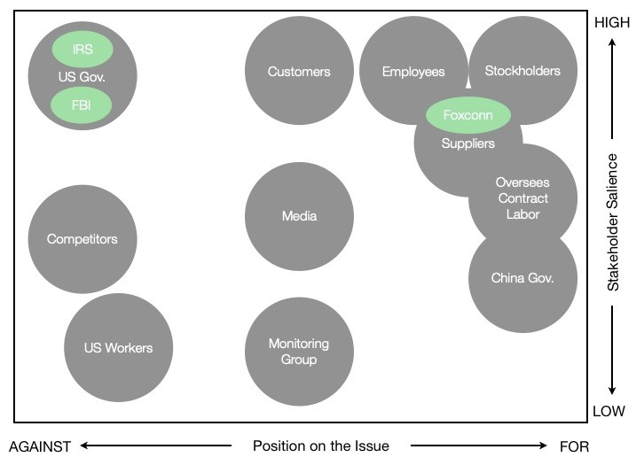
Figure 3-3: Stakeholder analysis in Apple Inc example
Source: (infocom, 2020)

Resistance to Change
There are different reasons for Apple’s employees to resist to change. These are necessary to explain in order to gather necessary information to apply strategies. Following gives the resistances to change, overcoming methods and needed approaches to overcome these resistances.
Table 4-1: Overcoming resistance
Source: Author created
Reasons for resistance | Overcoming method | Approaches to Use
Self-interest | Managers need to concentrate on employees and need to show that employees’ opinions are listened to. Managers should establish a collaborative culture towards the change. | Continuous communications, listening to the worker and motivating them
Misunderstanding and lack of trust | It is important for managers to announce the change and reasons for changing. In addition, communication is critical for ensuring that employee understand and believe in the outcome of the change. The expected results of the change should also be communicated to for relevant stakeholders. | Awareness sessions, communication about procedure, results and possible risks
Different perceptions on the change | Managers and employees need to have mutual understandings of the change and the change process management. Common objectives and strategies need to be published. | Publishing in bulletin in company about change objective and process.
Low tolerance for change | Develop soft skills for employees, improve employees’ capability for innovation and encourage creative ideas within the firm. | Training and development programs.
Afraid of change to current working pattern and condition | Advantages need to be communicated effectively to attract the employee towards change | Awareness, training, mentoring, supervision

Power and Politics
Apple Inc. is capable of understanding the resources available for the organization to deliver the outcomes successfully. Further, international relations are also taken into consideration within this this topic (Khan, et al., 2015). Understanding these factors is necessary to deliver the proper level of significance and proper level of outcomes. Apple Inc. is having significant understanding on the international relationships. The organization is using many different connections with the other countries (Barak, 2017). In this case, the personal interests of Apple's top executives, such as the desire to maintain its supply chain and ensure that the supply of iPhone is not disrupted by COVID lockdown, may have influenced the decision to move the factory from China to India. Moreover, the belief of success as Apple as a leading global brand may have given its executives the power to support the move. On the other hand, in term of organizational antecedents, the hierarchical structure of Apple's organization allows top executives make decisions without gaining approval for such movement from lower-level employees or other stakeholders. Besides that, Apple's culture of innovation and risk-taking also encourages its executives to take bold decisions such as moving its factory from China to India.
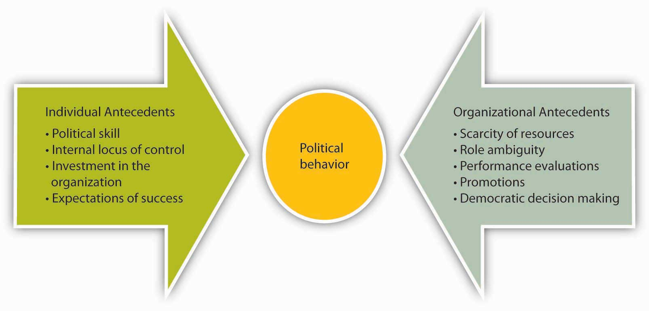
Figure 5-1: Power and Politics in organizations

Change Management Implementation in Apple Inc.
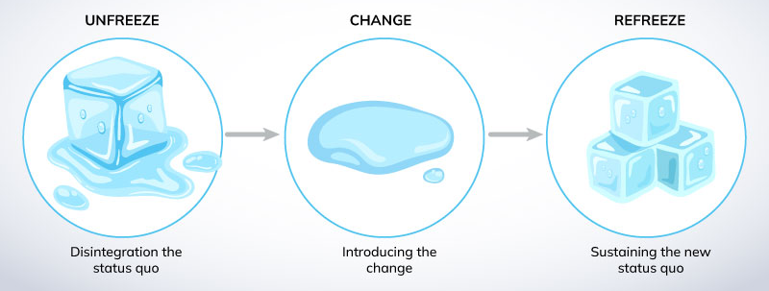
Change management is a significant factor in helping organizations achieve different objectives (Cummings, et al., 2016). The transition or transformation of the goals of the organizations is mainly done with respect to change management (Bashori, et al., 2020). There are different stages in change management, and one popular framework is Lewin’s change management model that comprises of three stages: Unfreeze, Change and Refreeze
Figure 6-1: Change Management Model
Source: (Lehmann, 2017)
Explanation of three stages are as follows.

Figure
6-2: Kurt Lewin Change model
Source: Author created
COVID-19 was a situation that occurred in the world, starting in China. This has caused difficulties in many areas of manufacturing and service organizations (Yu, et al., 2022). COVID-19 has made it difficult to run the supply chain smoothly in these companies (Kim, et al., 2021). Apple Inc. is one such organization. For instance, due to COVID-19 lockdown in China, Apple’s factory was under various lockdown order by the Chinese government, which negatively affected both the employees and the supply chain of the firm. In particular, Apple’s factory in Zhengzhou was locked down in November 2022, which caused a disruption for iPhone supply (Capoot, 2022). Moreover, COVID 19 had a negative impact on China, and the country's mobility policies were more restrictive (Xing, 2019). Thus, there were many difficult situations that Apple Inc. had to overcome to continue the manufacturing process in China.
Apple Inc. also has many disadvantages in its services and manufacturing. Apple Inc. is gaining the parts from different parts of the world and assembling them in China (Pun, et al., 2016). There are different suppliers for the manufacturing products. Nevertheless, the assembling process is mainly undertaken in China. Distribution of the products has been majorly carried out in Elk Grove, California. This is where the central warehouse is located (Lockamy III, 2017; Clarke & Boersma, 2017). Accordingly, Apple Inc. has well established its global supply chain in term of manufacturing and distribution.
In addition, Apple Inc has a proper and effective inventory management (Meredig, 2017). There were 154 key suppliers in 2013 and this number is still increasing with the increment in product types and innovations in the company (Liu, et al., 2022). According to Wang et al (2019), China is playing a significant role in the supply chain process of Apple. Thus, the movement of manufacturing factory from China to India is a significant change and critical challenge for Apple (Business Standard, 2022). Currently, the manufacturing part of Apple is mostly done in China due to lower production costs, efficiency and employees’ competencies (Tian, et al., 2022). As a result, moving the manufacturing processes suddenly out of the country was not an easy job . To properly handle the change of shifting the production process out of China, the Lewin’s change management model is applied.
Table 6-1: Kurt Lewin Change Management application for Apple Inc.
Source: Author Created
Unfreeze | In this stage, Apple needs to create the motivation and readiness for change among its stakeholders. Relevant stakeholders need to understand that the change is due to the COVID-19 pandemic, and the situation occurred due to the COVID-19 pandemic (McGee, 2023). China was restricted in many ways in its supply chain practices. Continuous lockdowns were reported, which made it difficult for Apple Inc. to continue their manufacturing process (Quick Books, 2020; Chan, et al., 2020). As China is a key partner in the manufacturing process of Apple, the need for change should be understood as per the difficulties faced by Apple Inc. due to COVID 19 (Liu, 2021). The lockdown in China has stopped Apple Inc. from sending its executives and engineers to the country. Thus, Apple Inc. faced hardships in checking the quality of their products (Oxford Analytica, 2022). Moreover, Apple also faced various challenges in handling the consequences of the lockdown such as power outage or violent protest in the Zhengzhou factory, China (Foxconn Plant; (Pun et al., 2016). Despite the fact that China has historically been more reliable, Apple Inc. did not have much confidence or comfort in continuing its manufacturing process in China (Oxford Analytica, 2022). Accordingly, it is important for involve communicating the reasons for the change, highlighting the benefits and creating a feeling of urgency for the change. Apple can involve its employees and suppliers, as well as legal authority in the change process to gain support and commitment for the change. Additionally, Apple can conduct an analysis of the risks and opportunities associated with the move as well as a feasibility study to evaluate the cost, time and the resources required for the change to take place.
Change | In this stage, Apple needs to implement the change by moving its manufacturing plant from China to India. As 95 percent of the Apple Inc. products (iPhone, iPad, Macs, and AirPods) are manufactured in China, the movement is not an easy activity. In 2023, only 1.87 percent of product is produced outside of China, with the remainder produced in China.  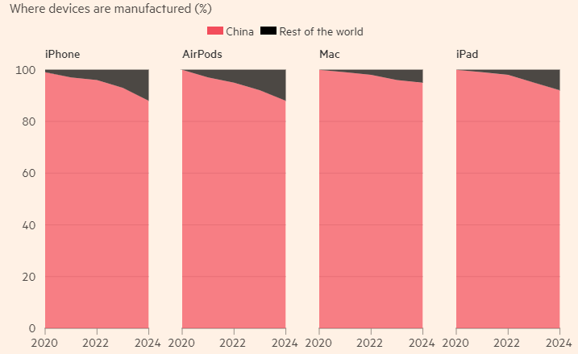  Figure 6-3: Where devices are manufactured  Source: (Financial Times, 2023)  For this stage to be successful, Apple needs to ensure effective communication, collaboration and coordination between its teams in China and India to ensure a smooth transition. Apple should also provide resources, training, and support to its employees to help them adapt to the new environment and work practices.  In fact, the implementation of such change is quite slow. India was able to make 3.1% of the iPhone in 2021 and such figure is estimated to increase to 6 or 7 percent in 2022 (Bhole & Shrivastava, 2021). As moving the whole production all the way from China was not done overnight (Thangavel, et al., 2022), there are various problems with the change. For example, China-based manufacturers are not willing to coordinate with factories in India, and thus, Apple is planning to relocate to Vietnam (Financial Times, 2023; Xing & Huang, 2021). This is mainly due to the issues in the political relationship between China and India. Nevertheless, Apple was able to start the iPhone 13 series manufacturing in India in 2021 (Xing, 2022). Likewise, the change has been implemented by the organization, with many different issues continuously facing change management implementation. Still, China is dominating the production and Apple Inc (Lockamy III, 2017). is slowly moving out the manufacturing from the country to India.
Refreezing | Apple Inc. has explained the situation to the management of the organization. Specially, engineers, executives, auditors, and other developers are moving from country to country to see the progress and quality in person (Business Standard, 2022). Adapting to the changes was not easy for these employees. Thus, Apple Inc. was introducing culturally relevant programs and making their staffs aware of the situation. These awareness’s make them adopt and face the challenges effectively (Xing, 2019). Different land locations caused various dificulties in the supply chain as people are used to the processes of working with China. Refreezing with the new change takes time and still, the organization is practicing the change management applications to gain outcomes effectively.

Effectiveness of Change Management Process
The change has occurred in the process of supply chain management and manufacturing by moving the production process to India (Meenakshi, 2022). India was the second-best option for Apple Inc. to implement the necessary manufacturing facility. There are various advantages in India, such as lower labor costs, personnel with high skills and capabilities (Dhanush & Nachiappan, 2023). Due to the COVID 19 pandemic, Apple Inc. has shifted its manufacturing practices to India, which is claimed to be incompleted but has experienced some success (Bhole & Shrivastava, 2021). For instance, the iPhone 13 series was started to be manufactured in India and the amount of products produced from Indian factory is increasing gradually. Apple reported that the production site is 300-acre in India near Bengaluru (Evans, 2023) with more than 100,000 jobs were presented. This is a positive measure of organizational change management success.
Initially, it was reported that India manufactured 3.1% of Apple Inc.'s products and covered the demand for the country. Recently, it was expected that India can produce 10 - 15% of total product production for Apple (Evans, 2023). The target of the company is to increase this percentage up to 25% in this year. Moreover, currently Apple’s exporters are exporting $2.5 billion worth of iPhones that are manufactured in India all over the world (Evans, 2023). This has motivated iPhone partners to open up stores in India, creating a significant market for iPhones in India. Accordingly, there are evidence to suggest that the change has been conducted effectively and it is proven to be a success.
Nevertheless, there are certain challenges for delivering the change successfully. For instance, there is political instability in India due to change in Indian government (Bhole & Shrivastava, 2021). Getting used to these changing policies and processes is challenging for the management of Apple, Inc. Due to such differences caused by government, regional legal problems still persists (Business Standard, 2022). Besides that, culture is another issue as the employees in different countries have different beliefs and social patterns (Thangavel, et al., 2022). For example, Apple Inc. is a Western organization, while India is Asian. However, Apple Inc. is capable of handling such challenges with its experience in different countries. Access to education is a problem in India compared to China. While the level of access to education is 97% in China, India’s level of literacy is only 78% (Evans, 2023).
There are certain advantages for Apple to implement the change in India. First, India is an English-speaking democracy country, which makes it easier for Apple to communicate with the relevant parties, including employees, supplers or partners (Quick Books, 2020). Moreover, Indians are friendly to Western culture (Business Standard, 2022). Indian also has a large population and young demographic profile. Such demographic profile allows Apple to hire young labour, which is cheaper and more effective in term of labour-extensive jobs.
By considering the above factors, it can be concluded that the implementation of change in India is successful for Apple. Nevertheless, understanding the forces for and against the change is critical to examining the effectiveness of the change's implementation. Force Field analysis is a typical method to understand these forces. The Force Field analysis for this is provided in appendix.

Conclusion
The report has provided an evaluation of the change management process of Apple for moving its manufacturing plant from China to India. In conclusion, Apple's project of moving its factory from China to India requires a strategic and comprehensive approach that involves effective communication with its relevant stakeholders. Understanding the organizational processes and change management procedure is necessary to maintain a positive flow in supply chain management.
COVID-19 has restricted various aspects of operations for the organization, especially in term of the mobility of experts from the parent company to the manufacturing centers in China. The lockdown has caused a discruption in the product-testing phase of final products in China due to travel restrictions. Accordingly, Apple Inc. planned to move the manufacturing from China to India. India was identified as the second-best option for Apple to place its manufacturing plant Asia. There are various advantages of moving from China to India as the Indian population has many similar traits compared to China. As a result, hiring skilled and educated individuals is possible in India.
There are various types of change management models proposed in existing literature. In this study, the change management of Apple has been investigated by using Kurt Lewin change management model. This model consists of three stages: unfreezing, changing, and refreezing. The report has shown that the change implementation has shown some early signs of success. Force Field Analysis is also used to understand the forces that support and oppose change. Moreover, various change management theories have been applied in this study. First, both external and internal factors and drivers for change were examined, including economic, political, cultural, logistics, and employee-related factors. Moreover, stakeholders may have a variety of concerns and resistance to the change. It is important for Apple to address these concerns and communicate effectively with stakeholders to ensure that related parties support the project. By implementing effective change management strategies, Apple can ensure a successful transition for continued growth and success in the global marketplace. The shift to India could provide significant advantages for the company, including access to new markets and resources and resolve the problem of disrupted supply chain caused by COVID-19. Ultimately, the success of the project depends on Apple's ability to effectively manage change and collaborate with stakeholders to achieve its goals.

Recommendations
From the analysis above, there are certain recommendations for Apple in particular and other businesses in general to improve the change management process in the firm.
First, it is important for business to set up the objectives of the change clearly. Apple Inc. needs to identify the reasons for the change and setting the necessary objectives. The shift of the manufacturing plant from China to India is merely due to the situation prevailed at COVID 19 era. Furthermore, India was the best option for Apple as it is a cost-effective option. Nevertheless, the objective and the plan of the change must be laid out and communicated clearly to relevant stakeholders.
Second, it is critical to ensure awareness among Apple’s staffs. While the change is mainly relevant for managerial staffs in Apple Inc, it is important for Apple to communicate the change to all staffs to ensure trust and belief in the success of the change from all employees.
Third, financial planning is another critical factor for consideration when change is applied. Apple Inc. need to plan for the necessary budget to deal with the developments to ensure that the change brings about positive financial performance for the firm.
Last but not least, it is important for monitoring the changing process. Apple should assign a separate team to monitor and follow up the change management process to make sure that the project reaches the necessary outcomes. Moreover, Apple needs to collect feedbacks from stakeholders as it enables organizations to evaluate the effectiveness of their change initiatives and make necessary adjustments. By actively receiving feedback from stakeholders, organizations can show that they value stakeholders’ input and are committed to making change initiatives successful.

References
- Apple Inc, (2023), Apple.Com. [Online]
Available at: https://www.apple.com/
[Accessed 17 03 2023].
- Barak, G., (2017), 'Unchecked corporate power: Why the crimes of multinational corporations are routinized away and what we can do about it' (Vol. 1), s.l.: Taylor & Francis.
- Bashori, B., Prasetyo, M. A. M. & Susanto, E., (2020), 'Change management transfromation in islamic education of Indonesia'. Social work and education, 7(1), pp. 84-99.
- Bhole, V. & Shrivastava, P., (2021), 'An empirical investigation Impact of COVID-19 on Make in India'. PalArch's Journal of Archaeology of Egypt/Egyptology, 18(7), pp. 2068-2074.
- Business Standard, (2022). 'Apple Inc planning to ramp up production in India over China: Report', s.l.: https://www.business-standard.com/article/companies/apple-inc-planning-to-ramp-up-production-in-india-over-china-report-122052200075_1.html.
- Chan, J., Selden, M. & Pun, N., (2020), 'Dying for an iPhone: Apple, Foxconn, and the Lives of China's Workers', s.l.: Haymarket Books.
- Clarke, T. & Boersma, M., (2017), 'The governance of global value chains: Unresolved human rights, environmental and ethical dilemmas in the apple supply chain'. Journal of business ethics, Volume 143, pp. 111-131.
- Cummings, S., Bridgman, T. & Brown, K. G., (2016), 'Unfreezing change as three steps: Rethinking Kurt Lewin’s legacy for change management'. Human relations, 69(1), pp. 33-60.
- Dhanush, R. & Nachiappan, S., (2023), 'Comparative Study of Consumer Perception between IPhone and Android Mobiles'. Journal homepage: www. ijrpr. com ISSN, 25(82), p. 7421.
- Evans, J., (2023), 'Apple's supply chain is accelerating the move to India', s.l.: https://www.computerworld.com/article/3689970/apples-supply-chain-is-accelerating-the-move-to-india.html.
- Financial Times, (2023), 'Financial Times, How Apple tied its fortunes to China'. [Online]
Available at: https://www.ft.com/content/d5a80891-b27d-4110-90c9-561b7836f11b
[Accessed: 17 03 2023].
- infocom, (2020), 'Apple Stakeholder Analysis', s.l.: https://teletype.in/@infocom/g0p2oP-gu.
- Khan, U. A., Alam, m. N. & Alam, S., (2015), 'A critical analysis of internal and external environment of Apple Inc'. International Journal of Economics, Commerce and Management, 3(6), pp. 955-961.
- Kim, J., Kim, J. & Wang, Y., (2021), 'Uncertainty risks and strategic reaction of restaurant firms amid COVID-19: Evidence from China'. International Journal of Hospitality Management, Volume 92, p. 102752.
- Lehmann, S., (2017), 'Bridging strategies and action: Towards a method for change management in Danish emergency management organizations'. Journal of Change Management, 17(2), pp. 138-154.
- Liu, L., (2021), 'The rise of data politics: digital China and the world'. Studies in Comparative International Development, Volume 56, pp. 45-67.
- Liu, W., Wei, W., Choi, T. M. & Yan, X., (2022), 'Impacts of leadership on corporate social responsibility management in multi-tier supply chains'. European Journal of Operational Research, 299(3), pp. 483-496.
- Li, Y., (2021), Apple Inc. 'Analysis and Forecast Evaluation'. Proceedings of Business and Economic Studies, 4(4), pp. 71-78.
- Lockamy III, A., (2017), 'An examination of external risk factors in Apple Inc.’s supply chain'. Supply Chain Forum: An International Journal. Taylor & Francis, 18(3), pp. 177-188.
- McGee, P., (2023), 'How Apple tied its fortunes to China', s.l.: https://www.ft.com/content/d5a80891-b27d-4110-90c9-561b7836f11b.
- Meenakshi, V. I. T., (2022), 'EMPLOYMENT PRACTICES AT APPLE; SOCIAL AND LEGAL ISSUES DISRUPTING INDIA'S INDUSTRIAL RELATIONS LANDSCAPE'. Journal of the International Academy for Case Studies, 28(4).
- Meredig, B., (2017), 'Industrial materials informatics: Analyzing large-scale data to solve applied problems in R&D, manufacturing, and supply chain'. Current Opinion in Solid State and Materials Science, 21(3), pp. 159-166.
- Oxford Analytica, (2022), 'China will lose leverage as some firms move elsewhere'. Emerald Expert Briefings, (oxan-db).
- Oxford Analytica, (2022), 'India benefits from Apple's rethink on China. Emerald Expert Briefings, (oxan-db).
- Pathiranage, Y. L., Jayatilake, l. V. & Abeysekera, (2020), A literature review on organizational culture towards corporate performance. International journal of management, accounting and economics, 7(9), pp. 522-544.
- Podolny, J. M. & Hansen, M. T., (2020), 'How Apple is organized for innovation. Harvard Business Review', 98(6), pp. 86-95.
- Pun, N. et al., (2016), 'Apple, Foxconn, and Chinese workers’ struggles from a global labor perspective'. Inter-Asia Cultural Studies, 17(2), pp. 166-185.
- Quick Books, (2020), 'Apple Supply Chain - The Best Supply Chain in the World', s.l.: https://quickbooks.intuit.com/r/supply-chain/apple-the-best-supply-chain-in-the-world/.
- Rosdiana, N. & Aslami, N., (2022), 'The Main Models of Change Management in Kurt Lewin's Thinking'. Jurnal Akuntansi, Manajemen dan Bisnis Digital, 1(2), pp. 251-256.
- Song, J., Sun, Y. & Jin, L., (2017). 'PESTEL analysis of the development of the waste-to-energy incineration industry in China'. Renewable and Sustainable Energy Reviews, Volume 80, pp. 276-289.
- Thangavel, P., Pathak, P. & Chandra, B., (2022), 'COVID-19: Globalization—Will the course change?'. Vision, 26(1), pp. 7-10.
- Tian, X., Yang, L., Huang, Y. & Fang, Y., (2022), 'Research on Supply Chain Shortage of Electronic Technology Companies under the Pandemic Situation: A Case Study of Apple Inc. and Xiaomi Inc'. 2022 13th International Conference on E-Education, E-Business, E-Management, and E-Learning (IC4E) (pp. 605-610).
- Wang, N., He, Q. & Jiang, B., (2019), Hybrid closed-loop supply chains with competition in recycling and product markets. International Journal of Production Economics, Volume 217, pp. 246-258.
- Xing, Y., (2019), 'How the iPhone widens the US trade deficit with China: The case of the iPhone X (No. 19-21)'. National Graduate Institute for Policy Studies.
- Xing, Y., (2022), 'China and global value chain restructuring'. China Economic Journal, 15(3), pp. 310-329.
- Xing, Y. & Huang, S., (2021), 'Value captured by China in the smartphone GVC–A tale of three smartphone handsets'. Structural Change and Economic Dynamics, Volume 58, pp. 256-266.
- Yang Jie & Tilley, A., (2022), 'Apple Makes Plans to Move Production Out of China', s.l.: https://www.wsj.com/articles/apple-china-factory-protests-foxconn-manufacturing-production-supply-chain-11670023099.
- Yu, J. et al., (2022), 'Exploring impacts of COVID-19 on city-wide taxi and ride-sourcing markets: Evidence from Ningbo, China'. Transport Policy, Volume 115, pp. 220-238.
- Hussain, S. T., Lei, S., Akram, T., Haider, M. J., Hussain, S. H., & Ali, M. (2018), 'Kurt Lewin's change model: A critical review of the role of leadership and employee involvement in organizational change'. Journal of Innovation & Knowledge, 3(3), 123-127
- Cummings, S., Bridgman, T., & Brown, K. G. (2016), 'Unfreezing change as three steps: Rethinking Kurt Lewin’s legacy for change management'. Human relations, 69(1), 33-60.

Appendix
Force Field Analysis
Forces against Change
Apple Inc. Manufactruing movement from China to India
Forces to Change
Operational cost saving with low cost manufacturing
Having larger population making lower hiring costs
Resources are saving with operations and can be used in somewhere else
Speed manufacturing with speed implementations
Social image and reliability is increasing
Possibility to supply for the demand even in the difficult times (COVID 19 period)
Increasing the good will of the organization
Energy can be saved and processes can be applied effectively
Overcoming the personal visiting issues for the self-checking in manufacturing process
Percentage of error reduction
10
9
9
10
9
10
10
10
8
9
Barriers of culture in the country
Less access to education (78 %) than China (97 %)
Competition among the companies is higher
Initial investment costs can be higher
Adaption to the cultural changes taking time
Competition towards the employments as there are different stages of personnel
Risk of the change resistance by the current employees
Population is younger with majority and still growing towards aging population
Policies and procedure changes by the governmental changes
Uncertainty situations in the market and suppliers
7
9
9
7
7
8
8
7
8
6

Forces to Change | 94/100
Forces against Change | 76/100

