Lab 8
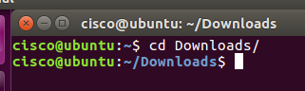
Message currently reads;
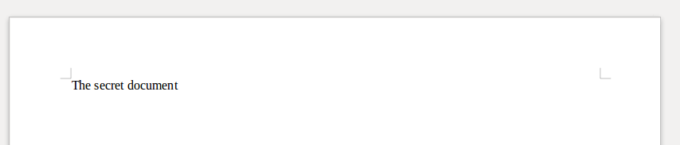

Gimp keyboard.jpg
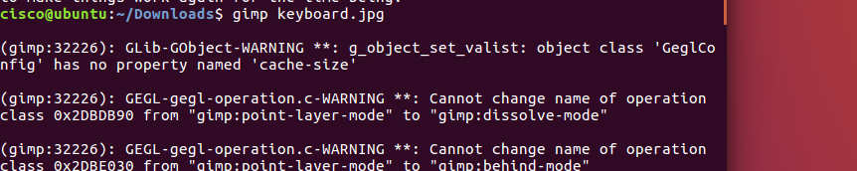
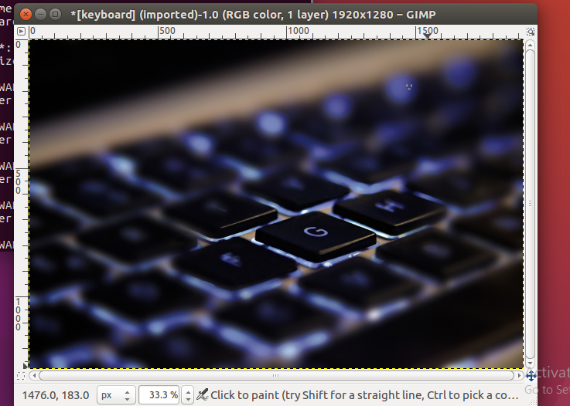
Embed
PW = Cisco
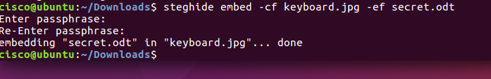
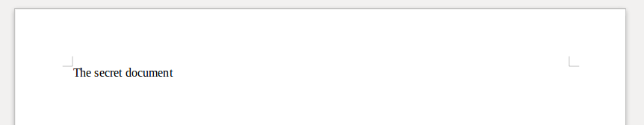
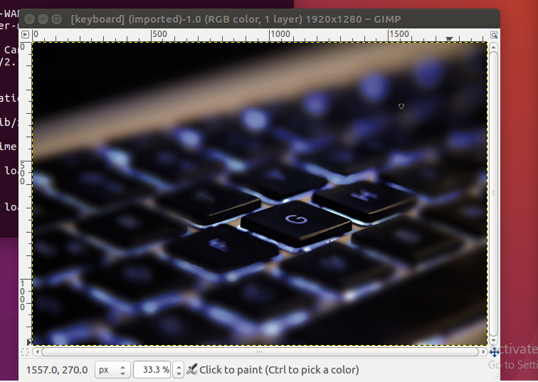
Files did not change
Extract
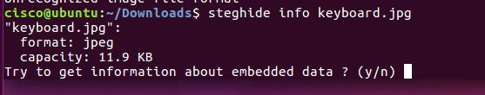
Do NOT ENTER, just type y
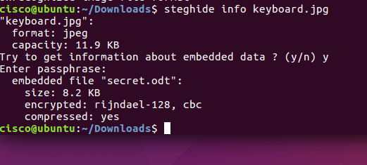
Shows secret.odt is embedded
Extract
Cut file to desktop
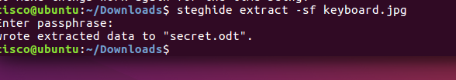

Back to file to see extraction

